**Q.1**

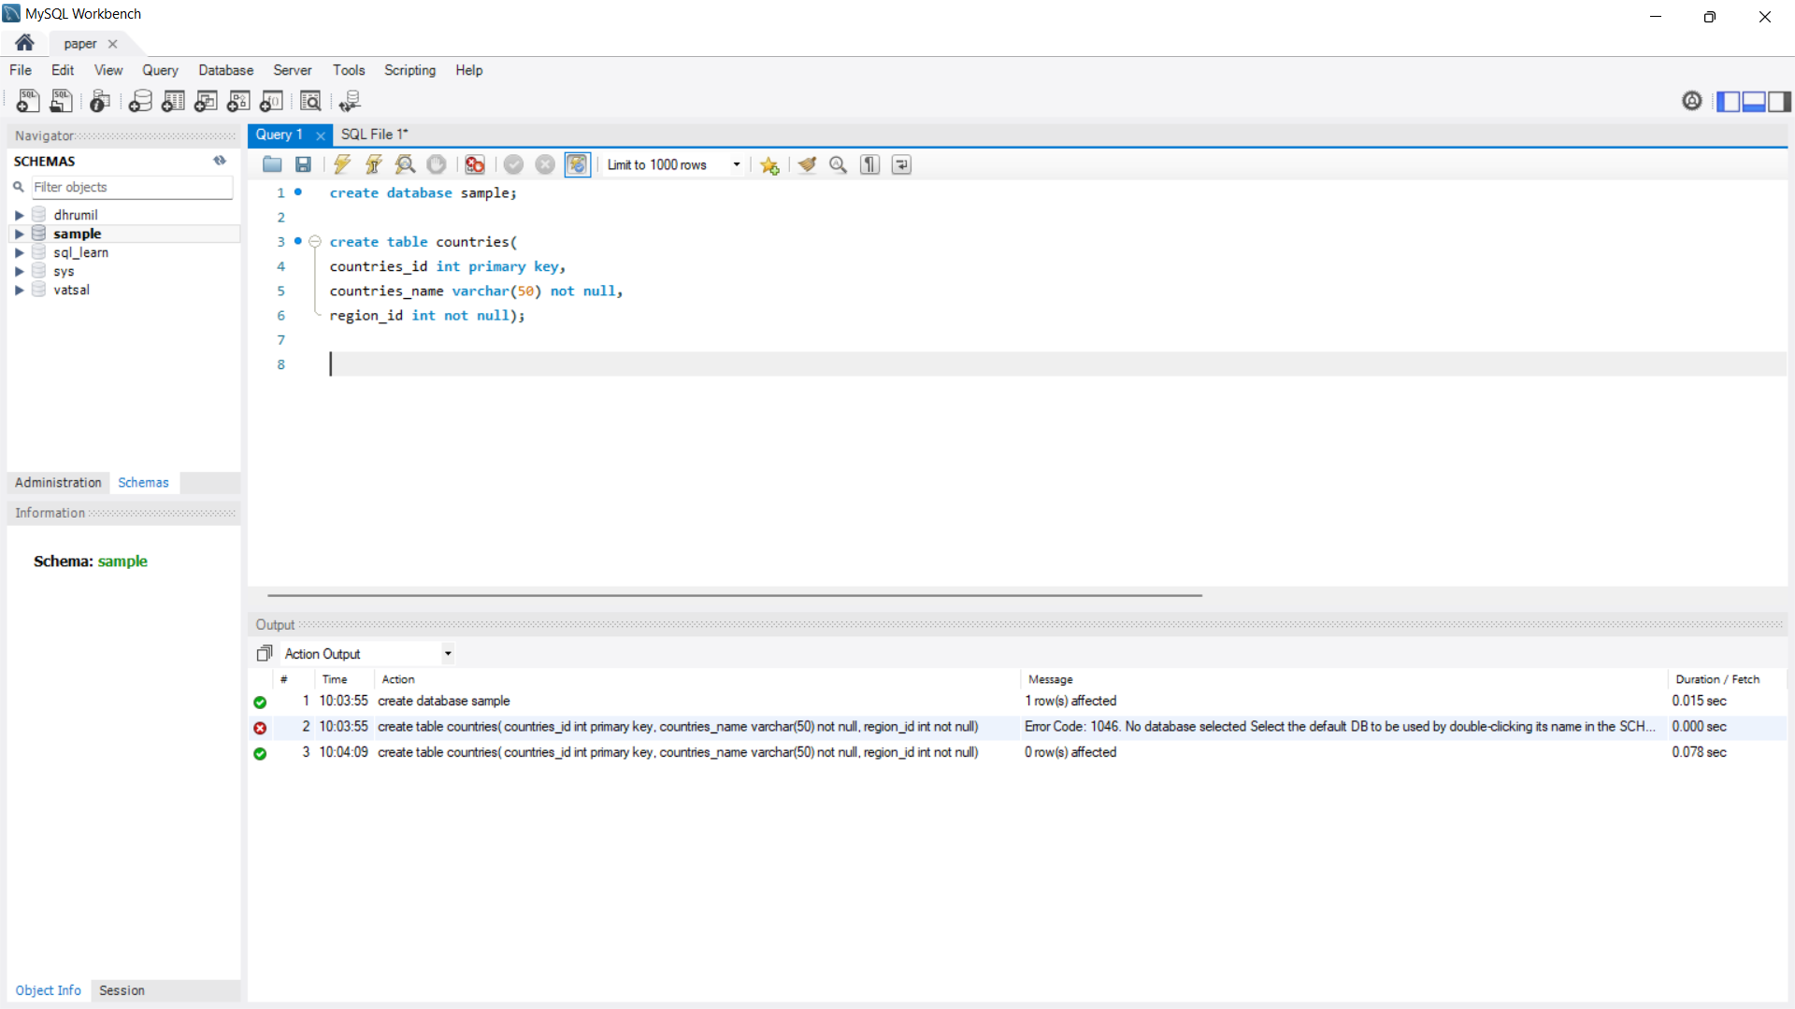A)

Step 1 :- Frist create database sample

Step 2 :- After create the database then you select the database in mySQL or Use the database

Step 3 :- Now create the table countries their contain is “countries_id” , “countries_name” and “region_id”

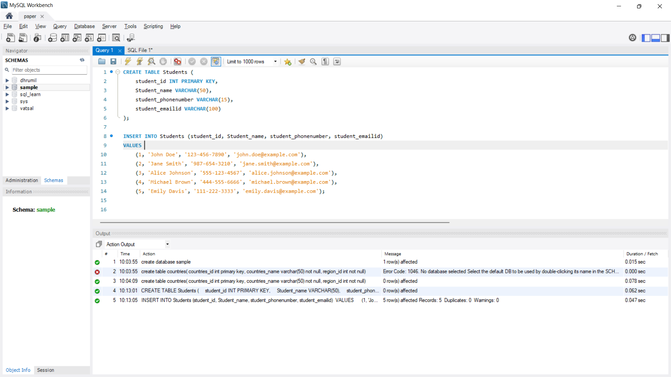B)

Step 1:- create table student on their contain is student_id, Student_name, student_phonenumber and student_emailid.

Step 2 :- insert 5 records in student table.

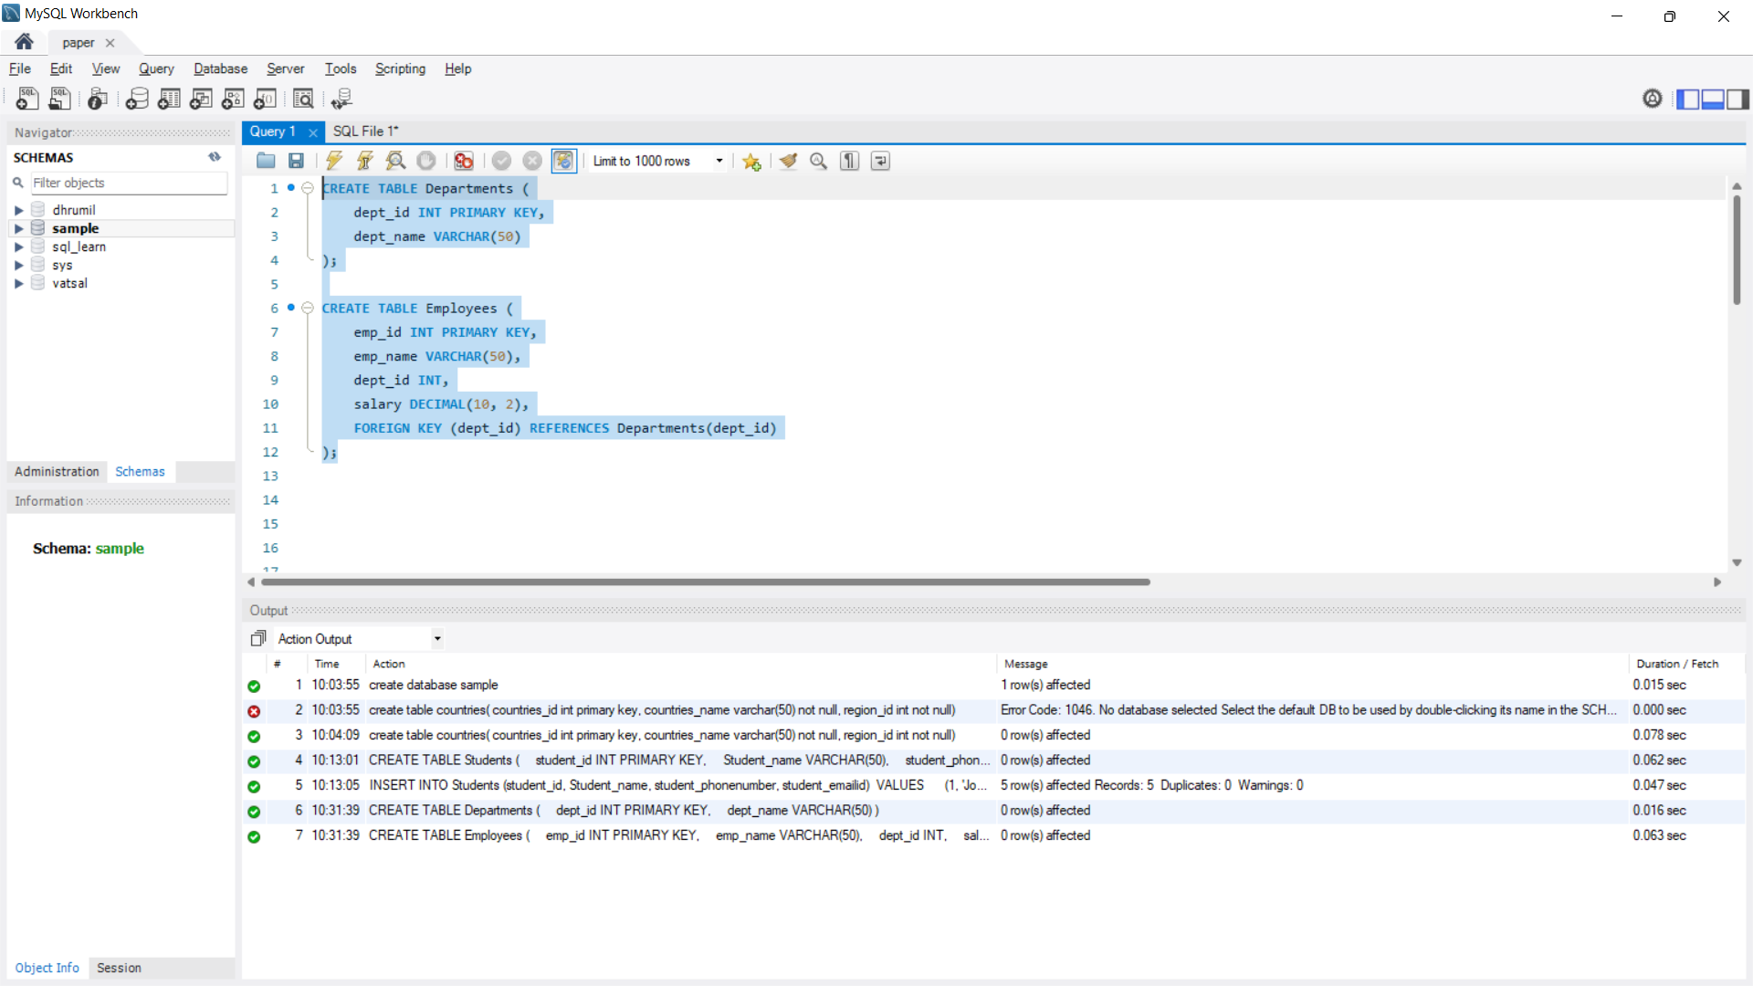**Q.2**

