**INDEX**

|  |  |  |
| --- | --- | --- |
| **SL No.** | **Topic** | **Page No.** |
| 1 | Acknowledgement | 2 |
| 2 | Preface | 3 |
| 3 | Project profile | 4 |
| 4 | Introduction to project | 5 |
| 5 | Software & Hardware requirement | 6 |
| 6 | Tools | 7 |
| 7 | System requirement study | 10 |
| 8 | Project planning | 12 |
| 9 | SDLC (Software Development Life Cycle) | 15 |
| 10 | Data Flow Diagram (DFD) | 20 |
| 11 | Use Case Diagram | 25 |
| 12 | ER Diagram | 27 |
| 13 | Data Dictionary | 29 |
| 14 | Layout (Screenshot) | 34 |
| 15 | Conclution | 59 |
| 16 | Limitation & Future Enhancement | 60 |
| 17 | Bibliography | 61 |

**ACKNOWLEDGEMENT**

It is matter of great pleasure for us to get this opportunity expressing our sincere sense of gratitude to Saurashtra University.

My external guide was the main force behind all these because of his valuable suggestions and proper guidance for this project. He taught me most importantly how to work in an organization, how to complete given work within deadlines, working under pressure and being independent.

It is our great pleasure to present our project report on “FurniMart Furniture Store” which developed during the 5th Semester in BCA affiliated to Saurashtra University, Rajkot.

I would like to thanks principal and lecturers of the “M.V.M.M. Com. Sci. & Management College” for Better guidance me and provide me a permission to collect all information about My project. I also like to say thanks to all my classmates that are always helping me directly and indirectly.

Thank You

Developed By

Dhrumil Bhindora

Nidhip Solanki

**PREFACE**

To achieve all this, there is a need of good computer literacy and for this, there are so many course.

A student of BCA according to the syllabus subscripted by Saurashtra University is required to submit project report as practical training. The main objective is to develop awareness regarding the application of theories in the practical world of Information Technology or Management and to give exposure to the student.

For this, we have prepared project work on FurniMart Furniture Store which is portal for buying and giving information of furnitures like chairs, sofa, table, etc. . .

**PROJECT PROFILE**

Project Name :- FurniMart Furniture Store

Develop By :- Dhrumil Bhindore & Nidhip Solanki

Submitted To :- MVMM Computer Sci. Collage, Wankaner

Front End :- PHP

Back End :- MYSQL

Documentation :- Microsoft Word

Project Guide :- Pro. Sanjay Parmar

Project Duration :- Academic Year 2023-2024,

5th Semester of BCA.

**INTRODUCTION TO PROJECT**

In traditional system customer is going to the store and purchase thing that he or she want but now customer can purchase or buy anything online.

In our website customer can buy any kind of furniture that they want. Furniture is not just about how things look. It's also about how they work and fit into our homes and offices.

There is two side in this project : (i) Admin Side (ii) Client Side

Admin can manage whole website. Admin can add admin, categories, products. Update categories, products. Admin can see all products, categories, payments, users.

Client can buy furniture from website. Client can search through search bar and can go with category that he/she want to buy.

**HARDWARE & SOFTWARE REQUIREMENTS**

* Hardware:
* I3 or higher processor
* Free disk space 250MB
* 4GB or higher RAM
* Color Monitor
* Internet Connection
* Keyboard
* Mouse
* Software:
* Windows 7 or higher
* Xampp
* Notepad/Notepad ++
* Browser(Chrome, Mozila Firefox, Microsoft Edge, ETC..)

**TOOLS**

FRONT END:

* PHP :-

* PHP (Hypertext Preprocessor) is a widely-used open source general-purpose scripting language that is especially suited for web development and can be embedded into HTML.
* PHP files can contain text, HTML, CSS, JavaScript, and PHP code.
* PHP code is executed on the server, and the result is returned to the browser as plain HTML.
* PHP can generate dynamic page content.
* PHP runs on various platforms (Windows, Linux, Unix, Mac OS X, etc.)
* PHP support multiple database.
* BOOTSTRAP :-
* **Bootstrap** is the most popular **CSS Framework** for developing responsive and mobile-first websites.
* Bootstrap has its own classes that makes its very easy framework of css.
* We can easily design our website using this framework.
* Bootstrap is free (open source).

BACK END :

* MYSQL :-
* MySQL is a relational database management system.
* MySQL stores data in tables made up of rows and columns. Users can define, manipulate, control, and query data using Structured Query Language, more commonly known as SQL.

**System Requirement Study**

The requirements gathering process is intensified and focused specially on website. Website requirement analysis encompasses understanding the information domain for the website as well as required function, performance, behavior and interfacing. Requirements for both the system and the software are documented and reviewed with the customer.

1. **Design**

Website design is multi-step process that focuses on four distinct attributes of a program : data structure, website architecture, interface representation, and procedural details.

1. **Code Generation**

The design is translated to machine - readable form. If design is performed in a detailed manner, code generation, can be accomplished mechanistically.

1. **Testing**

The testing process focuses on the logical internals of the website, assuring that all the statements have been tested, and on the functional externals i.e, conducting tests to uncover errors and ensure that defined input will produce actual results that agree with requires skills.

1. **Maintenance**

Website maintenance applies to following phases in the existing program:

* Change in website due to errors.
* Change in website because the website must be adapted to accommodate changes in its external environment.
* Change in website when the customer requires functional.

**Project Planning**

The purpose of developing this system is to fully automate the online shopping for furniture.

* Project Scheduling :

This website “FurniMart Furniture Store” focuses on selling furniture online. Client/user can buy furniture from this website. In this website the primary user is ‘Admin’ who can add, delete, update products or categories or users. Here people can buy furniture using categories as their requirements and choice.

* **Project features:**
* New products and categories can Add, Update and Delete.
* Admin can see all the stuff of website.
* Admin can change category, price and information of products.
* Admin can see users list, payment list.
* Client/User need to login for buying product. If user not registered them self to website they need to register first and then login through username and password.
* Client/User can buy products through search bar or category wise also.
* After buying and completing payment user can download/generate invoice of product that he or she purchased.

**Basic Functionality of project:**

* **Client :**
* Login
* Registration
* View category
* View products
* Pending orders
* All orders
* Payment and invoice
* Logout
* **Admin :**
* Login
* Add products
* View products
* Edit products
* Add category
* View category
* Edit category
* View users
* Edit users
* View orders
* Edit orders
* View payments
* Logout

**SDLC(Software Development Life Cycle)**

* SDLC stands for software development life cycle.
* The software development life cycle (SDLC) is a process by which software is developed and deployed.
* It is also called as software development process.
* The SDLC is blue print of entire project.
* A project manager can implement as SDLC process by following various models.
* SDLC is process followed for a software project, with in a software organization.
* It consists a detailed plan describing how to develop, maintain, replace and alter or enhance specific software.
* It includes six common stages, which are: requirement gathering and analysis, software design, coding and implementation, testing, deployment and maintenance.

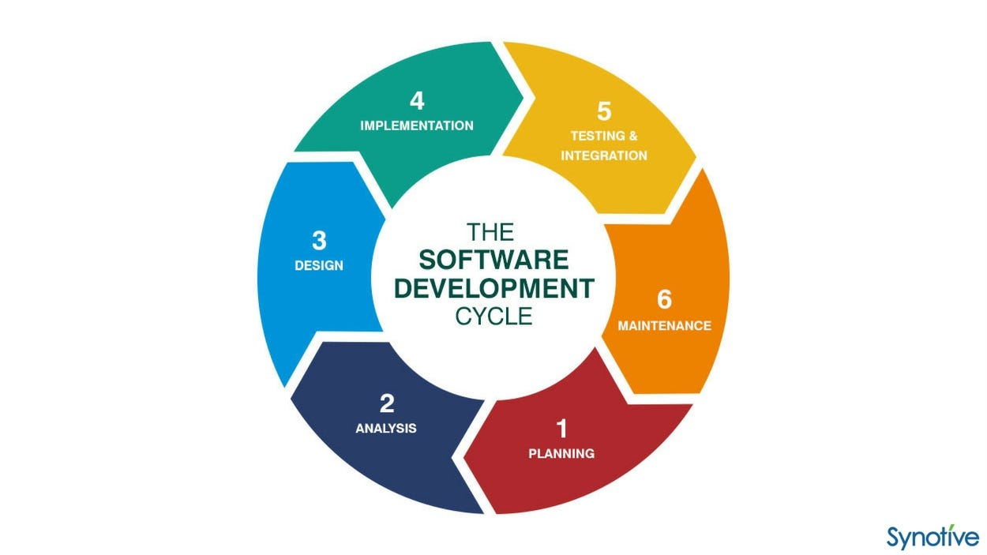

1. **Planning**

* This is the first phase of system development process.
* The purpose of first stage is making plan about your software.
* The purpose of this stage is also a find out the scope of problem and determine solutions.
* Resource, cost, time, benefits and other items should be considered at this stage.
* Planning for the quality assurance requirements and identifications of the risks associated with the project is also done in the planning stage.

1. **System analysis & requirement**

* The second phase is where we can consider as a requirement of our project & analysis the system.
* Requirement analysis is the most important and fundamental stage in SDLC.
* A software requirement specification (SRS) document, which specifies the software, hardware, functional, and network requirements of the system is prepared at the end of this phase.
* Requirements analysis is critical to the success of failure of the system or software project.
* This is done through SRS (Software Requirement Specification) document which consists of all the product requirements to be designed and developed during the project life cycle.

1. **System design**

* In third phase we have to start designing our system.
* Based on the user requirements and the detailed analysis of new **system**, the new **system** must be designed. This is the phase of **system designing**.
* The logical system designing arrived at as a result of system analysis and is converted into physical system design.
* The **logical design** produced during the analysis is turned into a physical design a detailed description of what is needed to solve original problem.
* Input, outputs, databases, forms, modification schemes and processing specifications are drawn up in detail.
* In the design phase, the programming language and the hardware and software platform in which the new system will run are also decided.

1. **Development**

* In fourth phase, we can develop the system.
* In this stage of SDLC the actual development starts and the product is built.
* Developers must follow the coding guidelines defined by their organization and coding tools like compilers, interpreters, debuggers, etc. are used to generate the code.
* Different high level programming languages such as C, C++, Pascal, Java and PHP are used for coding.
* The programming language is chosen with respect to the type of software being develop.

1. **Integration & testing**

* The software is tested at different levels of the software development to identify the defects and verify the requirements of the client by the developers QA team.
* Testing is process that checks to see weather solution meets the design specifications and is free from errors.
* There are two types of testing:

1. Black Box Testing

2. White Box Testing

* **Black Box Testing:**
* Black box testing is method of software testing that examines the functionality of application based on the specifications.
* It’s also known as specification based testing. Independent testing team usually performs this of testing during software testing life cycle.
* **White Box Testing:**
* White box testing is testing technique, that examines the program structure derives test data from the program logic/code.
* The other name of glass box testing is clear box testing, open box testing, logic driven testing or path driven testing or structural testing.

1. **Deployment in market and maintenance**

* At this stage, the goal is to the deploy the software to the production environment so user can start using the product. However, many organizations chose to move the product through different deployment environments such as a testing environment.
* Maintenance should include regular review and evaluations to ensure that it is achieving its objectives, identify ant aspects that can be improved or any operational problems. Maintenance falls into two categories, implementation of new features or elimination of errors.

**Data Flow Diagram**

A data flow diagram (DFD) is a graphical representation of the “flow” of the data through an information system.

In other word, it shows:

* What going in
* How it is changed
* What comes out

A data flow diagram can be used for the visualization of data processing (structured design). It is common practice for a designer to draw a context-level DFD is then “exploded” to show more detail system being method.

Data flow diagrams are useful and initiative way of a describing system. They are normally understandable without special training. Especially if control information is excluded. They show end-to-end processing. That is, the flow of processing from when data enters the system to where it leaves the system can be traced.

**Purpose:-**

To describe the functionality in a system and the corresponding exchanges of data between the functions. Conventions used in drawing the data flow diagram here, are:

Process

Dataflow

Source & Destination

Data store

**Context (Zero Level) Diagram**

FurniMartFurniture Store

Admin

Customer

**1 Level**

**Admin:**

Login

Add Product

View Product

Admin Login

Add Category

Admin

View Category

All orders

All Payments

All users

Logout

**User:**

Register

Login

Home

Products

User Login

Categories

**User**

Log Out

About Us

Feedback

Contact Us

View More

**Use Case Diagram**

**User**

**Admin**

**Er Diagram**

An entity-relationship (ER) diagram is a specialized graphic that illustrates to interrelationship between entities in a database. ER diagram often use symbols to represent types of information.

There are three basic elements in ER models:

* Entities are the “things” about which we seek information.
* Attributes are the provide the structure needed to draw information from multiple entities.

Entity

Relationship

Attribute

Shape

**ER Diagram**

Login

Products

Admin

Logout

Pending orders

Contact

Registration

User orders

Add to cart

Categories

Log out

Client

**Data Dictionary**

**1.Categories**

|  |  |  |
| --- | --- | --- |
| **Field Name** | **Data type** | **Constraint** |
| Category_id | Int | Auto Increment (Primary Key) |
| Category_title | Varchar | Not Null |

**2.Products**

|  |  |  |
| --- | --- | --- |
| **Field Name** | **Data type** | **Constraint** |
| Product_id | Int | Auto Increment (Primary Key) |
| Product_title | Varchar | Not Null |
| Product_description | Varchar | Not Null |
| Product_keywords | Varchar | Not Null |
| Product_image | Varchar | Not Null |
| Product_image2 | Varchar | Not Null |
| Product_image3 | Varchar | Not Null |
| Product_price | Varchar | Not Null |
| Category_id | Int | Not Null |
| Date | Timestamp | Not Null |
| Status | Varchar | Not Null |

**3.Cart Details**

|  |  |  |
| --- | --- | --- |
| **Field Name** | **Data type** | **Constraint** |
| Product_id | Int | Not Null |
| Ip_address | Varchar | Not Null |
| Quantity | Int | Not Null |
| Username | Varchar | Not Null |

|  |  |  |
| --- | --- | --- |
| **Field Name** | **Data type** | **Constraint** |
| Order_id | Int | Auto Increment (Primary Key) |
| User_id | Int | Not Null |
| Amount_due | Int | Not Null |
| Invoice_number | Int | Not Null |
| Total_products | Int | Not Null |
| Order_date | Timestamp | Not Null |
| Order_status | Varchar | Not Null |

**4.User Orders**

**5.Pending orders**

|  |  |  |
| --- | --- | --- |
| **Field Name** | **Data type** | **Constraint** |
| Order_id | Int | Auto Increment (Primary Key) |
| User_id | Int | Not Null |
| Invoice_number | Int | Not Null |
| Product_id | Int | Not Null |
| Product_title | Varchar | Not Null |
| Product_price | Int | Not Null |
| Quantity | Int | Not Null |
| Order_status | Varchar | Not Null |

**6.User_payments**

|  |  |  |
| --- | --- | --- |
| **Field Name** | **Data type** | **Constraint** |
| Payment_id | Int | Auto Increment (Primary Key) |
| Order_id | Int | Not Null |
| Invoice_number | Int | Not Null |
| Amount | Int | Not Null |
| Payment_mode | Varchar | Not Null |
| Date | Timestamp | Not Null |

**7.Admin_table**

|  |  |  |
| --- | --- | --- |
| **Field Name** | **Data type** | **Constraint** |
| Admin_id | Int | Auto Increment (Primary Key) |
| Admin_name | Varchar | Not Null |
| Admin_email | Varchar | Not Null |
| Admin_password | Varchar | Not Null |

**8.User_table**

|  |  |  |
| --- | --- | --- |
| **Field Name** | **Data type** | **Constraint** |
| User_id | Int | Auto Increment (Primary Key) |
| username | Varchar | Not Null |
| User_email | Varchar | Not Null |
| User_password | Varchar | Not Null |
| User_ip | Varchar | Not Null |
| User_address | Varchar | Not Null |
| User_mobile | Varchar | Not Null |

**9.Contact**

|  |  |  |
| --- | --- | --- |
| **Field Name** | **Data type** | **Constraint** |
| Feedback_id | Int | Auto Increment (Primary Key) |
| name | Varchar | Not Null |
| email | Varchar | Not Null |
| Feedback | Varchar | Not Null |

**SCREEN LAYOUT**

**Index Page**

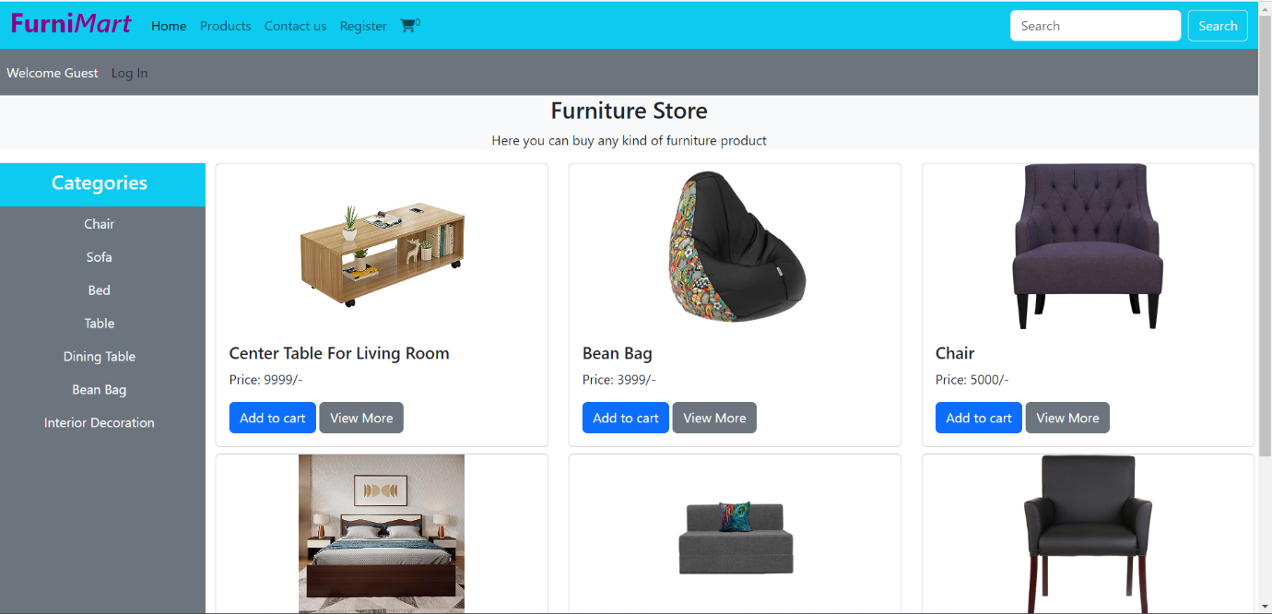

**User Registration**

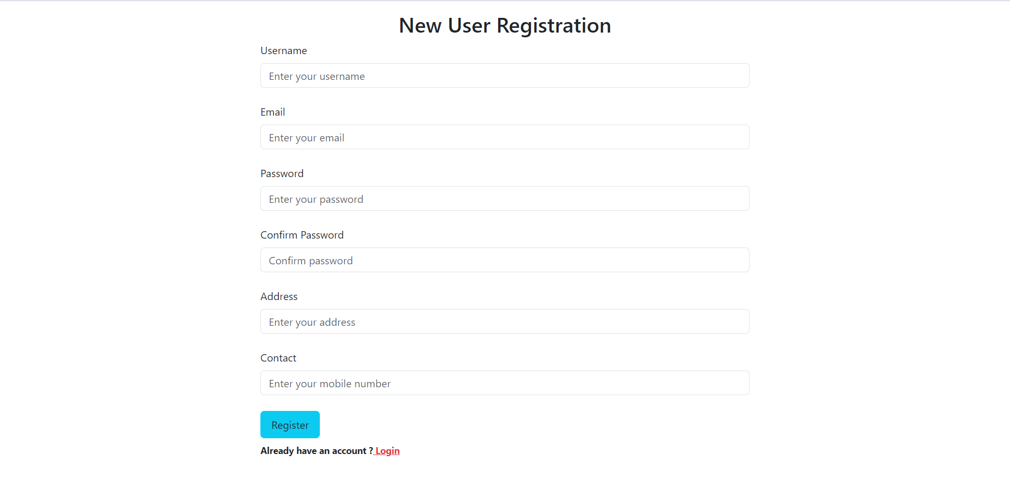

**User Login**

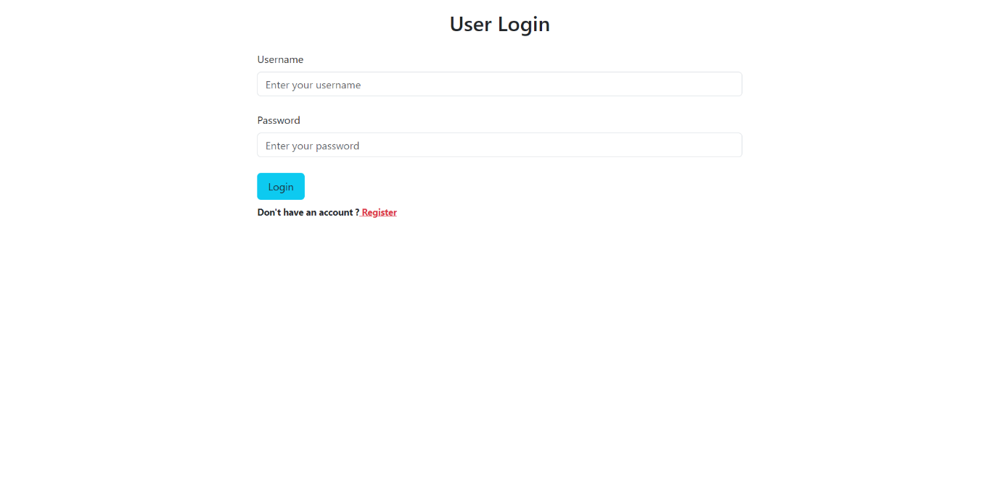

**User Account/Profile**

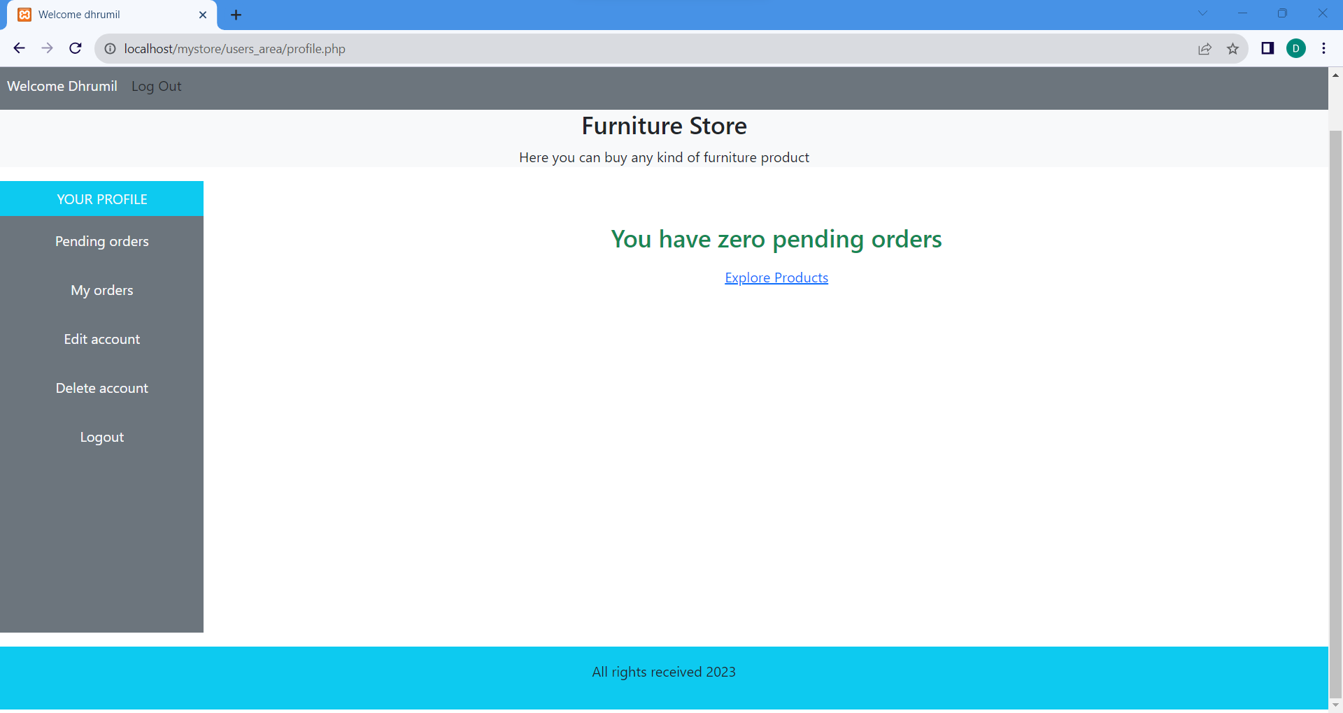

**All Products**

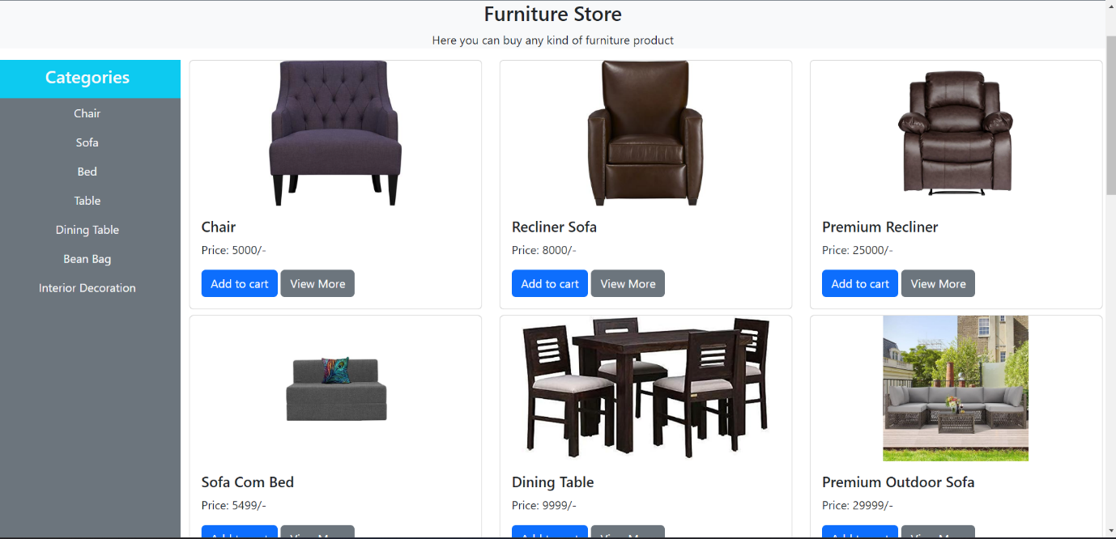

**View More**

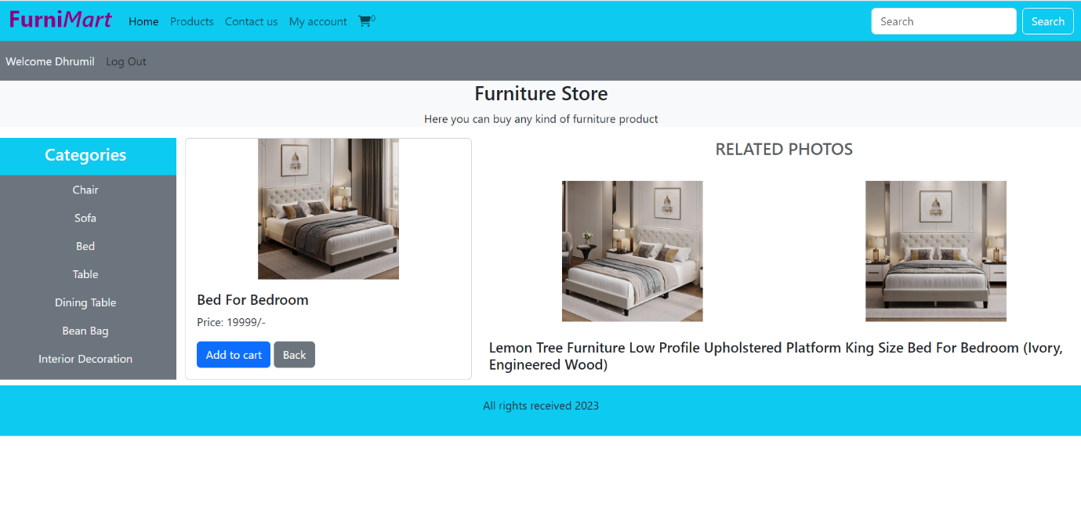

**Add Cart/Cart**

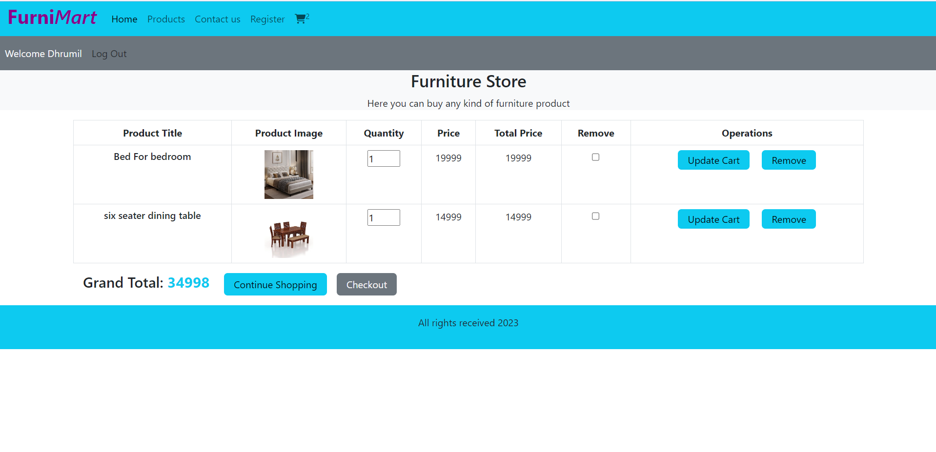

**Checkout**

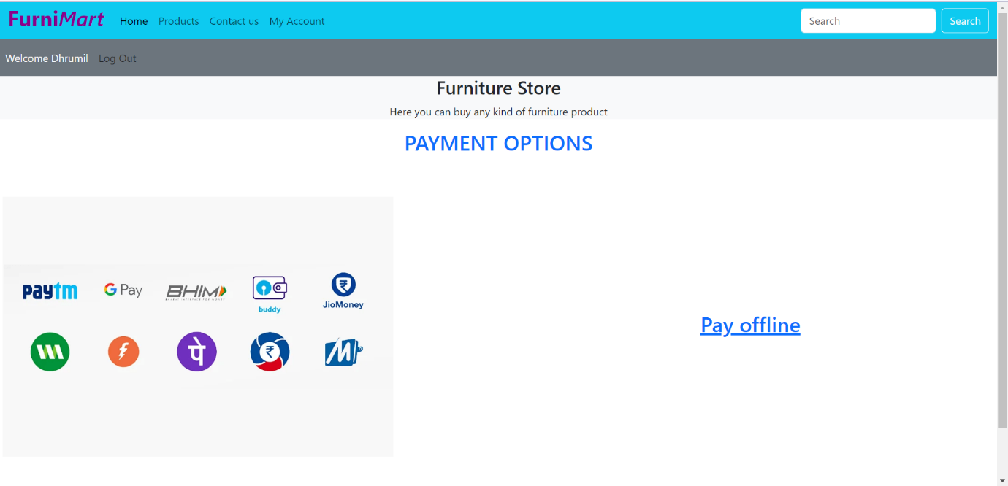

**Pending order/ Before payment**

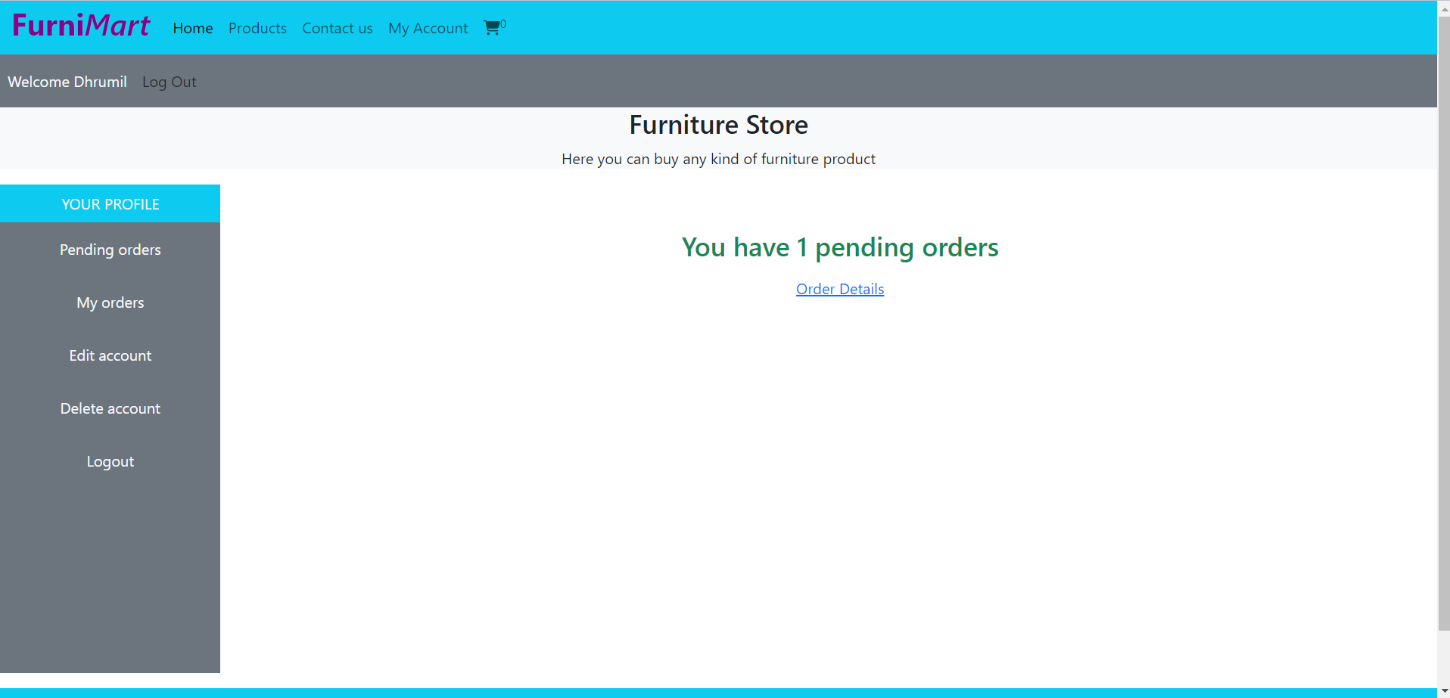

**User Order**

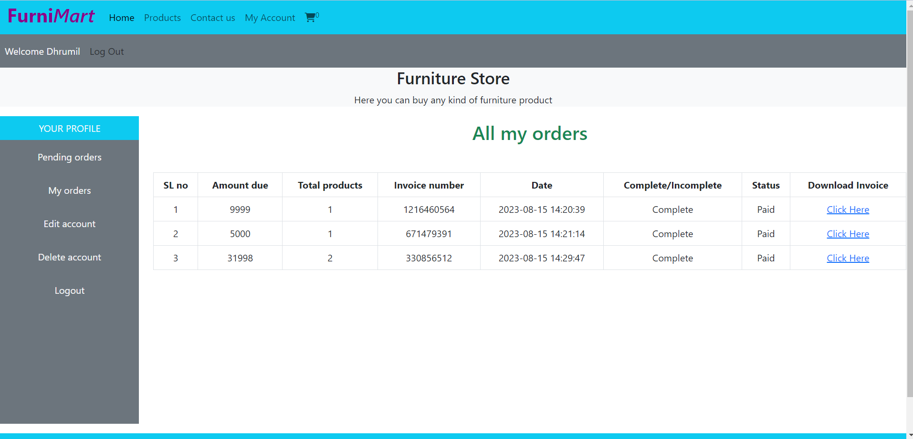

**Payment**



**Invoice of Purchase**

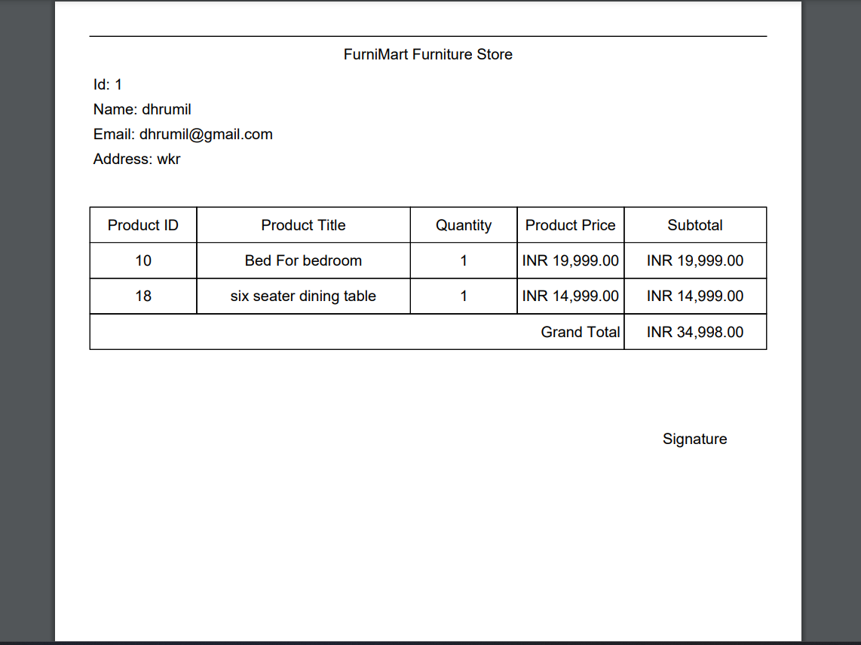

**Edit User Account**

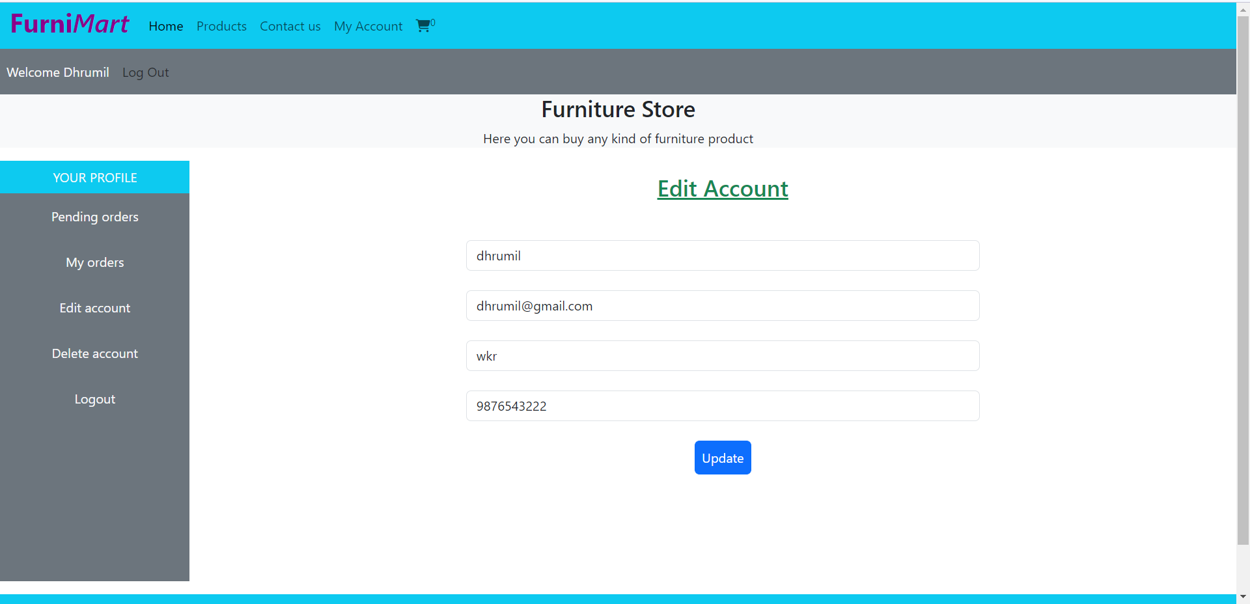

**Delete User Account**

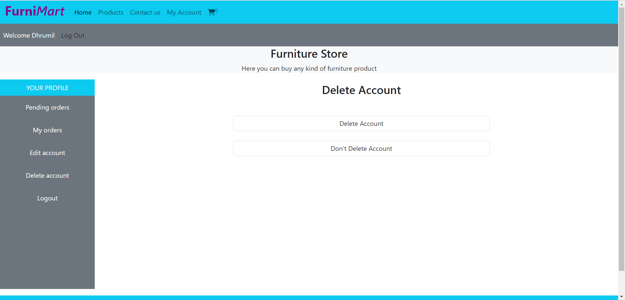

**Contact Us**

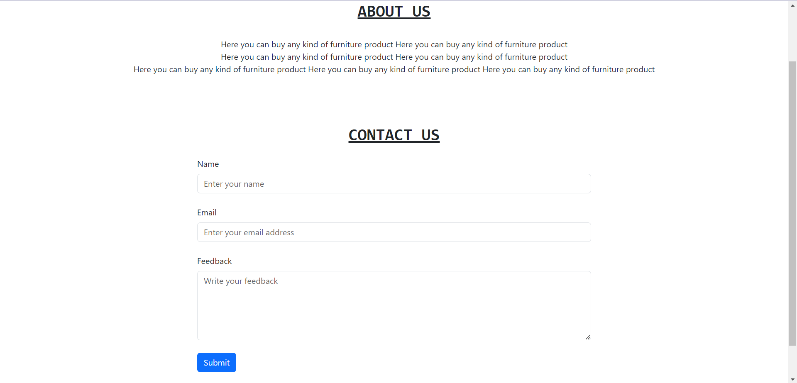

**Admin Side Login**

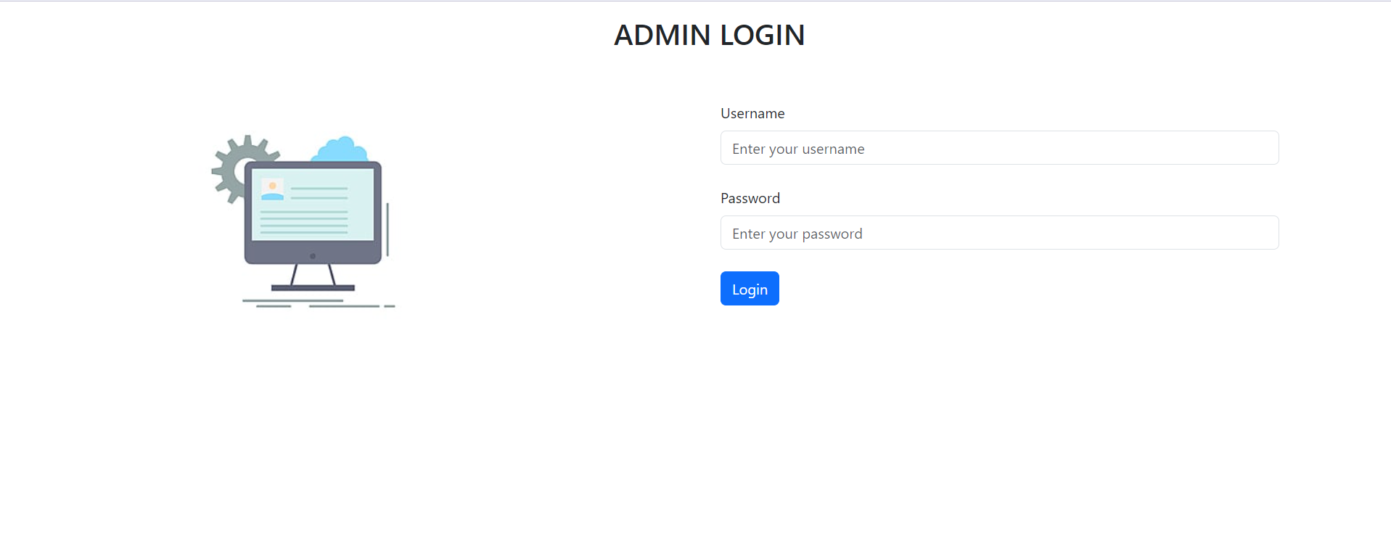

**Admin Page**

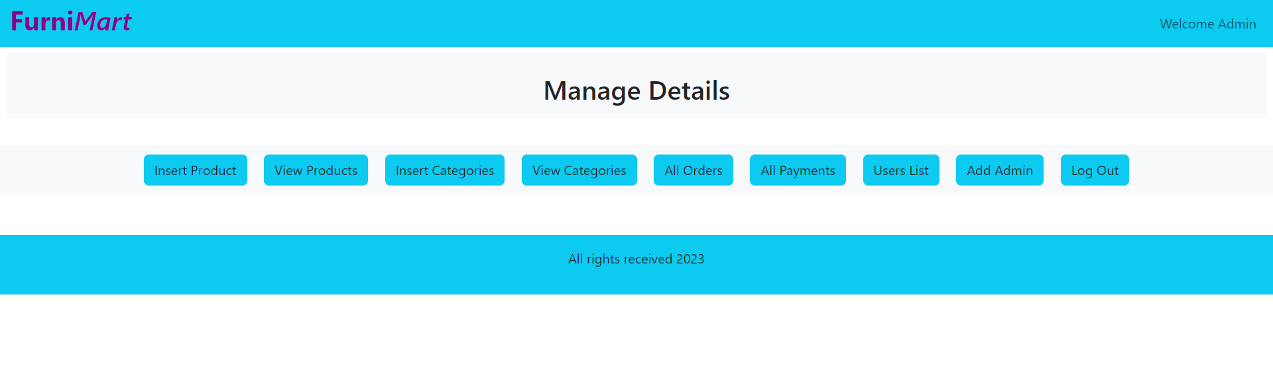

**Insert Product**

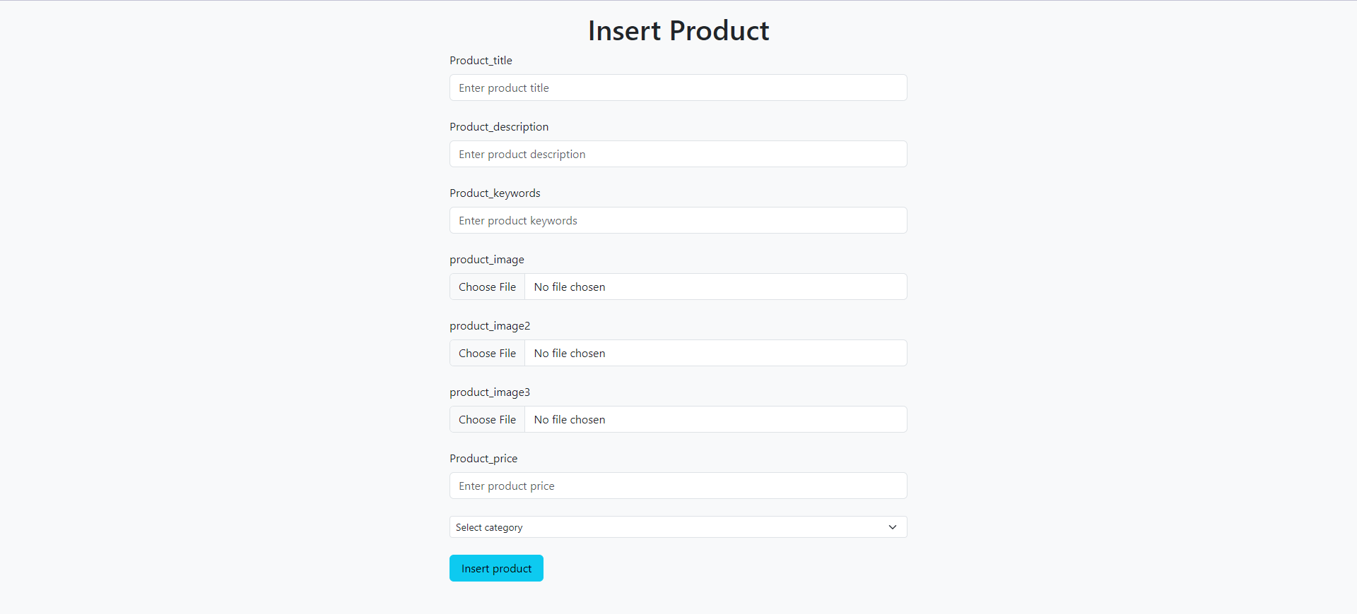

**View Products**

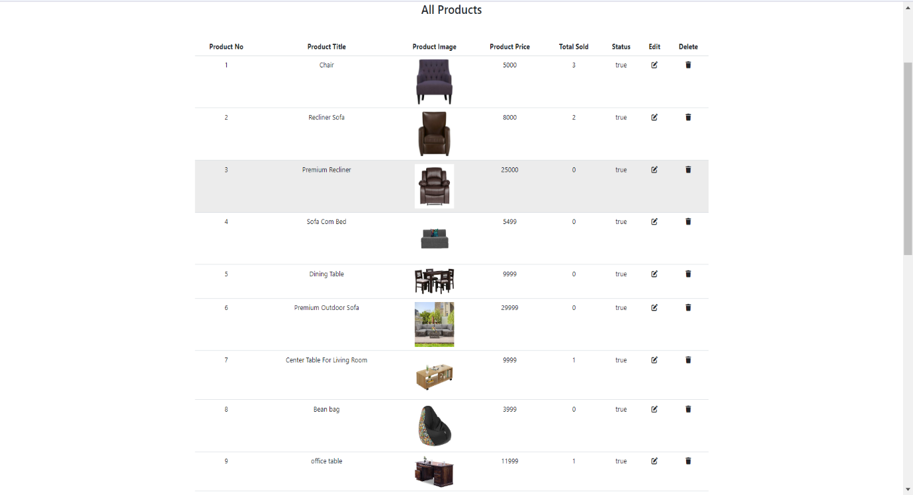

**Insert Category**

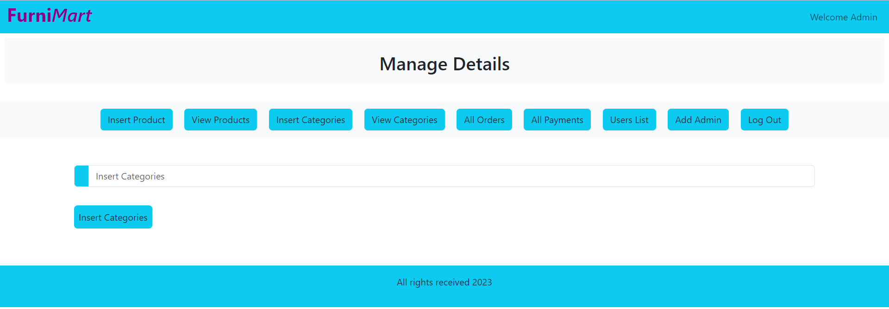

**View Category**

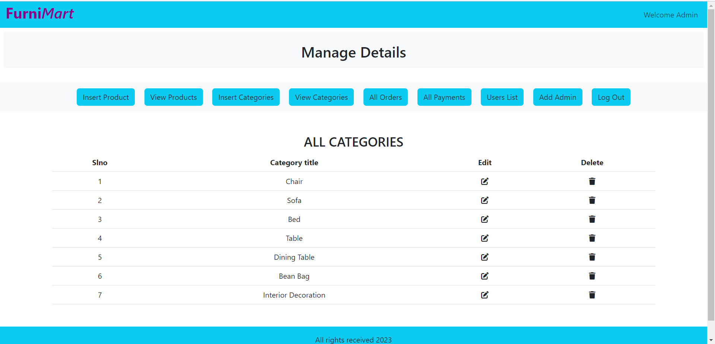

**All Orders**

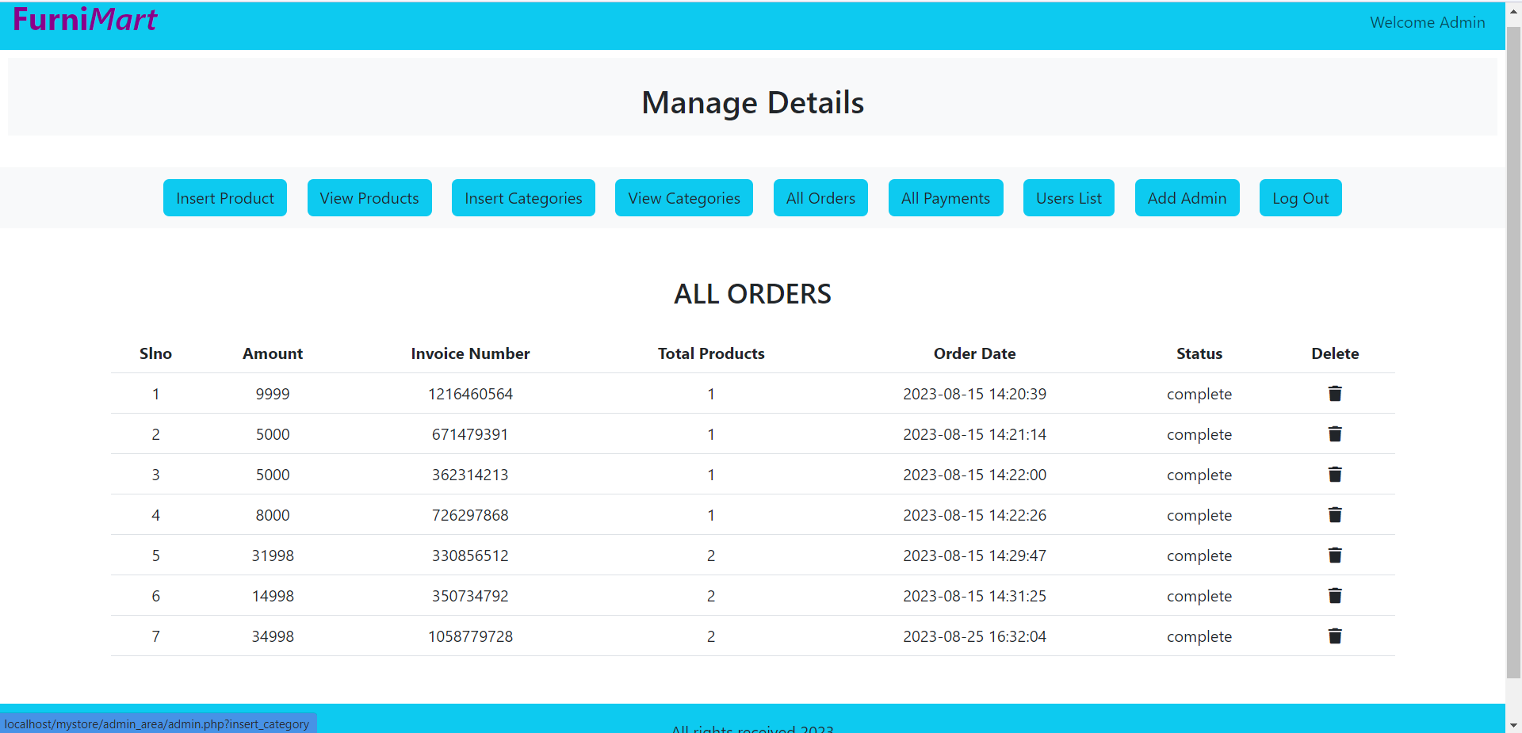

**All Payments**

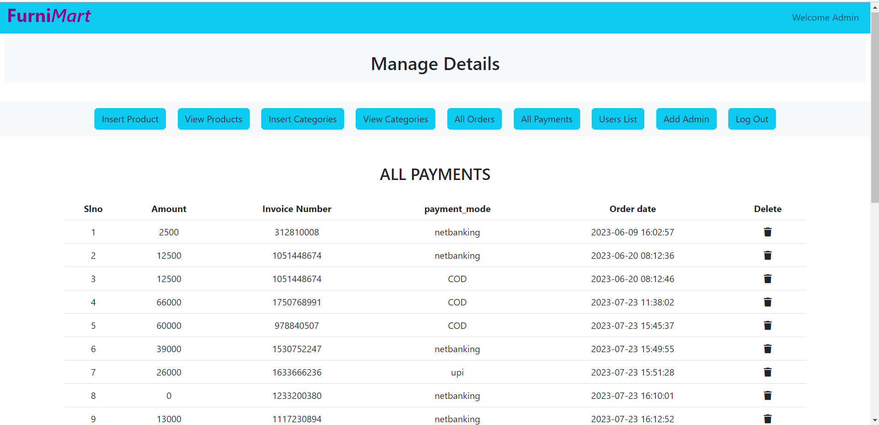

**Users List**

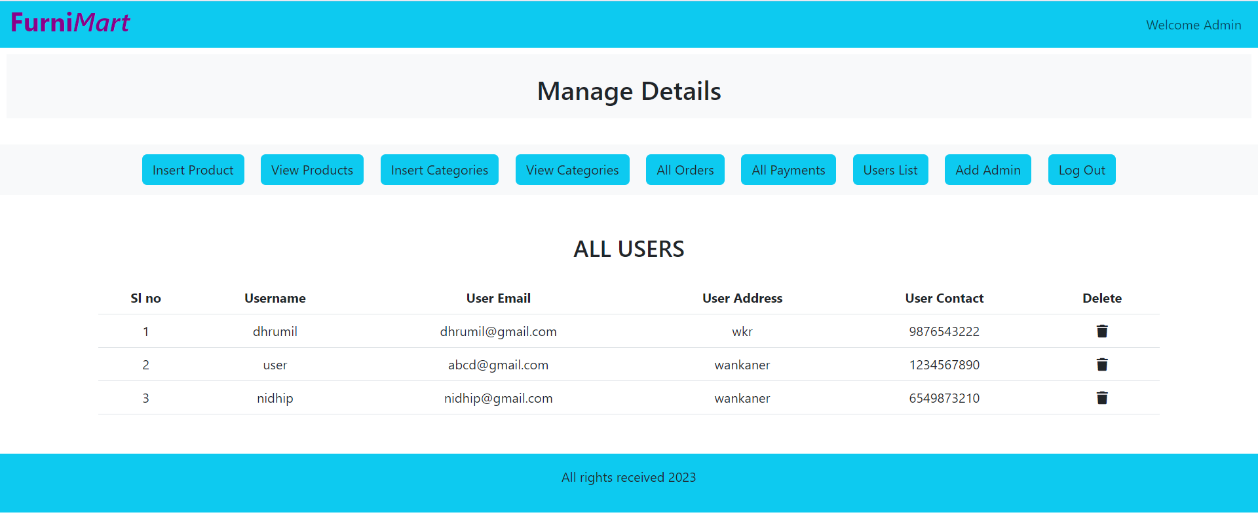

**Add New Admin**

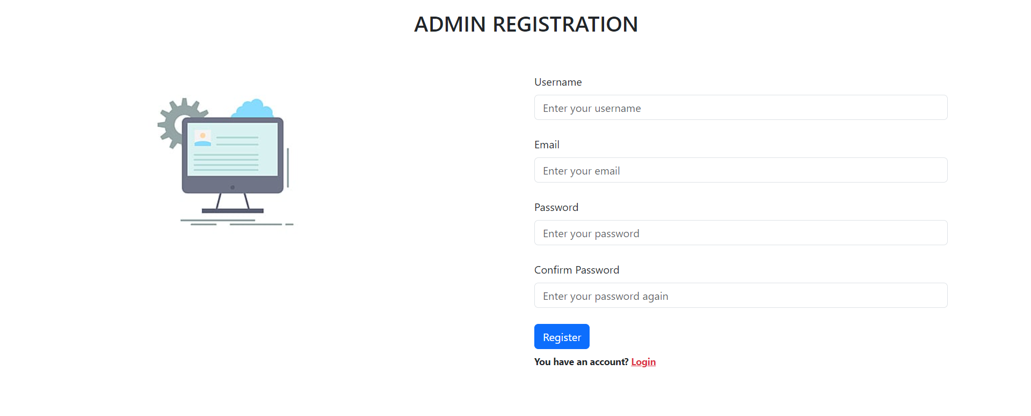

**Conclusion**

I Dhrumil Bhindora & Nidhip Solanki here by conclude my project training with great memories of developing website of FurniMart Furniture Store.

This project is very helpful for us in our professional carrier.

I am thankful to the computer department of our college for developing such a nice syllabus that gives us a chance to make a complete website with which we get a chance to improve our practical knowledge.

We have to successfully implemented site “FurniMart Furniture Store” with the help of various links & tools, we have been able to provide a site which is live & running on the web.

In this website customer can buy furniture online. It saves a lots time of customer. Customer can search for their desire product, category and purchase the product. After selection of product customer can pay online.

**Limitation and Future Enhancement**

**Limitation**

There is some limitation of our project.

* User cannot buy product without login.
* There are many photos in our websites that takes some time to load.

**Future Enhancement**

The development of “FurniMart Furniture Store” is had done keeping in mind all the recent developments and technologies. This system so developed much friendly interface and it is very flexible.

* We think that not a single project is ever considers as complete forever.
* Because our mind is always thinking new and our site are also growing.

**Bibliography**

To complete this project, we refer many websites and other stuff to learn many topics. Those are very useful to create this project. We use following websites:

1. [www.google.com](http://www.google.com)
2. [www.youtube.com](http://www.youtube.com)
3. [www.w3schools.com](http://www.w3schools.com)
4. [www.geeksforgeeks.com](http://www.geeksforgeeks.com)

**Suggestion**

………………………………………………………………………………………………………………………………………………………………………………………………………………………………………………………………………………………………………………………………………………………………………………………………………………………………………………………………………………………………………………………………………………………………………………………………………………………………………………………………………………………………………………………………………………………………………………………………………………………………………………………………………………………………

**Thank You!!!**