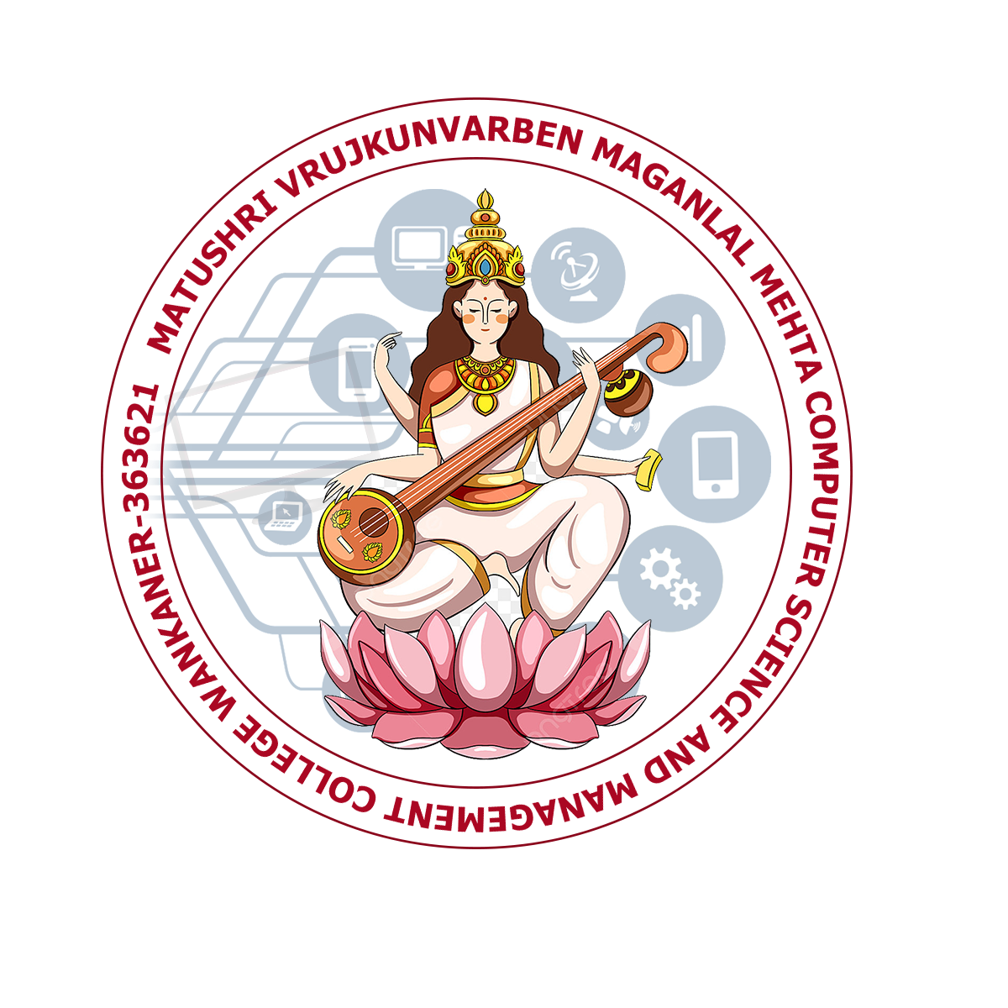



MATUSHREE V. M. MEHTA COMPUTER SCIENCE AND MANAGEMENT COLLEGE, WANKANER

Project Completion Certificate
(2023-2024)

This Is To Certify That Mr./Miss BHINDORA DHRUMIL SANJAYBHAI Has Successfully Completed The Project Work On FurniMart Furniture Store As Partial Fulfillment For The Requirements Of Semester 5 Bachelor Computer Application Of Saurashtra University Rajkot.

Date : -

_________ _____________ _________
Principal Project Guide Examiner

MATUSHREE V. M. MEHTA COMPUTER SCIENCE AND MANAGEMENT COLLEGE, WANKANER

Project Completion Certificate
(2023-2024)

This Is To Certify That Mr./Miss SOLANKI NIDHIP NATVARBHAI Has Successfully Completed The Project Work On FurniMart Furniture Store As Partial Fulfillment For The Requirements Of Semester 5 Bachelor Computer Application Of Saurashtra University Rajkot.

Date : -

_________ _____________ _________
Principal Project Guide Examiner

