The Naive Bayesian classifier is based on Bayes theorem with the independence assumptions between predictors.

A Naive Bayesian model is easy to build, with no complicated iterative parameter estimation which makes it particularly useful for very large datasets.

Despite its simplicity, the Naive Bayesian classifier often does surprisingly well and is widely used because it often outperforms more sophisticated classification methods.

Naive Bayes classifiers are linear classifiers that are known for being simple yet very efficient. The adjective naive comes from the assumption that the features in a dataset are mutually independent. In practice, the independence assumption is often violated, but naive Bayes classifiers still tend to perform very well under this unrealistic assumption. Especially for small sample sizes, naive Bayes classifiers can outperform the more powerful alternatives.

Naive Bayes classifiers are used in many different fields. Some examples include the diagnosis of diseases and making decisions about treatment processes, the classification of RNA sequences in taxonomic studies, and spam filtering in e-mail clients.

Step 1: Convert the data set into a frequency table

Step 2: Create Likelihood table by finding the probabilities

Step 3: Now, use Naive Bayesian equation to calculate the posterior probability for each class.

The class with the highest posterior probability is the outcome of prediction.

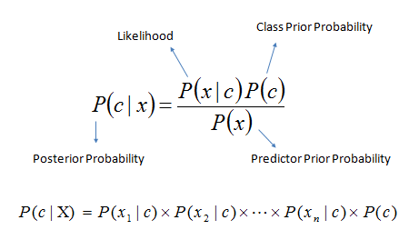

* *P*(*c|x*) is the posterior probability of *class* (*target*) given *predictor* (*attribute*).
* *P*(*c*) is the prior probability of *class*.
* *P*(*x|c*) is the likelihood which is the probability of *predictor* given *class*.
* *P*(*x*) is the prior probability of *predictor*.