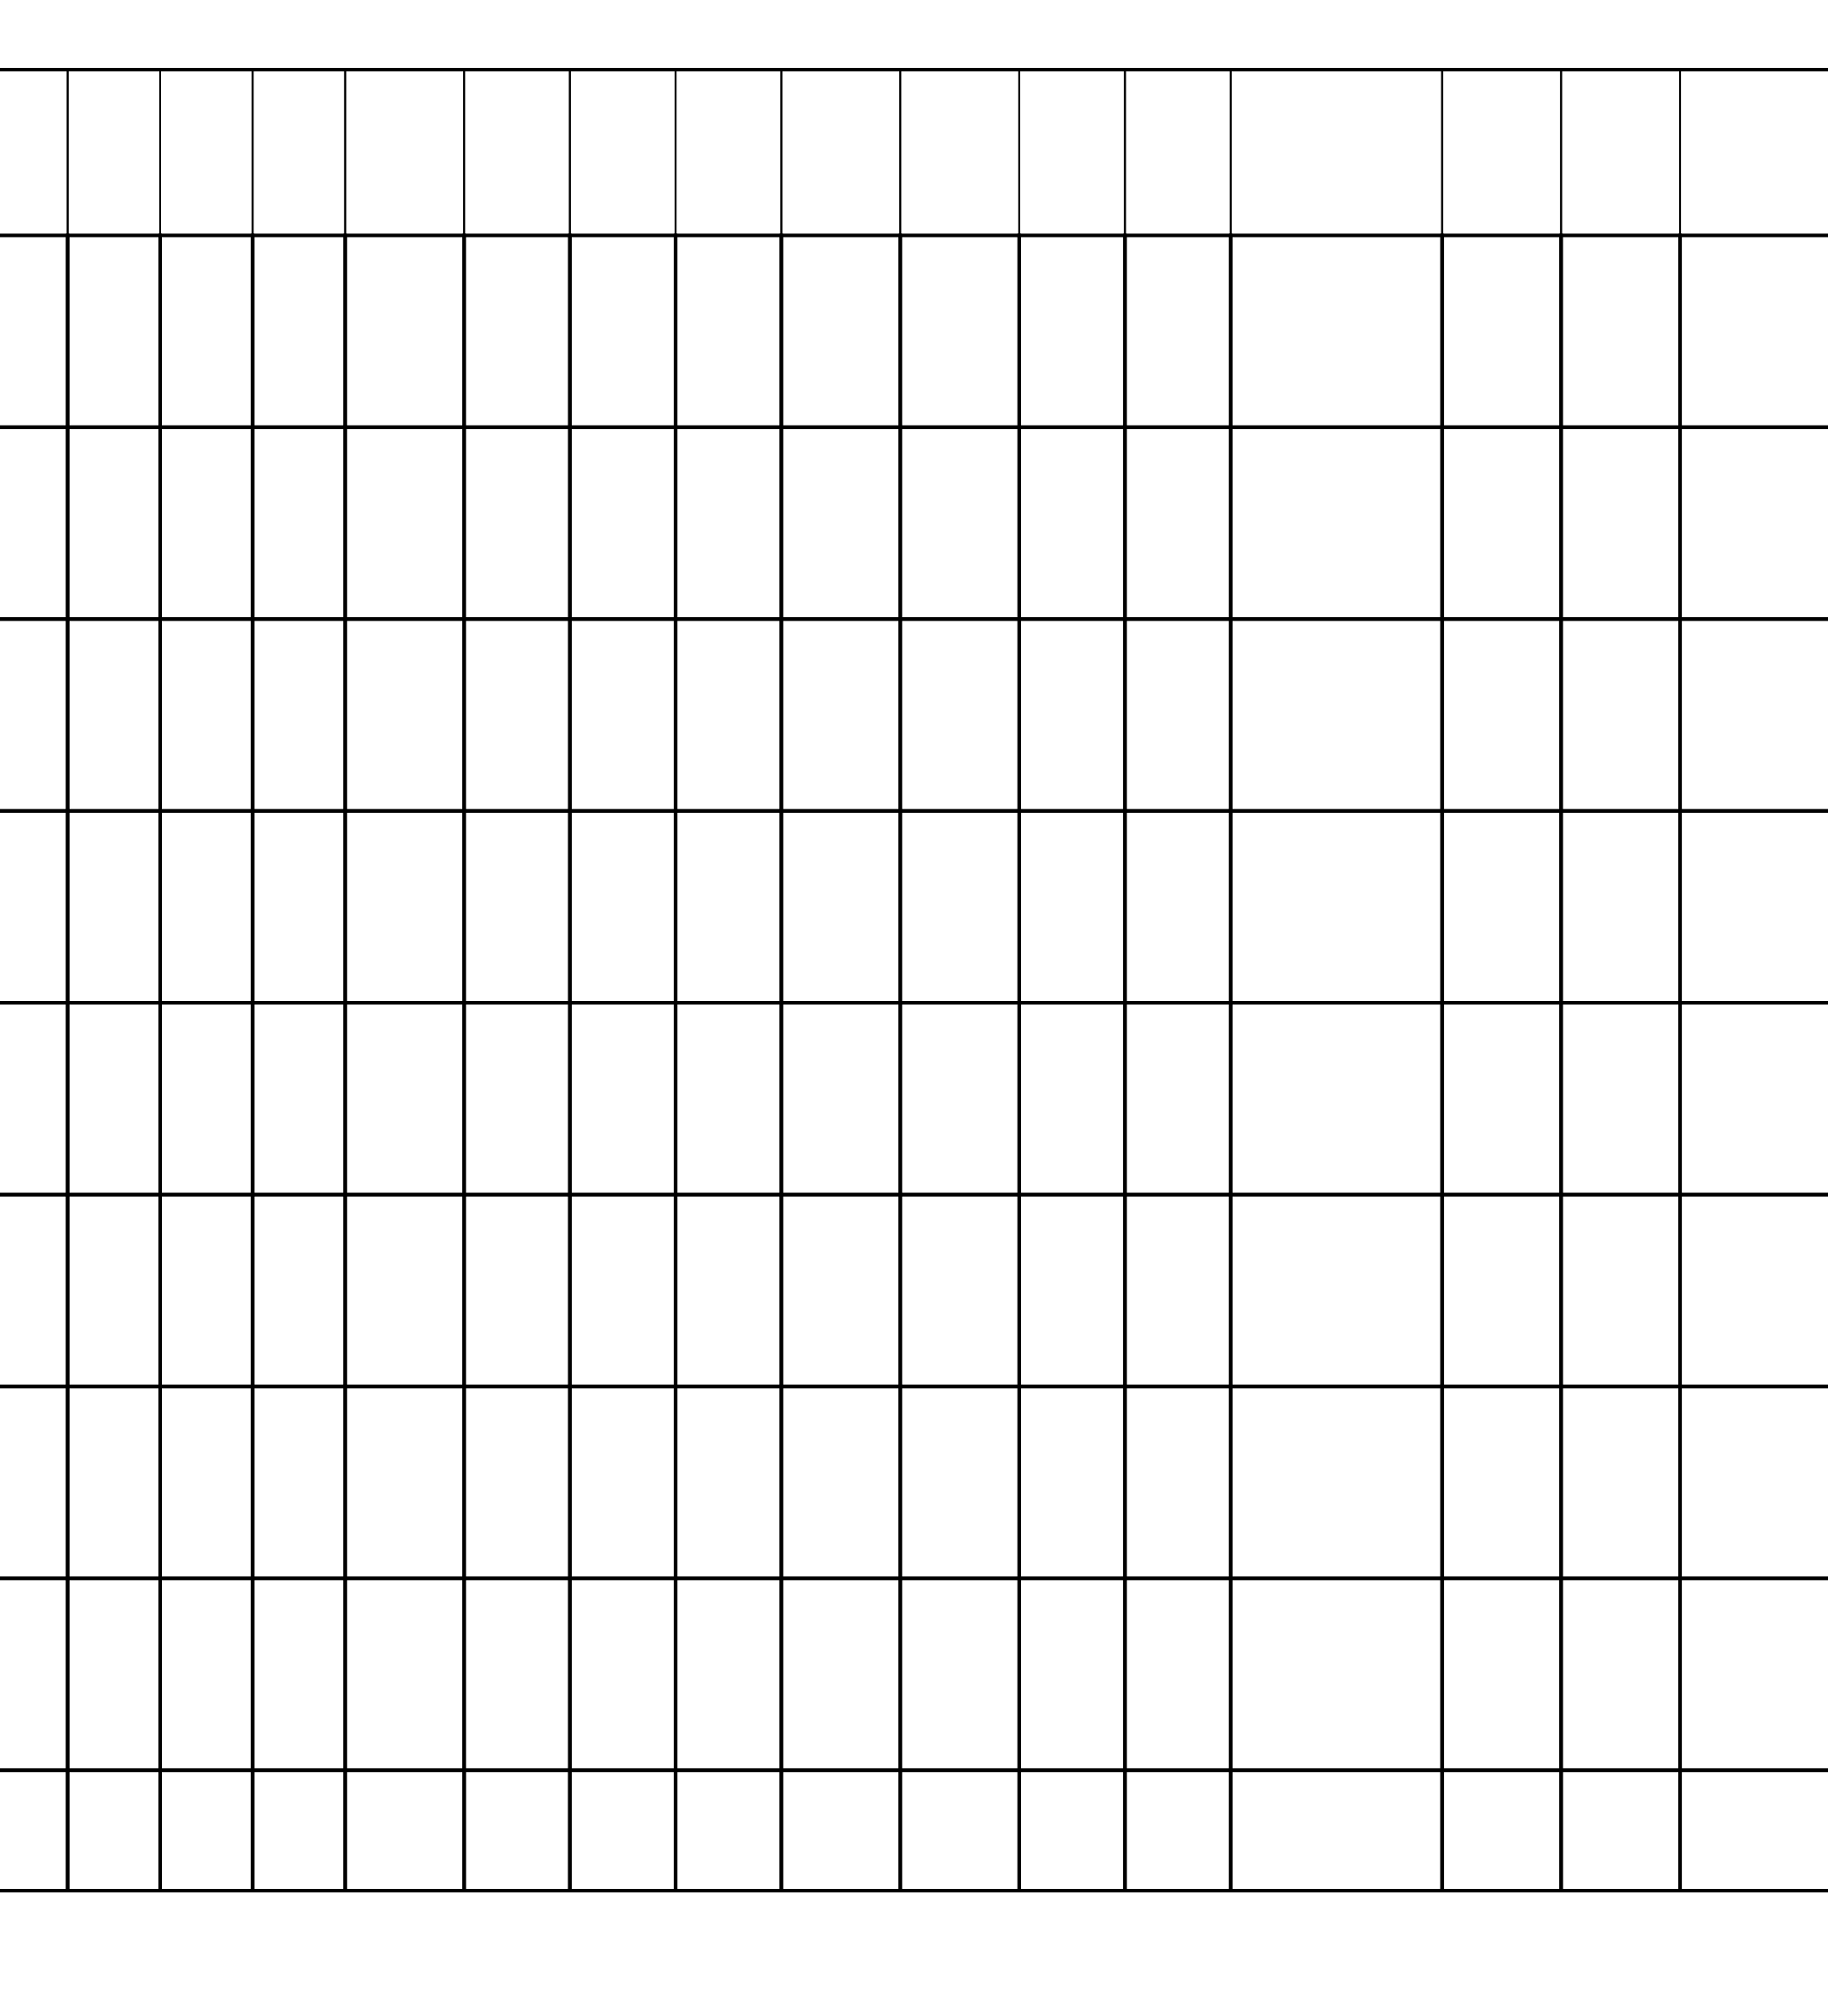
LONG ISLAND NEW | Date | Low- | Mostly | Seas | Item | Color Envir |  | Unit | Quali | Cond | Appea | Stora | Shelle | Purch | Sectio | Import/ | Suppl | Dema | Basis of Sale Market |  | Price | Comments
 | 10/19/2010 | High | Low- | on | Size | onm |  | of | ty | ition | rance | ge | d/Uns | ases | n | Export | y | nd | Tone |  | Comm | Offerings limited
 |  | Price | High |  |  | ent |  | Sale |  |  |  |  | helled |  |  |  | Tone | Tone |  |  | ent
 |  |  |  | 2010 | sz A |  |  |  | NONE | NONE | NONE | NONE |  |  |  |  |  |  | Sales F.O.B. | STEADY.
 |  | 8.75 - | - |  |  | NONE | NONE | NONE |  |  |  |  |  |  |  |  | NONE | FAIRLY |  |  | occas
YORK - POTATOES - | 10/19/2010 | 9.50 | 7.25 - | 2010 | sz A | NONE | NONE | NONE | NONE | NONE | NONE | NONE |  |  |  |  | NONE | LIGHT. | Shipping Point |  | lower | as movement to
ROUND WHITE - |  |  |  |  |  |  |  |  |  |  |  |  |  |  |  |  |  |  | and/or Delivered |  |  | storage is active.
baled 10 5-lb sacks - |  |  |  |  |  |  |  |  |  |  |  |  |  |  |  |  |  |  | Sales, Shipping
 |  | 7.00 - |  |  |  |  |  |  |  |  |  |  |  |  |  |  |  | FAIRLY
U.S. One |  |  |  |  |  |  |  |  |  |  |  |  |  |  |  |  |  |  | Point Basis |  |  | Offerings limited
LONG ISLAND NEW |  |  |  |  |  |  |  |  |  |  |  |  |  |  |  |  |  |  | Sales F.O.B. | STEADY.
YORK - POTATOES - |  | 7.25 | 7.25 |  |  |  |  |  |  |  |  |  |  |  |  |  |  | LIGHT. | Shipping Point |  |  | as movement to
ROUND WHITE - 50 |  |  |  |  |  |  |  |  |  |  |  |  |  |  |  |  |  |  | and/or Delivered |  |  | storage is active.
lb sacks - U.S. One |  |  |  |  |  |  |  |  |  |  |  |  |  |  |  |  |  |  | Sales, Shipping
Point Basis
LONG ISLAND NEW | 10/19/2010 | 8.75 - | - | 2010 | lge | NONE | NONE | NONE | NONE | NONE | NONE | NONE | NONE | FAIRLY | Sales F.O.B. | STEADY. | occas | Offerings limited
YORK - POTATOES - |  | 9.25 |  |  |  |  |  |  |  |  |  |  |  | LIGHT. | Shipping Point |  | lower | as movement to
ROUND WHITE - 50 |  |  |  |  |  |  |  |  |  |  |  |  |  |  | and/or Delivered |  |  | storage is active.
lb sacks - U.S. One |  |  |  |  |  |  |  |  |  |  |  |  |  |  | Sales, Shipping
Point Basis
NEW YORK - | 10/19/2010 | 15.00 - | 16.00 - | 2010 | 2 1/2" | NONE | NONE | NONE | NONE | NONE | NONE | NONE | FAIRLY | Sales F.O.B. | STEADY.
APPLES - RED | 10/19/2010 | 17.00 | 17.00 | 2010 | min | NONE | NONE | NONE | NONE | NONE | NONE | NONE | GOOD. | Shipping Point | STEADY.
DELICIOUS - cartons |  |  |  |  |  |  |  |  |  |  |  |  |  | and/or Delivered
12 3-lb film bags - |  |  |  |  |  |  |  |  |  |  |  |  |  | Sales, Shipping
 |  | 15.00 - | 16.00 - |  | 2 1/2" |  |  |  |  |  |  |  | FAIRLY
U.S. ExFcy |  |  |  |  |  |  |  |  |  |  |  |  |  | Point Basis
NEW YORK - |  |  |  |  |  |  |  |  |  |  |  |  |  | Sales F.O.B.
APPLES - GOLDEN | 10/19/2010 | 17.00 | 17.00 | 2010 | min | NONE | NONE | NONE | NONE | NONE | NONE | NONE | GOOD. | Shipping Point | STEADY. occasiona
DELICIOUS - cartons |  |  |  |  |  |  |  |  |  |  |  |  |  | and/or Delivered
12 3-lb film bags - |  |  |  |  |  |  |  |  |  |  |  |  |  | Sales, Shipping
 |  | 22.00 - | 24.00 - |  | 80s |  |  |  |  |  |  |  | FAIRLY
U.S. ExFcy |  |  |  |  |  |  |  |  |  |  |  |  |  | Point Basis
NEW YORK - |  |  |  |  |  |  |  |  |  |  |  |  |  | Sales F.O.B.
APPLES - GALA - |  | 26.00 | 25.00 |  |  |  |  |  |  |  |  |  | GOOD. | Shipping Point | l lower
cartons cell pack - |  |  |  |  |  |  |  |  |  |  |  |  |  | and/or Delivered
U.S. ExFcy |  |  |  |  |  |  |  |  |  |  |  |  |  | Sales, Shipping
Point Basis
NEW YORK - | 10/19/2010 | 17.00 - | 19.00 - | 2010 | 2 1/2" | NONE | NONE | NONE | NONE | NONE | NONE | NONE | FAIRLY | Sales F.O.B. | STEADY. occasiona
APPLES - GALA - |  | 21.00 | 20.00 |  | min |  |  |  |  |  |  |  | GOOD. | Shipping Point | l lower
cartons 12 3-lb film |  |  |  |  |  |  |  |  |  |  |  |  |  | and/or Delivered
bags - U.S. ExFcy |  |  |  |  |  |  |  |  |  |  |  |  |  | Sales, Shipping
Point Basis
NEW YORK - | 10/19/2010 | 20.00 - | 22.00 - | 2010 | 80s | NONE | NONE | NONE | NONE | NONE | NONE | NONE | FAIRLY | Sales F.O.B. | STEADY. occasiona
APPLES - |  | 24.00 | 24.00 |  |  |  |  |  |  |  |  |  | GOOD. | Shipping Point | l lower
MCINTOSH - cartons |  |  |  |  |  |  |  |  |  |  |  |  |  | and/or Delivered
cell pack - U.S. ExFcy |  |  |  |  |  |  |  |  |  |  |  |  |  | Sales, Shipping
Point Basis
NEW YORK - | 10/19/2010 | 18.00 - | 20.00 - | 2010 | 100s | NONE | NONE | NONE | NONE | NONE | NONE | NONE | FAIRLY | Sales F.O.B. | STEADY. occasiona
APPLES - |  | 22.00 | 20.00 |  |  |  |  |  |  |  |  |  | GOOD. | Shipping Point | l higher
MCINTOSH - cartons |  |  |  |  |  |  |  |  |  |  |  |  |  | and/or Delivered | and lower

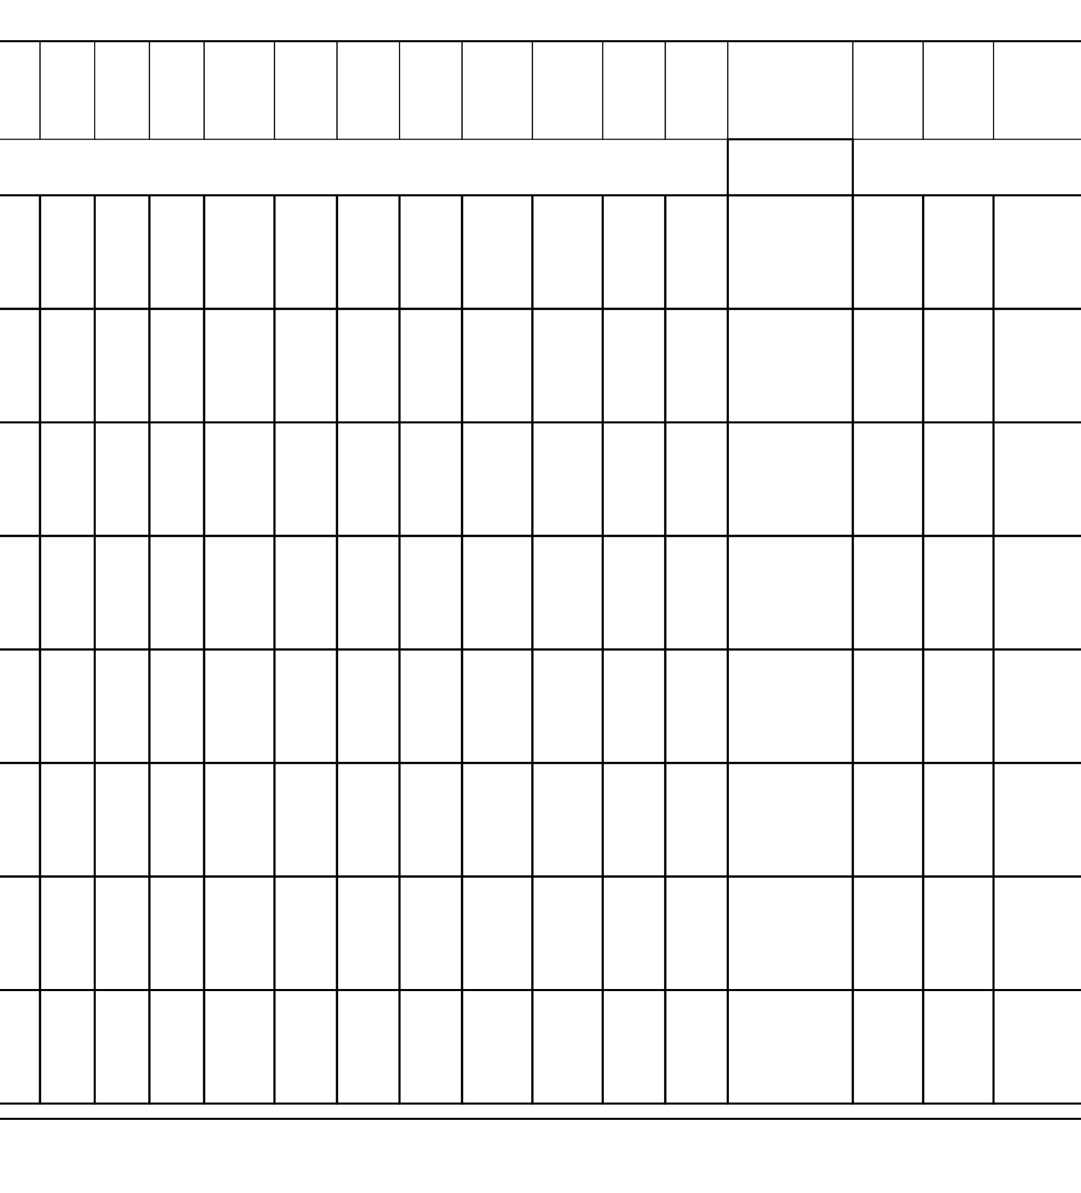
cell pack - U.S. ExFcy | Date | Low- | Mostly | Seas | Item | Color Envir | Unit | Quali | Cond | Appea | Stora | Shelle | Purch | Sectio | Import/ | Suppl | Dema | Basis of Sale Market | Price | Comments
 |  | High | Low- | on | Size | onm | of | ty | ition | rance | ge | d/Uns | ases | n | Export | y | nd | Tone | Comm
 |  | Price | High |  |  | ent | Sale |  |  |  |  | helled |  |  |  | Tone | Tone | Sales, Shipping | ent
Point Basis
NEW YORK - | 10/19/2010 | 15.00 - | 16.00 - | 2010 | 2 1/2" | NONE | NONE | NONE | NONE | NONE | NONE | NONE | FAIRLY | Sales F.O.B. | STEADY. few 14.00
APPLES - | 10/19/2010 | 17.00 | 16.00 | 2010 | min | NONE | NONE | NONE | NONE | NONE | NONE | NONE | GOOD. | Shipping Point | STEADY.
MCINTOSH - cartons |  |  |  |  |  |  |  |  |  |  |  |  |  | and/or Delivered
12 3-lb film bags - |  |  |  |  |  |  |  |  |  |  |  |  |  | Sales, Shipping
 |  | 15.00 - | 16.00 - |  | 2 1/2" |  |  |  |  |  |  |  | FAIRLY
U.S. ExFcy |  |  |  |  |  |  |  |  |  |  |  |  |  | Point Basis
NEW YORK - |  |  |  |  |  |  |  |  |  |  |  |  |  | Sales F.O.B.
APPLES - EMPIRE - |  | 17.00 | 17.00 |  | min |  |  |  |  |  |  |  | GOOD. | Shipping Point
cartons 12 3-lb film |  |  |  |  |  |  |  |  |  |  |  |  |  | and/or Delivered
bags - U.S. ExFcy |  |  |  |  |  |  |  |  |  |  |  |  |  | Sales, Shipping
Point Basis
NEW YORK - | 10/19/2010 | 20.00 - | 21.00 - | 2010 | 80s | NONE | NONE | NONE | NONE | NONE | NONE | NONE | FAIRLY | Sales F.O.B. | STEADY. few 24.00
APPLES - |  | 22.00 | 22.00 |  |  |  |  |  |  |  |  |  | GOOD. | Shipping Point
CORTLAND - cartons |  |  |  |  |  |  |  |  |  |  |  |  |  | and/or Delivered
cell pack - U.S. ExFcy |  |  |  |  |  |  |  |  |  |  |  |  |  | Sales, Shipping
Point Basis
NEW YORK - | 10/19/2010 | 16.00 - | - | 2010 | 2 1/2" | NONE | NONE | NONE | NONE | NONE | NONE | NONE | FAIRLY | Sales F.O.B. | STEADY. occasiona
APPLES - | 10/19/2010 | 17.00 | - | 2010 | min | NONE | NONE | NONE | NONE | NONE | NONE | NONE | GOOD. | Shipping Point | l lower
CORTLAND - cartons |  |  |  |  |  |  |  |  |  |  |  |  |  | and/or Delivered
12 3-lb film bags - |  |  |  |  |  |  |  |  |  |  |  |  |  | Sales, Shipping
 |  | 48.00 - |  |  | 88s |  |  |  |  |  |  |  | FAIRLY |  | STEADY. occasiona
U.S. ExFcy |  |  |  |  |  |  |  |  |  |  |  |  |  | Point Basis
NEW YORK - |  |  |  |  |  |  |  |  |  |  |  |  |  | Sales F.O.B.
APPLES - | 10/19/2010 | 50.00 | 17.00 - | 2010 | 2 1/2" | NONE | NONE | NONE | NONE | NONE | NONE | NONE | GOOD. | Shipping Point | l lower
HONEYCRISP - |  |  |  |  |  |  |  |  |  |  |  |  |  | and/or Delivered
cartons tray pack - |  |  |  |  |  |  |  |  |  |  |  |  |  | Sales, Shipping
 |  | 16.00 - |  |  |  |  |  |  |  |  |  |  | FAIRLY |  | STEADY. occasiona
U.S. ExFcy |  |  |  |  |  |  |  |  |  |  |  |  |  | Point Basis
NEW YORK - |  |  |  |  |  |  |  |  |  |  |  |  |  | Sales F.O.B.
APPLES - MACOUN - |  | 18.00 | 18.00 |  | min |  |  |  |  |  |  |  | GOOD. | Shipping Point | l higher
cartons 12 3-lb film |  |  |  |  |  |  |  |  |  |  |  |  |  | and/or Delivered
bags - U.S. ExFcy |  |  |  |  |  |  |  |  |  |  |  |  |  | Sales, Shipping
Point Basis
NEW YORK - | 10/19/2010 | 10.00 - | 10.00 - | 2010 | med 2 | NONE | NONE | NONE | NONE | NONE | NONE | NONE | FAIRLY | Sales F.O.B. | STEADY. | occas
ONIONS DRY - |  | 10.25 | 10.00 |  | 1/4"min |  |  |  |  |  |  |  | LIGHT. | Shipping Point |  | lower
YELLOW - GLOBE |  |  |  |  |  |  |  |  |  |  |  |  |  | and/or Delivered
TYPE - 50 lb sacks - |  |  |  |  |  |  |  |  |  |  |  |  |  | Sales, Shipping
Point Basis
NEW YORK - | 10/19/2010 | 9.00 - | - | 2010 | 2" min | NONE | NONE | NONE | NONE | NONE | NONE | NONE | FAIRLY | Sales F.O.B. | STEADY. | occas
ONIONS DRY - |  | 9.00 |  |  |  |  |  |  |  |  |  |  | LIGHT. | Shipping Point |  | higher
YELLOW - GLOBE |  |  |  |  |  |  |  |  |  |  |  |  |  | and/or Delivered |  | and lower
TYPE - 50 lb sacks - |  |  |  |  |  |  |  |  |  |  |  |  |  | Sales, Shipping
Point Basis

NEW YORK - | Date | Low- | Mostly | Seas | Item | Color Envir |  | Unit | Quali | Cond | Appea | Stora | Shelle | Purch | Sectio | Import/ | Suppl | Dema | Basis of Sale Market |  | Price | Comments
 | 10/19/2010 | High | Low- | on | Size | onm |  | of | ty | ition | rance | ge | d/Uns | ases | n | Export | y | nd | Tone |  | Comm
 |  | Price | High |  |  | ent |  | Sale |  |  |  |  | helled |  |  |  | Tone | Tone |  |  | ent
 |  |  |  | 2010 | med 2 |  |  |  | NONE | NONE | NONE | NONE |  |  |  |  |  |  | Sales F.O.B. | STEADY.
 |  | 12.00 - | 12.00 - |  |  | NONE | NONE | NONE |  |  |  |  |  |  |  |  |  | FAIRLY
ONIONS DRY - |  | 12.50 | 12.00 |  | 1/4"min |  |  |  |  |  |  |  |  |  |  |  |  | LIGHT. | Shipping Point
YELLOW - GLOBE |  |  |  |  |  |  |  |  |  |  |  |  |  |  |  |  |  |  | and/or Delivered
TYPE - master |  |  |  |  |  |  |  |  |  |  |  |  |  |  |  |  |  |  | Sales, Shipping
container 16 3-lb |  |  |  |  |  |  |  |  |  |  |  |  |  |  |  |  |  |  | Point Basis
mesh sacks -
NEW YORK - | 10/19/2010 | 11.00 - | - | 2010 | 2" min | NONE | NONE | NONE | NONE | NONE | NONE | NONE | FAIRLY | Sales F.O.B. | STEADY.
ONIONS DRY - |  | 11.50 |  |  |  |  |  |  |  |  |  |  | LIGHT. | Shipping Point
YELLOW - GLOBE |  |  |  |  |  |  |  |  |  |  |  |  |  | and/or Delivered
TYPE - master |  |  |  |  |  |  |  |  |  |  |  |  |  | Sales, Shipping
container 16 3-lb |  |  |  |  |  |  |  |  |  |  |  |  |  | Point Basis
mesh sacks -
WESTERN AND | 10/19/2010 | 9.00 - | 9.00 - | 2010 | med | NONE | NONE | NONE | NONE | NONE | NONE | NONE | NONE | MODER | Sales F.O.B. | STEADY. | few low | NONE
CENTRAL NEW | 10/19/2010 | 10.00 | 9.50 | 2010 | lge | NONE | NONE | NONE | NONE | NONE | NONE | NONE | NONE | ATE. | Shipping Point | STEADY. | as 8.50 | NONE
YORK - CABBAGE - |  |  |  |  |  |  |  |  |  |  |  |  |  |  | and/or Delivered
ROUND GREEN |  |  |  |  |  |  |  |  |  |  |  |  |  |  | Sales, Shipping
 |  | 6.00 - | - |  |  |  |  |  |  |  |  |  |  | MODER |  |  | occas
TYPE - 50 lb cartons - |  |  |  |  |  |  |  |  |  |  |  |  |  |  | Point Basis
WESTERN AND |  |  |  |  |  |  |  |  |  |  |  |  |  |  | Sales F.O.B.
CENTRAL NEW | 10/19/2010 | 7.00 | .11 - .12 | 2010 | lge | NONE | NONE | PER | NONE | NONE | NONE | NONE | NONE | ATE. | Shipping Point | STEADY. | higher | NONE
YORK - CABBAGE - |  |  |  |  |  |  |  |  |  |  |  |  |  |  | and/or Delivered
ROUND GREEN |  |  |  |  |  |  |  |  |  |  |  |  |  |  | Sales, Shipping
 |  | .10 - .12 |  |  |  |  |  |  |  |  |  |  |  | MODER
TYPE - 50 lb sacks - |  |  |  |  |  |  |  |  |  |  |  |  |  |  | Point Basis
WESTERN AND |  |  |  |  |  |  |  |  |  |  |  |  |  |  | Sales F.O.B.
CENTRAL NEW |  |  |  |  |  |  |  | LB |  |  |  |  |  | ATE. | Shipping Point
YORK - CABBAGE - |  |  |  |  |  |  |  |  |  |  |  |  |  |  | and/or Delivered
ROUND GREEN |  |  |  |  |  |  |  |  |  |  |  |  |  |  | Sales, Shipping
TYPE - bulk - |  |  |  |  |  |  |  |  |  |  |  |  |  |  | Point Basis

