 | 
Trigger Mechanism for
Anticipatory Action in the Central American Dry Corridor (CADC)
Technical Note
Version 3 (01 March 2024)
Anticipatory action is planned to preemptively intervene against drought-related impacts in the Central American Dry Corridor (CADC) that runs through Guatemala, Honduras, Nicaragua, and El Salvador. A framework was developed collaboratively by the regional and national partners and the Centre for Humanitarian Data (CHD). It includes pre-agreed financing, pre-selected interventions, and a trigger for automated activation. This note describes the technical aspects of the trigger mechanism.
Trigger Development
The CHD led the development of the technical development of the trigger mechanism with inputs from regional and local partners . The requirements for the mechanism were identified through conversations with the regional and national partners. Options for the mechanism were defined, validated against historical data, discussed with stakeholders, and tuned over several iterations. The version of the mechanism discussed in this note has been approved by the humanitarian country team and is currently being monitored for potential activations in 2024.
Trigger Overview
The Anticipatory Action (AA) project focuses on the 4 primary countries through which the CADC spans: Nicaragua, El Salvador, Guatemala, and Honduras. The triggering mechanism is based on the seasonal rainfall forecast with threshold set for individual countries based on historical seasonal rainfall forecasts and estimated return periods. Based on the requirements from operational partners the following analytical decisions had to be made:

Table 1. Key trigger design decisions
 | Decision Type | Decision made
1. | Event Type | MJJA & SON seasonal rainfall deficit
2. | Geographic level of analysis | Country level
3. | Forecast lead time | Up to 4 months
4. | Activation thresholds | 1 in 4 year rainfall deficit
5. | Forecast to use | ECMWF SEAS 51/ National Forecast (INSIVUMEH for Guatemala only)
The rationale and description of each of these decisions is provided in the next section with more additional details provided in the Appendix section.
Rationale
Event Type
The trigger is designed to monitor seasonal drought as measured by forecasted cumulative seasonal rainfall deficit. Country and regional partners identified the two key seasons for monitoring as the Primera (May - August) and Postrera (September - November) seasons. If critical rainfall deficits/drought conditions are forecasted in either window, the AA framework is to be activated.
Geographic level of analysis
The analysis and monitoring occurs at the country level. All countries are monitored simultaneously with the same framework and decision logic, but can be activated independently and at different times. To allow operational flexibility in targeting, the analysis was conducted over the entirety of each country to ensure that no area of possible intervention/activity was excluded.
Forecast used
The use of ECMWF, IRI, and national forecast data were assessed for all four countries during the design process. Where possible, the use of national forecast data was prioritized. Guatemala was the only country for which in-county partners could secure national forecast data. Therefore, the agreed upon forecast data sources for the trigger are:
● Nicaragua, Honduras, El Salvador - ECMWF Seasonal Forecast
Page 2 of 10

● | Guatemala - Official national forecast provided the Instituto nacional | de Sismología,
Vulcanologia, Meteorologia e Hidrología (INSIVUMEH) for all months except May where the national forecast does not provide a prediction for publication month as required by the implementing partners (Figure 1). For this month ECMWF Seasonal will be used.
For a more in depth discussion of the forecast data source please see the appendix below.
Forecast Lead Time
The forecast lead times used for the framework monitoring were decided based on the operational requirements of implementing partners and constraints of forecast data products. Each monthly global ECMWF forecast publication provides 7 monthly lead times including the forecast for the month of forecast publication whereas INSIVUMEH forecast provides 6 monthly lead times with the first month being the month after publication of the forecast. During the design process the CHD provided analysis and specific thresholds for each possible lead time and provided the recommendation to adopt the shortest lead time possible that still would provide the partners with sufficient time to implement activities.
After reviewing all activities, stakeholders/partners agreed to the following lead times and monitoring periods:
Table 2. Trigger matrix
Trigger | Potential activation points | Indicator | Data Source | Trigger
Primera Window (Window A) | Mar  April  May | MJJA  seasonal forecast | Global Forecast  (ECMWF) or  National Forecast | MJJA precipitation  <= 1 in 4 year RP
Postrera Window (Window B) | Jun  Jul  Aug | SON  seasonal forecast | Global Forecast  (ECMWF) or  National Forecast | SON precipitation <= 1 in 4 year RP
Page 3 of 10

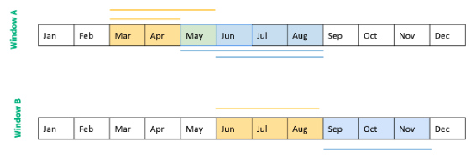
Figure 1. Time periods of interest in blue will be monitored from forecast data published in yellow. May is highlighted in green due to the overlap.
Thresholds
Thresholds were based on a 1 in 4 year return period (RP) event and calculated independently for each country. For each year of historical seasonal forecast data (1981-2022) the total seasonal rainfall (for each season) was calculated and averaged to each of the countries boundaries for each lead time. This historical record was then used to calculate the threshold that corresponded to 25 % activation rate (or 1 in 4 year RP). This process was run on both ECMWF seasonal and national forecast (for Guatemala) data separately. Thresholds were calculated per country, activation window, lead time, and forecast data source to compensate for any bias in forecast values across lead times (see Appendix for additional details).
Monitoring
The CHD is responsible for monitoring the seasonal forecast and updating the activation status on a monthly basis with an automated email alert to relevant stakeholders. As the ECMWF Seasonal forecast is published on the 5th of each month, the trigger notification for Nicaragua, Honduras, and El Salvador are distributed on the 5th of each month. INSIVUMEH provided a date range for the Guatemala national forecast publication as the 5th-10th each month. Therefore, the Guatemala trigger status update is made upon receival of this forecast. No cutoff date has been established for using the national forecast in Guatemala, but is at the discretion of CERF and partners based on operational requirements. The monitoring is automated through a GitHub action available in this GitHub .
Page 4 of 10

Appendix
Forecast (Lead Time & Data Source)
Data sources & Accessibility: to monitor seasonal drought, seasonal forecasts were required. The trigger was designed with flexibility to incorporate national forecast data sources where/when available and global data sets when no national forecasts could be obtained. Thus far Guatemala’s national forecast provided by INSIVUMEH was the only national forecast data set that could be obtained by in-country partners.
For Nicaragua, Guatemala, and El Salvador where no national forecast data could be secured, ECMWF and IRI global forecasts were evaluated. ECMWF was eventually chosen over IRI for the following reasons:
● ECMWF provides hindcast/forecast data from 1981 to present compared to IRI which is only available from 2017 onwards. The longer historical record of ECMWF allows the calculation of activation rates at different thresholds with a much higher degree of confidence.
● ECMWF provides monthly total precipitation which allows flexible temporal aggregation whereas IRI only provides trimester (3-month) probabilities
● ECMWF is released earlier in the month (5th compared to 16th)
● ECMWF units are easily converted to total precipitation which is easier for stakeholders to understand than tercile probabilities
● ECMWF seasonal forecast data obtained from the MARS catalog can be provided at 0.4 degrees resolution which is a higher resolution than IRI data which can only be obtained at 1 degree resolution.
The ECMWF Seasonal forecast is made public through the on the 5th of every month. This publicly available data has a resolution of 1 degree and contains 6 months of lead time (including publication month). The full ECMWF SEAS5 historical forecast data set which includes 7 months of lead time and has a resolution of 0.4 degrees is available to World Meteorological Organization (WMO) members through the . For up-to-date ECMWF data with the full 7 months of lead time at 0.4 degrees resolution the CHD receives the seasonal forecast data directly from ECMWF.
Operational requirements:
AA partners compiled a list of required start times by activity and agency (Figure 2). After receiving the required lead times by agencies and conducting a deep dive session it was decided to remove the February forecast publication from the Primera monitoring window and September from the Postrera monitoring window. This was done based on the activity timeline (Figure 2) and to standardize the monitoring period and probability of activation across countries and while reducing uncertainty in trigger mechanism.
Page 5 of 10

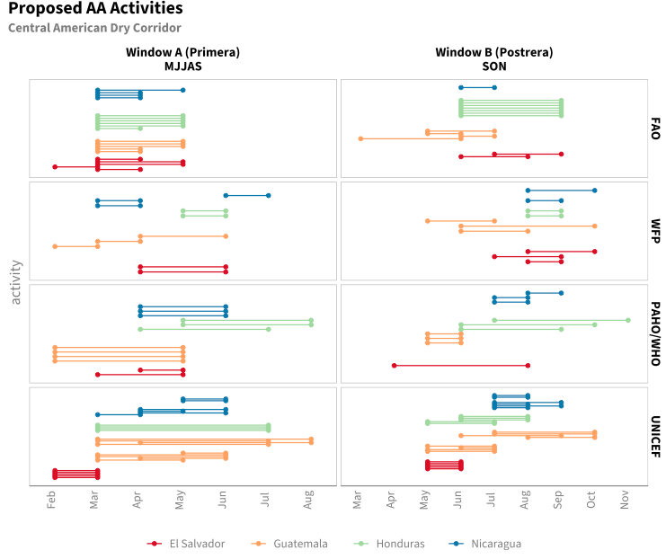
Figure 2. Timeline of activities and required activation months
Thresholds/Trigger
As no drought impact data was available in the regions, the thresholds were set primarily based on historical activation rates/return period level calculations. The threshold was finally set to activate only if the seasonal rainfall was forecasted to be at least a 1 in 4 year return period level deficit at any lead time. The calculated thresholds based on the 4 year return period levels are presented below in tables 3 and 4 for the Primera and Postrera season, respectively.
Page 6 of 10

Table 3. Primera Thresholds
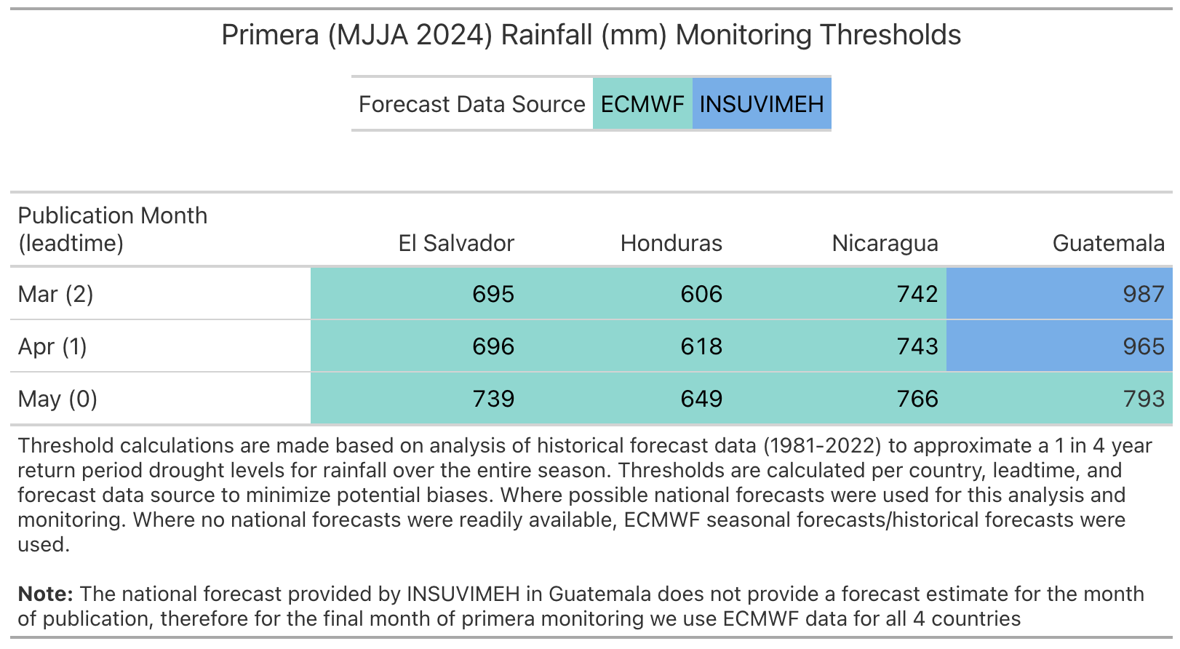
Table 4. Postrera Thresholds
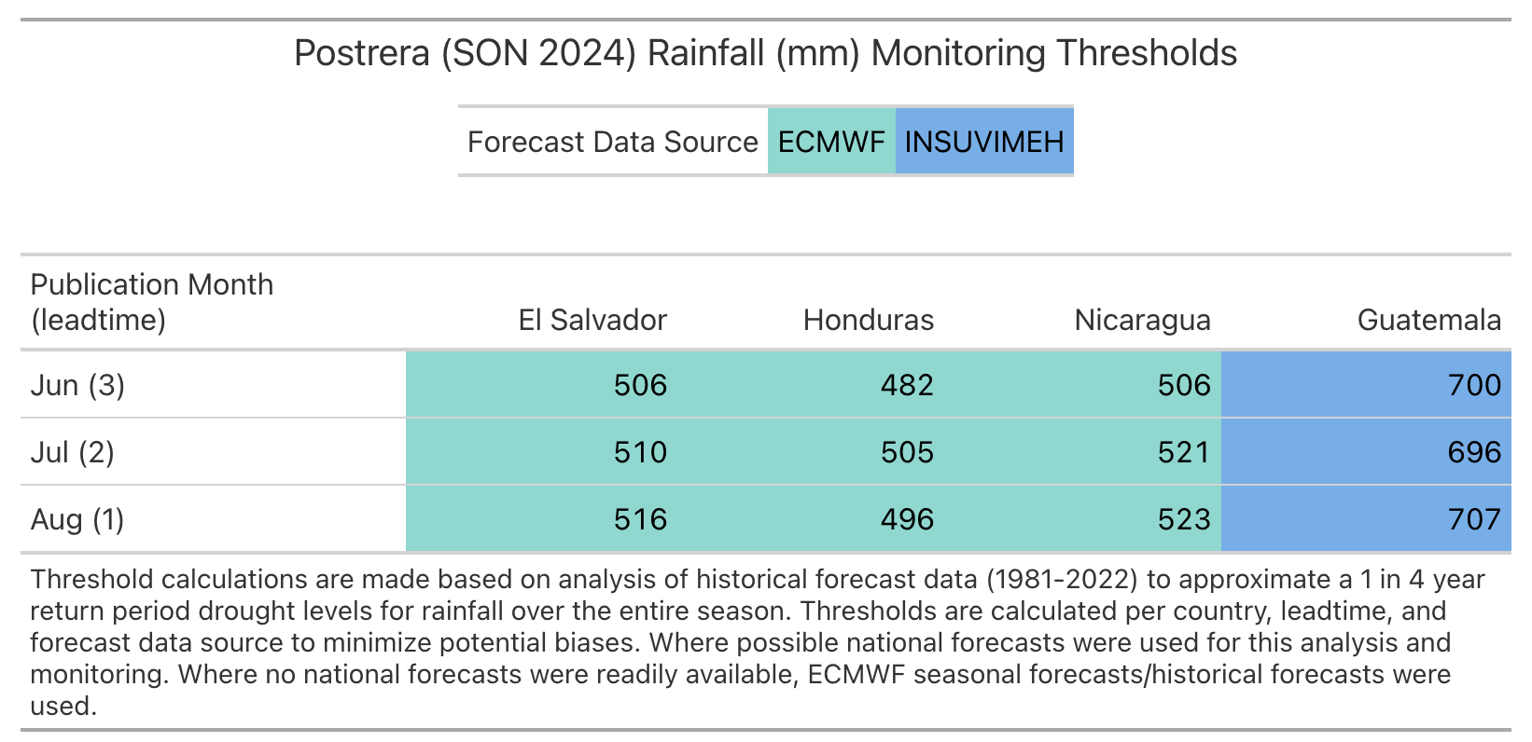
Page 7 of 10

The analytical method for historical analysis/thresholding can be conceptualized as two steps: 1. Data aggregation, 2. Return period/activation rate calculation & bias correction.
Aggregation
Thresholds were designed using ECMWF SEAS5 seasonal precipitation forecast from the public Copernicus Data Store & MARS catalog as well as the national seasonal precipitation forecast for Guatemala provided by INSIVUMEH . All available historical forecast data from 1981-2022 was downloaded and processed for historical analyses. The data was downloaded as monthly precipitation rate estimates over the area of interest, for each month the mean of the 51 ensemble members was calculated at the pixel level to obtain 1 raster per month.
The average monthly precipitation was then extracted for every month and lead time for each country by an area-weighted mean statistic. The zonal mean statistic was chosen as the aggregation method for simplification purposes. The monthly zonal statistics were then aggregated temporally to the seasonal windows (MJJA & SON) for each lead time combination available.
Threshold Setting & Bias Correction
From the yearly historical data, the 25th percentile (1 in 4 year RP level) was calculated for each country, window, and lead time. The percentile calculation was performed at each lead time separately as different lead times can be biased in a number of ways. For example, across all four countries of interest, we see that the ECMWF seasonal forecast systematically predicts lower rainfall quantities at longer lead times during the Primera season (Figure 3). By calculating the percentiles for each lead time separately we ensure equal probability across all relevant forecast publication months.
Page 8 of 10

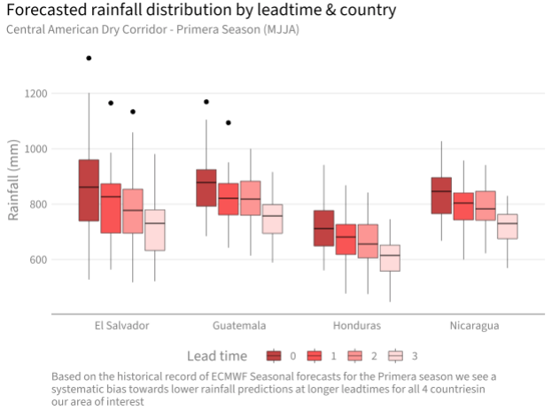
Figure 3. Forecasted rainfall bias by country and lead time during the primera season (ECMWF Seasonal).
It must be noted that by setting a threshold at the 4 year return period level and monitoring each publication month/lead time independently, the joint probability of activation across any forecast publication months rises substantially. Additionally, when considering, the probability of activation across either season (Primera/Postrera) this joint probability of activation rises further. These joint activation rates were discussed in the CADC AA Deep dive session led by CERF & the CHD and were considered in the final decision to choose a 1 in 4 year RP level for monitoring at each forecast publication date. Table 5 presents the joint activation rate across all lead times for each season as well as combined activation rates across seasons based on the thresholds and activation points presented in tables 3 & 4.
Table 5. Joint Return Periods/Activation Rates
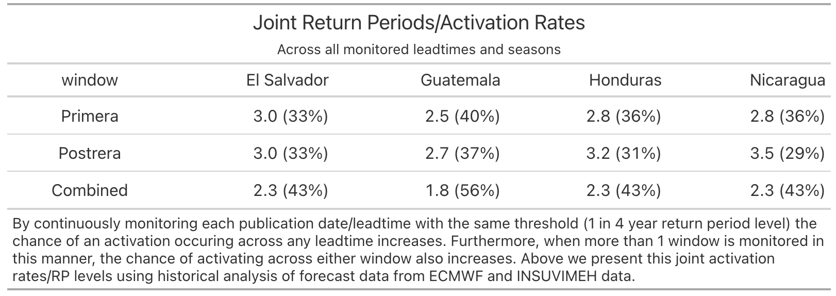
Page 9 of 10

Observation Indicators Consideration/Exclusion
Observational crop/vegetation monitoring with indicators such as Vegetative Health Index (VHI) & Agricultural Stress Index System (ASIS) were considered, but left out of the framework as data obtained during the identified critical seasons (as opposed to before) can’t preemptively inform or support the bulk of AA activities focused on agricultural provided by operational partners which must be implemented before the growing period commences.
The use of observational vegetative health indicators was initially proposed by the partners in early iterations of the framework. After initial investigation of VHI and ASIS by the CHD according to various framework revisions suggested by FAO, FAO recommended removing ASIS from consideration as it is meant to be monitored during certain stages of the growing season which do not align with lead time/operational requirements of the agencies. The use of VHI to capture pre-existing vulnerabilities and thereby condition triggers was suggested, but a coherent strategy that could align with operational requirements of agencies was not found or adopted.
Areas for Improvement in future iterations
The following two potential areas of improvement were identified and may be considered in future iterations of the framework:
● Integration of additional national forecast data sources.
● Observational indicators such as VHI could be further explored with key inputs from partners.
Contact the OCHA Centre for Humanitarian Data via Zachary Arno, Data Scientist at zachary.arno with any questions or feedback.
Page 10 of 10

