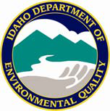
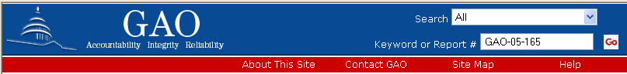
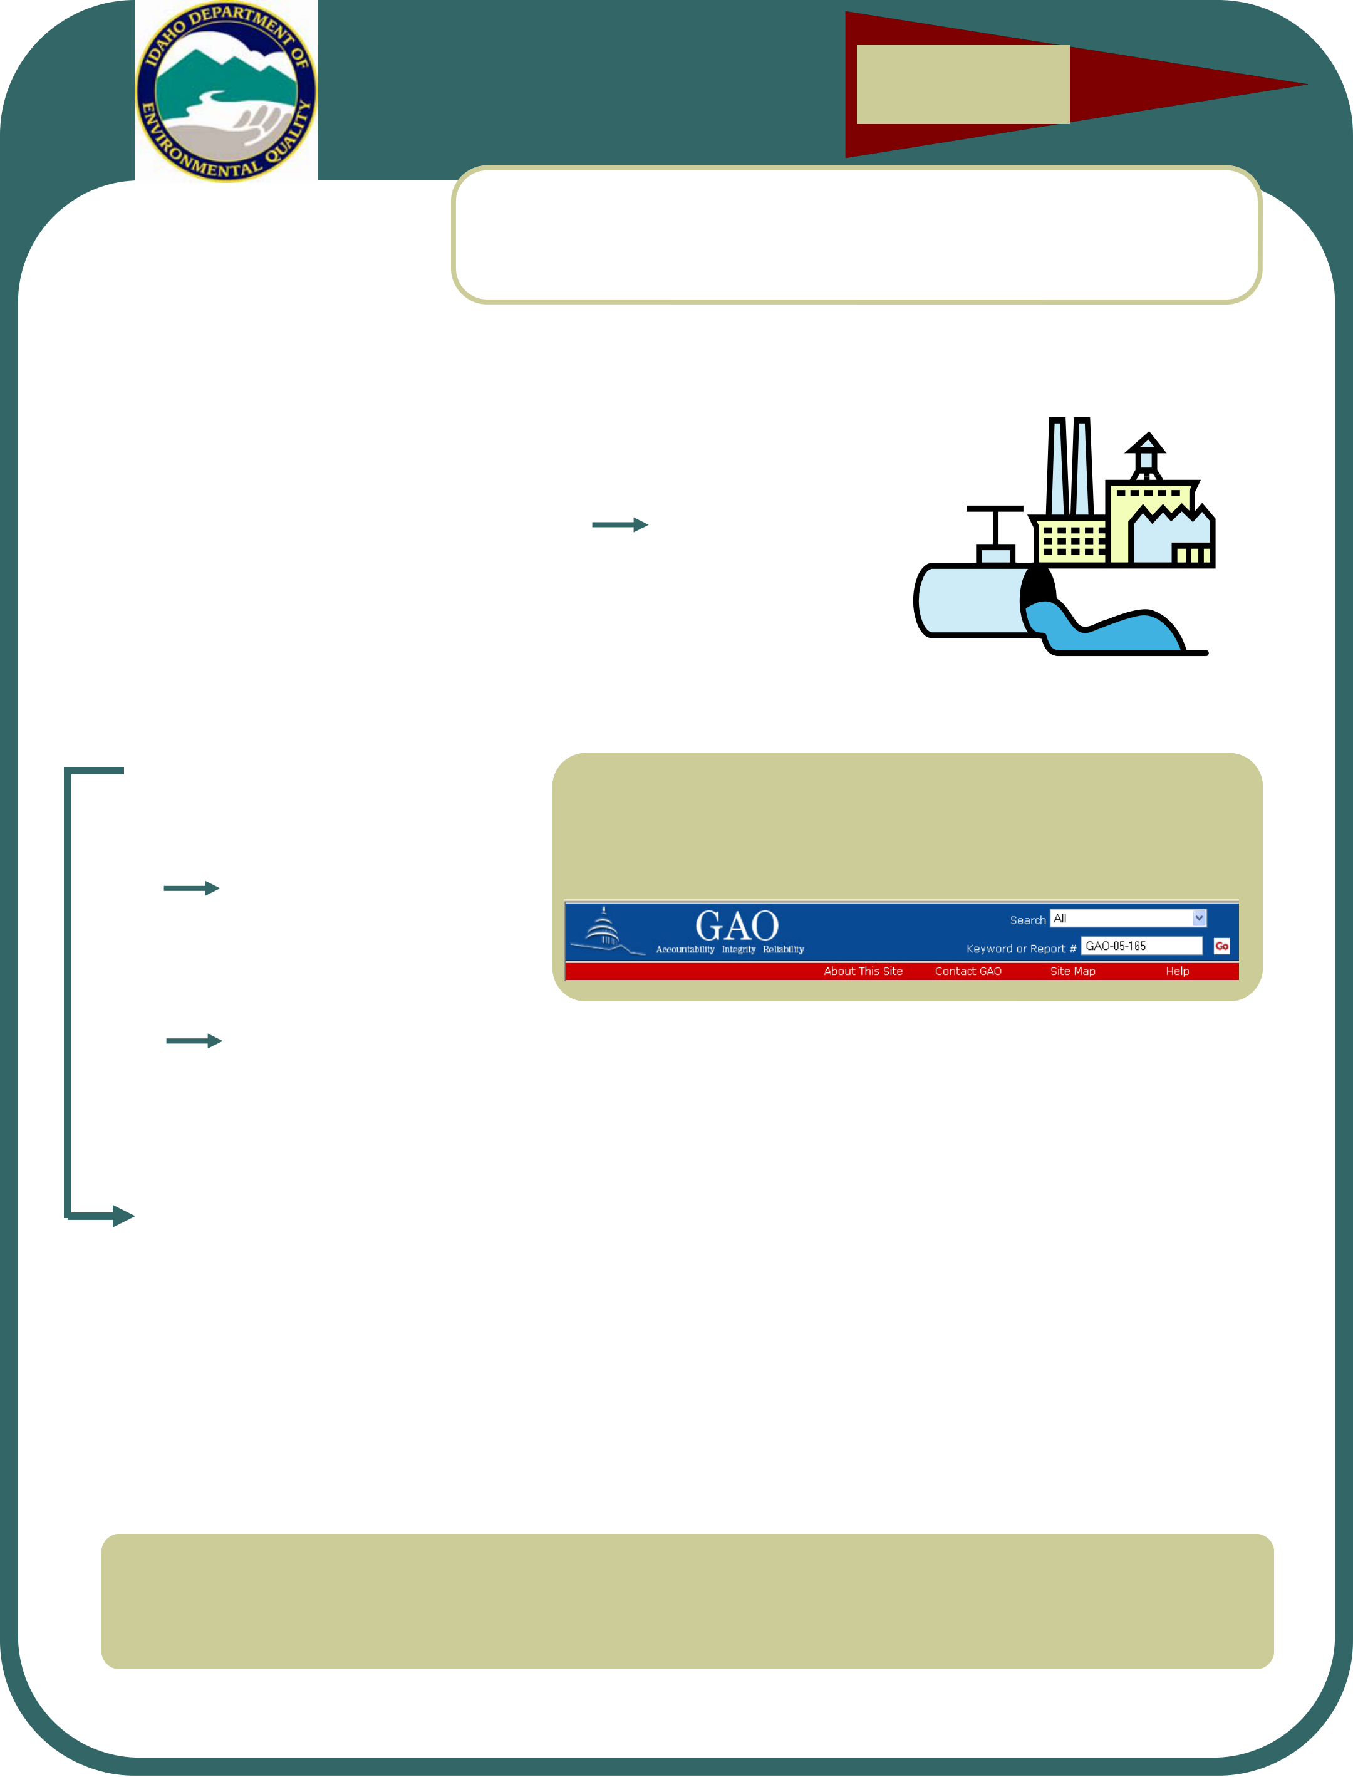

WASTEWATER
SECURITY FACT SHEET

Who do you call in an
emergency?
See back page.

2006 IDAHO DEPARTMENT OF ENVIRONMENTAL QUALITY, WASTEWATER PROGRAM
Wastewater Security is Focus of GAO-05-165 Report

In a recent report to the Senate Committee on Environment and Public Works, the Government Ac-countability Office (GAO) pre-
sented the results of a survey con-ducted among fifty wastewater ex-perts nationwide who were asked to answer the following questions:
• Which wastewater assets are most vulnerable to terrorist at-tacks?
(See below)
• What security enhancing actions are most deserving of federal support?
(See page 2)

• What is the best method
to distribute federal
funds?
(See page 2)
The results of the survey are presented in the follow-ing, starting immediately below and continuing on through page 2. | How can waste water security be enhanced?
To get a copy of GAO-05-165, “Wastewater Facilities: Expert’s Views on Should be Spent to Improve Security,” go to
and enter GAO-05-165 in the search box.

• What criteria should be used for
determining those utilities having
the highest priority for federal
funding to improve security?
(See page 2)
The Five Most Vulnerable Wastewater Assets
Fifty experts asked to identify  wastewater assets that are the most  vulnerable to  security threats  picked the following: | 1 | Collection system’s network of sewers (42 votes)
 | 2 | Treatment chemicals (32 votes)
 | 3 | Key components of the treatment plant, such as the headworks (29 votes)
 | 4 | Supervisory Control and Data Acquisition (SCADA) systems (18)
 | 5 | Pumping stations (16)
The Idaho National Laboratory (INL) maintains a SCADA test bed for conducting research aimed at enhancing utility infra-structures, making systems less susceptible to attacks. For more information on the INL test bed, go to:


Page 2 WASTEWATER SECURITY FACT SHEET
Security-Enhancing Activities Deserving Federal Support
How do wastewater experts think security can be enhanced and funded? Source: GAO-05-165. | When asked to pick those security-  enhancing activities most deserving of fed-eral support, the sur-vey of experts polled for GAO-05-165 cited the following: | 1 | Replacing gaseous chemicals used in wastewater treatment with less hazardous alternatives (29 votes)
 |  | 2 | Improving local, state, and regional collaboration efforts (23 votes)
 |  | 3 | Completing vulnerability assessments for individual wastewater systems (20 votes)
TWENTY-NINE OF FIFTY EXPERTS SURVEYED RATED THE REPLACEMENT OF GASEOUS CHEMICALS WITH LESS HAZARDOUS
ALTERNATIVES TO BE THE HIGHEST PRIORITY FOR FEDERAL FUNDING.
CWSRF Programs:  More than $40 Billion  In Low-Interest Loans  EPA’s Clean Water State  Revolving Fund (CWSRF)  program has provided more than 14,000 low-interest loans for  “water quality protection projects for wastewater treatment,  nonpoint source pollution control, and watershed and estuary  management.”  “CWSRFs offer: |  | Who Should Get Federal Funds?
 |  | When asked which utilities  should get top priority for fed-eral funds to enhance the se-curity of wastewater systems, the panel of fifty experts cited the following criteria most fre-quently: | 1 | Utilities serving critical infrastructure (39 votes)
 |  |  | 2 | Utilities using large quantities of gaseous chemicals (26 votes)
 |  |  | 3 | Utilities serving large populations (24 votes)
• | Low interest rates, flexible terms | How Should Federal Funds be Distributed?
• | Significant funding for  nonpoint source pollution control and estuary  protection
• | Assistance to a variety of borrowers
 |  | When asked to rate the best  mechanisms for distributing fed-eral funds to be used to enhance wastewater security, the fifty ex-perts chose the following: |  | 1 | Direct grants (34 votes)
• | Partnerships with other funding sources”
 |  |  |  | 2 | Clean Water State Revolving Fund (5 votes)
 |  |  |  | 3
For additional information, see the addresses below:
 |  |  |  |  | Loans or loan guarantees (1 vote)

FOR ADDITIONAL INFORMATION ON CONSTRUCTION LOANS FOR PUBLIC WATER SYSTEMS IN IDAHO, SEE:

Access EPA’s Water Security Web site at:


Page 3
EPA Resources
The Environmental • Vulnerability assessments Basic Elements of Protection Agency’s • Emergency/incident planning Vulnerability Water Security Web site provides resources of interest to utilities • Security enhancements, research, and technology Assessments:
1. Characterization of the water and others involved in • Legislation and directives, including system, including mission and
ensuring security. Top-ics addressed on this links to Homeland Security Presiden- tial Directives and federal laws 2. objectives Identification and prioritization of adverse consequences site include: • Resources for small utilities 3. Determination of critical assets
• Resources for public involvement 4. Assessment of the likelihood of malevolent acts
• Resources for information sharing 5. Evaluation of existing
countermeasures
6. Analysis of current risk and development of a prioritized plan for risk reduction.
Vulnerability Assessment Tools
For additional information, see the
Evaluating your vulner- • Vulnerability Self-Assessment Tools address below:
ability is the first step in (VSAT)
making your facility • National Environmental Training Center for Small Communities more secure. EPA pro- (NETCSC) guide to security for small water systems
vides links to resources that can help utilities perform security vul- • A video on developing vulnerability assessments, prepared especially for small water systems.
nerability assessments. • Security Vulnerability Self-Assessment Guide for Very Small (<3,300)
Among the resources Systems
that can be accessed • Risk Assessment Methodology for Water Utilities (RAM-W), developed
from the EPA site are by Sandia National Laboratory
the following: • Protecting Your Community's Assets: A Guide for Small Wastewater Systems
. . .for more, see the address below:
EPA Vulnerability Assessment Fact Sheet

A Message from the Wastewater Program Manager
In this wastewater fact sheet, the focus is on security, starting with the findings of GAO-05-165 and continu-ing through some other compelling wastewater security related suggestions and recommendations of merit.
In an era in which terrorism remains a major threat to the security of our country’s infrastructure, including wastewater systems, we are sure that you will find this information to be not only thought-provoking, but worthy of your attention.
Richard Huddleston, DEQ Wastewater Program Manager
(208) 37
Richard.

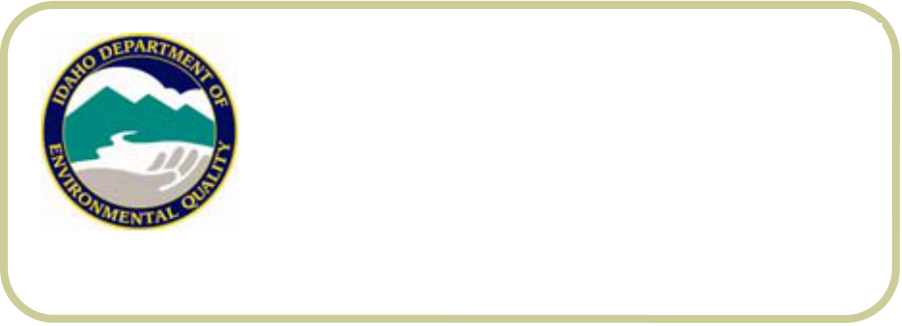



If you suspect contamination of or intrusion into your wastewater system, first call your local law enforcement agency by dialing 911. Then call the Idaho Com Center (1-800-632-8000) to set up an emergency telephone conference with state and local officials, who will advise you on what to do next.
 |  |  |  |  |  |  |  |  | Emergencies: Who to call, when to call, and what to do
 |  |  |  |  |  |  |  |  | If you suspect contamination or intrusion, call your local law enforcement agency  (911) and then the Idaho  Com Center, 1-800-  632-8000! | When to call  Conditions under which you  should call include the following: | sion (marks where devices  have been dragged across the ground or vehicle tracks) have been discovered.
• When physical security has
been compromised, or there is obvious evidence of accidental or malicious intrusion.
 |  |  |  |  |  |  |  |  |  |  | When anonymous threats have been directed at a facility.
 |  |  |  |  |  |  |  |  | Who to call  If you suspect contamination of or intrusion into your wastewa-ter system, first call your local law enforcement agency by  dialing 911. Then call the  Idaho Com Center (1-800-632-8000) to set up an emergency telephone conference with  state and local officials, who will advise you on what to do next. |  | What to do  If your concern meets any of the circumstances described, call your local law enforcement agency (911) and then the  Idaho Com Center at 1-800-  632-8000.
 |  |  |  |  |  |  |  |  |  | • When there is evidence of van-dalism that suggests intrusion leading to added vulnerability of the system—such as caused by holes in fences or gates, cuts in barbed wire, or the removal or destruction of locksets.
 |  |  |  |  |  |  |  |  |  |  | Clearly indicate that your call concerns a threat to a wastewa-ter system.
• When suspicious materials
(discarded packaging, plastic bags, unlabeled and discarded containers) or evidence of intru-
Idaho Department of Environmental Quality
Wastewater Program
1410 N. Hilton
Boise, Idaho 83706
ph: (208) 373-0502
fx: (208) 373-0417

