Frogs and Toads (Anura)
(click on common name for further information)
Common Name | Scientific Name

Columbia Spotted Frog Rana luteiventris
Northern Leopard Frog Rana pipiens
Oregon Spotted Frog Rana pretiosa
Rocky Mountain Tailed Frog Ascaphus montanus
Western Toad Bufo boreas
August 2008

Columbia Spotted Frog
Rana luteiventris
Washington Distribution by County*  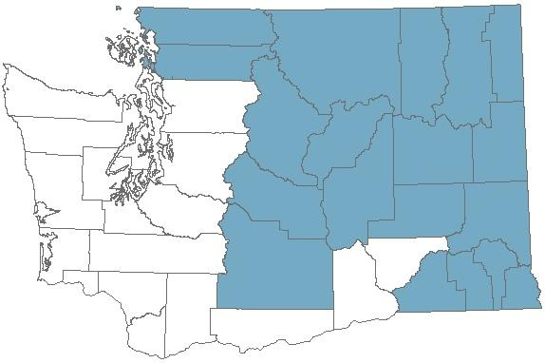 | andidate : None
 | #1
 | - Any occurrence
Online information and
guidelines formanagement of Columbia Spotted Frog:

NatureServe Species Report
* Distribution maps show the counties where a species is known to occur in one of its s well as the counties where a species is likely to occur in one of its priority areas due to the presence of sCounties that are part of the recovery area for Threatened and Endangered species are also shown as part of a species distribution. Occurrences of a species in other counties are possible as new information becomes available, and maps will be updated as necessary at the beginning of each calendar year. The date shown in the footer identifies when the last update was made to maps found on this page.
February 2009 66

Northern Leopard Frog
Rana pipiens
Washington Distribution by County*  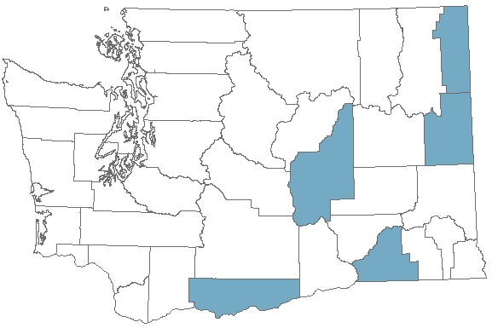 | ndangered : Species of
 | #1
 | - Any occurrence
Online information and
guidelines formanagement of Northern Leopard Frog:

NatureServe Species Report
* Distribution maps show the counties where a species is known to occur in one of its as well as the counties where a species is likely to occur in one of its priority areas due to the presence of s Counties that are part of the recovery area for Threatened and Endangered species are also shown as part of a species distribution. Occurrences of a species in other counties are possible as new information becomes available, and maps will be updated as necessary at the beginning of each calendar year. The date shown in the footer identifies when the last update was made to maps found on this page.
August 2008

Oregon Spotted Frog
Rana pretiosa
Washington Distribution by County*  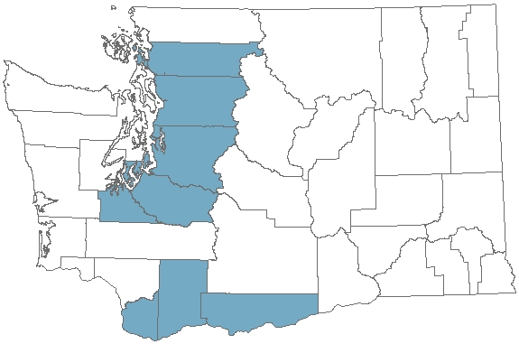 | ndangered : Candidate
 | #1
 | - Any occurrence
Online information and
guidelines formanagement of Oregon Spotted Frog:

NatureServe Species Report
* Distribution maps show the counties where a species is known to occur in one of its as well as the counties where a species is likely to occur in one of its priority areas due to the presence of s Counties that are part of the recovery area for Threatened and Endangered species are also shown as part of a species distribution. Occurrences of a species in other counties are possible as new information becomes available, and maps will be updated as necessary at the beginning of each calendar year. The date shown in the footer identifies when the last update was made to maps found on this page.
August 2008

Rocky Mountain Tailed Frog
Ascaphus montanus
Washington Distribution by County*  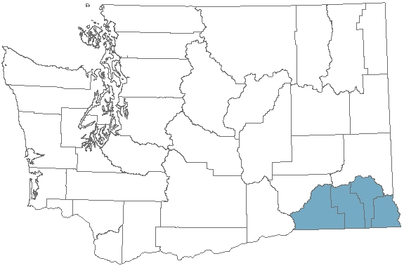 | andidate  : Species of
 | #1
 | - Any occurrence
Online information and
guidelines formanagement of Rocky Mountain Tailed Frog:

NatureServe Species Report
* Distribution maps show the counties where a species is known to occur in one of its , as well as the counties where a species is likely to occur in one of its priority areas due to the presence of s. Counties that are part of the recovery area for Threatened and Endangered species are also shown as part of a species distribution. Occurrences of a species in other counties are possible as new information becomes available, and maps will be updated as necessary at the beginning of each calendar year. The date shown in the footer identifies when the last update was made to maps found on this page.
August 2008

Western Toad
Bufo boreas
Washington Distribution by County*  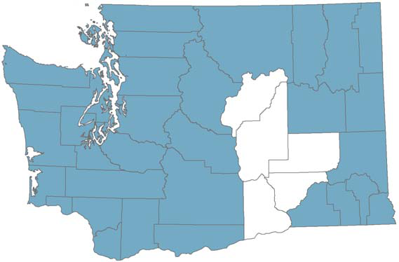 | andidate  : Species of
 | #1
 | - Any occurrence
Online information and
guidelines for management of Western Toad:

NatureServe Species Report
* Distribution maps show the counties where a species is known to occur in one of its , as well as the counties where a species is likely to occur in one of its priority areas due to the presence of s. Counties that are part of the recovery area for Threatened and Endangered species are also shown as part of a species distribution. Occurrences of a species in other counties are possible as new information becomes available, and maps will be updated as necessary at the beginning of each calendar year. The date shown in the footer identifies when the last update was made to maps found on this page.
August 2008

