 | United State Department of Agriculture  National Agriculture Statistics Service  Arkansas Weekly Broiler Report Released: February 03, 2016 | 
Cooperating with the University of Arkansas – Division of Agriculture 10800 Financial Centre Parkway, Suite 110 · Little Rock, Arkansas 72211 (501) 228-9926 · (501) 224-5630 FAX · www.nass.usda.gov/ar
Arkansas Chick Placements Up 4 Percent from Last Year
Broiler-type chicks placed for meat production in Arkansas were 19.6 million during the week ending January 30, 2016. Placements were up 4 percent from the comparable week in 2015 but down 5 percent from the previous week.
Arkansas hatcheries set 21.8 million broiler-type eggs during the week ending January 30, 2016, down 2 percent from the same period last year and down slightly from the previous week.
Million Chicks | 23 | Chicks Placed In Arkansas, 2015-2016 |  |  |  | Million Eggs | Eggs Set In Arkansas, 2015-2016
 |  | 2015 |  |  | 2016
 |  |  |  |  |  |  | 2015 | 2016
 |  | 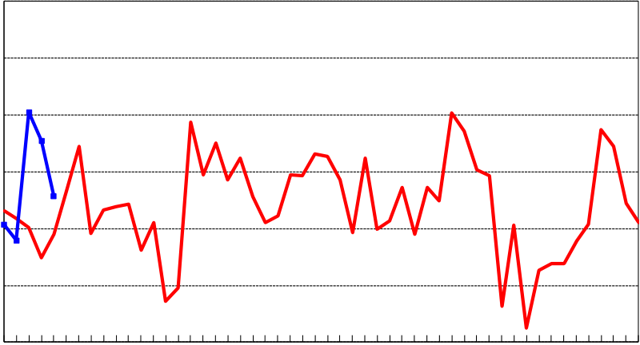 |  |  |  |  | 23  20  19  18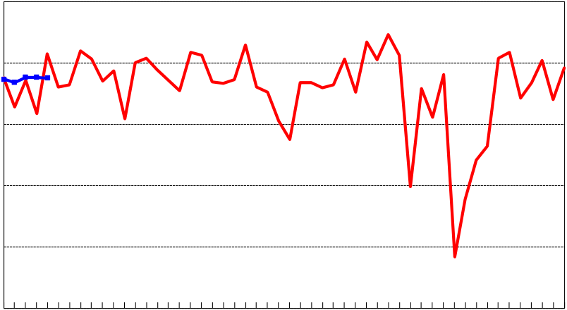  22  21  Jan Feb Mar Apr May Jun Jul Aug Sep Oct Nov Dec
 | 22
 | 21
 | 20
 | 19
 | 18
 | 17
 |  | Jan Feb Mar | Apr May | Jun Jul Aug Sep Oct Nov Dec
 |  | Month |  |  |  |  | Month
Broiler Eggs Set and Chicks Placed in 19 Major States by Week, January 2, 2016 - January 30, 2016
State | Eggs Set |  |  |  |  | Chicks Placed
 | Week Ending |  |  |  |  | Week Ending
 | 2-Jan | 9-Jan | 16-Jan | 23-Jan | 30-Jan | 2-Jan | 9-Jan | 16-Jan | 23-Jan | 30-Jan
1,000 eggs  Alabama 29,249 29,562 29,902 29,261 29,669  Arkansas 21,735 21,680 21,764 21,764 21,753  Delaware 4,888 4,856 4,876 4,853 4,822  Florida 1,225 1,224 1,225 1,224 1,175  Georgia 33,441 34,019 33,273 34,409 34,811  Kentucky 7,801 7,496 7,828 7,967 7,934  Louisiana 3,419 3,455 3,500 3,470 3,726  Maryland 7,777 8,118 8,113 7,796 7,333  Mississippi 16,942 17,798 17,692 18,125 18,051  Missouri 8,062 7,964 8,071 7,877 8,071  N. Carolina 20,890 20,731 20,915 21,421 21,101  Oklahoma 6,752 6,689 6,962 6,738 7,036  Pennsylvania 4,848 4,586 4,632 4,299 4,325  S. Carolina 5,701 5,760 5,627 5,612 5,614  Texas 14,522 14,557 15,237 15,200 15,231  Virginia 6,315 6,374 6,349 6,305 5,941  CA,TN & WV 12,078 12,292 12,040 12,442 12,402 |  |  |  |  |  | 1,000 chicks  21,587 22,653 22,745 22,369 21,707  19,067 18,792 21,043 20,540 19,567  6,137 6,077 5,593 6,920 5,730  1,311 1,320 1,072 1,098 1,283  27,462 26,306 27,244 25,339 27,577  6,119 6,051 5,731 6,295 6,068  3,291 3,164 3,042 2,994 2,997  4,746 5,206 6,770 4,740 6,440  15,215 15,560 14,900 14,400 15,142  5,657 6,059 6,111 6,126 5,675  16,818 16,455 16,487 16,134 16,008  5,014 5,218 3,342 3,856 4,912  4,018 3,959 3,754 3,882 3,736  4,580 5,723 4,812 5,647 5,100  12,628 12,198 12,221 11,754 11,852  5,936 5,087 4,755 5,527 5,014  10,327 11,192 10,668 10,671 11,348
19 State Total 205,645 207,161 208,006 208,763 208,995  % of Prev. Year 100 101 101 101 102  Other States 7,219 8,191 7,980 7,909 7,883 |  |  |  |  |  | 169,913 171,020 170,290 168,292 170,156  100 101 100 99 101  6,615 6,495 6,595 5,996 6,490
U.S. Total 212,864 215,352 215,986 216,672 216,878 |  |  |  |  |  | 176,528 177,515 176,885 174,288 176,646
Revisions made to the previous four-week's data during the current week are published in this report.
Broiler-Type Eggs Set in the United States Up 2 Percent
Hatcheries in the United States weekly program set 217 million eggs in incubators during the week ending January 30, 2016, up 2 percent from a year ago. Hatcheries in the 19 State weekly program set 209 million eggs in incubators during the week ending January 30, 2016, up 2 percent from the year earlier. Average hatchability for chicks hatched during the week in the United States was 84 percent. Average hatchability is calculated by dividing chicks hatched during the week by eggs set three weeks earlier.
Broiler-Type Chicks Placed in the United States Up 1 Percent
Broiler growers in the United States weekly program placed 177 million chicks for meat production during the week ending January 30, 2016, up 1 percent from a year ago. Broiler growers in the 19 State weekly program placed 170 million chicks for meat production during the week ending January 30, 2016, up 1 percent from the year earlier. Cumulative placements from the week ending January 9, 2016 through January 30, 2016 for the United States were 705 million. Cumulative placements were up 1 percent from the same period a year earlier.
USDA is an equal opportunity provider and employer

