Final Report
1 October 2011 – 30 September 2013
Project Title: A Retrospective Analysis of Spatial and Temporal Patterns of Growth and Abundance of Juvenile Anadromous Fishes in the Maryland Chesapeake Bay
NOAA Grant Number: NA11NMF4570219
NOAA Funds Awarded: $52,000
Project Duration: 24 months; 1 October 2011 to 30 September2013
Co-Principal Investigators: William J. Connelly, Edward D. Houde
Institution: University of Maryland Center for Environmental Science, Chesapeake Biological Laboratory, P.O. Box 38, Solomons, MD 20688
SYNOPSIS
Recruitment success of anadromous fishes (striped bass, white perch and alosines) in Maryland tributaries to Chesapeake Bay varies dramatically from year to year.
Additionally, the tributaries and their watersheds differ in the degree of human
development and impact that may affect reproductive success and productivity of anadromous fishes. In this project we undertook a retrospective analysis of data on abundance, sizes, growth rates, and production of young-of-the-year (YOY)
anadromous fishes based on data from the Maryland Department of Natural Resources (DNR) Juvenile Striped Bass Seine Survey that has been conducted since 1959.
Additionally, data on taxable structures located within three watersheds (Choptank, Nanticoke, and Patuxent rivers) were analyzed as a proxy for level of human activity and anthropogenic stress to evaluate potential effects of watershed development on growth, distribution, and abundance of YOY anadromous fishes. Significant increases in the combined-taxa abundance and biomass of YOY anadromous fishes were detected in the subestuaries that were sampled over the full time course of the DNR surveys. Abundances of the YOY alosines group declined significantly in the Choptank River but increased in the Potomac River, attributable to increasing numbers of YOY American shad in the Potomac. Significant negative temporal trends in mean lengths were detected for some YOY anadromous fish taxa. Despite the apparent trends in abundance and biomass, only a few of the trends in net production of anadromous fishes were judged to be significant. Shifts in spatial distribution of some YOY
anadromous fishes occurred during the 53-yr time series, with observed shifts in centers of abundance being primarily down-estuary in some tributaries. Principal components analyses identified correlations and temporal patterns among water quality parameters, freshwater flow, anadromous fish abundances and their centers of abundance.
1

Research initiated in this project is being continued under funding from Maryland DNR via the Atlantic States Marine Fisheries Commission. Analyses on a suite of biotic and abiotic variables to identify and evaluate sources of interannual variability in abundance, sizes, and growth rates of YOY anadromous fishes are being conducted in the
continuing research.
INTRODUCTION AND BACKGROUND
This is the Final Report for NOAA Grant NA11NMF4570219. The research was conducted in response to a NOAA Chesapeake Bay Office RFP priority requesting retrospective analyses of long-term monitoring data to develop resource management products. The project was initiated on 1 October 2011 and was funded for a single year. A one-year no-cost extension was granted that extended the project to 30 September 2013. This research is continuing under a contract from Maryland
Department of Natural Resources (Contract Number K00B3400024) via the Atlantic States Marine Fisheries Commission for the period 16 July 2012 to 15 July 2014.
Anadromous fishes, including striped bass, white perch, and alosines (American shad, hickory shad, alewife, and blueback herring) are ecologically and economically important in Chesapeake Bay. Recruitment success of many anadromous fishes exhibits more than 10-fold inter-annual variability in the Bay. While the recruitment levels of these fishes are correlated among Maryland’s Chesapeake Bay tributaries (Kraus and Secor 2005; Wood and Austin 2009), the contribution of YOY recruits by each tributary depends on numerous factors in addition to watershed size or areal extent of available habitat. Watersheds of each of the tributaries have experienced different land use patterns and nutrient loading regimes that can affect carrying capacity and production potential (Carlisle et al. 2013).
The proximity of many of the spawning and nursery grounds in Maryland to urbanized areas makes these species especially sensitive to anthropogenic influences (Schaaf et al. 1993; Uphoff 2008). Analyses conducted by the Maryland Department of Natural Resources (DNR) indicated negative relationships between the area of impervious surface (IS) within a watershed, dissolved oxygen concentrations, and abundance of juvenile anadromous fishes in several small Chesapeake Bay and Potomac River tributaries (McGinty et al. 2006; Uphoff 2008; Uphoff et al. 2011). Furthermore, the occurrences of white perch and yellow perch eggs, larvae, and adults were diminished in the Bush River watershed in 2006 (IS coverage = 13%) relative to 1973 (IS coverage = 9%) (Uphoff et al. 2007). Relationships among long-term trends in nutrients and dissolved oxygen (Hagy et al. 2004; Kemp et al. 2005; Testa et al. 2008; Prasad et al. 2010; Williams et al. 2010) and changes in land use and agricultural practices in Chesapeake watersheds and the Bay have been documented (Cronin and Vann 2003; Kemp et al. 2005; McGinty et al. 2006; Uphoff et al. 2011; Williams et al.
2010). The research conducted by DNR on watersheds differing in IS coverage was limited to data collected during a 3-year period. We evaluated relationships among long-term trends in abundance, growth, and production of young-of-the-year (YOY)
2

anadromous fishes that may facilitate management decisions on allocation of restoration efforts and protective regulations.
OBJECTIVES
• Quantify differences and trends in abundance, size, and growth rate among YOY anadromous fishes in Maryland’s upper Chesapeake Bay and tributaries.
• Document shifts in distributions of YOY anadromous fishes in Maryland’s upper Chesapeake Bay and tributaries and relate to human habitation/land-use.
• Compare the historical abundance of zooplankton and benthic prey organisms for YOY anadromous fishes across tributaries and quantify temporal trends.
• Evaluate relationships between YOY fish, their zooplankton/benthos prey, environmental variables, and land use metrics.
METHODS AND APPROACHES
Monitoring Data
The Maryland Department of Natural Resources Juvenile Striped Bass Seine Survey (http://www.dnr.state.md.us/fisheries/juvindex/) has collected, enumerated, and measured YOY anadromous fishes in the Maryland tributaries of the Bay since 1957 (Figure 1). The systems sampled since initiation of the survey include the Potomac River, the Choptank River, the Nanticoke River, and the head of the Bay. The Patuxent River has been sampled since 1983. There are multiple permanent and auxiliary sampling sites in each system. Each site is sampled once each month in July, August, and September using a 30.5-m x 1.24-m bag-less beach seine of untreated 6.4-mm bar mesh. The time series is sufficiently long to capture shifts in abundance that appear to be related to changes in freshwater flow patterns, other environmental variables, and adult spawning stock biomasses. These data were analyzed to compare trends and differences in abundance, growth rates and biomass across tributaries under varying environmental conditions. With the exception of the Choptank River, only the sites sampled continuously in each tributary since the beginning of the survey were used in the analyses. In the Choptank River, only one site was sampled continuously since the beginning of the survey. However, replacement sites were selected in close proximity to the original sites and these were assumed to be representative of the respective regions of the Choptank River.
The Chesapeake Bay Program (CBP) has monitored water quality, species composition and abundance of mesozooplankton (through 2002), and the species composition and abundance of benthic organisms at fixed stations in Maryland since 1984 (Figure 1). Additional water quality data collected by the Chesapeake Bay
3

Institute dating back to 1949 are available. These data are being analyzed in the continuation phase of the project (with MD DNR and ASMFC support) to evaluate the potential of each tributary to support YOY anadromous fishes and to compare trends and patterns in the seine survey data.

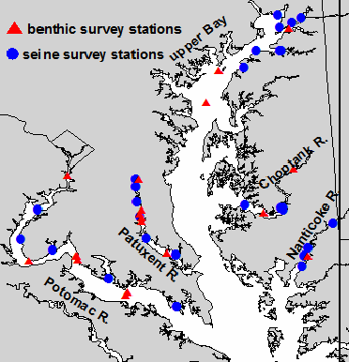

Figure 1. Map of the Maryland portion of Chesapeake Bay and tributaries.
Sampling sites included in the analyses described in this report are represented by symbols. The sites are seine-
sampling sites from the Maryland DNR Striped Bass Juvenile Index Survey (http://www.dnr.state.md.us/
fisheries/juvindex/)

Data on taxable structures from the Maryland State Department of Assessment and Taxation (SDAT) were incorporated into an analysis that examines anthropogenic alteration of the watershed and its relationship to abundance and growth of YOY anadromous fishes, shifts in water quality, and changes in land-use. The taxable structures data were selected for analysis because SDAT has collected data annually on the number and foundation footprint area of structures in each Maryland county since 1950. Additionally, area occupied by taxable structures has been reported to be strongly, positively correlated with estimates of impervious surface coverage (J. Uphoff, unpublished data).
Analyses
Annual mean abundance (number per 100 m2) and biomass (grams wet weight per 100 m2) estimates were calculated for alewife (Alosa pseudoharengus), blueback herring (Alosa aestivalis), American shad (Alosa sapidissima), striped bass (Morone saxatilis), and white perch (Morone americana). Area swept by the MD DNR seine in a deployment was estimated using a quarter circle sweep or an approximately-trapezoidal sweep depending on the fraction of the seine’s length that was deployed in a seine set (Martino and Houde 2012). The density (number per square meter) of each species was estimated for each sampling site during the survey each year, and the annual mean
4

density was then calculated for each tributary (upper Chesapeake Bay, Choptank River, Nanticoke River, Patuxent River, and Potomac River). Length-to-wet-weight
conversions were used to obtain a relative biomass estimate for each species at each sampling site. The number of years in the biomass time series differs for each species. Striped bass was the only species for which length was measured from the beginning of the seine survey (1957). White perch lengths were recorded since 1971 and the lengths of the alosines (alewife, American shad, and blueback herring) since 1991. Abundance and biomass for each species were estimated using only the survey sites at which a species occurred at least twice since the beginning of the survey. Prior to analysis, one-half of the minimum, non-zero abundance or biomass estimate for each tributary-species combination was added to all zero-catch sites in the tributary to allow inclusion of zero abundance values in a log-transformed data analysis. Trends in the transformed abundance and biomass data were identified and quantified using linear regression.
Trends in the sizes of YOY anadromous fishes over the survey years were quantified by examining median total lengths in September. Median lengths, rather than mean lengths, were analyzed because medians tend to be less sensitive to outliers. The analysis of growth rates was based on differences in median length of fish between the August and September surveys.
An index of net production of each species from August to September was calculated for each tributary by subtracting the mean relative biomass estimated in August from the mean relative biomass in September and then dividing by the number of days between the two sampling events.
Patterns or trends over years in the spatial distribution of each species were evaluated by estimating the center of abundance of each species in each system for the entire seine survey time series. The center of abundance was calculated as a weighted mean location (distance from the mouth of each tributary to each survey sampling site), with the location weighted by the abundance of each species collected at each site.
A principal components analysis was conducted to examine and evaluate relationships among fish density for each species with respect to their centers of abundance, freshwater flow, water quality variables, and the number of taxable
structures in each watershed. Monthly mean freshwater discharge data for the
Susquehanna, Choptank, Nanticoke, Patuxent, and Potomac rivers were retrieved from the United States Geological Survey (USGS) National Water Information Survey (USGS 2012). Water quality data, including water temperature, salinity, pH, dissolved oxygen (DO), chlorophyll a, dissolved nitrate + nitrite, and dissolved phosphate, collected from 1985 to 2010, the first and last available full years of data, were downloaded from the Chesapeake Bay Program (CBP) website
(http://www.chesapeakebay.net/data/downloads/cbp_water_quality_database_1984_pr esent). These variables were chosen because they provide biologically relevant information about environmental conditions within each tributary and because there were few missing observations (less than 10%). Mean values for each water quality
5

variable and the flow data from each tributary were calculated for spring (March, April, May) and summer (June, July, and August) because conditions during these two seasons strongly influence the survival and growth of anadromous fish larvae and juveniles (North and Houde 2001, 2003, 2006; Martino and Houde 2010, 2012). Data on taxable structures were available only for the Choptank, Nanticoke, and Patuxent river watersheds.
PROGRESS
Abundance and biomass
There were several significant trends in the abundance of anadromous fishes included in the analysis. Herein, we first report on the abundances and biomasses of combined groups of taxa and species and then on the individual species. Striped bass and white perch data were combined into a moronid group while the data for American shad and the river herrings were combined into an alosine group. Finally, the data for all five species were combined into an anadromous group.
Abundance
Combined Groups
While there were periods of below-average abundance (i.e., density) for each of the groups from 1957 to approximately 1960, and again in the 1980s, the abundances of YOY anadromous fishes, most notably the moronid group, tended to exhibit positive trends since the beginning of the time series, which is consistent with patterns reported by Martino and Houde (2012) for striped bass and Wood and Austin (2009) for a suite of species. Conversely, with the exception of the Potomac River where YOY alosine abundances increased, alosine abundances were declining throughout the time series (Figure 2). The trends in abundance were fairly consistent among tributaries and within species groups, although slopes often were not statistically different from zero (Table 1).
Alosine abundance was more variable than the moronid or anadromous groups because of frequent extreme high and low catches. Trends in the anadromous group abundance appear to be mostly driven by the moronid group, with absolute abundance scaled upwards by large alosine catches. Negative trends in abundance across groups within the Choptank River may be a consequence of the spatial distribution of survey sites in this tributary, which included only one site in the tidal fresh region. This site was excluded from our analysis because it was not sampled until 1984.
6

Table 1. Abundance of YOY anadromous fish groups in Chesapeake Bay. Slope, intercept, r2 (%), and regression p-value estimates for the trends in mean annual abundance (log10 number per 100 m2) of alosines (American shad, alewife, blueback
herring), moronids (striped bass and white perch), and all anadromous species
combined. Significant p-values (p ≤ 0.05) are in bold.
System | Group | Slope | Intercept | r2 | p-value
Head of Bay | Alosines | -0.0005 | 1.67 | 0.01 | 0.9437
Choptank | Alosines | -0.0120 | 23.66 | 9.34 | 0.0208
Nanticoke | Alosines | -0.0031 | 6.62 | 0.48 | 0.6078
Patuxent | Alosines | -0.0057 | 11.10 | 0.81 | 0.6293
Potomac | Alosines | 0.0157 | -30.32 | 14.84 | 0.0031
Head of Bay | Moronids | 0.0040 | -7.07 | 2.90 | 0.2052
Choptank | Moronids | -0.0034 | 7.68 | 0.88 | 0.4889
Nanticoke | Moronids | 0.0079 | -14.62 | 8.66 | 0.0263
Patuxent | Moronids | 0.0080 | -15.17 | 1.75 | 0.4786
Potomac | Moronids | 0.0049 | -8.72 | 5.08 | 0.0920
Head of Bay | Anadromous | 0.0038 | -5.90 | 1.30 | 0.3987
Choptank | Anadromous | -0.0015 | 4.30 | 0.14 | 0.7791
Nanticoke | Anadromous | 0.0083 | -14.92 | 7.90 | 0.0342
Patuxent | Anadromous | 0.0042 | -7.10 | 0.47 | 0.7129
Potomac | Anadromous | 0.0127 | -23.47 | 22.16 | 0.0002
7

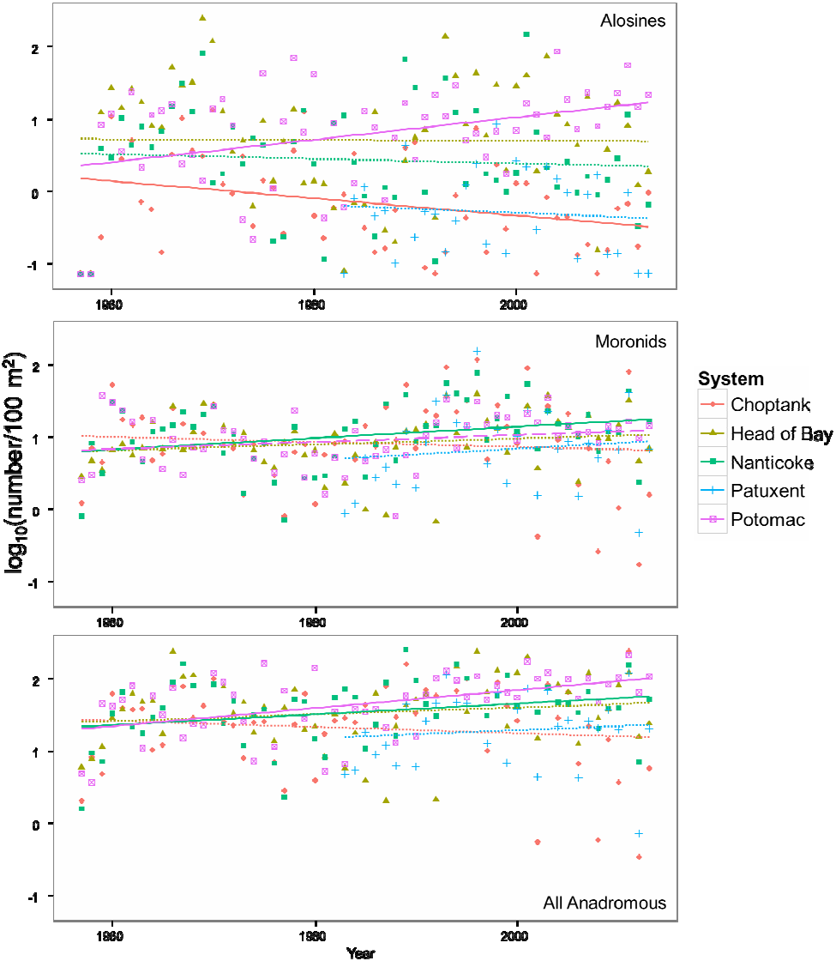
Figure 2. Trends in log10- transformed density (i.e., abundance) of young-of-the-year moronids, alosines, and all anadromous species combined. Solid lines represent regressions with p-values ≤ 0.05. Dashed lines indicate regressions are near significant at 0.05 < p ≤ 0.10. Dotted lines indicate regressions with p > 0.10.
8

Abundance
Species-specific
The significant, positive trend in Potomac River alosine abundance (Table 1) reflects a concurrent significant increase in Potomac River YOY American shad abundance over the time series (Table 2; Figure 3). Similarly, decreasing trends in alosine-group abundance follow decreasing trends in the constituent species across the systems investigated (Table 2). Except in the Head of Bay, YOY alewife decreased across systems, although the trend was only significant within the Choptank. YOY blueback herring was the most variable in abundance of the alosines investigated, differing three orders of magnitude among years. Bluebacks declined significantly in the Choptank River but not in the other systems (Table 2; Figure 3).
YOY white perch exhibited the most significant abundance trends. With the exception of the Choptank, in which a slight, but not significant, negative trend was observed, trends in abundance were positive and comparatively large (Table 2; Figure 4).Trends in YOY striped bass abundance were consistently flat, with little evidence of any significant, long-term change in abundance in these systems.
9

Table 2. Abundance of YOY anadromous fishes in Chesapeake Bay. Slope, intercept, r2 (%), and regression p-value estimates for the trends in mean annual abundance (log10 number per 100 m2) of American shad, alewife, blueback herring, striped bass,
and white perch. Significant p-values (p ≤ 0.05) are in bold.
System | Species | Slope | Intercept | r2 | p-value
Head of Bay | Alewife | 0.0000 | -0.18 | 0.00 | 0.9917
Choptank | Alewife | -0.0117 | 22.67 | 13.79 | 0.0045
Nanticoke | Alewife | -0.0024 | 4.30 | 0.99 | 0.4607
Patuxent | Alewife | -0.0128 | 24.80 | 6.27 | 0.1742
Potomac | Alewife | -0.0056 | 10.68 | 2.96 | 0.2008
Head of Bay | Blueback herring | 0.0046 | -8.69 | 0.68 | 0.5431
Choptank | Blueback herring | -0.0125 | 24.39 | 12.72 | 0.0065
Nanticoke | Blueback herring | -0.0013 | 2.80 | 0.09 | 0.8258
Patuxent | Blueback herring | -0.0081 | 15.52 | 1.64 | 0.4922
Potomac | Blueback herring American shad | 0.0031 | -5.79 | 0.47 | 0.6123
Head of Bay |  | 0.0013 | -3.15 | 0.17 | 0.7642
Choptank | American shad | -0.0146 | 27.74 | 10.64 | 0.0902
Nanticoke | American shad | -0.0061 | 11.21 | 15.10 | 0.0028
Patuxent | American shad | 0.0225 | -45.51 | 10.82 | 0.0708
Potomac | American shad | 0.0265 | -52.89 | 36.89 | <0.0001
Head of Bay | Striped bass | -0.0044 | 8.77 | 3.45 | 0.1664
Choptank | Striped bass | 0.0059 | -11.61 | 3.02 | 0.1959
Nanticoke | Striped bass | 0.0010 | -2.05 | 0.19 | 0.7459
Patuxent | Striped bass | 0.0116 | -23.02 | 3.21 | 0.3349
Potomac | Striped bass | 0.0052 | -10.24 | 5.43 | 0.0811
Head of Bay | White perch | 0.0143 | -27.91 | 20.92 | 0.0003
Choptank | White perch | -0.0077 | 15.59 | 3.25 | 0.1800
Nanticoke | White perch | 0.0129 | -24.92 | 14.53 | 0.0034
Patuxent | White perch | 0.0226 | -44.55 | 11.49 | 0.0623
Potomac | White perch | 0.0081 | -15.58 | 8.24 | 0.0304
10

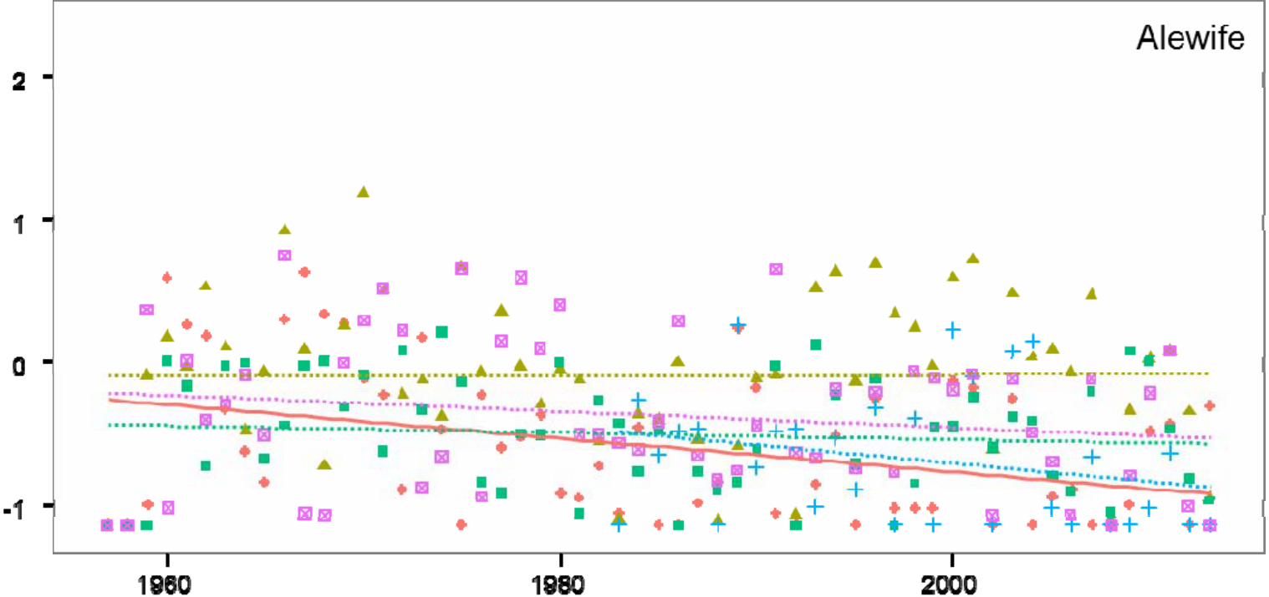
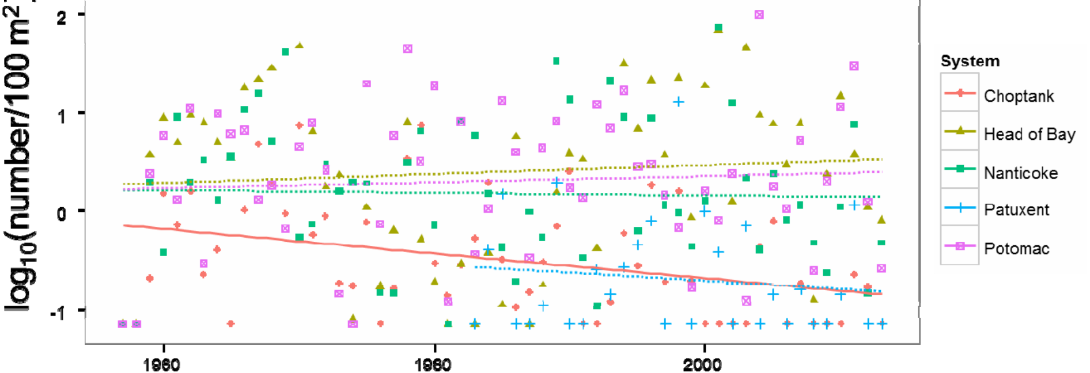
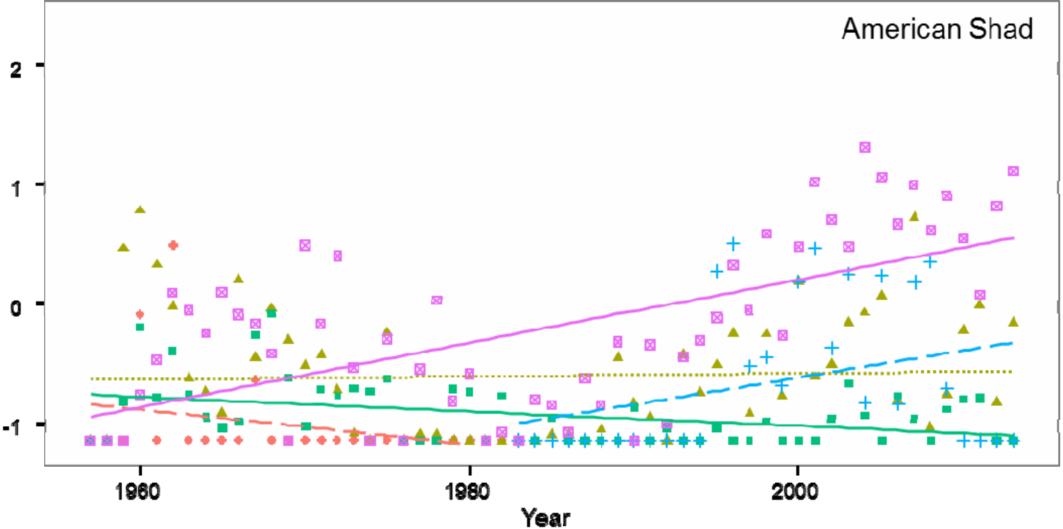
Figure 3. Trends in log10 - transformed density (i.e., abundance) of young-of-the-year alosines (alewife, blueback herring, and American shad). Solid lines represent
regressions with p-values ≤ 0.05. Dashed lines indicate regressions are near significant at 0.05 < p ≤ 0.10. Dotted lines indicate regressions with p > 0.10.
11

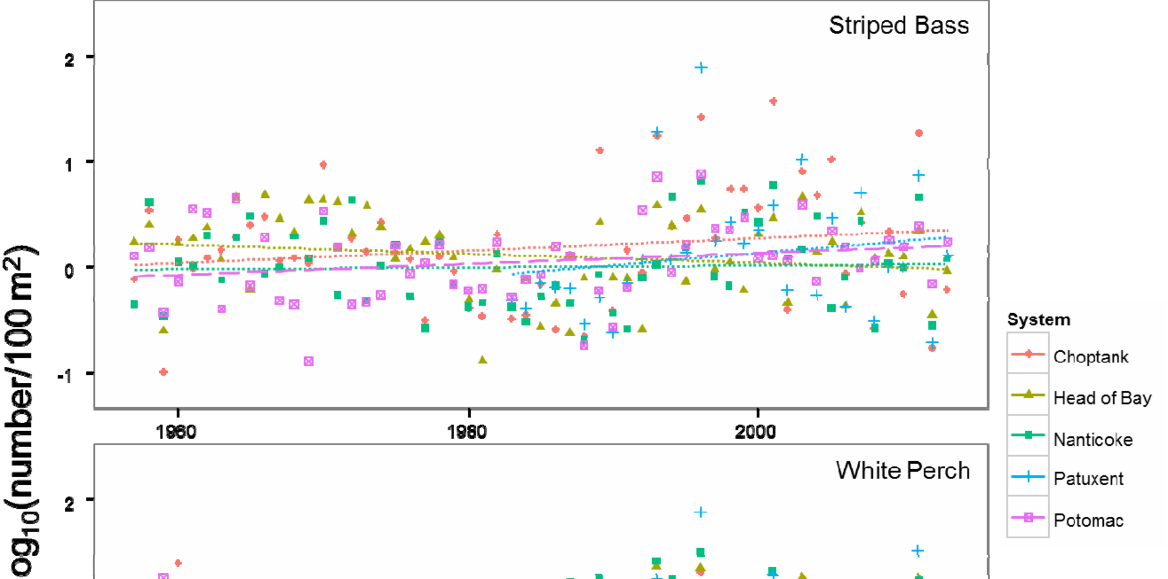
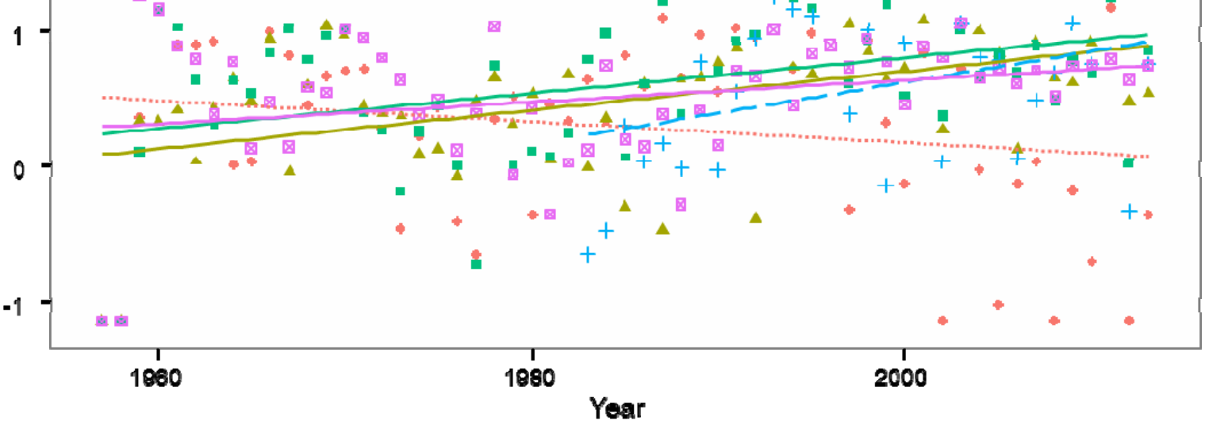
Figure 4. Trends in log10 - transformed density (i.e., abundance) of young-of-the-year
moronids (striped bass and white perch). Solid lines represent regressions with p-values
≤ 0.05. Dashed lines indicate regressions are near significant at 0.05 < p ≤ 0.10.
Dotted lines indicate regressions with p > 0.10.
Biomass
Combined Groups
With the exception of the Patuxent River, which had the shortest duration in the DNR survey, there were significant, positive trends in the biomass of YOY moronids.
Biomass of YOY alosines, which could only be estimated since 1990, exhibited no significant trends in any of the systems (Figure 5, Table 3). No slopes of the trends in biomass for the combined YOY alosine or anadromous fishes differed significantly from zero in any of the systems for the period 1990 to present. There were fewer significant trends in the biomass data than in the abundance data, primarily because of the shorter period of data availability on fish sizes in the survey.
12

Table 3. Biomass of YOY anadromous fish groups in Chesapeake Bay. Slope, intercept, r2 (%), and regression p-value estimates for the trends in mean annual biomass (log10 grams wet weight per 100 m2) of alosines (American shad, alewife,
blueback herring), moronids (striped bass and white perch), and all anadromous
species combined. Significant p-values (p ≤ 0.05) are in bold.
System | Group | Slope | Intercept | r2 | p-value
Head of Bay | Alosines | -0.0040 | 9.06 | 0.09 | 0.8997
Choptank | Alosines | 0.0158 | -32.01 | 2.12 | 0.5284
Nanticoke | Alosines | 0.0254 | -50.43 | 3.67 | 0.4053
Patuxent | Alosines | 0.0023 | -4.30 | 0.07 | 0.9063
Potomac | Alosines | 0.0179 | -34.74 | 5.65 | 0.2997
Head of Bay | Moronids | 0.0182 | -34.96 | 31.66 | 0.0001
Choptank | Moronids | 0.0185 | -35.49 | 11.44 | 0.0306
Nanticoke | Moronids | 0.0216 | -41.76 | 28.33 | 0.0004
Patuxent | Moronids | 0.0141 | -26.80 | 5.27 | 0.2310
Potomac | Moronids | 0.0181 | -34.97 | 26.42 | 0.0006
Head of Bay | Anadromous | 0.0064 | -10.68 | 0.66 | 0.7256
Choptank | Anadromous | -0.0501 | 102.27 | 15.20 | 0.0807
Nanticoke | Anadromous | -0.0140 | 30.01 | 4.79 | 0.3408
Patuxent | Anadromous | -0.0155 | 32.55 | 3.68 | 0.4046
Potomac | Anadromous | 0.0003 | 1.55 | 0.00 | 0.9759
13

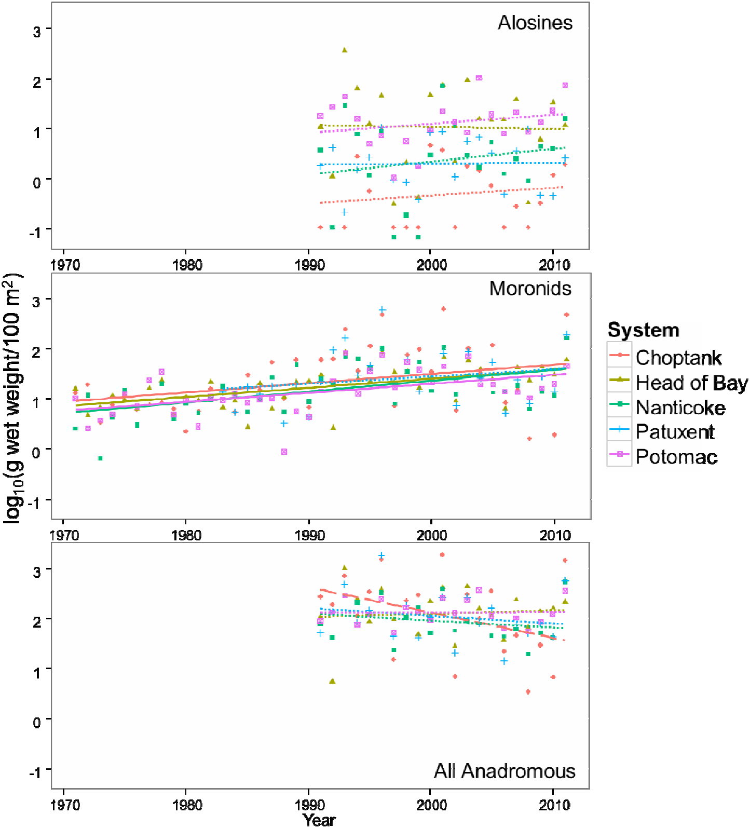
Figure 5. Trends in log10-transformed biomass of young-of-the-year moronids, alosines, and all anadromous species combined. Solid lines represent regressions with p-values ≤ 0.05. Dashed lines indicate regressions are near significant at 0.05 < p ≤ 0.10. Dotted lines are regressions with p > 0.10.
14

Biomass
Species-specific
YOY American shad had significant positive trends in biomass within the Nanticoke and Potomac Rivers (Figure 6, Table 4). There were, however, no significant trends in biomass in any of the systems for YOY alewife or blueback herring. YOY white perch had strongly significant positive trends in biomass in all systems except the Choptank River. The slopes for the significant trends were similar, ranging from 0.0260-0.0284 log10 grams wet weight 100 m-2 year-1 (Figure 7, Table 4). Conversely, slopes of the trends in YOY striped bass biomass over the time series were near-zero and not significant, indicating that the trends in white perch biomass drove the observed biomass trends in the combined moronid group.
Table 4. Biomass of YOY anadromous fishes in Chesapeake Bay. Slope, intercept, r2
(%), and regression p-value estimates for the trends in mean annual biomass (log10 grams wet weight per 100 m2) of American shad, alewife, blueback herring, striped
bass, and white perch. Significant p-values (p ≤ 0.05) are in bold.
System | Species | Slope | Intercept | r2 | p-value
Head of Bay | Alewife | 0.0029 | -5.29 | 0.06 | 0.9162
Choptank | Alewife | 0.0104 | -21.16 | 2.08 | 0.5325
Nanticoke | Alewife | 0.0070 | -14.26 | 0.62 | 0.7342
Patuxent | Alewife | -0.0206 | 41.13 | 4.85 | 0.3375
Potomac | Alewife | 0.0022 | -4.60 | 0.06 | 0.9169
Head of Bay | Blueback herring | -0.0045 | 9.83 | 0.07 | 0.9122
Choptank | Blueback herring | -0.0018 | 2.98 | 0.05 | 0.9267
Nanticoke | Blueback herring | 0.0126 | -25.14 | 0.68 | 0.7231
Patuxent | Blueback herring | -0.0041 | 7.68 | 0.32 | 0.8073
Potomac | Blueback herring American shad | 0.0101 | -19.93 | 0.34 | 0.8022
Head of Bay |  | 0.0326 | -65.23 | 17.11 | 0.0623
Nanticoke | American shad | 0.0366 | -73.58 | 36.76 | 0.0036
Patuxent | American shad | 0.0197 | -39.32 | 3.17 | 0.4399
Potomac | American shad | 0.0779 | -155.28 | 51.12 | 0.0003
Head of Bay | Striped bass | -0.0056 | 11.84 | 4.67 | 0.1165
Choptank | Striped bass | 0.0083 | -15.47 | 3.17 | 0.1978
Nanticoke | Striped bass | -0.0064 | 13.31 | 4.45 | 0.1294
Patuxent | Striped bass | 0.0150 | -29.06 | 4.18 | 0.2876
Potomac | Striped bass | 0.0003 | -0.02 | 0.01 | 0.9388
Head of Bay | White perch | 0.0284 | -55.50 | 33.95 | 0.0001
Choptank | White perch | 0.0010 | -1.43 | 0.02 | 0.9350
Nanticoke | White perch | 0.0284 | -55.52 | 30.37 | 0.0002
Patuxent | White perch | 0.0262 | -51.12 | 15.10 | 0.0372
Potomac | White perch | 0.0260 | -51.06 | 27.68 | 0.0004
15

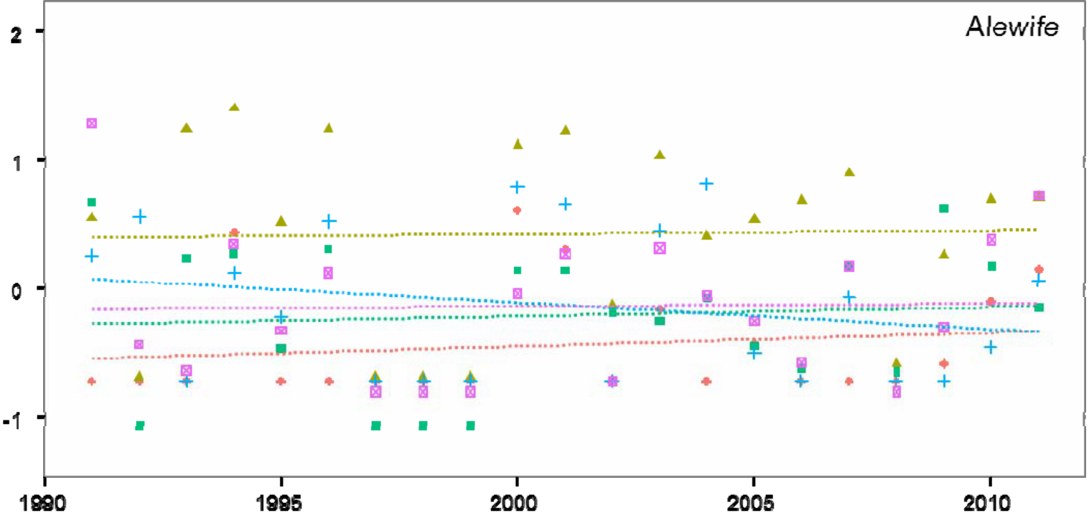
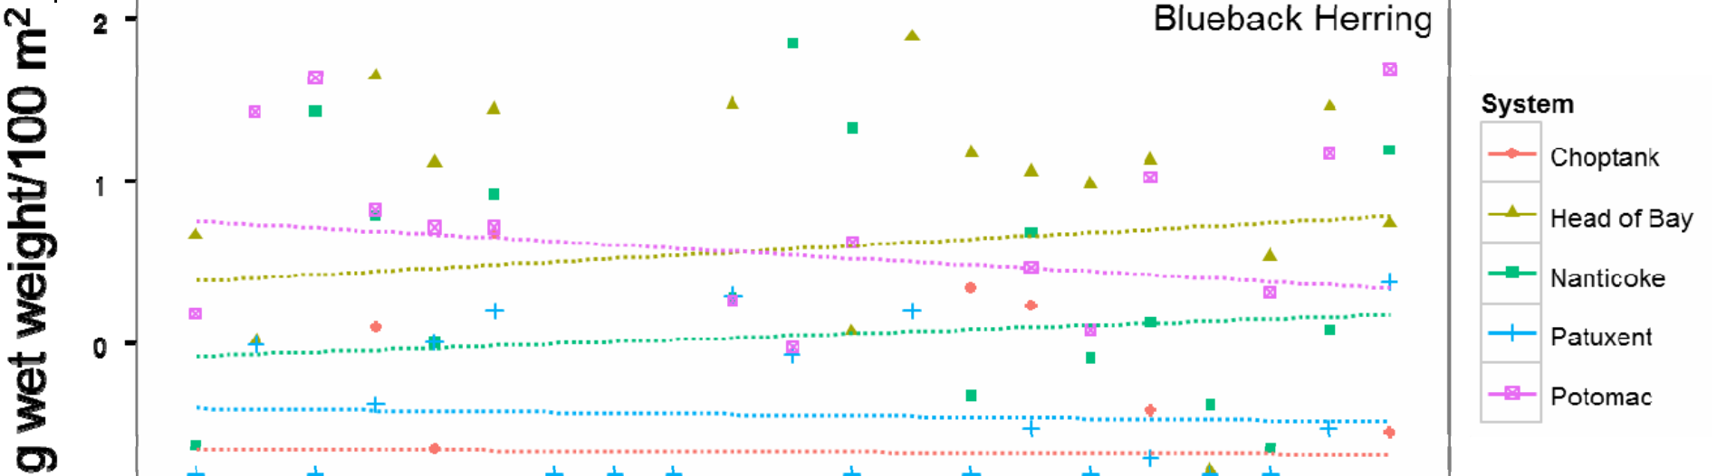
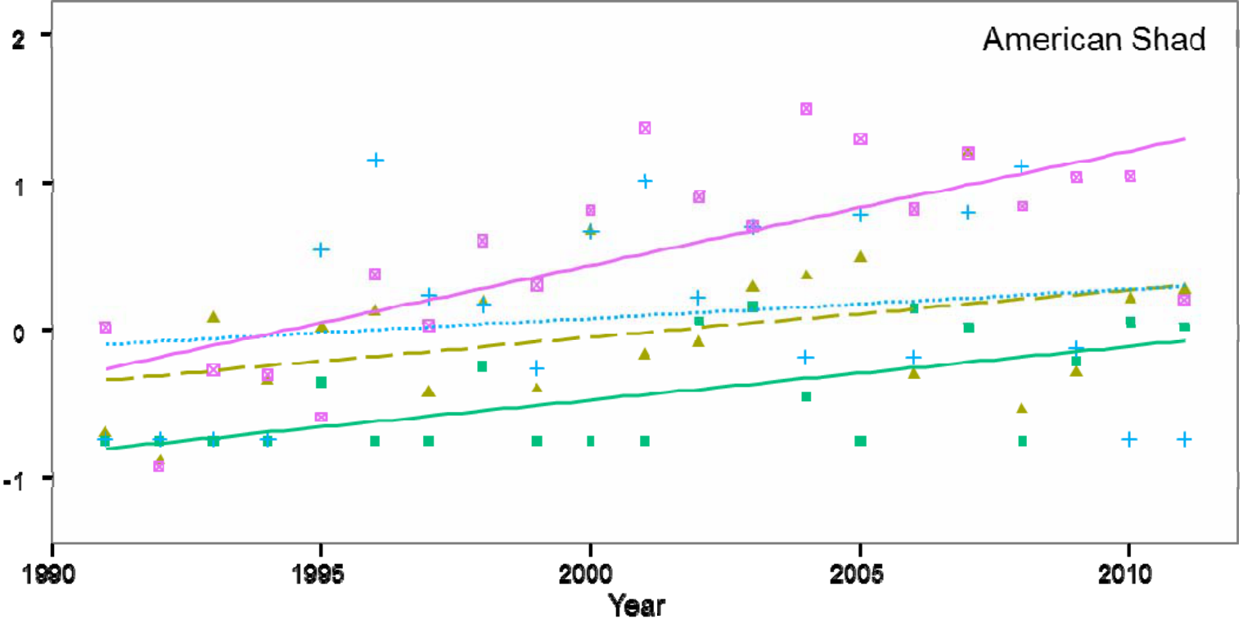
Figure 6. Trends in log10 - transformed biomass of young-of-the-year alosines (alewife, blueback herring, and American shad) for the period 1990 to present. Solid lines represent regressions with p-values ≤ 0.05. Dashed lines indicate regressions are near significant at 0.05 < p ≤ 0.10. Dotted lines are regressions with p > 0.10.
16

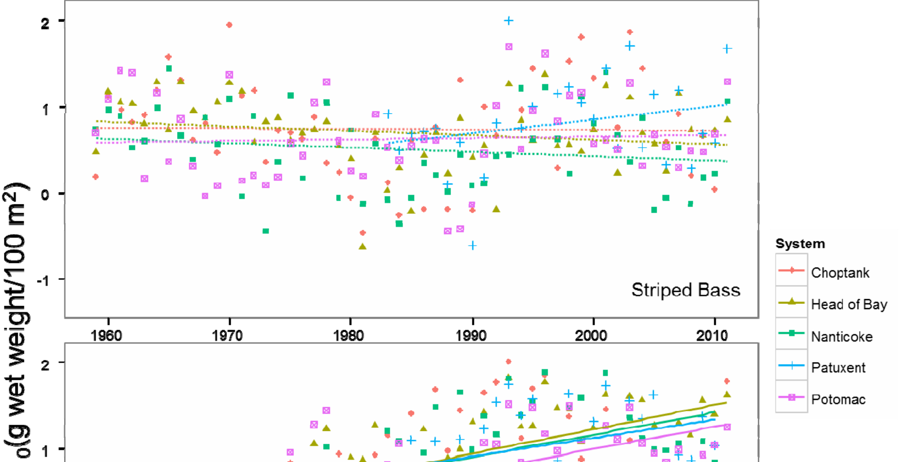
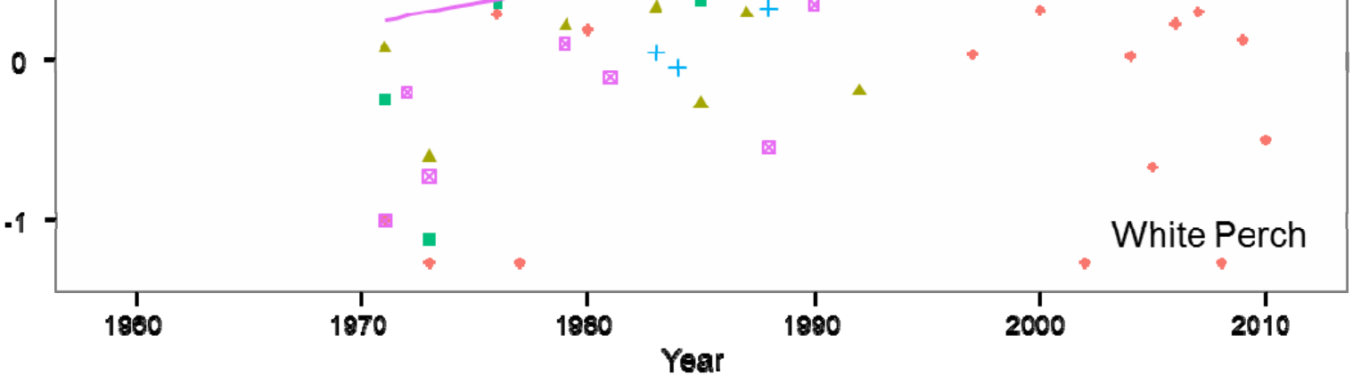
Figure 7. Trends in log10 - transformed biomass of young-of-the-year moronids (striped bass and white perch) for the periods 1957 to present (striped bass) and 1971 to present (white perch). Solid lines represent regressions with p-values ≤ 0.05. Dashed lines indicate regressions are near significant at 0.05 < p ≤ 0.10. Dotted lines indicate regressions with p > 0.10.
Length, growth, and production
Length
The analysis of median lengths in September indicated six significant negative trends (Figure 8, Table 5) and no significant positive trends in length over the survey period. Only YOY striped bass and American shad exhibited significant negative trends in more than one tributary. No significant trends in length were observed for YOY alewife or blueback herring.
17

Growth
There were no strong or consistent trends in growth rates of the YOY
anadromous fishes. Only three close-to-significant trends in August-September growth rates were observed (Table 6). One (white perch, Potomac) was positive and two (white perch, Patuxent and American shad, Potomac) were negative. Trends in growth rates were more variable than trends in median length because too few individuals were collected (<5) in several survey years to provide robust estimates. Additionally, there were many years when small individuals continued to recruit (become available) to the seine gear in September, which resulted in lower or negative estimates of growth rates. We will conduct a modal length progression analysis in the continuation of this research that may provide better and more consistent growth rate estimates.
Table 5. Lengths of YOY anadromous fishes in Chesapeake Bay. Slope, intercept, r2
(%), and regression p-value estimates for the trends in median length in September.
Significant (p ≤ 0.05) trends are in bold. Significant p-values (p ≤ 0.05) are in bold.
Species | System | Slope | Intercept | r2 | p-value
Alewife  Alewife  Alewife  Alewife  Alewife  American shad  American shad  American shad  Blueback herring Blueback herring Blueback herring Blueback herring Blueback herring Striped bass  Striped bass  Striped bass  Striped bass  Striped bass  White perch  White perch  White perch  White perch  White perch | Head of Bay Choptank  Nanticoke  Patuxent  Potomac  Head of Bay Patuxent  Potomac  Head of Bay Choptank  Nanticoke  Patuxent  Potomac  Head of Bay Choptank  Nanticoke  Patuxent  Potomac  Head of Bay Choptank  Nanticoke  Patuxent  Potomac | -0.23  1.03  -0.63  -3.44  -0.61 | 544.86  -1960.46 1337.28 6972.49 1304.77 1493.2  -2288.83 1709.25 119.89  306.79  -261.42  307.08  110.02  89.52  849.03  762.43  1423.79 240.35  79.23  -159.3  55.12  1054.3  14.21 | 2.17  30.13 25.03 76.22 19.95 46.23 39.05 30.20 0.24  5.30  8.75  2.92  0.34  0.24  11.04 15.41 26.81 0.70  0.01  2.39  0.00  17.99 0.31 | 0.615 0.380 0.082 0.127 0.145
 |  | -0.70 |  |  | 0.011
 |  | 1.19 |  |  | 0.133
 |  | -0.81 |  |  | 0.022
 |  | -0.03  -0.12  0.16  -0.12  -0.02  0.00 |  |  | 0.851 0.496 0.305 0.746 0.835 0.976
 |  | -0.38 |  |  | 0.036
 |  | -0.34 |  |  | 0.007
 |  | -0.67 |  |  | 0.005
 |  | -0.08  -0.01  0.12  0.00 |  |  | 0.576 0.947 0.470 0.976
 |  | -0.49 |  |  | 0.024
 |  | 0.03 |  |  | 0.739
18

Figure 8. The six significant, negative trends in September median lengths of YOY anadromous fishes in tributaries and the head of Chesapeake Bay (see Table 5).
median total length (mm) | 125

Table 6. Growth Rates of YOY anadromous fishes in Chesapeake Bay. Slope,
intercept, r2( %), and regression p-value estimates for the trends in growth rates (mm
total length/d)from August to September) over the survey years. No trends were
significant at the p ≤ 0.05 level, although three (Patuxent white perch and Potomac
American shad and white perch) approached the significance level.
System | Species | Slope | Intercept | r2 | p-value
Head of Bay Head of Bay Head of Bay Head of Bay Head of Bay Choptank  Choptank  Choptank  Nanticoke  Nanticoke  Nanticoke  Nanticoke  Patuxent  Patuxent  Patuxent  Patuxent  Potomac  Potomac  Potomac  Potomac  Potomac | Alewife  American shad  Blueback herring Striped bass  White perch  Blueback herring Striped bass  White perch  Alewife  Blueback herring Striped bass  White perch  American shad  Blueback herring Striped bass  White perch  Alewife  American shad  Blueback herring Striped bass  White perch | -0.0211 -0.0065 -0.0005 -0.0031 -0.0020 -0.0031 -0.0040 0.0020 -0.0091 -0.0111 -0.0028 0.0002 -0.0243 -0.0099 -0.0076 -0.0068 0.0044 -0.0094 -0.0053 -0.0055 0.0039 | 42.43  13.42  0.99  6.39  4.24  6.26  8.32  -3.76  18.42  22.29  6.05  -0.26  48.94  20.07  15.49  13.69  -8.54  19.05  10.78  11.28  -7.48 | 18.33 6.01  0.02  3.04  1.34  5.98  1.86  2.22  13.01 15.02 0.76  0.03  27.49 15.21 8.03  13.60 2.86  22.99 4.79  5.55  13.28 | 0.127  0.443  0.954  0.241  0.484  0.526  0.428  0.498  0.306  0.239  0.579  0.924  0.227  0.610  0.152  0.054  0.599  0.052  0.452  0.124  0.052
Net Production
Estimating net production based on the changes in median sizes of YOY fish between August and September indicated a single significant trend (positive for blueback herring, Choptank River) for years in the survey where both abundance and sizes of YOY anadromous fishes were available (Table 7). The difficulties in estimating growth rates (see above paragraph) were magnified in the net production analysis.
20

Table 7. Net Production of YOY anadromous fishes in Chesapeake Bay. Slope,
intercept, r2 (%), and regression p-value estimates for the trends in net production (g wet
weight/m2/d) from August to September over the survey years. Too few American shad
were collected in the Choptank River to estimate production. Significant (p < 0.05)
trends are in bold.
System | Species | Slope | Intercept | r2 | p-value
Bay  Bay  Bay  Bay  Bay  Choptank Choptank Choptank Choptank Choptank Nanticoke Nanticoke Nanticoke Nanticoke Nanticoke Patuxent  Patuxent  Patuxent  Patuxent  Patuxent  Potomac  Potomac  Potomac  Potomac  Potomac | Alewife  American shad  Blueback herring Striped bass  White perch  Alewife  American shad  Blueback herring Striped bass  White perch  Alewife  American shad  Blueback herring Striped bass  White perch  Alewife  American shad  Blueback herring Striped bass  White perch  Alewife  American shad  Blueback herring Striped bass  White perch | -0.00006 -0.00006 0.00021 -0.00002 0.00001 -0.00002 NA | 0.13  0.12  -0.41  0.05  -0.03  0.03  NA  -0.79  -3.69  0.22  0.05  -0.01  1.22  0.09  -0.10  -0.04  0.31  0.03  0.15  0.07  0.16  0.17  -1.88  0.28  0.13 | 0.43  4.55  0.21  0.75  0.14  0.50  NA  24.84 4.52  1.72  2.62  9.14  4.50  5.42  1.05  1.06  10.04 9.96  1.21  0.25  12.30 0.26  2.06  7.14  3.59 | 0.778  0.353  0.844  0.553  0.814  0.766  NA
 |  | 0.00039  0.00187  -0.00011 0.00003  0.000004 0.00061  -0.00005 0.00005  0.00002  -0.00015 -0.00002 -0.00007 -0.00003 -0.00008 -0.00009 0.00095  -0.00010 -0.00007 |  |  | 0.022  0.147  0.414  0.484  0.183  0.356  0.111  0.524  0.658  0.162  0.164  0.570  0.798  0.119  0.825  0.535  0.066  0.236
Centers of abundance
Eight of the eleven significant slopes of trends in the location of the center of abundance of YOY anadromous fishes indicated a down-estuary shift (Table 8). Alewife, in all systems with the exception of in the upper-Bay, experienced substantial down-estuary shifts of 0.16 to 0.60 km year-1 since the beginning of the survey. Shifts in the center of mass that occurred for other species were not consistent, though most up-estuary shifts were not statistically significant. All species had significant down-estuary shifts in the Choptank River, ranging from 0.45 to 0.75 km year-1. Most trends in the upper Bay were up-bay. Since sites sampled by the DNR seine survey include only one or two stations in upper-Bay tributaries, the survey design may be inadequate to detect down-estuary shifts.
21

Table 8. Centers of Abundance of YOY anadromous fishes in Chesapeake Bay. Slope
(river km year-1), intercept, r2 (%), and regression p-value estimates for trends during the
survey years in the annual centers of abundance. Negative slopes indicate a down-
estuary shift in the center of abundance, and positive slope values indicate an up-
estuary shift. Significant (p < 0.05) trends are in bold.
System | Species | Slope | Intercept | r2 | p-value
Head of Bay | Alewife | 0.0614 | 178.50 | 2.10 | 0.2917
Choptank | Alewife | -0.4505 | 936.19 | 19.77 | 0.0022
Nanticoke | Alewife | -0.1666 | 364.25 | 8.17 | 0.0420
Patuxent | Alewife | -0.6044 | 1265.06 | 25.85 | 0.0186
Potomac | Alewife | -0.4539 | 1016.35 | 13.71 | 0.0063
Head of Bay | Blueback Herring | 0.0631 | 176.91 | 1.33 | 0.4151
Choptank | Blueback Herring | -0.5629 | 1161.87 | 30.74 | 0.0001
Nanticoke | Blueback Herring | 0.0239 | -4.15 | 0.28 | 0.7026
Patuxent | Blueback Herring | -0.1079 | 280.35 | 2.76 | 0.5243
Potomac | Blueback Herring | -0.3236 | 775.21 | 17.70 | 0.0015
Head of Bay | American Shad | 0.0290 | 246.99 | 1.01 | 0.5106
Nanticoke | American Shad | 0.1176 | -188.09 | 7.84 | 0.1145
Patuxent | American Shad | -0.2092 | 482.13 | 10.84 | 0.2307
Potomac | American Shad | -0.0449 | 225.17 | 0.78 | 0.5508
Head of Bay | Striped bass | -0.0228 | 341.91 | 0.43 | 0.6269
Choptank | Striped bass | -0.4486 | 925.96 | 30.33 | <0.0001
Nanticoke | Striped bass | 0.0055 | 18.62 | 0.02 | 0.9124
Patuxent | Striped bass | -0.0562 | 162.85 | 0.24 | 0.7955
Potomac | Striped bass | 0.3620 | -617.81 | 8.62 | 0.0267
Head of Bay | White perch | 0.1535 | -1.70 | 17.21 | 0.0016
Choptank | White perch | -0.7541 | 1542.72 | 57.74 | <0.0001
Nanticoke | White perch | 0.0445 | -51.05 | 0.88 | 0.4952
Patuxent | White perch | -0.2216 | 497.88 | 6.84 | 0.1551
Potomac | White perch | 0.2858 | -449.54 | 7.91 | 0.0376
Principal components analyses
Some common patterns were detected by the principal components analyses (PCA). The first two principal components (PCs) captured between 39.6% and 46% of the variance (Figures 9-13). As expected, there were positive correlations in each tributary between freshwater flow and nutrients in both spring and summer. The abundances of YOY anadromous fishes were generally positively correlated with freshwater flow and loaded highly on PC1, indicating that freshwater flow and nutrients were important sources of variability in the data. Additionally, there were temporal
22

trends in all five tributaries, due in part to the abundance trends of anadromous fishes during the survey period (described above). However, there also were some
differences in the patterns among tributaries. The definitions of variables in the PCA are provided in Table 9.
Table 9. Definitions of the variable abbreviations in Figures 5-9.
Variable | Definition | Variable | Definition
am | Atlantic menhaden density | sp.chla | spring chlorophyll a
as | American shad density | sp.do | spring dissolved oxygen
aw | alewife density | sp.no23f | spring nitrite + nitrate
bb | blueback herring density | sp.ph | spring pH
sb | striped bass density | sp.po4 | spring phosphate
wp | white perch density | sp.salt | spring salinity
amcent | Atlantic menhaden center of abundance | sp.temp | spring water temperature
ascent | American shad center of abundance | su.chla | summer chlorophyll a
awcent | alewife center of abundance | su.do | summer dissolved oxygen
bbcent | blueback herring center of abundance | su.no23f | summer nitrite + nitrate
sbcent | striped bass center of abundance | su.ph | summer pH
wpcent | white perch center of abundance | su.po4 | summer phosphate
sp.flo | spring freshwater flow | su.salt | summer salinity
su.flo struct | summer freshwater flow taxable structure count | su.temp | summer water temperature
Upper Bay
In the upper Bay, spring and summer flows, spring (N and P) and summer (N) nutrients, and YOY anadromous fish abundances were positively correlated and loaded highly on PC1 (Figure 9). However, the center of abundance for the alosines loaded on PC2, indicating that the centers of abundance for alosines were uncorrelated with their abundances. The center of abundance for striped bass also loaded on PC2 but was negatively correlated with the centers of abundance for the alosines. The center of abundance for white perch was negatively correlated with white perch abundance, suggesting that the center of abundance for white perch shifts down-estuary in years of higher abundance. The temporal trend for the upper Bay oriented along PC1, indicating that spring and summer flows, spring and summer nutrient levels, and abundances of YOY anadromous species generally increased from 1985 until 2003. Since 2004, PC1 scores have tended to shift back toward negative values similar to those in the late 1980s.
23

Choptank River
YOY striped bass and white perch abundances were positively correlated with spring and summer flows and spring (N and P) and summer (N) nutrient levels (Figure 10). However, alewife abundance was negatively correlated with those variables. The center of abundance for striped bass shifted down-estuary in years of higher striped bass abundance while the center of abundance of white perch tended to move up-estuary with increasing white perch abundance. The temporal trend for the Choptank River progressed from the lower left hand corner of Figure 10 to the upper right hand corner, toward conditions of higher summer nutrient levels, higher summer water temperature, and increasing numbers of taxable structures.
17.1% | 0.4 | -4 | -2 | PC1 scores 0 | 2 | 4 | 4 | PC2 scores

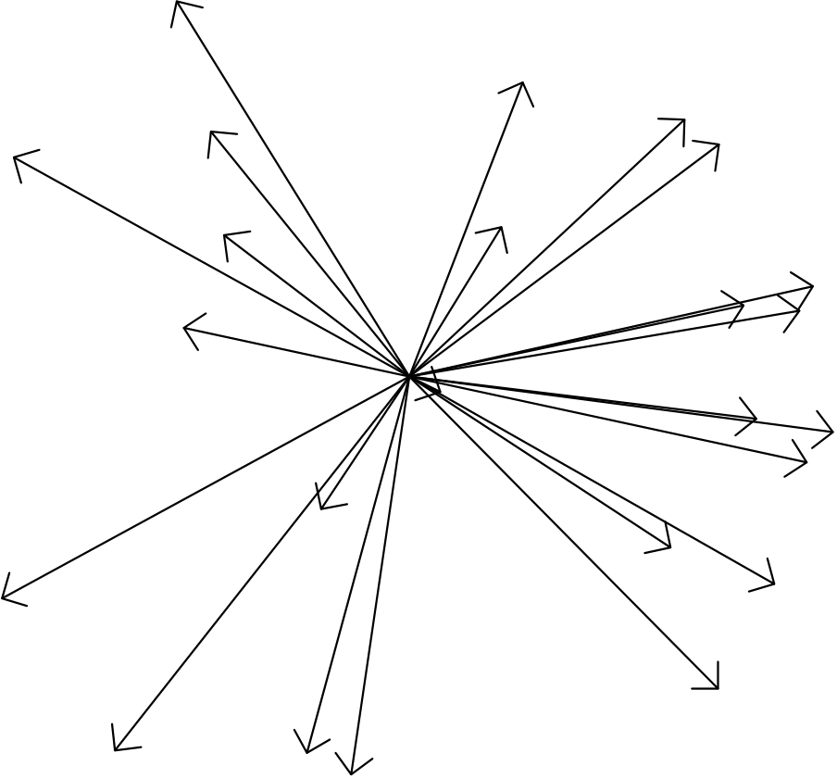
PC1 scores
17.2% | 0.4 | -4 | -2 | 0 | 2 | 4 | 4 | PC2 scores
Choptank | 02 | 06 | later years
sp.salt
09
su.po4f
su.salt | sp.temp |  |  | su.ph | 89  su.temp |  | 07 00 | 05 | struct  wpcent
 | sp.ph |  |  |  |  |  |  |  | 01 | 03
92 | 99 08 |  |  |  | 04 |  |  |  | su.flo  bb su.no23f
 | 85 | sbcent | 95
 |  |  |  |  |  |  |  |  | am | wp
 | 86 |  |  |  | sp.chla
 | 88 | 91
 |  |  |  |  |  |  |  |  | sb
aw | 87 |  |  |  | 93
 |  |  |  |  |  |  |  |  | sp.po4f
 |  |  |  |  | 90 | 98 |  |  | sp.flo
sp.no23f
su.do  early years | sp.do su.chla 97 | 94 | 96

 | 0.2 |  |  |  |  |  | 2
PC2 loadings | 0.0 |  |  |  |  |  | 0
 | -0.2 |  |  |  |  |  | -2
 | -0.4 |  |  |  |  |  | -4
 |  | -0.4 | -0.2 | 0.0 | 0.2 | 0.4
 |  | PC1 loadings |  |  | 28.8%
Figure 10. Principal components analysis biplot for the Choptank River. The numbers
indicate the years of the observations. See Table 9 for abbreviations of variables.
Nanticoke River
The Nanticoke River exhibited fewer patterns than observed in the other
tributaries (Figure 11). Flow and nutrients were correlated during each season, but abundances of YOY anadromous fishes were either uncorrelated or negatively
correlated with flow and nutrients. The center of abundance for each species was negatively correlated with flow indicating down-estuary shifts with increased flow. The temporal pattern for the Nanticoke River was oriented from the upper left hand corner of Figure 11 to the lower right hand corner, which signified a shift from high summer DO and chlorophyll a levels toward higher summer flow levels, nutrient concentrations, and taxable structure counts.
25

PC1 scores
15.5% | 0.4 | -4 | -2 | 0 | 2 |  | 4 | 4 | PC1 scores
early years |  |  |  |  | 09 | 94 | Nanticoke
su.do su.chla |  |  |  |  |  | 98
97 90 |  |  |  |  |  | sp.po4f |  | sp.flo
sbcent |  |  |  |  |  | 96
su.ph |  |  | 93 |  |  | 89 |  |  | sp.no23f
bb
am
wpcent awcent sp.do 86 99 |  | wp  amcent 87 | bbcent | 07 |  | su.po4f 05 |  |  |  | su.flo  su.no23f
92
su.salt | sp.chla 88  95 |  | sp.temp su.temp aw  sb
sp.ph |  |  | 00
 |  |  |  |  |  | 03
08 |  |  |  |  |  | struct | 04  01
sp.salt |  |  |  |  | 06
 |  |  |  |  |  | later years
02

the upper right hand corner, indicating a reduction in spring and summer nutrients since the mid-1980s and an increase in taxable structures.
PC1 scores
16.1% | 0.4 | -4 | -2 | 0 | 2 |  | 2 | PC2 scores
Patuxent | 02 | 99 | 06 08 |  |  | later years
sbcent |  |  |  |  |  | struct
 |  |  |  |  |  | ascent
su.salt
sp.temp sp.salt | su.temp | 92 | 09 |  |  | as
wpcent |  |  | awcent | 07 | 01
91  su.chla |  |  |  |  |  | bbcent
 |  |  | 95
 |  |  |  |  |  | 05
87 | amcent |  | 97
 |  |  | sp.chla | 04
am
 |  |  | 00
86 |  | 90 | 94 |  |  | sb  wp | su.flo 03
sp.po4f  su.po4f | 88 |  | sp.ph su.ph | 98
 |  |  | 93 |  |  | sp.flo
85
sp.no23f
 |  |  | aw
 |  |  | bb |  |  | 96
su.no23f | su.do
 |  |  | sp.do 89
early years

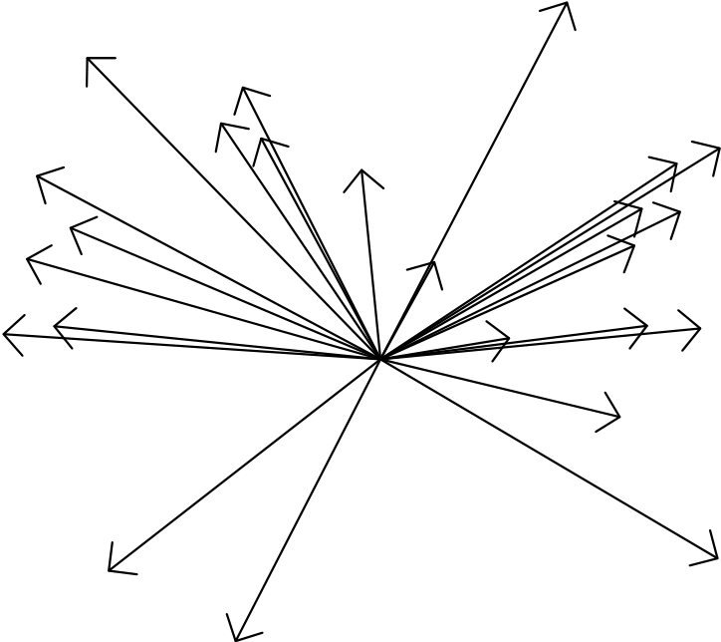
correlated with their centers of abundance, which indicated that the centers of abundance shifted down-estuary in years of higher abundance. The temporal pattern was oriented along PC1 and reflected the increasing trend in abundance of YOY anadromous fishes.
PC1 scores
12.9% | 0.4 | -4 | -2 | 0 | 2 | 4 | 4 | PC1 scores
 |  |  |  |  | 10 |  |  | P | o | tomac
 | s | s
 |  |  | arly yea wpcent 85 | s | awcent  sp.temp su.temp | su.c | h | la  su.ph
 | e | e
 | s | u | sbcent  bbcent am 86 .salt ascent 9 | 1 | sp.ch  08 | la 97 95 93  00 aw  99  bb |  | wp  98  sp.ph su.do  sp.flo  sp.do sb |  | years
 |  |  | 88 87 |  | 90  02  92 | 05  01 07 04 |  | as |  | 96 later
 |  |  | sp.salt |  | amcent 06 89 09 | 9 |  |  | 0 | 3

Comp. 2 PC2 loadings | 0.2 |  |  |  |  |  | 2
 | 0.0 |  |  |  |  |  | 0
 | -0.2 |  |  |  |  |  | -2
 | -0.4 |  |  |  |  |  | -4
 |  | -0.4 | -0.2 | 0.0 | 0.2 | 0.4
 |  | PC1 loadings |  |  |  | 26.7%
Figure 13. Principal components analysis biplot for the Potomac River. The numbers
indicate the years of the observations. See Table 9 for abbreviations of variables.
28

Strategy and plan for remaining analyses
Analyses that we conducted with support from the NOAA Chesapeake Bay Office evaluated trends in abundance, biomass, length, growth, production, and spatial distribution of YOY anadromous fishes. Under the continuing contract from Maryland DNR and ASMFC, we are analyzing abundance trends and patterns of the YOY anadromous fishes and other species (e.g., Atlantic menhaden) to document inter-annual variability, analyze its causes, and evaluate effects of variability in abundance on sizes and growth rates of the YOY anadromous fishes. In an extension of analyses completed to date, abundances of YOY and age-1+ fish of all common species in the DNR seine survey will be included in our principal components analysis. Water quality, zooplankton prey abundance, and benthic prey abundance data from the Chesapeake Bay Program will be included in our multivariate analyses to identify and quantify drivers of interannual variability in growth and production of YOY anadromous fishes.
REFERENCES
Carlisle, D. M. M. R. Meador, T. M. Short, C. M. Tate, M. E. Gurtz, W. L. Bryant, J. A.
Falcone and M. D. Woodside. 2013. The quality of our Nation’s waters- -Ecological health in the Nation’s streams, 1993-2005. U.S. Geological Survey, Circular 1391. (http://pubs.usgs.gov/circ/1391/)
Cronin, T. M. and C. D. Vann. 2003. The sedimentary record of climatic and anthropogenic influence on the Patuxent Estuary and Chesapeake Bay ecosystems. Estuaries 26:196-209.
Hagy, J. D., W. R. Boyton, C. W. Keefe, and K. V. Wood. 2004. Hypoxia in
Chesapeake Bay, 1950-2001: Long-term changes in relation to nutrient loading and river flow. Estuaries, 27, 634–658.
Kemp, W. M. and 17 coauthors. 2005. Eutrophication of Chesapeake Bay: historical trends and ecological interactions. Marine Ecology Progress Series 303:1-29.
Kraus, R. T. and D. H. Secor. 2005. Connectivity in estuarine white perch populations of Chesapeake Bay: evidence from historical fisheries data. Estuarine, Coastal, and Shelf Science 64:108-118.
Martino, E. J. and E. D. Houde. 2010. Recruitment of striped bass in
Chesapeake Bay: spatial and temporal environmental variability and availability of zooplankton prey. Marine Ecology Progress Series 409:213-228.
Martino, E. J. and E. D. Houde. 2012. Density-dependent regulation of year-class strength inage-0 juvenile striped bass (Morone saxatilis). Canadian Journal of Fisheries and Aquatic Science 69:430-446.
29

McGinty, M., J. Uphoff, R. Lukacovic, J. Mowrer, and B. Pyle. 2006. Development of habitat based reference points for Chesapeake Bay fishes of special concern: impervious surface as a test case. Chesapeake Bay Finfish/Habitat
Investigations 152006, Project 3. Maryland Department of Natural Resources, Annapolis, Maryland.
North, E. W. and E. D. Houde. 2001. Retention of white perch and striped bass larvae: biological-physical interactions in Chesapeake Bay Estuarine Turbidity Maximum. Estuaries 24:756-769.
North, E. W. and E. D. Houde. 2003. Linking ETM physics, zooplankton prey, and fish early-life histories to striped bass Morone saxatilis and white perch M.
americana recruitment. Marine Ecology Progressive Series 260:219-236.
North, E. W. and E. D. Houde. 2006. Retention mechanisms of white perch
(Morone americana) and striped bass (Morone saxatilis) early-life stages in an estuarine turbidity maximum: an integrative fixed-location and mapping approach. Fisheries Oceanography 15:429-450.
Prasad, M. B. K., M. R. P. Sapiano, C. R. Anderson, W. Long, and R. Murtugudde. 2010. Long-term variability of nutrients and chlorophyll in the Chesapeake Bay: a retrospective analysis, 1985-2008. Estuaries and Coasts 33:1128-1143.
Schaaf, W. E., D. S. Peters, L. Coston-Clements, D. S. Vaughan, and C. W. Krause. 1993. A simulation model of how life history strategies mediate pollution effects on fish populations. Estuaries 16:697-702.
Testa, J. M., W. M. Kemp, W. R. Boynton, and J. D. Hagy. 2008. Long-term changes in water quality and productivity in the Patuxent River Estuary: 1985-2003. Estuaries and Coasts 31:1021-1037.
Uphoff, J., 2008. Identifying priority areas for protection and restoration: Chesapeake Bay striped bass spawning and larval nursery area as a model. Fisheries Tech. Rep. Series, Number 52. Maryland Department of Natural Resources, Fisheries Service, Stevensville, MD.
Uphoff, J., M. McGinty, R. Lukacovic, J. Mowrer, and B. Pyle. 2007. Development of habitat based reference points for Chesapeake Bay fishes of special concern: impervious surface as a test case. Chesapeake Bay Finfish/Habitat
Investigations 2006, F-61-R-1, Project 3.Maryland Department of Natural Resources, Annapolis, Maryland.
Uphoff, J., M. McGinty, R. Lukacovic, J. Mowrer, and B. Pyle. 2011. Impervious surface, summer dissolved oxygen, and fish distribution in Chesapeake Bay subestuaries: Linking watershed development, habitat conditions, and
30

fisheries management. North American Journal of Fisheries Management 31:554-566.
USGS (United States Geological Survey). 2012. USGS surface-water monthly statistics for the nation.
http://waterdata.usgs.gov/nwis/monthly/?referred_module=sw. Accessed 22 June 2012.
Williams, M. R., S. Filoso, B. J. Longstaff, W. C. Dennison. 2010. Long-term trends of water quality and biotic metrics in Chesapeake Bay: 1986-2008. Estuaries and Coasts 33:1279-1299.
Wood, R. J. and H. M. Austin. 2009. Synchronous multidecadal fish recruitment patterns in Chesapeake Bay, USA. Canadian Journal of Fisheries and Aquatic Science 66:496-508.
PRODUCTS
A. Presentations (since October 2011)
Houde, E. D. and W. J. Connelly. 2012. A retrospective analysis of spatial and temporal patterns of growth and abundance of juvenile anadromous fishes in the Maryland Chesapeake Bay. NOAA Chesapeake Bay Office Fisheries Science Rollout Edgewater, MD. January, 2012.
Houde, E. D. 2012. Forage fishes and YOY anadromous fishes in Chesapeake Bay: causes of variability in abundance. Invited presentation. Fisheries Goal
Implementation Team, Chesapeake Bay Program, Port Isobel, VA. 7 December 2012.
Lozano, C. and E. D. Houde. 2013. Offshore growth of Atlantic menhaden larvae
before entering Chesapeake Bay. American Fisheries Society, Tidewater
Chapter, Annual Meeting, Solomons, MD. 22 March 2013.
O’Brien, M. H. P., A. N. Atkinson and D. H. Secor. 2013. Preconditioning of summer
juvenile fish assemblage by winter conditions in a temperate estuary. American
Fisheries Society, Tidewater Chapter, Annual Meeting, Solomons, MD. 22
March 2013.
31

Personnel
The Principal Investigator is Dr. E. D. Houde. The principal scientist involved was Dr. W. J. Connelly, Assistant Research Scientist. Dr. Connelly left UMCES in October 2012 to take a new position with the Federal Energy Regulatory Commission. C. Lozano and M. O’Brien provided technical assistance.
32

