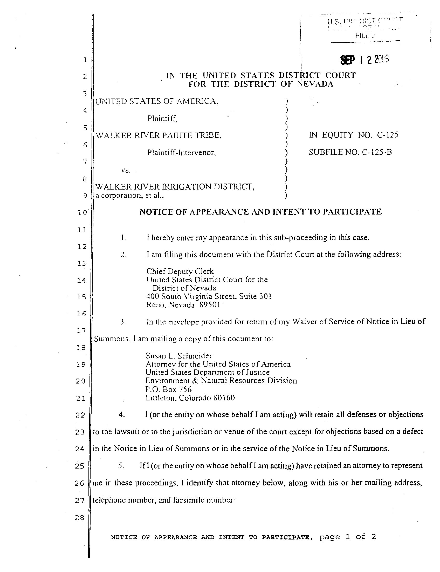
Case 3:73-cv-00127-RCJ-WGC Document 979 Filed 09/12/06 Page 1 of 2

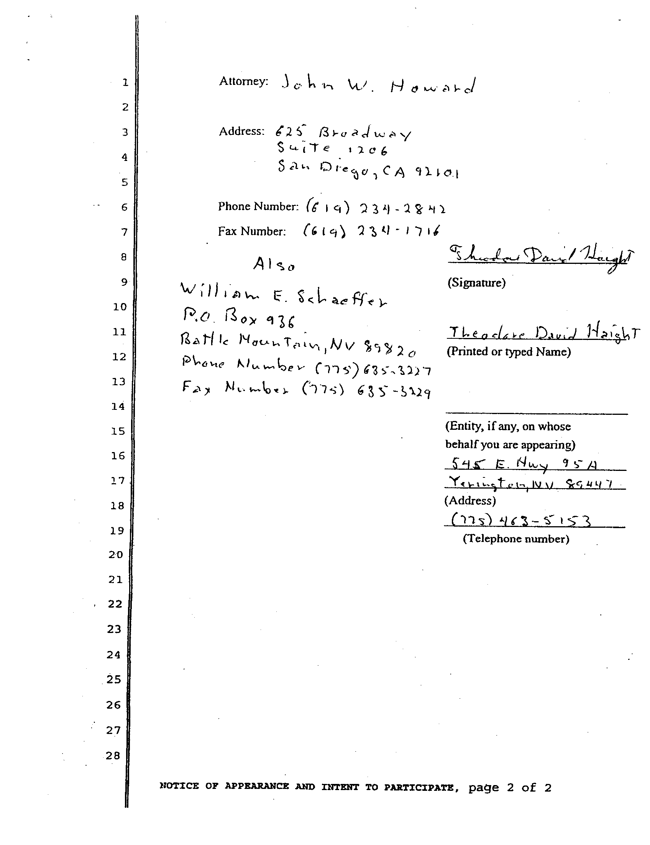
Case 3:73-cv-00127-RCJ-WGC Document 979 Filed 09/12/06 Page 2 of 2

