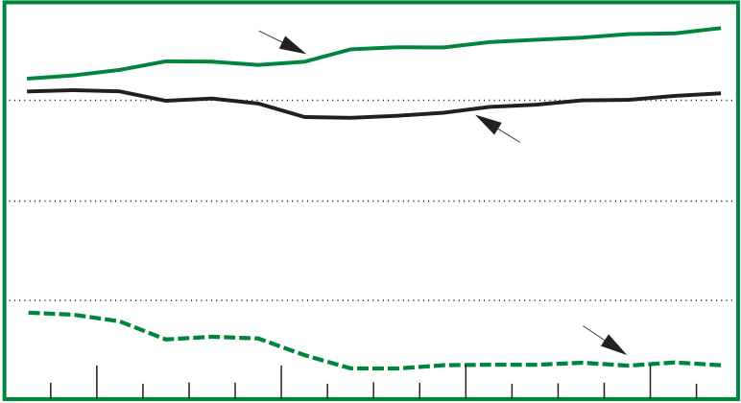
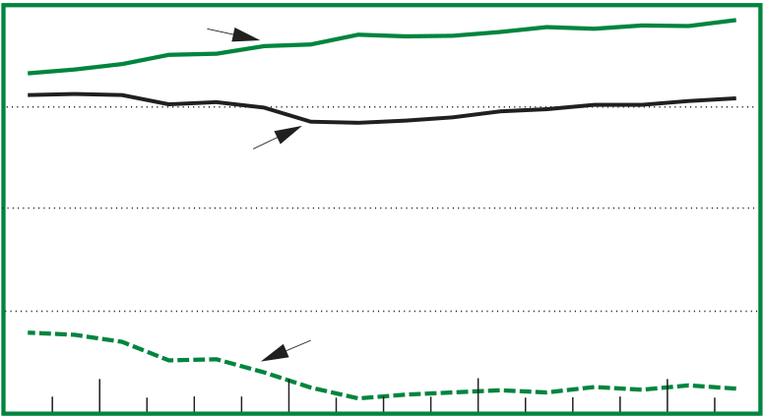
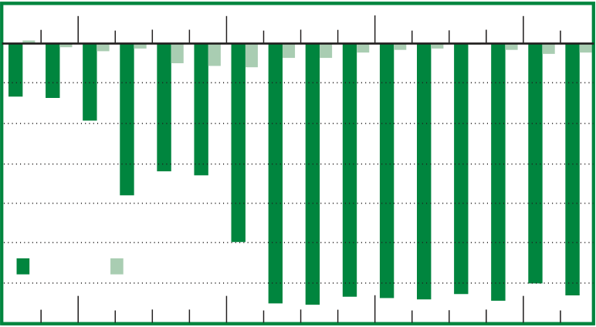
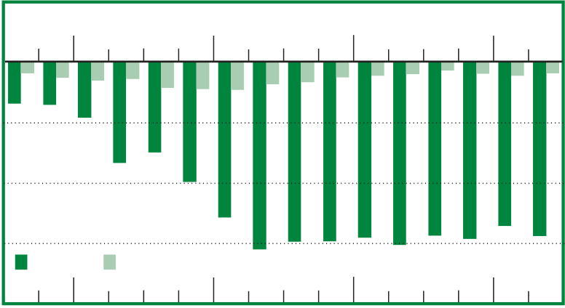
September 2011 11
Government Receipts and Expenditures
Second Quarter of 2011
Chart 1. Governm ent Fiscal P osition

Table 1. Net Government Saving and Net Lending or Net Borrowing [Billions of dollars, seasonally adjusted at annual rates]
 | Level | Change from preceding quarter
 | 2011 | 2010 |  | 2011
 | II | III | IV | I | II
Current receipts ................................  Current expenditures ........................  Net government saving .................. Federal .......................................... State and local...............................  Net lending or net borrowing (–) ... Federal .......................................... State and local............................... | 4,157.0  5,470.0  –1,313.0 –1,264.4 –48.6  –1,529.3 –1,435.6 –93.7 | 88.4  45.2  43.3 20.3 23.0  109.3 78.4 30.9 | 9.6  69.4  –59.9 –29.6 –30.3  –55.1 –28.4 –26.7 | 81.0  16.5  64.5 86.2 –21.7  88.4 106.4 –18.0 | 51.0  105.7  –54.7 –63.3 8.6  –62.8 –82.8 20.0
Raymen Labella prepared this article.

Current Receipts, Current Expenditures, and Net Government Saving Billions of dollars
6,000 | Current expenditures
4,000
Current receipts
2,000
0 | Net governm ent saving
–2,000
2007  Net Saving  Billions of dollars |  | 2008 | 2009 | 2010 | 2011
200  0  –200  –400  –600  –800  –1,000 –1,200 –1,400 | Federal State and local
 | 2007 | 2008 | 2009 | 2010 | 2011
Total Receipts,Total Expenditures, and Net Lending or Borrowing
Billions of dollars
6,000
–2,000
2,000
0
T otal expenditures
T otal receipts
Net lending or borrowing
4,000
2007 2008 2009 2010 2011
Net Lending or Net Borrowing
Billions of dollars
500
0
–500
–1,000
–1,500 |  |  |  | 2010 | 2011
Federal |  | State and local
–2,000 | 2007 | 2008 | 2009
N O TE. All estimates are seasonally adjusted at annual rates.
U .S. Bureau of Economic Analysis

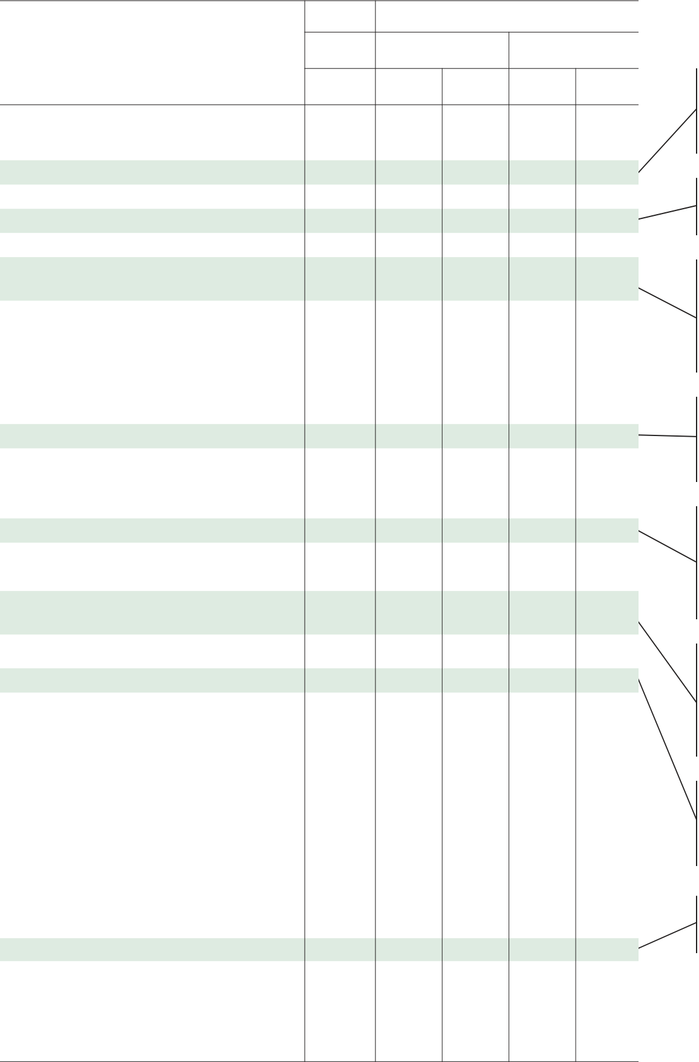
12 | Government Receiptsand Expenditures | September 2011

Federal Government
Table 2. Federal Government Current Receipts and Expenditures
Level Change from preceding quarter
2011 2010 2011
II III IV I II
Gross government investment decreased less, reflect­
ing an upturn in defense equipment and software.
Federal Government Estimates
3.4–3.8, 3.12, and 3.13. Detailed quarterly estimates are available in underlying NIPA tables at www.bea.gov/ national/nipaweb/nipa_underlying/Index.asp.
Each year, BEA translates the information in the federal
budget into a NIPA framework.1 For a historical time series
of these estimates, see NIPA table 3.18B, which is scheduled
to be published in the October 2011 SURVEY.

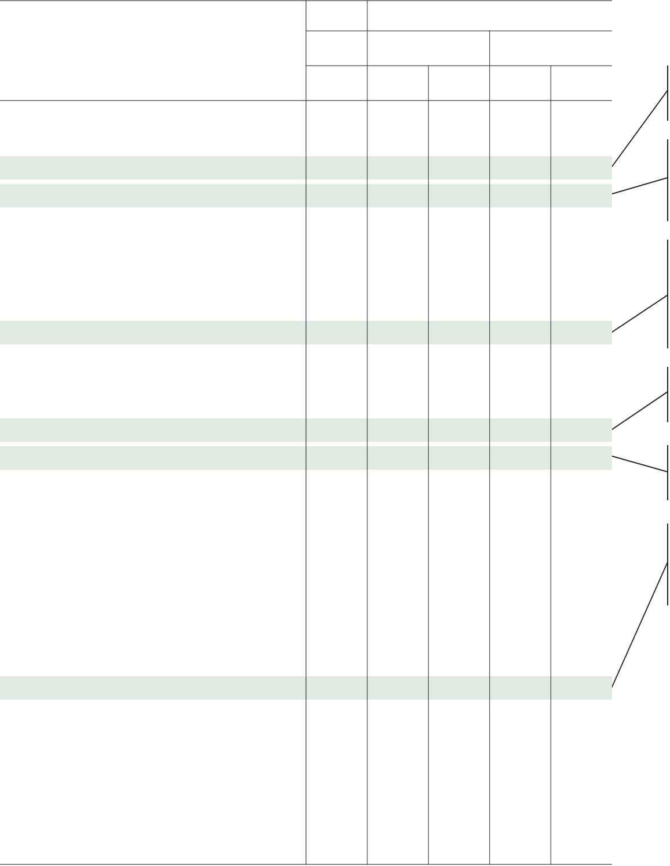
September 2011 | SURVEY OF CURRENT BUSINESS | 13

State and Local Government
Table 3. State and Local Government Current Receipts and Expenditures
Level Change from preceding quarter
2011 2010 2011
II III IV I II
Estimates of State and Local Government Receipts and Expenditures
annually in NIPA tables 3.4–3.8, 3.12, and 3.13. Detailed quarterly estimates are available in underlying NIPA tables at www.bea.gov/national/nipaweb/nipa_underlying/

