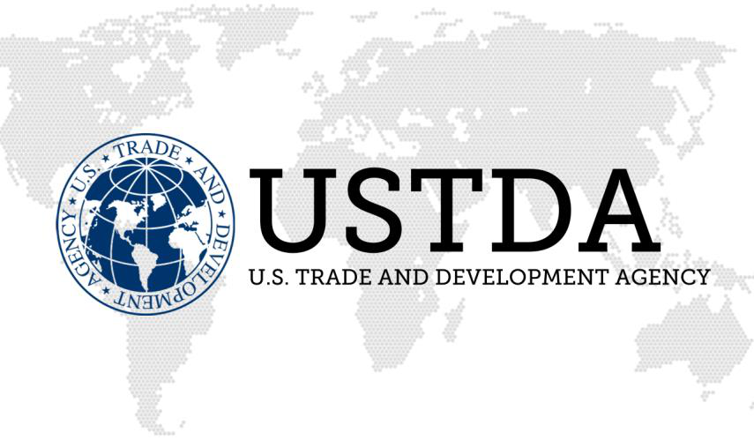 | China  Linking U.S. Businesses to  Global Infrastructure Opportunities

w w w. u s t d a . g o v

The U.S. Trade and Development Agency helps companies create U.S. jobs through the export of U.S. goods and services for priority development projects in emerging economies. USTDA links U.S. businesses to export opportunities by funding project planning activities, pilot projects, and reverse trade missions while creating sustainable infrastructure and economic growth in partner countries.
USTDA in China  USTDA's program in China focuses on advancing U.S. policy and U.S. industry trade and commercial interests in the transportation, energy, agriculture, and healthcare sectors. These efforts help open China’s market for increased exports of U.S.-manufactured goods.  The Agency’s success in China is due in part to the public-private Cooperation Programs that are the hallmark of USTDA’s programs in country. These programs provide a forum for government agencies and private companies from both countries can share technical, policy, and commercial knowledge relevant to a specific field. USTDA has successfully established programs based on this model in the aviation, energy, agriculture and healthcare sectors.  By adapting to the evolving needs of China’s market and closely coordinating with Chinese decision makers, these public-private partnerships have achieved long-term Specifically, the partnerships are providing success.  increased market access for U.S. companies and advancing U.S. policy interests including climate change and aviation safety and security.  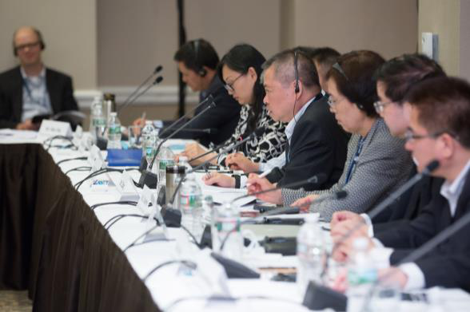  In 2016, USTDA conducted 9 reverse trade missions to introduce Chinese public and private sector officials to U.S. best practices and advanced technology solutions. | Implementing Climate Change Policy Goals  One of USTDA’s primary goals in China is to take bilateral  policies and move them toward implementation. For example,  at the 2016 U.S.-China Strategic & Economic Dialogue in  Beijing, USTDA announced several new activities that  promote public-private collaboration to address climate  change. One initiative will reduce emissions from seaports in  China while another will demonstrate big data technologies  for smarter grids and greater integration of renewable energy.  USTDA also announced eight workshops and two study tours  that will focus on electric vehicles, promoting environmental  protection technologies for shale gas, and reducing nitrogen  oxide from gas-fired boilers.  At the 2ndU.S.-China Climate Leaders’ Summit in Beijing, two  contracts were signed launching USTDA-supported projects.  The Agency is partnering with the Beijing Environmental  Protection Bureau and Kansas-based firm, Power Flame, to  pilot technologies that will lower nitrogen oxide (NOx)  emissions from gas-fired boiler sites across Beijing.  The other program will develop and demonstrate a new  model for smart grid information and communication  integration for State Grid Corporation of China (SGCC).  USTDA is partnering with California-based firm, OSIsoft, and  the China Power Electric Research Institute (CEPRI), on this  innovative initiative.  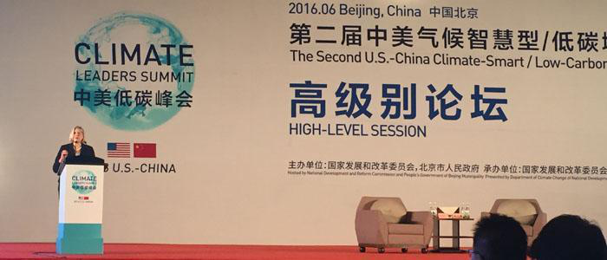  Director Leocadia I. Zak delivers remarks at the 2nd U.S.-China  Climate Leaders’ Summit.

 | China  Linking U.S. Businesses to  Global Infrastructure Opportunities

w w w. u s t d a . g o v

Leveraging Partnerships for Win-Win Results  Aviation Cooperation Program (ACP): The U.S.-China Aviation Cooperation Program (ACP) promotes aviation sector-wide cooperation. Endorsed by the U.S. Federal Aviation Administration and the Civil Aviation Administration of China, ACP works cooperatively to design programs that promote technical, policy and commercial collaboration.  USTDA partners with the ACP in several key areas, including executive leadership development training programs, technical assistance aimed at reducing flight delays, advancing general aviation, and reducing the environmental footprint of the aviation sector. Now in its 12thphase with over 40 U.S. industry members and 6 public sector partners, the ACP has provided executive and safety management training for over 1,500 Chinese aviation officials.  Energy Cooperation Program (ECP): The U.S.-China Energy Cooperation Program (ECP) promotes the development and commercialization of clean energy and energy efficiency solutions. USTDA has supported a number of projects under the ECP focused on developing clean energy technologies such as smart grid, natural gas, energy efficiency, fuel cells, and distributed energy combined heat and power.  The U.S.-China ECP has expanded membership to over 25 U.S. companies across 10 subsector working groups. To support ECP and promote clean energy development in China, USTDA has funded a number of reverse trade missions, pilot projects, feasibility studies, technical assistance programs, and workshops for Chinese public and private sector leaders.  Healthcare Cooperation Program (HCP): The HCP focuses on improving healthcare delivery by connecting industry and government resources to promote health system development, cooperation, and trade between the U.S. and China. The HCP has over 30 U.S. industry and 9 non-governmental members. USTDA supports HCP by partnering with U.S. universities and hospitals, alongside HCP member companies to host executive training programs in the United States and workshops in China.  Agriculture & Food Partnership (AFP): The U.S.-China Agriculture & Food Partnership (AFP) is a public-private partnership that aims to enhance U.S.-China agricultural cooperation. USTDA supports the AFP by acting as an advisor and supporting workshops and reverse trade missions in the agribusiness, cold chain, and food safety sectors in China. In addition, USTDA is launching a fourth phase of its Agricultural Biotechnology Training Program. This training will bring the public and private sectors together to discuss new advances in agricultural biotechnology.  Standards & Conformity Assessment: USTDA has partnered with the private sector in organizing over 60 workshops covering a wide range of sectoral topics related to standards harmonization, conformity assessment programs, and technical regulations that impact U.S. industry in China. | 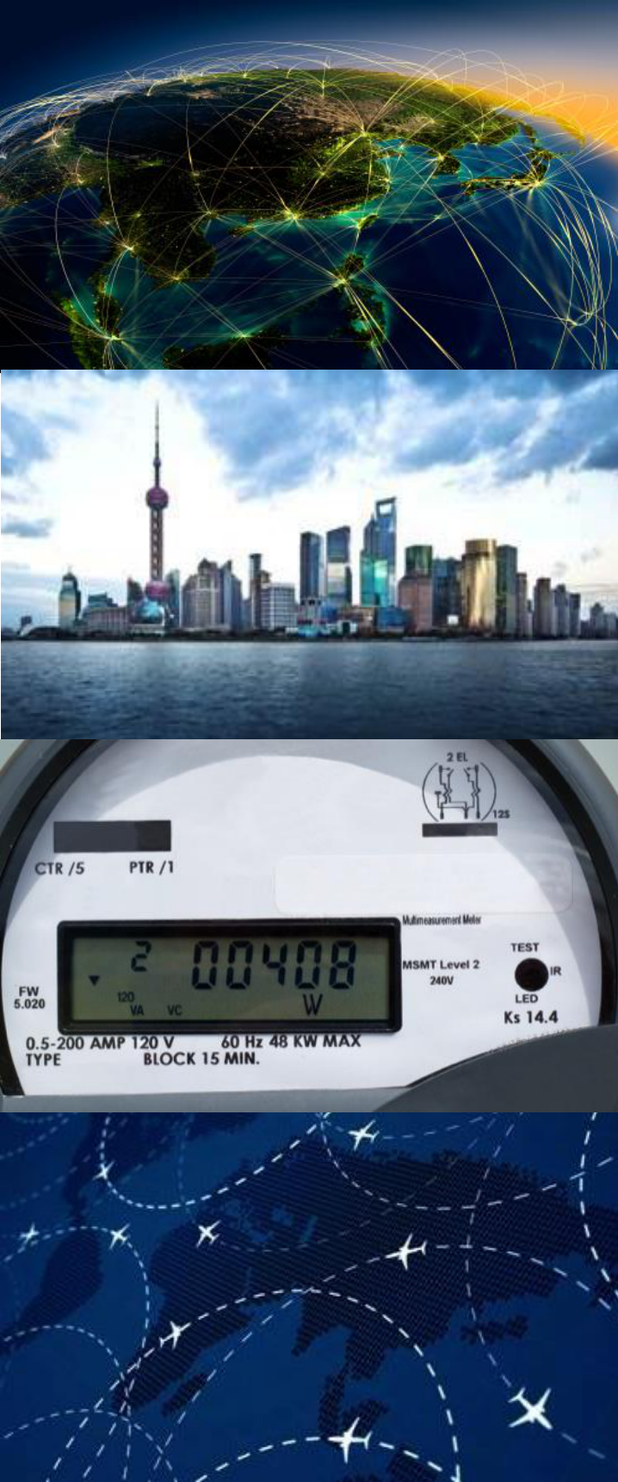  
Contact us for more information:
E-mail: East_Asia@ustda.gov Phone: 703-875-4357

Carl B. Kress – East Asia Regional Director
Verinda Fike – East Asia Country Manager
Susan Shifflett – East Asia Country Manager
Steve Winkates – Director of Program Management, U.S. Embassy Xiaolei Wan – USTDA China Representative

Connect with USTDA

twitter.com/USTDA

facebook.com/USTDA

youtube.com/USTDAvideo

flickr.com/USTDAphotos

