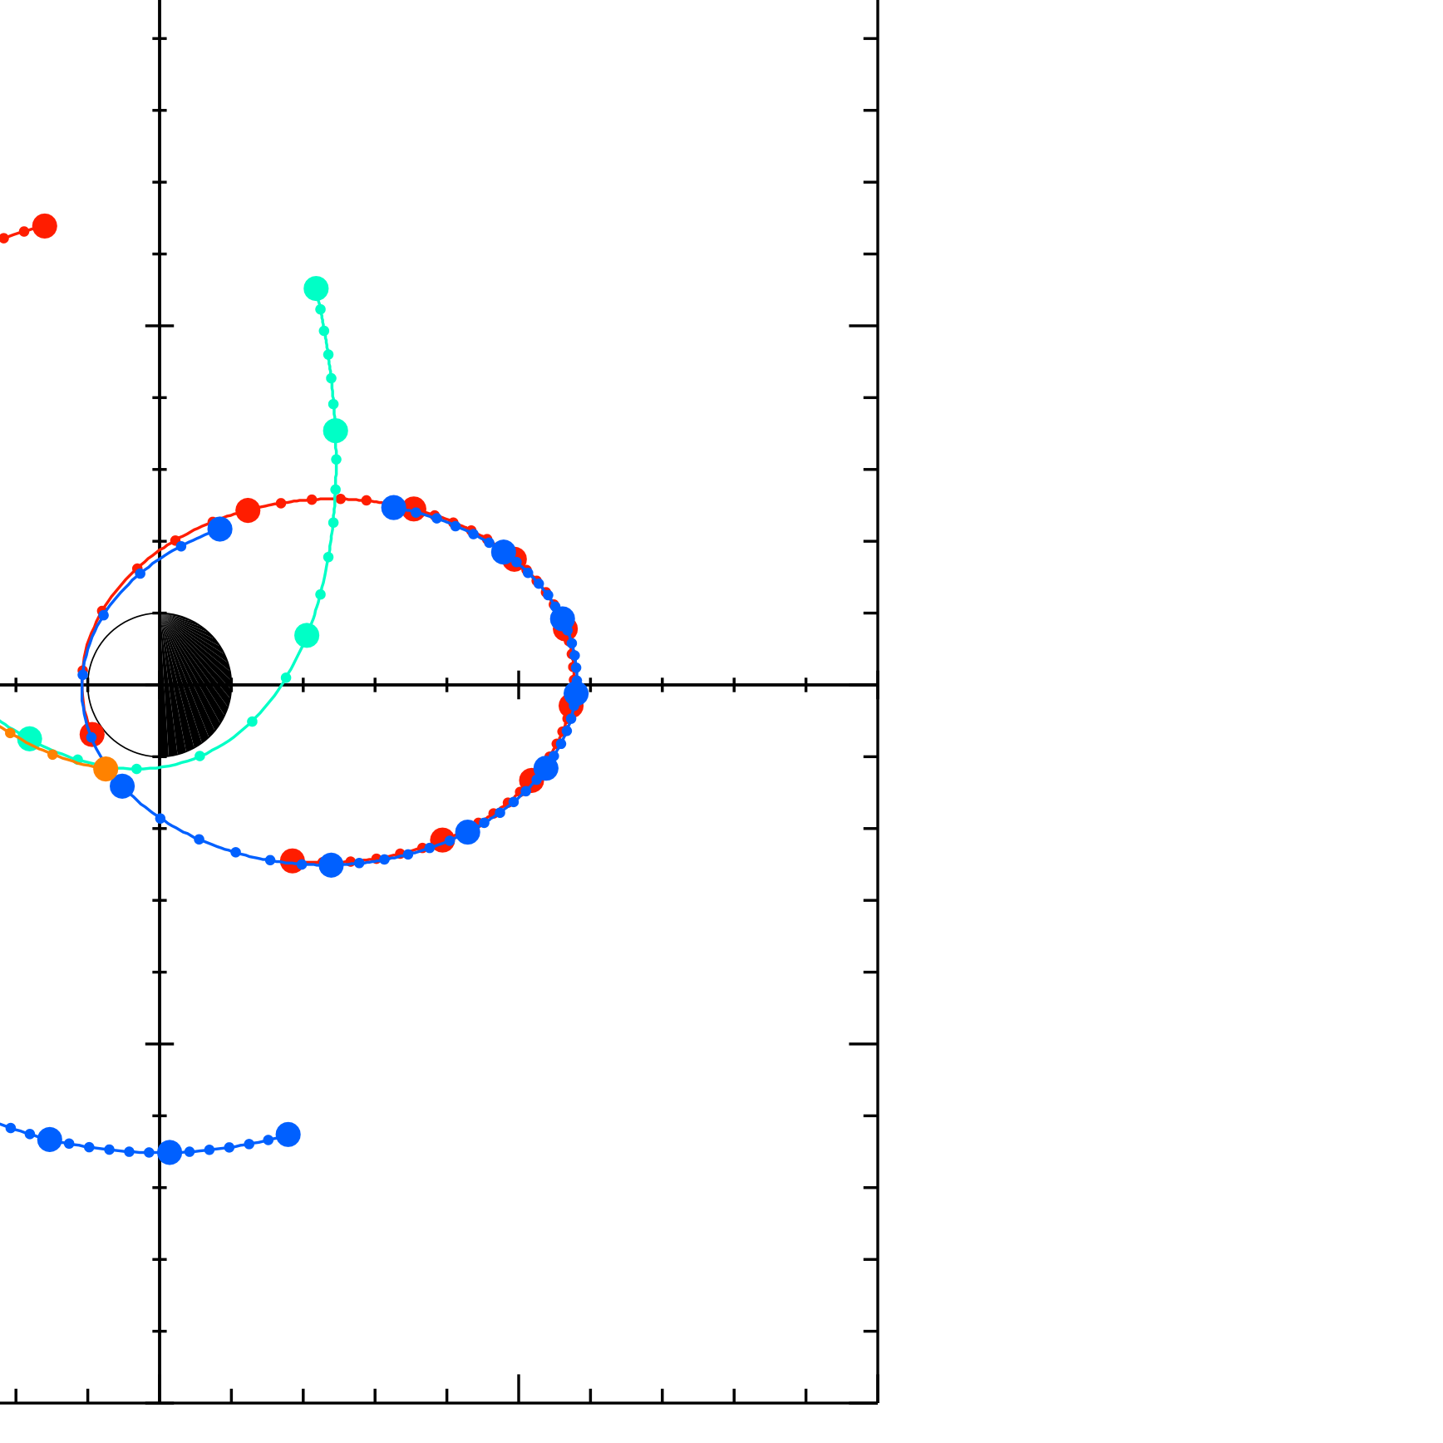
16T5
−10 VAN ALLEN PROBES 2013 099 (04/09) 16:00 to 2013 100 (04/10) 00:00 16T4
16T3
YSM | −5 | 00T5 | 16G15 | 16B | 00T3
 | 0 | 16G13 | 00A  00T4 |  | 00B
16A
5 | 00C4 | 00G15 16C4
00G13
Fri Aug 16 09:37:55 2013 | 10
 | 10 | 5 | 0  XSM | −5 | −10
 | RBSPA−A, RBSPB−B, THEMISA−T5, THEMISD−T3, THEMISE−T4, CLUSTER4−C4, GOES13−G13, GOES15−G15,

