Northeast Skate Complex Wing Fishery | For week ending: | April 27, 2013
 | For data reported through: | May 1, 2013
 | Quota Period: | FY 2012  05/01/12 to 04/30/13
 | Quota Period Dates:
Weekly Report

Previously Reported  Landings  (Whole  Pounds) | Previous Weeks'  Updates (Whole Pounds) | Current  Week's  Landings (Whole  Pounds) | Cumulative Landings  (Whole  Pounds) | Quota  (Whole Pounds) | Percent of  Quota  (%)
18,711,284 | 23,920 | 325,710 | 19,060,914 | 31,609,884 | 60

Notice: Effective September 1, 2012 the skate wing possession limit has increased to 4,100 lb of skate wings (9,307 lb whole weight). This possession limit increase is only applicable for those fishing on a NE multispecies, scallop, or monkfish Day-At-Sea (DAS). This possession limit will remain in effect until April 30, 2013 or until 85% of the skate wing quota is harvested. Vessels fishing on a NE multispecies category B DAS may only possess 220 lb of skate wings (500 lb whole weight) and non-DAS vessels may possess the incidental trip limit of 500 lb of skate
wings (1,135 lb whole weight). |  | These data are the best available to NOAA Fisheries Service when this report was compiled. Data are supplied to NOAA Fisheries Service by dealers via Dealer Electronic Reporting to the Standard Atlantic Fisheries Information System (SAFIS) and/or by state agencies and may be preliminary. Discrepancies with data from previous Weekly Landings Reports are due to corrections made to the database.
 | National  Oceanic and  Atmospheric  Administration
__________________________________________________________________________________
Cumulative Landings (Pounds) | 15,000,000  10,000,000  5,000,000  0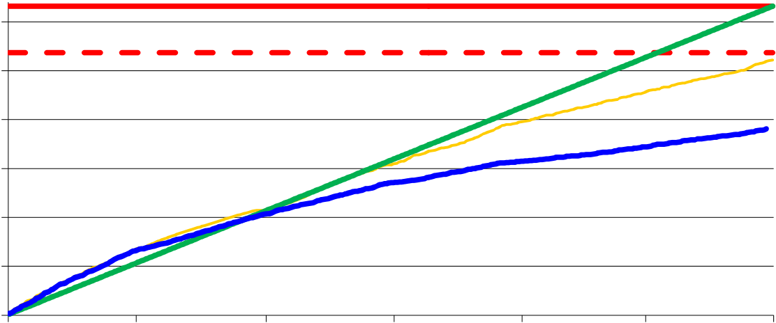  30,000,000  25,000,000  20,000,000  5/1/2012 7/1/2012 9/1/2012 11/1/2012 1/1/2013 3/1/2013
Date
85% Quota
Quota
Prior Year's Landings (whole wt. in pounds)
Quota Rationing Trajectory
Current Year's Landings (whole wt. in pounds)

