
U.S. Department East Building, PHH – 30
of Transportation 1200 New Jersey Avenue, Southeast
Washington, D.C. 20590
Pipeline and Hazardous
Materials Safety Administration
SPECIAL PERMIT AUTHORIZATION
DOT-SP 14175
EXPIRATION DATE: July 31, 2018
GRANTEE: WestAir Gases & Equipment Inc. National City, CA
In response to your July 23, 2014 application for renewal of DOT-SP 14175, the grantee status to DOT-SP 14175 for WestAir Gases & Equipment Inc. is hereby renewed in accordance with 49 CFR § 107.109.
Copies of this special permit may be obtained by accessing the
.
The most recent revision of the special permit supersedes all previous revisions of the special permit. Photo reproductions and legible reductions of this special permit are permitted. Any alteration of this special permit is prohibited.
If you have questions regarding this action please call the Office of Hazardous Materials Special Permits and Approvals at (202)366-4535.
Issued in Washington D.C. on August 27, 2014.
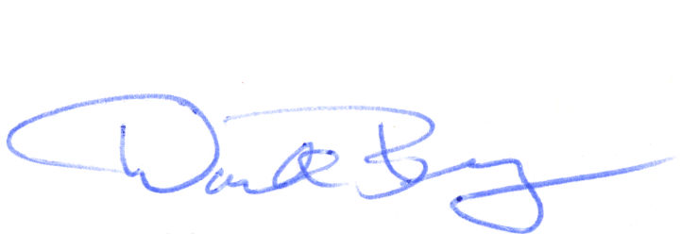
_________________________
for Dr. Magdy El-Sibaie
Associate Administrator for Hazardous Materials Safety

