Belarus - Corporate Taxation Indicators
Corporate Income Tax Rate
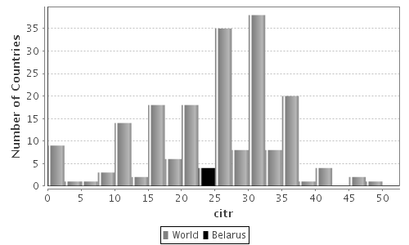
Summary of Statistics
Economy/Region | citr | Std. Dev | Min | Max | Max
Belarus | 24.00 | -- | -- | -- | 1
Central Europe and Central Asia Region | 15.03 | 5.36 | 0.00 | 24.00 | 30
Low-middle-income Economies Group | 22.62 23.90 | 10.71 | 0.00 | 45.00 | 56
World |  | 9.88 | 0.00 | 50.00 | 193

Corporate Income Tax Revenues
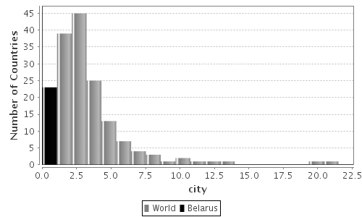
Summary of Statistics
Economy/Region | city | Std. Dev | Min | Max | Max
Belarus | 0.95 | -- | -- | -- | 1
Central Europe and Central Asia Region | 2.08 | 1.79 | 0.31 | 9.10 | 28
Low-middle-income Economies Group | 3.68 | 3.45 | 0.01 | 21.50 | 48
World | 3.32 | 3.01 | 0.01 | 21.50 | 167

Corporate Income Tax Revenue Productivity
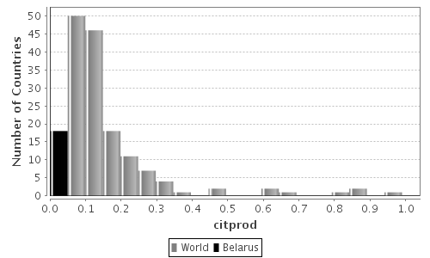
Summary of Statistics
Economy/Region | citpro d | Std. Dev | Min | Max | Max
Belarus | 0.04 | -- | -- | -- | 1
Central Europe and Central Asia Region | 0.14 | 0.12 | 0.02 | 0.49 | 27
Low-middle-income Economies Group | 0.18 | 0.18 | 0.00 | 0.86 | 46
World | 0.15 | 0.16 | 0.00 | 0.99 | 164

