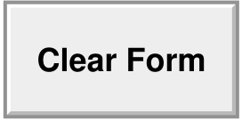
STATEMENT OF INTENT | Clear Form | Wisconsin Department of Transportation
MV2489 10/2000

Person Making Statement | Vehicle Year | Make
Address | Vehicle Identification Number
Any person who knowingly makes a false statement in an application for a certificate of title may be fined not more than $5,000 or imprisoned not more than 7 years and 6 months or both s.342.06(2) Wis. Stats.
____ My name appears in error on the title of the vehicle described. I did not purchase the vehicle and have no interest in it.
____ As seller, I signed/printed my name in the purchaser area of the title by mistake. I do not wish to be a co-owner of the vehicle.
____ As seller, I signed/printed my name in the lien area of the title by mistake. I do not wish to be a lienholder of the vehicle.
____ As seller, I printed the wrong name in the purchaser area. The vehicle was actually sold to:________________________________________.
____ Other (describe in detail):
(Signature of Person Certifying) | (Date)
The Wisconsin Department of Transportation complies with the Americans with Disabilities Act.

