John Adams
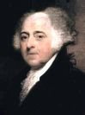
"Children should be educated and instructed in the principles of freedom." (Defense of the Constitutions, 1787)
---
John Adams was the Second President of the United States, revolutionary statesman and signer of the Declaration of Independence.
1 / 1

