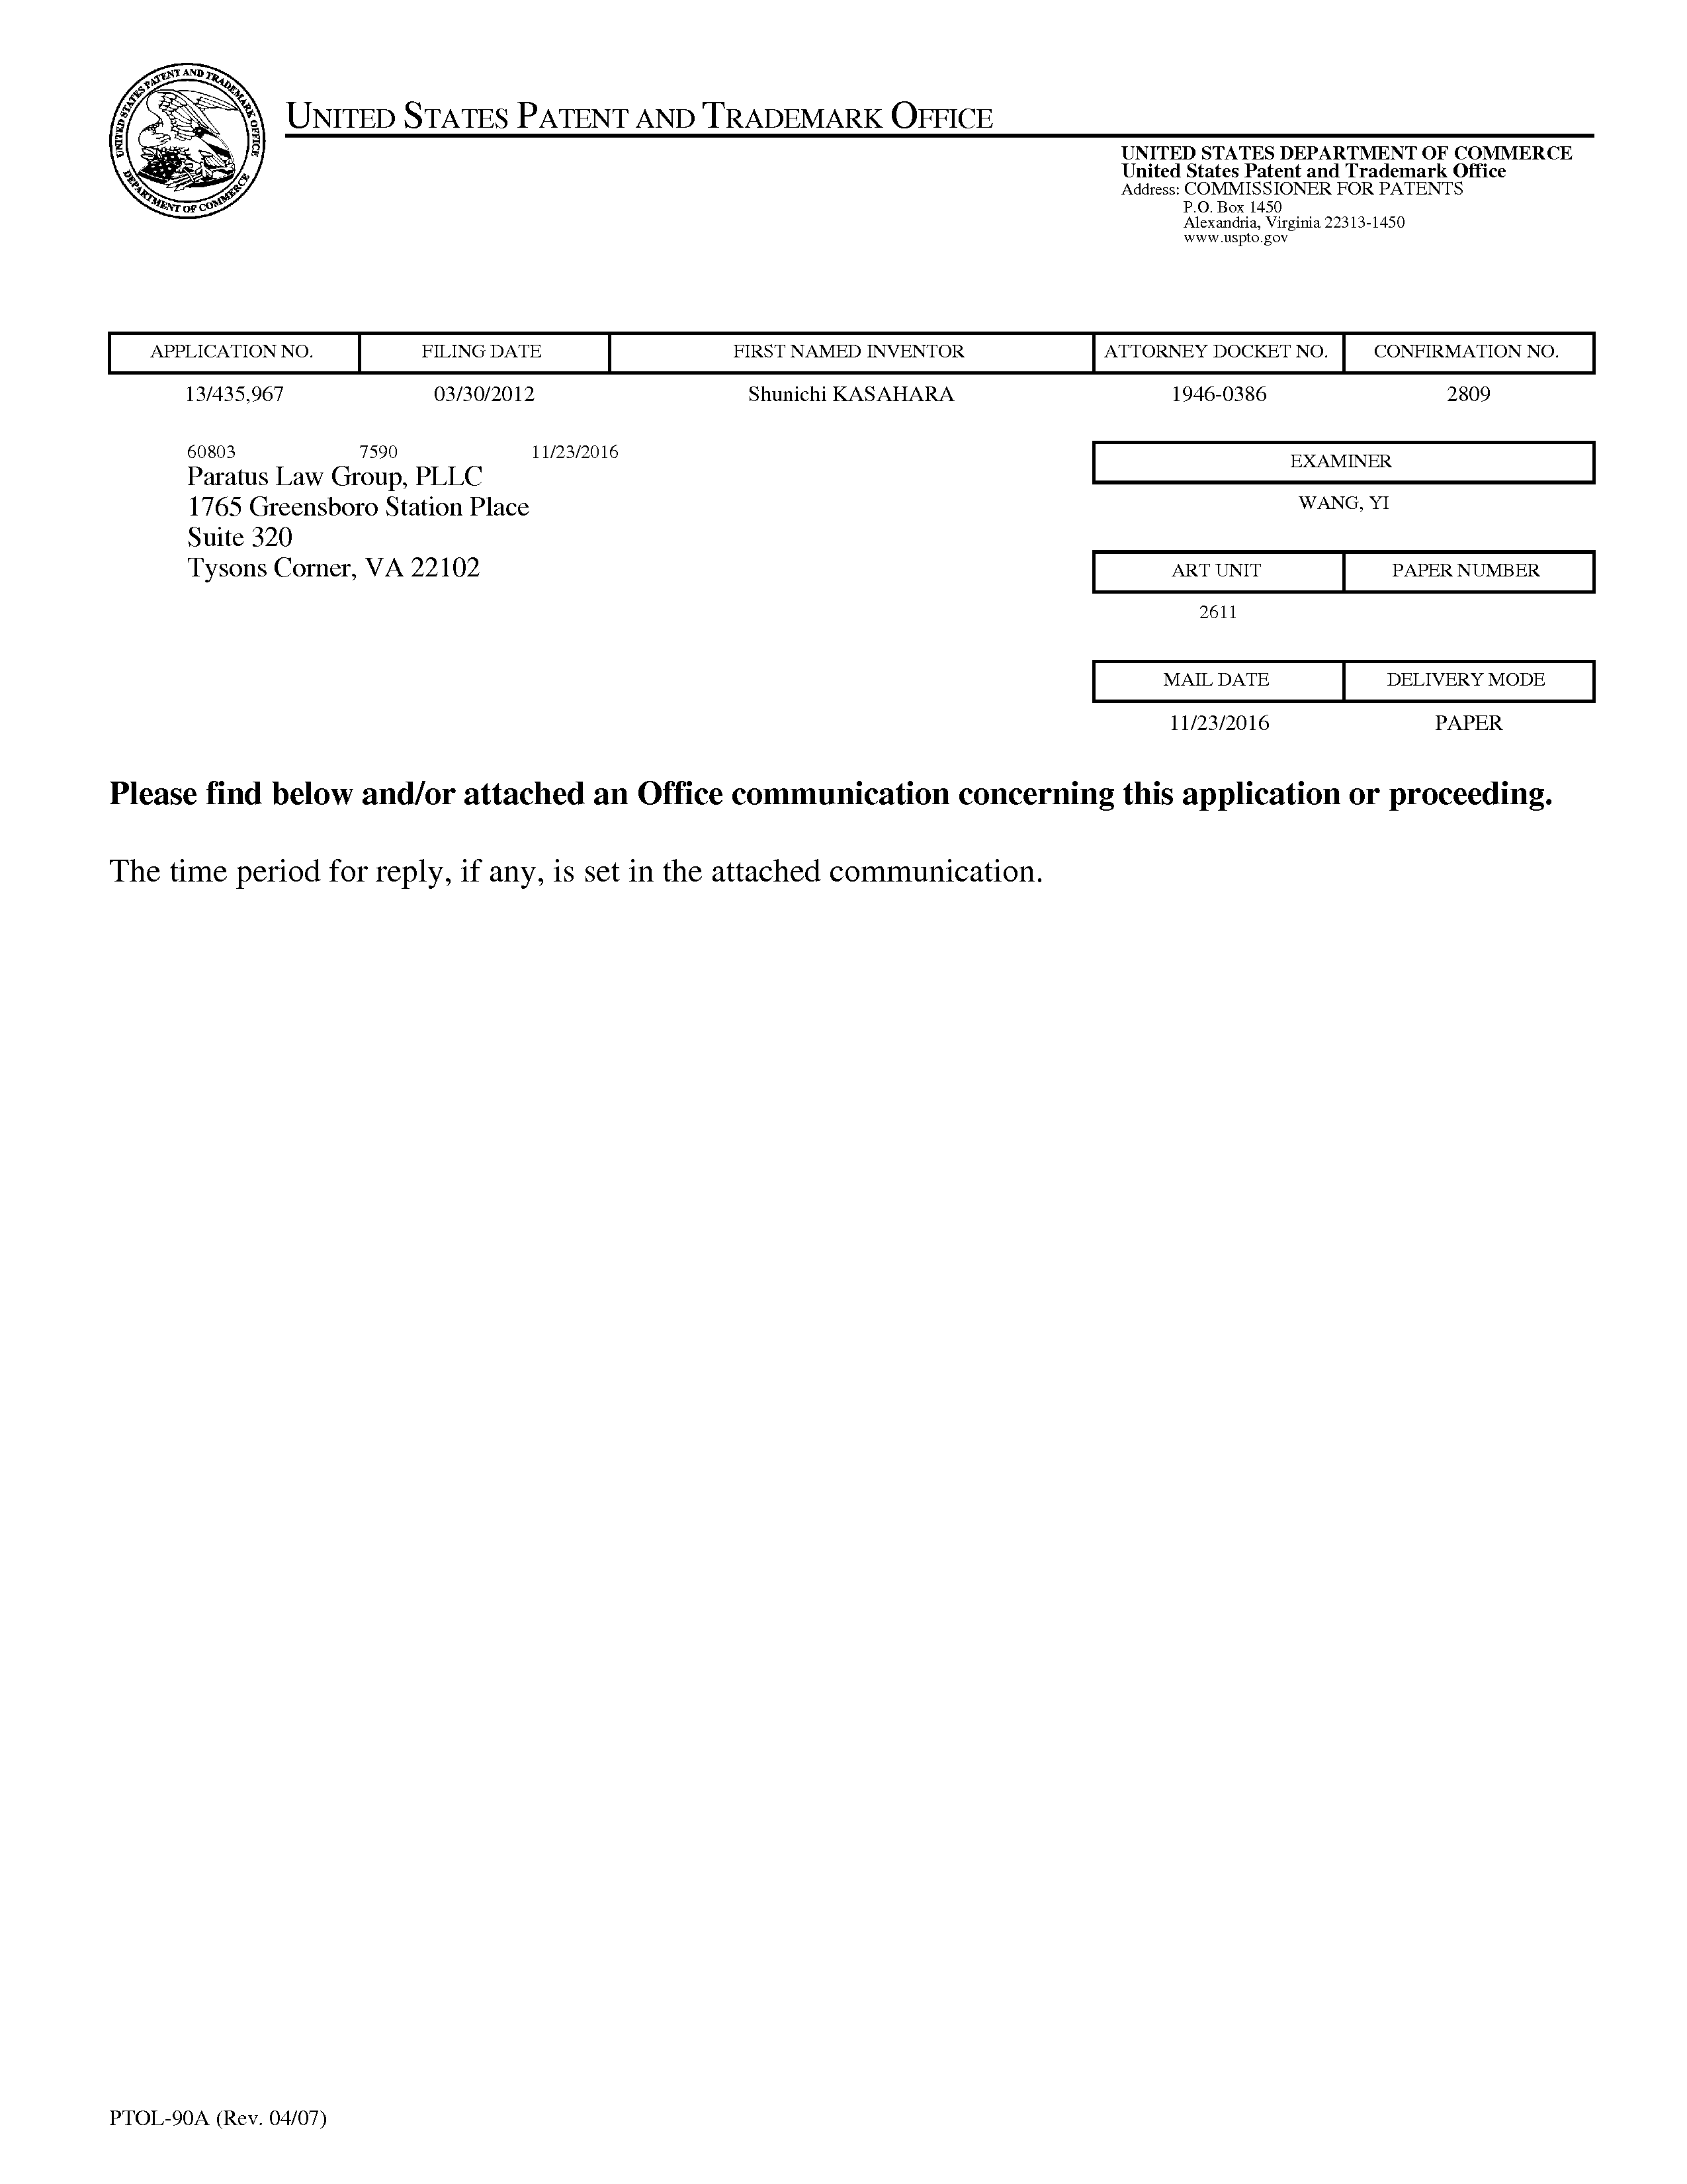
UnitedStatesPatentandTrademarkOffice
UNITEDSTATES DEPARTMENTOFCOMMERCE UnitedStatesPatentandTrademarkOffice Address:COMMISSIONERFORPATENTS P.O.Box1450
Alexandria,Virginia22313-1450
www.uspto.gov
APPLICATIONNO. | FILINGDATE |  | FIRSTNAMEDINVENTOR | ATTORNEYDOCKETNO. | CONFIRMATIONNO.
13/435,967 | 03/30/2012 |  | ShunichiKASAHARA | 1946-0386 | 2809
60803 7590  Paratus LawGroup,PLLC |  | 11/23/2016 |  | EXAMINER
1765GreensboroStationPlace |  |  |  | WANG,YI
Suite320 |  |  |  | ARTUNIT | PAPERNUMBER
TysonsCorner,VA22102
2611
MAILDATE DELIVERYMODE
11/23/2016 PAPER
Pleasefindbelowand/orattached anOfficecommunicationconcerningthis applicationor proceeding.
Thetimeperiodforreply,ifany,issetintheattachedcommunication.
PTOL-90A(Rev.04/07)

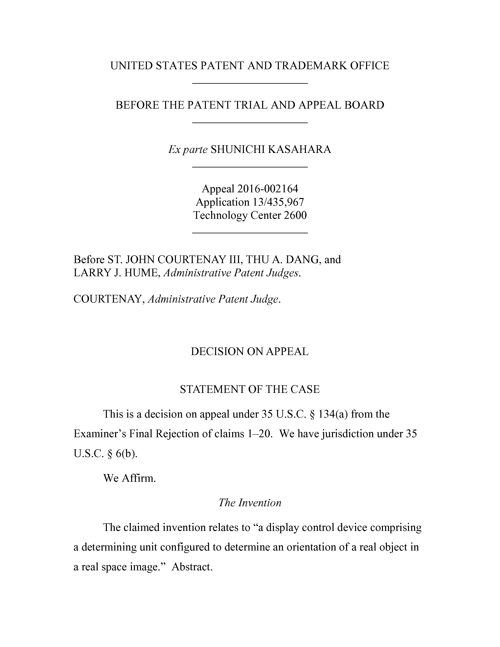
UNITEDSTATESPATENTANDTRADEMARKOFFICE
BEFORETHEPATENTTRIAL ANDAPPEALBOARD
ExparteSHUNICHIKASAHARA
Appeal2016-002164
Application13/435,967
TechnologyCenter2600
BeforeST.JOHN COURTENAYIII,THUA.DANG,and
LARRYJ.HUME,AdministrativePatentJudges.
COURTENAY,AdministrativePatentJudge.
DECISIONONAPPEAL
STATEMENTOFTHECASE
Thisisadecisiononappealunder35U.S.C.§134(a)fromthe
Examiner’sFinalRejectionofclaims1—20.Wehavejurisdictionunder35
U.S.C.§6(b).
WeAffirm.
TheInvention
Theclaimedinventionrelatesto“a display controldevicecomprising
adeterminingunitconfiguredtodetermineanorientation ofarealobjectin
arealspaceimage.”Abstract.

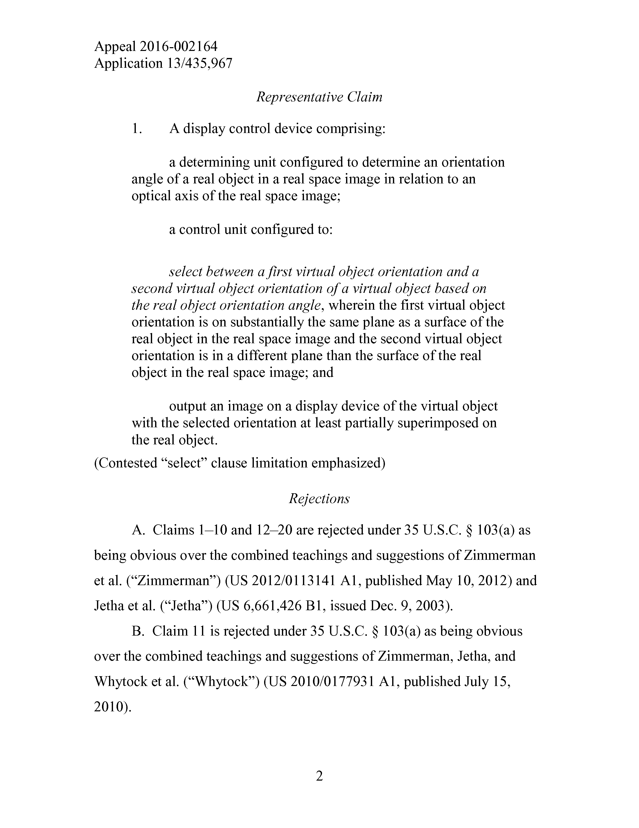
Appeal2016-002164
Application13/435,967
RepresentativeClaim
1. A display controldevicecomprising:
adeterminingunitconfiguredtodetermineanorientation angleofarealobjectin arealspaceimageinrelationtoan opticalaxisoftherealspaceimage;
a control unit configured to:
selectbetweenafirstvirtualobjectorientationanda secondvirtualobjectorientationofavirtualobjectbased on therealobjectorientationangle,wherein thefirstvirtualobject orientationisonsubstantiallythesameplaneasasurfaceofthe realobjectintherealspaceimageand thesecondvirtualobject orientationisinadifferent planethan thesurfaceofthereal objectin therealspaceimage;and
outputanimageona display deviceofthevirtualobject withtheselectedorientationatleastpartiallysuperimposedon therealobject.
(Contested“select”clauselimitationemphasized)
Rejections
A.Claims1—10and12—20arerejectedunder35U.S.C.§103(a)as
beingobviousoverthecombined teachingsandsuggestionsofZimmerman
etal.(“Zimmerman”)(US2012/0113141Al,publishedMay10,2012)and
Jethaetal.(“Jetha”)(US6,661,426Bl,issuedDec.9,2003).
B.Claim11isrejectedunder35U.S.C.§103(a)asbeingobvious
overthecombinedteachingsandsuggestionsofZimmerman,Jetha,and
Whytocketal.(“Whytock”)(US2010/0177931Al,publishedJuly15,
2010).
2

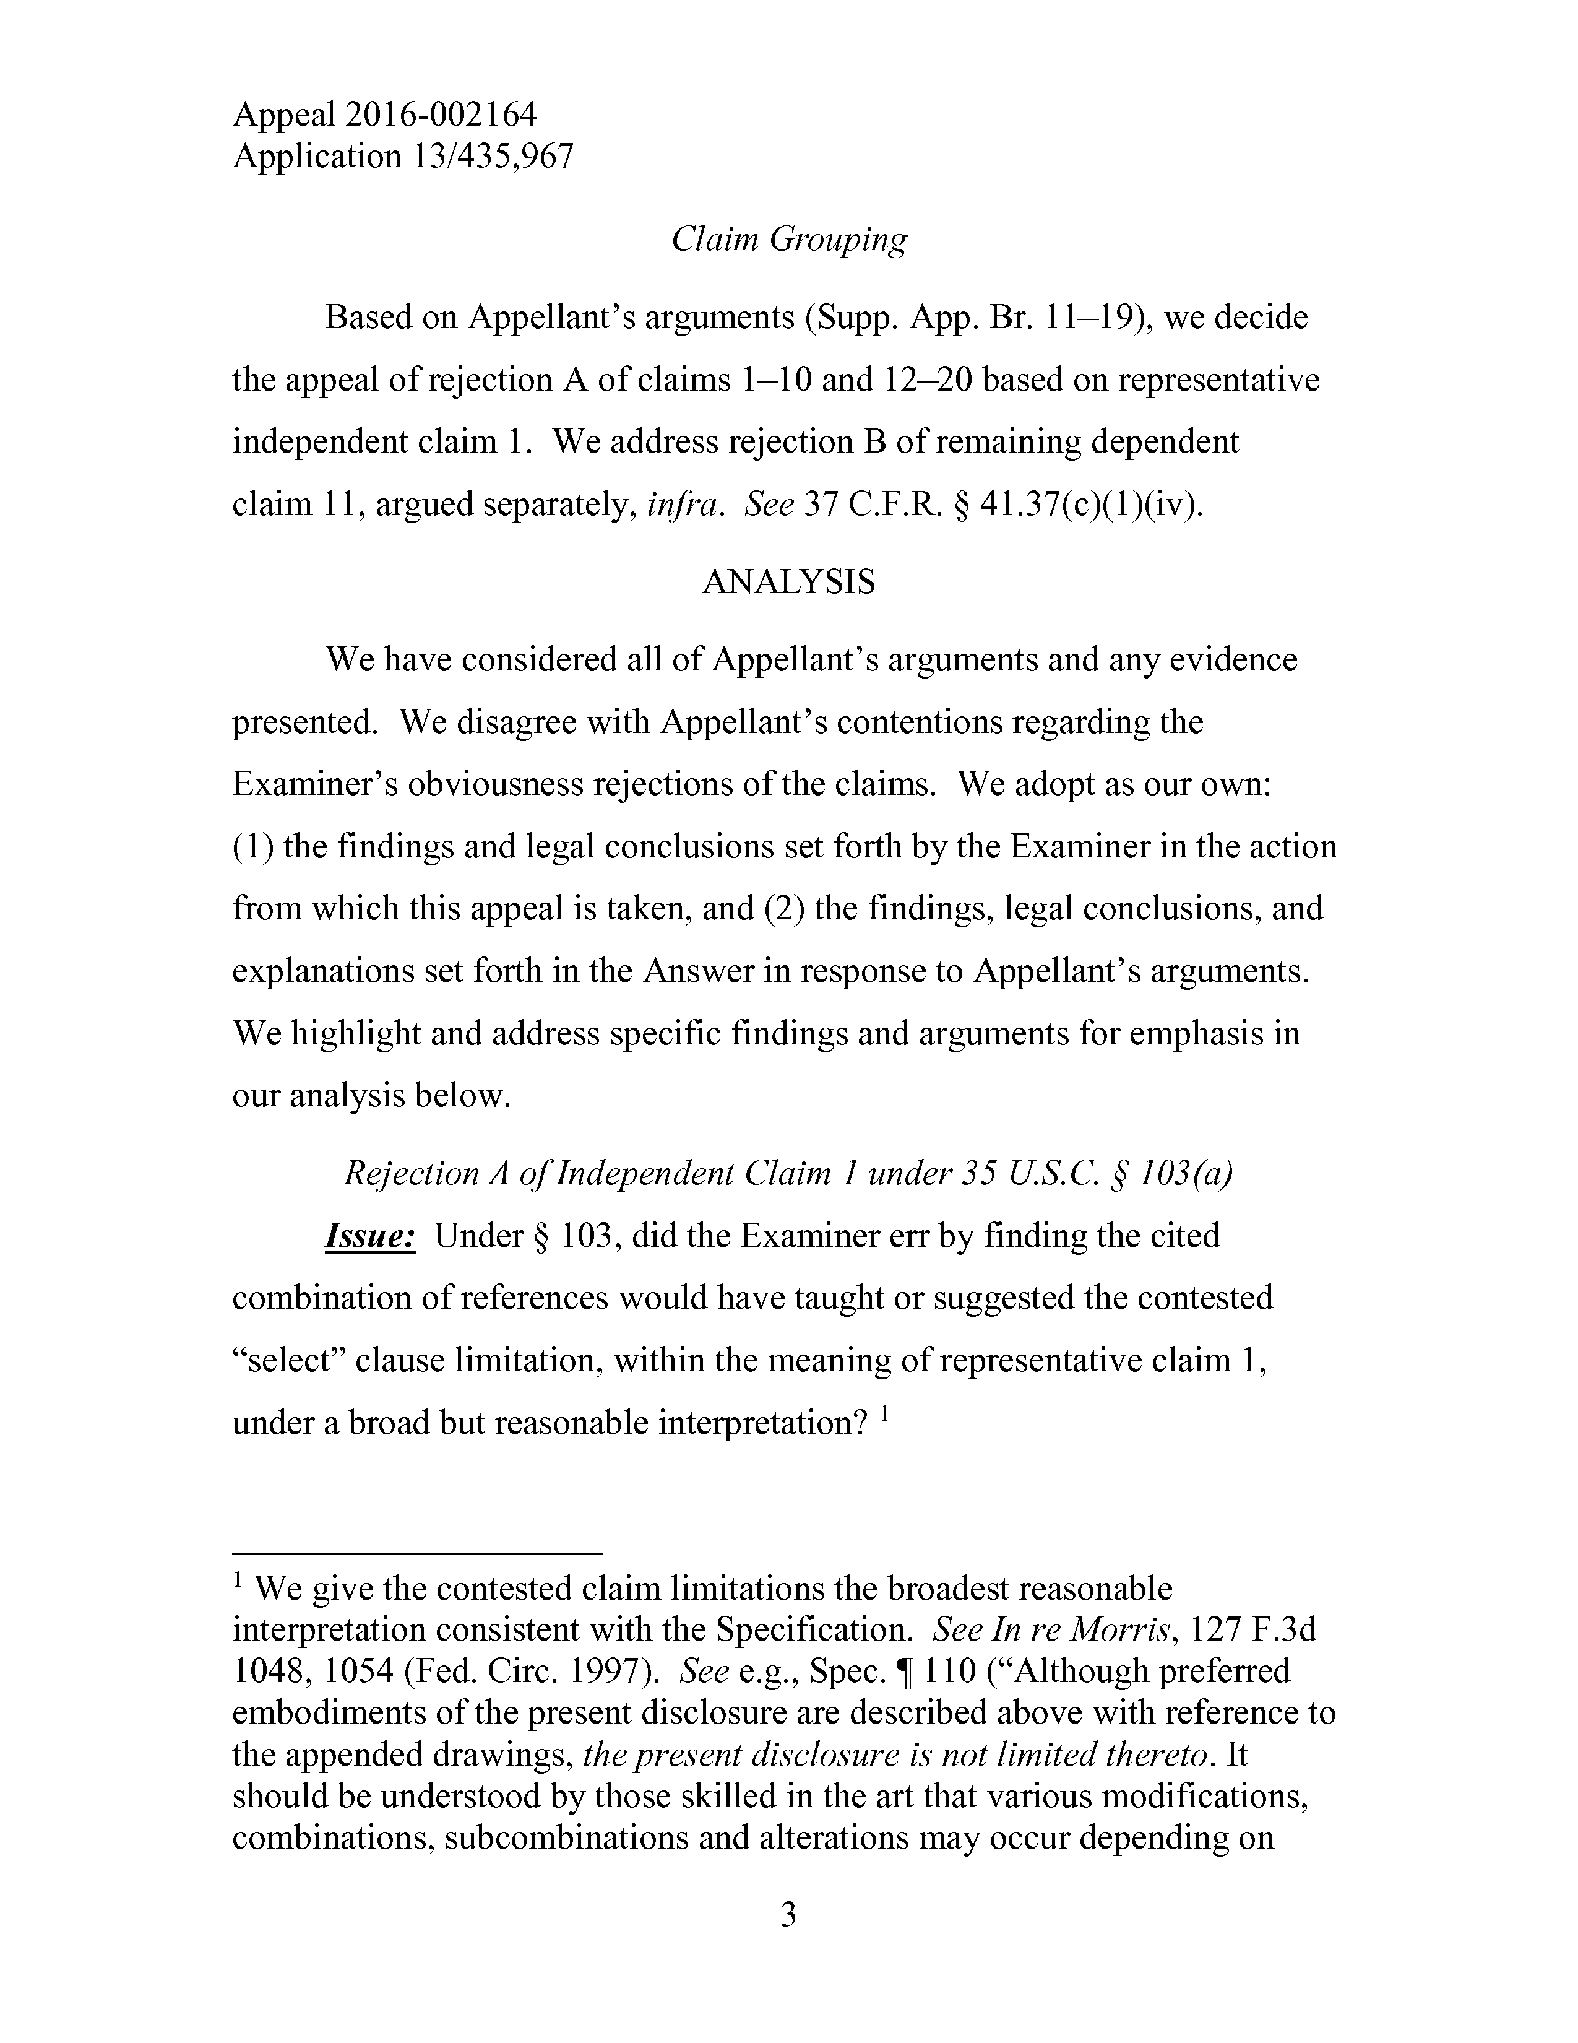
Appeal2016-002164
Application13/435,967
ClaimGrouping
BasedonAppellant’sarguments(Supp.App.Br.11—19),wedecide
theappealofrejectionAofclaims1—10and12—20basedon representative
independentclaim1.Weaddressrejection B ofremainingdependent
claim11,arguedseparately,infra.See37C.F.R.§41.37(c)(l)(iv).
ANALYSIS
WehaveconsideredallofAppellant’sargumentsandanyevidence
presented.WedisagreewithAppellant’scontentionsregardingthe
Examiner’sobviousnessrejectionsoftheclaims.Weadoptasourown:
(1)thefindingsandlegalconclusionssetforthbytheExaminerintheaction
fromwhichthisappealistaken,and(2)thefindings,legalconclusions,and
explanationssetforthintheAnswerinresponsetoAppellant’sarguments.
Wehighlight andaddressspecificfindingsandargumentsforemphasisin
our analysisbelow.
RejectionA ofIndependentClaim1under35U.S.C.§103(a)
Issue:Under§103,didtheExaminererrbyfinding thecited
combinationofreferenceswould havetaughtorsuggested thecontested
“select”clauselimitation,within themeaningofrepresentativeclaim1,
underabroadbut reasonableinterpretation?1
1Wegivethecontestedclaim limitationsthebroadest reasonable
interpretationconsistentwiththeSpecification.SeeInreMorris,111F.3d 1048,1054(Fed.Circ.1997).Seee.g.,Spec.1110(“Althoughpreferred embodimentsofthepresentdisclosurearedescribedabovewithreferenceto theappendeddrawings,thepresentdisclosureisnot limitedthereto.It shouldbeunderstoodbythoseskilledin theartthatvariousmodifications, combinations,subcombinationsandalterationsmayoccurdependingon
3

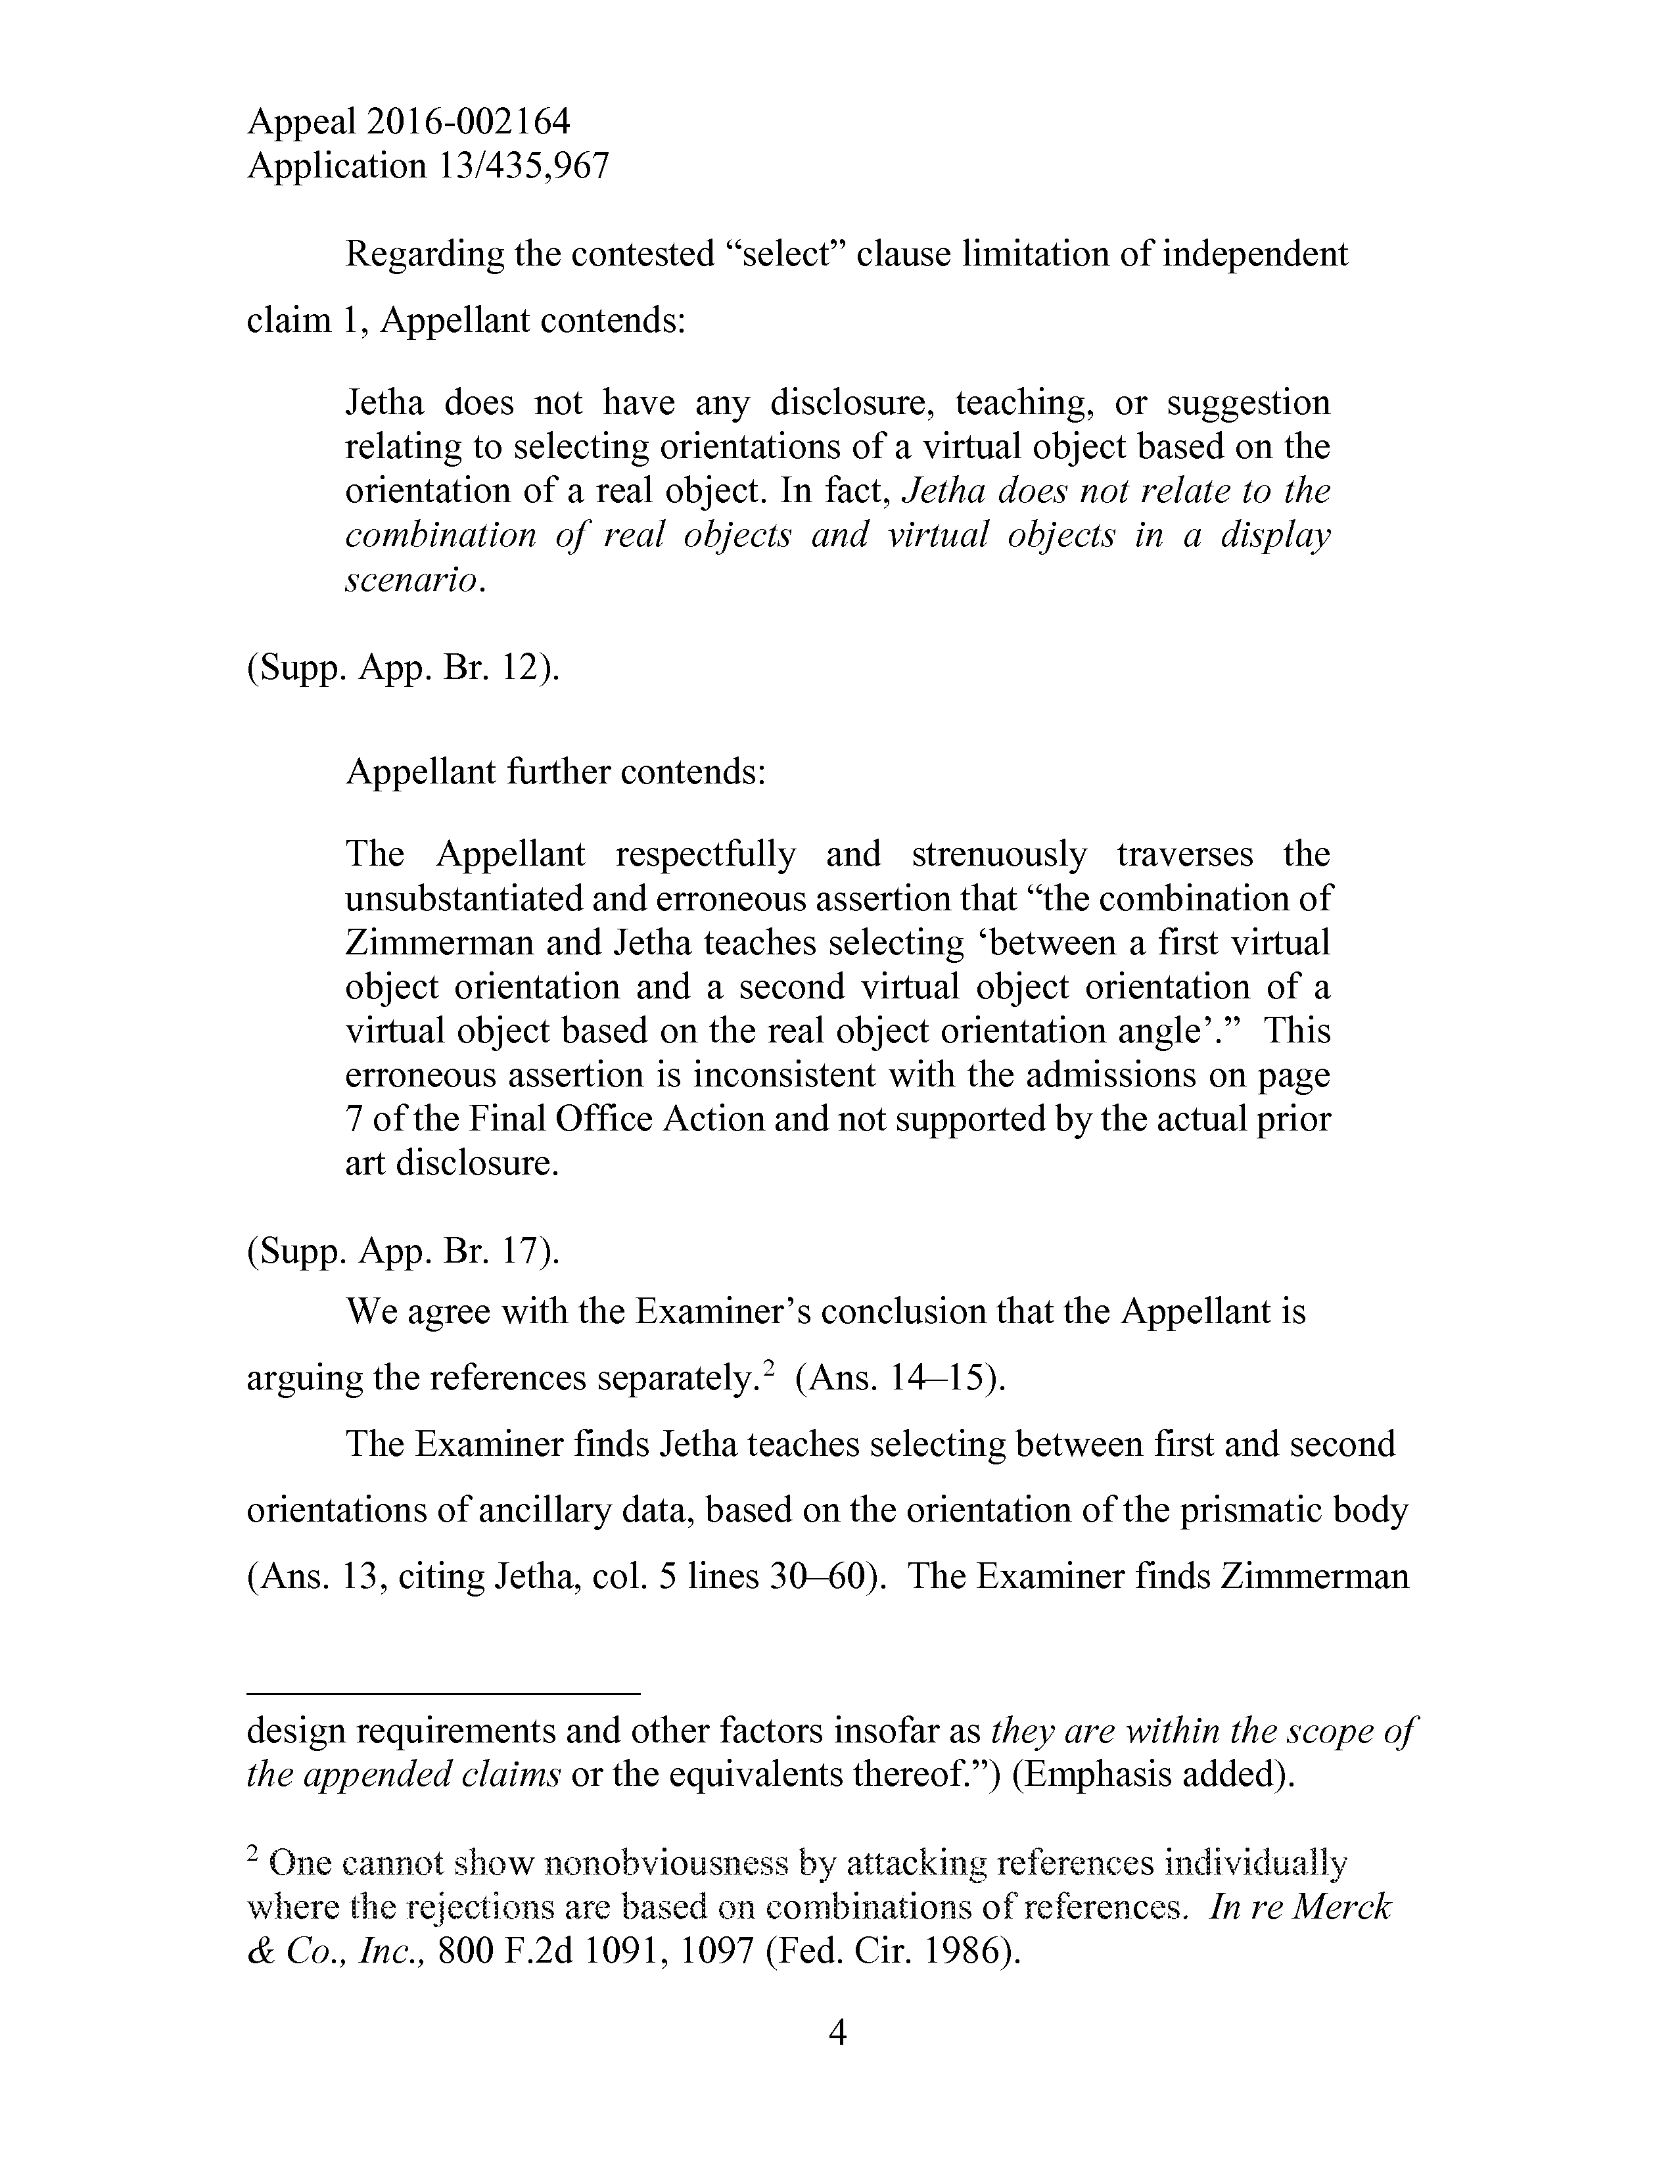
Appeal2016-002164
Application13/435,967
Regardingthecontested“select”clauselimitationofindependent
claim1,Appellantcontends:
Jethadoesnothaveanydisclosure,teaching,orsuggestion relatingtoselectingorientationsofavirtualobjectbasedonthe orientationofarealobject.Infact,Jethadoesnotrelatetothe combinationofrealobjectsandvirtualobjectsinadisplay scenario.
(Supp.App.Br.12).
Appellantfurthercontends:
TheAppellantrespectfullyandstrenuouslytraversesthe unsubstantiatedand erroneousassertionthat“thecombinationof ZimmermanandJethateachesselecting‘betweenafirstvirtual objectorientationandasecondvirtualobjectorientationofa virtualobjectbasedontherealobjectorientationangle’.”This erroneousassertionisinconsistentwiththeadmissionsonpage 7ofthe Final OfficeActionandnot supportedbytheactualprior artdisclosure.
(Supp.App.Br.17).
WeagreewiththeExaminer’sconclusionthattheAppellantis
arguingthereferencesseparately.* 2(Ans.14—15).
TheExaminer findsJethateachesselectingbetweenfirstandsecond
orientationsofancillarydata,basedontheorientationoftheprismaticbody
(Ans.13,citingJetha,col.5lines30—60).TheExaminer findsZimmerman
design requirementsandotherfactorsinsofarastheyarewithinthe scopeof theappendedclaimsortheequivalentsthereof.”)(Emphasisadded).
2Onecannotshownonobviousnessbyattackingreferences
wheretherejectionsarebasedoncombinationsofreferences.InreMerck &Co.,Inc.,800F.2d1091,1097(Fed.Cir.1986).
4

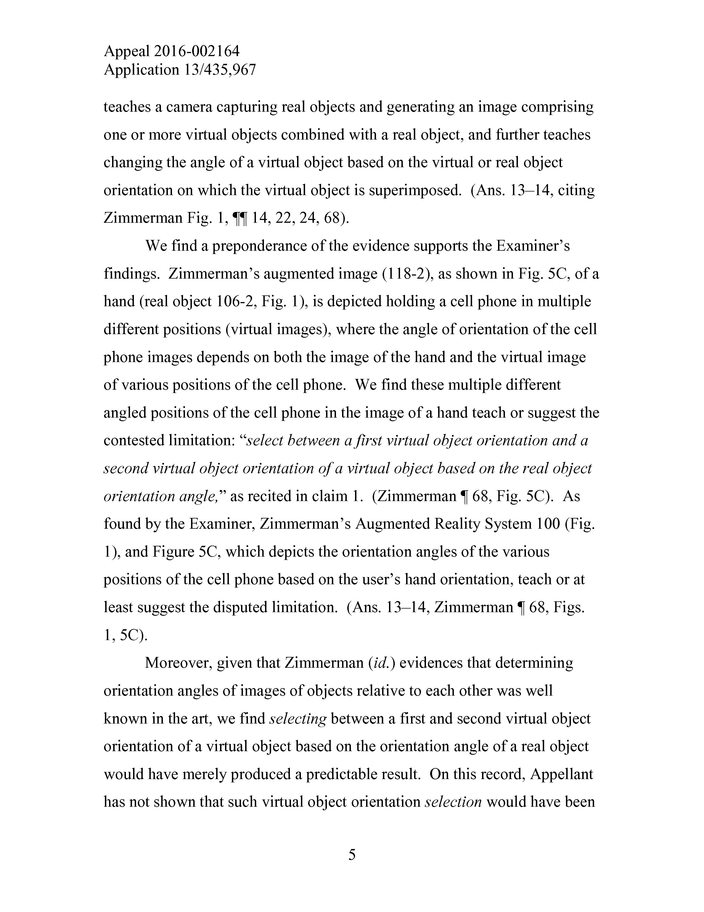
Appeal2016-002164
Application13/435,967
teachesacameracapturingrealobjectsandgeneratinganimagecomprising oneormorevirtualobjectscombinedwitharealobject,andfurtherteaches changingtheangleofavirtualobjectbasedonthevirtualorrealobject orientationonwhichthevirtualobjectissuperimposed.(Ans.13—14,citing ZimmermanFig.1,||14,22,24,68).
WefindapreponderanceoftheevidencesupportstheExaminer’s findings.Zimmerman’saugmentedimage(118-2),asshowninFig.5C,ofa hand(realobject106-2,Fig.1),isdepictedholdinga cell phoneinmultiple differentpositions(virtualimages),wheretheangleoforientationofthecell phoneimagesdependsonboththeimageofthehandand thevirtualimage ofvariouspositionsofthecellphone.Wefindthesemultipledifferent angledpositionsofthecell phoneintheimageofahand teachorsuggestthe contestedlimitation:“selectbetweenafirstvirtualobjectorientationanda secondvirtualobjectorientationofavirtualobjectbasedontherealobject orientationangle,”asrecitedinclaim1.(Zimmerman|68,Fig.5C).As foundbytheExaminer,Zimmerman’sAugmentedRealitySystem100(Fig.
1),andFigure5C,whichdepictstheorientationanglesofthevarious positionsofthecell phonebasedon theuser’shandorientation,teachor at leastsuggestthedisputedlimitation.(Ans.13—14,Zimmerman|68,Figs. 1,5C).
Moreover,giventhatZimmerman(id.)evidencesthatdetermining orientationanglesofimagesofobjects relative toeachotherwaswell knownin theart,wefindselectingbetweenafirst andsecondvirtualobject orientationofavirtualobjectbasedontheorientationangleofarealobject would havemerelyproducedapredictableresult.Onthisrecord,Appellant has notshownthatsuchvirtualobjectorientationselectionwouldhavebeen
5

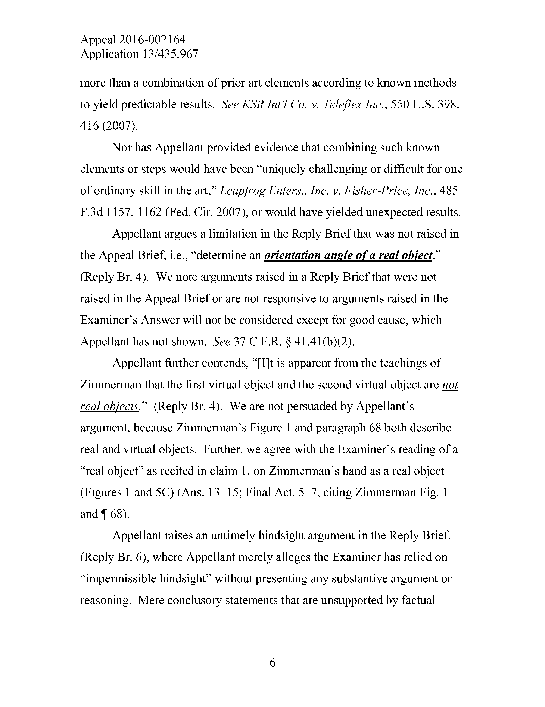
Appeal2016-002164
Application13/435,967
morethanacombinationofpriorartelementsaccordingtoknownmethods toyieldpredictableresults.See KSRInt'lCo.v.TeleflexInc.,550U.S.398, 416(2007).
Nor hasAppellantprovidedevidencethatcombiningsuchknown elementsorstepswouldhavebeen“uniquelychallengingor difficult forone ofordinaryskill intheart,”LeapfrogEnters.,Inc.v.Fisher-Price,Inc.,485 F.3d1157,1162(Fed.Cir.2007),orwouldhave yielded unexpected results.
AppellantarguesalimitationintheReplyBriefthatwas notraisedin theAppealBrief,i.e.,“determineanorientationangle ofa realobject (ReplyBr.4).Wenoteargumentsraisedina ReplyBriefthatwerenot raisedin theAppealBriefor are notresponsivetoargumentsraisedinthe Examiner’sAnswerwill notbeconsideredexcept forgoodcause,which Appellanthas notshown.See37C.F.R.§41.41(b)(2).
Appellantfurthercontends,“[I]tisapparentfromtheteachingsof Zimmermanthatthefirstvirtualobjectandthesecondvirtualobjectarenot realobjects.”(ReplyBr.4).Wearenotpersuaded byAppellant’s
argument,becauseZimmerman’sFigure1andparagraph68bothdescribe realandvirtualobjects.Further,weagreewiththeExaminer’sreadingofa“realobject”asrecitedinclaim1,onZimmerman’shandasarealobject (Figures1and5C)(Ans.13—15;FinalAct.5—7,citingZimmermanFig.1 and 168).
Appellantraisesanuntimelyhindsightargument intheReplyBrief.
(ReplyBr.6),whereAppellant merely allegestheExaminerhasreliedon“impermissible hindsight”withoutpresentinganysubstantiveargumentor reasoning.Mereconclusorystatementsthatareunsupportedbyfactual
6

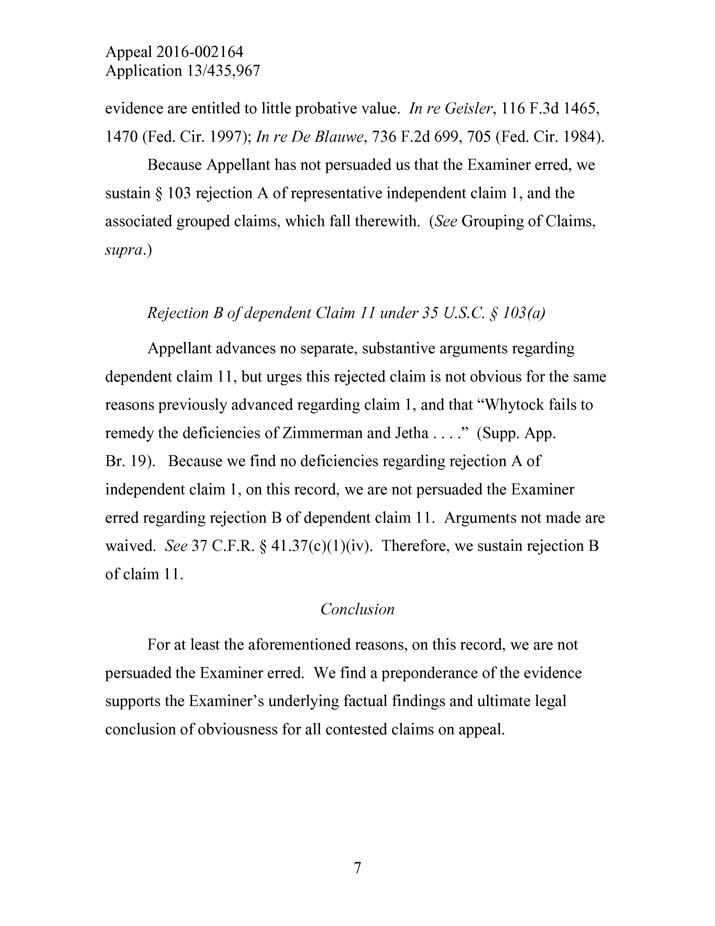
Appeal2016-002164
Application13/435,967
evidenceareentitledtolittleprobativevalue.InreGeisler,116F.3d1465, 1470(Fed.Cir.1997);InreDeBlauwe,736F.2d699,705(Fed.Cir.1984).
BecauseAppellanthas not persuaded usthat theExaminererred,we sustain§103rejection Aofrepresentativeindependentclaim1,andthe associatedgroupedclaims,whichfalltherewith.(SeeGroupingofClaims, supra.)
RejectionBofdependentClaim11under35U.S.C.§103(a)
Appellantadvancesnoseparate,substantiveargumentsregarding dependentclaim11,but urgesthisrejectedclaim is not obviousforthesame reasonspreviouslyadvanced regardingclaim1,andthat“Whytockfailsto remedythedeficienciesofZimmermanandJetha....”(Supp.App.
Br.19).Becausewefindnodeficienciesregarding rejection Aof
independentclaim1,onthisrecord,weare not persuaded theExaminer erred regarding rejectionBofdependentclaim11.Arguments not madeare waived.See37C.F.R.§41.37(c)(l)(iv).Therefore,wesustain rejection B ofclaim11.
Conclusion
For atleasttheaforementionedreasons,on this record,weare not persuadedtheExaminererred.Wefind apreponderanceoftheevidence supportstheExaminer’sunderlyingfactualfindingsandultimatelegal conclusionofobviousnessforallcontestedclaimsonappeal.
7

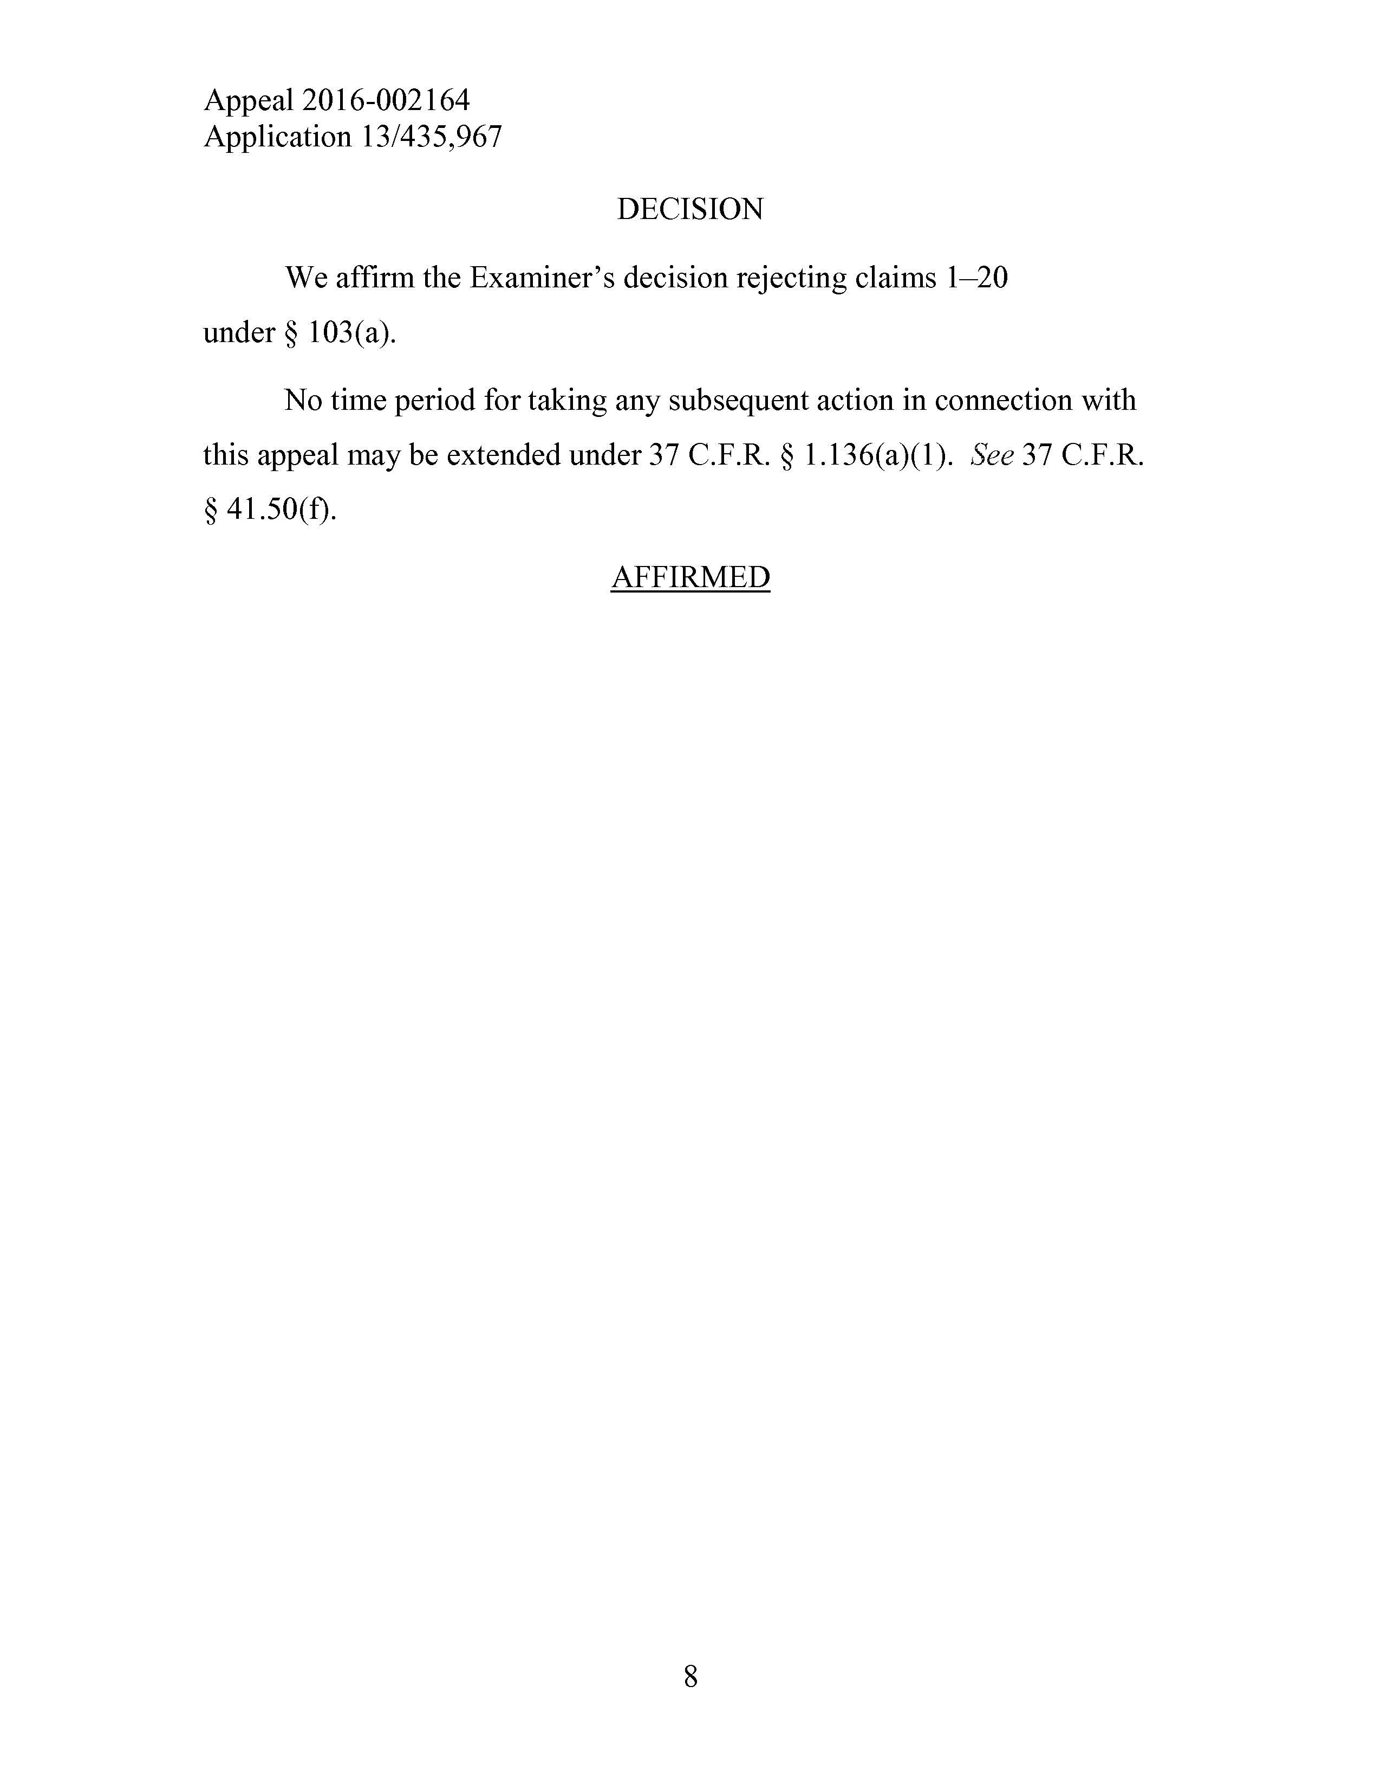
Appeal2016-002164
Application13/435,967
DECISION
Weaffirm theExaminer’sdecisionrejectingclaims1—20
under§103(a).
Notime period fortakinganysubsequentactioninconnectionwith
thisappealmaybeextended under37C.F.R.§1.136(a)(1).See37C.F.R.
§41.50(f).
AFFIRMED
8

