STATE OF CALIFORNIA — THE RESOURCES AGENCY | ARNOLD SCHWARZENEGGER, Governor
CALIFORNIA ENERGY COMMISSION 1516 Ninth Street  Sacramento, California 95814  Main website: www.energy.ca.gov | 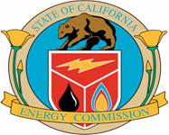
Notice of Energy Commission Committee-Ordered
Workshop for the
Calico Solar Project (08-AFC-13)
Pursuant to direction provided by the presiding Committee for the Calico Solar Project, the California Energy Commission (Energy Commission) staff will conduct a workshop starting at 1:00 PM on August 24, 2010. During the August 18, 2010 evidentiary hearing for the Calico Solar Project, the presiding Committee waived the normal notice period for this workshop. Although the primary purpose of the workshop is to discuss the Biological Resources, Cultural Resources, and Traffic and Transportation sections of the
Supplemental Staff Assessment, additional topics may be raised as necessary. All interested agencies and members of the public are invited to participate. The workshop will be held as follows:
Tuesday, August 24, 2010 1:00 P.M.  California Energy Commission Hearing Room A  1516 Ninth Street  Sacramento, CA 95814  (Wheelchair Accessible)  (Map Attached) | DOCKET 08-AFC-13  DATE 08/19/10  RECD. 08/19/10 MAR.
To Participate in the Workshop:
Instructions to Connect via Telephone Only (No Computer Access) 1. Call: 1-866-469-3239
2. When prompted enter this meeting number: 925 642 882
3. When it asks for Attendee ID press: #
Instructions to Connect via Computer Logon with a Direct Phone Number 1. Go to https://energy.webex.com and enter the unique meeting number: 925 642 882 2. When prompted, enter your information and the following meeting password: SITING123!
3. After you login, a prompt will appear on-screen for you to provide your phone number.
In the Number box, type your area code and phone number and click OK to receive a
PROOF OF SERVICE ( REVISED | 8/9/10 | ) FILED WITH
ORIGINAL MAILED FROM SACRAMENTO ON |  | 8/19/10  MS

call back on your phone for the audio of the meeting. International callers can use the "Country/Region" button to help make their connection.
Purpose of the Workshop
During the August 18, 2010 Evidentiary Hearing for the Calico Solar Project, the parties raised concerns over the analysis and/or mitigation in the Biological Resources, Cultural Resources, and Traffic and Transportation sections of the Supplemental Staff
Assessment. Since the August 18, 2010 evidentiary hearing has been continued to August 25, 2010, the presiding Committee announced at the hearings that is was waiving the normal notice period in order to allow the parties to attempt to resolve any issues prior to the hearing.
Public Participation
The Energy Commission’s Public Adviser’s Office provides the public with assistance in participating in Energy Commission activities. If you want information on how to
participate in this proceeding, please contact the Public Adviser, Jennifer Jennings, at: (916) 654-4489, toll free at (800) 822-6228, by FAX at (916) 654-4493, or by e-mail at public.adviser@energy.state.ca.us If you have a disability and require assistance to participate, please contact Lourdes Quiroz at lquiroz@energy.state.ca.us or at (916) 654-5146 at least five days in advance or the workshop. For those persons with limited English knowledge, request interpreter services by contacting Christopher Meyer, the Energy Commission Project Manager (contact information provided below).
Questions
General information about the proposed Calico Solar Project and related documents are available on the Energy Commission’s website at:
http://www.energy.ca.gov/sitingcases/calicosolar/index.html
Please direct all news media inquiries to the Energy Commission’s media office at (916) 654-4989 or e-mail at mediaoffice@energy.state.ca.us. For technical questions on the subject matter, please contact Christopher Meyer, the Energy Commission Project Manager, at (916) 653-1639 or by e-mail at: cmeyer@energy.state.ca.us or Jim Stobaugh, the BLM Project Manager, at (775) 861-6478 or by e-mail at:
jim_stobaugh@blm.gov. If you are unable to participate in the workshop, written comments may be sent to the Energy Commission Project Manager electronically or to the Energy Commission’s street address shown on the letterhead of this notice.
Date: | _ _  TERRENCE O’BRIEN, Deputy Director  Siting, Transmission, and Environmental Protection Division
Calico Proof of Service Lists
August 19, 2010 | 2 | Calico Solar Workshop Notice

Tuesday, August 24, 2010
1:00 P.M.
California Energy Commission
Hearing Room A
1516 Ninth Street
Sacramento, CA 95814
(Wheelchair Accessible)
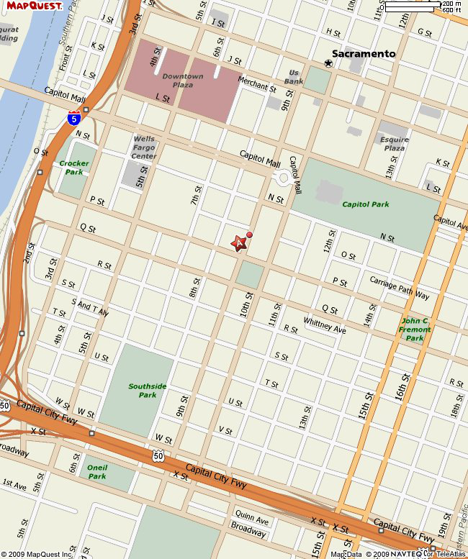
August 19, 2010 | 3 | Calico Solar Workshop Notice


 | BEFORE THE ENERGY RESOURCES CONSERVATION AND DEVELOPMENT COMMISSION OF THE STATE OF CALIFORNIA  1516NINTH STREET,SACRAMENTO,CA95814  1-800-822-6228– WWW.ENERGY.CA.GOV

U

APPLICATION FOR CERTIFICATION Docket No. 08-AFC-13
For the CALICO SOLAR (Formerly SES Solar One) PROOF OF SERVICE

APPLICANT  Felicia Bellows  Vice President of Development & Project Manager  Tessera Solar  4800 North Scottsdale Road, #5500  Scottsdale, AZ 85251  felicia.bellows@tesserasolar.com | INTERESTED AGENCIES California ISO  e-recipient@caiso.com | California Unions for Reliable  Energy (CURE)  c/o: Loulena A. Miles,  Marc D. Joseph  Adams Broadwell Joseph  & Cardozo  601 Gateway Boulevard, Ste. 1000 South San Francisco, CA 94080 lmiles@adamsbroadwell.com
Jim Stobaugh
BLM – Nevada State Office P.O. Box 12000
Reno, NV 89520
jim_stobaugh@blm.gov
CONSULTANT  Angela Leiba  AFC Project Manager  URS Corporation  1615 Murray Canyon Rd.,  #1000  San Diego, CA 92108  angela_leiba@URSCorp.com | Rich Rotte, Project Manager Bureau of Land Management Barstow Field Office  2601 Barstow Road  Barstow, CA 92311  richard_rotte@blm.gov
Defenders of Wildlife
Joshua Basofin
1303 J Street, Suite 270
Sacramento, California 95814 e-mail service preferred
jbasofin@defenders.org
Becky Jones
California Department of Fish & Game
36431 41st Street East Palmdale, CA 93552
dfgpalm@adelphia.net
Society for the Conservation of
Bighorn Sheep
Bob Burke & Gary Thomas
P.O. Box 1407
Yermo, CA 92398
cameracoordinator@sheepsociety.com
APPLICANT’S COUNSEL Allan J. Thompson
Attorney at Law
21 C Orinda Way #314
Orinda, CA 94563
allanori@comcast.net
INTERVENORS
County of San Bernardino Ruth E. Stringer,
County Counsel
Bart W. Brizzee,
Deputy County Counsel
385 N. Arrowhead Avenue, 4th Floor
San Bernardino, CA 92415- bbrizzee@cc.sbcounty.gov
Basin and Range Watch
Laura Cunningham &
Kevin Emmerich
P.O. Box 70
Beatty, NV 89003
atomictoadranch@netzero.net
Ella Foley Gannon, Partner Bingham McCutchen, LLP Three Embarcadero Center San Francisco, CA 94111 ella.gannon@bingham.com
*indicates change | 1

INTERVENORS CONT.
Patrick C. Jackson
600 N. Darwood Avenue
San Dimas, CA 91773
e-mail service preferred
ochsjack@earthlink.net
Gloria D. Smith, Senior Attorney *Travis Ritchie
Sierra Club
85 Second Street, Second floor San Francisco, CA 94105
gloria.smith@sierraclub.org
travis.ritchie@sierraclub.org
Newberry Community
Service District
Wayne W. Weierbach
P.O. Box 206
Newberry Springs, CA 92365 newberryCSD@gmail.com
Cynthia Lea Burch
Steven A. Lamb
Anne Alexander
Katten Muchin Rosenman LLP 2029 Century Park East,
Ste. 2700
Los Angeles, CA 90067-3012 Cynthia.burch@kattenlaw.com Steven.lamb@kattenlaw.com
Anne.alexander@kattenlaw.com

ENERGY COMMISSION
ANTHONY EGGERT
Commissioner and Presiding Member aeggert@energy.state.ca.us
JEFFREY D. BYRON
Commissioner and Associate Member jbyron@energy.state.ca.us
Paul Kramer
Hearing Officer
pkramer@energy.state.ca.us
Lorraine White, Adviser to
Commissioner Eggert
e-mail service preferred
lwhite@energy.state.ca.us
Kristy Chew, Adviser to
Commissioner Byron
e-mail service preferred
kchew@energy.state.ca.us
Caryn Holmes
Staff Counsel
cholmes@energy.state.ca.us
Steve Adams
Co-Staff Counsel
sadams@energy.state.ca.us
Christopher Meyer
Project Manager
cmeyer@energy.state.ca.us
Jennifer Jennings
Public Adviser
e-mail service preferred
publicadviser@energy.state.ca.us

*indicates change 2

DECLARATION OF SERVICE
I, Maria Santourdjian, declare that on August 19, 2010, I served and filed copies of the attached Notice of Energy Commission Committee-Ordered Workshop, dated August 19, 2010. The original document, filed with the Docket Unit, is accompanied by a copy of the most recent Proof of Service list, located on the web page for this project at: [www.energy.ca.gov/sitingcases/solarone].
The documents have been sent to both the other parties in this proceeding (as shown on the Proof of Service list) and to the Commission’s Docket Unit, in the following manner:
(Check all that Apply)
FOR SERVICE TO ALL OTHER PARTIES:
x | sent electronically to all email addresses on the Proof of Service list;
by personal delivery;
by delivering on this date, for mailing with the United States Postal Service with first-class postage thereon fully prepaid, to the name and address of the person served, for mailing that same day in the ordinary course of business; that the envelope was sealed and placed for collection and mailing on that date to those addresses NOT marked “email preferred.”
AND
FOR FILING WITH THE ENERGY COMMISSION:
sending an original paper copy and one electronic copy, mailed and emailed respectively, to the address below (preferred method);
OR
depositing in the mail an original and 12 paper copies, as follows:
CALIFORNIA ENERGY COMMISSION
Attn: Docket No. 08-AFC-13
1516 Ninth Street, MS-4
Sacramento, CA 95814-5512
docket@energy.state.ca.us
I declare under penalty of perjury that the foregoing is true and correct, that I am employed in the county where this mailing occurred, and that I am over the age of 18 years and not a party to the proceeding.
Original Signed by:
Maria Santourdjian
*indicates change 3

