

ING DATA ECOSYSTEMS
INTRODUCTION
A data ecosystem consists of the data management activities and related data, infrastructure, tools, processes, stakeholders and applicable guidance in a context. Understanding how the different components of a data ecosystem relate to one another and how data moves within and between organizations helps to ensure that data is managed in a responsible way.
There are three steps to understanding data ecosystems in a humanitarian response:
• Developing an organization-level data management registry and activity diagrams.
• Compiling registries at the cluster/sector-level and system-wide level.
• Developing data ecosystem maps.
This tip sheet offers instructions and templates for completing these steps in line with the IASC Operational Guidance on Data Responsibility in Humanitarian Action.1
STEP 1: DEVELOPING AN ORGANIZATION-LEVEL DATA MANAGEMENT REGISTRY AND ACTIVITY DIAGRAMS
The first step to understanding a data ecosystem is documenting each of the data management activities led by your organization in the context. Examples of data management activities include needs assessments, displacement tracking, beneficiary registration and enrollment, protection case management, community perception surveys, and response monitoring and evaluation, among others.
Organizations should document these activities in a data management registry, which typically includes the following details:
• Activity description, including type (e.g. registration, needs assessment, survey), purpose, location and sensitivity of the data being managed.
• Timeframe and status, including whether the activity is one-off or recurring, and whether it is ongoing, completed or planned.
• Actors and responsibilities, including the lead actor, collaborators, roles, and relevant cluster and sub-cluster/working group/area of responsibility.
• Infrastructure and tools used for collecting, receiving, storing, analyzing and destroying the data.
• Data disaggregation, such as by admin level, sex, age or disability, and if relevant, the methodology used.
• Data sharing, including the websites, reports and information products the data management activity will contribute to.
• Guidance and governance, including Standard Operating Procedures for the activity, applicable legislation and regulations, and applicable Information Sharing Protocols or similar documents.
1 For reference see the .
JULY 2022 |  | 1


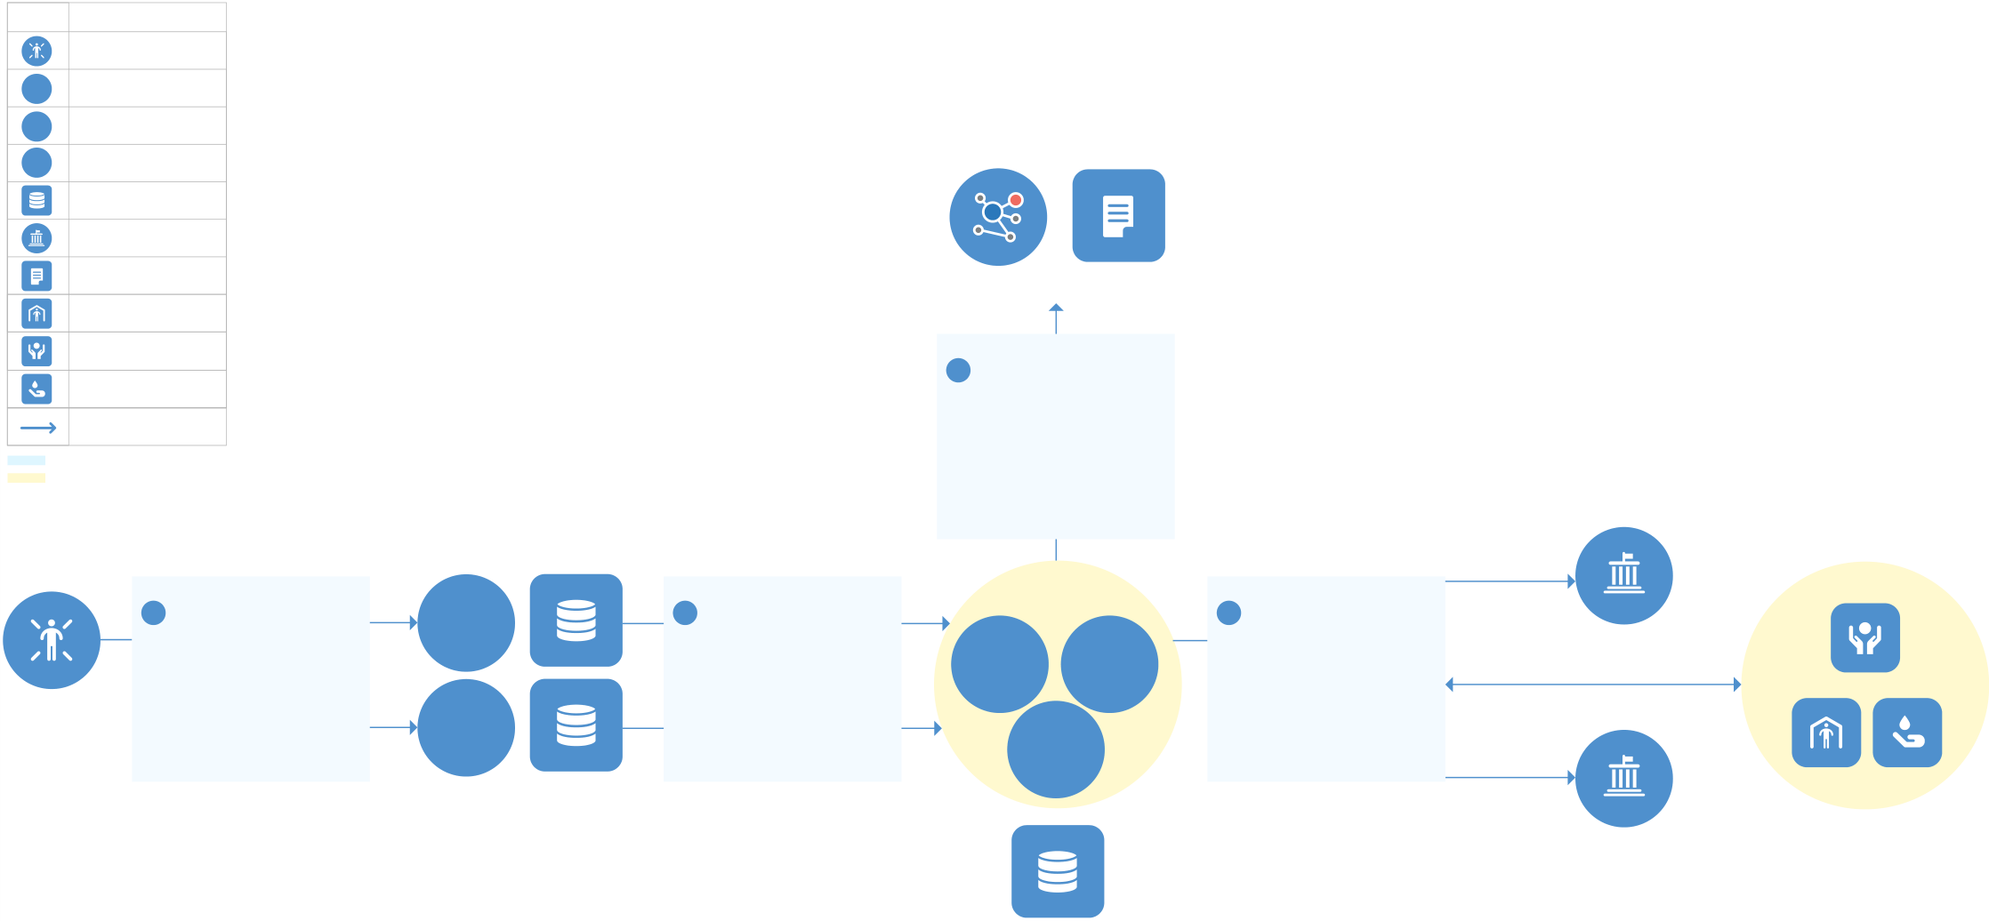
Use the to develop and maintain the registry for your organization.
The details of each data management activity can also be visualized in a data management diagram. A diagram offers a can help identify gaps in data sharing, infrastructure or guidance.
Use the to develop the diagram. The organization-level registry and diagrambed below.
The data management diagram below shows the steps of a hypothetical Multi-Sector Needs Assessment (MSNA).
1. Two NGOs collect data from affected people after obtaining consent using the MSNA Informed Consent Form. The NGOs store the data locally on servers in their offices in line with the MSNA Terms of Reference (ToR) and local data protection legislation.
2. The NGOs share the data with the Assessment Working Group (AWG), which consists of two UN entities and an International Organization. The AWG compiles the data and stores it in the cloud.
3. The AWG shares disaggregated data with the clusters for analysis, which the clusters share back with the AWG once complete. The AWG also shares aggregated data with the local government and a donor government in line with the Information Sharing Protocol (ISP).
4. The AWG synthesizes the clusters’ analysis and publishes a needs assessment report. It also shares the underlying aggregated data on the Humanitarian Data Exchange.
DATA MANAGEMENT DIAGRAM: A MULTI-SECTOR NEEDS ASSESSMENT
Symbols Entity or Object
Afected People
UN UN
IO Other IO
NGO NGO
Infrastructure
Government
Publication | HDX | REPORT
Shelter
Protection  Wash  Data Transfer  Governance / Guidance | 4 PUBLICATION  MSNA Terms of Reference;  Information Sharing  Protocol
Group / Cluster
AFFECTED | 1 COLLECT & STORE | NGO | LOCAL STORAGE | 2 SHARE | Assessment  Working Group |  | 3 SHARE | Aggregated Data | Clusters
 | MSNA Terms of Reference; Local Data Protection  Legislation; Informed  Consent Form |  |  | MSNA Terms of Reference; Information Sharing  Protocol | UN | UN | MSNA Terms of Reference; Information Sharing  Protocol; Local Data  Protection Legislation | LOCAL GOVERNMENT | PROTECTION
 |  | NGO |  |  | IO |  |  | Disaggregated Data | SHELTER | WASH
PEOPLE
 |  |  |  |  |  |  |  | Aggregated Data
DONOR GOVERNMENT
CLOUD STORAGE
JULY 2022 |  | 2


STEP 2: COMPILING REGISTRIES AT THE CLUSTER/SECTOR-LEVEL AND SYSTEM-WIDE LEVEL
The second step to understanding data ecosystems involves sharing the organization-level data management registry and diagrams with relevant clusters/sectors and with the Information Management Working Group (IMWG) or similar coordination group for compilation. This helps identify data gaps and duplication at the cluster/sector-level and system-wide level. It also enables prioritization and strategic decision-making on responsible data management.
Clusters/sector leads should maintain a cluster/sector-level registry of the data management activities led by their members and relevant to their thematic area of focus. For example, a health cluster data management registry might include activities such as disease monitoring, health facility tracking, distribution of medical supplies. The cluster/sector-level registry should be developed based on the Data Management Registry Template.
At the system-wide level, a registry should contain all data management activities in a response, categorized by lead orga registry would be compiled by OCHA on behalf of the IMWG, again using the .
Registries should be shared publicly to ensure transparency around data management activities.2 In some response environments — notably in conflict settings — the fact that a given data management activity is taking place or specific details about the activity may need to be kept confidential. Any risk associated with sharing the registry should be considered by the lead organization for the activity and in consultation with the relevant cluster/sector partners and OCHA.
STEP 3: DEVELOPING DATA ECOSYSTEM MAPS
The third step is developing data ecosystem maps. A data ecosystem map is a visualization of the various ways that data flows between and among actors in multiple data management activities. OCHA should develop a data ecosystem map at the system-wide level, in consultation with the IMWG and ICCG.
Given the complexity of data ecosystems, it may be best to use a white-board or flip chart to sketch out the priority data management activities in your response. If useful, you can then create a digital version using the visualization tools and software designed for this purpose.3 Some details may be excluded to reduce complexity and improve the legibility of the data ecosystem map.
The data ecosystem map below represents a data ecosystem in which four hypothetical data management activities are taking place. These include a mobility tracking activity, a needs assessment, internal displacement tracking, and response monitoring. Visualizing these data management activities together helps gain a quick understanding of the actors involved in data management across the response, how data flows between those actors and where there is room for improving the data ecosystem.
2 For example .
3 Tools include the , the (see package 4 from
page 163) or the template provided in Annex D of the . is a suitable
tool to visualize data ecosystem maps. Free online tools should be used with caution given data security risks.
3


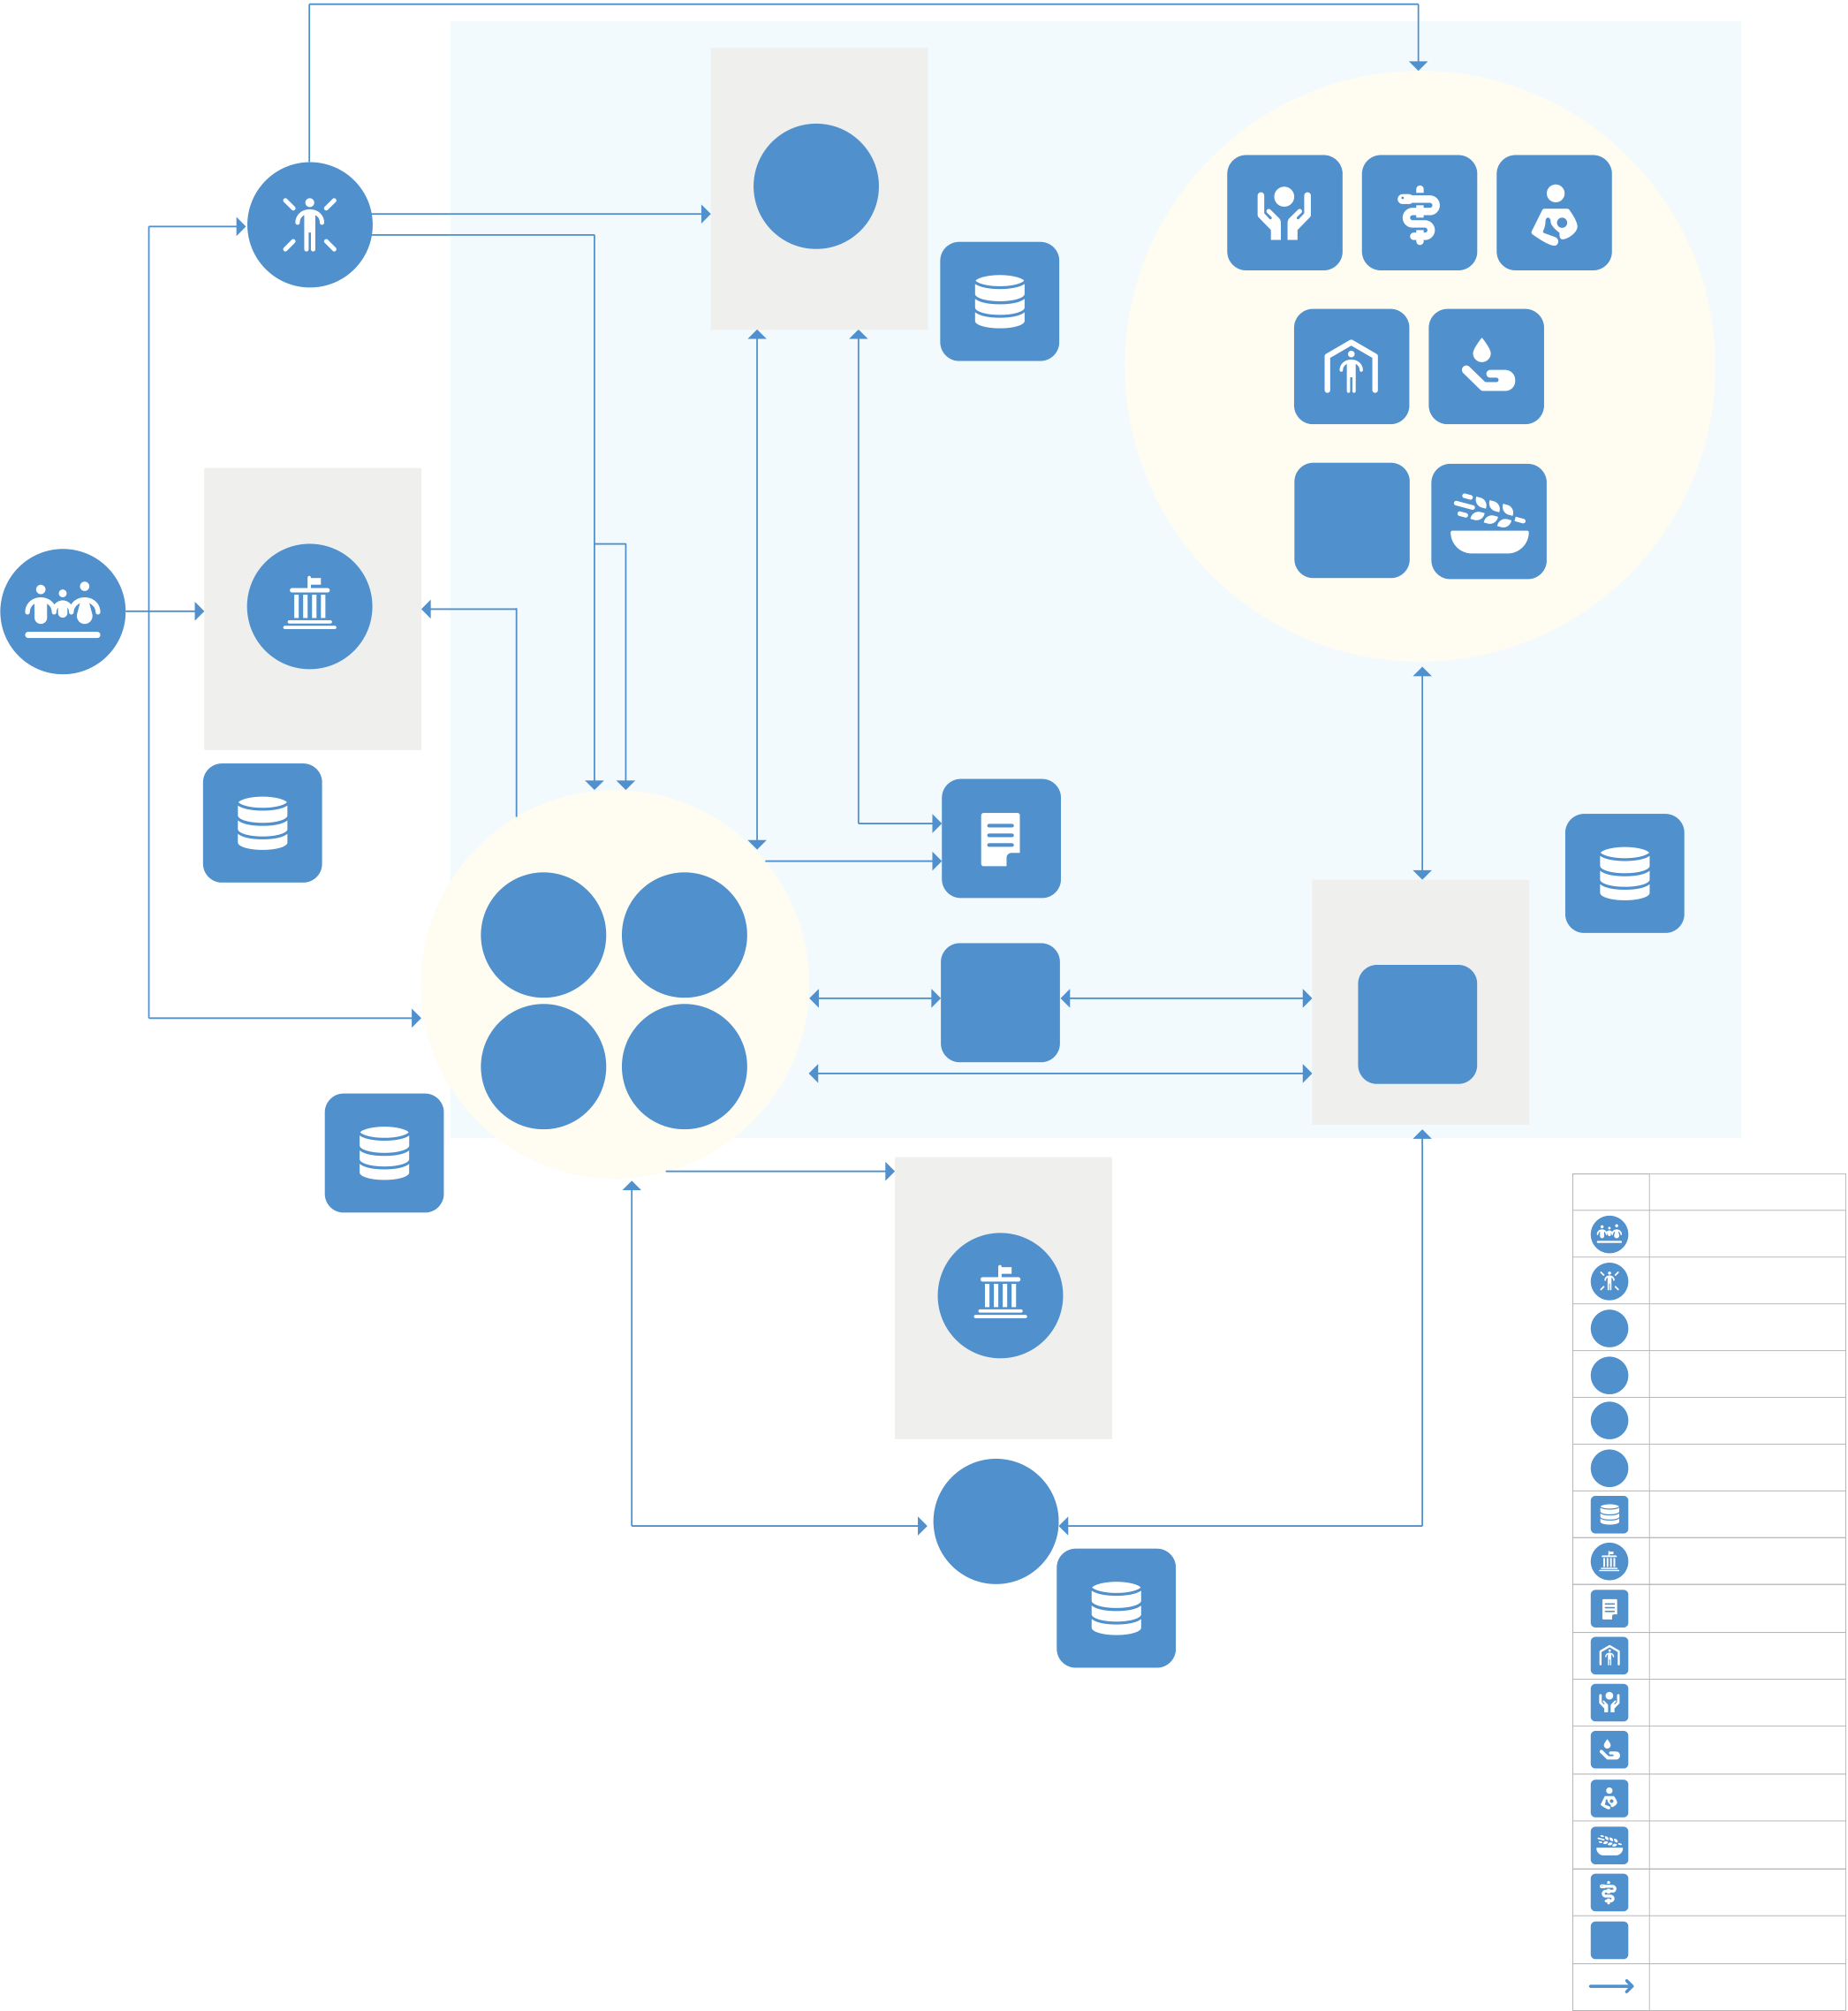
POPULATION, ASSESSMENT, INTERNAL DISPLACEMENT & RESPONSE MONITORING ECOSYSTEM MAP
Response data
Information Sharing  Protocol | IDP Guiding  Principles
UN
POPULATION | AFFECTED POPULATION | Needs | Displacement | IOM-DTM | LOCAL & CLOUD | PROTECTION | HEALTH | NUTRITION
 | Census Data  Protocol |  |  |  | STORAGE | SHELTER |  | WASH
 |  |  |  |  |  | NFI
 | HAC | data | data |  |  | FOOD SECURITY
 | LINE MINISTRIES
IA Assessment
Groups
LOCAL STORAGE | UN | IO | PUBLICATION |  | Data Management Protocols | LOCAL & CLOUD
 |  |  | ISCG | 3/4Ws data
 |  |  |  |  |  | STORAGE
Population data SADD | NGO | CBO | IMWG |  | SECTORS | Symbols Entity or Object
 |  |  | Population, Assessment, Displacement data
Data Protection
Legislation
LOCAL & CLOUD |  |  | DONOR |  |  | Population
STORAGE |  |  |  |  |  | Afected Population
 |  |  |  |  |  | UN | UN
 |  |  |  |  |  | IO | Other IO
 |  |  | GOVERNMENT |  |  | NGO | NGO
 |  |  | FTS |  |  | CBO | CBO
 |  |  |  |  |  | Infrastructure
Government
Publication
Shelter
CLOUD STORAGE Protection
Wash
Nutrition
Food Security
Health
NFI NFI
Data Transfer
Information Sharing Protocol
Applicable Guidance
Group / Cluster
4



Data ecosystem maps should be completed and updated annually by OCHA in consultation with the IMWG and ICCG. They can be shared publicly unless they contain data management activities that should be kept confidential. They should also be shared with the Humanitarian Country Team for reference.
CONCLUSION
The development of data management registries, diagrams and data ecosystem maps improves the transparency of data management in humanitarian response. Following the three steps presented in this tip sheet can lead to a better understanding of the actors, data flows and opportunities for improving data management across a data ecosystem. The OCHA Centre for Humanitarian Data is available for advisory support to offices and organizations interested in developing these outputs.
COLLABORATORS: .
The('the Center'), together with key partners, is publishing a series of guidance notes and n Humanitarian Action over t the and the , respectms to provide additional guidance on specific issues, processes and tools for data responsibility in practice. The guidance notes and tip sheets published in 2022-2023 have been made possible with the support of the Government of Switzerland.

5

