Some sites references:
csszengarden.com
caniuse.com → to check which browser support which tag

Block-Level Element Inline Element
Render to begin on new line(By Default) Render on the same line (By Default)
May Cotain Inline or other Block-level Element May Only contain Inline Element
Roughly traslet into a new HTML5 category of Flow Content Roughly translet into a new HTML5 category of Phrasing Content
<section>,<article> <nav> element is inline element
<a> is block-level Content Element
and Inline Elemt
It's always good idea to define <title> attribute for <a> tag.

Semantic Html element
The element which tells you something about the content.
wheather it's little bit of description or wheather it's importance.
Basically hints to you to that meaning.
May help search engine ranking.
Help human to better understand the structure of the page.
Help Computer to better understand the structure of the page

List
It simply allows you to group related content.
Text aren't allowed in UI tag without using LI tag.

Istead of followig characters
< > &

We ca use
< > &
&lt; &gt; &amp;

&nbsp is very usefull for nonbreaking space.

if you change the view selection in browser from default to any other
for example: use &quote for "

Links
If defined links are in a same directory then it's good to use title like "same dir link" or something.

External link
always defined with starting of https://

Image
ALways remeber to define width and height

<html>
<!-- CSS -->
</html>

It's always good idea to define <title> attribute for <a> tag.

Syntax of CSS rule
Selector
Declaration
Property/Value Pair

Element Selector
Let's clear this with an example:

p{
color: blue;
}

This will give blue color to every paragraph

Class Selector

.blue{
color: blue;
}

<p class="blue">...</p>
<p>..</p>
<div class="blue">..<div>
...

ID selector

#blue{
color: blue;
}

<p class="blue">...</p>
<p>..</p>
<div id="blue">..<div>

Grouping Selectors

div, .blue{
color: blue;
}

<p class="blue">...</p>
<p>..</p>
<div>..<div>

So above will apply blue color to paragraph and every div in that file.

p.big {
font-size: 20px;
}

<p class="big">....</p>
<div class"big">..</p>

text withing <p> will get font-size 20 while text withing div will not.

Child Selector

selector > selector

selector followed by another selector

for an Example

article > p
{
color: blue;
}

<article>
<p>...</p> ->text wil affect with above css
</article>

<p>...</p> -> text won't affect with above css

<article>
<div><p>..</p></div> -> text won't affect with above css
</article>

article p
{
color: blue;
}

<article>
<p>...</p> ->text wil affect with above css
</article>

<p>...</p> -> text will affect with above css

<article>
<div><p>..</p></div> -> text will affect with above css
</article>

css will apply to <p> with any level untill it's inside <article>

.colored p {
color: blue;
}

Every p inside an element with class="colored"

article > .colored {
color: blue;
}

Every element with class="colored" that is direct child of article element.

Pseudo classBest

Link
Visited
hover
active
nth-child

Link:
Links arent easy to design like other elements.
Links have states that can be express using pseudo classes.

for example:
a: link; a: visited;
| |
one state second state

a:hover -> used to change color when hovering the mouse.
a:active -> used to keep hover effect untill you release the click. -> important

Important element:nth-child
defied using below example.

<header>
<ul>
<li><a href="/">Home</a></li>
<li><a href="http://goo.gl/V0Wl6s" target="_blank">AngularJS Course</a></li>
<li><a href="http://www.facebook.com/CourseraWebDev" target="_blank">Facebook Fan Page</a></li>
</ul>
</header>

if you want to change anything related to facebook link which 3rd child of ul given above.
use-> header li:nth-child(3){
font-size: 40px;
}

You can use odd and even with nth-child as well
for example: nth-child(odd)
nth-child(even)

Style Placement

you can also apply style directly inside the tag using style="text-align: centre;"

for external stylesheet
<link href:"style.css">

Some Rule

origin
merge
inheritance
spcificity

merge:
define some css in external link and define some css in same html file. if defined css within same html file will
overide external css if it's same and remained effects of external css will be the same.

Inheritance

Specificity -> important
style"" ID class,pseudo class,attibute # of Elements

so it's totaly depends on above ranking which css will apply.

Important example of specificity

header.navigation p {
color: blue;
}
p.blurb {
color: red;
}
p {
color: green !important; -> what ever the score will be counted if css is applied withing this type of specific tag then that will apply first
} although the score of p is 1 which is less then both of above defined css 12 and 11 respectively.

Styling text
For text style always try to use "font-family" as you can't not rely on what kind of browser client is using.
For color #0000ff;
R G B
Font-weight is also very useful, you can give range from 100 ... 900 .. bold. It's very useful for font thickness.

Important

<style>
body {
font-size: 120%;
}
</style>
</head>
<body>
<div>Regular text</div>
<div style="font-size: 2em;">2em text
<div style="font-size: 2em;">4em text
<div style="font-size: .5em;">2em again!</div>
</div>
</div>
</body>

Here in above example you can see that for inner font-size we have use "em" which is basically used for the font unit.
2em used in second div basically double the size of "2em text" based on Regular text used in first div.
Same way 4em text will be double based on "2em text".
While "2em again" will be same as "2em text" as we have used font-size: .5em.

The Box Model

Some times it's better to give padding: 0px and Margin: 0px
Because sometime browser by default sets some margin, so you will see some space at the beginning and ending of the sentence.

Important notes
Once you will define width for box for an example:

#box {
background-color: blue;
padding: 10px;
border: 5px solid black;
margin: 40px;
width: 300px;

}

The width of the original box won't be the 300px, it will be 330 which is equal to width + 2 sides border + 2 sides padding.
So because of this reason css3 has given a new feature “box-sizing: border-box” which will give total 300px width to the box.
See example below:

#box {

background-color: blue;
padding: 10px;
border: 5px solid black;
margin: 40px;
width: 300px;
box-sizing: border-box

}

While box-sizing: content-box will give same result of 330px;

Now let's look in to a bit deep inside this.

Let's try to apply box-sizing: border-box to whole body.
If you will remove it from #box and add into body tag and you think it will work like inheritance but it won't work. So what we can do here is

* {
box-sizing: border-box;
}

Here above tag is not asking to inherit anything. It's saying to apply box-sizing: border-box to each and every tag in that file.

Cumulative Margin

For Horizontal:
You give margin to left box 40px from it's right and right box 50px from it's left. The cumulative will become 90px. (distance between two box: 90px)

For Vertical:
You give 20px margin to above box from it's bottom and 30px margin to below level box from it's top. Here margin will collapse and major margin will win. So there will be 30px distance will create between two box.

Overflow: auto is also very use full whenever you can see the text is going out of the box. It's will put scroll bar to that box. By default Overflow is always on “visible”.
Overflow: scroll isn't the preferable one but still you can use it for both way scroll.

Background Property

#bg {
width: 500px;
height: 500px;
background-color: blue;
background-image: url ("/home/dhrumit/Coursera-test1/1.png")
}

Here you will get either single or repeated image on blue background

You can set below property in above css.
Like no-repeat, right, center to set an image.

You can define these properties by using “background-repeat: no-repeat” and “background-position: bottom right”
Or best way is to define all the properties in single like below

background-image: url ("/home/dhrumit/Coursera-test1/1.png") no-repeat right center;

If you will use above formate then you won't get blue color in background because above formate obvious overlap the old properties which defined using background tag in same id. So by defaul It will take white color to overlap blue color in background.

Position Elements by Floating

One thing we should have to know during floating is, once you apply floating then some text might can change their positions. So what we can do is, we should give
section {
clear: left;
}

Above will put text back into left. It will command to the text that nothing is floated in the left.

Clear: both; → important

Once you applied floating the browser will take out that element from regular flow.
For example: There are 4 vertical box in left and if you will apply “float: right;” to first box then first box will move to the right and other box will move upper. Second box will take position of first box.

Applied element's margin will never collapse.

Static positioning
Normal document flow, Default setting for all, except html.
Relative positioning

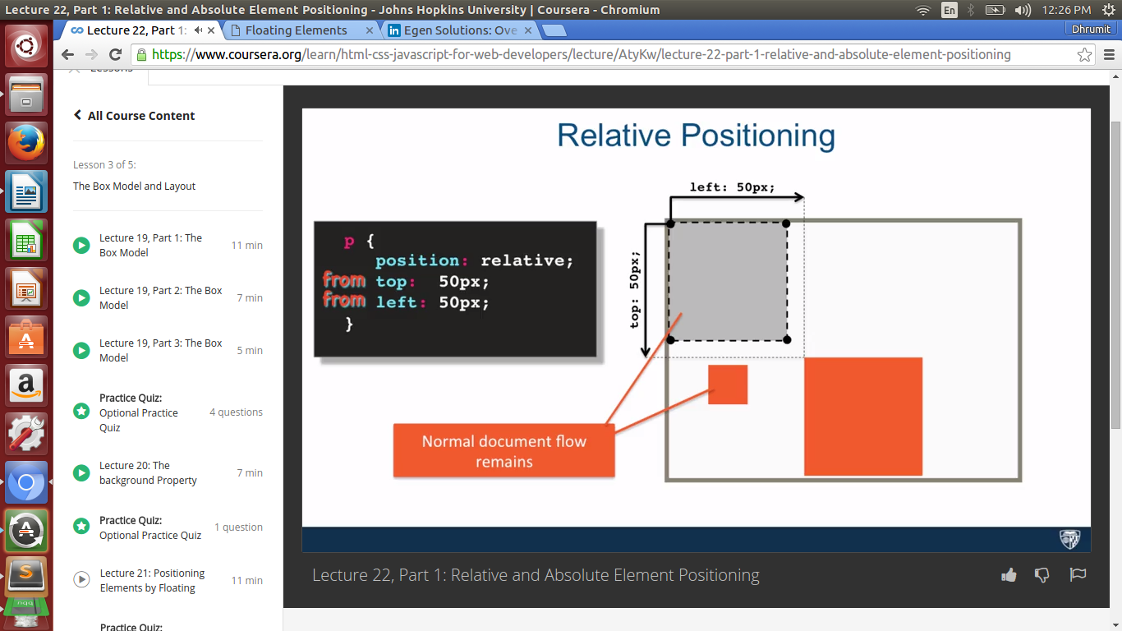

Here you can see position: relative;
Given margins in top ad left are basically “from” top and left.

You ca see normal document flow remains. It's still remain with that space.

Absolute Positioning

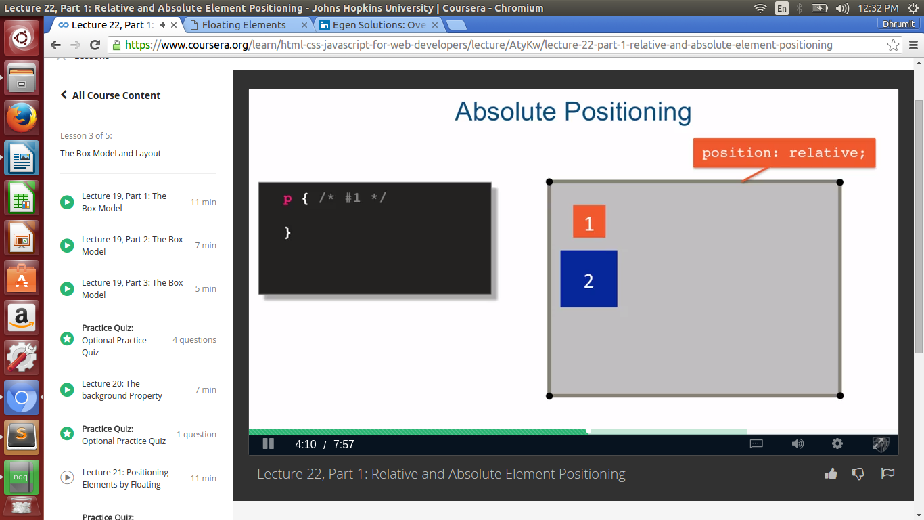

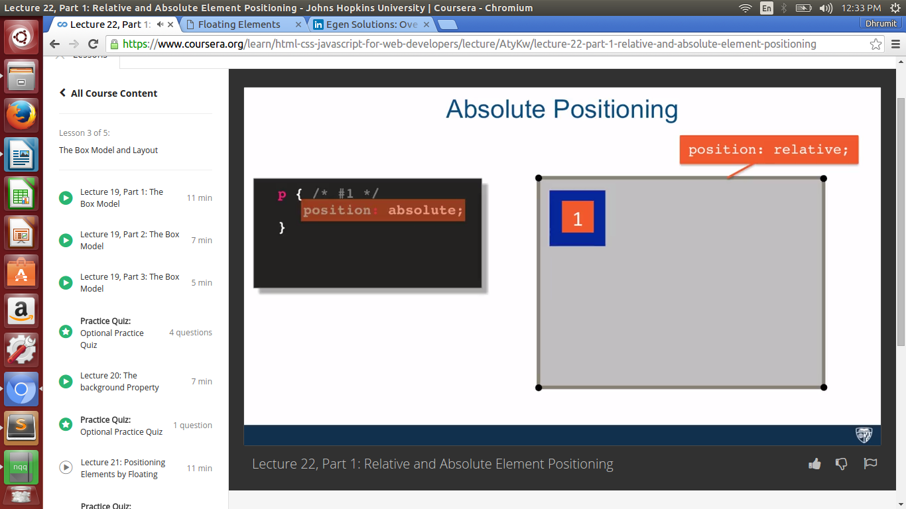

You will get an idea about absolute positioning from above images.
One important thing about the absolute positioning is they need one relative or an absolute parent for positioning.

Static positioning is default for all elements except html. Html has by default relative positioning.

Media Query

@media (max-width: 767px) {
p{
color: blue; }

}

it's starts with media tag and followed by Media features (max-width: 767px).

This is seems to be like conditions if Media features gets true then defined css inside it will apply.

Some common Media query features

@media (max-width: 800 px) {…}
@media (min-width: 800 px) {…}
@media (orientation: properties) {…}
@media screen {…}
@media print {…}

We can apply conditions within media query as well.

@media (max-width: 800px) and @media (min-width 800px)
@media (max-width: 800px) , @media (min-width 800px)

Things to learn:

Don't overlap media rang points.

Responsive Design:

It's very important to keep in mind that our design must works for moblie browsers as well.

12 column grid layout

media (min-width: 1200px) {
.col-lg-1, .col-lg-2, .col-lg-3, .col-lg-4, .col-lg-5, .col-lg-6, .col-lg-7, .col-lg-8, .col-lg-9, .col-lg-10, .col-lg-11, .col-lg-12 {
float: left;
border: 1px solid green;
}
.col-lg-1 {
width: 8.33%;
}
.col-lg-2 {
width: 16.66%;
}
.col-lg-3 {
width: 25%;
}
.col-lg-4 {
width: 33%;
}
.col-lg-5 {
width: 41.66%;
}
.col-lg-6 {
width: 50%;
}
.col-lg-7 {
width: 58.33%;
}
.col-lg-8 {
width: 66.66%;
}
.col-lg-9 {
width: 74.99%;
}
.col-lg-10 {
width: 83.33%;
}
.col-lg-11 {
width: 91.66%;
}
.col-lg-12 {
width: 100%;
}
}

/********** Medium devices only **********/
@media (min-width: 950px) and (max-width: 1199px) {
.col-md-1, .col-md-2, .col-md-3, .col-md-4, .col-md-5, .col-md-6, .col-md-7, .col-md-8, .col-md-9, .col-md-10, .col-md-11, .col-md-12 {
float: left;
border: 1px solid green;
}
.col-md-1 {
width: 8.33%;
}
.col-md-2 {
width: 16.66%;
}
.col-md-3 {
width: 25%;
}
.col-md-4 {
width: 33%;
}
.col-md-5 {
width: 41.66%;
}
.col-md-6 {
width: 50%;
}
.col-md-7 {
width: 58.33%;
}
.col-md-8 {
width: 66.66%;
}
.col-md-9 {
width: 74.99%;
}
.col-md-10 {
width: 83.33%;
}
.col-md-11 {
width: 91.66%;
}
.col-md-12 {
width: 100%;
}
}

Just understand the code above. It's given for large size device and medium size device.

Bootstrap

Bootstrap is most popular HTML,CSS and JS Framework for developing responsive, mobile first projects on the web.
Consists mostly of css classes.

<title>Boostrap Starter Page</title>
<link rel="stylesheet" href="css/bootstrap.min.css">
<link rel="stylesheet" href="css/styles.css">

Here we will customize the css and overlap the bootsrap css using our css.

<script src="js/jquery-1.11.3.min.js"></script>
<script src="js/bootstrap.min.js"></script>
<script src="js/script.js"></script>

Here is the bootstrap javascript. Bootstrap javascript is depends upon the jquery, so first we have to declare a jquery.

Bootstrap grid system

Just look below two images you will get an idea about the bootstrap grid system,

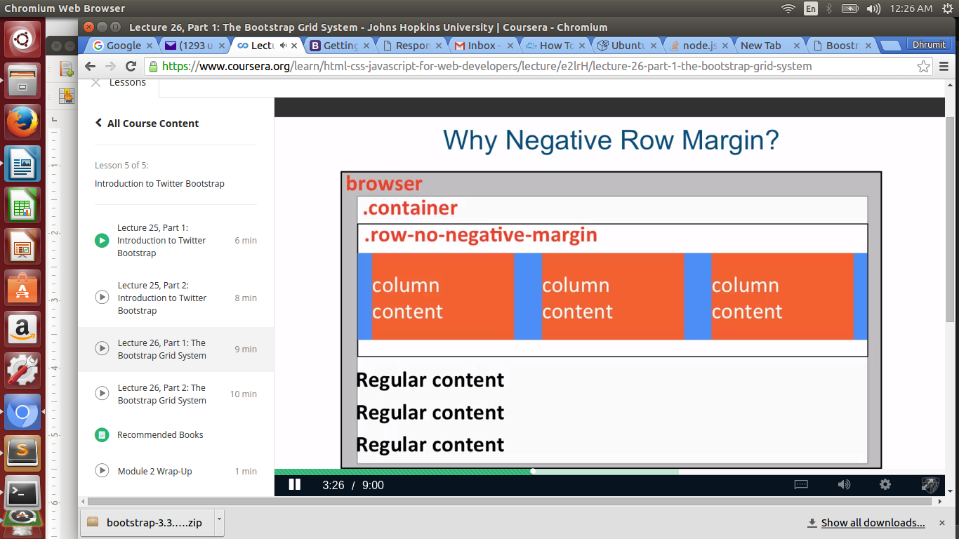
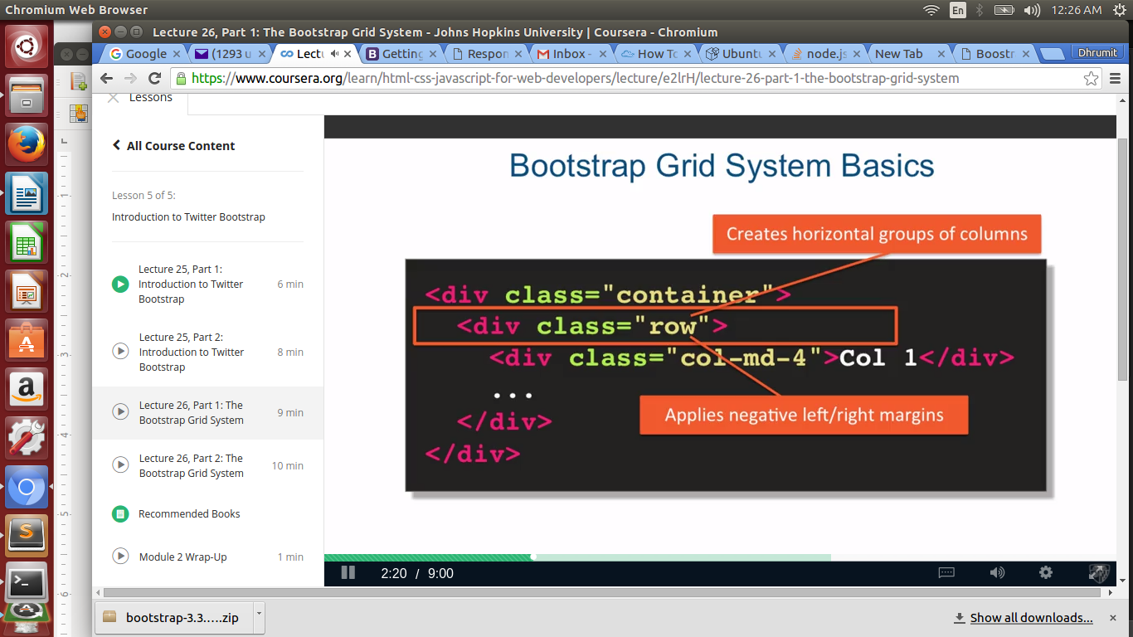

Above you can see that Regular contents aren't properly placed below the .row class

what we will do now is we will add .row class withing -15px negative margins.
So we will get result as below.

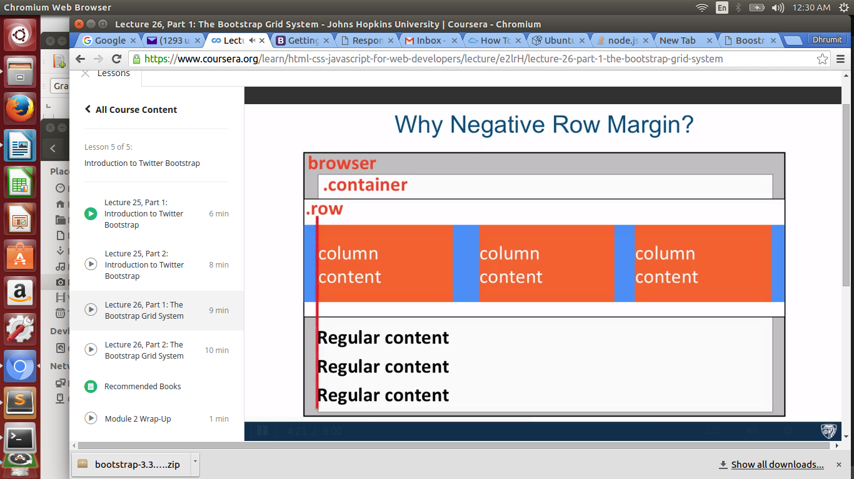

For class=”col-md-4”

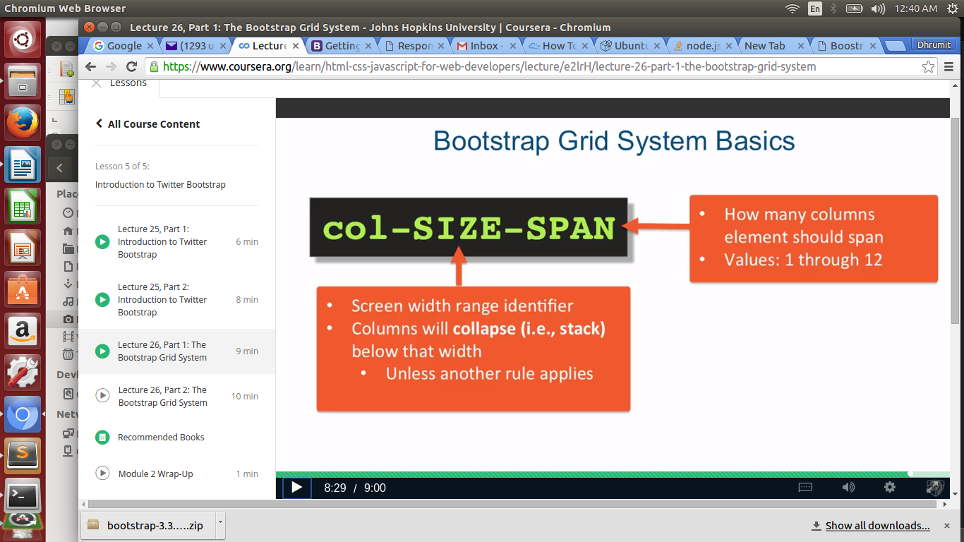

Grid Behaviour → Important

small: .col-sm-
(>=768px)

medium: col-md-
(>=992px)

Larg: col-lg-
(>=1200px)

but for extra small it's different

Extra small: .col-xs-
(<768px) → this will keep layout no matter what size the screen is.

