**Technologies that I have used as below.**

**Client side:**Angular2  
 **Server side:** Node.Js  
  
**Database:** MongoDB

1. **Front look**

This is the front page of my mentor-mentee web application.

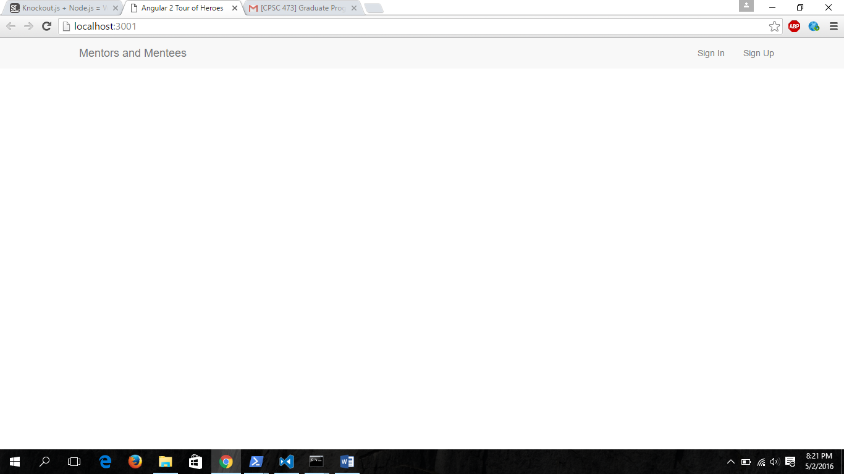

1. **Now I will sign-up two user.**
2. **Dhrumit Thakkar as a mentor**
3. **You me as a mentee.**

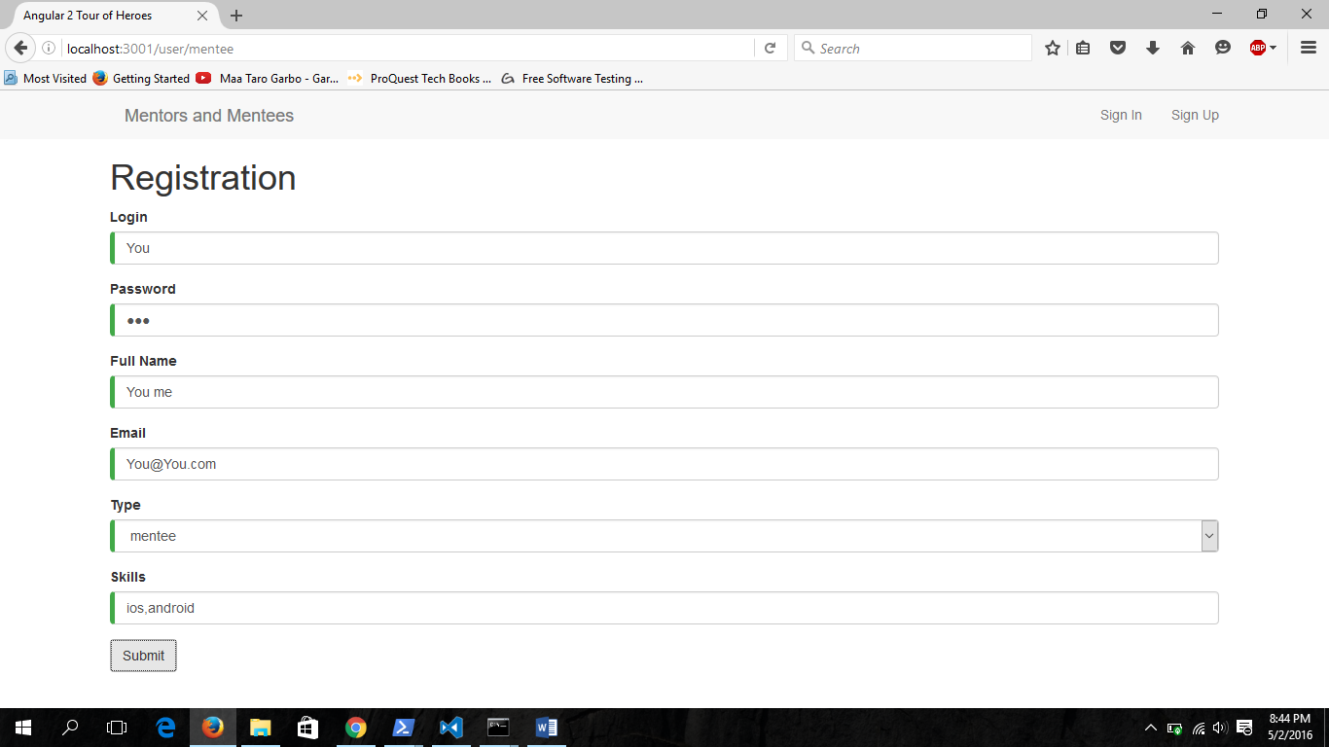

1. **I will click on sign in and will enter my login and password**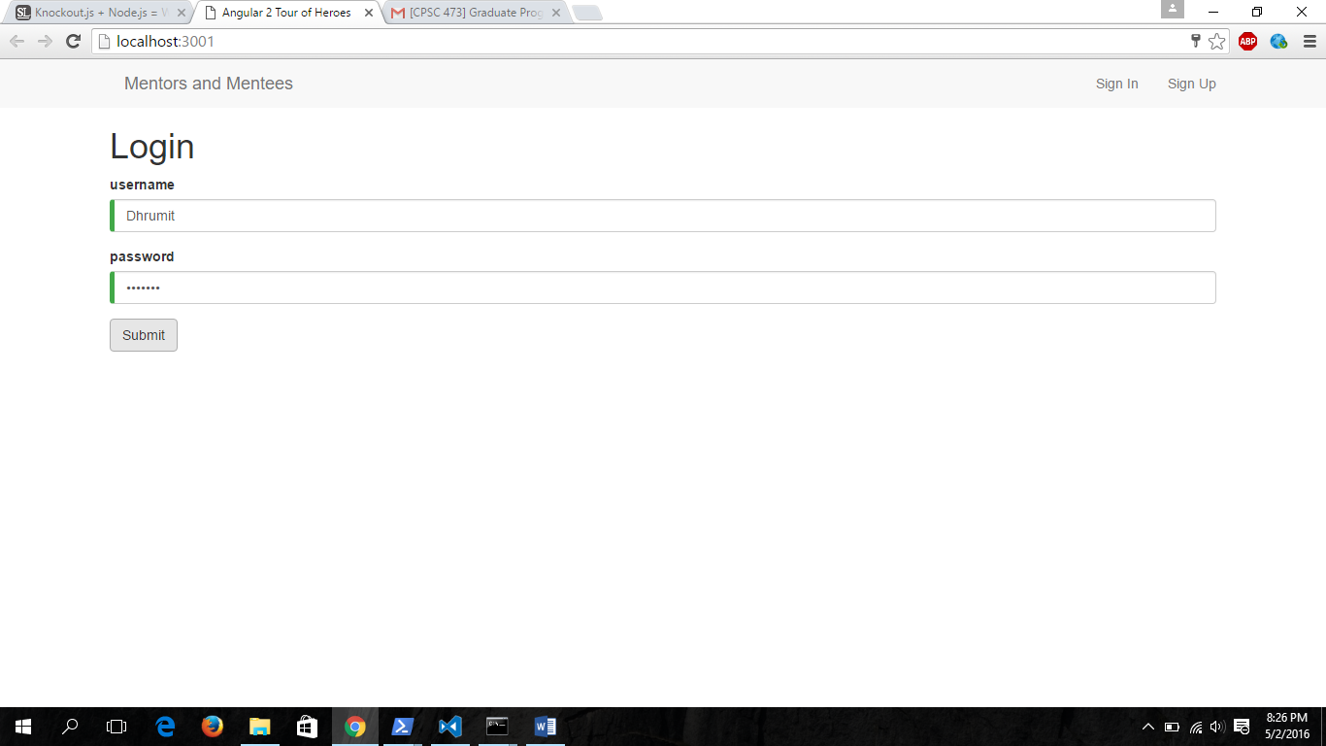
2. **When I will be logged in using my signup information then it will be look like as below. Here I have chosen Dhrumit Thakkar as a “mentor” so when he will login it will show three main pages.**
3. **Left hand side on top, list of mentees: “Mentees”. This will gives you list of people who are registered as mentee.** 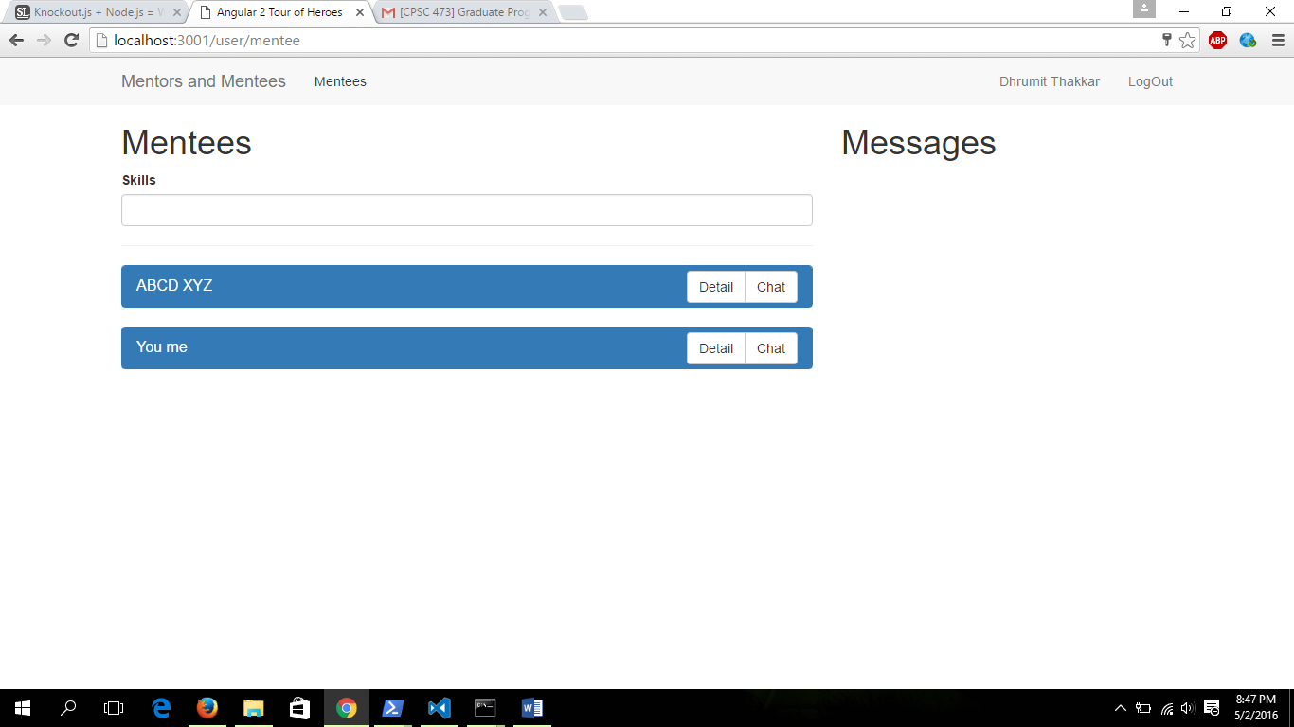
4. **As per my project proposal I have put search button based on skill**

**Let me write “ios” so it will gives you mentees based on skill “Ios”.  
This will work same for mentees. “Mentees” can search mentor based on skill using that search button.**

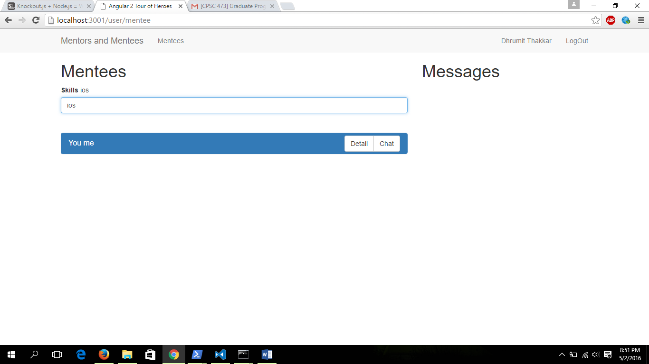

1. **Details will gives you info about mentee  
   which includes mail id:** [**you@you.com**](mailto:you@you.com) **(mentee profile)**

**Skills: (ios,android)**

**Rate button: which I have set 4 for this mentee and you can see on right side of detail button which shows 4 rate for this mentee.**

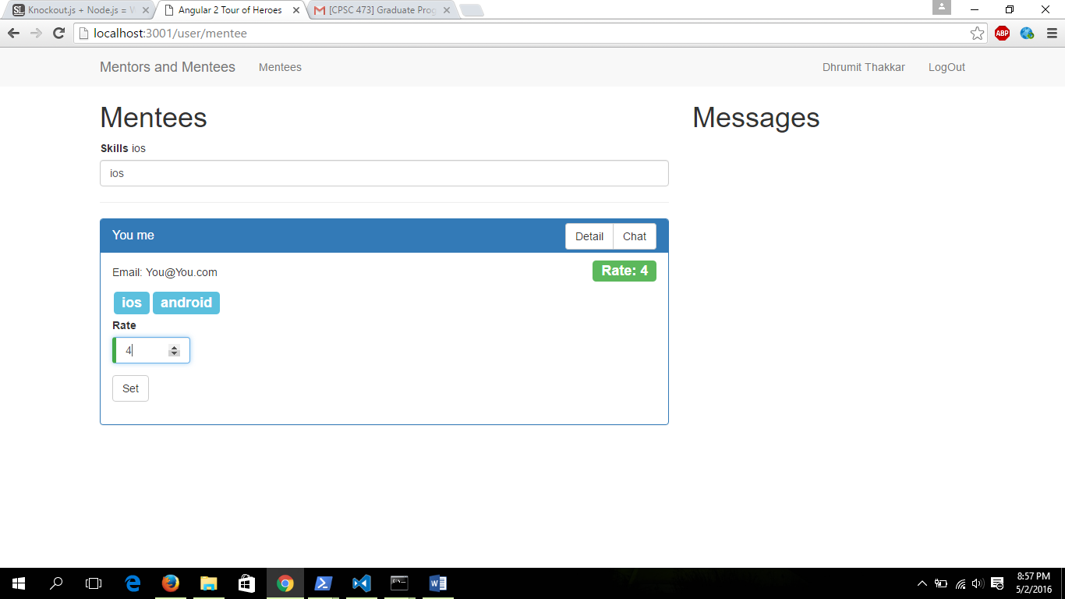

1. **By simpli clicking on chat button Mentor “Dhrumit Thakkar” can send message to Mentee ”You me”.**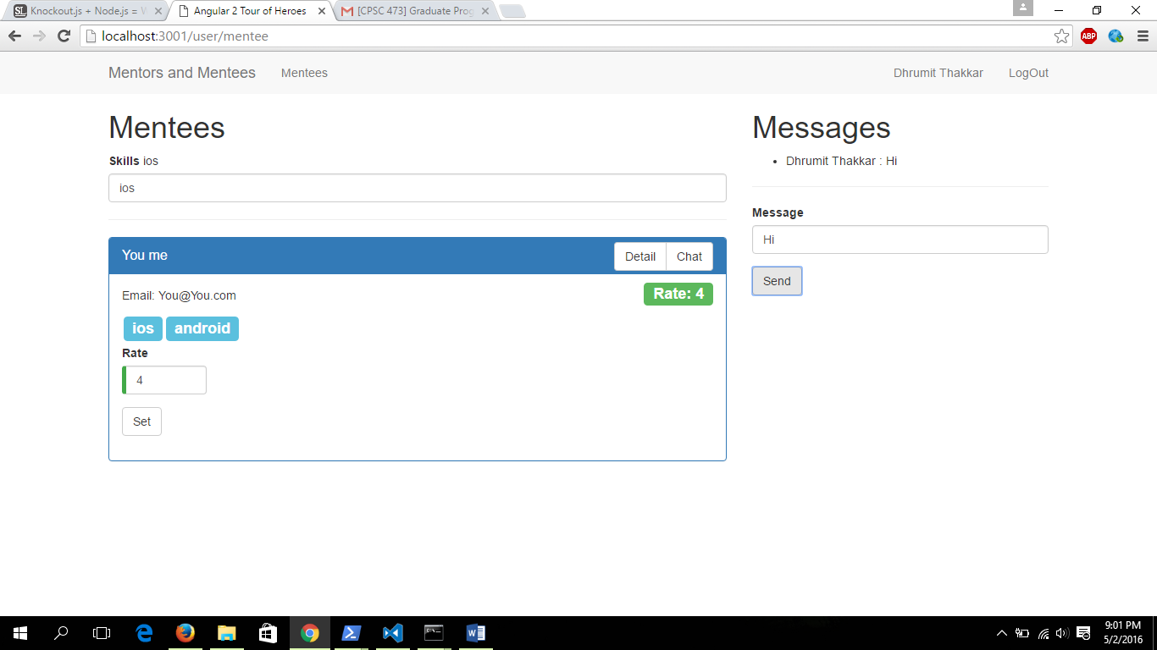

**Now I will open profile of Mentee “You me”. Here mentee which get notification on the top which will shows that Mentee “You me” got message from Mentor “Dhrumit Thakkar”.**

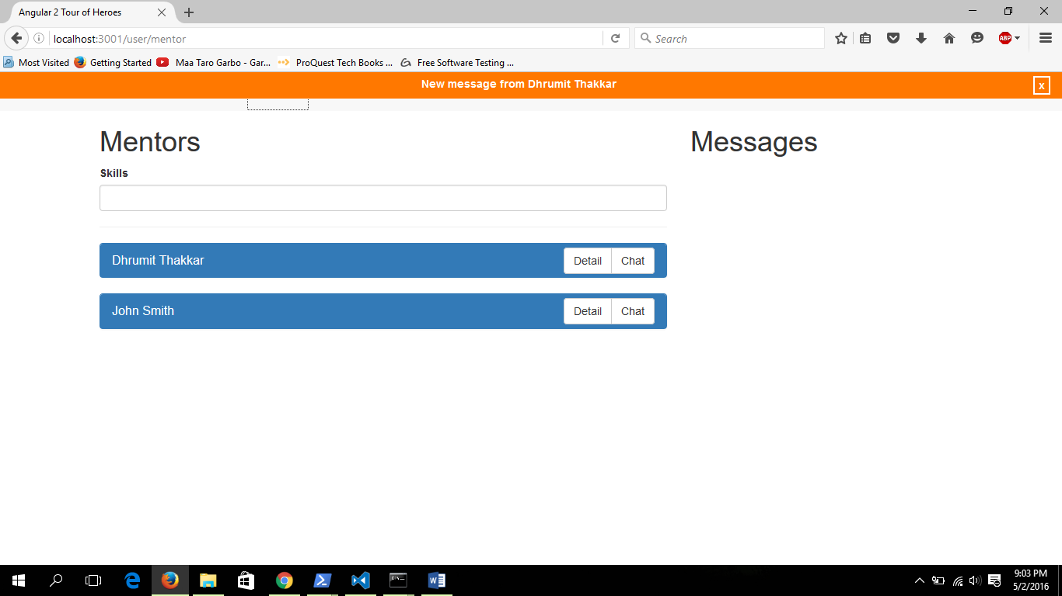

**Now From Mentee profile you can simply click on chat button of Mentor “Dhrumit Thakkar” it will show you message from mentor “Dhrumit Thakkar” and by replying Mentor “Dhrumit Thakkar” and Mentee “You me” can chat with each other.**

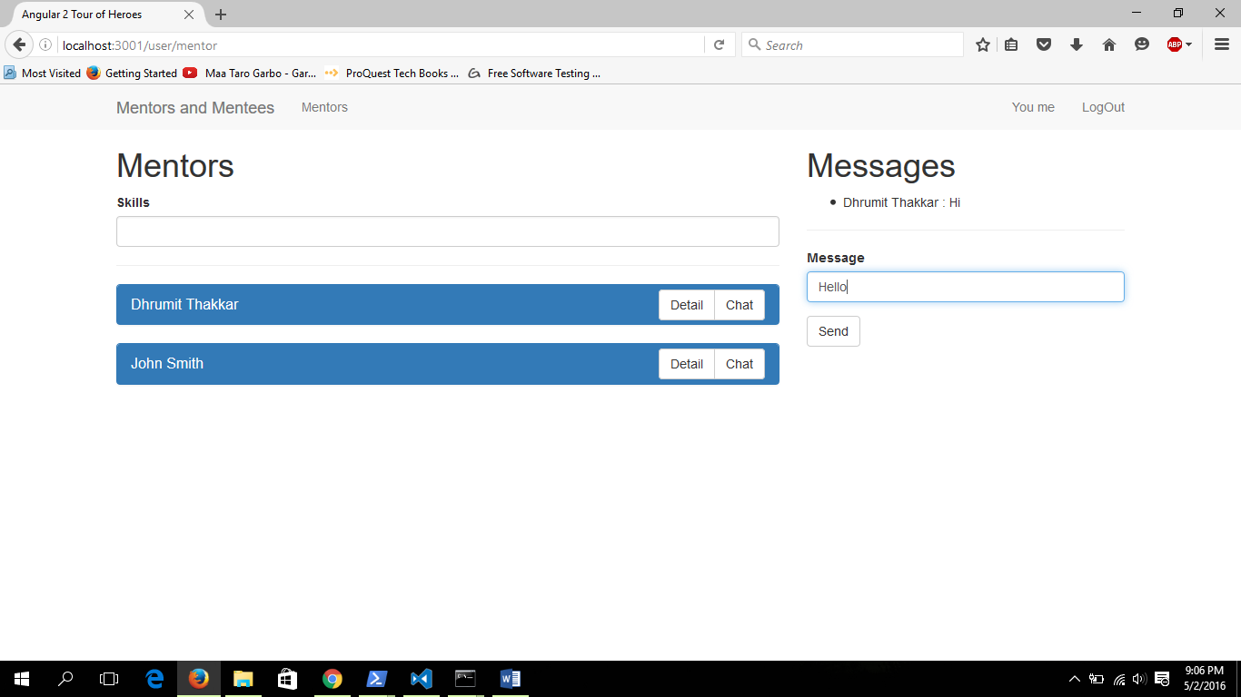

**Here mentee “you me” is replying back to mentor “dhrumit Thakkar” and you can see that text is received by “Dhrumit Thakkar”**

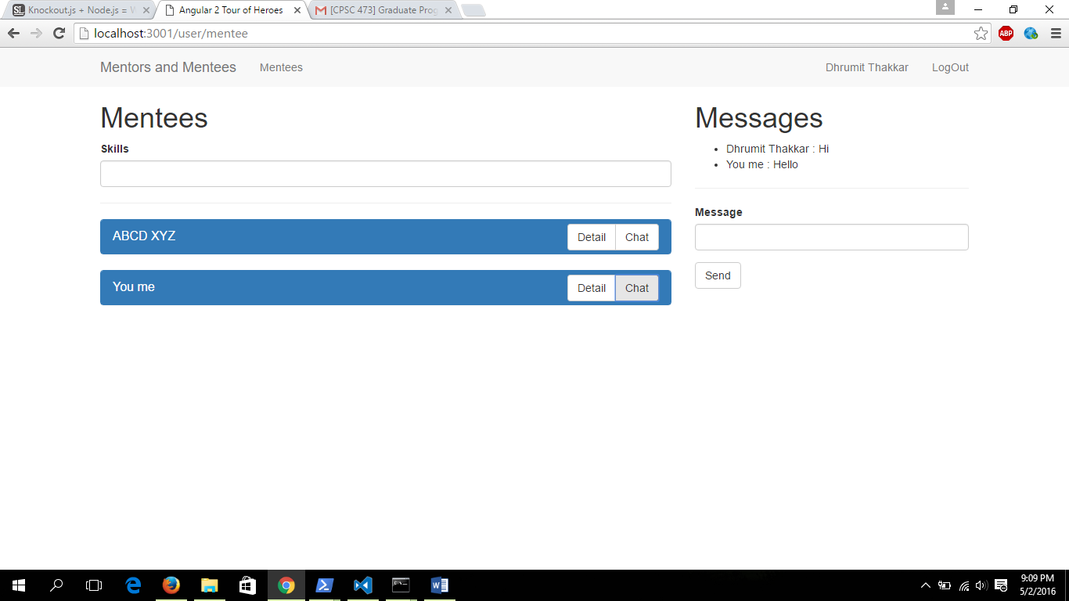

**2. Right hand side on top Profile of “Dhrumit Thakkar” Which shows profile of “Dhrumit Thakkar” as below.**

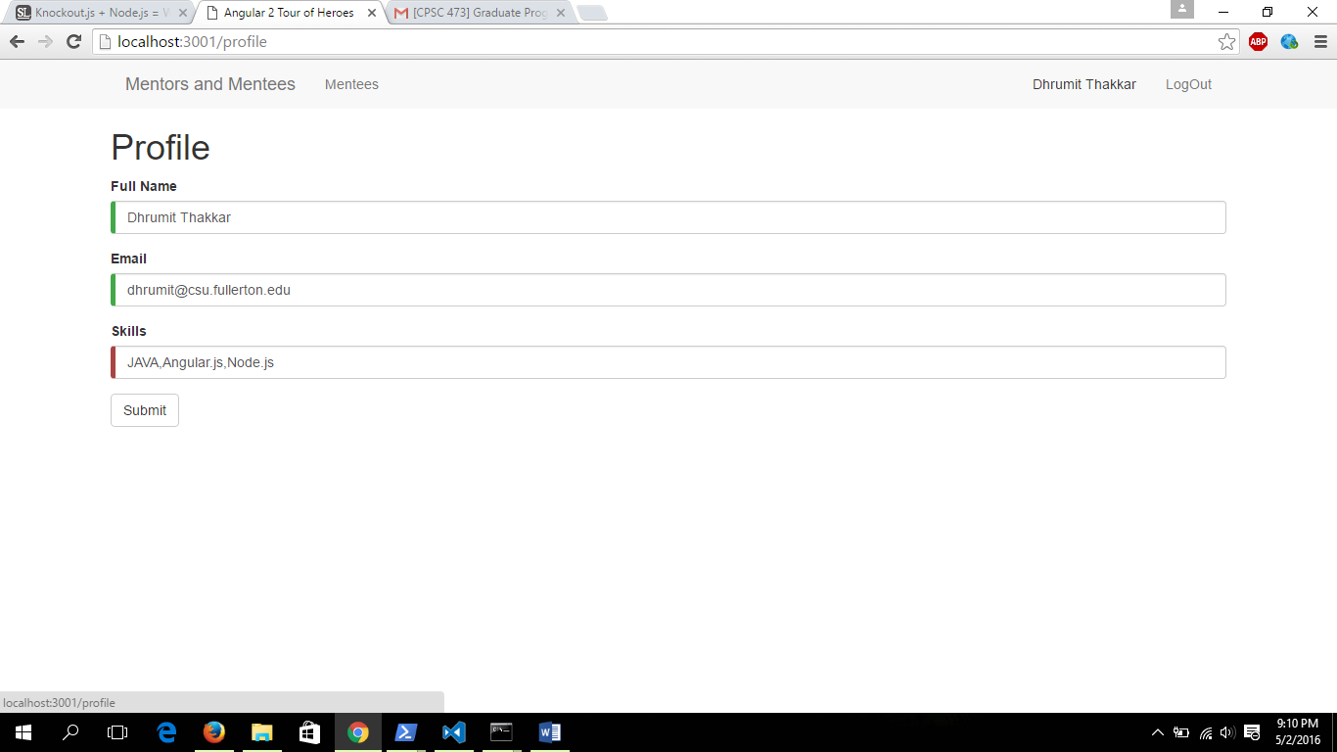

1. **Let me update skills of “Dhrumit Thakkar” from JAVA,Angularjs,Node js to .NET**

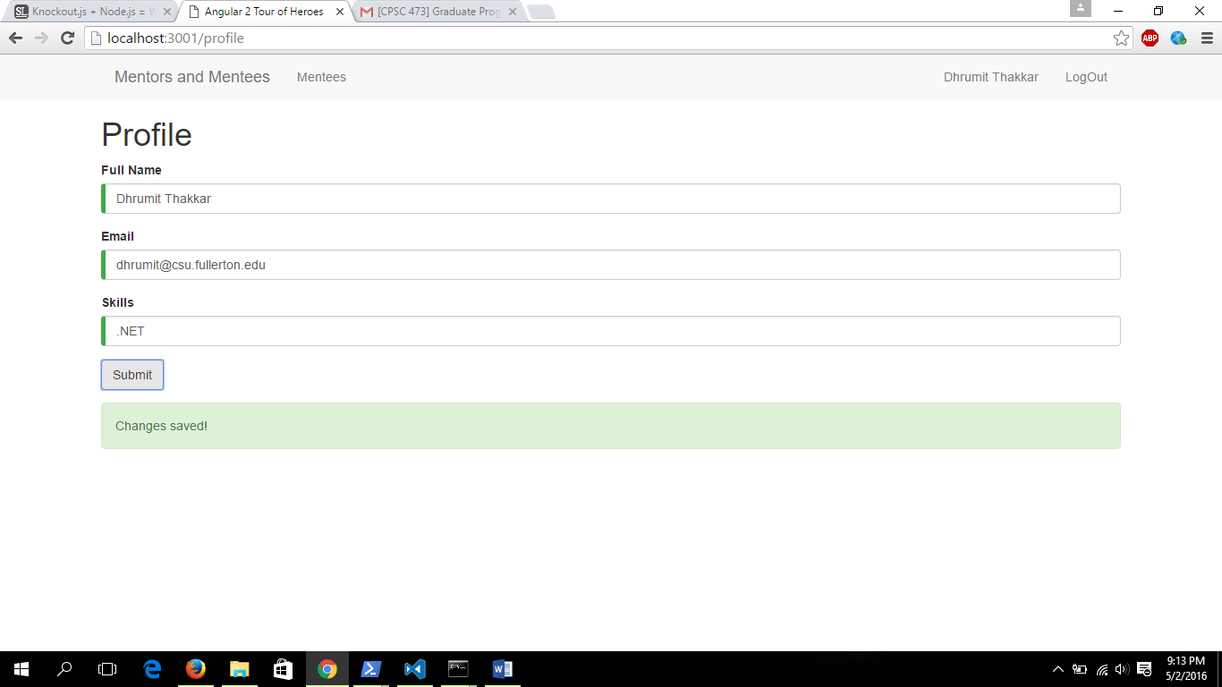

1. **Now from the profile of mentee “You Me” you can see in to “Dhrumit Thakkar”. Skills are changed to .NET.**

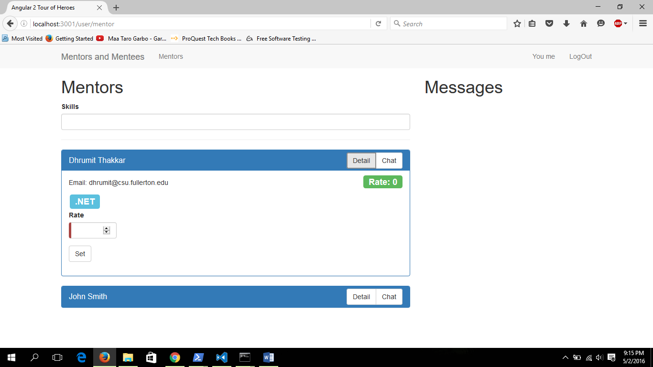

**3. Logout.**

**By simply clicking on Logout button it will redirect you to the login page.**

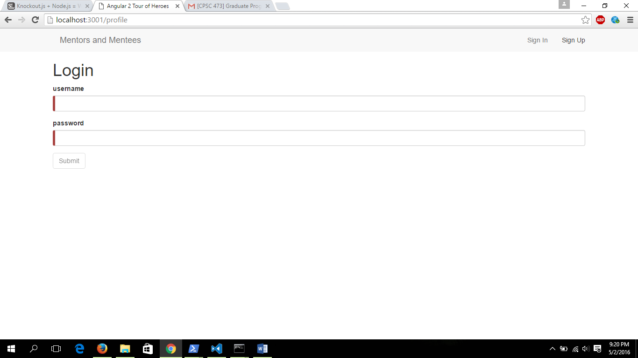

**Here in my application we can’t use same Login Name for multiple registration.**