CUSTOMER SHOPPING
BEHAVIOR ANALYSIS
Project Report
SQL • Python • Power BI

Table of Contents
1. Project Overview
2. Dataset Summary
3. Exploratory Data Analysis using Python
4. Data Analysis using SQL
5. Power BI Dashboard
6. Business Recommendations
7. Conclusion
Appendix A — Screenshot Reference

1. Project Overview
This project analyses customer shopping behaviour using transactional data from 3,900 purchases across multiple product categories. The primary goal is to uncover insights into spending patterns, customer segments, product preferences, discount behaviour, shipping choices, and subscription activity so that the findings can support practical business decisions.
The workflow combines Python-based data preparation and exploratory analysis, SQL-based business analysis, and an interactive Power BI dashboard for visual communication.

2. Dataset Summary
Attribute | Description
Rows | 3,900
Columns | 18
Customer demographics | Age, Gender, Location, Subscription Status
Purchase details | Item Purchased, Category, Purchase Amount, Season, Size, Color
Shopping behavior | Discount Applied, Promo Code Used, Previous Purchases, Frequency of Purchases, Review Rating, Shipping Type
Missing data | 37 values in the Review Rating column
The dataset contains customer-level transactional records. The analysis uses both numeric fields (such as age, purchase amount and review rating) and categorical fields such as category, gender, subscription status and shipping type.

3. Exploratory Data Analysis using Python
The initial stage focused on understanding the dataset's structure and quality before loading the cleaned data into the database for SQL analysis.
- Data Loading: Imported the dataset using pandas.
- Initial Exploration: Used df.info() to inspect the structure and df.describe() for summary statistics.
- Missing Data Handling: Checked for null values and imputed missing values in the Review Rating column using the median rating of each product category.
- Column Standardisation: Renamed columns to snake_case for better readability and documentation.
- Feature Engineering: Created an age_group column by binning customer ages.
- Feature Engineering: Created purchase_frequency_days from the purchase-frequency information.
- Data Consistency Check: Verified whether discount_applied and promo_code_used were redundant and dropped promo_code_used.
- Database Integration: Connected the Python workflow to the database and loaded the cleaned DataFrame for SQL analysis.
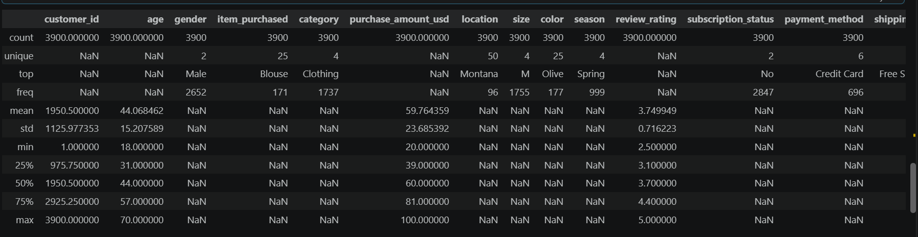
Figure 1. Python dataset preview and descriptive statistics.
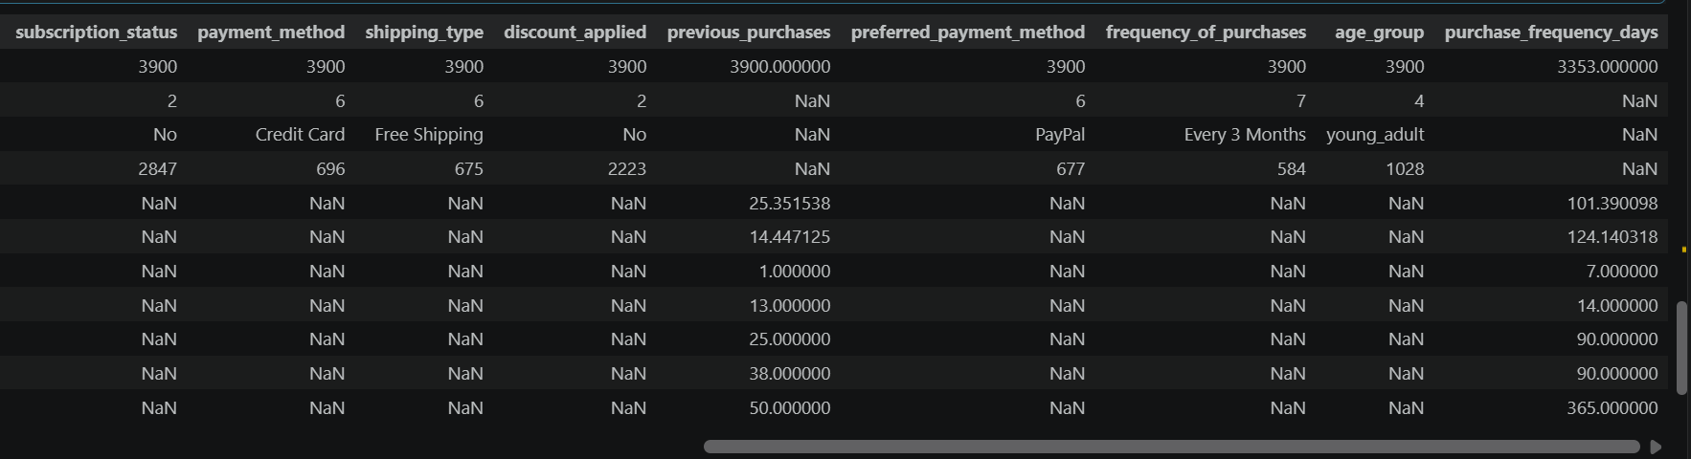
Figure 2. Continued descriptive statistics and engineered fields.

4. Data Analysis using SQL
Structured SQL analysis was then performed to answer key business questions. The following sections present the question, the analytical approach, the result, and the supplied MySQL Workbench evidence.

4.1 Revenue by Gender
Business question: What is the total revenue generated by male versus female customers?
Male customers generated the larger total revenue in the supplied result set, while female customers contributed a smaller but still material share.
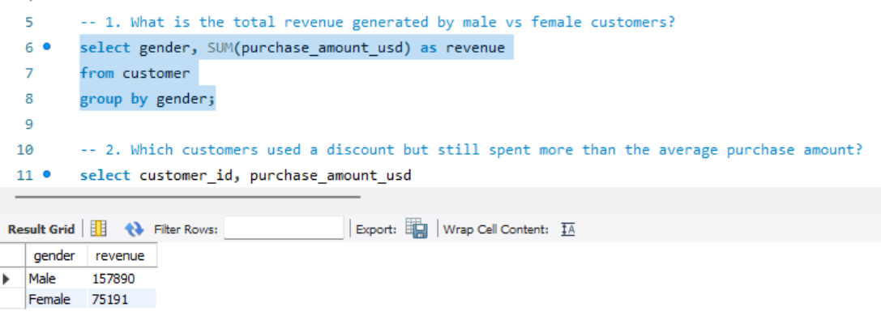
Figure 3. SQL result — total revenue by gender.

4.2 High-Spending Discount Users
Business question: Which customers used a discount but still spent more than the average purchase amount?
The query identified 839 customers who met both conditions, showing that discount use was not limited to low-value transactions.
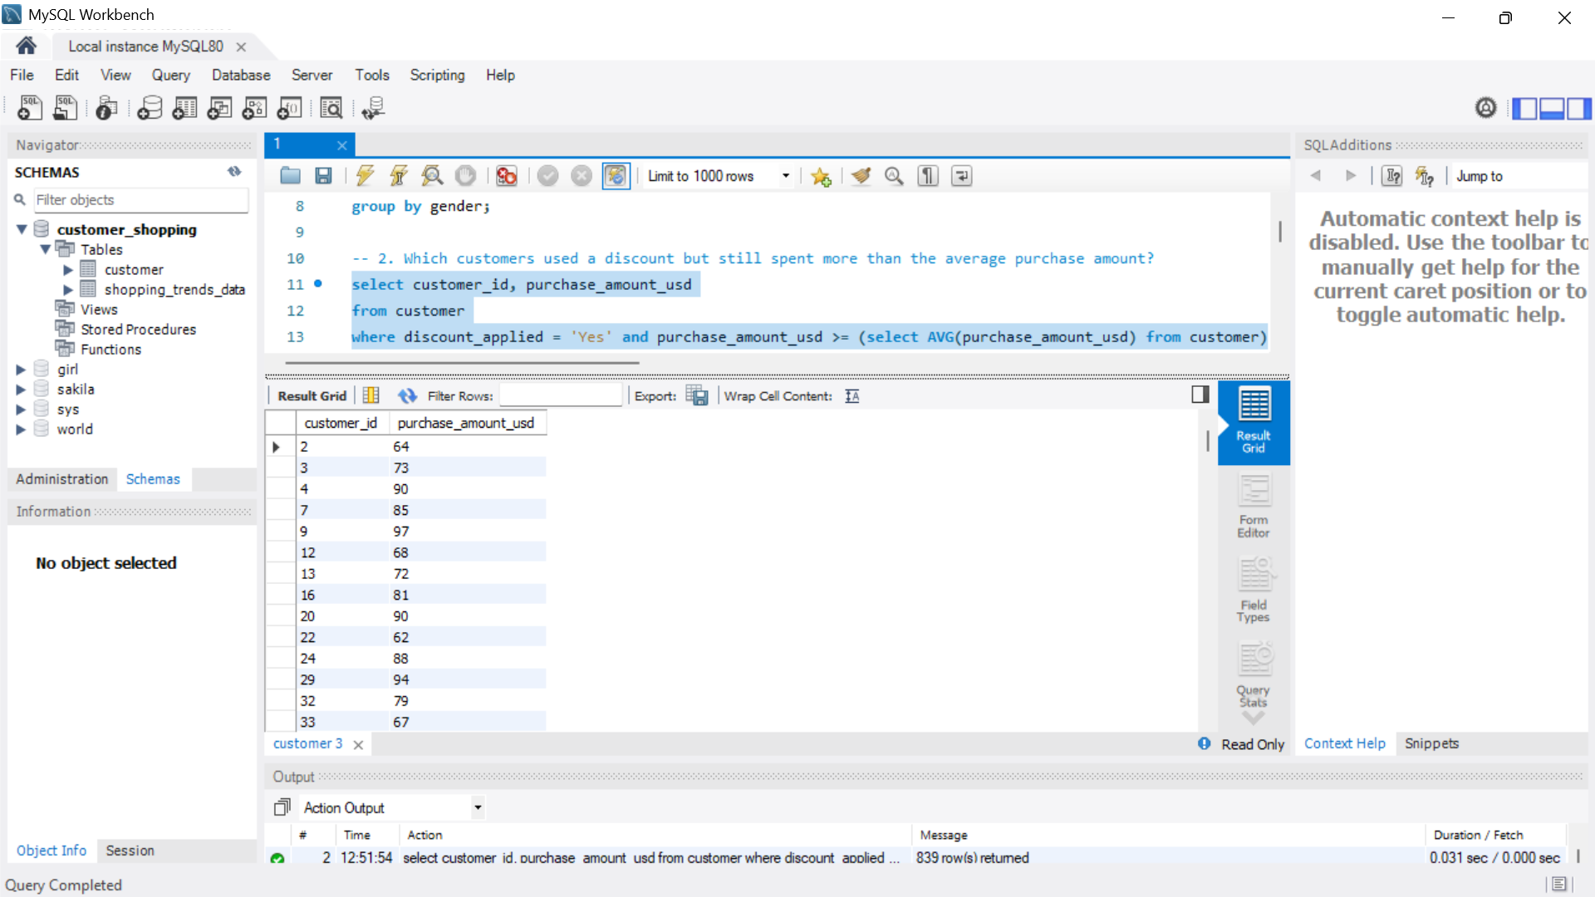
Figure 4. SQL result — discounted customers whose purchase exceeded the average.

4.3 Top 5 Products by Review Rating
Business question: Which five products have the highest average review rating?
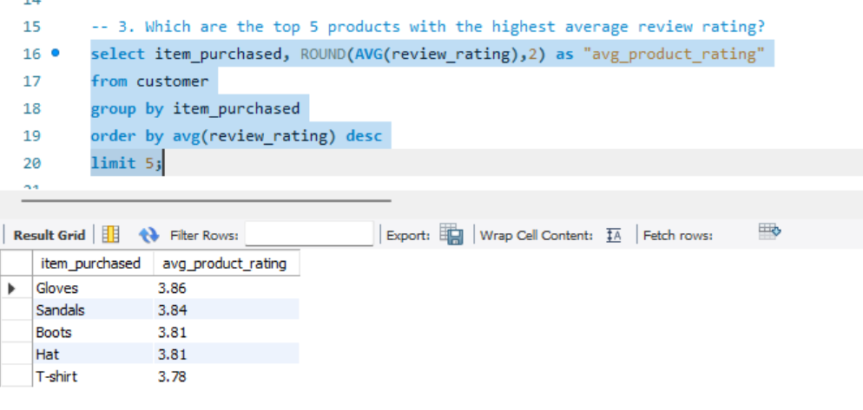
Figure 5. SQL query and result — top products by average review rating.

4.4 Average Purchase Amount by Shipping Type
Business question: How does the average purchase amount compare between Standard and Express shipping? 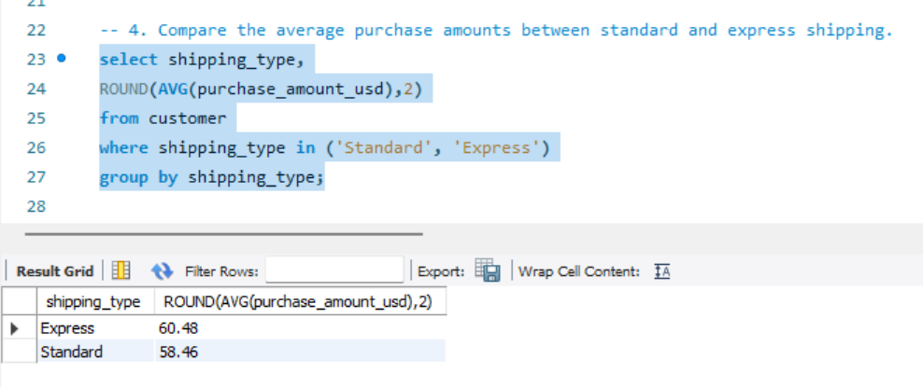
Figure 6. SQL result — average purchase amount by shipping type.
The supplied results show that Express-shipping transactions have a higher average purchase amount.

4.5 Subscribers vs. Non-Subscribers
Business question: Do subscribed customers spend more? The analysis compares customer count, average spend and total revenue for subscribers and non-subscribers. 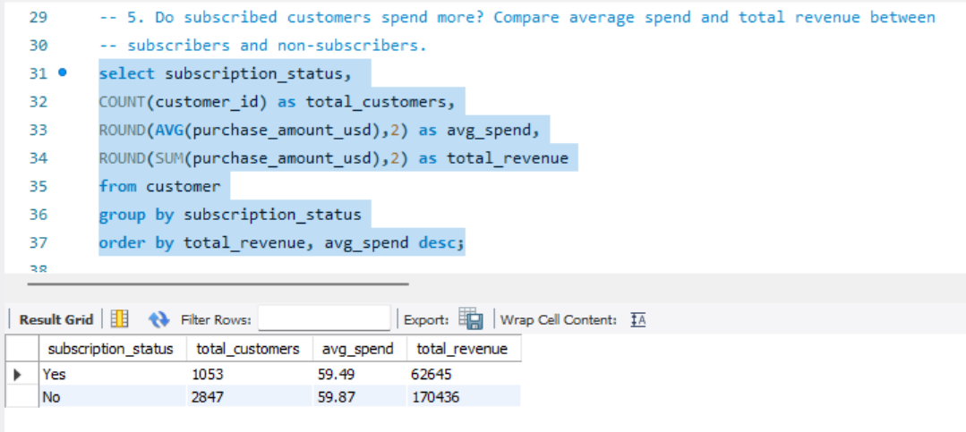
Figure 7. SQL result — subscriber versus non-subscriber performance.
Subscribers have a slightly lower average spend in the supplied result, while non-subscribers generate much higher total revenue because they represent the larger customer group.

4.6 Discount-Dependent Products
Business question: Which five products have the highest percentage of purchases with discounts applied?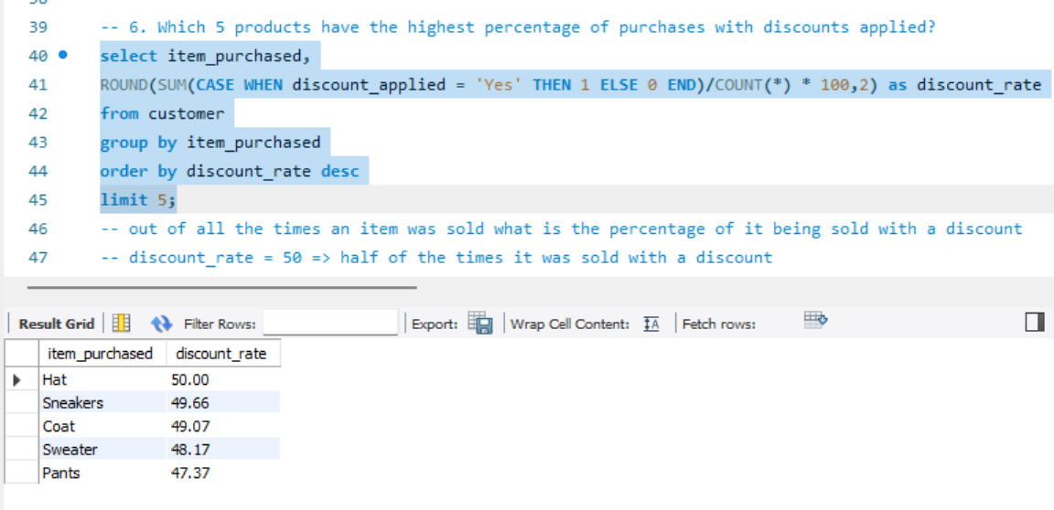
Figure 8. SQL result — products with the highest discount rates.
Hats have the highest discount incidence among the products shown, with half of the recorded purchases involving a discount.

4.7 Customer Segmentation
Customers were classified into New, Returning and Loyal segments using previous-purchase history.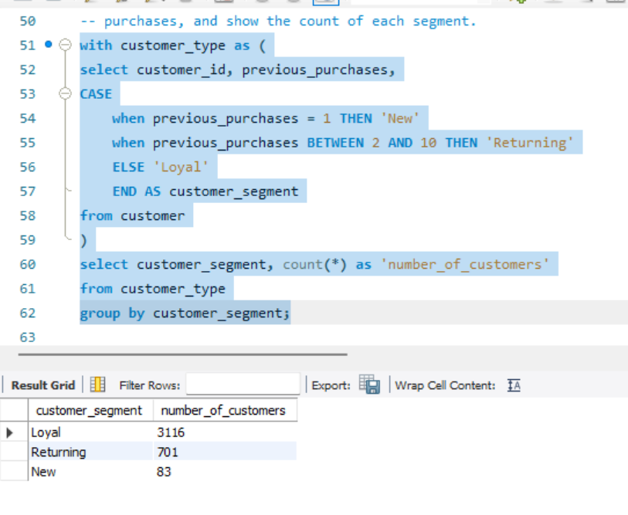
Figure 9. SQL result — customer segmentation by previous purchases
The dataset is dominated by the Loyal segment under the project's defined rules, followed by Returning customers and then New customers.

.

4.8 Top 3 Products per Category
Business question: Which products are the most purchased within each product category?
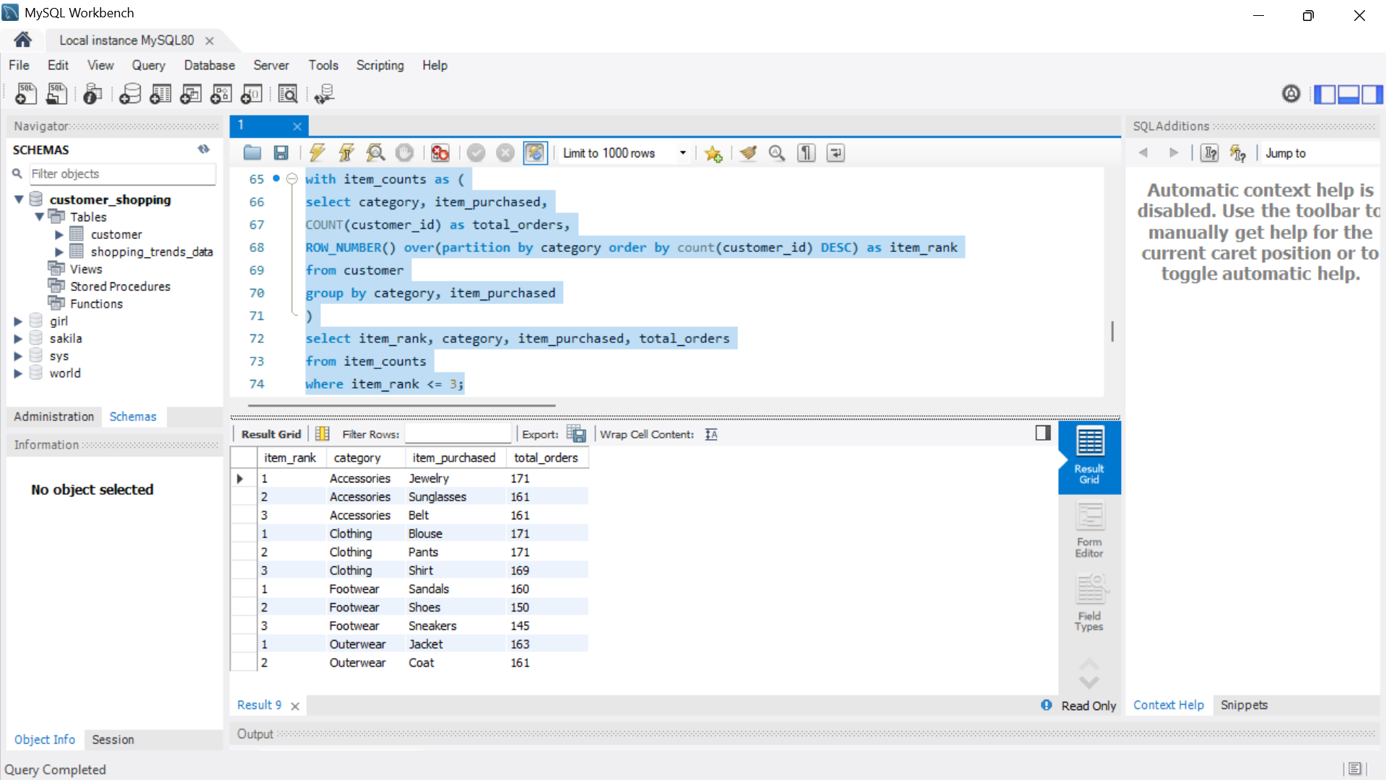
Figure 10. SQL result — top products by category.

4.9 Repeat Buyers and Subscription Status
Business question: Are customers with more than five purchases also likely to subscribe?
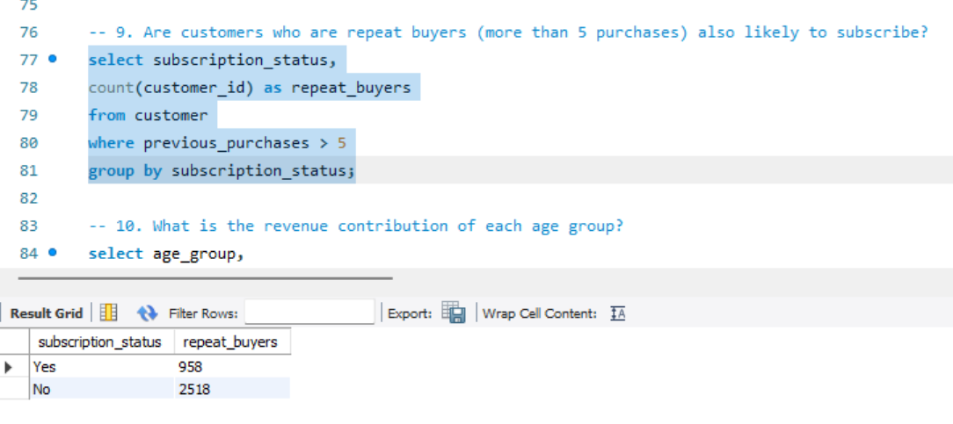
Figure 11. SQL result — repeat buyers according to subscription status.
Among customers with more than five previous purchases, the non-subscribed group is larger in absolute count than the subscribed group.

Figure 13. SQL result — repeat buyers by subscription status.

4.10 Revenue by Age Group
Business question: What is the revenue contribution of each age group?
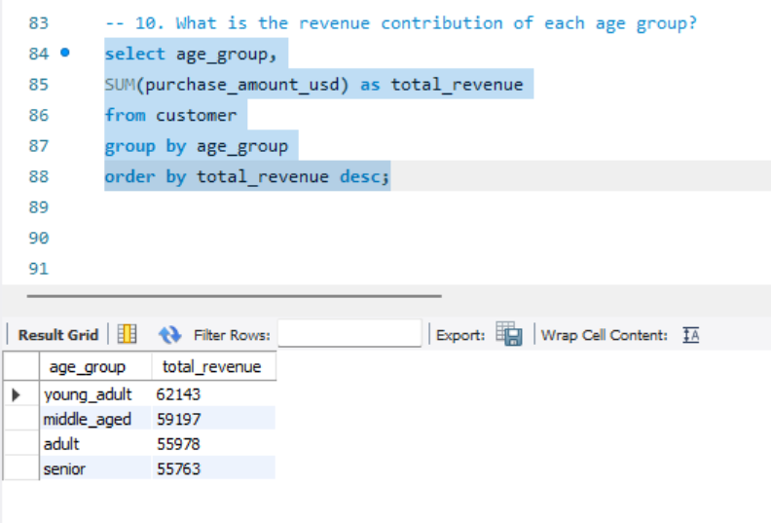
Figure 12. SQL result — revenue contribution by age group.
Young Adults contribute the highest revenue in the supplied results, followed by Middle-aged, Adult and Senior customers.

5. Power BI Dashboard
The final stage of the project was to build an interactive Power BI dashboard that brings the major findings together in a single visual interface. The supplied dashboard includes filters for subscription status, gender, category and shipping type, together with KPI cards and category/age-group charts.
Dashboard Element | Purpose
Number of Customers | Shows the overall customer count.
Average Purchase Amount | Summarizes the typical transaction value.
Average Review Rating | Provides a high-level view of product feedback.
Subscription Status | Shows the share of subscribers and non-subscribers.
Revenue by Category | Compares revenue contribution across product categories.
Sales by Category | Compares order volume across categories.
Revenue by Age Group | Highlights the age groups contributing the most revenue.
Sales by Age Group | Compares customer/order volume across age groups.
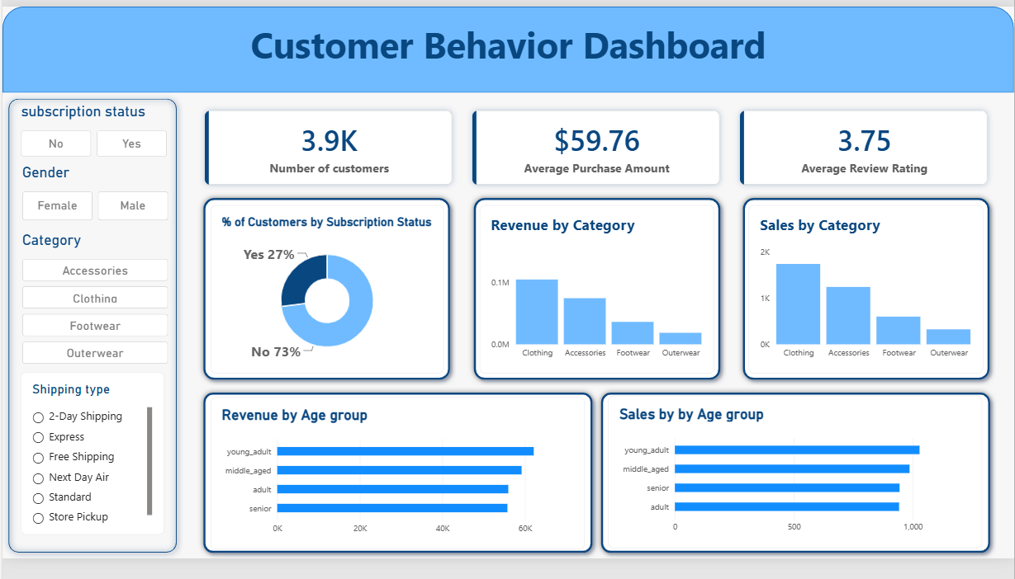
Figure 13. Power BI Customer Behaviour Dashboard.

6. Business Recommendations
- Boost Subscriptions — Promote exclusive benefits and clearer value propositions for subscribers.
- Customer Loyalty Programs — Reward repeat buyers and use targeted incentives to move customers into the Loyal segment.
- Review Discount Policy — Balance sales stimulation with margin control, particularly for products with high discount incidence.
- Product Positioning — Highlight top-rated and best-selling products in campaigns and merchandising.
- Targeted Marketing — Focus promotional efforts on high-revenue age groups and customers who prefer Express shipping.
These recommendations follow directly from the analysis presented in the supplied project reference: subscription participation is relatively low, repeat/loyal customers dominate the defined segments, and several products show strong ratings or high discount dependence.

7. Conclusion
The Customer Shopping Behaviour Analysis demonstrates an end-to-end analytics workflow: data preparation in Python, structured business analysis in SQL, and visual communication through Power BI. The analysis identifies meaningful differences in revenue by gender and age group, highlights high-rated products and frequently purchased products, compares shipping and subscription behaviour, and segments customers by purchasing history.
The resulting dashboard provides a concise way to monitor these patterns, while the SQL analysis supplies the underlying evidence needed for business recommendations. Together, the workflow provides a practical foundation for customer-focused marketing, loyalty, discount and product strategies.

Appendix A — Screenshot Reference
The following figures are the project screenshots supplied with the reference report. They are embedded throughout the report above at the relevant analytical steps.
Figure 1: Python dataset preview and descriptive statistics
Figure 2: Python descriptive statistics continuation
Figure 3: Revenue by gender
Figure 4: High-spending discount users
Figure 5: Top products by review rating — query and result
Figure 6: Top products by review rating — result evidence
Figure 7: Average purchase by shipping type
Figure 8: Subscribers versus non-subscribers
Figure 9: Products with highest discount rates
Figure 10: Customer segmentation
Figure 11: Top products per category
Figure 12: Revenue by age group / SQL continuation
Figure 13: Power BI dashboard

