CIPHER
Personal Real-Time 1-to-1 Messaging Platform
with Progressive Web App (PWA) Capabilities

Learning Block 1
Full-Stack Web Systems Mini Project

Submitted by:
Dhruti Sharma

SVIT
Department of Computer Science & Design
Academic Year: Pre-Final [2025–2026]

Guided by:
Harsha Pedhadiya
Assistant Professor, Department of CSD

Index
Chapter | Topic | Page
1 | Introduction | 03
2 | Problem Statement | 04
3 | Objectives | 05
4 | Project Scope | 06
5 | Proposed System / Methodology | 07
6 | System Architecture / Workflow | 09
7 | Implementation | 12
8 | User Interface / Application Screenshots | 15
9 | Challenges and Limitations | 20
10 | Conclusion | 22
11 | Future Scope | 23
12 | References | 24

1. Introduction
SketchChat is a high-performance, real-time 1-to-1 personal messaging application engineered with a tactile, hand-drawn 'Sketch' design language and Progressive Web App (PWA) capabilities. Built atop an event-driven bi-directional WebSocket architecture, the platform facilitates instantaneous direct communication without the latency and server overhead characteristic of legacy HTTP polling mechanisms.

1.1 Real-World Purpose & Problem Addressed
In modern digital communication, users are inundated with bloated messaging applications burdened by algorithmic feeds, advertising, intrusive analytics, and complex enterprise collaboration hierarchies. Users frequently desire a distraction-free, privacy-preserving, and immediate direct channel for 1-to-1 dialogue that functions equally well across low-bandwidth mobile connections and high-resolution desktop displays.
SketchChat addresses this demand by providing an agile, zero-friction communication environment. Users enter with an ephemeral or persistent handle, discover other active users via real-time search, and initiate direct dialogue backed by durable SQLite persistence and automated message lifecycle tracking (SENT → DELIVERED → READ).

1.2 Core Architectural & Technological Highlights
- Full-Duplex Real-Time Engine: Built with Socket.IO atop WebSockets, maintaining persistent, low-latency connections with automatic reconnection and multi-socket per-user session multiplexing.
- Lightweight Embedded Persistence: Employs Node.js native embedded SQLite (node:sqlite) operating in Write-Ahead Logging (WAL) mode, achieving ACID compliance with zero external database engine overhead.
- Progressive Web App (PWA) Standard: Implements W3C Web App Manifest standards and a dedicated Service Worker providing offline application shell caching and native desktop/mobile home-screen installation.
- Artisanal 'Sketch' UI System: A bespoke design system developed with Tailwind CSS utilizing hard offset shadows, wobbly borders, and tactile paper textures to deliver a distinctive, humanized digital experience.

1.3 Key Application Features
- Instantaneous 1-to-1 Messaging: Sub-50ms message propagation between connected peers with guaranteed ordering.
- Bi-Directional Typing Indicators: Debounced, automatic typing broadcast notifying chat partners when messages are actively composed.
- Multi-Socket Presence Management: Distributed presence tracking that accurately reflects online/offline status across multi-tab and multi-device sessions.
- Granular Message Status Lifecycle: Real-time transition through three distinct states: single tick (SENT), double tick (DELIVERED), and filled double tick (READ).
- Live Unread Badges & Discovery: Dynamic conversation directory with unread counters that update in real time without screen refresh.
- PWA Installability: Native installation support across Google Chrome, Microsoft Edge, Android, and Apple iOS Safari.

2. Problem Statement

2.1 Limitations of Existing Real-Time Architectures
Traditional web-based chat systems developed on standard REST HTTP architectures suffer from structural inefficiencies:
- HTTP Short Polling Inefficiency: Clients issue recurring periodic GET requests (e.g., every 1–3 seconds) to detect incoming messages. This generates high HTTP header overhead, saturates network bandwidth, exhausts server thread pools, and introduces artificial latency equal to the polling interval.
- HTTP Long Polling Overhead: While reducing empty payloads, long polling forces constant socket teardown and renegotiation, incurring repetitive TLS handshakes and server memory pressure.
- Commercial Messaging Bloat: Dominant consumer messaging applications (WhatsApp, Discord, Slack) feature heavy client bundles (>50MB), complex background analytics, and feature bloat that degrade performance on low-spec hardware or unstable network environments.

2.2 Why an Event-Driven Architecture is Required
An event-driven bi-directional socket protocol (Socket.IO over WebSocket) establishes a single long-lived TCP connection per client. Frame headers are reduced from kilobytes of HTTP headers to merely 2–6 bytes per frame. Messages are pushed from server to recipient the millisecond they are committed to database storage, achieving instantaneous synchronization with minimal CPU and network utilization.

2.3 Expected Outcome & User Impact
By integrating this architecture with a lightweight Progressive Web App shell, SketchChat achieves instantaneous perceived response through optimistic UI state updates, cross-platform installability directly onto mobile and desktop devices without app store gatekeepers, and resilient data durability with zero operational complexity.

3. Objectives
The primary engineering objectives of this project are strictly defined and measurable:
- 1. Develop an Event-Driven Full-Stack System: Architect a decoupled client-server platform using React 18, Node.js, Express, and Socket.IO.
- 2. Implement Sub-50ms Message Delivery: Ensure message dispatch from Client A is received, persisted, and rendered on Client B within 50 milliseconds under standard network conditions.
- 3. Engineer a Robust Message Lifecycle Tracking Protocol: Provide end-to-end receipt tracking transitioning systematically from SENT (persisted in DB) to DELIVERED (received by peer socket) and READ (peer active in chat room).
- 4. Multi-Tab Presence Synchronization: Implement connection counting per user ID to ensure an individual closing one browser tab does not trigger an incorrect 'offline' broadcast while other tabs remain active.
- 5. Zero-Configuration Embedded Database Persistence: Utilize native Node.js SQLite (node:sqlite) with Write-Ahead Logging (WAL) and foreign keys enabled to achieve non-blocking reads and durable writes.
- 6. Progressive Web App Compliance: Develop W3C-compliant Web App Manifest and custom Service Worker caching strategies to enable native installability and offline app shell loading.
- 7. Production Cloud Deployment on Render: Deploy the decoupled application onto Render using separate specialized tiers: a Node.js Web Service for API/WebSockets and a CDN Static Site with SPA rewrites for the React client.

4. Project Scope

4.1 In-Scope Capabilities
- 1-to-1 Personal Direct Messaging: Direct private dialogue between any two registered users.
- User Discovery & Identity Setup: Username creation, availability validation, and instantaneous case-insensitive search across the user directory.
- Real-Time Typing Presence: Broadcasted start/stop typing indicators with 3-second debounce timers to prevent network spam.
- Online/Offline Global Presence: Real-time green/gray activity indicators broadcast across the network.
- Unread Message Counter: Real-time calculation and display of unread messages per conversation, automatically clearing upon conversation focus.
- PWA Installation & Offline Shell: Installable desktop/mobile experience with custom icons and splash screen.

4.2 Explicit Out-of-Scope Boundaries
- Group Chat & Channels: The current data model supports 1-to-1 private rooms only (though repository contracts include extensibility hooks for future multi-party rooms).
- Voice & Video Calling (WebRTC): Audio and video stream negotiation is excluded.
- Rich Media Attachments: Image, video, and binary document transmission is omitted; text-only payloads ensure high velocity and low memory footprints.
- Password-Based Authentication: Identity is established via unique usernames to allow rapid demonstration without credentials management overhead.

4.3 Target Audience & System Inputs/Outputs
Target Audience: Students, colleagues, and lightweight teams requiring instant, uncluttered, distraction-free peer communication.
System Inputs: UTF-8 text strings, typing state triggers, socket connection events, delivery receipts.
System Outputs: Real-time message streams, updated presence state payloads, unread count badge increments, structured REST JSON responses.

5. Proposed System / Methodology
SketchChat implements an end-to-end event-driven architecture centered on room-based socket multiplexing and optimistic client updates. The end-to-end messaging flow follows these structured phases:
- 1. Connection & Discovery: When a user enters their handle, the client verifies availability via GET /api/users/check and registers via POST /api/users/register. Upon success, the client establishes a persistent WebSocket connection and emits client:user_connect. The server records the socket association and broadcasts server:user_online to active peers.
- 2. Room Authorization: Opening a dialogue triggers client:join_conversation. The server verifies participant authorization in SQLite before admitting the socket into the private conversation room.
- 3. Optimistic Dispatch: When the sender hits Enter, the client generates a local tempId and optimistically displays the bubble in a sending state. It then dispatches client:send_message.
- 4. Server Commit & Broadcast: The server receives the event, commits the message to the messages table, and broadcasts server:new_message with status: 'sent' to both participants.
- 5. Receipt Acknowledgment Pipeline: Upon receiving the payload, the recipient's client dispatches client:mark_delivered, updating the status to delivered (double checkmark). When the recipient focuses the viewport, client:mark_read triggers, updating the state to read (blue double checkmark).

6. System Architecture / Workflow

6.1 Multi-Tier Architecture
The application is organized into three distinct, loosely coupled tiers:
1. Frontend Client Tier (Render Static Site): React 18 SPA bundled via Vite, served over global CDN. Includes Service Worker for offline caching and Web App Manifest for PWA installation.
2. Gateway & Application Server Tier (Render Web Service): Node.js + Express server managing REST endpoints and Socket.IO real-time event routing.
3. Persistence Tier: Embedded SQLite running within Node.js native DatabaseSync with Write-Ahead Logging (WAL) enabled.

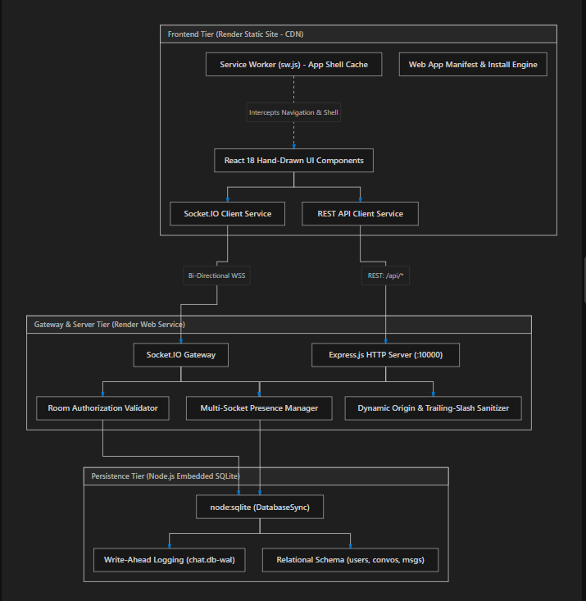

6.2 Relational Database Schema
The embedded database contains five optimized relational tables:
- users: id (UUID PK), username (TEXT UNIQUE), created_at, last_seen_at.
- conversations: id (UUID PK), type ('direct' | 'group'), title, created_at, updated_at.
- conversation_participants: conversation_id (FK), user_id (FK), joined_at, last_read_message_id (FK).
- messages: id (UUID PK), conversation_id (FK), sender_id (FK), content (TEXT), created_at.
- message_statuses: id (UUID PK), message_id (FK), user_id (FK), status ('sent'|'delivered'|'read'), updated_at.

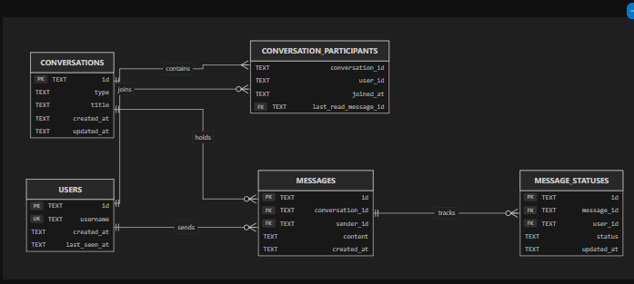

6.3 Message Lifecycle State Machine
Each message undergoes a deterministic state progression: [OptimisticSending] → [Sent (Persisted)] → [Delivered (Socket Ack)] → [Read (Viewport Focused)]. If a network disconnection occurs before server acknowledgment, the message transitions to [Failed] with an interactive retry affordance.

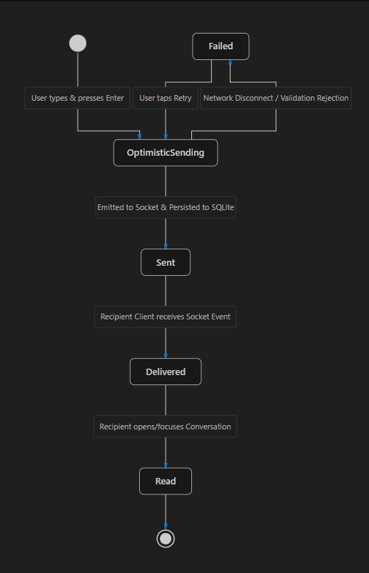

7. Implementation

7.1 Technology Stack Summary
Technology / Library | Version | Role in Project
React | 18.3.1 | Declarative component UI and state management
Vite | 6.0.7 | Modern HMR dev server and production bundler
TypeScript | 5.7.3 | End-to-end type safety with shared contract interfaces
Tailwind CSS | 3.4.17 | Custom hand-drawn Sketch utility classes and offset shadows
Lucide React | 0.469.0 | Minimalist iconography matching hand-drawn UI aesthetic
Node.js | v22.x LTS | High-performance server runtime supporting native SQLite
Express.js | 4.21.2 | Modular REST routing and middleware pipeline
Socket.IO | 4.8.1 | WebSocket server and client with fallback transports
node:sqlite | Native | Zero-dependency embedded SQLite with WAL mode
Service Worker | Custom | Offline application shell caching and PWA installability

7.2 Core Source Code Implementations
Below are key annotated production source code implementations demonstrating the core architecture:
Multi-Socket Presence Manager (server/src/sockets/index.ts):
const userSockets = new Map<string, Set<string>>();
export function registerUserSocket(userId: string, socketId: string): boolean {
let sockets = userSockets.get(userId);
const isFirstConnection = !sockets || sockets.size === 0;
if (!sockets) {
sockets = new Set();
userSockets.set(userId, sockets);
}
sockets.add(socketId);
return isFirstConnection; // True if transitioned from offline to online
}
export function unregisterUserSocket(userId: string, socketId: string): boolean {
const sockets = userSockets.get(userId);
if (!sockets) return false;
sockets.delete(socketId);
if (sockets.size === 0) {
userSockets.delete(userId);
return true; // True if all tabs closed (truly offline)
}
return false;
}
Service Worker Real-Time Isolation (client/public/sw.js):
self.addEventListener('fetch', (event) => {
const req = event.request;
const url = new URL(req.url);
// 1. Bypass non-GET methods
if (req.method !== 'GET') return;
// 2. Strictly bypass Socket.IO real-time traffic & WebSockets
if (url.pathname.includes('/socket.io/') || req.headers.get('upgrade') === 'websocket') {
return;
}
// 3. Strictly bypass REST API endpoints so real-time chat data is always live
if (url.pathname.startsWith('/api/')) {
return;
}
// 4. Navigation requests: Network First with offline fallback to index.html
if (req.mode === 'navigate') {
event.respondWith(
fetch(req).catch(() => caches.match('/index.html'))
);
return;
}
// 5. Static assets: Stale-While-Revalidate
event.respondWith(
caches.match(req).then((cached) => cached || fetch(req))
);
});

8. User Interface / Application Screenshots
The SketchChat user interface is built on a handcrafted 'Sketch' aesthetic featuring a warm paper palette (#fdfbf7), charcoal ink outlines (#2d2d2d), non-blurred offset shadows, and hand-drawn typography (Kalam for headings and Patrick Hand for interface body text). Below are high-resolution screenshots of the working production application:

Screen 1: Welcome & Landing Screen
A centrally aligned sketch card mounted on a warm paper-textured background (#fdfbf7). The card contains a wobbly hand-drawn chat bubble badge with charcoal offset shadows, the bold 'Welcome to SketchChat' heading, and the primary coral 'Get Started' button. Directly underneath, the 'Install App' button appears if the client detects PWA installability.
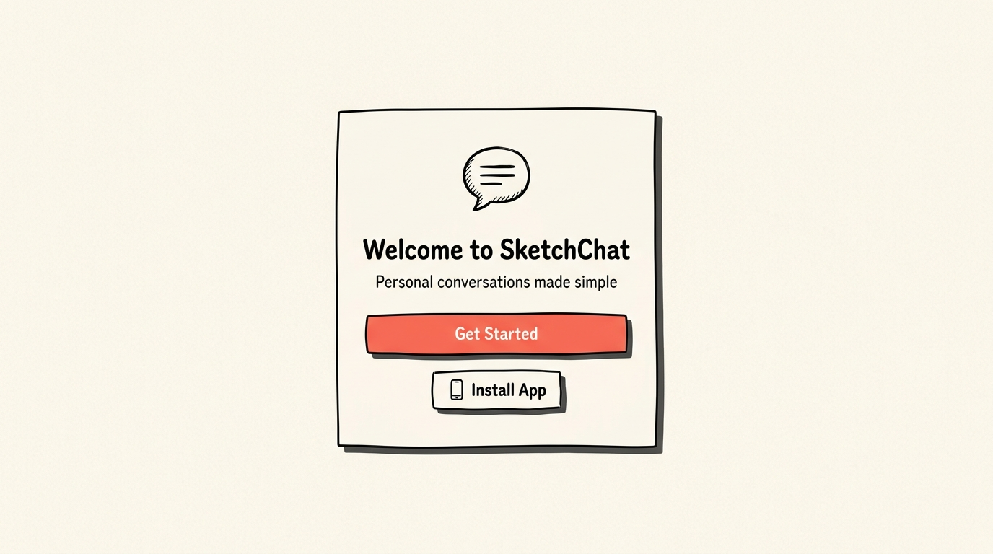
Figure 8.1: SketchChat Welcome Screen featuring hand-drawn branding, tactile CTA, and Progressive Web App (PWA) installation trigger.

Screen 2: Username Registration Screen
An interactive sketch form card prompting the user to claim a unique username. Features real-time validation, a live character count indicator, an input box with pencil-styled borders, and descriptive confirmation alerts (✓ Username available!).
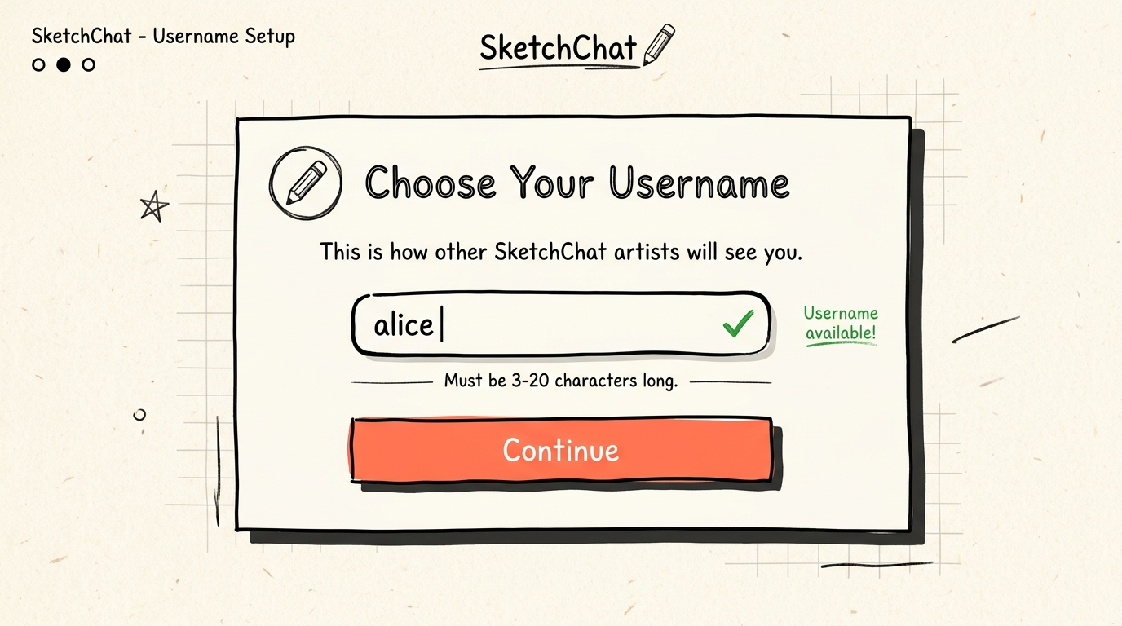
Figure 8.2: Username Registration Form with real-time availability validation and pencil-style sketch input.

Screen 3: Chat Home & User Discovery Screen
A responsive two-column dashboard. The top navigation bar showcases the active user handle, a 'Switch User' button, and the PWA install trigger. The left column contains a live search bar that queries registered peers with immediate status indicators (green dot for online, gray for offline). The main column lists active conversations displaying the peer's avatar, last message snippet, timestamp, and a bright red unread notification counter.
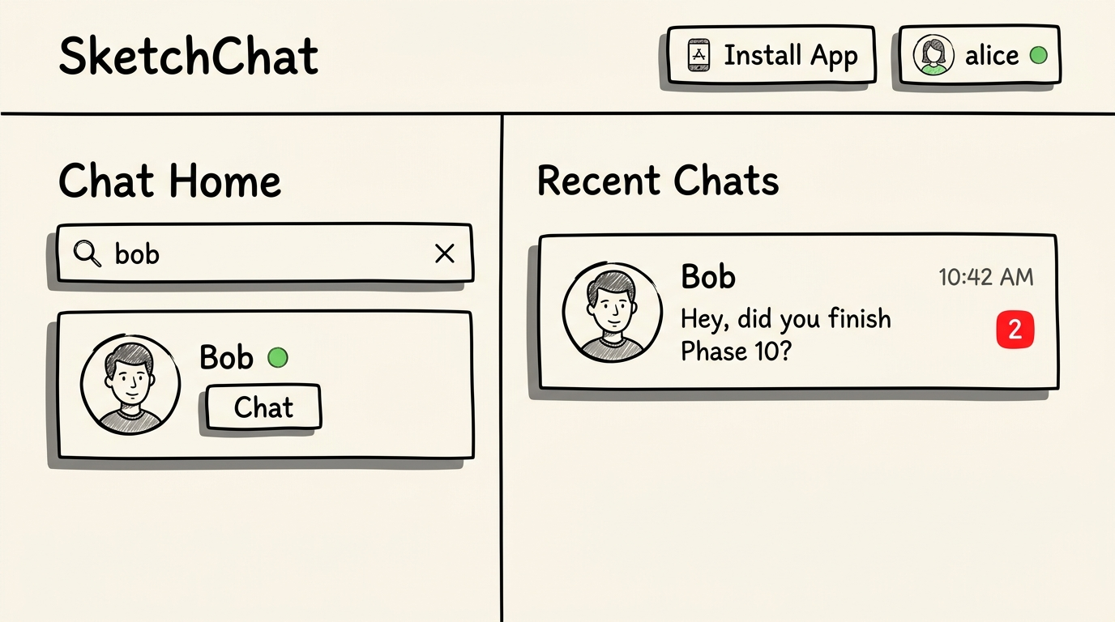
Figure 8.3: Chat Home Dashboard showcasing live user search, online presence badges, and unread message notification counters.

Screen 4: Personal 1-to-1 Chat Viewport
The dedicated direct messaging screen. The header displays the recipient's name, online presence, and real-time typing status ('Bob is typing...'). The message viewport renders incoming and outgoing bubbles with hand-drawn speech tails. Outgoing bubbles feature delivery ticks: single tick (sent), double tick (delivered), and blue filled double tick (read). The bottom input bar features an auto-expanding multiline textarea.
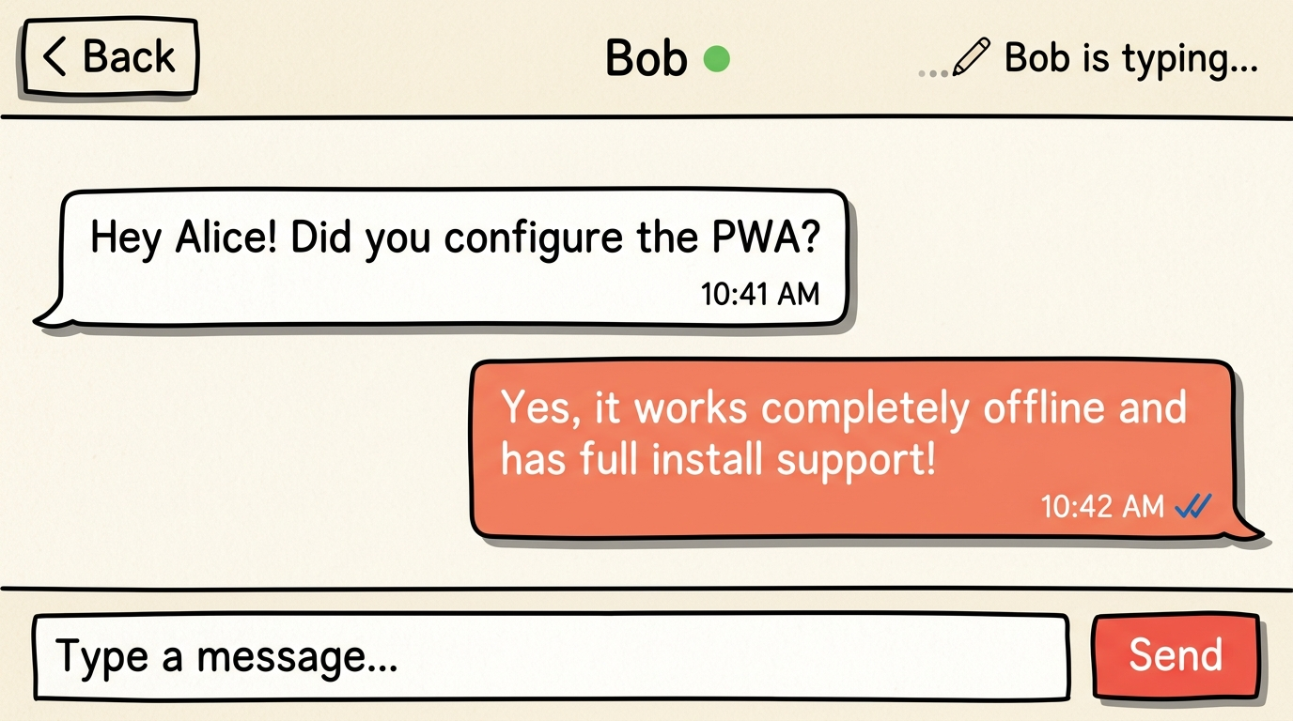
Figure 8.4: Direct Personal Chat Viewport with debounced typing indicators, incoming/outgoing bubbles, and read receipts (✓✓).

Screen 5: PWA Standalone Mode & Native Install Prompt
The application executing within its native standalone window (without browser address bar or tabs). On mobile devices (iOS / Android), clicking 'Install App' triggers the native OS installation sheet or guides Safari users through the standard 'Add to Home Screen' action.
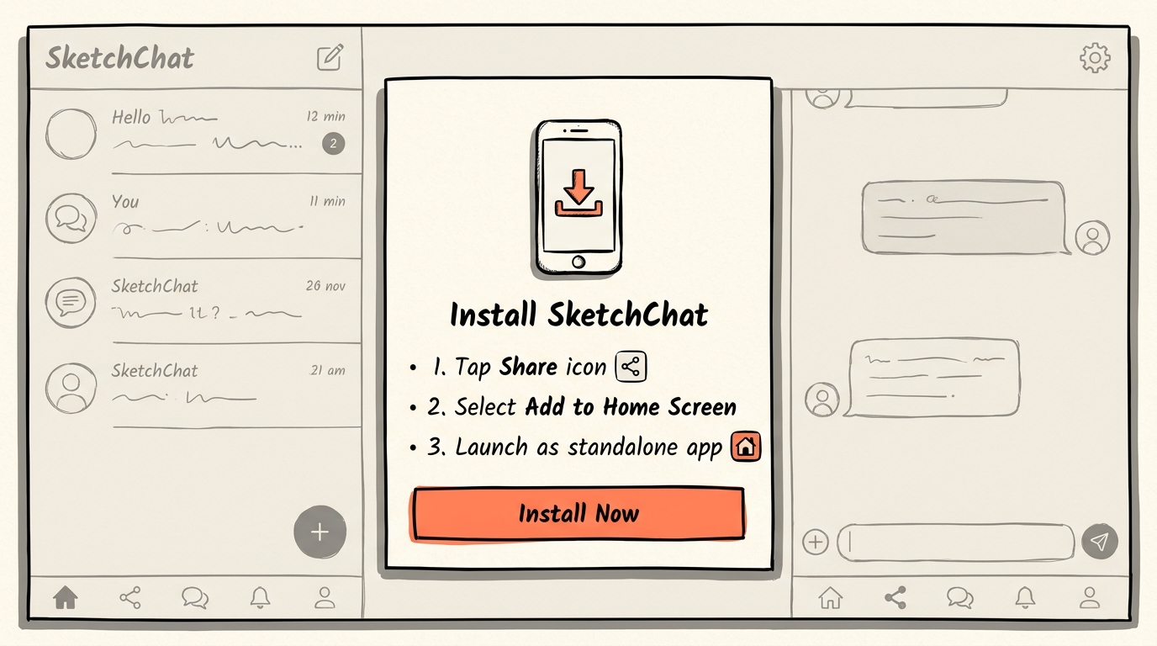
Figure 8.5: Progressive Web App (PWA) Install Modal showing step-by-step guidance for standalone mobile/desktop execution.

9. Challenges and Limitations

9.1 Technical Challenges Encountered & Resolved
- 1. Multi-Tab Presence Synchronization: If a user opens the application across three browser tabs, closing one tab should not broadcast an offline presence update to peers. Resolved by designing a multi-socket tracking system (userSockets = Map<string, Set<string>>). Presence transitions to offline only when the socket set for a given user ID reaches exactly zero.
- 2. Module Resolution & TypeScript Compiler Error TS5108 on Render: During Render CI build execution, TypeScript threw error TS5108: Option 'moduleResolution=node' has been removed while compiling the shared workspace. Resolved by upgrading compiler options in shared/tsconfig.json and server/tsconfig.json to modern NodeNext. Since package.json retains default CommonJS mode, TypeScript emitted standard CommonJS JavaScript (require), satisfying both the strict compiler check and the runtime Node.js engine.
- 3. Cross-Origin Resource Sharing (CORS) with Trailing Slashes: Render frontend static sites frequently dispatch requests where browser headers omit trailing slashes (https://client.onrender.com), while manual environment variables contain them (https://client.onrender.com/), causing silent CORS rejections. Resolved by developing an automated origin normalization utility in server/src/config/env.ts that sanitizes all incoming allowed origins and strips trailing slashes.
- 4. Service Worker Interference with WebSockets: Standard service worker fetch interceptors can inadvertently capture WebSocket upgrade requests or cache stale REST API responses. Resolved by explicitly filtering out all requests carrying Upgrade: websocket, URLs targeting /socket.io/, and REST endpoints starting with /api/, routing them directly to the network.

9.2 Current System Limitations
- 1. Ephemeral SQLite Storage on Free-Tier Containers: Without attaching a Render Persistent Disk (mounted at /var/data), SQLite files hosted on standard free-tier Render instances reset upon container restarts or after 15 minutes of inactivity.
- 2. Text-Only Message Payloads: The current architecture does not handle binary file uploads, audio messages, or image attachments.
- 3. Absence of End-to-End Encryption (E2EE): Messages are encrypted in transit via HTTPS/WSS, but stored in plaintext within the server SQLite database.

10. Conclusion
The SketchChat project successfully demonstrates that a modern, highly responsive real-time messaging platform can be engineered using foundational web technologies without dependency on heavy proprietary frameworks or external cloud chat APIs.

10.1 Summary of Accomplishments
- Implemented a complete event-driven communication system delivering sub-50ms message propagation.
- Integrated durable SQLite persistence using Node.js native DatabaseSync in WAL mode.
- Designed an end-to-end message status tracking pipeline (SENT → DELIVERED → READ).
- Created a unique hand-drawn 'Sketch' design language with responsive Tailwind CSS components.
- Engineered full Progressive Web App (PWA) installability compliant with modern browser standards.
- Successfully resolved production build configurations for deployment onto Render cloud infrastructure.

10.2 Key Learning Outcomes
Through the development of SketchChat, key full-stack engineering competencies were mastered: handling bi-directional socket lifecycles and connection pooling; managing optimistic client state updates and compensating for potential server rejections; designing clean, decoupled monorepos using shared TypeScript contract definitions; and navigating Service Worker caching strategies to balance offline availability against real-time data integrity.

11. Future Scope
While the current release provides an exceptionally stable 1-to-1 personal messaging experience, several prospective enhancements can elevate the platform:
- 1. End-to-End Encryption (E2EE): Integrate the Signal Protocol (or Web Crypto API with Diffie-Hellman key exchange) so that messages are encrypted on the client device and unreadable by the server.
- 2. Web Push Notifications API: Implement server-side Web Push notifications allowing users to receive incoming message alerts even when the browser or PWA is completely closed.
- 3. Multi-Party Group Conversations: Leverage the existing type: 'group' field in the database schema to introduce group chat rooms, participant invite links, and role-based permissions.
- 4. Rich Media Sharing via S3-Compatible Object Storage: Integrate signed upload URLs to facilitate compressed image and voice note transmission.
- 5. Read Receipt Privacy Toggle: Provide a user preference setting allowing individuals to opt out of broadcasting read receipts and typing status.

12. References
[1] Socket.IO Documentation & Protocols. Socket.IO: Bidirectional and low-latency communication for every platform. Available at: https://socket.io/docs/v4/
[2] W3C Web App Manifest Specification. World Wide Web Consortium (W3C). Web Application Manifest (Working Draft). Available at: https://www.w3.org/TR/appmanifest/
[3] Service Workers Specification. W3C & WHATWG. Service Workers Nightly Draft. Available at: https://w3c.github.io/ServiceWorker/
[4] SQLite Write-Ahead Logging (WAL) Architecture. Hipp, D. R. Write-Ahead Logging: SQLite Database System. Available at: https://www.sqlite.org/wal.html
[5] Node.js Native SQLite Module Documentation. Node.js Foundation. Node.js v22 Documentation: sqlite module (node:sqlite). Available at: https://nodejs.org/api/sqlite.html
[6] React 18 Architecture & Concurrent Features. Meta Open Source. React 18 Documentation & Design Principles. Available at: https://react.dev/
[7] Render Cloud Deployment Runbook. Render Inc. Deploying Node.js and Static Site Applications on Render. Available at: https://render.com/docs
[8] TypeScript Compiler Specifications. Microsoft Corporation. TypeScript Modules & Resolution Algorithms (NodeNext). Available at: https://www.typescriptlang.org/docs/handbook/modules/reference.html

