Setting up CI/CD Pipeline for SSI Backend Project

(Sprint6 -CI/CD Demo with Assessment)

Name: Teena Maria Thomas
Student No.: 9043201
Subject: Capstone (Web Development) PROG8751 - W26 - Sec1
Group No.: Group 5
Explanation :-
- Backend-ci.yml file
The backend-ci.yml file is a CI workflow created using GitHub Actions. It runs automatically whenever code is pushed to the “prod” branch or when a pull request is created.
The workflow checks out the repository, sets up the .NET environment, restores dependencies, and builds the backend using dotnet commands. If there are any errors in the code, the build fails and the pipeline stops. It also includes a validation step to check if important backend files exist. If any required file is missing, the pipeline fails.
Overall, this CI pipeline ensures that the backend code is valid and buildable, helping to detect errors early and maintain code quality.
Screenshots :-
- After pushing the project into the GitHub the pipeline FAIL.
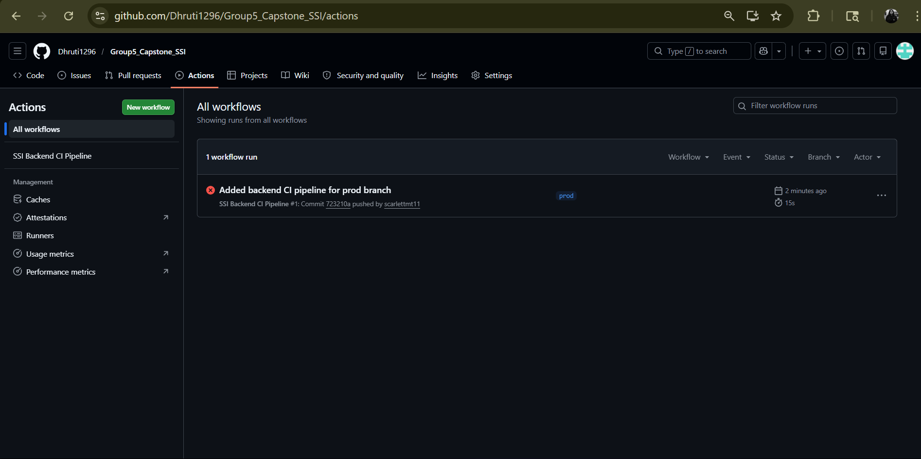
Fig 1.1: Screenshot - Failed pipeline of SSI.
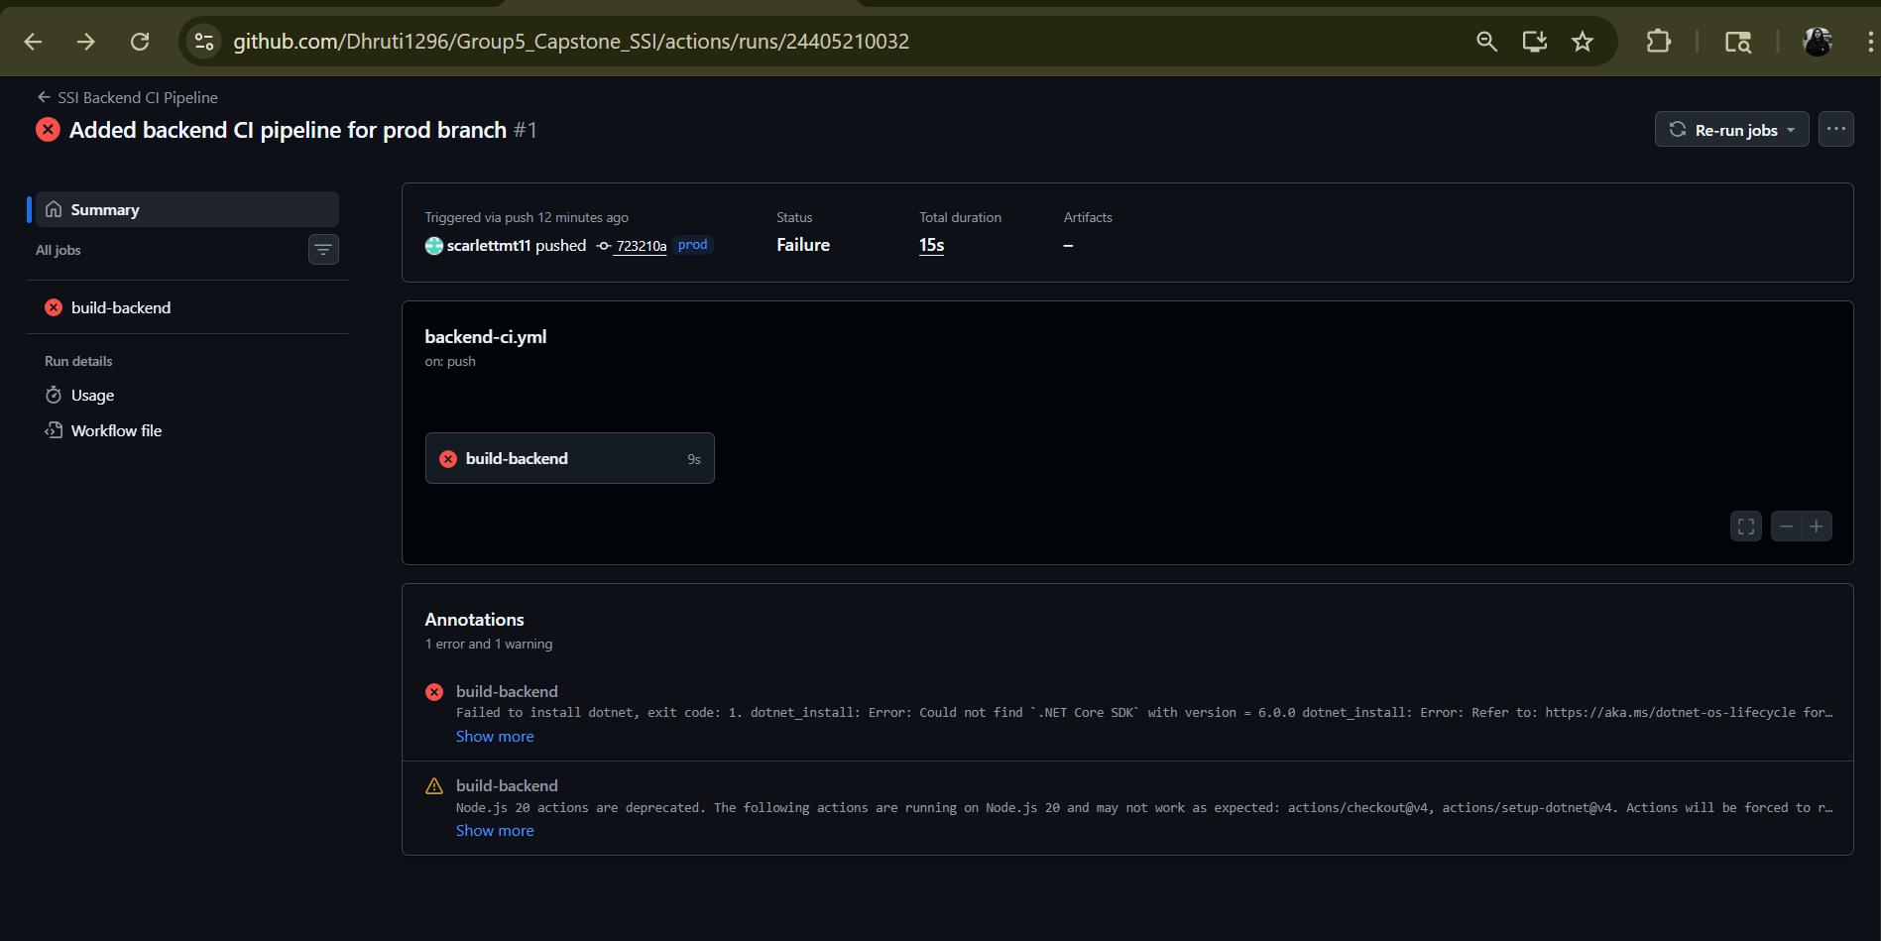
Fig1.2: Screenshot - Error while running the SSI (contd..).

- After correcting the code and pushed into the project into the GitHub the pipeline FAIL.

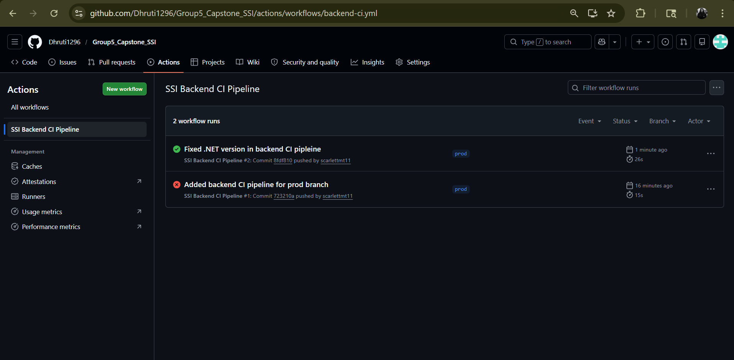
Fig 2.1(a): Screenshot - Successful pipeline of SSI.

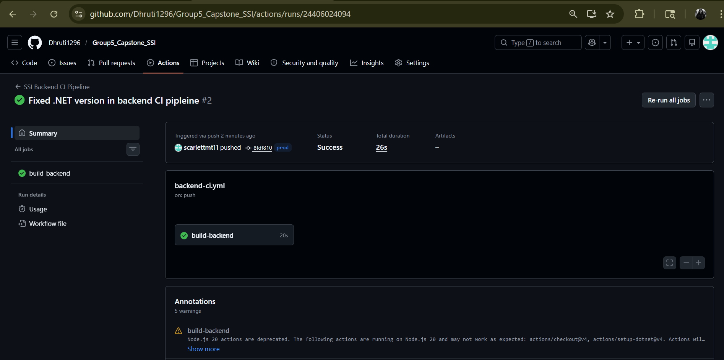
Fig 2.1(b): Screenshot - Successful pipeline of SSI (contd..).

- New failing test case for AdminController.
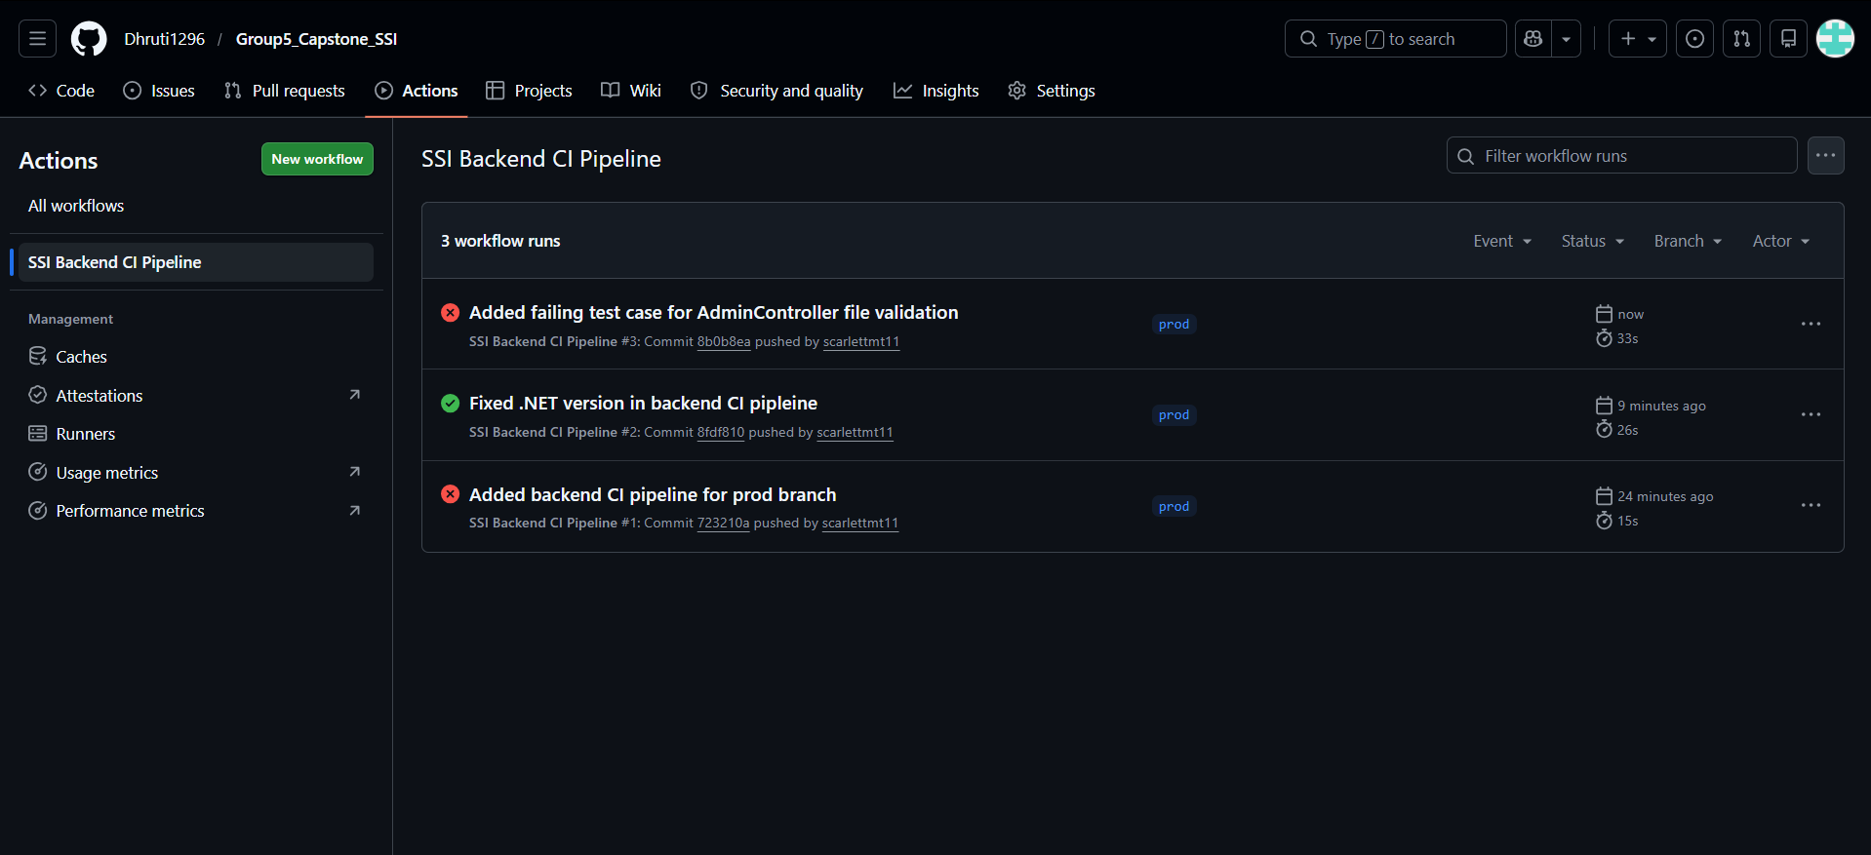
Fig 4.1(a): Screenshot - Failed test case added with commit message “Added failing test case for AdminController file validation”.
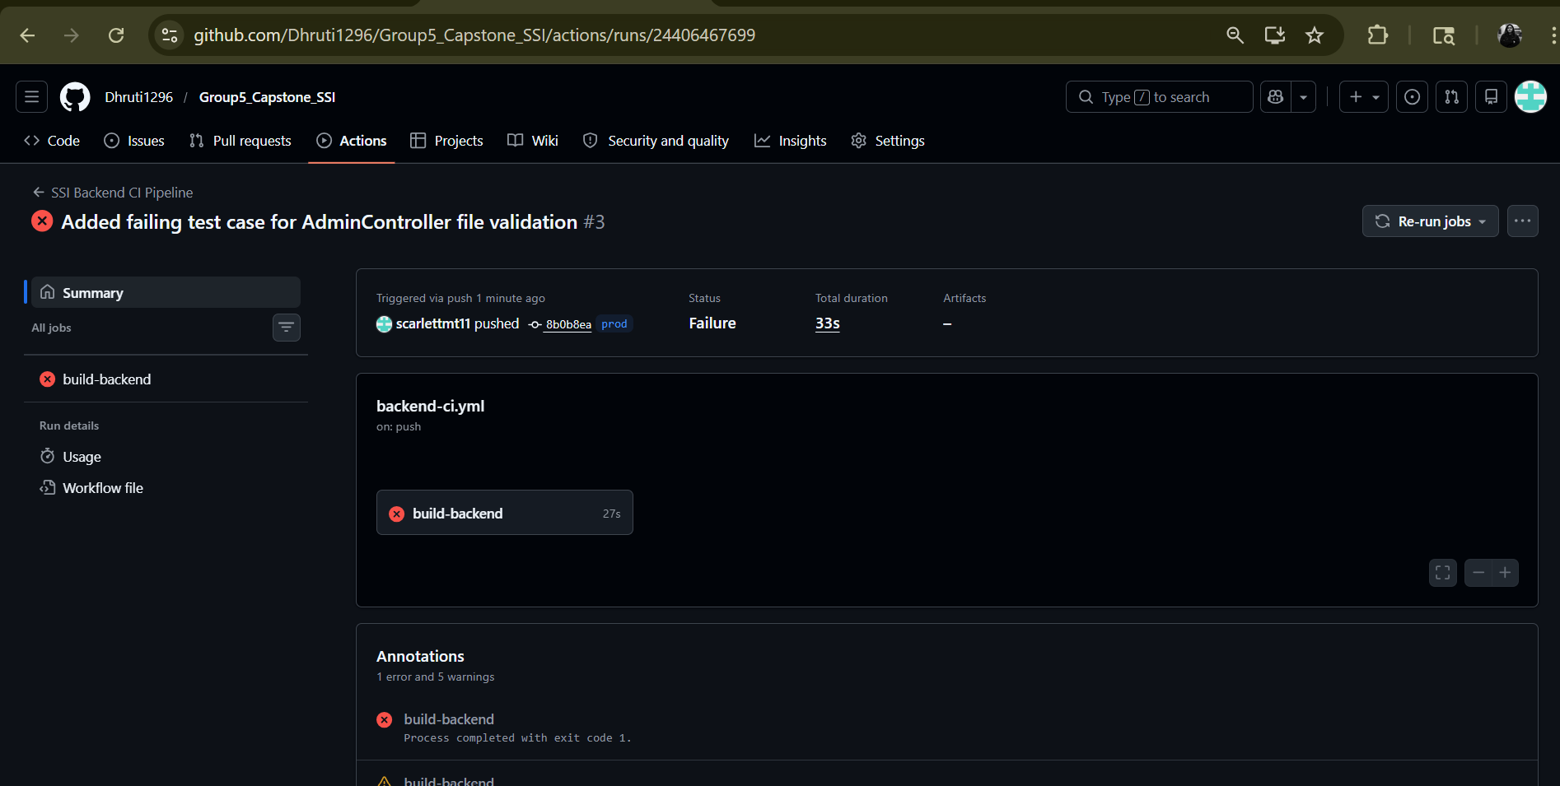Fig 4.1(b): Screenshot - Failed test case in SSI (contd..).
Reason behind the failed pipeline :
The pipeline failed because the validation step could not find the required backend file named “AdminControllers.cs”, so it returned an error and stopped execution.

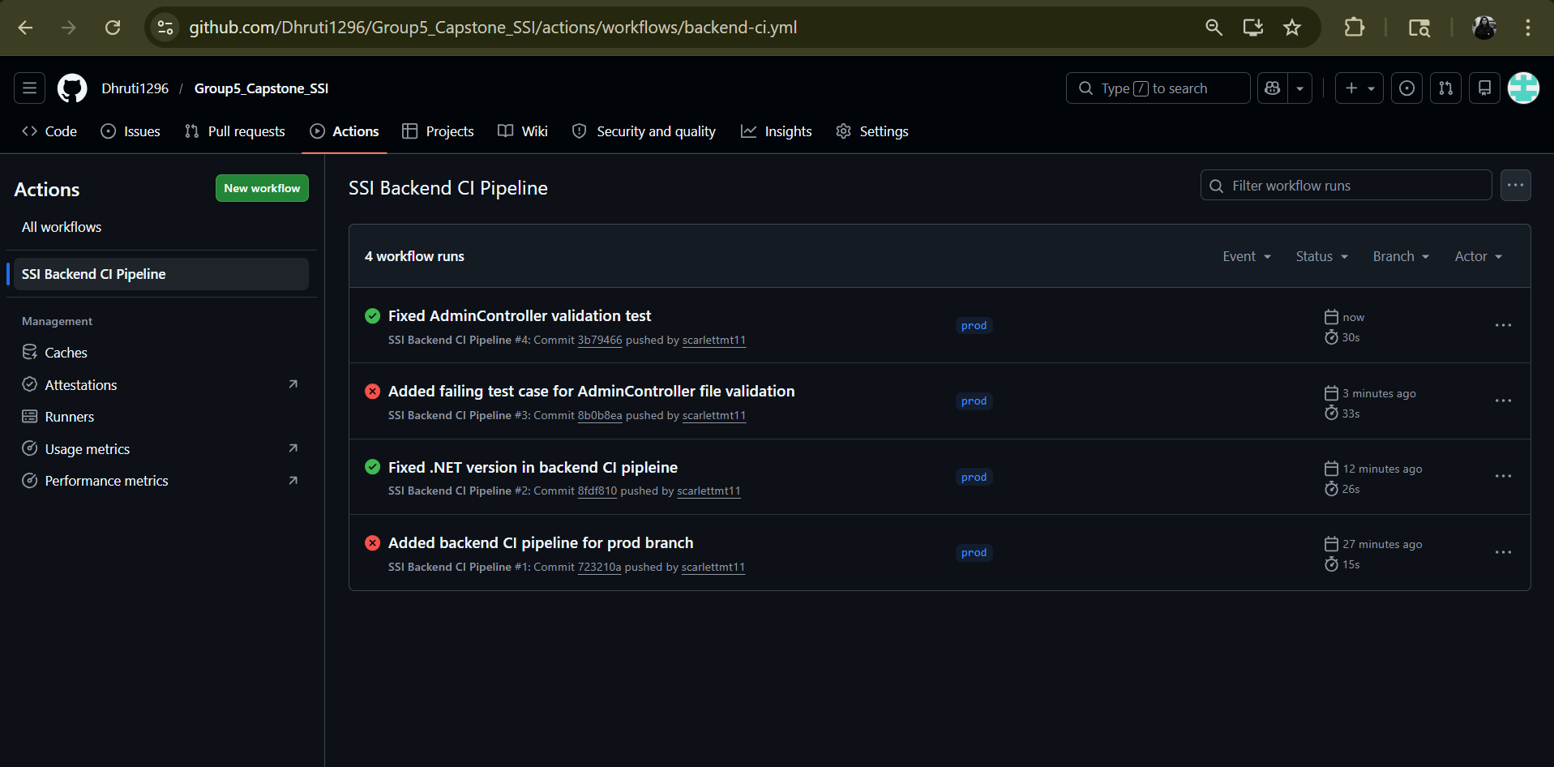
Fig 4.2 (a): Screenshot - Succeeded the test case in SSI” with commit message “Fixed AdminController validation test”.

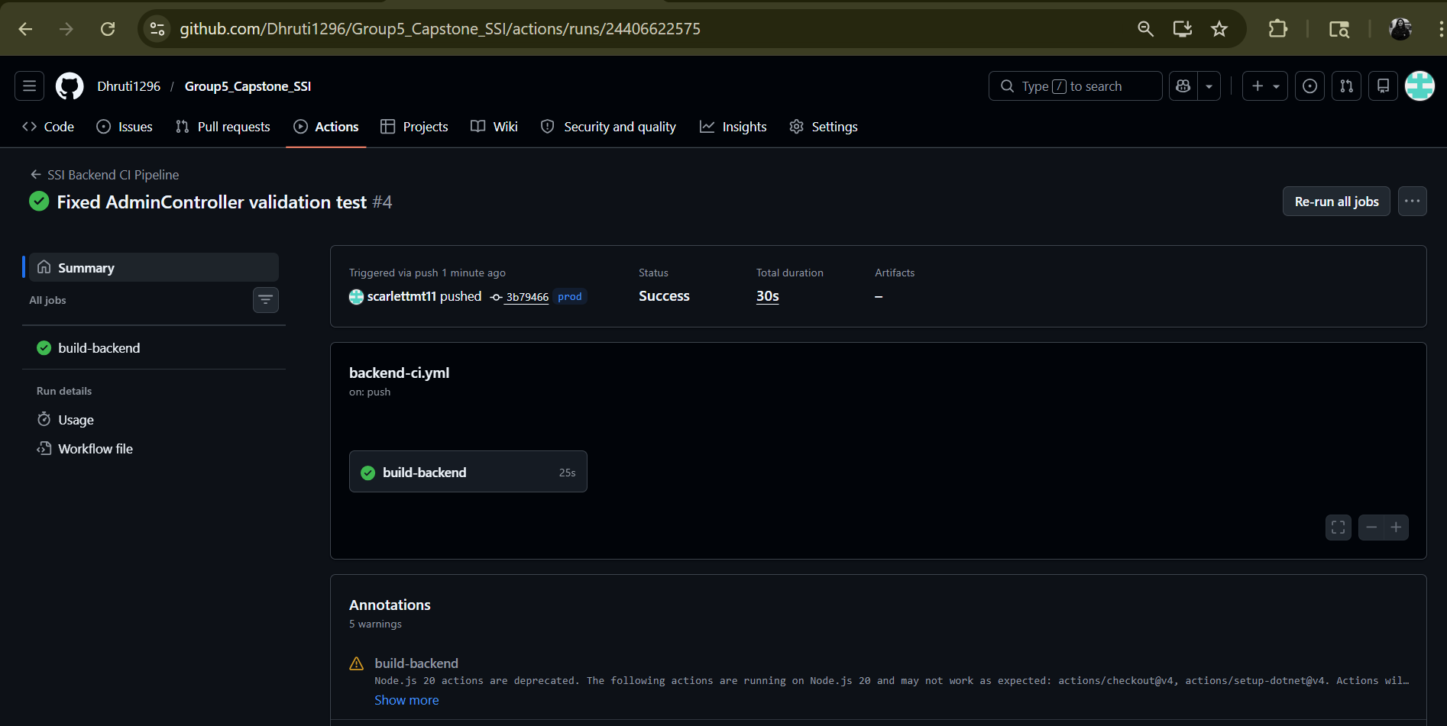
Fig 4.2 (b): Screenshot - Succeeded the test case in SSI (contd..)
Reason behind the successful pipeline :
The pipeline succeeded because all required backend files were present and the build completed without any errors.
- Conclusion :
In this task, a CI/CD pipeline was successfully implemented for the SSI backend using GitHub Actions. The pipeline automatically builds and validates the backend whenever code is pushed to the production branch. Both failure and success scenarios were tested to demonstrate how errors are detected and resolved. This process ensures early detection of issues, improves code quality, and maintains a stable and reliable backend system.

x----------------------------x--------------------------x

