

System Design Document
AI Resume Analyzer and Job Matcher
CSCI 5411 – Advanced Cloud Computing

Submitted By: Dhruti Patel (B01060910)

Table of Contents
1. Introduction …….3
2. System Architecture Overview 3
2.1 Architecture Diagram 3
2.2 Architectural Style 4
3. Component Design 4
3.1 Lambda Functions 4
3.2 Step Functions State Machine 5
4. Database Design 5
4.1 DynamoDB ResultsTable 5
4.2 DynamoDB JobsTable 6
5. API Design 6
6. Frontend Architecture 6
7. Security Design 7
8. Monitoring and Observability 7
9. Sequence Diagrams 7
9.1 Student Resume Analysis Sequence 7
10. Deployment Architecture 8

1. Introduction
This System Design Document (SDD) describes the architecture, components, data models, API contracts, and design decisions for the AI Resume Analyzer and Job Matcher. The system is entirely serverless, using AWS managed services to eliminate operational overhead and achieve elastic scalability.

2. System Architecture Overview

2.1 Architecture Diagram

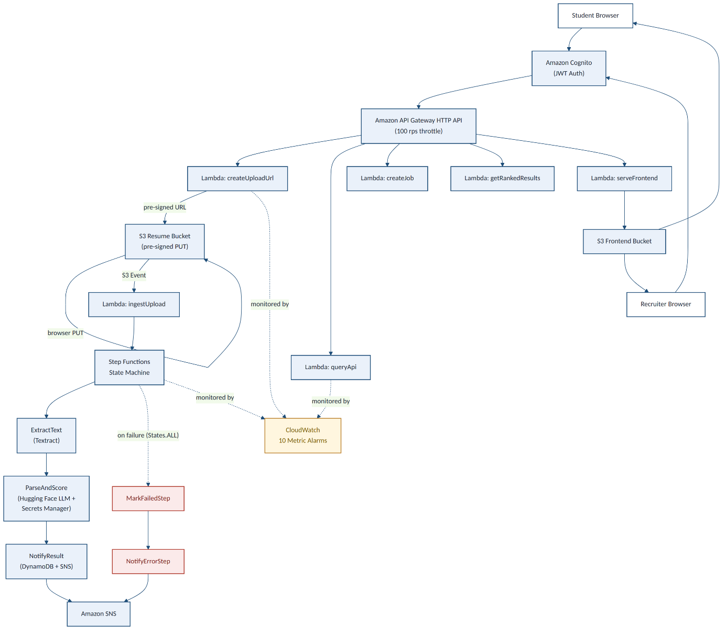
Figure 1. End-to-end serverless architecture: authentication, upload, AI analysis pipeline, and frontend delivery.
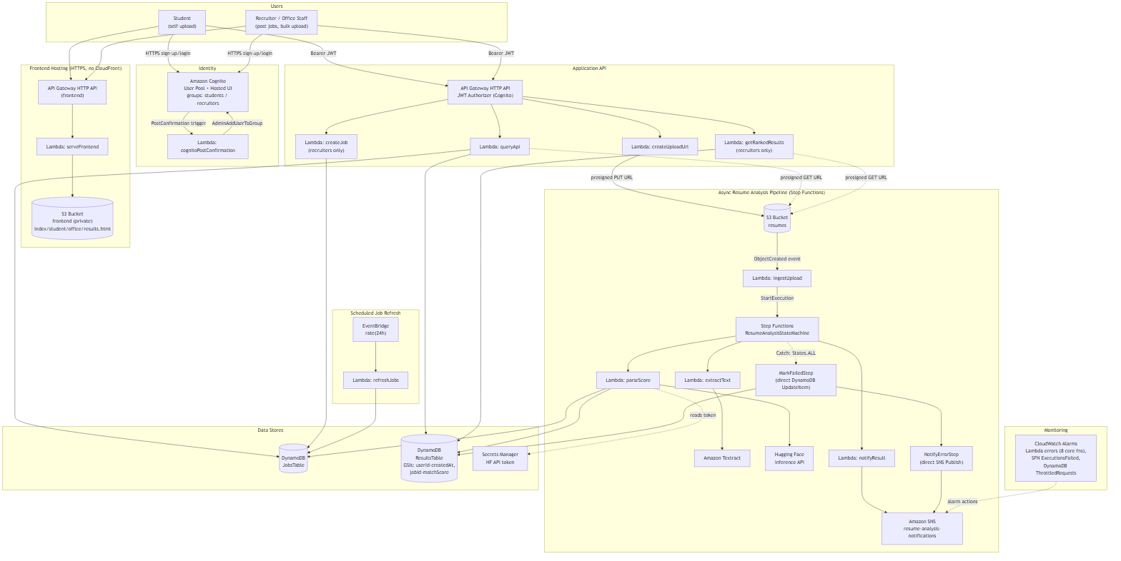
Architecture Diagram

2.2 Architectural Style
The system follows an event-driven, serverless microservices architecture. Each Lambda function has a single responsibility. Communication between services is asynchronous (S3 events, Step Functions) except for synchronous API calls (API Gateway -> Lambda). All state is in DynamoDB and S3.

3. Component Design

3.1 Lambda Functions
Function | Trigger | Responsibility | Timeout
createUploadUrl | API Gateway POST /upload | Generate pre-signed S3 URL; seed DynamoDB status=pending | 10s
ingestUpload | S3 Object Created | Validate event; start Step Functions execution | 10s
extractText | Step Functions | Call Textract DetectDocumentText on resume S3 object | 60s
parseAndScore | Step Functions | Fetch HF token from Secrets Manager; call LLM; parse JSON result | 120s
notifyResult | Step Functions | Update DynamoDB status=completed; publish SNS success email | 10s
markFailedStep | Step Functions (catch) | Update DynamoDB status=failed with error message | 10s
notifyErrorStep | Step Functions (catch) | Publish SNS error alert email | 10s
queryApi | API Gateway GET /results, /my-results, /jobs | Query DynamoDB; generate S3 download URL; enforce ownership | 10s
createJob | API Gateway POST /jobs | Validate recruiter role; insert into DynamoDB JobsTable | 10s
getRankedResults | API Gateway GET /jobs/{id}/results | Query GSI jobId-matchScore-index sorted desc; enforce ownership | 10s
serveFrontend | API Gateway GET /* | Read HTML/JS/CSS from private S3 bucket; set security headers | 10s
cognitoPostConfirmation | Cognito Post Confirmation | Add newly confirmed user to students group automatically | 5s

3.2 Step Functions State Machine
The state machine is a Standard Workflow. States:
- ExtractTextStep: Invokes extractText Lambda. On success → ParseAndScoreStep. On failure → MarkFailedStep.
- ParseAndScoreStep: Invokes parseAndScore Lambda. On success → NotifyResultStep. On failure → MarkFailedStep.
- NotifyResultStep: Invokes notifyResult Lambda. On success → END. On failure → MarkFailedStep.
- MarkFailedStep: Invokes markFailedStep Lambda. Always transitions to NotifyErrorStep.
- NotifyErrorStep: Invokes notifyErrorStep Lambda. END.
All failure transitions use a Catch block on States.ALL to guarantee the error path always runs.

4. Database Design

4.1 DynamoDB ResultsTable
Attribute | Type | Role
candidateId | String | Partition Key - Cognito sub for students; UUID for bulk uploads
resumeId | String | Sort Key - UUID generated per upload
userId | String | Cognito sub of the uploading user (ownership check)
jobId | String | Reference to JobsTable entry
jobTitle | String | Denormalized job title for display
candidateName | String | Filename-derived name for recruiter view
status | String | pending | completed | failed
matchScore | Number | 0-100 match percentage from LLM
matchedSkills | List<String> | Skills present in both resume and job description
strengths | List<String> | Candidate's notable strong points
gaps | List<String> | Missing or weak areas identified by LLM
recommendations | List<String> | Improvement suggestions from LLM
summary | String | One-paragraph LLM-generated overall assessment
s3Key | String | S3 object key for the resume PDF
createdAt | String | ISO 8601 timestamp
error | String | Error message if status=failed

Global Secondary Indexes:
- userId-createdAt-index: PK=userId, SK=createdAt – used for student history (sorted by date).
- jobId-matchScore-index: PK=jobId, SK=matchScore – used for recruiter ranking (sorted descending).

4.2 DynamoDB JobsTable
Attribute | Type | Role
jobId | String | Partition Key - recruiter-provided unique ID
recruiterId | String | Cognito sub of the creating recruiter (ownership)
title | String | Job posting title
description | String | Full job description text
skills | List<String> | Required skills list
location | String | Job location
createdAt | String | ISO 8601 timestamp

5. API Design
Method | Path | Role | Description
POST | /upload | any | Get pre-signed S3 URL; seed DynamoDB pending record
GET | /jobs | any | List all job postings
POST | /jobs | recruiters | Create a new job posting
GET | /results/{candidateId} | owner | Get analysis result (403 if not owner)
GET | /my-results | students | Paginated personal analysis history
GET | /jobs/{jobId}/results | recruiters | Ranked candidates for a job (ownership enforced)

6. Frontend Architecture
File | Purpose
index.html | Login page - Cognito InitiateAuth flow
callback.html | OAuth callback handler - exchanges code for tokens
student.html | Student portal - analyze tab + history tab
office.html | Recruiter portal - job list + upload modal
results.html | Ranked candidates page - charts + table
config.js | Runtime config - API base URL, Cognito client ID (injected by serveFrontend Lambda)

7. Security Design
- No credentials in source code or IaC. HF token in Secrets Manager.
- S3 bucket: private + server-side encryption (AES-256) + lifecycle rules.
- All Lambda functions use least-privilege IAM roles.
- Frontend security headers: Strict-Transport-Security, X-Frame-Options: DENY, X-Content-Type-Options, CSP.
- DynamoDB: ownership enforced in Lambda code (userId claim from JWT must match record userId).
- API Gateway throttling: 100 RPS / 50 burst prevents abuse.

8. Monitoring and Observability
CloudWatch Alarms configured for: Lambda Errors > 0 for all 8 core functions, Step Functions ExecutionsFailed > 0, DynamoDB SystemErrors > 0, DynamoDB ConsumedWriteCapacityUnits > 80%. All alarms send to the notification SNS topic.

9. Sequence Diagrams

9.1 Student Resume Analysis Sequence
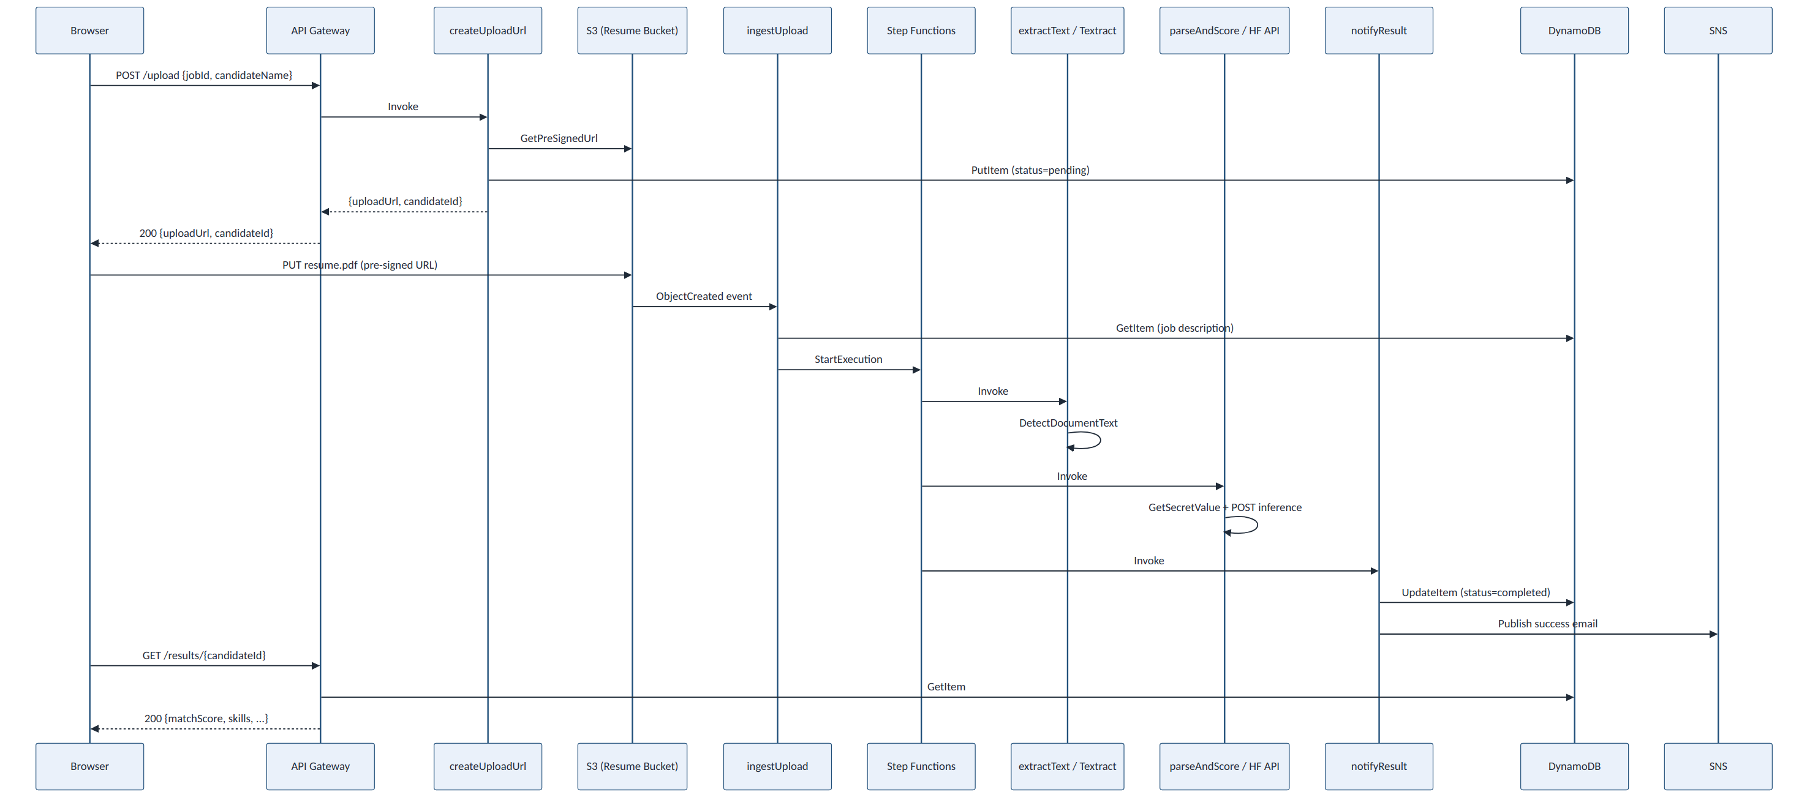
Figure 2. Sequence flow for a student uploading a resume and receiving an AI match score.

10. Deployment Architecture
All resources defined in Terraform (infra/ directory). Key resource groups:
- lambda.tf: 12 Lambda functions + IAM roles + archive data sources
- dynamodb.tf: ResultsTable + JobsTable + 3 GSIs
- cognito.tf: User pool, client, groups, demo users, UI customization
- stepfunctions.tf: State machine with full error handling
- apigateway.tf: HTTP API, routes, JWT authorizer, throttling, CORS
- s3.tf: Resume bucket + frontend bucket + lifecycle rules + events
- secrets.tf: Secrets Manager resource for HF token
- monitoring.tf: 10 CloudWatch alarms + SNS topic
- providers.tf: S3 remote state backend

