

User Manual
AI Resume Analyzer and Job Matcher

Submitted By: Dhruti Patel (B01060910)

Table of Contents
Introduction 3
Part 1: Getting Started 3
1.1 Accessing the Application 3
1.2 Registering a New Account 3
1.3 Logging In 4
1.4 Logging Out 4
Part 2: Student Portal 5
2.1 The Analyze Resume Tab 5
Step 1: Provide the Job Description 5
Step 2: Upload Your Resume 5
Step 3: Start Analysis 5
Step 4: Review Your Results 5
2.2 The My History Tab 6
2.3 Tips for Best Results 6
Part 3: Recruiter Portal 7
3.1 Posting a New Job 7
3.2 Uploading Resumes for Analysis 7
3.3 Viewing Ranked Candidates 8
Stat Cards 8
Charts 8
Ranked Candidate Table 8
Part 4: Troubleshooting 9

Introduction
Welcome to the AI Resume Analyzer and Job Matcher. This manual covers everything you need to use the platform as either a Student (job seeker) or a Recruiter (hiring professional). Open any modern browser (Chrome, Firefox, Edge, Safari) and navigate to the application URL provided by your administrator.

Part 1: Getting Started

1.1 Accessing the Application
Navigate to the application URL. You will see the Login page with email and password fields and a Sign In button.
https://2ftfx5av88.execute-api.us-east-1.amazonaws.com/
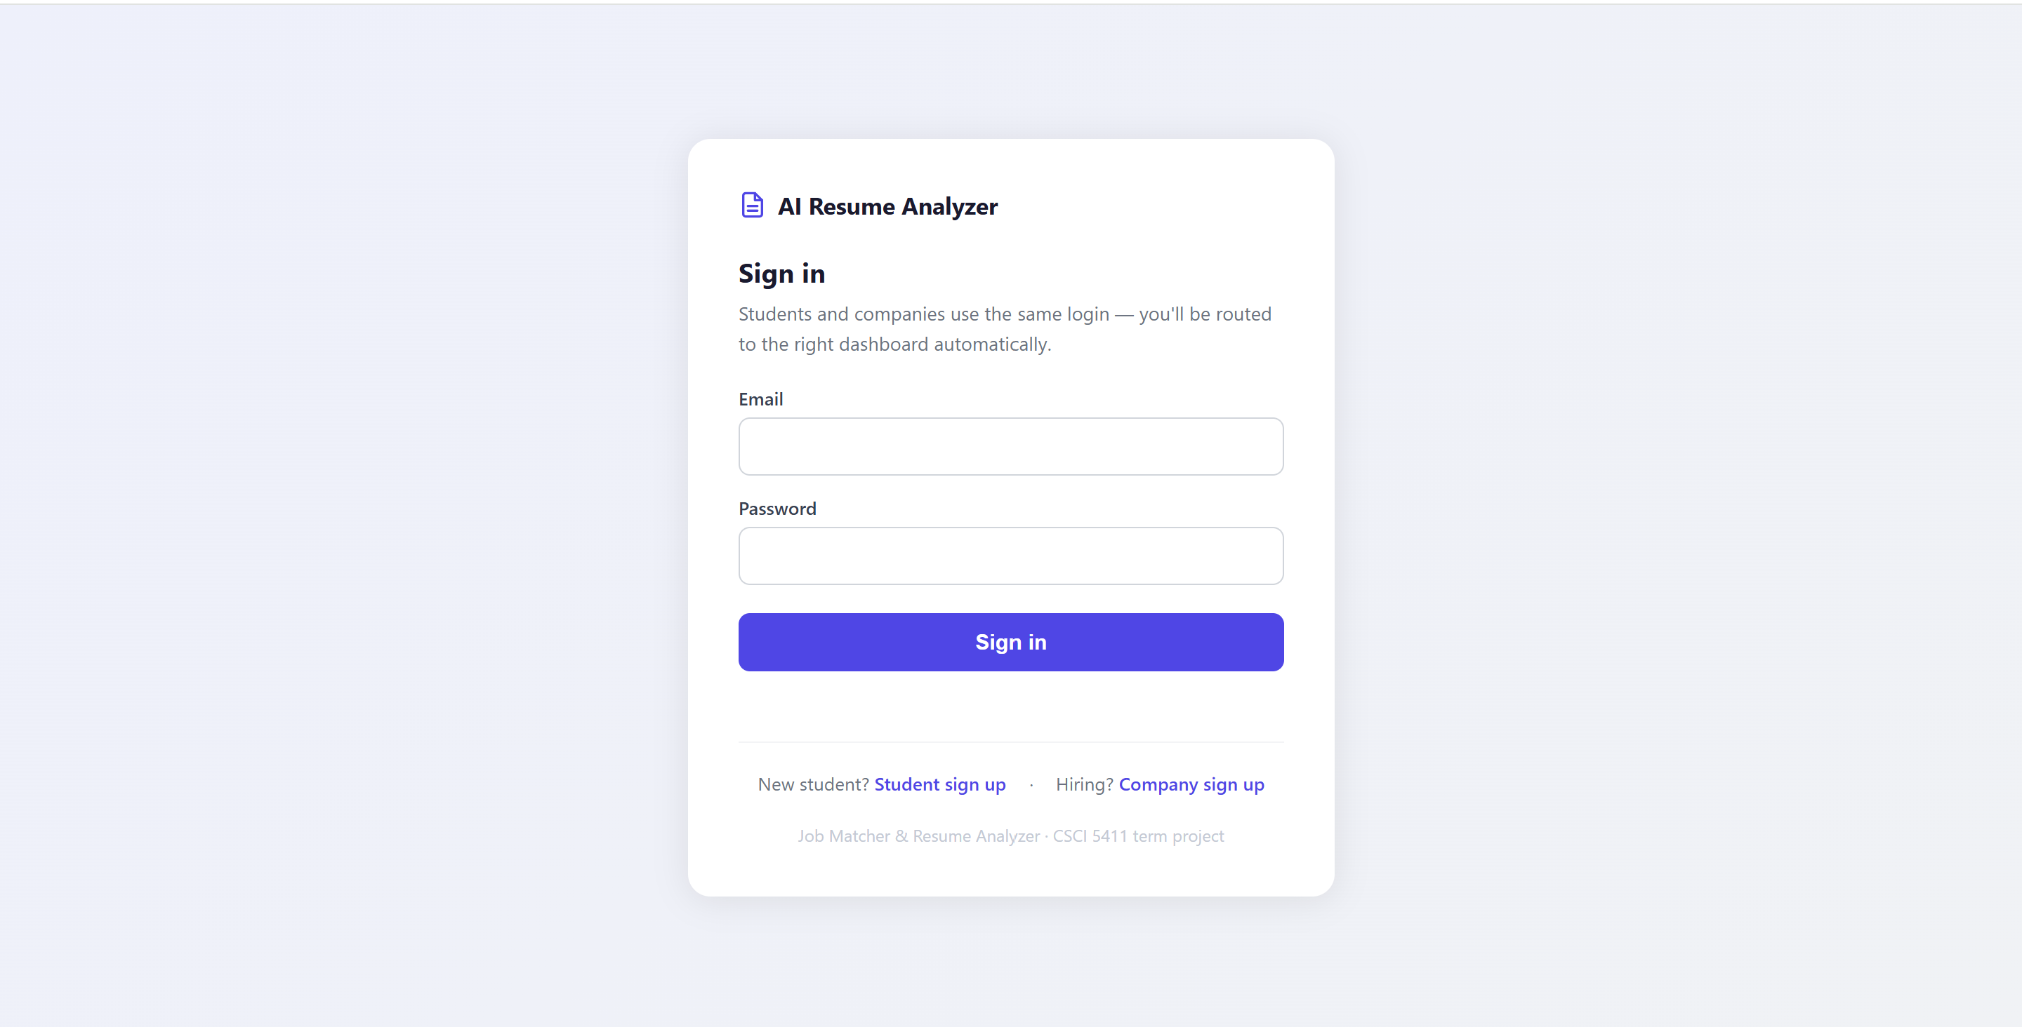

1.2 Registering a New Account
- On the Login page, click 'Don't have an account? Register'.
- Enter your email address and choose a password (minimum 8 characters, must include uppercase, lowercase, and a number).
- Click Sign Up. You will receive a verification email.
- Enter the 6-digit verification code from the email.
- After verification, you are automatically assigned the Student role and redirected to the Student Portal.

Note: Recruiter accounts are created by administrators and cannot self-register.
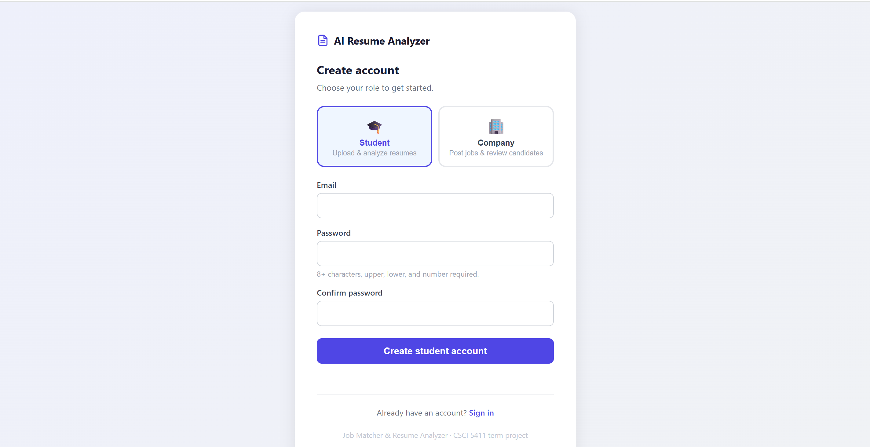

1.3 Logging In
- Enter your email address.
- Enter your password.
- Click the Sign In button.
You will be redirected to the appropriate portal: Student Portal for students, Recruiter Portal for recruiters.

1.4 Logging Out
Click the arrow/logout icon in the top-right corner of the navigation bar. You will be redirected to the login page.

Part 2: Student Portal
After logging in as a student, you see the Student Portal with two tabs: Analyze Resume and My History.

2.1 The Analyze Resume Tab

Step 1: Provide the Job Description
- Upload Job PDF: Click 'Upload Job PDF', then click 'Choose File' and select a PDF file of the job posting.
- Paste Description: Click 'Paste Description', then type or paste the job description text into the text area.

Step 2: Upload Your Resume
Click 'Choose File' under 'Your Resume (PDF)' and select your resume PDF from your computer. Supported format: PDF only. Maximum file size: 10 MB.

Step 3: Start Analysis
Click the 'Analyze Resume' button. A loading overlay will appear on the screen while the AI processes your resume (typically 45-80 seconds).

Step 4: Review Your Results
- Match Score: A large number (0-100). Green = strong match (70+), Blue = moderate (50-69), Yellow = developing (below 50).
- Matched Skills: Skills from your resume that match the job requirements.
- Strengths: Specific areas where your profile stands out.
- Skill Gaps: Areas required by the job but missing or weak in your resume.
- Recommendations: Specific, actionable advice on how to improve your resume for this role.

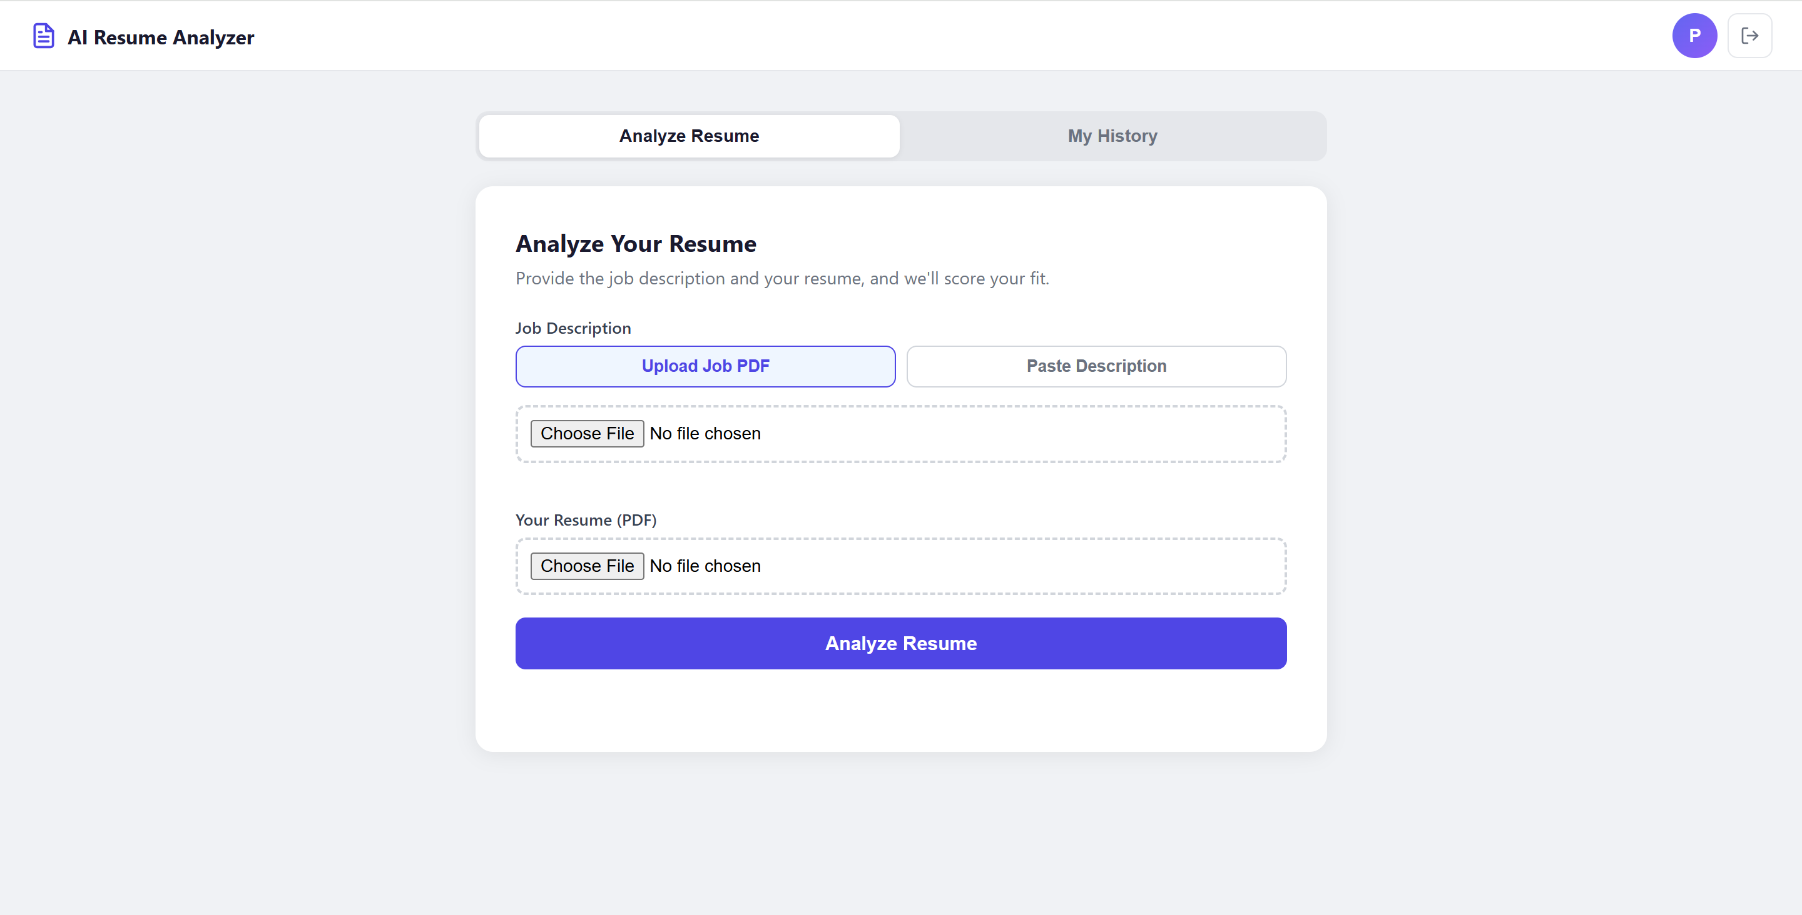

2.2 The My History Tab
Click 'My History' to see all your past resume analyses. Each entry shows job title, date, status badge (Completed/Pending/Failed), match score, and a download button for your original resume PDF.
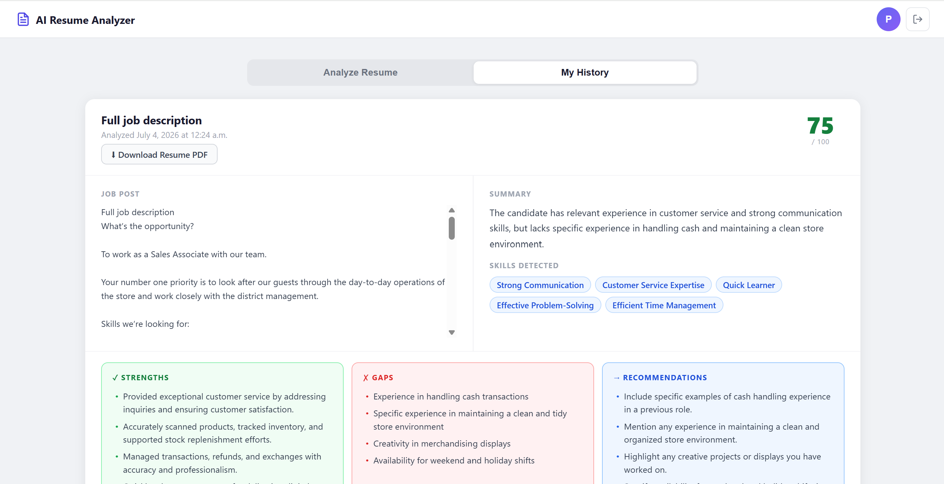

2.3 Tips for Best Results
- Use a well-formatted PDF resume – avoid scanned images; Textract works best with text-based PDFs.
- Provide the complete job description, not just the title – the more detail, the better the match analysis.
- Re-analyze after updating your resume – the system tracks each version independently.
- If analysis shows Failed, try again with a different PDF or check the file is not password-protected.

Part 3: Recruiter Portal
After logging in as a recruiter, you see the Recruiter Portal with a list of your job postings.

3.1 Posting a New Job
- Click the 'Post New Job' button (top right of the job list).
- Fill in: Job ID (unique identifier e.g. SWE-001), Job Title, Description, Required Skills (comma-separated), Location.
- Click 'Create Job'. The job appears in your job list.

3.2 Uploading Resumes for Analysis
- Click 'Upload Resumes' on any job card.
- Drag and drop PDF files onto the drop zone, or click 'Browse Files' to select files from your computer.
- Click 'Upload and Analyze'. Each file shows a progress badge as it uploads.
- When all uploads complete, a success message appears. Click 'View Rankings' to go to the rankings page.

Note: AI analysis runs in the background – results appear in the rankings page as they complete (typically within 60-90 seconds per resume).

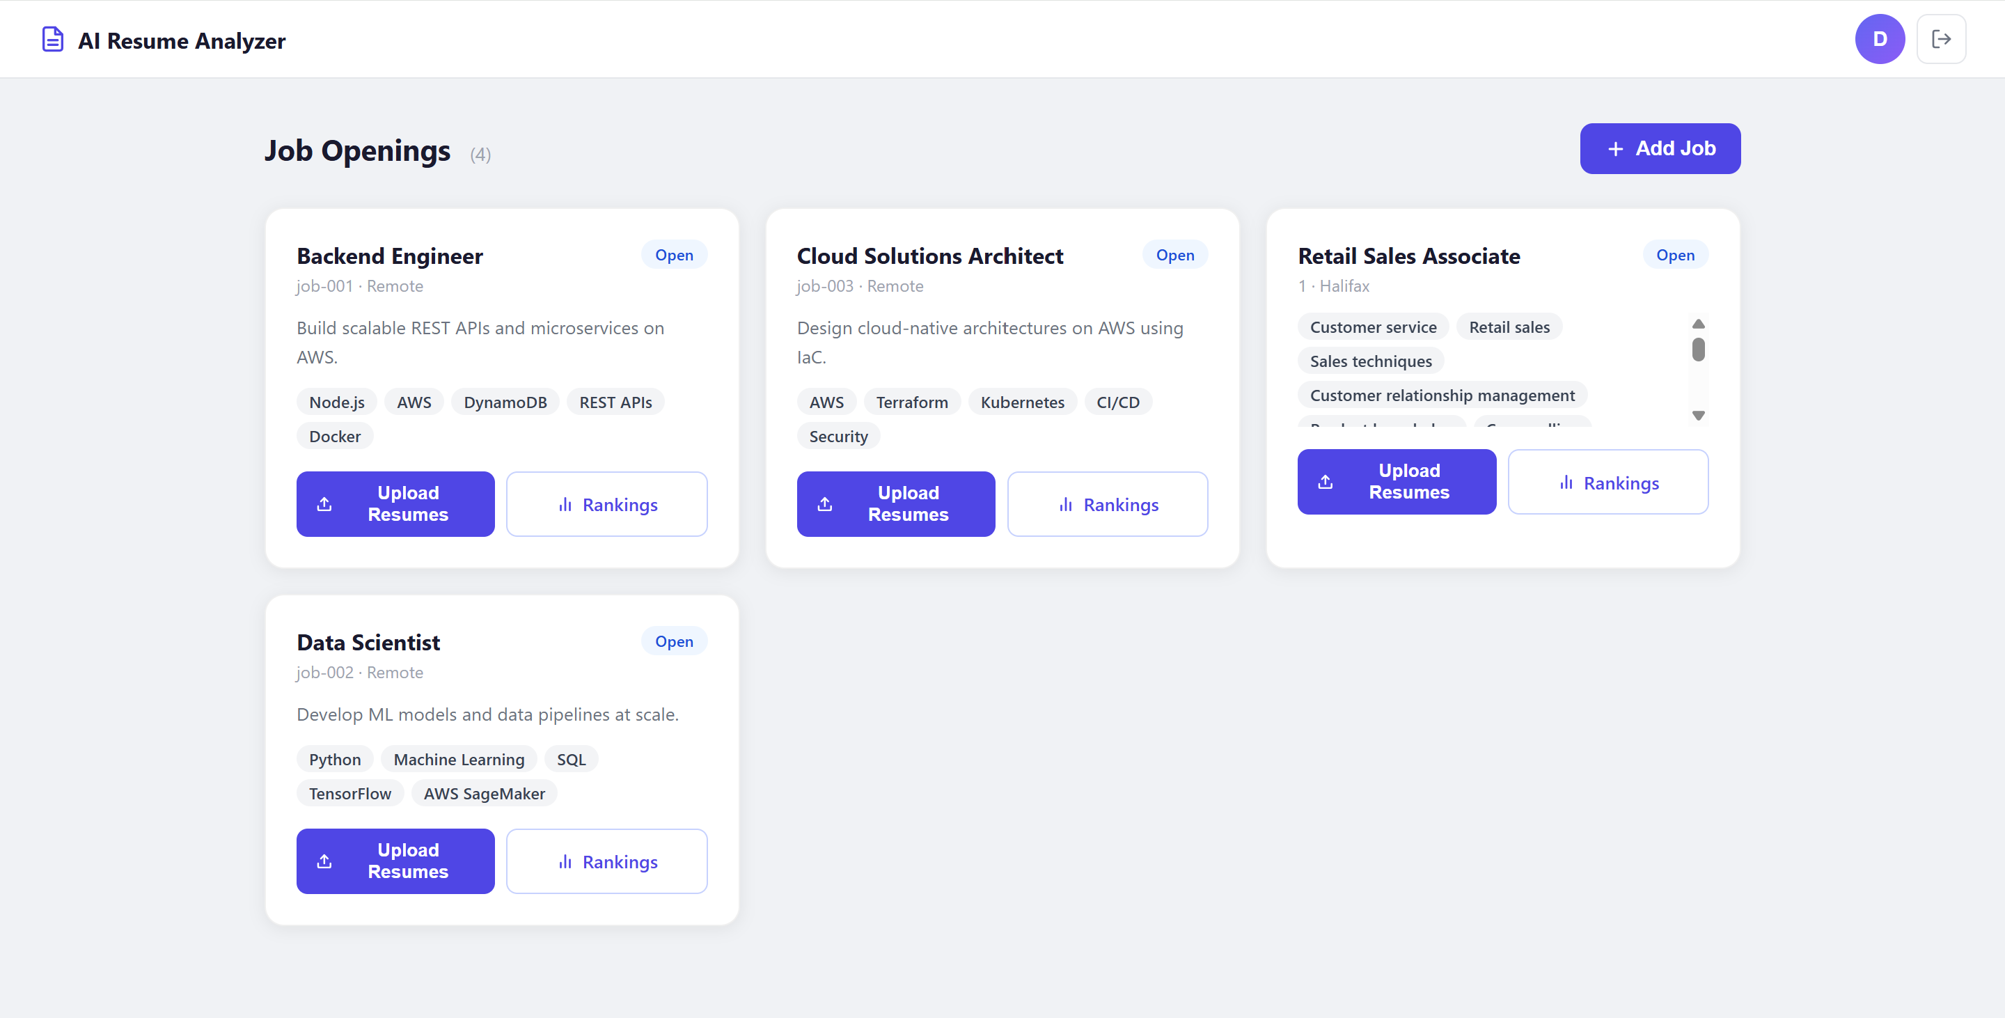

3.3 Viewing Ranked Candidates
Click 'Rankings' on a job card, or 'View Rankings' after uploading.

Stat Cards
- Total Applicants: Number of resumes analyzed for this job.
- Average Score: Mean match score across all candidates.
- Top Score: Highest match score achieved.
- Strong Matches: Number of candidates scoring 70 or above.

Charts
- Score Distribution: Bar chart showing how many candidates fall in each score range.
- Top Skills: Frequency chart showing which skills appear most across all candidate resumes.

Ranked Candidate Table
Candidates are sorted by match score (highest first). Each row shows rank, candidate name, score pill, progress bar, top skills, and AI-generated summary.
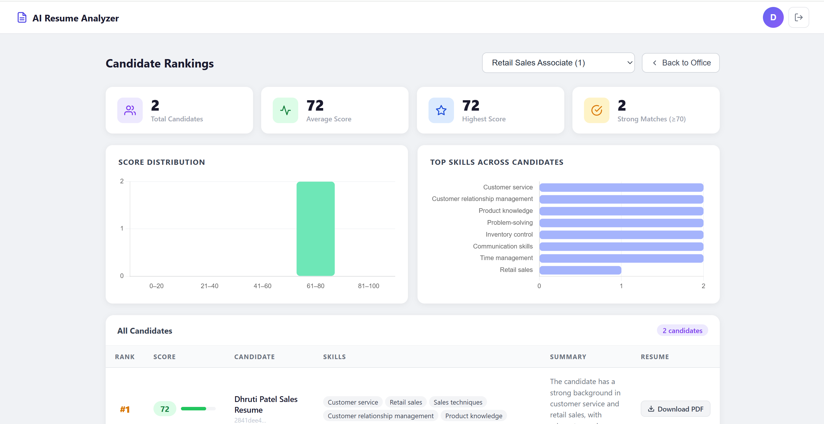

Part 4: Troubleshooting
Problem | Likely Cause | Solution
Login fails with 'Incorrect username or password' | Wrong credentials | Check email spelling; use password reset if needed
Analysis stuck on loading for > 3 minutes | Pipeline error | Check My History – status will show Failed; try again
Analysis failed in history | Textract could not read PDF | Ensure PDF is text-based, not a scanned image; try a different PDF
Upload button greyed out | No files selected | Add at least one PDF file to the upload list
Rankings page shows no results | Analysis still running | Wait 60-90 seconds and refresh the page
Unauthorized error on API call | JWT token expired | Log out and log back in to get a fresh token
Score seems too low | Resume lacks job-relevant keywords | Read the Gaps and Recommendations sections; revise resume accordingly

