High-Level Architecture
AI Resume Analyzer & Job Matcher — CSCI 5411 Term Project

Diagram
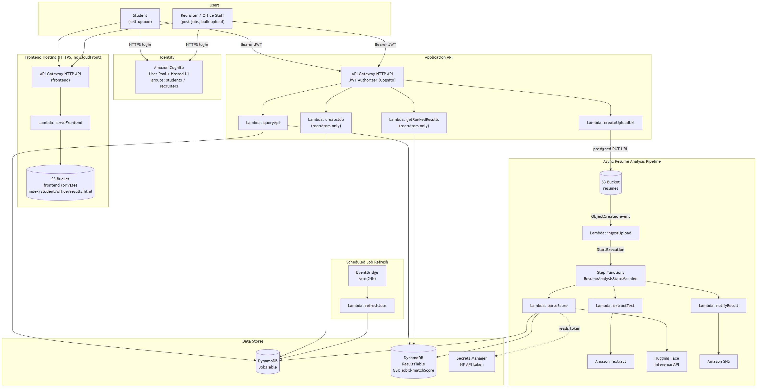
Figure 1. High-level component architecture.

Narrative
The system has two cooperating planes. A synchronous request/response plane (login, uploads, queries) is fronted by Amazon Cognito and two API Gateway HTTP APIs. An asynchronous, event-driven plane (AWS Step Functions) performs the actual resume analysis. Every hop is over HTTPS or an AWS-internal service API (also TLS-encrypted); the only call a browser ever makes outside of AWS infrastructure is to S3 (for the resume upload itself) — the Hugging Face LLM call happens entirely server-side inside a Lambda function, never from the client.
1. Students and recruiters both authenticate through the same Amazon Cognito Hosted UI (implicit OAuth flow). Cognito issues an access token and ID token; the ID token's cognito:groups claim (students or recruiters) determines which dashboard the frontend routes the user to.
2. The static frontend (5 HTML pages: index, callback, student, office, results) is served over HTTPS by a dedicated API Gateway HTTP API backed by a Lambda function (serveFrontend) that reads the page content from a private S3 bucket. This replaces the role CloudFront would normally play; CloudFront's CreateDistribution permission is blocked in this AWS Academy Learner Lab account, so this Lambda-fronted-API pattern is the HTTPS-terminating layer that Cognito's HTTPS-only callback URLs require instead.
3. All application requests (uploads, job postings, results) go to a second API Gateway HTTP API protected by a JWT authorizer that validates the Cognito access token on every route. Group-based authorization (e.g., recruiter-only routes) is then enforced inside each target Lambda by reading the validated token's claims.
4. POST /upload (createUploadUrl Lambda) returns a short-lived S3 presigned PUT URL. The browser uploads the resume PDF directly to the resumes S3 bucket, bypassing the API for the large binary payload. Recruiters performing a bulk upload pass an optional jobId, which is encoded into the S3 object key.
5. An S3 ObjectCreated event triggers the ingestUpload Lambda, which starts an execution of the ResumeAnalysisStateMachine in AWS Step Functions. Decoupling ingestion from processing this way gives the pipeline retry semantics instead of relying on one large, fragile Lambda.
6. The state machine runs three steps in sequence: extractText calls Amazon Textract to OCR the resume; parseScore reads current postings from JobsTable, calls the Hugging Face Inference API to score the resume against them, and writes the result (match score, skills, summary) to ResultsTable; notifyResult publishes a completion message to an Amazon SNS topic.
7. Students poll GET /results/{candidateId} for their own results; recruiters call GET /jobs/{jobId}/results, which queries the jobId-matchScore-index Global Secondary Index on ResultsTable to return candidates pre-sorted by score for that job, highest first.
8. An EventBridge rule on a 24-hour schedule invokes refreshJobs to seed a baseline set of job postings into JobsTable, running alongside (not instead of) live postings recruiters create through POST /jobs.

Two Hosting APIs, By Necessity
The architecture deliberately uses two separate API Gateway HTTP APIs rather than one: a public, unauthenticated 'frontend' API serving static page content, and a JWT-authorized 'application' API serving data. This split exists because CloudFront — the service that would normally terminate HTTPS in front of a static S3 website — is blocked in this Learner Lab account. Splitting the concerns this way kept the JWT authorizer scoped only to the routes that actually need it, rather than special-casing static asset routes around it.

