Name: Dhruv Jariwala K.  
Roll No: 32  
Div: A  
Sem: 7th  
Subject: 701  
Practical: Assignment-2

Output : 1



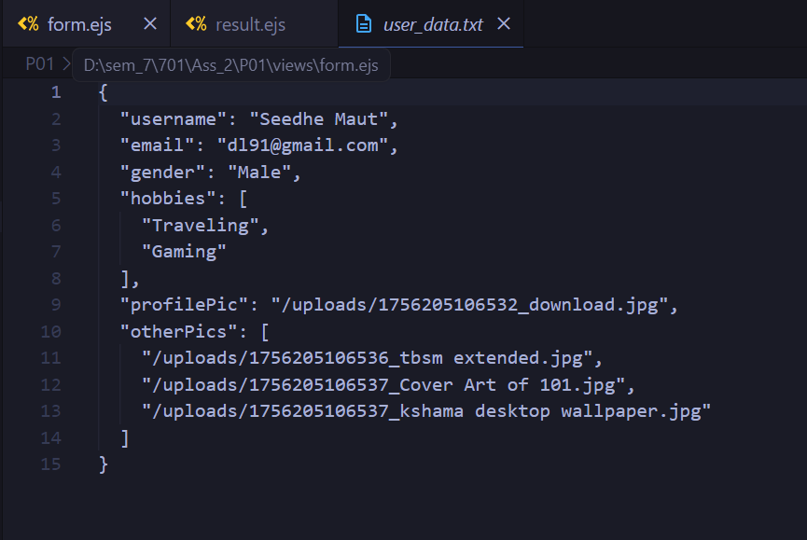

Output :2 





Output : 3

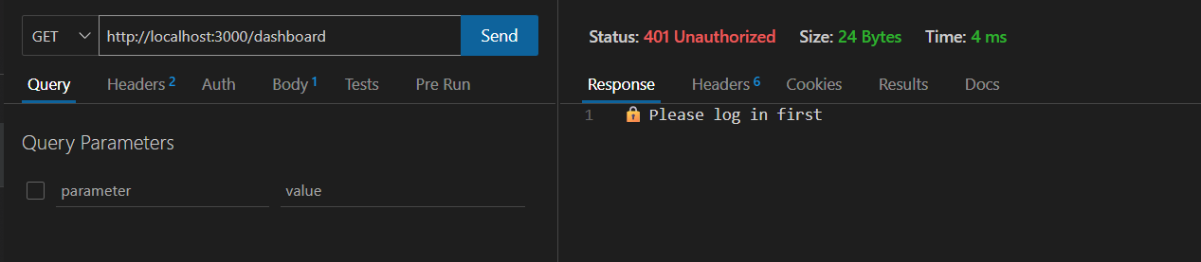

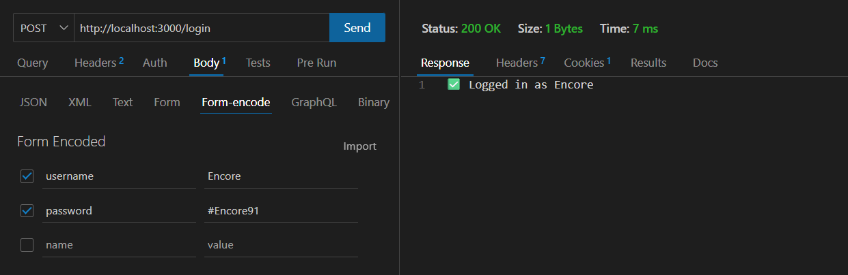





Output : 4





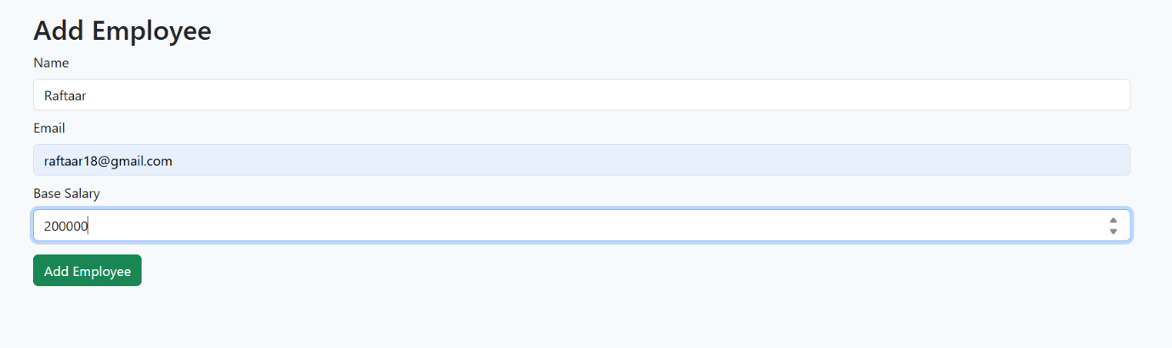

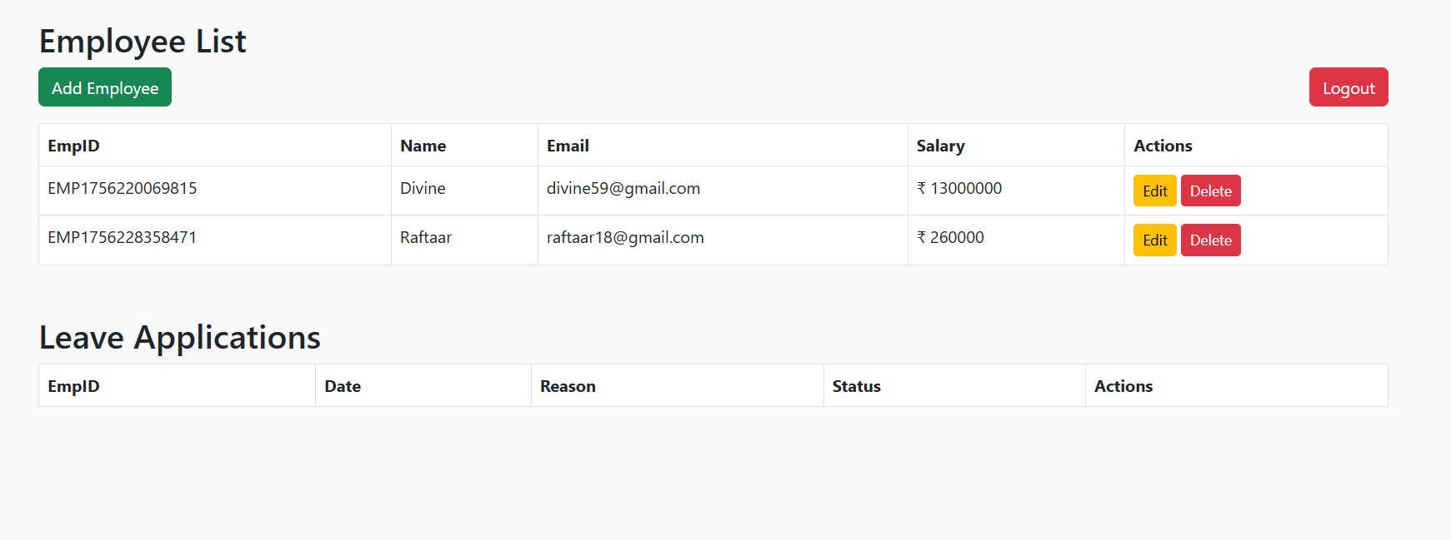

Output : 5



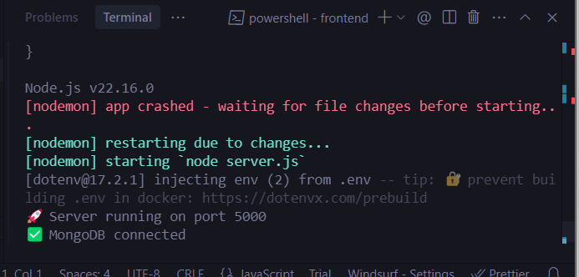

Output : 6

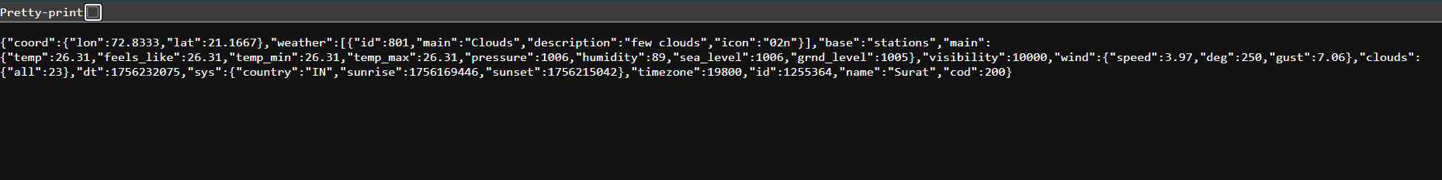

Output : 7

