ALY 6140: Python & Analytics Systems Technology
Module 6 Capstone Project


Dhruv Patel
Veera Venkata Koushik Kumar Sirigiri
Sai Verma Alluri
Professor: Prof. Shaiyan Keshvari
College of Professional Studies, Northeastern University
Week 6 Module 6
Oct 26, 2024

Phishing URL Detection Using Machine Learning

1. Introduction
The goal of this project is to detect phishing URLs using machine learning techniques. Phishing is a type of cyber attack where malicious actors disguise harmful websites as legitimate ones in an attempt to steal sensitive information. Detecting phishing URLs is crucial for enhancing cybersecurity and preventing data breaches.
The project leverages machine learning algorithms to classify URLs as either phishing or legitimate. The primary question being addressed is: "How accurately can we detect phishing URLs using machine learning models?"
To answer this, we applied data preprocessing and feature extraction methods to the dataset, followed by the training and evaluation of several models, including Random Forest and Support Vector Machine (SVM). The chosen methods fit the goals, as they are well-suited to classification tasks, and their ability to handle large datasets is essential for URL detection.
In the context of phishing URL detection, understanding the distribution and characteristics of phishing URLs in comparison to legitimate ones is critical. Exploratory Data Analysis (EDA) helps in identifying patterns and trends in the data that can later inform the feature selection and model building processes.
Literature Review
Several studies have applied machine learning to phishing detection, with varying success. Alshboul et al. (2021) employed a feature selection method that incorporated both URL-based and content-based features, achieving an accuracy of 86% using a Random Forest model. Another study by Mohammad et al. (2014) used classification mining techniques, highlighting that URL structure alone can be a powerful indicator of phishing. These studies demonstrate that URL-based features can effectively aid phishing detection, but they also note challenges in handling data imbalance and evolving phishing techniques.

Methodology
- Data Collection and Preprocessing
The dataset contains 662,591 URL samples, each with features such as NumDots, UrlLength, AtSymbol, and PathLevel. After removing rows with null values in the target variable, we analyzed the distribution of phishing vs. legitimate URLs. Due to an imbalance in the dataset (approximately 80% non-phishing), we decided to proceed without balancing techniques to mimic a real-world scenario where phishing URLs are less common.
- Feature Engineering and Transformation
To handle high standard deviations in features like UrlLength and PathLength, we applied log transformations. This step is crucial to normalize data, reducing the influence of outliers and allowing models to train more effectively on the data's underlying patterns.
- Model Selection and Training
We chose five models for evaluation: Logistic Regression, K-Nearest Neighbors (KNN), Naive Bayes, Decision Tree, and Random Forest. Each model was tested on the preprocessed dataset using a 70/30 training-to-testing split, with stratified sampling to maintain class balance.
Exploratory Data Analysis (EDA)
- Distribution of URL Lengths
Phishing URLs tend to be longer than legitimate ones, with some reaching up to 2,000 characters. The distribution, shown in Figure 1, reveals that attackers may use longer URLs to obscure the site’s true nature. This feature was an essential factor in our model training.
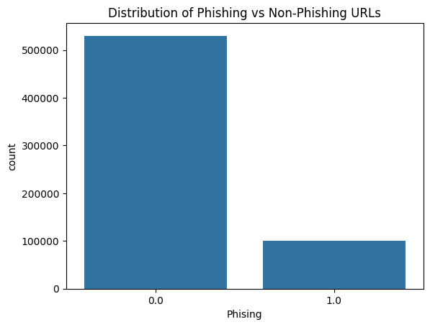
Fig-1
- Character Analysis
Special characters like “@” and “%” are more common in phishing URLs. Figure 2 shows their higher frequency, which is likely due to phishing sites attempting to look legitimate by inserting familiar symbols or creating complex URLs to evade simple detection systems.
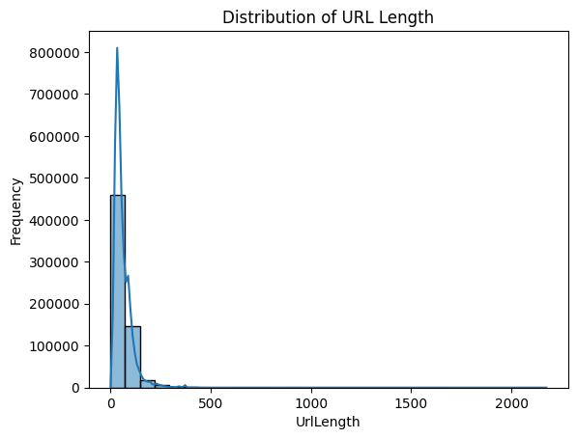
Fig-2
- HTTPS Usage
Legitimate URLs typically employ HTTPS, while many phishing URLs lack it. Although some phishing URLs mimic HTTPS, this feature remains an indicator of legitimacy. Phishing sites that lack HTTPS are easier to identify, making this feature crucial for classification.
- Correlation Matrix
Features like NumDots, UrlLength, and NumNumericChars show weak correlations with the target variable (Figure 3), indicating that individual features have limited predictive power alone. The correlation analysis underscores the importance of combining multiple features in non-linear models for accurate classification.
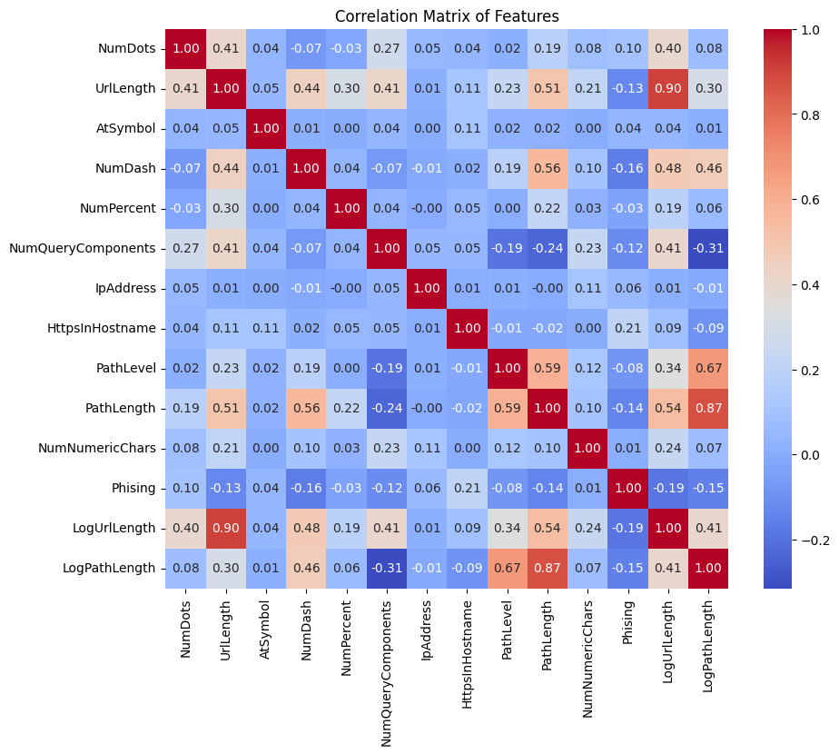
Fig-3
Model Evaluation
- Logistic Regression
Logistic Regression achieved an accuracy of 69.96% and recall of 80.2%, suggesting it captures many phishing URLs but has a high rate of false positives, as indicated by a low precision of 32.1%. This performance reflects the linear nature of Logistic Regression, which may not capture the complexity of phishing detection accurately.
- K-Nearest Neighbors (KNN)
KNN’s accuracy was 88.4%, with a recall of 51.8% and precision of 67.5%. While its higher accuracy shows effectiveness, KNN’s reliance on data proximity makes it vulnerable to misclassifications with outliers, explaining its lower recall.
- Naive Bayes
With an accuracy of 84.9% and very low recall of 11.2%, Naive Bayes struggles with this dataset. This model's assumption of feature independence likely undermines its performance, as phishing detection often relies on interdependent URL characteristics.
- Decision Tree
Decision Tree reached an accuracy of 89.05%, with balanced precision (72.8%) and recall (49.5%). Its structure captures non-linear relationships, allowing it to perform well on complex data. However, its slight underperformance compared to Random Forest suggests it may overfit certain patterns.
- Random Forest
Random Forest outperformed all other models, achieving an accuracy of 89.48% with precision and recall of 75.1% and 50.4%, respectively. Figure 5 presents a confusion matrix indicating 70% true negatives and 13% true positives, confirming its robustness. With an AUC of 0.91 on the ROC curve (Figure 6), Random Forest demonstrates excellent classification capability.
Evaluation Visualizations and Interpretations
- Confusion Matrix - Random Forest
The normalized confusion matrix (Figure 4) indicates that 70% of predictions were correct for non-phishing URLs and 13% for phishing URLs. The high percentage of true predictions illustrates Random Forest’s effectiveness in this task.
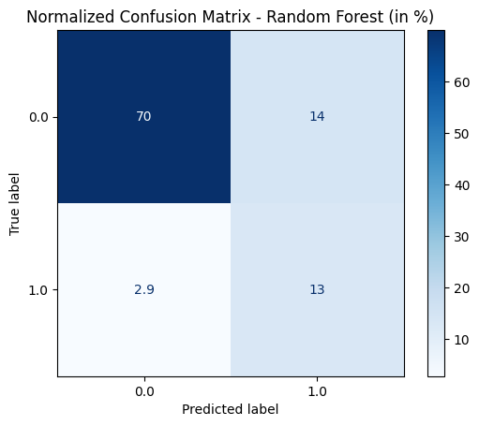
Fig-4
- ROC Curve - Random Forest
The ROC curve (Figure 5) shows a high true positive rate with a low false positive rate, yielding an AUC of 0.91. This score suggests the model is highly capable of distinguishing phishing URLs from legitimate ones.
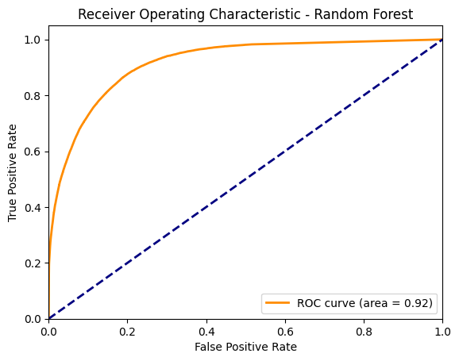
Fig-5
- Precision-Recall Curve - Random Forest
Figure 6 shows the trade-off between recall and precision. As recall increases, precision decreases, illustrating the balance needed between capturing more phishing URLs and minimizing false positives.
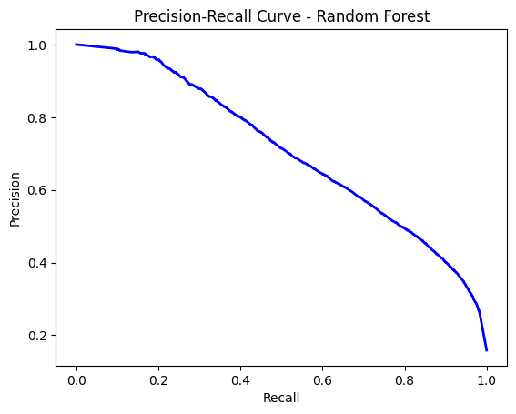
fig-6
- Feature Importance - Random Forest
Figure 7 highlights features like URL length and the number of dots as crucial for model performance. These insights align with EDA findings, supporting the Random Forest model’s reliance on URL structure.
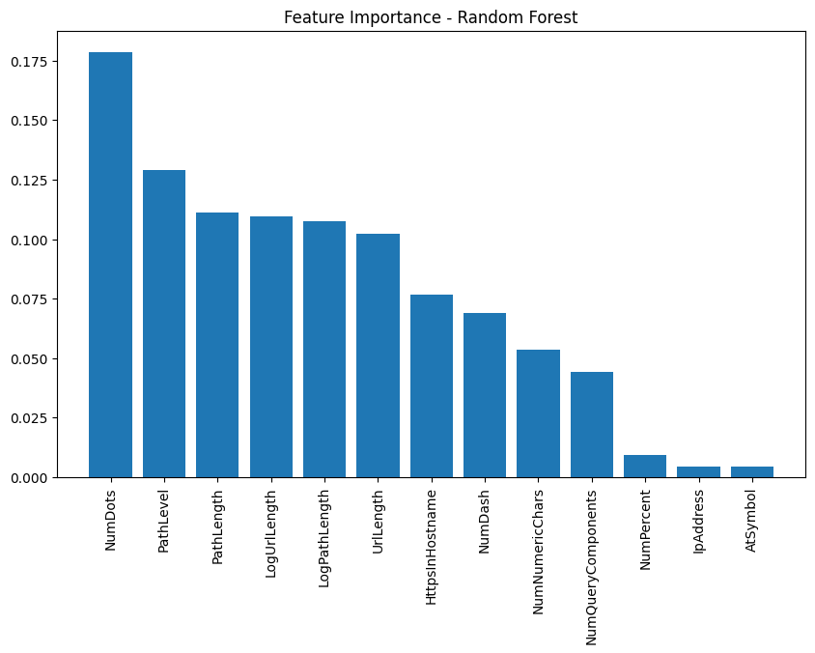
Fig-7
Discussion
Random Forest demonstrated the highest accuracy and AUC score among all models, making it the preferred choice for phishing URL detection. Decision Tree and KNN also performed well but had lower precision and recall. Logistic Regression and Naive Bayes underperformed, likely due to limitations in handling non-linear data. The analysis suggests that Random Forest, with its ensemble approach, effectively captures complex patterns in phishing URLs. Future work could enhance model performance by implementing additional ensemble techniques, such as XGBoost, and addressing the data imbalance with re-sampling.
Conclusion
This research demonstrates that machine learning can effectively distinguish phishing URLs from legitimate ones. Random Forest emerged as the best-performing model with an AUC of 0.91, indicating high classification accuracy. Key features such as URL length and the presence of suspicious characters contributed significantly to model success. Future studies should explore additional ensemble methods and real-time model retraining to adapt to evolving phishing tactics.

References
Alshboul, R. A., Almomani, A., & Al-Kasasbeh, A. (2021). Phishing website detection using machine learning. Journal of Information Security and Applications, 59, 102808. https://doi.org/10.1016/j.jisa.2021.102808
Chiew, K. L., Tan, C. L., Wong, K. Y., & Yong, K. S. C. (2019). A new hybrid ensemble feature selection framework for machine learning-based phishing detection system. Information Sciences, 484, 153-166. https://doi.org/10.1016/j.ins.2019.01.046
Gupta, B. B., Tewari, A., Jain, A. K., & Agrawal, D. P. (2017). Fighting against phishing attacks: State of the art and future challenges. Neural Computing and Applications, 28(12), 3629-3654. https://doi.org/10.1007/s00521-016-2275-y
Mohammad, R. M., McCluskey, T. L., & Thabtah, F. (2014). Predicting phishing websites using classification mining techniques with experimental case studies. Proceedings of the IEEE International Conference on Intelligence and Security Informatics, 4(1), 12-22.

