BIN MUJEEB LOGISTICS - WEBSITE CONTENT REVIEW
Please review each section below and provide your updated content in the answer fields.

SECTION 1: HEADER/NAVBAR
Question 1.1: What should be the company logo text?
Current Answer: Bin Mujeeb
Your Updated Answer: _________________________________________________

SECTION 2: HOME PAGE - HERO SECTION
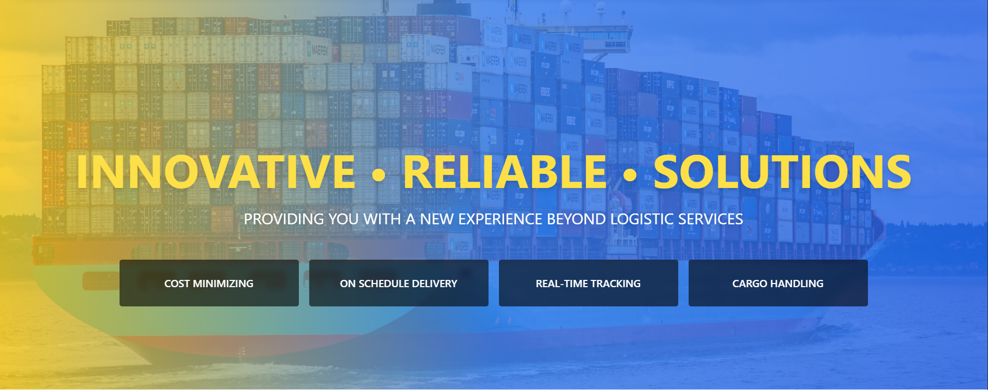
Question 2.1: What should be the main hero heading?
Current Answer: INNOVATIVE • RELIABLE • SOLUTIONS
Your Updated Answer: _________________________________________________
Question 2.2: What should be the hero subtitle?
Current Answer: PROVIDING YOU WITH A NEW EXPERIENCE BEYOND LOGISTIC SERVICES
Your Updated Answer: _________________________________________________
Question 2.3: What are the four feature boxes? (Please list all four)
Current Answers:
1. COST MINIMIZING
2. ON SCHEDULE DELIVERY
3. REAL-TIME TRACKING
4. CARGO HANDLING
Your Updated Answers:
1. _________________________________________________
2. _________________________________________________
3. _________________________________________________
4. _________________________________________________

SECTION 3: HOME PAGE - ABOUT US SECTION
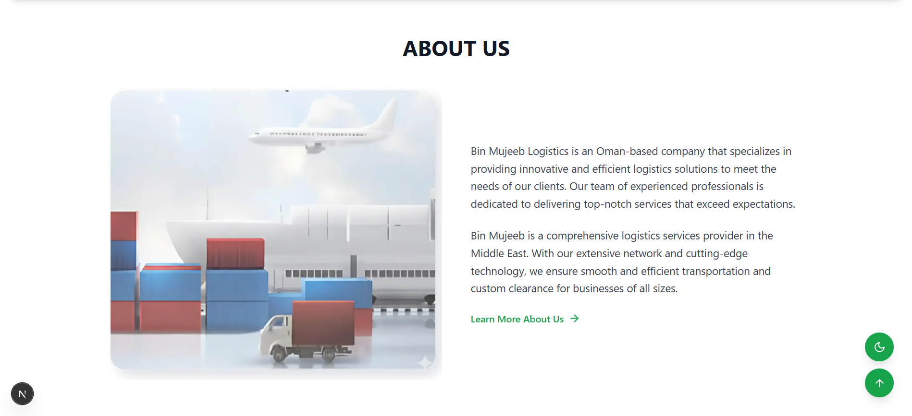
Question 3.1: What should be the About Us description (first paragraph)?
Current Answer: Bin Mujeeb Logistics is an Oman-based company that specializes in providing innovative and efficient logistics solutions to meet the needs of our clients. Our team of experienced professionals is dedicated to delivering top-notch services that exceed expectations.
Your Updated Answer: _________________________________________________
Question 3.2: What should be the About Us description (second paragraph)?
Current Answer: Bin Mujeeb is a comprehensive logistics services provider in the Middle East. With our extensive network and cutting-edge technology, we ensure smooth and efficient transportation and custom clearance for businesses of all sizes.
Your Updated Answer: _________________________________________________

SECTION 4: SERVICES PAGE - OUR SERVICES BANNER
Question 4.1: What should be the main heading?
Current Answer: OUR SERVICES
Your Updated Answer: _________________________________________________
Question 4.2: What should be the subtitle?
Current Answer: Comprehensive logistics solutions for your business needs
Your Updated Answer: _________________________________________________

SECTION 5: HOW WE WORK
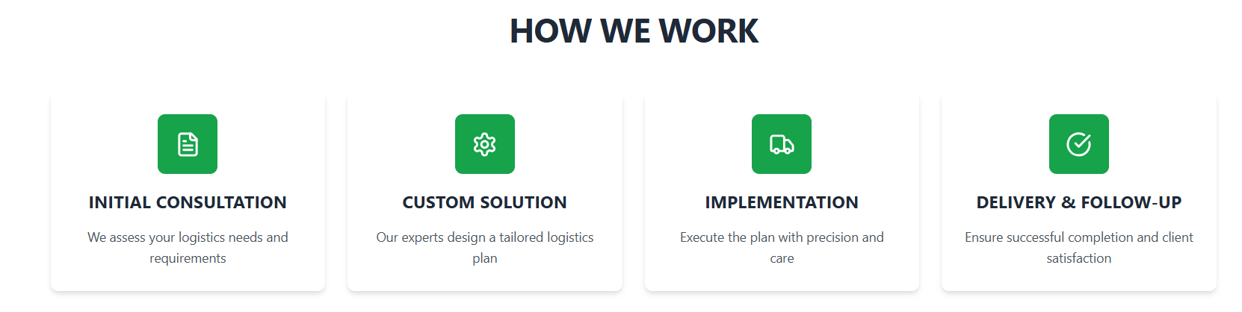
Question 5.1: Card 1 - What should be the title?
Current Answer: INITIAL CONSULTATION
Your Updated Answer: _________________________________________________
Question 5.2: Card 1 - What should be the description?
Current Answer: We assess your logistics needs and requirements
Your Updated Answer: _________________________________________________
Question 5.3: Card 2 - What should be the title?
Current Answer: CUSTOM SOLUTION
Your Updated Answer: _________________________________________________
Question 5.4: Card 2 - What should be the description?
Current Answer: Our experts design a tailored logistics plan
Your Updated Answer: _________________________________________________
Question 5.5: Card 3 - What should be the title?
Current Answer: IMPLEMENTATION
Your Updated Answer: _________________________________________________
Question 5.6: Card 3 - What should be the description?
Current Answer: Execute the plan with precision and care
Your Updated Answer: _________________________________________________
Question 5.7: Card 4 - What should be the title?
Current Answer: DELIVERY & FOLLOW-UP
Your Updated Answer: _________________________________________________
Question 5.8: Card 4 - What should be the description?
Current Answer: Ensure successful completion and client satisfaction
Your Updated Answer: _________________________________________________

SECTION 6: CORE CAPABILITIES
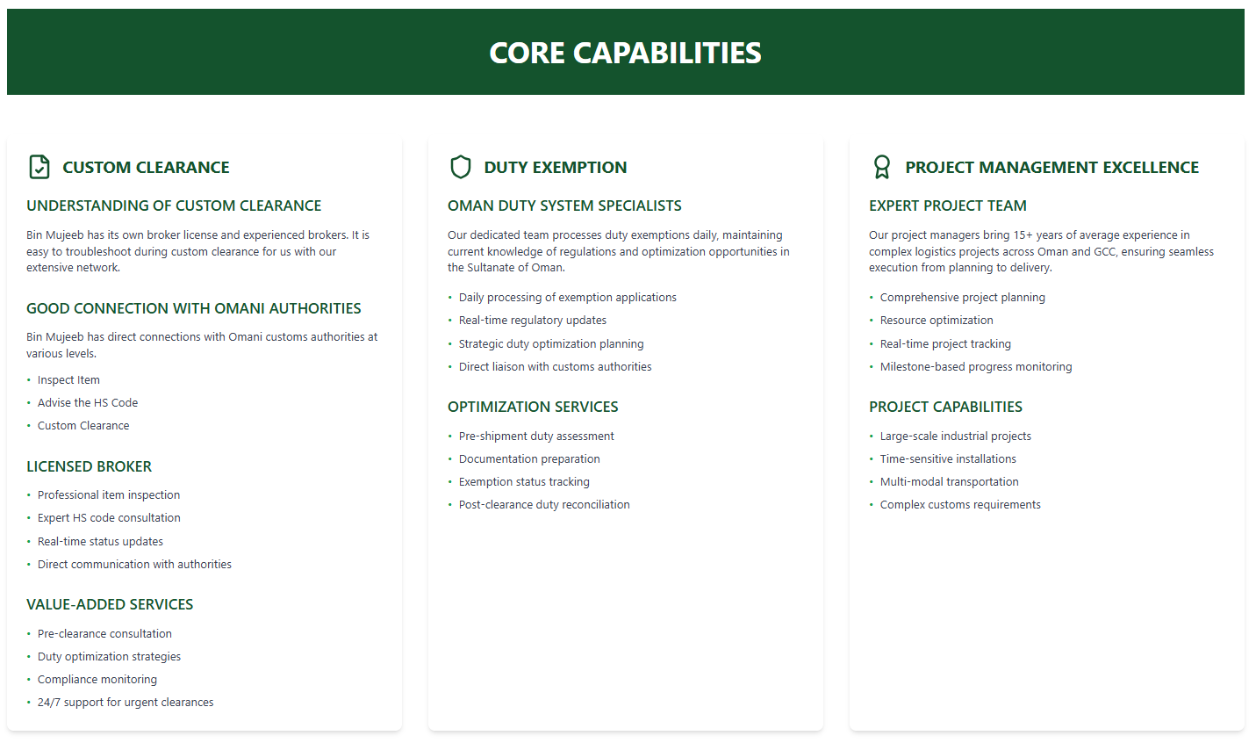
Question 6.1: Column 1 - CUSTOM CLEARANCE - 'UNDERSTANDING OF CUSTOM CLEARANCE' description?
Current Answer: Bin Mujeeb has its own broker license and experienced brokers. It is easy to troubleshoot during custom clearance for us with our extensive network.
Your Updated Answer: _________________________________________________
Question 6.2: Column 1 - 'GOOD CONNECTION WITH OMANI AUTHORITIES' description?
Current Answer: Bin Mujeeb has direct connections with Omani customs authorities at various levels.
Your Updated Answer: _________________________________________________
Question 6.3: Column 2 - DUTY EXEMPTION - 'OMAN DUTY SYSTEM SPECIALISTS' description?
Current Answer: Our dedicated team processes duty exemptions daily, maintaining current knowledge of regulations and optimization opportunities in the Sultanate of Oman.
Your Updated Answer: _________________________________________________
Question 6.4: Column 3 - PROJECT MANAGEMENT EXCELLENCE - 'EXPERT PROJECT TEAM' description?
Current Answer: Our project managers bring 15+ years of average experience in complex logistics projects across Oman and GCC, ensuring seamless execution from planning to delivery.
Your Updated Answer: _________________________________________________

SECTION 7: TRANSPORTATION SOLUTIONS
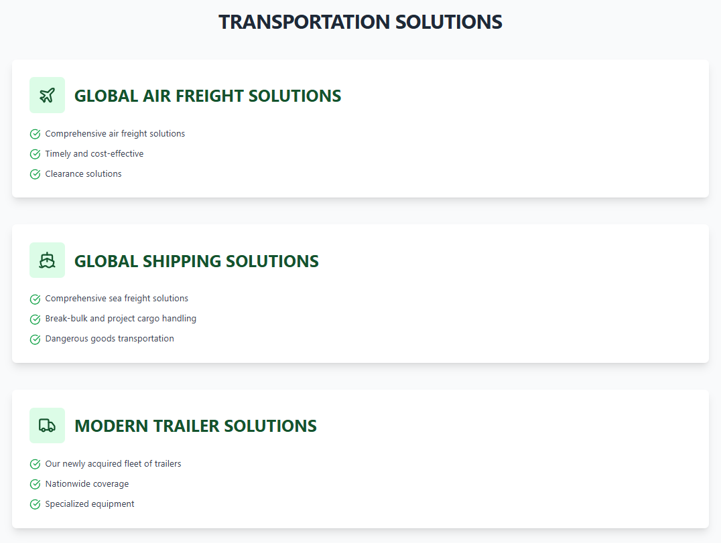
Question 7.1: GLOBAL AIR FREIGHT SOLUTIONS - What are the key points? (List all)
Current Answers:
• Comprehensive air freight solutions
• Timely and cost-effective
• Clearance solutions
Your Updated Answers:
• _________________________________________________
• _________________________________________________
• _________________________________________________
Question 7.2: GLOBAL SHIPPING SOLUTIONS - What are the key points? (List all)
Current Answers:
• Comprehensive sea freight solutions
• Break-bulk and project cargo handling
• Dangerous goods transportation
Your Updated Answers:
• _________________________________________________
• _________________________________________________
• _________________________________________________
Question 7.3: MODERN TRAILER SOLUTIONS - What are the key points? (List all)
Current Answers:
• Our newly acquired fleet of trailers
• Nationwide coverage
• Specialized equipment
Your Updated Answers:
• _________________________________________________
• _________________________________________________
• _________________________________________________

SECTION 8: SERVICE CATEGORIES
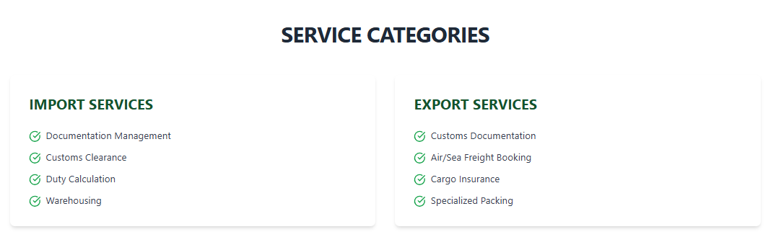Question 8.1: IMPORT SERVICES - What services should be listed? (List all)
Current Answers:
• Documentation Management
• Customs Clearance
• Duty Calculation
• Warehousing
Your Updated Answers:
• _________________________________________________
• _________________________________________________
• _________________________________________________
• _________________________________________________
Question 8.2: EXPORT SERVICES - What services should be listed? (List all)
Current Answers:
• Customs Documentation
• Air/Sea Freight Booking
• Cargo Insurance
• Specialized Packing
Your Updated Answers:
• _________________________________________________
• _________________________________________________
• _________________________________________________
• _________________________________________________

SECTION 9: INDUSTRY-SPECIFIC SOLUTIONS
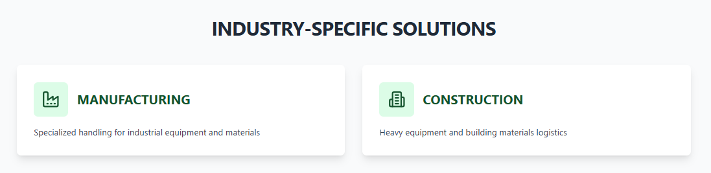
Question 9.1: MANUFACTURING - What should be the description?
Current Answer: Specialized handling for industrial equipment and materials
Your Updated Answer: _________________________________________________
Question 9.2: CONSTRUCTION - What should be the description?
Current Answer: Heavy equipment and building materials logistics
Your Updated Answer: _________________________________________________

SECTION 10: READY TO GET STARTED?
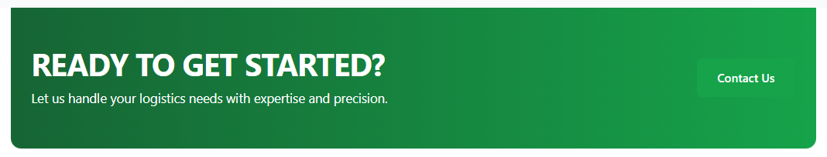
Question 10.1: What should be the main heading?
Current Answer: READY TO GET STARTED?
Your Updated Answer: _________________________________________________
Question 10.2: What should be the subtitle?
Current Answer: Let us handle your logistics needs with expertise and precision.
Your Updated Answer: _________________________________________________

SECTION 11: ABOUT PAGE
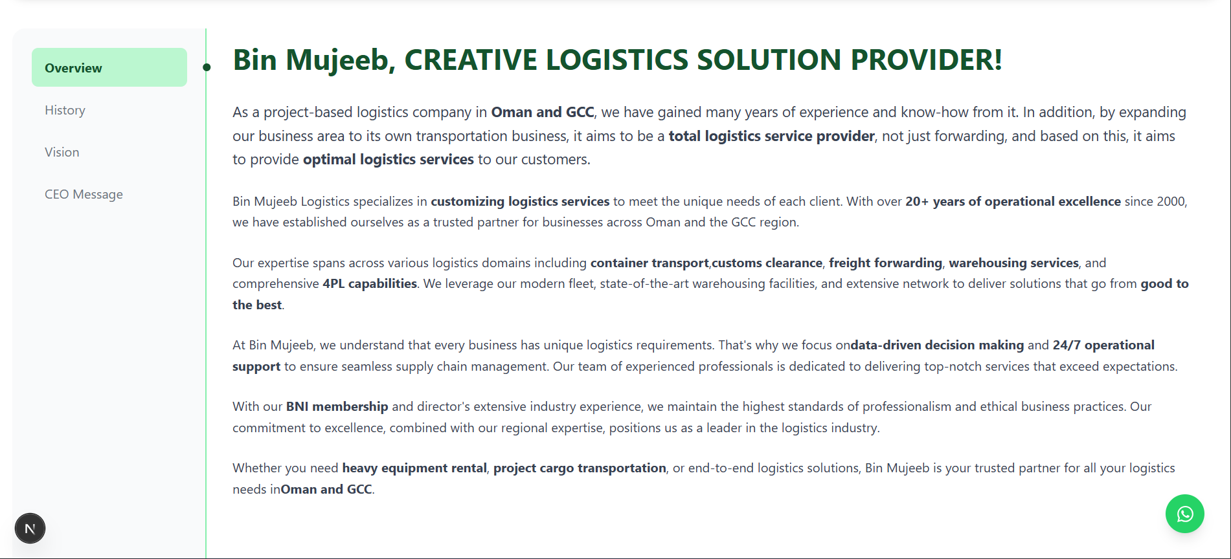
Question 11.1: What should be the main heading?
Current Answer: Bin Mujeeb, CREATIVE LOGISTICS SOLUTION PROVIDER!
Your Updated Answer: _________________________________________________
Question 11.2: What should be the first paragraph?
Current Answer: As a project-based logistics company in Oman and GCC, we have gained many years of experience and know-how from it. In addition, by expanding our business area to its own transportation business, it aims to be a total logistics service provider, not just forwarding, and based on this, it aims to provide optimal logistics services to our customers.
Your Updated Answer: _________________________________________________
Question 11.3: What should be the second paragraph?
Current Answer: Bin Mujeeb Logistics specializes in customizing logistics services to meet the unique needs of each client. With over 20+ years of operational excellence since 2000, we have established ourselves as a trusted partner for businesses across Oman and the GCC region.
Your Updated Answer: _________________________________________________
Question 11.4: What should be the third paragraph?
Current Answer: Our expertise spans across various logistics domains including container transport, customs clearance, freight forwarding, warehousing services, and comprehensive 4PL capabilities. We leverage our modern fleet, state-of-the-art warehousing facilities, and extensive network to deliver solutions that go from good to the best.
Your Updated Answer: _________________________________________________
Question 11.5: What should be the fourth paragraph?
Current Answer: At Bin Mujeeb, we understand that every business has unique logistics requirements. That's why we focus on data-driven decision making and 24/7 operational support to ensure seamless supply chain management. Our team of experienced professionals is dedicated to delivering top-notch services that exceed expectations.
Your Updated Answer: _________________________________________________
Question 11.6: What should be the fifth paragraph?
Current Answer: With our BNI membership and director's extensive industry experience, we maintain the highest standards of professionalism and ethical business practices. Our commitment to excellence, combined with our regional expertise, positions us as a leader in the logistics industry.
Your Updated Answer: _________________________________________________
Question 11.6: What should be the sixth paragraph?
Current Answer: Whether you need heavy equipment rental, project cargo transportation, or end-to-end logistics solutions, Bin Mujeeb is your trusted partner for all your logistics needs in Oman and GCC.
Your Updated Answer: _________________________________________________

SECTION 12: PROJECTS PAGE
[IMAGE PLACEHOLDER: Screenshot of the Projects page with project cards]
Question 12.1: What should be the main heading?
Current Answer: OUR PORTFOLIO
Your Updated Answer: _________________________________________________
Question 12.2: Please provide details for each project card (Project Name, Date, Client, Services, Partner if any)
Current Projects:
Project 1: FADHILI (2024 ~ PRESENT) - Client: SAMSUNG E&A - Services: GENERAL/HEAVY CARGO TRANSPORT, IMPORT CLEARANCE - Partner: Saudi Aramco
Project 2: JAFURAH COGEN (2023 ~ 2024) - Client: DOOSAN Enerbility - Services: GENERAL/HEAVY CARGO TRANSPORT, DUTY EXEMPTION & CONSULTING, IMPORT CLEARANCE - Partner: KEPCO
Project 3: S-PROJECT (2023 ~ 2024) - Client: SeAH - Services: GENERAL/HEAVY CARGO TRANSPORT, DUTY EXEMPTION & CONSULTING, IMPORT CLEARANCE
Project 4: SS8D (2022 ~ 2023) - Client: HYUNDAI ENGINEERING & CONSTRUCTION - Services: GENERAL CARGO TRANSPORT, IMPORT CLEARANCE - Partner: Saudi Electricity Company
Your Updated Projects:
Project 1: _________________________________________________
Project 2: _________________________________________________
Project 3: _________________________________________________
Project 4: _________________________________________________
Question 12.3: OUR CLIENTS SECTION - Please provide company logo images for the sliding client logos section
Current Client Companies Displayed:
• Samsung E&A
• Doosan Enerbility
• SeAH
• Hyundai Engineering & Construction
• Saudi Aramco
• KEPCO
• Saudi Electricity Company
Please provide:
1. High-resolution logo images (PNG format preferred, transparent background if possible)
2. Any additional client companies you would like to add to the sliding logos section
3. Any companies you would like to remove from the list

SECTION 13: CONTACT PAGE
[IMAGE PLACEHOLDER: Screenshot of the Contact page]
Question 13.1: What should be the main heading?
Current Answer: CONTACT BIN MUJEEB LOGISTICS
Your Updated Answer: _________________________________________________
Question 13.2: What should be the subtitle?
Current Answer: Get in touch with our offices in Muscat and Sohar for logistics solutions tailored to your needs.
Your Updated Answer: _________________________________________________
Question 13.3: Please provide contact details for each location (Muscat and Sohar only)
Current Answers:
Muscat: P.O BOX No. [Your Box Number], Muscat, Sultanate of Oman | Phone: (+968) [Your Phone Number] | Email: info@binmujeeb.com
Sohar: P.O BOX No. [Your Box Number], Sohar, Sultanate of Oman | Phone: (+968) [Your Phone Number] | Email: sohar@binmujeeb.com
Your Updated Answers:
Muscat - Address: _________________________________________________
Muscat - Phone: _________________________________________________
Muscat - Email: _________________________________________________
Sohar - Address: _________________________________________________
Sohar - Phone: _________________________________________________
Sohar - Email: _________________________________________________

SECTION 14: FOOTER & WHATSAPP BUTTON
[IMAGE PLACEHOLDER: Screenshot of the Footer and WhatsApp button]
Question 14.1: What should be the company tagline?
Current Answer: Providing you with a new experience beyond Logistic Services.
Your Updated Answer: _________________________________________________
Question 14.2: What should be the copyright text?
Current Answer: Copyright © 2025 BIN MUJEEB Logistics LLC. All rights reserved.
Your Updated Answer: _________________________________________________
Question 14.3: WHATSAPP CONTACT NUMBER - Please provide your WhatsApp business number
Current Answer: [Placeholder - 968XXXXXXXXX]
NOTE: The WhatsApp button is now displayed on all pages (fixed position, bottom right). When clicked, it will open WhatsApp with a pre-filled message.
Please provide:
1. WhatsApp Number (format: country code + number without + or spaces, e.g., 96812345678): _________________________________________________
2. Default message for WhatsApp (optional - currently: 'Hello, I would like to know more about Bin Mujeeb Logistics services.'): _________________________________________________

SECTION 15: SERVICES CAROUSEL (HOME PAGE)
[IMAGE PLACEHOLDER: Screenshot of the Services Carousel section]
Question 15.1: AIR FREIGHT FORWARDING - What should be the description?
Current Answer: Fast and reliable air freight services connecting Oman and GCC to global markets. We offer express and standard air freight options with real-time tracking and specialized handling for time-sensitive cargo.
Your Updated Answer: _________________________________________________
Question 15.2: OCEAN FREIGHT FORWARDING - What should be the description?
Current Answer: Cost-effective and comprehensive ocean freight services including FCL, LCL, and special cargo handling. We provide optimal routing, competitive rates, and end-to-end visibility for your maritime shipments.
Your Updated Answer: _________________________________________________
Question 15.3: CUSTOM CLEARANCE - What should be the description?
Current Answer: Expert customs clearance services in Oman and GCC, handling import / export documentation, duty calculations, and compliance with local regulations. We ensure smooth and efficient customs processing for all your shipments.
Your Updated Answer: _________________________________________________
Question 15.4: DUTY EXEMPTION - What should be the description?
Current Answer: Specialized assistance in obtaining duty exemptions and managing tax benefits for qualified shipments. Our team helps navigate complex regulations to maximize your cost savings through available exemption programs.
Your Updated Answer: _________________________________________________
Question 15.5: INLAND FREIGHT FORWARDING - What should be the description?
Current Answer: Efficient land transportation solutions for domestic and cross-border shipments. Our extensive network covers all major routes with tracking capabilities, specialized vehicles, and time-definite delivery options.
Your Updated Answer: _________________________________________________

END OF DOCUMENT
Thank you for reviewing this document. Please fill in your updated answers and return this document. We will update the website content accordingly.

