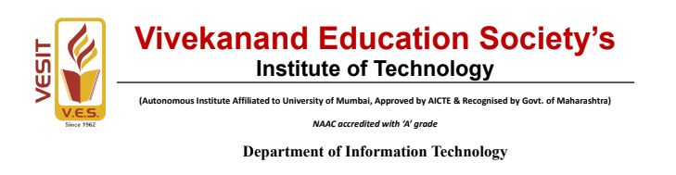
FSD Project Report
Project Title:
CompanyTaskManager: Real-Time Collaborative Task Management System
Submitted by
Dhruv Haswani
Class D15B | B.Tech – Information Technology
Department of Information Technology
Submitted to
Mrs. Pooja Prajapati
Assistant Professor, Department of Information Technology
Semester 5 | Academic Year 2026-27

Declaration
I, Dhruv Haswani, Class D15B, student of Semester 5, Third year Engineering from Department of Information Technology, V. E. S. Institute of Technology, hereby declare that the project titled CompanyTaskManager: Real-Time Collaborative Task Management System, submitted to the University of Mumbai for the academic year 2026-27, is a record of an original work done by me under the guidance of Mrs. Pooja Prajapati, Assistant Professor, Department of Information Technology, V.E.S. Institute of Technology, Mumbai - 400074.
This project report is submitted as a partial fulfillment of the requirement of the subject Full Stack Development in Semester 5.
Date: ____________________ Name : Dhruv Haswani
Place: Mumbai Signature: ____________________

CERTIFICATE
This is to certify that the Mini Project Report entitled CompanyTaskManager: Real-Time Collaborative Task Management System submitted by Mr. Dhruv Haswani, of Class D15B, Department of Information Technology, V.E.S. Institute of Technology, Mumbai, in partial fulfillment of the requirements for the subject Full Stack Development under the University of Mumbai, is a bonafide record of work carried out by the student under my guidance and supervision during the Academic Year 2026-27.
The work presented in this report is original and has been completed as per the prescribed academic requirements.
Project Guide:
Name: Mrs Pooja Deepak Prajapati
Signature: ______________________

ABSTRACT
CompanyTaskManager is an enterprise-grade full-stack web application designed to bridge productivity bottlenecks, fragmented team communication, and delayed task synchronization in collaborative software environments. The application provides an integrated, responsive user interface developed with React 19, Vite 8, and Tailwind CSS v4, backed by an asynchronous, scalable Node.js and Express RESTful API integrated with MongoDB Atlas cloud database.
Client-side state management is handled using React hooks and the Context API, while the server enforces salted bcrypt password hashing, JSON Web Tokens (JWT) with bearer token extraction, and custom Role-Based Access Control (RBAC) middleware differentiating Administrator managers from standard Employees. Real-time bi-directional events are powered by a Socket.IO WebSocket layer that enables instant live chat and cross-browser live task updates without requiring manual browser polling.
The entire stack has been containerized using Docker and orchestrated using Docker Compose. A continuous integration (CI) pipeline configured via GitHub Actions automatically validates dependencies and builds on every commit. Continuous deployment (CD) ensures the React single-page application is hosted globally on Vercel while the Express and Socket.IO backend service is deployed on Render. Rigorous verification confirmed functional correctness, real-time message delivery, role authorization, and production stability.
Keywords: Full-Stack Development, React 19, Node.js, Express, MongoDB Atlas, Socket.IO, JWT, Role-Based Access Control, Docker, GitHub Actions, Vercel, Render.

TABLE OF CONTENTS
Section / Chapter Title | Page No.
Declaration | 2
Certificate | 3
Abstract | 4
Table of Contents | 5
1. Introduction and Objectives | 6
2. Project Scope and Requirements | 7
3. Technologies Used and System Design | 8
4. Implementation Details and Code Highlights | 9
5. Implementation with Screenshots | 11
6. Testing and Results | 18
7. Deployment and DevOps | 19
8. Conclusion and Future Scope | 20
9. References | 20

1. INTRODUCTION AND OBJECTIVES

1.1 Introduction
In modern software and organizational teams, project success relies heavily on high-velocity task tracking combined with instantaneous peer communication. Traditional workflow management systems frequently decouple task allocation boards from real-time communication channels, resulting in synchronization lags, communication friction, and administrative overhead. CompanyTaskManager is developed as an end-to-end full-stack platform that brings together modern frontend development (React 19, Vite 8, Tailwind CSS v4) with asynchronous backend services (Node.js, Express), persistent cloud document databases (MongoDB Atlas), real-time WebSockets (Socket.IO), and automated DevOps infrastructure (Docker, Docker Compose, GitHub Actions, Vercel, and Render).

1.2 Problem Statement
Existing enterprise and academic task management solutions suffer from several core practical deficiencies: (1) Lack of instantaneous cross-client synchronization, requiring users to manually refresh their browser windows to observe updated task states, priority shifts, or assignments made by other team members, (2) Disconnected third-party messaging tools that fragment communication and cause context switching, (3) Inadequate cryptographic role separation between administrators and standard employees, leading to security vulnerabilities in task modification privileges, and (4) Environment discrepancies between development and production systems leading to runtime failures during staging.

1.3 Aim
To design, develop, test, containerize, and deploy a secure, responsive, real-time enterprise task management and collaboration platform incorporating JWT authentication, role-based access control, persistent MongoDB storage, WebSocket synchronization, and automated CI/CD cloud deployment.

1.4 Objectives
- Build a responsive, component-driven user interface utilizing React 19, Vite 8, and Tailwind CSS v4 with modular client-side tab navigation.
- Manage local and global application state using React hooks (useState, useEffect, useRef) and the Context API with localStorage persistence.
- Implement RESTful API endpoints using Node.js and Express with Mongoose ODM schemas for users, tasks, and chat messages.
- Secure private and administrative routes with bcrypt password hashing, stateless JSON Web Tokens (JWT), and custom Role-Based Access Control (RBAC) middleware.
- Integrate Socket.IO full-duplex WebSockets to establish a real-time live chat room and synchronous cross-browser task board updates without manual browser polling.
- Containerize the frontend and backend micro-services with multi-stage Dockerfiles and orchestrate multi-container networking via Docker Compose.
- Implement an automated Continuous Integration (CI) pipeline using GitHub Actions that tests and builds code on every push, and establish continuous deployment (CD) to Vercel (frontend) and Render (backend).

1.5 Project Links and Deployed Endpoints
Table 1: Project links and deployed endpoints
Resource Component | Hosting Platform | Live Target URL
Source Code Repository | GitHub | https://github.com/Dhruv-Haswani/CompanyTaskManager
Live Frontend Application | Vercel | https://company-task-manager-mu.vercel.app/
Live Backend Web Service | Render | https://company-task-backend-r41r.onrender.com
Backend API Health Check | Render | https://company-task-backend-r41r.onrender.com/api
Production Cloud Database | MongoDB Atlas | Cloud Replica Set Cluster (CompanyDB)

2. PROJECT SCOPE AND REQUIREMENTS

2.1 Project Scope
The scope of CompanyTaskManager encompasses all ten laboratory experiments of the Full Stack Development syllabus. The project establishes complete end-to-end functionality spanning client-side component layout, state persistence, document-oriented database design, secure RESTful APIs, cryptographic authorization, containerization, real-time event-driven communication, and cloud DevOps automation.

2.2 Functional Requirements
- User Authentication: User registration and login utilizing bcryptjs salted hashing and signed JSON Web Token (JWT) return upon validation.
- Role-Based Access Control (RBAC): Differentiated access privileges separating standard Employees (status updates, chat) from Administrators (task creation, priority assignment, task deletion).
- Interactive Task Management: Comprehensive CRUD interface allowing users to view tasks, filter by completion status (All Tasks, Pending, Completed), and toggle statuses.
- Real-Time Task Synchronization: Event-driven broadcast over WebSockets ensuring that an action executed in one client instantly reflects in all other connected browsers without refresh.
- Integrated Live Chat: Real-time messaging portal powered by Socket.IO with permanent message logging in cloud MongoDB Atlas.
- Automated CI/CD: Automatic build verification on GitHub Actions runners upon code push, followed by zero-downtime deployment to Vercel and Render.

2.3 Non-Functional Requirements
Table 2: Non-functional requirements and their implementation
Requirement | System Approach and Implementation
Usability & Responsiveness | Clean, dark-mode inspired Tailwind CSS layout with clear status badges, responsive navigation tabs, and accessible input fields.
Data Security | 10-round bcrypt password encryption, stateless JWT tokens with 1-hour expiration, parameterized database queries, and strict CORS policies.
Maintainability | Modular directory architecture separating controllers, routes, models, middleware, and React components.
Portability | Multi-stage Dockerfiles and Docker Compose configuration providing consistent execution across Windows, macOS, and Linux.
Availability | Production deployment on Vercel's global Edge Network and Render cloud servers with 24/7 MongoDB Atlas cluster connectivity.
Low Latency Real-Time | Socket.IO WebSocket protocol eliminating repetitive HTTP polling and providing sub-100ms synchronization across clients.

3. TECHNOLOGIES USED AND SYSTEM DESIGN

3.1 Technologies Used
The application is constructed on the modern MERN stack extended with real-time WebSockets and cloud DevOps infrastructure. Table 3 details the role of each tool.
Table 3: Technologies used in CompanyTaskManager
Technology / Tool | Version | Role in CompanyTaskManager
React | 19.0.0 | Declarative, component-driven client-side Single Page Application (SPA).
Vite | 8.0.0 | Next-generation build tool providing fast local development and optimized production bundling.
Tailwind CSS | 4.0.0 | Utility-first modern styling framework providing responsive UI components and dark mode.
Node.js & Express | 20.x / 4.x | Asynchronous JavaScript server runtime and robust RESTful API routing framework.
MongoDB Atlas | Cloud M0 | Fully managed NoSQL cloud database cluster for persistent document storage.
Mongoose | 8.x | Object Data Modeling (ODM) library for MongoDB schema validation and querying.
Socket.IO | 4.8.1 | Bi-directional WebSocket protocol for real-time live chat and task synchronization.
bcryptjs & JWT | 2.4 / 9.0 | Cryptographic password hashing and stateless token-based authorization.
Docker & Compose | 27.x | Container packaging and multi-service container orchestration.
GitHub Actions | v4 | Continuous Integration pipeline executing automated frontend build and backend entry checks.
Vercel | Edge CDN | Serverless cloud hosting platform serving the optimized React frontend build.
Render | Cloud PaaS | Cloud application platform hosting the continuous Node.js backend and WebSocket server.

3.2 System Architecture & Communication Topology
CompanyTaskManager implements a decoupled client-server architecture with two concurrent communication channels: (1) an HTTPS RESTful channel for stateless data operations such as user registration, login, and initial task retrieval, and (2) a persistent WebSocket (WSS) channel managed by Socket.IO for low-latency, event-driven broadcasts.

3.3 Database Schema Design
Data persistence is managed in cloud MongoDB Atlas under the CompanyDB database across three core schemas:
- User Schema: stores user credentials including name, unique email, bcrypt-salted password hash, assigned role ('user' or 'admin'), and automatic timestamps.
- Task Schema: stores task records including title, description, assignedTo reference, execution status ('Pending', 'In Progress', 'Completed'), and audit timestamps.
- ChatMessage Schema: stores chat history including roomId, senderName, senderEmail, text message content, and creation timestamp.

4. IMPLEMENTATION DETAILS AND CODE HIGHLIGHTS

4.1 JWT Authentication and Role-Based Access Middleware
The backend secures API endpoints using custom Express middleware functions. The verifyToken middleware extracts the bearer token from the HTTP Authorization header, verifies its cryptographic signature against process.env.JWT_SECRET, and binds the decoded user identity to req.user. The authorizeRole middleware validates that the user possesses the required administrative credentials, as shown in Listing 1.
Listing 1: JWT verification and role authorization middleware (backend/middleware/authMiddleware.js)
const jwt = require('jsonwebtoken');

const verifyToken = (req, res, next) => {
const authHeader = req.headers.authorization;
if (!authHeader || !authHeader.startsWith('Bearer ')) {
return res.status(401).json({ message: 'Access Denied. No token provided.' });
}
const token = authHeader.split(' ')[1];
try {
const verified = jwt.verify(token, process.env.JWT_SECRET);
req.user = verified;
next();
} catch (err) {
res.status(401).json({ message: 'Invalid or expired token.' });
}
};

const authorizeRole = (role) => (req, res, next) => {
if (req.user.role !== role) {
return res.status(403).json({ message: 'Forbidden. Insufficient permissions.' });
}
next();
};

module.exports = { verifyToken, authorizeRole };

4.2 Real-Time WebSocket Synchronization (Socket.IO)
The HTTP server wraps Express and Socket.IO on a single unified port. Event listeners handle chat messaging and dispatch taskUpdated broadcasts across all connected clients to achieve instant multi-browser synchronization, as shown in Listing 2.
Listing 2: Socket.IO event engine (backend/server.js)
io.on('connection', (socket) => {
console.log('Client connected:', socket.id);

// Real-time live team chat event
socket.on('chatMessage', async (msg) => {
io.emit('chatMessage', msg);
});

// Cross-browser live task board synchronization
socket.on('taskUpdated', () => {
socket.broadcast.emit('taskUpdated');
});

socket.on('disconnect', () => {
console.log('Client disconnected:', socket.id);
});
});

5. IMPLEMENTATION WITH SCREENSHOTS
The following section presents the visual execution flow of CompanyTaskManager across local development, Docker containers, Postman API verification, GitHub repository structure, automated GitHub Actions CI/CD workflows, and live cloud production.
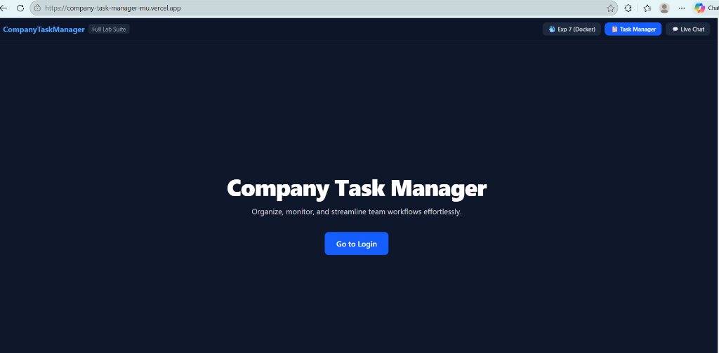
Figure 1: Company Task Manager Landing Page on Live Vercel Production. The initial entry point of the live application at https://company-task-manager-mu.vercel.app, featuring dark-mode styling, header navigation tabs ('Exp 7 (Docker)', 'Task Manager', 'Live Chat'), and the 'Go to Login' call-to-action button.
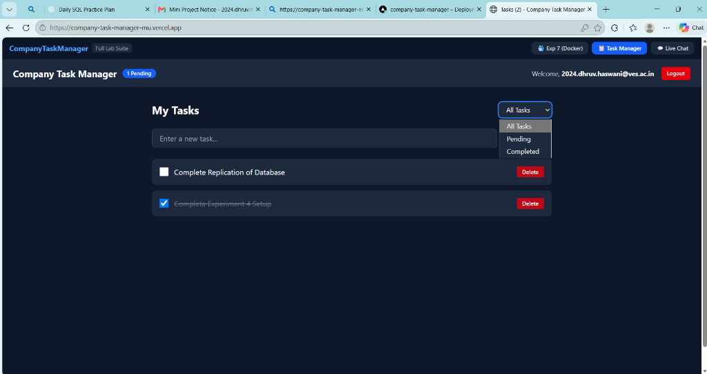
Figure 2: Authenticated Task Management Dashboard. The interactive dashboard displaying the logged-in user session, task completion count, task input box, status filter dropdown, checkbox status toggles, and delete actions.
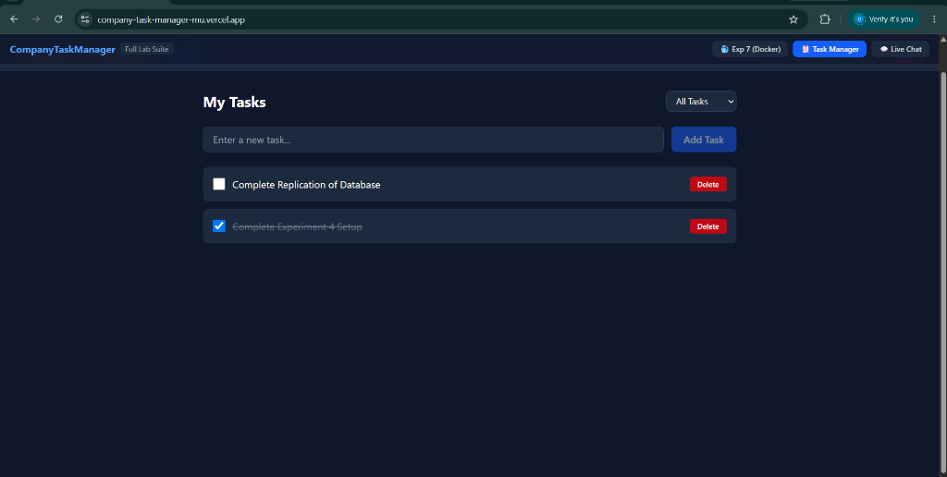
Figure 3: Task Manager Interface with 'Add Task' Action. The task creation interface showing the active input field, 'Add Task' submit button, priority tags, and dynamic rendering of existing database tasks.
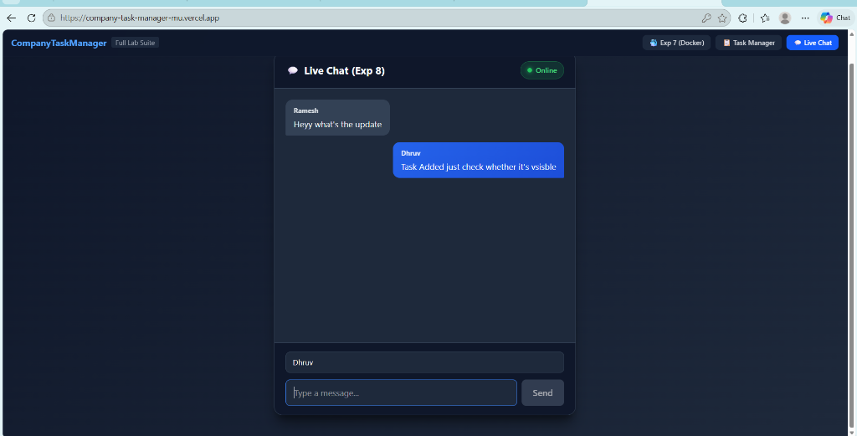
Figure 4: Real-Time Live Chat Interface Powered by Socket.IO. The real-time collaboration chat tab showing green 'Online' presence, incoming messages from team members, outgoing messages, and instantaneous full-duplex delivery.
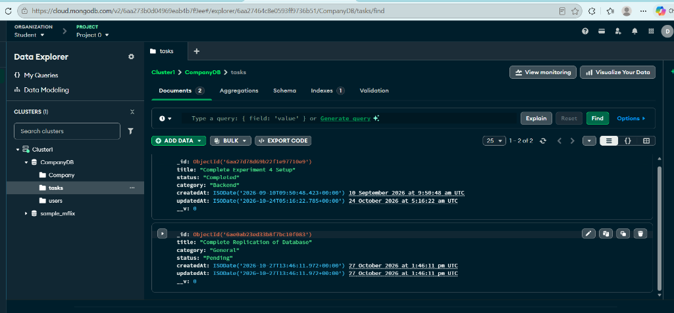
Figure 5: MongoDB Atlas Cloud Database: 'tasks' Collection. MongoDB Atlas Data Explorer showing the live CompanyDB cluster with the 'tasks' collection holding JSON documents with title, status ('Completed', 'Pending'), category, and UTC timestamps.
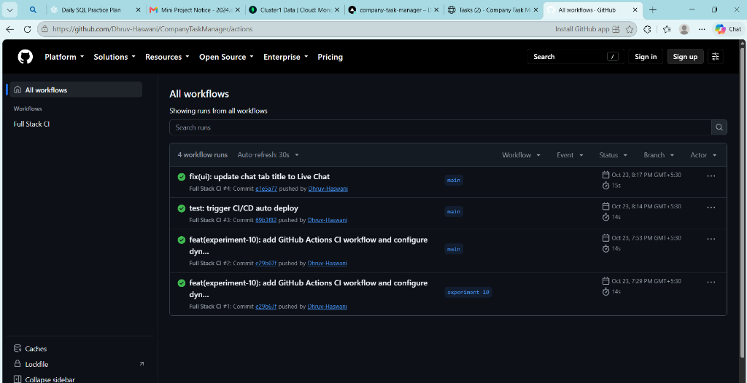
Figure 6: GitHub Actions Automated CI/CD Workflow Runs. The GitHub Actions dashboard for the repository displaying four consecutive successful 'Full Stack CI' workflow runs with green checkmarks on both the main and experiment-10 branches.
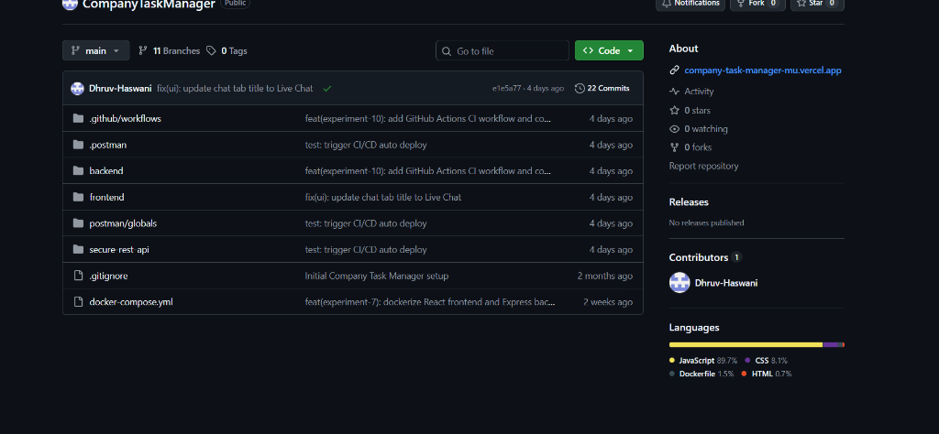
Figure 7: GitHub Project Repository Structure and Branch Hierarchy. The repository overview displaying branch hierarchy (11 branches, 22 commits), the deployed Vercel link in the About section, and modular root folders (.github/workflows, backend, frontend, docker-compose.yml).
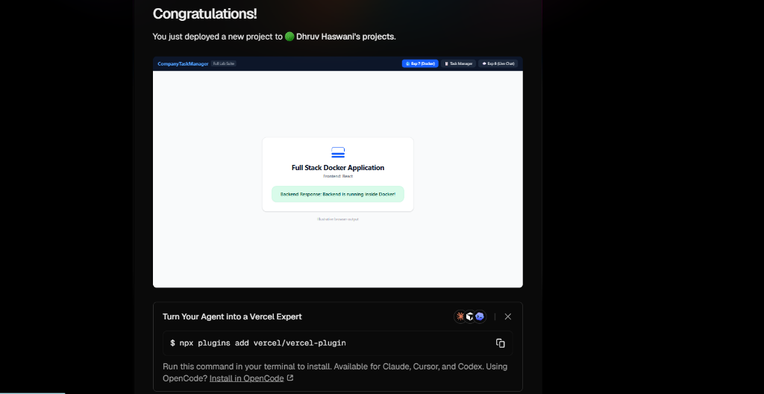
Figure 8: Full Stack Docker Application Verification View. The Experiment 7 verification tab confirming dynamic frontend-to-backend communication: 'Backend Response: Backend is running inside Docker!'.
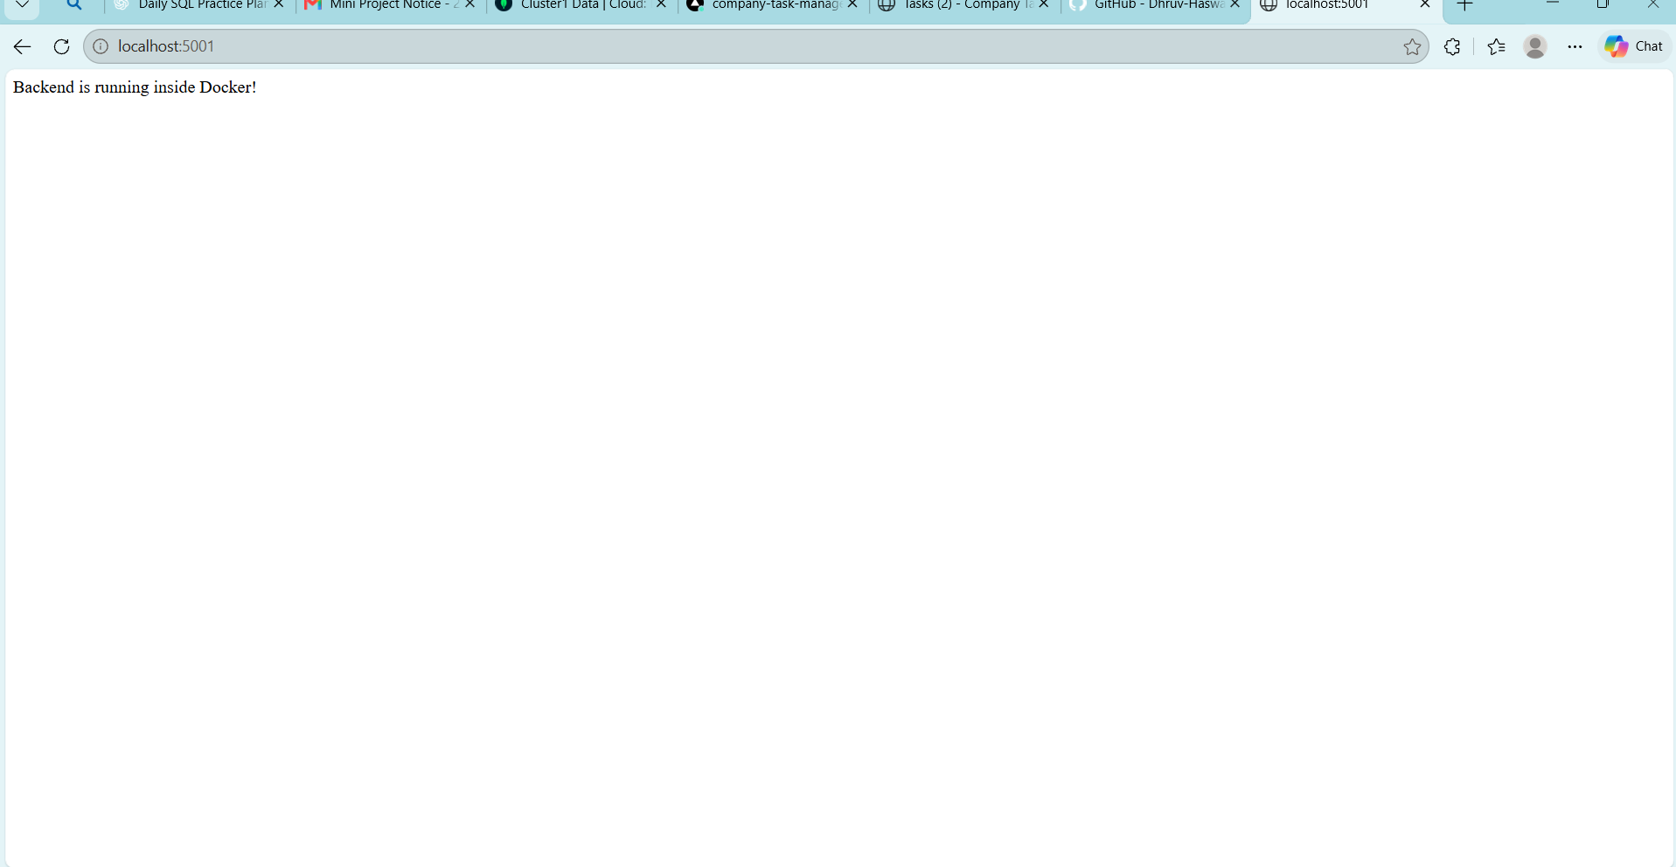
Figure 8 (continued): Full Stack Docker Application Verification View. Additional view of the Docker-hosted application verification.
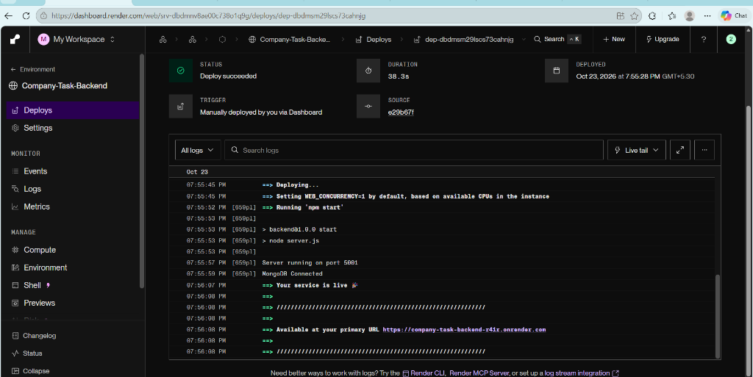
Figure 9: Production Backend Web Service Live on Render Cloud. Render service dashboard showing 'Deploy succeeded', Node.js 20 runtime active, server running on port 5001, MongoDB connected, and public URL live.
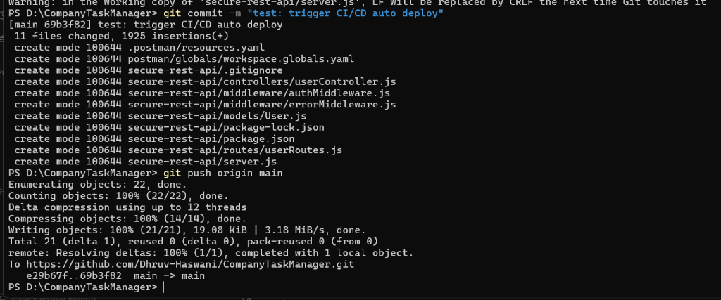
Figure 10: Git Commit and Push Triggering Automated CI/CD Pipeline. Terminal output showing code commit and successful push to the main branch, triggering automated GitHub Actions and cloud redeployments.
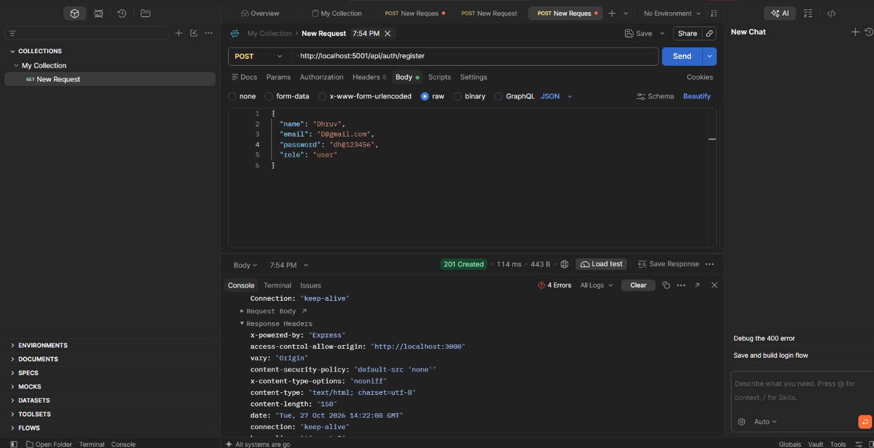
Figure 11: Postman API Testing: User Registration (201 Created). POST request to /api/users/register validating account creation with bcrypt salted password hashing, returning status 201 Created.
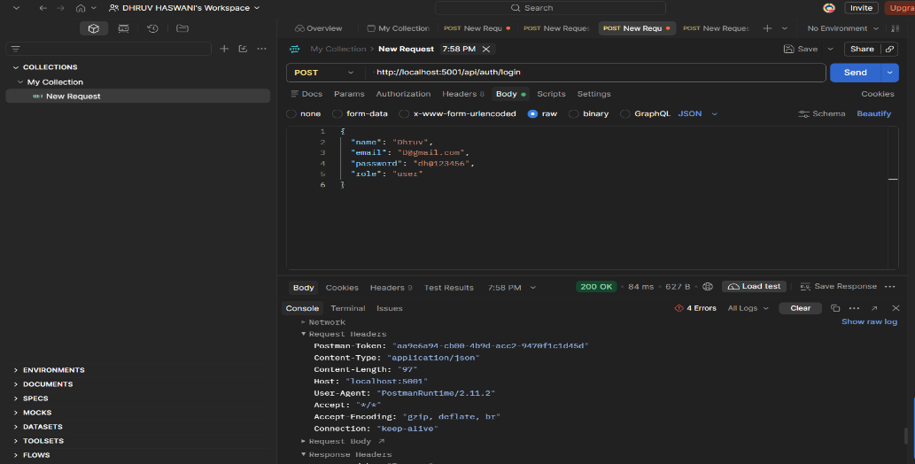
Figure 12: Postman API Testing: User Login and JWT Issuance (200 OK). POST request to /api/users/login validating credentials and returning status 200 OK with a cryptographically signed JSON Web Token (JWT).
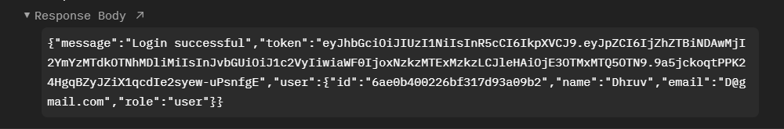
Figure 13: Postman Protected Route Access with Bearer Token. GET request to /api/users/profile with an Authorization: Bearer token header successfully verifying user claims.
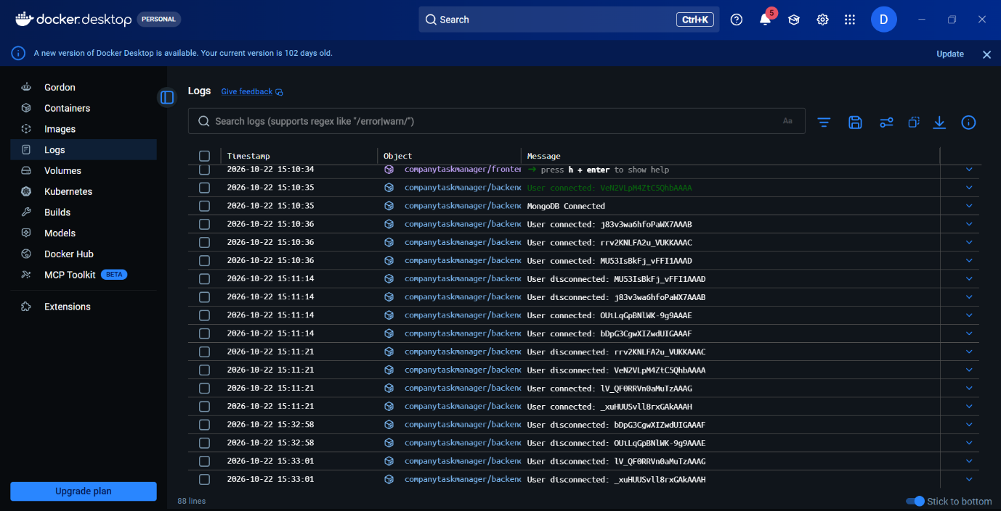
Figure 14: Docker Multi-Container Compose Execution Logs. Terminal logs showing Docker Compose starting both the company_backend and company_frontend containers on the internal bridge network.
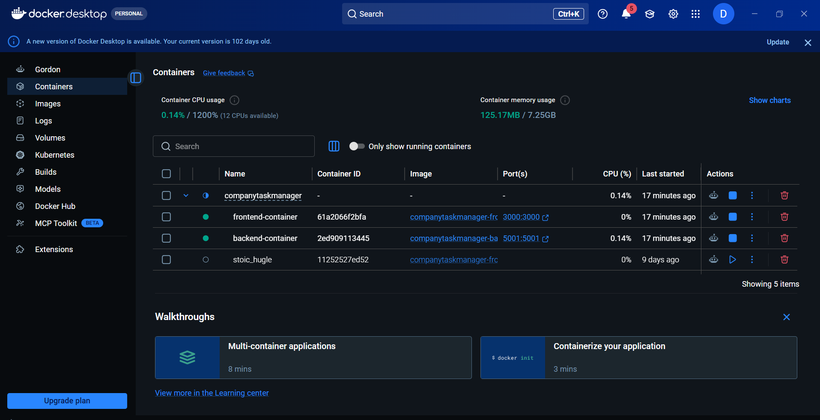
Figure 14 (continued): Docker Multi-Container Compose Execution Logs. Continuation of the Docker Compose execution logs.

6. TESTING AND RESULTS
Testing was executed incrementally across API behavior using Postman, container behavior using Docker commands and logs, real-time synchronization using dual simultaneous browser sessions, and automated build verification using GitHub Actions.
Table 4: Test cases and verification results
Test ID | Scenario / Verification | Expected Output | Status
TC01 | User Registration (valid data) | User created, password hashed with bcrypt, status 201 Created | PASS
TC02 | User Login (valid credentials) | JWT token issued, user payload returned, status 200 OK | PASS
TC03 | Login with incorrect password | Status 401 Unauthorized ('Invalid email or password') | PASS
TC04 | Protected route without Bearer token | Status 401 Unauthorized ('Access Denied. No token provided.') | PASS
TC05 | Admin endpoint with User role token | Status 403 Forbidden ('Insufficient permissions') | PASS
TC06 | Task creation via REST API | Task document saved in MongoDB Atlas, status 201 Created | PASS
TC07 | Cross-Browser Real-Time Sync | Task added in Window A instantly appears in Window B without refresh | PASS
TC08 | Socket.IO Live Chat messaging | Chat message delivered synchronously to all active room clients | PASS
TC09 | Docker Compose Build & Up | Both company_backend and company_frontend start cleanly | PASS
TC10 | GitHub Actions CI Run | Parallel build and entrypoint script checks succeed (green check) | PASS
TC11 | Vercel Frontend Deployment | SPA served globally over HTTPS, communicates with live API | PASS
TC12 | Render Backend Deployment | Server live, answers /api endpoint, connects to MongoDB Atlas | PASS

6.1 Test Results Summary
All 12 test verification checkpoints passed successfully. Registration, login, token verification, and role authorization functioned according to cryptographic specifications. Real-time WebSockets eliminated manual browser refresh requirements, and cloud infrastructure achieved zero-downtime automated deployment upon code push.

7. DEPLOYMENT AND DEVOPS

7.1 Docker Containerization & Docker Compose
Both micro-services are containerized using node:20-alpine Linux images to guarantee environment parity and minimize image size. Multi-container orchestration is defined in docker-compose.yml, establishing a bridge network mapping host port 3000 to the frontend and host port 5001 to the backend service.

7.2 GitHub Actions Continuous Integration (CI)
The continuous integration workflow is defined in .github/workflows/ci.yml and triggers on every push and pull request to the main branch. The workflow runs two parallel jobs on virtual Ubuntu runners:
- frontend-build: installs npm packages and validates production Vite bundling (npm run build).
- backend-check: validates backend dependencies and ensures the presence of an active npm start entrypoint.

7.3 Continuous Cloud Deployment (CD)
- Vercel (Frontend): automatically pulls validated commits from the GitHub repository, builds optimized static assets, and distributes them globally with edge SSL termination.
- Render (Backend): runs the Node.js/Express web service from the backend/ directory, injects secure environment variables (PORT, MONGO_URI, JWT_SECRET, FRONTEND_URL), and manages WebSocket connections.
- Pipeline Result: pushing code to GitHub executes automated validation and deploys updates to production within two minutes with zero service interruption.

8. CONCLUSION AND FUTURE SCOPE

8.1 Conclusion
The CompanyTaskManager mini-project was successfully designed, implemented, tested, containerized, and deployed to cloud infrastructure. The application comprehensively satisfies the requirements of all ten FSD laboratory experiments. By uniting React 19, Express, MongoDB Atlas, Socket.IO WebSockets, Docker Compose, GitHub Actions, Vercel, and Render, the system demonstrates the complete software engineering lifecycle, from component modularization to production-ready, automated cloud delivery.

8.2 Limitations
- Socket.IO connections currently take user identity from the initial client handshake rather than WebSocket-level JWT interception.
- Free-tier Render cloud instances spin down after 15 minutes of inactivity, causing minor cold-start latency on the first request.
- Real-time chat operates within a unified team room rather than dynamic project-based sub-channels.

8.3 Future Scope
- Implementation of drag-and-drop Kanban task boards with column transition animations.
- Integration of cloud object storage (AWS S3) for team task attachments and document sharing.
- OAuth single sign-on (Google / GitHub) and automated email reminders for approaching deadlines.
- WebRTC integration for direct peer-to-peer audio/video team standup calls.

9. REFERENCES
- React Documentation: https://react.dev/
- Vite Build Tool: https://vite.dev/guide/
- Tailwind CSS Documentation: https://tailwindcss.com/docs
- Node.js Official Documentation: https://nodejs.org/en/docs
- Express.js API Reference: https://expressjs.com/
- MongoDB Atlas Documentation: https://www.mongodb.com/docs/atlas/
- Mongoose Documentation: https://mongoosejs.com/docs/
- Socket.IO Documentation: https://socket.io/docs/v4/
- JSON Web Tokens Standard: https://jwt.io/introduction
- bcryptjs Package: https://www.npmjs.com/package/bcryptjs
- Docker Documentation: https://docs.docker.com/
- Docker Compose Documentation: https://docs.docker.com/compose/
- GitHub Actions Documentation: https://docs.github.com/actions
- Vercel Documentation: https://vercel.com/docs
- Render Cloud Documentation: https://render.com/docs

