Multi-Teacher Distillation for Aviation Conflict Resolution
Is the LLM always the best teacher? Evidence from a controlled study

Terms used in this document
- MAPPO. The reinforcement learning algorithm that controls the aircraft. It is the only thing that ever flies an aircraft. Everything below changes how MAPPO learns, never what it does.
- Episode (or scenario). One complete simulated situation, from the aircraft entering the sector until it ends. It ends in exactly one of four ways: success, collision, weather, or truncation (time ran out).
- Run. One complete training job, producing one trained network. Nine runs are compared here.
- Return. The total reward collected over a stretch of simulation. Higher is better. It is the measure used to judge whether one action was better than another.
- Guide. Something that can suggest a turn: the LLM, or one of two simple rules.
- Teacher. A guide converted into a small, fast neural network that copies its choices.
- Distillation. Training MAPPO to move towards a teacher's choices by adding a term to its loss function. MAPPO still learns from its own experience; the teacher only nudges it.
- Shadow validation. Copying the simulator and running a short look-ahead to see which action really was best. Runs whose names contain "shadow" use it to weight their teachers.
- Competence weighting. Trusting each teacher in proportion to how much it improves on MAPPO right now, instead of trusting all teachers equally.
- Leave-one-out (LOO). A run that uses every teacher except one, to measure what the missing one contributed.
- Loss of separation (LOS). Two aircraft coming closer than the permitted minimum. The standard safety measure in the air-traffic literature, counted per aircraft rather than per scenario.

1. Summary
Published work on LLM-guided reinforcement learning appoints a large language model as the teacher and does not test whether that role is deserved. I measured it. Decision by decision, the LLM is the single best guide only 38 to 39 percent of the time; MAPPO is already best about 40 percent of the time, and two cheap simulator rules are best at the rest.
I therefore built a system with three teachers rather than one, each trusted in proportion to how much it demonstrably improves on MAPPO in the situation at hand. Nine networks were trained, differing only in which teachers they use and how those teachers are weighted, and all nine were tested on the same 900 scenarios.
Three findings. First and most robustly, the teachers are complementary: the rule-based teacher is significantly safer around other aircraft and the LLM teacher is significantly safer around storms, so neither is better at both. Second, at an equal training budget the proposed method reaches 85.8 percent success against 81.3 percent for a single LLM teacher and 80.2 percent for the same three teachers weighted equally; since those last two runs differ only in the weighting, the gain is attributable to competence weighting itself. Third, none of this survives in a crowded sector: at eight aircraft every run degrades sharply and the untaught baseline degrades no worse.
All results come from a single training seed per configuration. Section 10 explains why that is the most important limitation of the work.

2. The Task, and Why Teaching Was Considered

2.1 What the system has to do
Several aircraft fly through a controlled piece of airspace called a sector. Each must reach its destination without coming too close to another aircraft and without flying into a storm cell. Every few moments each aircraft picks one of thirteen possible heading changes, from thirty degrees left to thirty degrees right. A neural network makes that choice, and training it to choose well is the whole problem.
Most experiments use four aircraft and two storm cells, with a limit of sixty simulated steps. A scenario counts as a success only if every aircraft in it arrives safely. Later sections also test six and eight aircraft to see what happens when the sector becomes crowded.

2.2 Why an LLM was brought in at all
Multi-agent reinforcement learning suits this kind of cooperative, safety-critical task, but the learning signal is sparse. Genuine conflicts are rare and the large rewards arrive only at the end of a scenario, so the policy improves slowly. A common remedy is to add a teacher that suggests good actions.
Two studies provide the immediate context. LLM-MAPPO (Yuan et al.) distils an LLM-generated expert policy into the agents. LGDRL (Pang et al.) constrains the learned policy towards an LLM expert, querying the model during training. Both give the LLM the privileged role of teacher, and neither tests whether cheaper guides might be better in particular situations.
That is the assumption examined here. Aviation conflict resolution involves trade-offs between traffic separation, weather avoidance, boundary safety and route progress. A guide that is strong in one kind of situation may be weak in another.

3. The Diagnostic That Motivated This Work
Before committing to a multi-teacher design, I measured whether any single guide deserves to be the sole teacher. Two measurements were made; the second is decisive.

3.1 Each guide flying on its own
Here MAPPO is removed and each guide flies the aircraft for the whole scenario, which shows how capable each one is in absolute terms. Three guides were compared: the LLM (gpt-oss-20B); best preview (BP), a rule that takes the highest-ranked safe turn from a shortlist the simulator pre-checks by testing each turn a few steps ahead; and preview safe (PS), a rule that takes a turn at random from that same shortlist.
Controller | Success | Traffic collision | Weather collision | Truncation
gpt-oss-20B (the LLM) | 76 | 1 | 12 | 11
Best preview (BP) | 64 | 2 | 11 | 23
Preview safe (PS) | 54 | 1 | 15 | 30
Percentages of scenarios, four aircraft and two weather cells.

The LLM wins on overall success. But the failure columns already hint at something the success column hides: PS records the fewest traffic collisions despite the worst overall score. Repeating the measurement with eight aircraft collapses all three to between 13 and 18 percent success, mostly through weather failures, with the LLM still marginally ahead.
One point of record: gpt-oss-20B is far stronger than Gemma 3:12B, the model used in my earlier work, which scored only 33 percent here against 76. That difference was overlooked initially and changes how the LLM should be judged.

3.2 Which guide is best at each individual decision
Whole-scenario averages cannot answer the question that matters for a teacher: at this moment, in this situation, whose advice should MAPPO follow? To answer it I copied the simulator at each decision point, tried each candidate action, continued five steps under MAPPO, and recorded which candidate produced the best return.
Best guide at a decision | Easy (4 aircraft) | Hard (8 aircraft)
MAPPO (the student, already best) | 40% | 40%
LLM | 38% | 39%
Best preview (BP) | 15% | 10%
Preview safe (PS) | 8% | 11%

This is the central observation of the project. The LLM is best at well under half of decisions. At roughly 40 percent MAPPO already needs no teacher, and at the remaining fifth a cheap rule beats a twenty-billion-parameter model. No single guide is best everywhere, so the sensible design is to combine several and trust each where it is strong.

4. The Proposed Approach

4.1 Core idea
Teach MAPPO from all three guides at once, and trust each one in the situations where it is stronger, instead of assuming a single teacher is best everywhere. The two stages of the pipeline are shown in Figure 1 and Figure 2.

4.2 The two-stage pipeline
Stage 1, offline. Each guide flies scenarios on its own, its decisions are recorded, and a small network is trained to reproduce them. This turns each guide into a fast learned policy. The language model is queried thousands of times here and never again, which is what makes the method affordable to train.
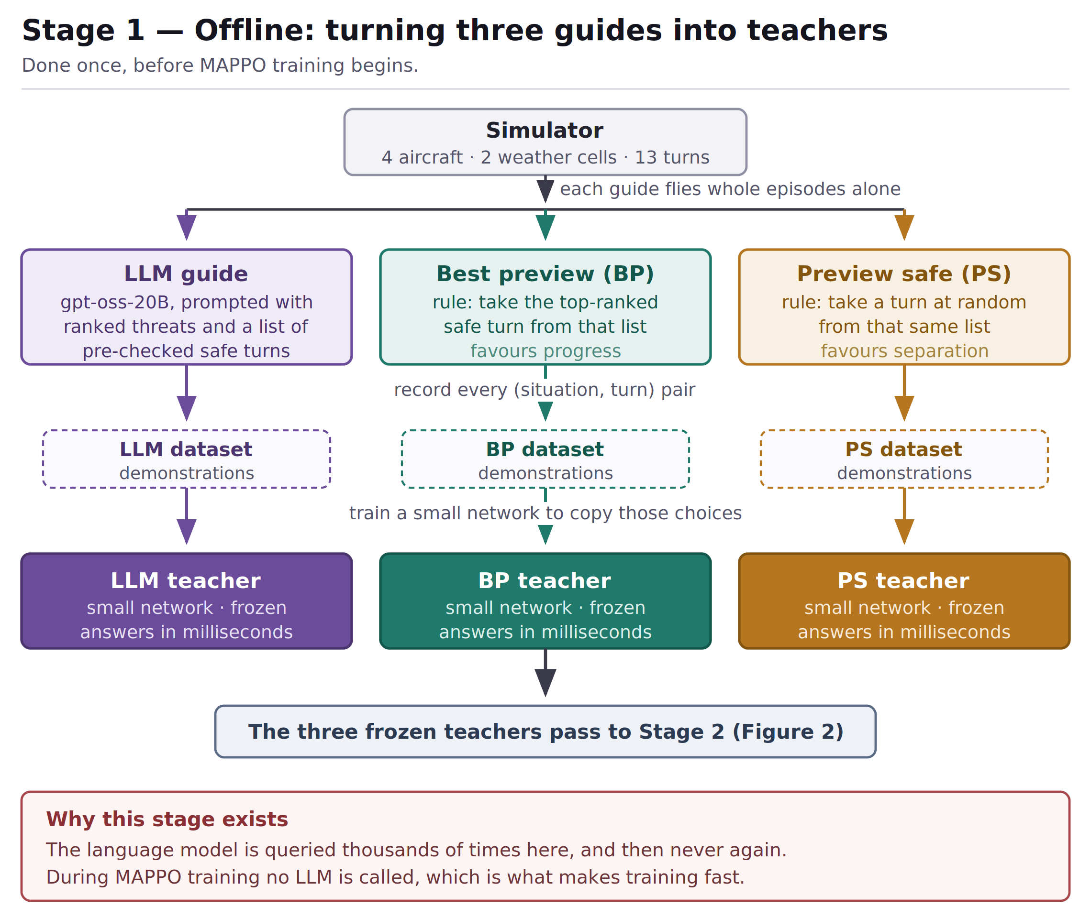
Figure 1. Stage 1 — three guides become three frozen teacher networks.
Stage 2, training. MAPPO is trained against those frozen teachers. At each step every teacher proposes a turn, and MAPPO's loss gains a term pulling it towards the proposals. Each teacher's pull is scaled by how well it is doing in the current situation. No LLM is called during training.
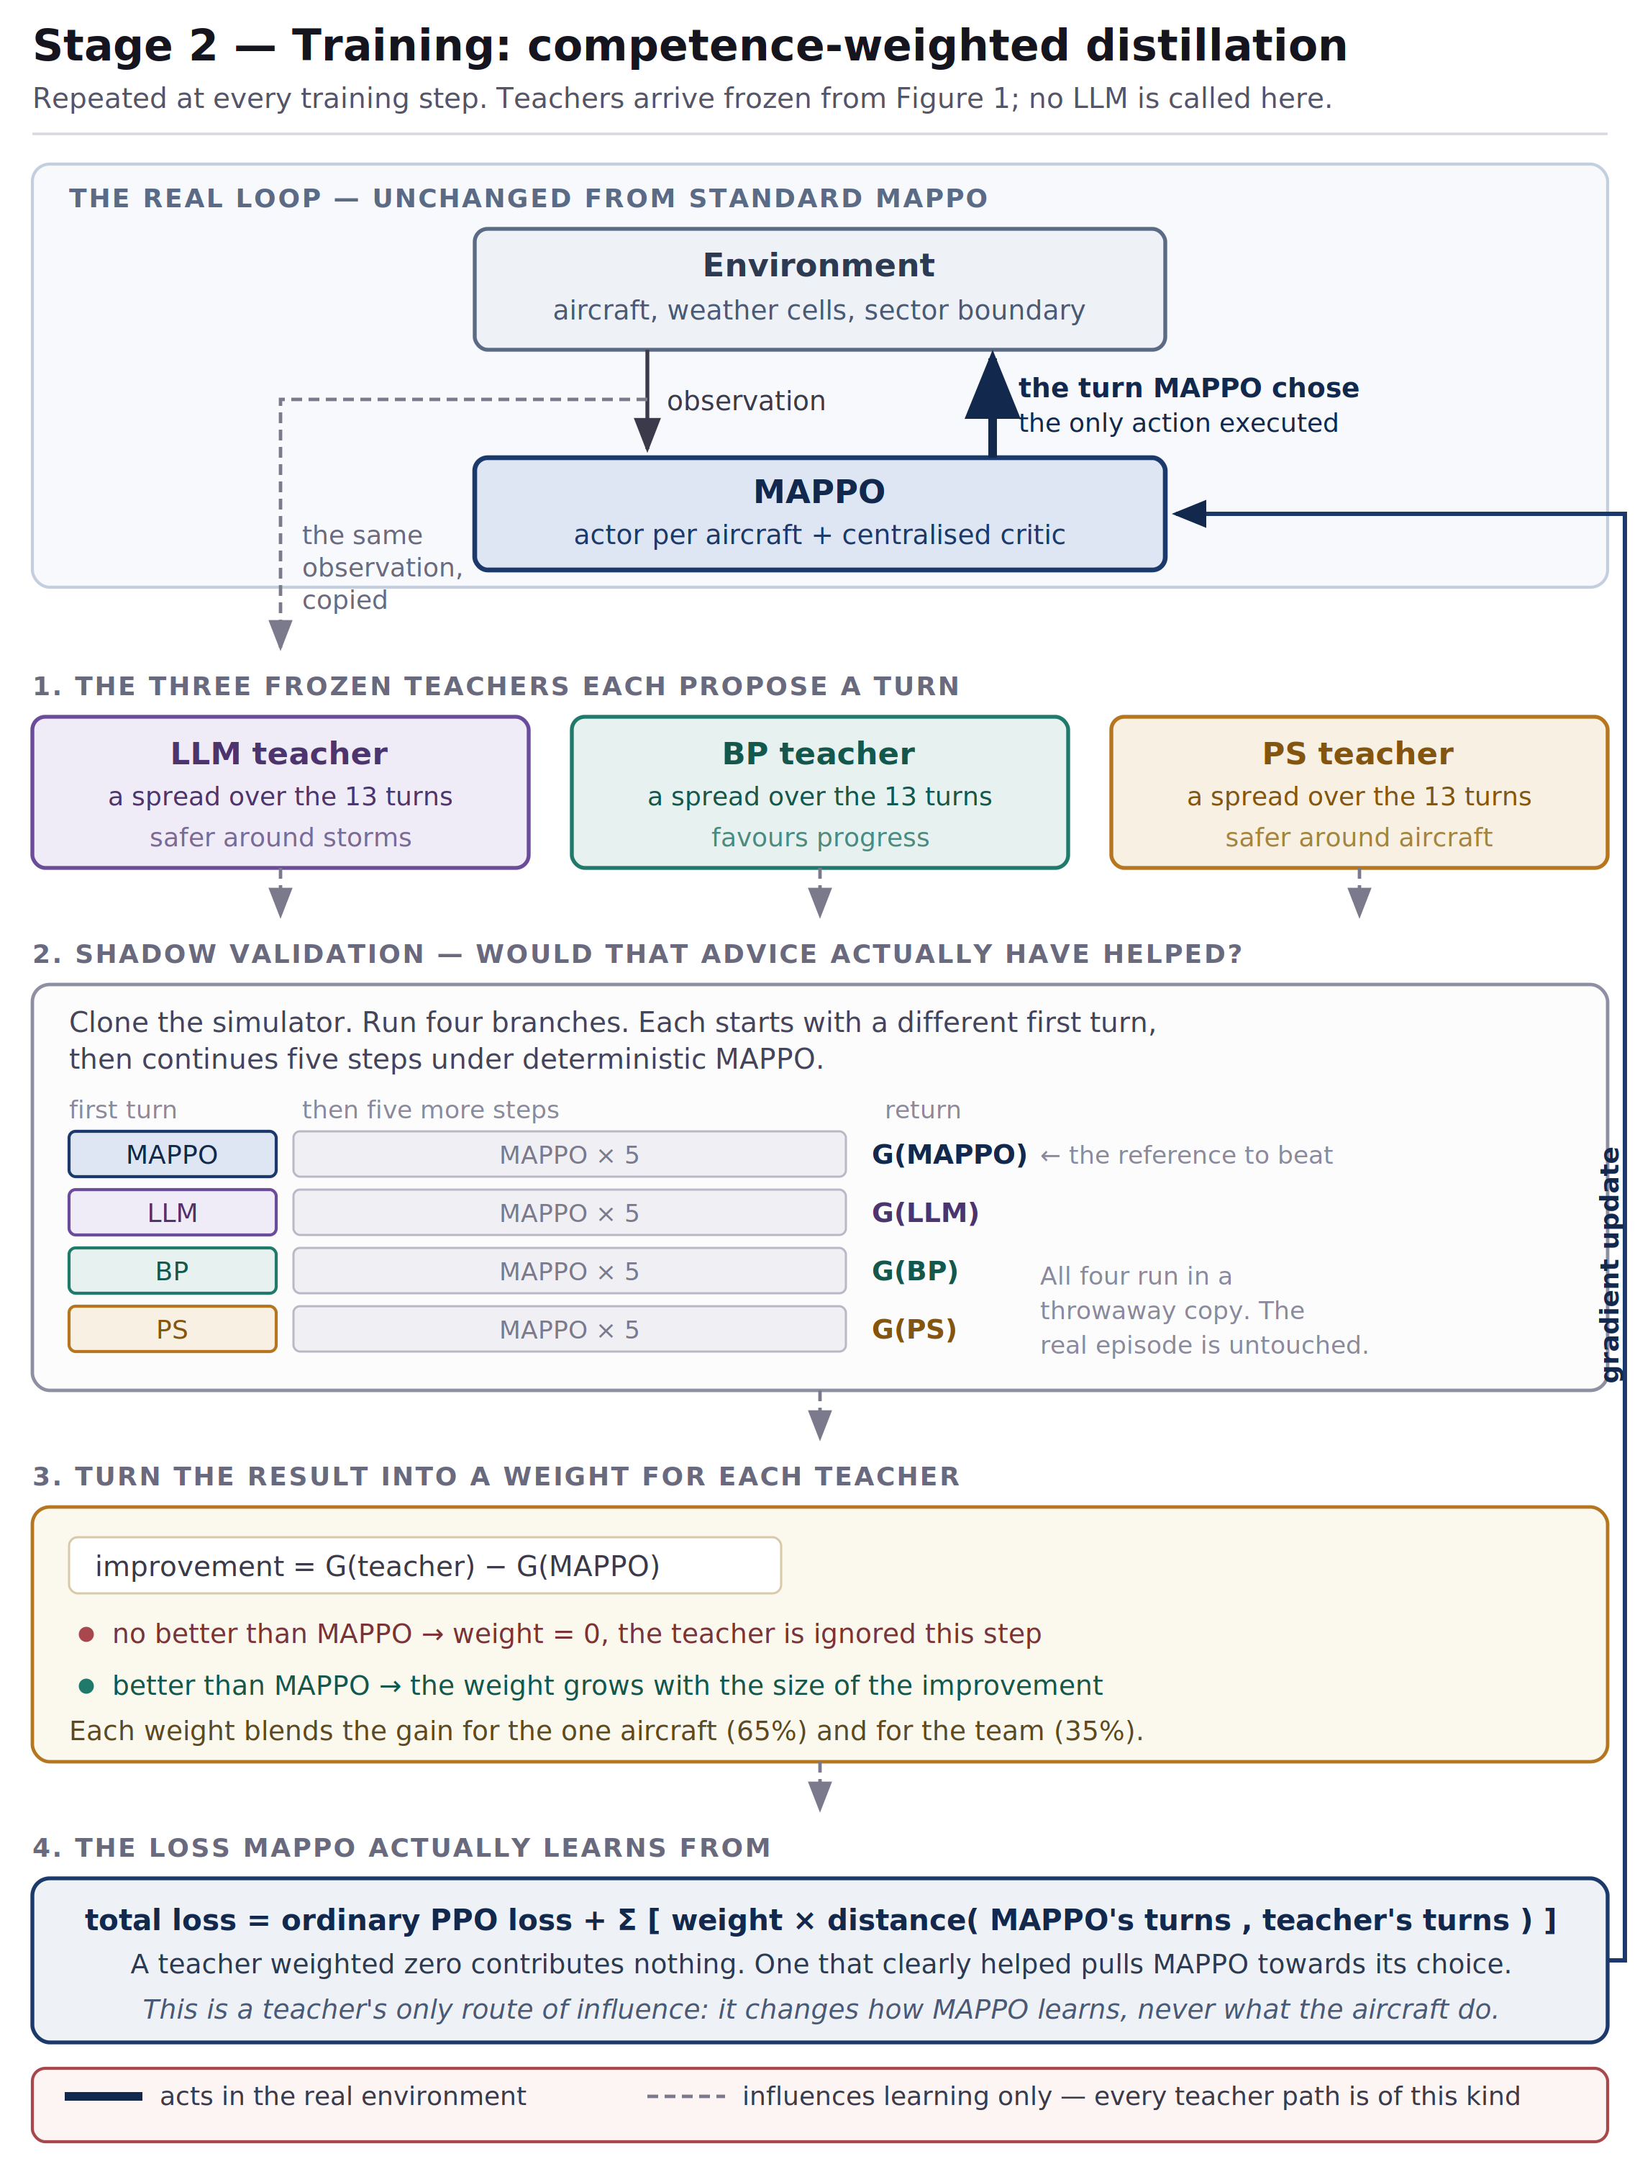
Figure 2. Stage 2 — the training loop. MAPPO alone acts in the environment (the single heavy arrow); every teacher path is dashed and reaches only the loss.

4.3 How competence weighting works
This is the mechanism the study tests, so it is worth setting out plainly. Steps 2 and 3 of Figure 2 show the same procedure. At a given decision point:
- Copy the simulator, so candidates can be tried without disturbing the real scenario.
- In the copy, try each teacher's proposed turn, and separately try MAPPO's own turn.
- After that first turn, continue every branch under MAPPO for five more steps.
- Compare each teacher's return against MAPPO's. A teacher that does no better gets a weight of zero and is ignored at this step. One that does better gets a weight proportional to the improvement.
- The weight blends the gain for the individual aircraft and for the team, roughly 65 to 35, so advice that helps one aircraft at the expense of the others is not rewarded.
In one sentence: a teacher influences MAPPO only when a short simulation confirms its advice would have helped, and the strength of that influence matches how much it helped. MAPPO alone acts in the real environment throughout.

4.4 The control that makes the study meaningful
A three-teacher system that works could be succeeding for either of two reasons: because competence weighting is a good idea, or merely because three teachers carry more information than one. To separate these I trained an otherwise identical run that weights the same three teachers equally, with no competence measurement. Any difference between the two is caused by the weighting and nothing else. This is the most important comparison in the study.

5. The Experiments
Nine networks were trained, varying only the teachers used and the weighting.
Run | Teachers | Weighting | Question it answers
T0_baseline | none | — | How well does MAPPO do alone? Everything is measured against this.
S_LLM | LLM | competence | Does a single LLM teacher help? This is the prior-work setup, and the one to beat.
S_BP | BP | competence | How far does one rule-based teacher get?
S_PS | PS | competence | How far does the other rule-based teacher get?
LOO_noLLM | BP + PS | competence | With the LLM removed, do the two rules suffice?
LOO_noBP | LLM + PS | competence | What does BP contribute, judged by removing it?
LOO_noPS | LLM + BP | competence | What does PS contribute, judged by removing it?
TRI_equal | all three | equal | Is simple averaging enough? This is the control from Section 4.4.
TRI_shadow | all three | competence | Does trusting each teacher where it is stronger work best? The proposed method.

Three comparisons decide the study, in increasing order of value: TRI_shadow against T0_baseline asks whether teaching helps at all; against S_LLM, whether the method beats prior work; and against TRI_equal, whether competence weighting rather than merely having three teachers is the source of any gain.

6. How the Results Were Calculated
This section covers the evaluation procedure and the two ideas needed to read the results tables. No statistical background is assumed.

6.1 What is measured
Each trained network flies 900 scenarios. A scenario is a success only if every aircraft in it arrives safely. The success rate is the percentage of the 900 that succeeded, and it is the main score throughout. The 900 are three separate blocks of 300, each block containing entirely different traffic and weather situations.

6.2 Every run is tested on the same scenarios
This is the most important design decision in the evaluation. All nine networks saw exactly the same 900 scenarios, in the same order, with the same weather, routes and starting positions.
Some scenarios are simply harder than others. If one network happened to receive easier ones it would score better for no reason connected to its skill, and an identical list removes that problem entirely. It also allows a sharper comparison than putting two averages side by side: because the scenarios match, one can go scenario by scenario and ask which networks solved this particular situation.

6.3 Percentage points, and why small gaps mean nothing
Percentage points (pp). The gap between two success rates is a plain subtraction. If one run scores 90.0 percent and another 84.0 percent, the gap is 6.0 percentage points. The separate unit avoids confusion with a relative change, since 90.0 is also about 7 percent larger than 84.0, which is a different statement. Every gap in this document is computed from the underlying scenario counts, so it may differ by 0.1 from subtracting the two rounded percentages shown.
Small gaps are not evidence. Toss a fair coin 300 times and you expect 150 heads but will see 143, or 158. The same applies here: two networks of equal skill will not score the same. For a run scoring around 85 percent the random wobble is roughly plus or minus 4 pp on 300 scenarios, falling to about plus or minus 2.3 pp on 900. That is why 900 were used, and why a two- or three-point gap in a table is not a finding.

6.4 The significance test, worked through
Because the two runs being compared saw identical scenarios, every scenario falls into one of four categories. Taking the headline comparison, TRI_shadow against S_LLM over 900 scenarios:
Category | Scenarios | What it tells us
Both succeeded | 649 | nothing — discarded
Both failed | 45 | nothing — discarded
Only TRI_shadow succeeded | 123 | evidence for TRI_shadow
Only S_LLM succeeded | 83 | evidence for S_LLM
Informative scenarios | 206 | 123 + 83

All the information is in the last two rows. If the two networks were equally skilled, then on each of those 206 informative scenarios it should be an even chance which one succeeds, like a coin toss. One would expect about 103 each. The observed split is 123 to 83.
The test used, McNemar's test, asks one question: tossing a fair coin 206 times, how often would the result be at least this lopsided? The answer is 0.0064, or about one occasion in 156. That number is the p-value. The success gap is +4.4 pp.
How to read a p-value. It is the probability that chance alone would produce a gap at least this large, supposing the two runs were really equal. A small value means chance is an implausible explanation.
p-value | Chance would produce this gap... | Conclusion
0.60 | on 60 percent of occasions | proves nothing
0.05 | one occasion in twenty | the conventional threshold
0.006 | one occasion in 156 | strong evidence
below 0.001 | essentially never | very strong evidence

Below 0.05 is called real throughout; 0.05 or above is called not proven, meaning the evidence is insufficient to decide rather than that the runs are equal. A p-value says nothing about how large a difference is, which is why every result below gives the gap in pp alongside it.

6.5 Why every experiment was run twice
Three of the nine runs had not finished training, one of them the proposed method. Comparing each network at whatever point it had reached would have given the proposed method 34 percent less training than its rivals. Every experiment was therefore run under two comparisons. (A checkpoint is a saved copy of a network's weights at a particular moment during training, so a run can be scored at any point in its history.)
 | Same-age comparison | Latest-weights comparison
Which checkpoint | every run at its first checkpoint at or after 3 million steps (exact files listed below) | every run at its newest checkpoint
Training amount | equal for all nine | unequal, 3.8 to 5.0 million steps
Everyday analogy | all students examined after the same number of lessons | each student examined whenever they happen to be ready
Role here | primary — the basis for every claim | secondary — reported as a check

The same-age comparison is the fair one, and all tables below use it. Latest-weights results are given in the text wherever they differ, because that difference is itself informative. Note that the latest-weights figures were refreshed on 9 September 2026, after LOO_noBP and LOO_noPS finished training at five million steps and TRI_shadow was re-scored at 3.78 million. The same-age comparison is unaffected.
Which checkpoint each run was scored at. Every results table in Sections 7 and 8 uses the same-age column. The latest-weights column is reported in the text only, wherever the two comparisons differ.
Run | Same-age checkpoint (used for every table) | Steps | Latest-weights checkpoint (text only) | Steps
TRI_shadow (proposed) | checkpoint_3280741.pt | 3,280,741 | checkpoint_3780743.pt | 3,780,743
S_LLM | checkpoint_3103544.pt | 3,103,544 | last_checkpoint.pt | 5,000,004
TRI_equal | checkpoint_3000458.pt | 3,000,458 | last_checkpoint.pt | 5,000,033
T0_baseline | checkpoint_3000307.pt | 3,000,307 | last_checkpoint.pt | 5,000,051
S_PS | checkpoint_3263303.pt | 3,263,303 | last_checkpoint.pt | 5,000,012
S_BP | checkpoint_3332359.pt | 3,332,359 | last_checkpoint.pt | 5,000,036
LOO_noLLM | checkpoint_2999287.pt | 2,999,287 | last_checkpoint.pt | 5,000,094
LOO_noBP | checkpoint_3304236.pt | 3,304,236 | last_checkpoint.pt | 5,000,094
LOO_noPS | checkpoint_3285558.pt | 3,285,558 | last_checkpoint.pt | 5,000,089
"Same-age" means every run is judged at the first checkpoint it saved at or after three million training steps. Checkpoints are written periodically rather than at exact step counts, so the nine runs land between 2,999,287 and 3,332,359 steps — a spread of about 11 percent, which is why the label is "about 3 million" rather than an exact figure. LOO_noLLM at 2,999,287 is 713 steps under the mark and is the closest available snapshot.

7. Results
A note on which weights these tables use. Every table in this section and in Section 8 reports the same-age comparison: each run judged at its first checkpoint at or after three million training steps, so all nine have had an equal amount of training. Section 6.5 lists the exact checkpoint file and step count for each run. Latest-weights results are given in the text wherever the two comparisons reach different conclusions, and are never mixed into a table.

7.1 Overall scores
Run | Success | Collision | Weather | Truncation | Mean return
LOO_noBP | 87.2% | 5.3% | 6.6% | 0.9% | 139.6
S_PS | 85.9% | 5.1% | 7.9% | 1.1% | 135.6
TRI_shadow (proposed) | 85.8% | 6.4% | 6.2% | 1.6% | 135.9
T0_baseline | 81.9% | 4.0% | 9.0% | 5.1% | 125.4
S_LLM (prior work) | 81.3% | 10.8% | 4.9% | 3.0% | 124.3
LOO_noPS | 80.8% | 10.1% | 4.6% | 4.6% | 124.1
S_BP | 80.8% | 6.6% | 6.7% | 6.0% | 123.2
TRI_equal | 80.2% | 10.3% | 5.2% | 4.2% | 120.7
LOO_noLLM | 75.7% | 9.8% | 6.6% | 8.0% | 111.8
Same-age comparison: every run at about 3 million steps, 900 scenarios, four aircraft, two weather cells. Higher success is better; lower is better in the three failure columns.

The ordering is not a ranking. The top three are separated by 1.4 pp, well inside the plus or minus 2.3 pp wobble of Section 6.3, so they are statistically indistinguishable. Section 7.3 confirms this properly. What is meaningful here is the 11.5 pp span from top to bottom, and the failure columns.
The failure columns tell a story the success column hides. S_LLM has 10.8 percent collisions but only 4.9 percent weather failures: poor around aircraft, good around storms. T0_baseline is the opposite, at 4.0 and 9.0. TRI_shadow sits at 6.4 and 6.2, with no dominant weakness — it does not fix one kind of failure by creating another. It also has the lowest truncation of any three-teacher variant, 1.6 percent against the baseline's 5.1, which indicates decisive rather than hesitant flying.
Under the latest-weights comparison the same nine runs score between 82.1 and 86.4 percent, a much narrower spread, with S_LLM top at 86.4, TRI_shadow at 86.1 and T0_baseline bottom at 82.1. The top six there are separated by only 1.2 pp, which is half the random wobble, so that ordering carries no information at all.

7.2 Does teaching beat no teaching?
Each run is compared against T0_baseline on the same 900 scenarios. The disagreements column gives the two informative counts: scenarios the run alone solved, against scenarios the baseline alone solved.
Run | Its score | Baseline | Gap | Disagreements | p-value | Verdict
LOO_noBP | 87.2% | 81.9% | +5.3 pp | 125 vs 77 | 0.0009 | real
S_PS | 85.9% | 81.9% | +4.0 pp | 104 vs 68 | 0.0074 | real
TRI_shadow | 85.8% | 81.9% | +3.9 pp | 119 vs 84 | 0.0168 | real
S_LLM | 81.3% | 81.9% | -0.6 pp | 124 vs 129 | 0.8015 | not proven
LOO_noPS | 80.8% | 81.9% | -1.1 pp | 120 vs 130 | 0.5693 | not proven
S_BP | 80.8% | 81.9% | -1.1 pp | 108 vs 118 | 0.5495 | not proven
TRI_equal | 80.2% | 81.9% | -1.7 pp | 113 vs 128 | 0.3672 | not proven
LOO_noLLM | 75.7% | 81.9% | -6.2 pp | 105 vs 161 | 0.0007 | real, but worse
Same-age comparison, 900 scenarios, against T0_baseline.

Reading the TRI_shadow row: 119 scenarios were solved by TRI_shadow but not the baseline, and 84 by the baseline but not TRI_shadow. The other 697 were ties and carry no information. Equal skill would have split those 203 informative scenarios about evenly; 119 to 84 arises by chance on about 1.7 percent of occasions.
Three runs beat the baseline in both comparisons: TRI_shadow, S_PS and LOO_noBP. Those are the results to rely on.
Two runs change sign between the comparisons, which is itself a finding. LOO_noLLM is significantly worse than the baseline in the same-age comparison (-6.2 pp, p = 0.0007) and significantly better in the latest-weights one (+3.4 pp, p = 0.0368). S_LLM likewise moves from -0.6 pp (not proven) to +4.3 pp (p = 0.0058). Nothing about the method changed; only the checkpoint did. No claim should be made about either run. With their full five-million-step weights, LOO_noBP (+3.1 pp, p = 0.0499) and LOO_noPS (+4.2 pp, p = 0.0057) also now beat the baseline in the latest-weights comparison, where their earlier 4.1-million-step snapshots did not; that is what additional training bought them, not a change of method.
TRI_equal never beats the baseline in either comparison. Given that it has all three teachers, this matters, and it sets up the next section: three teachers combined without regard to competence are worth nothing.

7.3 The proposed method against each alternative
Comparison | TRI_shadow | The other run | Gap | Disagreements | p-value | Verdict
against LOO_noLLM | 85.8% | 75.7% | +10.1 pp | 167 vs 76 | below 0.0001 | wins
against TRI_equal | 85.8% | 80.2% | +5.6 pp | 123 vs 73 | 0.0004 | wins
against LOO_noPS | 85.8% | 80.8% | +5.0 pp | 126 vs 81 | 0.0022 | wins
against S_BP | 85.8% | 80.8% | +5.0 pp | 124 vs 79 | 0.0019 | wins
against S_LLM | 85.8% | 81.3% | +4.4 pp | 123 vs 83 | 0.0064 | wins
against T0_baseline | 85.8% | 81.9% | +3.9 pp | 119 vs 84 | 0.0168 | wins
against LOO_noBP | 85.8% | 87.2% | -1.4 pp | 80 vs 93 | 0.3616 | tie
against S_PS | 85.8% | 85.9% | -0.1 pp | 84 vs 85 | 1.0000 | tie
Same-age comparison, 900 scenarios. This is the primary results table of the study.

The proposed method wins six of the eight comparisons with statistical significance and ties the other two. It never loses. Two wins carry most of the argument.
Against S_LLM: +4.4 pp, p = 0.0064. S_LLM is the prior-work configuration — a single LLM teacher. Beating it at an equal training budget is the central claim of the work, and it is the comparison worked through in Section 6.4.
Against TRI_equal: +5.6 pp, p = 0.0004. This is the cleanest result in the study. The two runs use the same three teachers, the same data and the same procedure; the only difference is competence weighting versus equal trust. The gap is therefore attributable to the weighting mechanism itself, at about one chance in 2,500 of arising by luck. Together with Section 7.2, where TRI_equal fails to beat even the untaught baseline, the story is that three teachers alone achieve nothing and the weighting is what makes them useful.
The two ties must be reported as ties. A p-value of 1.0000 against S_PS is as flat as a result can be: 84 scenarios won against 85. It cannot be claimed that the method beats the preview-safe teacher used alone. Against LOO_noBP, what can be said is that removing the BP teacher does not measurably harm the system — which is not the same as saying that removing it helps.
The latest-weights comparison partly agrees. The advantage over TRI_equal survives there (+3.1 pp, p = 0.0486), so the competence-weighting result now holds in both comparisons — though that p-value sits a whisker under the threshold, so the same-age comparison remains the stronger evidence. The advantage over S_LLM does not survive: the two tie (-0.3 pp, p = 0.88), because TRI_shadow is judged after 3.78 million steps while S_LLM, S_PS, TRI_equal and LOO_noLLM each have 5.00 million, roughly 24 percent more. Matching them under that handicap is arguably in the method's favour, but it is not a clean claim and I do not make it. The correct summary: at an equal budget the method significantly outperforms both the single-LLM baseline and the equal-weight ablation; at an unequal budget in its disfavour it retains the advantage over the equal-weight ablation but only draws with the single-LLM baseline.

7.4 The teachers are genuinely complementary
This is the most robust finding in the study. It holds in both comparisons, has the smallest p-values obtained anywhere in this work, and confirms the assumption the project rests on.
S_PS, taught only by the safety rule, is compared against S_LLM, taught only by the LLM, over the same 900 scenarios. The question asked is not which succeeded more often, but which failed, and how.
Failure type | Both failed this way | Only S_PS | Only S_LLM | p-value | Conclusion
Collision with another aircraft | 12 | 34 | 85 | below 0.00001 | S_PS is significantly safer
Entry into a storm cell | 14 | 57 | 30 | 0.0050 | S_LLM is significantly safer
Same-age comparison, 900 scenarios.

Reading the first row: 34 scenarios saw S_PS collide while S_LLM did not, and 85 saw the reverse. Equal safety would have split those 119 informative scenarios about 60 to 60; 34 to 85 arises by chance fewer than once in 300,000 times. The second row applies the same procedure to storm entries and gives the opposite verdict. The latest-weights comparison reaches identical conclusions, at 20 against 58 for collisions (p = 0.00002) and 46 against 23 for storms (p = 0.0076).
Why this matters. The direction reverses between the two failure types, in both comparisons, with high confidence every time. The rule-based teacher is significantly better at keeping aircraft apart; the LLM teacher is significantly better at keeping them out of storms. Neither is better at both. The teachers are not being combined because combination seemed appealing, but because their weaknesses are measurably complementary.
How much is on offer. A perfect oracle that knew which teacher to follow in each scenario would reach 94.9 percent, against the 85.8 the method achieves — so roughly half the available headroom is captured, with clear room left. And among the 46 scenarios that both single teachers failed, TRI_shadow succeeded on 23. The combined method is not merely picking the better teacher; it recovers situations neither could handle.

7.5 Learning speed
Each run was also scored at points during training, on 100 scenarios each, so those figures carry about plus or minus 8 pp of noise and are trends rather than measurements. Two observations survive it. TRI_shadow reaches 87 percent by about 2.6 million steps, whereas T0_baseline is still at 78 percent at 2.5 million and reaches only 82 percent after the full 5 million: teaching improves sample efficiency, with the method attaining the untaught baseline's final performance at roughly half the training budget. Second, TRI_shadow is flat from 2.6 to 3.3 million steps, suggesting it is near its plateau, which softens the concern that it has not been trained to 5 million.

8. Benchmark Against Published Work
Everything so far is internal: nine runs against one another. This section adds an external reference point, the AAMAS 2025 paper on multi-agent conflict resolution, whose strongest method is IDDPG and which also reports a classical planner, FMT, as a weaker comparison.

8.1 A necessary caveat
This is not a head-to-head comparison and must not be presented as one. The two studies use different simulators, sector geometry, routes and episode lengths — theirs run to 150 steps against my 60. No claim that one method beats the other can be drawn from putting the numbers side by side. What the comparison gives is a sense of scale: whether this system operates in the same region as published work or far outside it.

8.2 Results
That paper reports outcomes per aircraft rather than per scenario, so every run was re-scored in the same format. Aircraft-LOS is the percentage of aircraft that lost separation from another aircraft; goal-reach is the percentage that arrived; distance ratio is the distance actually flown divided by the straight-line planned distance, so 1.00 is perfectly direct and 1.10 is ten percent further than necessary.
Method | 4 aircraft: LOS / goal | 8 aircraft: LOS / goal | Distance ratio (4 / 8) | Decision time
IDDPG (published, their best) | 0% / 100% | 0% / 95% | 1.08 / 1.17 | below 20 ms
FMT (published, weaker baseline) | 5.2-7.3% / 100% | 16.8% / 93% | 1.13-1.26 / 1.28 | 3 to 41 s
TRI_shadow (proposed) | 2.8% / 88.2% | 13.4% / 35.2% | 1.041 / 1.085 | not measured
LOO_noBP (best of my runs at 8) | 2.5% / 88.1% | 10.8% / 40.1% | 1.036 / 1.095 | not measured
T0_baseline (no teaching) | 1.0% / 86.4% | 11.6% / 35.6% | 1.105 / 1.178 | 146-150 ms (measured)
S_LLM (single LLM teacher) | 5.5% / 85.0% | 16.2% / 23.1% | 1.047 / 1.073 | 133-168 ms (measured)
My runs use the same-age comparison, 300 scenarios at each traffic level. Published figures are as reported in that paper. Six-aircraft results sit between the two, for example TRI_shadow at 8.7 percent LOS and 66.6 percent goal-reach.

At four aircraft the system is competitive. TRI_shadow's 2.8 percent loss-of-separation rate is worse than IDDPG's reported 0 percent but better than FMT's 5.2 to 7.3 percent, so it sits between the paper's strong and weak baselines. Its goal-reach of 88.2 percent is behind their 100.
Route efficiency is the one measure where this work is clearly ahead. Its distance ratio is 1.041 at four aircraft and 1.085 at eight, against 1.08 and 1.17 for IDDPG and 1.13 to 1.26 and 1.28 for FMT. Lower is better, so the proposed method flies more direct routes than either published method at both traffic densities. This holds subject to the comparability caveat in Section 8.1, and it is the only measure on which this work is ahead of the published figures.
At eight aircraft the system does not hold up. Goal-reach falls from between 82 and 88 percent down to between 23 and 40 percent across all nine runs, while IDDPG is reported to hold at 95. This work does not compete with that paper on scalability and no claim to the contrary should be made.

8.3 Why performance collapses in a crowded sector
It is tempting to blame the 60-step limit. The data contradicts that.
Run | 4 aircraft: success / collision / truncation | 8 aircraft: success / collision / truncation
TRI_shadow | 86.7% / 5.7% / 1.7% | 28.0% / 52.0% / 5.7%
T0_baseline | 81.0% / 2.0% / 6.7% | 24.7% / 46.0% / 11.3%
S_LLM | 83.0% / 11.0% / 1.3% | 18.0% / 63.7% / 3.3%
Scenario-level outcomes. Across all nine runs, collisions rise from 2-12 percent at four aircraft to 43-64 percent at eight, while truncation never exceeds 12 percent at either traffic level.

Collisions rise roughly fivefold while truncation barely moves. The collapse is a safety failure, not a time-budget failure: scenarios end early because two aircraft conflict, and every aircraft still airborne at that moment counts as not having arrived, which is what produces the low goal-reach figures.
The main cause is an observation limit, not a defect in the teaching. Each aircraft's policy sees only its three nearest neighbours. At four aircraft that is everyone; at eight it is under half the traffic, so the network is blind to most of the airspace and cannot anticipate conflicts it never sees. This is an architectural constraint and is addressable.
Teaching does not help with crowding. Measured by the fall in goal-reach from four to eight aircraft, TRI_shadow loses 53.0 pp and the untaught baseline 50.8 pp. The taught runs degrade no more gracefully. One nuance: on collisions specifically, TRI_shadow at eight aircraft (52.0 percent of scenarios) is better than S_LLM at 63.7 and TRI_equal at 60.7, though still worse than the untaught baseline at 46.0. The teaching helps relative to other taught variants while still losing to no teaching at all.

8.4 Decision speed
Run | Aircraft | Mean | Median | Slowest decision in a scenario
T0_baseline | 4 | 149.8 ms | 131.1 ms | 304.7 ms
T0_baseline | 8 | 145.2 ms | 148.2 ms | 232.5 ms
S_LLM | 4 | 133.2 ms | 118.8 ms | 199.7 ms
S_LLM | 8 | 167.5 ms | 163.3 ms | 381.3 ms

Timing stays within the same range as traffic doubles: 133 to 168 milliseconds across the two runs measured and both traffic levels. That is far removed from the classical planner FMT, whose computation time grows from 3.4 to 41.3 seconds over the same range. Be precise about the strength of this claim, however: the two runs moved in opposite directions. T0_baseline fell slightly, from 149.8 to 145.2 ms, while S_LLM rose by 26 percent, from 133.2 to 167.5 ms. The honest statement is that latency stays in the same order of magnitude, not that it does not grow.
Two caveats. First, latency was measured only for T0_baseline and S_LLM, not for the proposed method; every run shares the same network architecture, so their cost should be comparable, but that is an inference and the benchmark table marks them as not measured. Second, these figures come from a heavily loaded shared processor, with eight evaluation sessions and three training jobs running at once and GPU acceleration deliberately disabled. They are an upper bound, not a deployment figure. The published IDDPG figure of below 20 milliseconds is faster than anything recorded here, and I do not claim otherwise.

9. What Can and Cannot Be Claimed
Setting out both sides makes the account easier to check and harder to over-read.
Supported claim | Evidence
The teachers have significantly different, complementary weaknesses. | Collisions 34 against 85, p below 0.00001; storms 57 against 30, p = 0.0050. Replicated in both comparisons.
Competence weighting, not merely having several teachers, produces the gain. | +5.6 pp over the identical three teachers weighted equally, p = 0.0004. The advantage persists under unequal budgets (+3.1 pp, p = 0.0486) where the method has about 24 percent less training. The equal-weight run does not beat plain MAPPO in either comparison.
The method beats the prior single-LLM-teacher approach at an equal budget. | +4.4 pp over S_LLM, p = 0.0064, on 900 paired scenarios. State "at an equal budget" explicitly: under unequal budgets the two tie (-0.3 pp, p = 0.88).
Teaching improves sample efficiency. | About 87 percent by 2.6 million steps, flat through 3.78 million; the untaught baseline needs 5 million to reach 82.
Route efficiency compares favourably with published figures. | Distance ratio 1.041 at four aircraft and 1.085 at eight, against 1.08 and 1.17 for IDDPG and 1.13-1.26 and 1.28 for FMT. Lower is better, so this work is ahead of both published methods at both densities. Subject to the caveat in Section 8.1.
Decision latency stays in the same range as traffic doubles. | 133 to 168 ms across both runs measured and both traffic levels, against 3 to 41 seconds for the classical planner. Note the two runs moved in opposite directions (one fell slightly, one rose 26 percent), so this is a same-order-of-magnitude claim, not a no-growth claim.

Claim that might be tempting | Why it is not supported
TRI_shadow is the best method tested. | It ties S_PS (p = 1.0000) and LOO_noBP (p = 0.3616).
All three teachers are necessary. | Removing BP does not measurably harm performance.
The work outperforms the AAMAS 2025 paper. | Their IDDPG reaches 95 percent goal-reach at eight aircraft; the best run here reaches 40.
The method is faster than IDDPG. | Not measured, and on the available figures almost certainly not the case.
Anything about S_LLM or LOO_noLLM on their own. | Both change sign between the two comparisons.
Teaching helps with scalability. | The untaught baseline degrades slightly less from four to eight aircraft.

10. Limitations

10.1 A single training seed — the principal limitation
Every run was trained once, from one random starting point. A network trained twice with different seeds does not give identical results, and here the difference can be very large. The baseline is the only configuration for which several seeds were completed:
Run | Training seed | Success rate
T0_baseline | 0 | 81.7%
T0_baseline | 1 | 80.7%
T0_baseline | 2 | 59.7%
Identical code, settings and evaluation. Only the random starting point differs.

A 22 pp swing from the seed alone is larger than every effect in this document. A result of +4.4 pp, however small its p-value, could in principle be an artefact of the particular seed used. The distinction is worth stating precisely: the p-values here establish that a difference is not caused by which evaluation scenarios were drawn, because those were matched across runs. They say nothing about which training seed was drawn. Any external presentation of these results should carry that sentence. Section 7.2 gives the same limitation made visible in the data, where two runs reverse their verdict between the two comparisons.

10.2 The proposed method is not fully trained
TRI_shadow has reached about 3.83 million of the intended 5 million steps and is still training. The same-age comparison handles this correctly by judging every run at the same point, and its handicap in the latest-weights comparison has narrowed from 34 to about 24 percent. The learning curve now reads 87 percent at 2.6 million, 87 at 3.28 million and 86 at 3.78 million — flat across 1.2 million steps — so the run appears to have plateaued. No five-million-step figure exists for the proposed method, but that gap matters less than it did.
The reason for the slow progress is worth reporting in itself. Competence weighting needs extra simulated roll-outs at every training step, and because the minimum teacher weight is set above zero, that computation never switches off. This run advances at roughly 75,000 steps per day against about a million for runs without it. The mechanism that produces the gain is also by far the most expensive part of the system.

10.3 Scalability results are negative
Goal-reach falls to between 23 and 40 percent at eight aircraft, and the untaught baseline is no worse affected than the taught runs. The structural reasons are in Section 8.3.

10.4 Reproducibility
The simulator depends on route and sector data files that are not published, and there is no community benchmark for this environment, so these figures cannot presently be reproduced by a third party. Releasing those files should be considered.

11. Current Status
As of 4 September 2026.
Item | Status
Diagnostics, code, teacher training data, teacher networks | Complete
Runs finished at the full 5 million steps (seed 0) | T0_baseline, S_BP, S_PS, S_LLM, LOO_noLLM, TRI_equal, LOO_noBP, LOO_noPS (eight of nine)
Run still training (seed 0) | TRI_shadow only, at about 3.83M of 5M. Evaluated at its frozen 3.78M snapshot.
Evaluation | Complete — both comparisons, 900 scenarios per run, plus per-aircraft scoring at four, six and eight aircraft, latency and learning-curve points. Latest-weights figures refreshed 9 September 2026 after the two LOO runs finished.
Outstanding | Additional training seeds. This is the principal requirement, for the reason in Section 10.1

The results behind every table are stored under new_approach/eval_results, in setting2_3M for the same-age comparison and setting1_latest for the latest-weights comparison. A walkthrough of the raw files, with commands to verify any individual figure, is in new_approach/RESULTS_EXPLAINED.md.

12. References
[1] Yuan et al. LLM-MAPPO: improving MAPPO by distilling an LLM-generated expert policy into multi-agent reinforcement learning through knowledge distillation and fine-tuning.
[2] Pang et al. LGDRL: LLM-guided deep reinforcement learning that constrains the learned policy toward an LLM expert using a Jensen-Shannon divergence policy constraint, with the LLM queried during training.
[3] AAMAS 2025. Multi-agent conflict resolution for air traffic control, reporting IDDPG and the FMT sampling-based planner. Used in Section 8 as an external reference point.

