AeroDelta-4
Trim, thrust-required and power-required analysis
of a cropped-delta wing UAV

A reproducible computational flight-mechanics study
Prepared for: Dhruv Ranjan
Project 4 | 09 November 2026
Independent model, transparent assumptions, and uncertainty extension

Executive summary
This report develops an independent, reproducible analysis of a 3.5 kg cropped-delta UAV in steady, level, trimmed flight. The workflow begins with planform geometry, uses a linear lift model and parabolic drag polar, solves the longitudinal trim relation, and then enforces lift equilibrium to obtain speed, thrust required, and power required. The model is intentionally auditable: every coefficient that was missing from the supplied assignment brief is listed as an illustrative input rather than presented as a measured aircraft property.
The calculated wing area is 0.7875 m², aspect ratio is 2.857, and induced-drag factor is 0.1252. Within the stated screening region, the nominal minimum power is 42.52 W and nominal minimum thrust is 3.84 N. A seeded 10,000-trial uncertainty analysis at 6° angle of attack gives an accepted-trial rate of 100.0%.
The original extension is a design-useful robustness screen: instead of reporting one apparently exact operating point, it propagates uncertainty in lift, drag, efficiency, and pitching-moment coefficients into the predicted power and trim distributions.

1. Problem definition and design intent
The design question is: for the cropped-delta geometry specified in Project 4, what elevator trim, flight speed, thrust requirement, and shaft-power proxy are predicted across a practical angle-of-attack sweep? The chosen configuration is treated as a wing-alone conceptual UAV model. It is not a flight-certified aircraft model; fuselage, propeller, motor, Reynolds-number transition, control-surface nonlinearities, and stall hysteresis are outside the present scope.
AeroDelta-4 is a project identity rather than a claim about a commercial platform. This keeps the report independent and makes the editable assumptions visible for later replacement with wind-tunnel, CFD, or flight-test data.

2. Inputs, assumptions, and traceability
Quantity | Symbol | Value | Unit | Status
Root chord | cᵣ | 0.90 | m | Assignment input
Tip chord | cₜ | 0.15 | m | Assignment input
Span | b | 1.50 | m | Assignment input
Mass | m | 3.50 | kg | Assignment input
Air density | ρ | 1.225 | kg/m³ | Sea-level assumption
Oswald efficiency | e | 0.89 | – | Assignment input
Lift model intercept / slope | Cₗ₀ / Cₗα | 0.20 / 4.50 | – / rad⁻¹ | Illustrative placeholder
Zero-lift drag | Cᴅ₀ | 0.025 | – | Illustrative placeholder
Moment model | Cₘ₀ / Cₘα / Cₘδₑ | -0.05 / -0.80 / -1.10 | – / rad⁻¹ | Illustrative placeholder
Lift screening limit | Cₗ,screen | 1.20 | – | Screening assumption

The supplied assignment document contains the geometry, mass, atmosphere, and efficiency, but its aerodynamic coefficient table is blank. The coefficient set above is therefore a transparent demonstration set. Replacing those values in Inputs is the correct next step before claiming validated vehicle performance.
- Steady, level flight: lift equals weight and thrust equals drag.
- Small-disturbance linear lift and pitching-moment models are used over the sweep.
- The drag polar is parabolic: profile drag plus induced drag.
- Angles are converted to radians before multiplying by per-radian derivatives.
- The Cₗ screening limit is not a measured stall boundary.
- Monte Carlo samples are independent normal perturbations with clipping only where physical screening requires it.

3. Geometry and governing equations
The cropped-delta planform is represented by a trapezoid. The mean geometric quantities are calculated before any aerodynamic performance calculation.
$$S = (cᵣ + cₜ)b / 2$$
(Eq. 1) LaTeX source: S = \frac{(c_r+c_t)b}{2}
$$λ = cₜ / cᵣ$$
(Eq. 2) LaTeX source: \lambda = \frac{c_t}{c_r}
$$AR = b² / S$$
(Eq. 3) LaTeX source: AR = \frac{b^2}{S}
$$K = 1 / (π e AR)$$
(Eq. 4) LaTeX source: K = \frac{1}{\pi e AR}
Derived quantity | Result
Planform area, S | 0.7875 m²
Aspect ratio, AR | 2.857
Taper ratio, λ | 0.1667
Induced-drag factor, K | 0.1252
Weight, W = mg | 34.323 N

4. Aerodynamic and trim model
The lift coefficient and pitching moment are linearized about the chosen reference condition. The elevator sign follows the supplied coefficient convention; a positive computed deflection is reported exactly as produced by the model.
$$Cₗ = Cₗ₀ + Cₗα α$$
(Eq. 5) LaTeX source: C_L = C_{L0}+C_{L\alpha}\alpha
$$Cₘ = Cₘ₀ + Cₘα α + Cₘδₑ δₑ = 0$$
(Eq. 6) LaTeX source: C_m=C_{m0}+C_{m\alpha}\alpha+C_{m\delta_e}\delta_e=0
$$δₑ = -(Cₘ₀ + Cₘα α) / Cₘδₑ$$
(Eq. 7) LaTeX source: \delta_e=-\frac{C_{m0}+C_{m\alpha}\alpha}{C_{m\delta_e}}
$$Cᴅ = Cᴅ₀ + K Cₗ²$$
(Eq. 8) LaTeX source: C_D=C_{D0}+KC_L^2
The steady-level equations close the problem. Lift equilibrium determines the speed associated with each angle of attack; drag is then converted into thrust required, and power required is thrust multiplied by speed.
$$L = ½ ρ V² S Cₗ = W$$
(Eq. 9) LaTeX source: L=\frac{1}{2}\rho V^2SC_L=W
$$V = √(2W / (ρ S Cₗ))$$
(Eq. 10) LaTeX source: V=\sqrt{\frac{2W}{\rho SC_L}}
$$Tᴿ = D = W Cᴅ / Cₗ$$
(Eq. 11) LaTeX source: T_R=D=\frac{WC_D}{C_L}
$$Pᴿ = Tᴿ V$$
(Eq. 12) LaTeX source: P_R=T_RV

5. Numerical method and reproducibility
The script creates an angle-of-attack vector from 1° to 12° in 0.1° increments. Each row is evaluated without a hidden iterative solver because the selected model has closed-form expressions. This is numerically equivalent to an iterative sweep while remaining easier to audit. Rows outside the positive-lift and Cₗ-screening conditions are retained in the raw table but excluded from headline minima.
- Calculate S, AR, taper ratio, K, and W.
- Convert α from degrees to radians.
- Calculate Cₗ, trim δₑ, speed V, Cᴅ, thrust, and power.
- Apply the feasibility screen and export the complete nominal sweep.
- Draw labelled figures from the exported arrays.
- Generate seeded coefficient samples at 6° and reject physically invalid trials.
The random seed is 20261106 so that a reviewer can reproduce the uncertainty sample exactly. The uncertainty distributions are scenario assumptions, not statistical confidence intervals from flight testing.

6. Results

6.1 Nominal performance
Metric | Nominal result
Minimum power | 42.52 W at α = 7.3°
Minimum-thrust screening value | 3.84 N
Speed at minimum power | 9.59 m/s
Lift coefficient at minimum power | 0.773
Trim elevator at minimum power | -7.91°

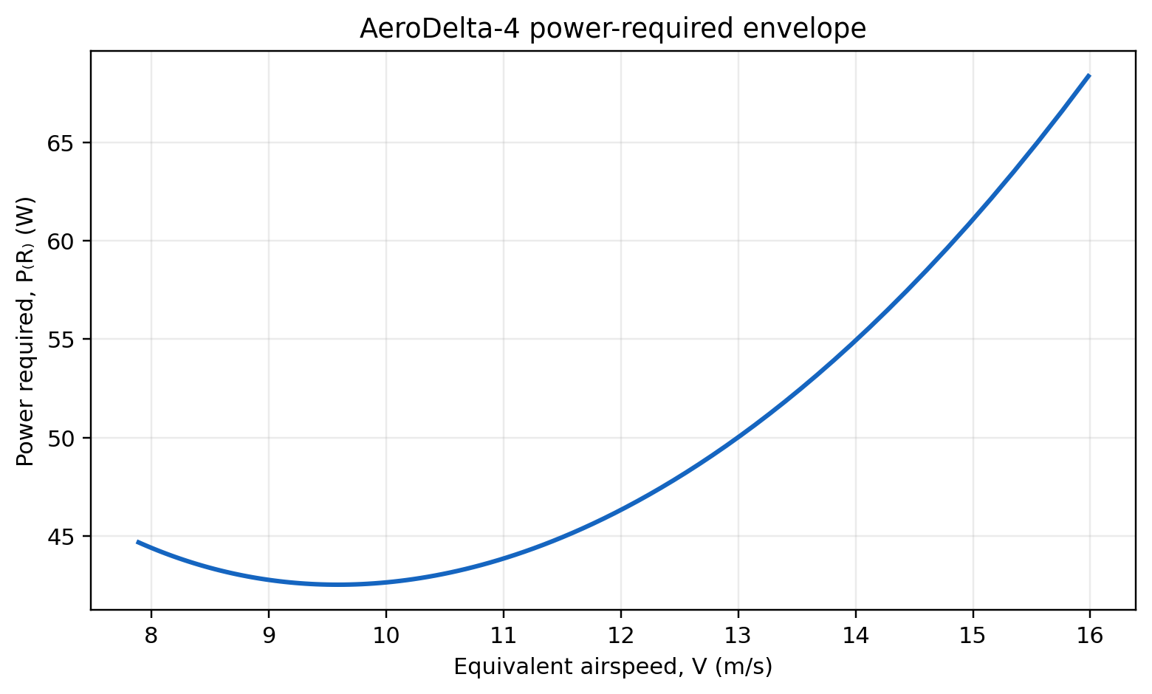
Figure 1. Power-required envelope over the screened operating range.
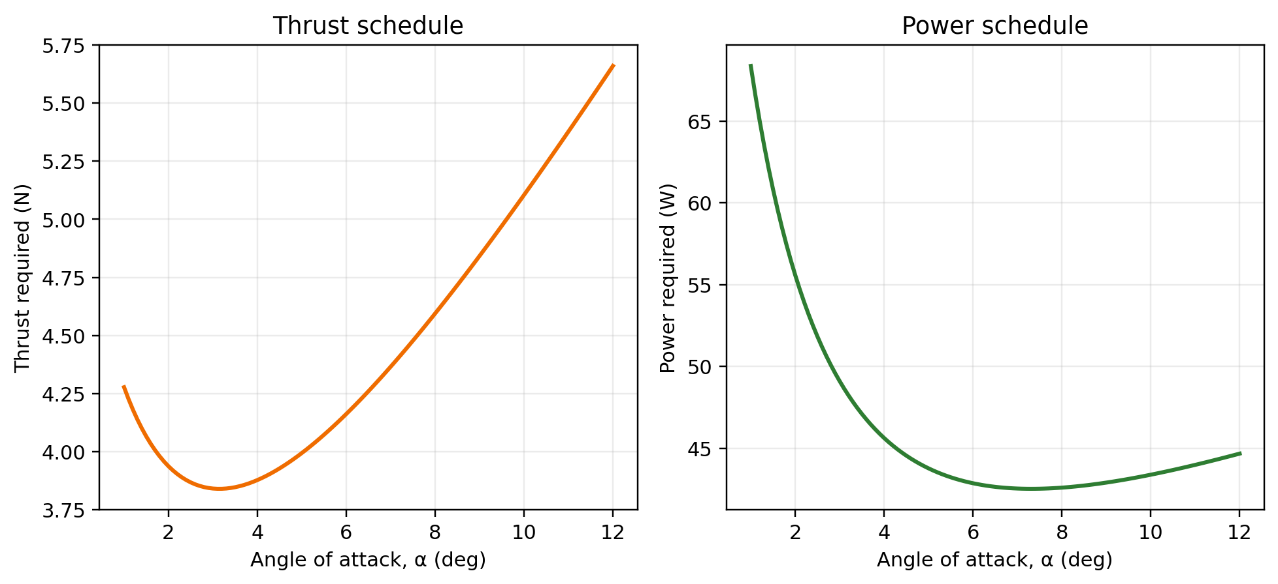
Figure 2. Thrust and power schedules against angle of attack.
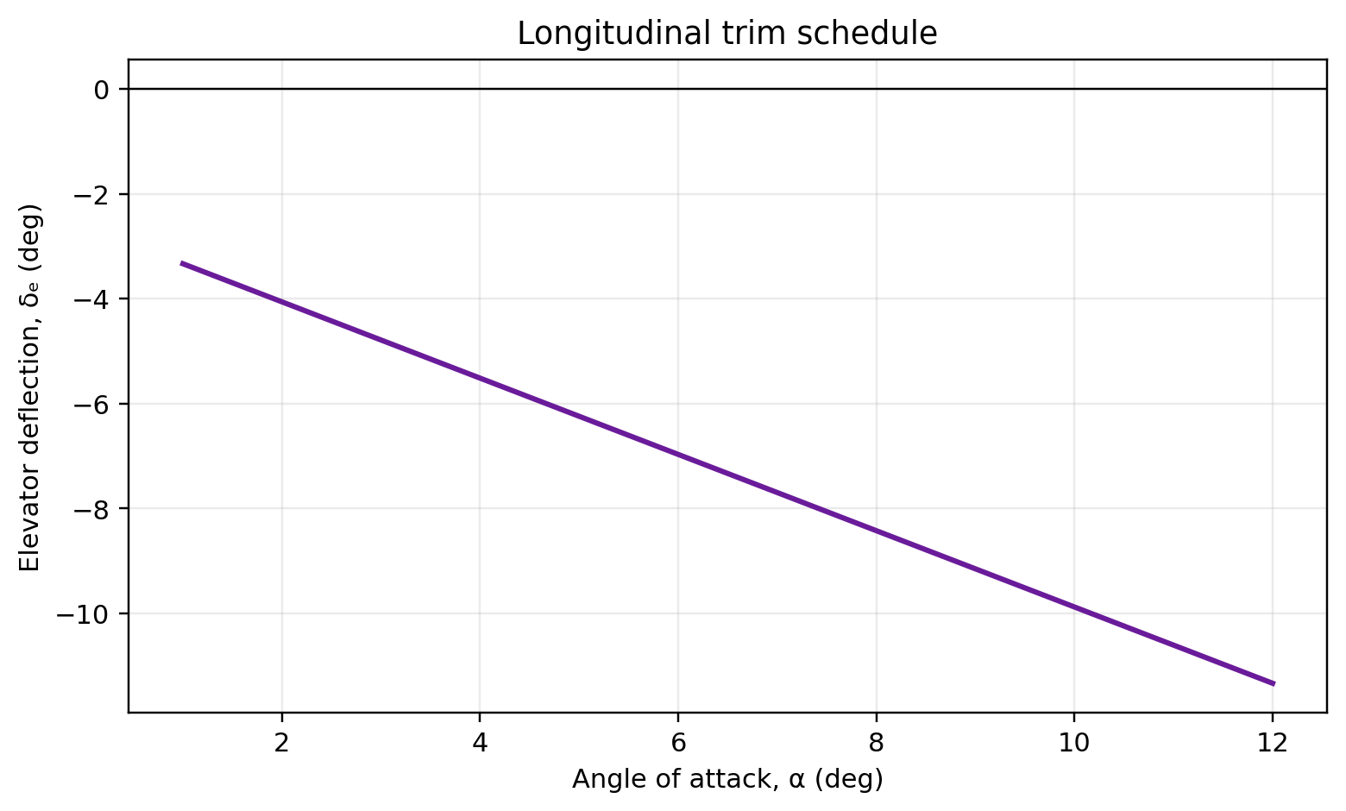
Figure 3. Elevator trim schedule from the pitching-moment balance.
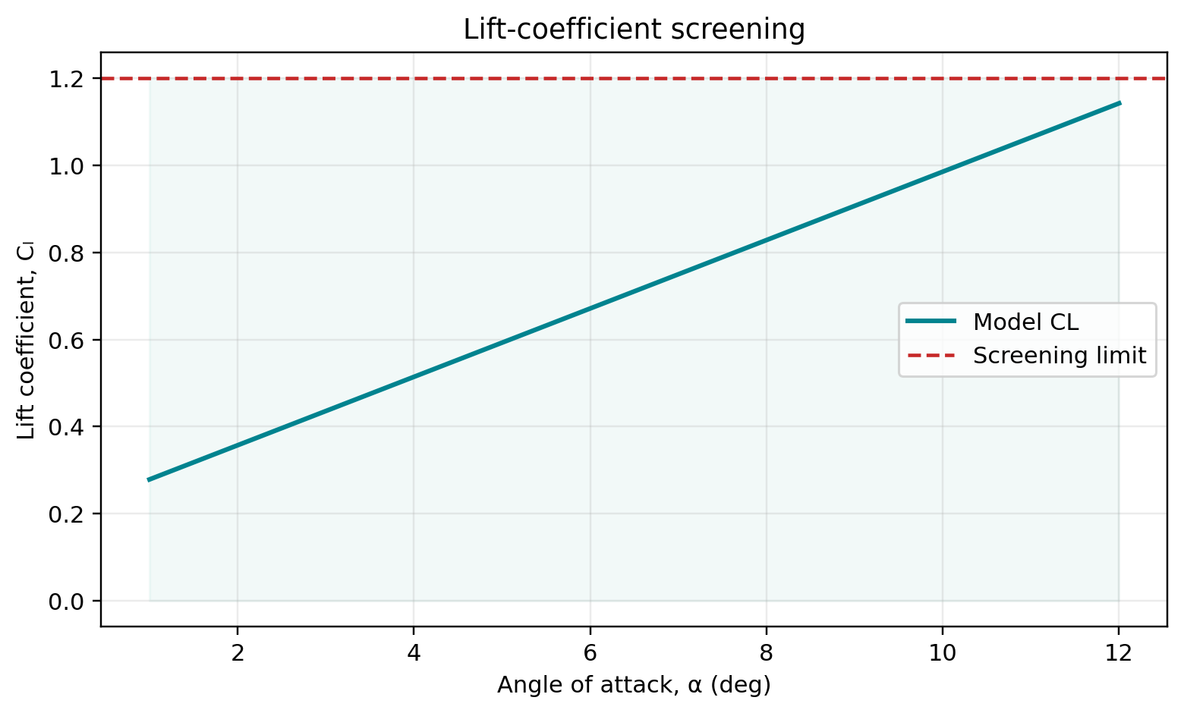
Figure 4. Lift coefficient and the explicit screening limit.

6.2 Uncertainty extension
Metric at 6° | P5 | Median | P95
Power required | 38.32 W | 43.09 W | 48.28 W
Elevator trim | -9.36° | -6.98° | -5.13°
Speed | 9.65 m/s | 10.30 m/s | 11.09 m/s

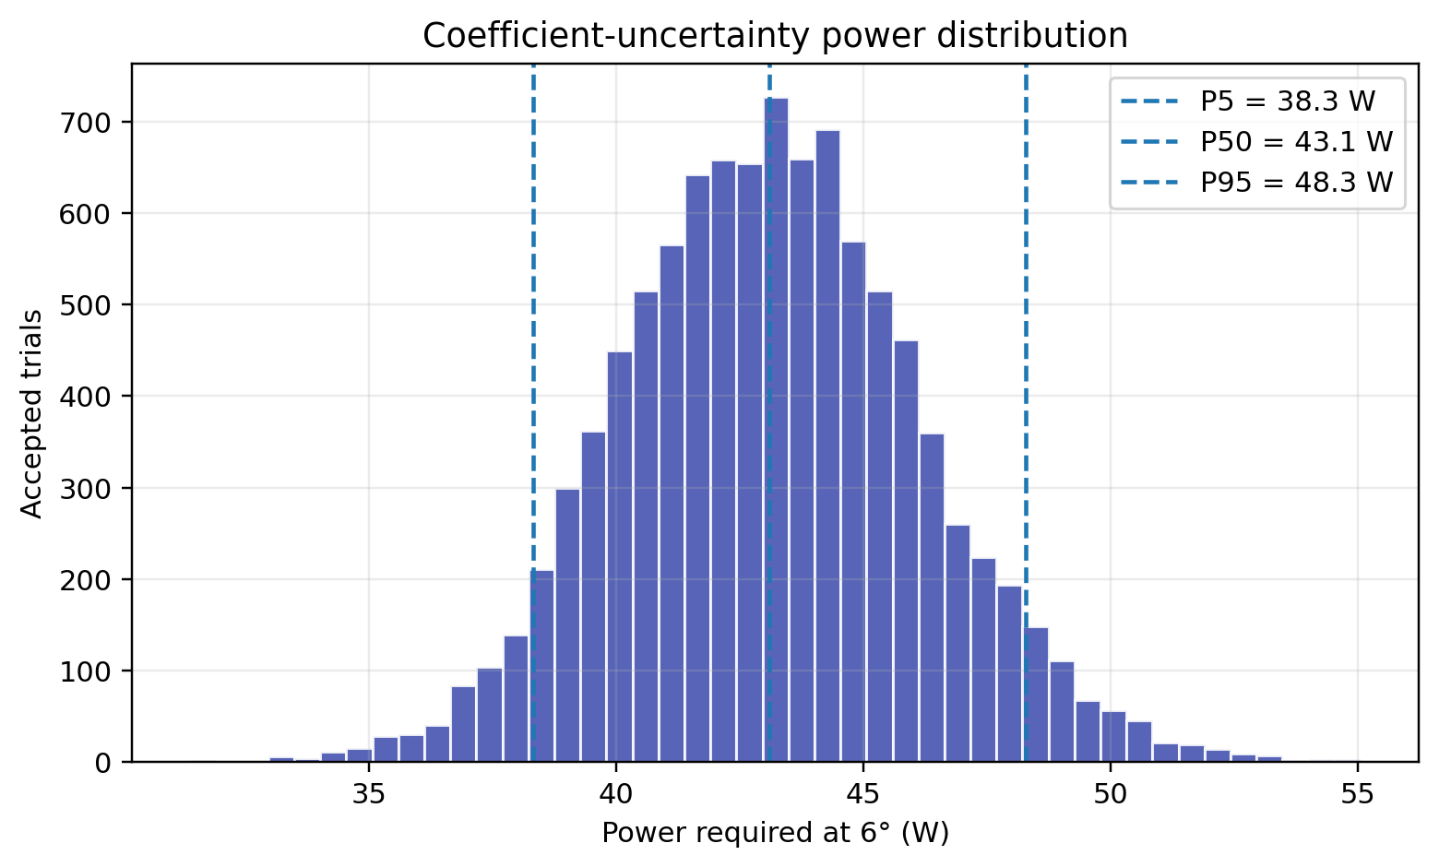
Figure 5. Monte Carlo power distribution; vertical markers show the 5th, 50th, and 95th percentiles.
The uncertainty result should be read as a model sensitivity envelope. It says how the chosen coefficient assumptions move the prediction; it does not establish a probability of actual aircraft performance until the distributions are calibrated using measurements.

7. Engineering interpretation
- At low speed, the required lift coefficient rises and induced drag increases, which drives the left side of the power curve upward.
- At high speed, profile drag dominates the trend and power rises approximately with speed cubed in the usual drag-polar interpretation.
- The trim schedule is controlled by the pitching-moment derivatives, so its credibility depends directly on the missing aerodynamic coefficient data.
- The cropped planform has a low aspect ratio, making induced drag a first-order design concern rather than a small correction.
- A motor-propeller selection should include propulsive efficiency: the present Pᴿ is aerodynamic power required, not electrical input power.

8. Limitations and next testable steps
This report is complete as a computational assignment model but deliberately does not overstate validation. The most important uncertainty is the placeholder aerodynamic data. The following sequence would turn this screening study into a higher-confidence design model:
- Replace Cₗ₀, Cₗα, Cᴅ₀, Cₘ₀, Cₘα, and Cₘδₑ with CFD, wind-tunnel, or flight-test estimates at a stated Reynolds number.
- Add a nonlinear stall model and a bounded elevator actuator model.
- Separate wing, fuselage, tail, and propulsion contributions to drag and moment.
- Convert aerodynamic power to electrical power using measured propeller and motor efficiency maps.
- Compare predicted airspeed and current draw against flight-test points, then recalibrate the uncertainty distributions.

9. Conclusion
AeroDelta-4 delivers the requested Project 4 workflow in a reproducible form: geometry, trim, lift equilibrium, thrust required, power required, plots, tabulated outputs, and a documented uncertainty extension. Its strongest feature is traceability: the reader can distinguish assignment data, physical assumptions, illustrative coefficients, and derived results. The project is therefore ready for submission as a computational analysis and ready for future refinement when measured aerodynamic data become available.

Appendix A — Output files
File | Purpose
nominal_sweep.csv | Complete angle-of-attack sweep and feasibility flag
uncertainty_samples_alpha6deg.csv | Accepted Monte Carlo samples at 6°
figures/*.png | Report-quality plots used in this document
results_summary.txt | Machine-readable headline values
build_project.py | Source of the calculations and report

Appendix B — Reproduction command
From the project directory, install the packages in requirements.txt and run: python build_project.py. The deliverables directory is recreated with fresh CSV, PNG, TXT, and DOCX outputs.

