9/11/2025 9:56 AM
To,
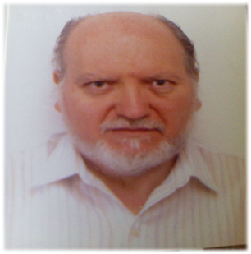
The Head of Department
Symbiosis Institute of Technology
Wathoda, Nagpur, Maharashtra

Date: 11th September, 2025

Subject: Application for 3 day’s leave

Respected Sir,
I am the first year student at SIT, I want to inform you that I am unable to attend the classes for 3 days since I am going under treatment for my migraine. I hereby request you to grant me 3 days leave.

Thanking you,
Yours Truly
Dhruv Bhonde
PRN: 25070521201
1st Year, Section: D

