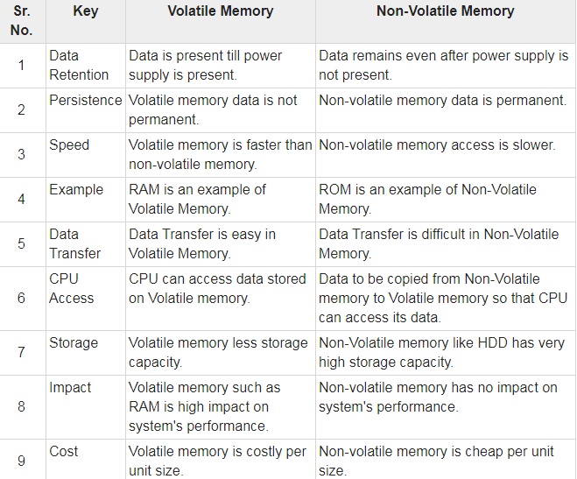

**Application software**

**Systems software**

***Operating system***

***compiler***

***assembler***

**User**

***Programs user***

***writes and runs***

**Hardware**

