Experiment 3:

number=43

i=2

f=0

while test $i -le `expr $number / 2`

do

if test `expr $number % $i` -eq 0

then

f=1

fi

i=`expr $i + 1`

done

if test $f -eq 1

then

echo "Not Prime"

else

echo "Prime"

fi

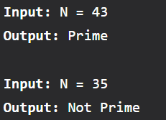

**B. Fibonacci**

Program

echo "Enter number: "

read N

a=0

b=1

echo -n "The Fibonacci series is : "

for (( i=0; i<N; i++ ))

do

echo -n "$a "

fn=$((a + b))

a=$b

b=$fn

done

echo " "

**output:-**

