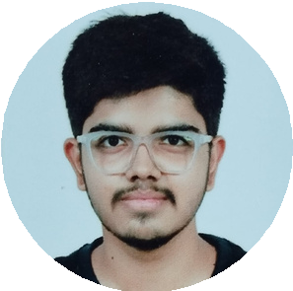
CONTACT

DHRUV SHAH
HTML/CSS WEB DEVELOPER
I am a passionate HTML/CSS Web Developer with hands-on experience in building responsive and user-friendly websites. I enjoy turning ideas into real projects and continuously learning new web technologies to improve my skills.
EDUCATION


+91 8866039007

dushah2007@gmail.com


Junagadh - 362001 Gujarat, India
2023 – Present
BCA - Bachelor of Computer Applications College Name – Noble University

SKILLS

HTML5 CSS3
Bootstrap 5
Basic JavaScript
Responsive Web Design Website Layout Design Basic Python

ACHIEVEMENT

1st Rank in University – Semester 1 3rd Rank in University – Semester 2 3rd Rank in University – Semester 3
Completed personal web project “Cars 24X7”

CERTIFICATION

Web Development Basics – HTML & CSS Bootstrap Fundamentals

EXPERIENCES

2025 – Cars 24X7 (Web Project)
-- Designed and developed a car rental website using HTML, CSS, and Bootstrap.
- Static website with responsive layout for mobile and desktop.
2026 – Cars 24x7 (Web Project)
- Developed a car rental website using JSP, JS, JDBC.
- Dynamic website with complete data flow and admin panel.

