Brain tumor diagnosis via MRI Scans

Abdulwahab Abdussamy & Dhruv Shah

Professor Nagib Hakim

CS 171 Introduction to Machine Learning

13 May 2025

# Abstract

# In this project, we classify T1-weighted brain MRI scans into four categories—glioma, meningioma, pituitary tumor, and absence of tumor. Initial benchmarks using a custom convolutional network, a shallow fully convolutional network, and a U-Net architecture yielded only modest accuracies and imposed substantial training times. To address limited data and computational demands, we employed transfer learning with MobileNetV2 pretrained on ImageNet: the convolutional base was frozen, and a classification head (global average pooling → Dense(128, ReLU) → Dropout(0.3) → Softmax) was appended. Input volumes underwent cropping, resizing, intensity normalization, and aggressive augmentation. This strategy markedly reduced training duration and achieved 90.16% test accuracy, demonstrating the efficacy of pretrained feature extractors in small-scale medical imaging tasks.

# Introduction

Brain tumor diagnosis via MRI is essential but time-consuming and error-prone. Deep learning—especially CNNs—can automate feature extraction, yet medical imaging poses challenges like class imbalance, limited data, and variable scan protocols. Our initial baselines (custom CNN, FCN, U-Net) learned features but plateaued below 62% validation accuracy and required lengthy training. We therefore adopted MobileNetV2 pretrained on ImageNet, leveraging transfer learning to overcome data scarcity and speed up convergence, and achieved substantially higher accuracy on this small MRI dataset.

# Data Preparation

The dataset includes 7,023 T1-weighted brain MRI images categorized into four classes: glioma, meningioma, pituitary tumor, and no tumor. Images vary in size, background, and modality (grayscale/RGB). **Cropping and Resizing**: Using OpenCV, we implemented a preprocessing function that converts images to grayscale, applies Gaussian blur, then uses binary thresholding and contour detection to isolate the brain region. Cropped images are resized to 224×224 to match CNN input requirements. **Normalization**: Pixel values were scaled to [0, 1] to stabilize gradient descent and reduce internal covariate shift. **Handling Corrupted Data**: Images that failed to load were automatically skipped, preventing interruptions during training. **Data Augmentation**: To increase generalization, we applied real-time augmentations during training: translations, rotations, brightness/contrast adjustments, and flips.

# Method

To evaluate different strategies for brain tumor classification, we implemented a set of CNN-based models including a custom CNN, FCN, and U-Net, followed by MobileNetV2 using transfer learning.  
1. **Custom CNN**: This model was built from scratch and comprises three convolutional layers with ReLU activation, max pooling, and a fully connected dense layer. While simple and efficient for small tasks, it failed to capture high-level features effectively, especially under constrained data.  
2. **FCN (Fully Convolutional Network)**: This architecture follows an encoder-style design without any fully connected layers. It achieved marginally better performance than the custom CNN, but lacked spatial hierarchies that are important for distinguishing tumor shapes and textures.  
3. **U-Net**: Originally designed for biomedical image segmentation, U-Net features a symmetrical encoder-decoder structure with skip connections that preserve spatial information during reconstruction. However, due to its high complexity, training time exceeded 14 hours, and classification accuracy plateaued around 61%. It is better suited for segmentation than classification tasks.  
4. **MobileNetV2**: We shifted to MobileNetV2 for greater performance and efficiency. Its depthwise separable convolutions avoid parameters without compromising on high capacity. We used the convolutional base as a fixed feature extractor and added a light-weight classification head in the form of a global average pooling layer, a 128 ReLU unit dense layer, a 0.3 dropout layer, and a final dense layer with four softmax output units for multi-class classification. The model was trained using the Adam optimizer with a learning rate of 1e-4 and categorical cross-entropy loss. We added callbacks like ReduceLROnPlateau and ModelCheckpoint to reduce the learning rate and save weights dynamically. The training continued for around 17 minutes, and we attained a test accuracy of 90.16%.

We tried three custom architectures—a simple CNN (Conv2D→pooling→Conv2D→pooling→flatten→Dense(128)→Dropout(0.5)→Softmax), shallow FCN encoder–decoder with global avg pooling, and U-Net with skip connections—training all for 20 epochs with Adam (lr = 1e-4). Although training accuracy improved modestly, none achieved over 62% validation accuracy and both FCN and U-Net took very long runtimes (U-Net > 14 h). A pre-trained ImageNet MobileNetV2 backbone, a lightweight head—GlobalAveragePooling, Dense(128, ReLU), Dropout(0.3), Softmax—training for 10 epochs with the same optimizer and learning rate, quickly reached 90.16% test accuracy.

# Results

|  |  |  |
| --- | --- | --- |
| Model | Test Accuracy | Training Time |
| Custom CNN | 55.9% | 356 min |
| FCN | 58.2% | 55 min |
| U-Net | 61.0% | 894 min |
| MobileNetV2 | 90.2% | 17 min |

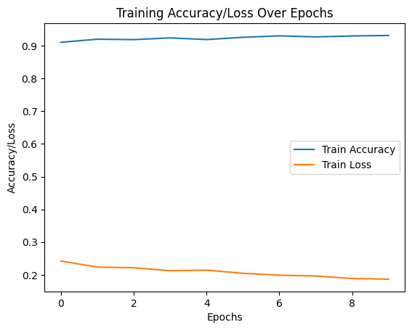

Figure 1: Training Accuracy/Loss Over Epochs

# Analysis and Conclusion

The performance gap between MobileNetV2 and the baseline models confirms the effectiveness of transfer learning in resource-constrained settings. The custom CNN, FCN, and U-Net struggled due to their architectural depth and lack of pretraining. U-Net, though powerful for segmentation, is inefficient for classification tasks without extensive tuning.

MobileNetV2 delivered high accuracy with minimal computation by leveraging its efficient architecture and pretrained weights. Our findings underscore the utility of pretrained CNNs for medical image classification, particularly when domain-specific labeled data is limited.

Limitations:  
- No Grad-CAM or interpretability tools were used to visualize model attention.  
- Validation loss was not consistently recorded due to a code bug in callbacks.

Future Work:  
- Introduce attention visualization (e.g., Grad-CAM)  
- Explore ensemble methods combining lightweight CNNs  
- Perform k-fold cross-validation to ensure model robustness

# References

* Afshar et al., "Brain tumor classification using deep CNN features via transfer learning," Computers in Biology and Medicine, vol. 111, 2019.
* Zahoor and Khan, "Brain Tumor MRI Classification using a Novel Deep Residual and Regional CNN," arXiv:2211.16571, 2022.
* Imam and Alam, "Optimizing Brain Tumor Classification: A Comprehensive Study on Transfer Learning," arXiv:2308.06821, 2023.
* C. et al., "Comparative Study of CNN Architectures for Brain Tumor Classification Using MRI: Exploring GradCAM," Proceedings, vol. 83, no. 1, 2023. Liu and Wang, "Deep Learning in Medical Image Classification from MRI-based Brain Tumor Images,"

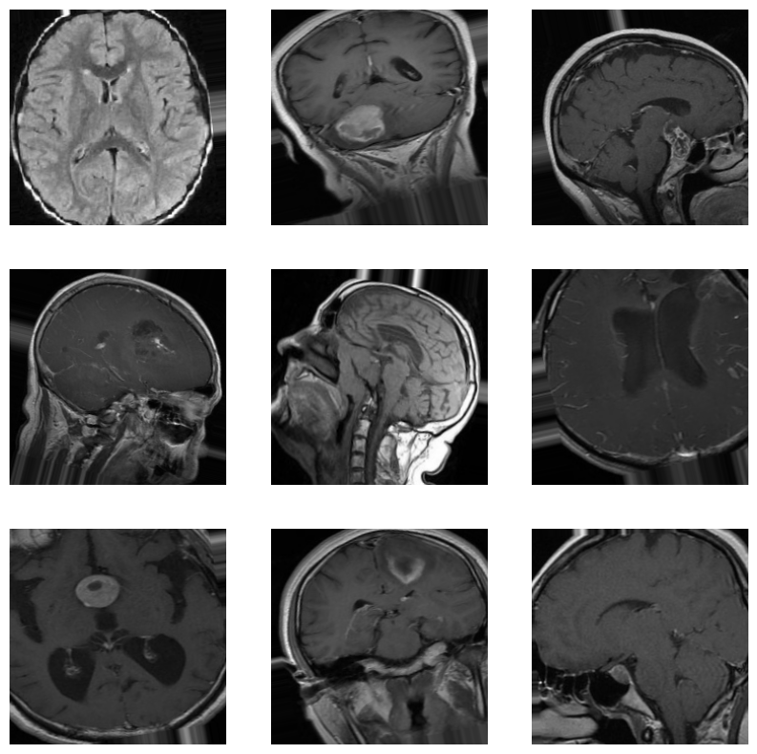

Figure 2: Uncropped (top) vs Cropped (bottom) MRI scans. Cropping removes black background areas to help the model focus on relevant anatomical structures.