Assignment-1

Name : Dhruv k. parmar

Enrollment No. : 2401031830002

Batch : E

Division : E1

Roll No. : 03

Subject : WT-UI/UX

Domain : Interactive Language Learning : Develop a website that uses interactive games and exercises for language learning.

Home Page

Login Page

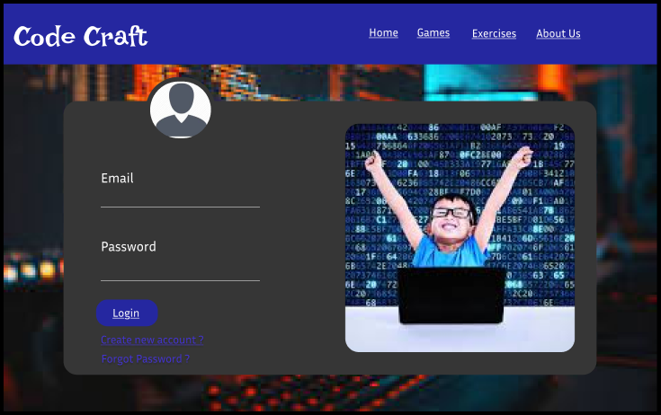

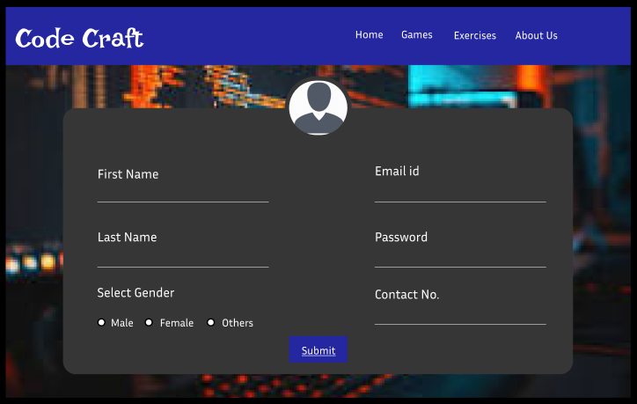Registration Page

Language Selection Page

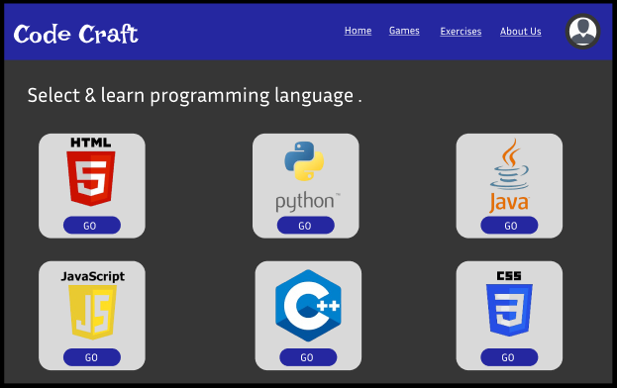

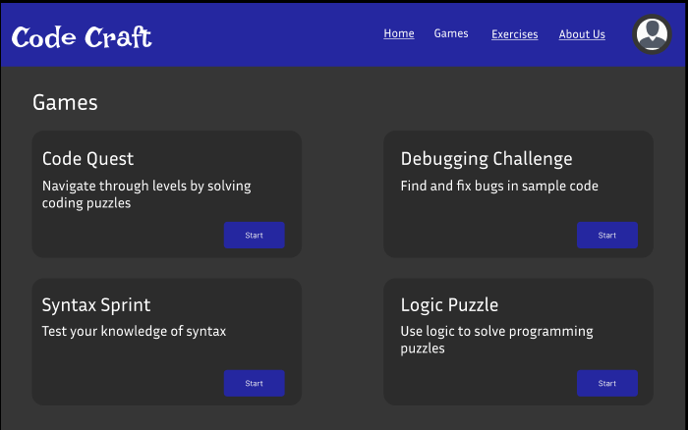Games Page

Exercises Page

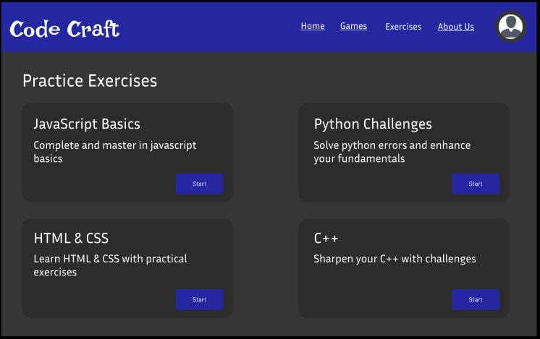

Membership Page

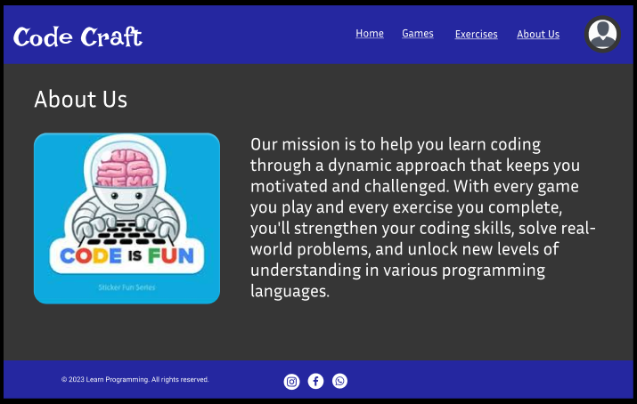About Us Page