ZOMATO DATA ANALYSIS

Table | No of Records
orders | 20,000
users | 6,000
restaurant | 3,000
menu | 3,000
food | 2,500

Q1 Total number of users,restaurants,order
SELECT COUNT(user_id) as no_of_user FROM users;
SELECT COUNT(id) as no_of_restaurants FROM restaurants;
SELECT COUNT(order_id) as no_of_orders FROM orders;

Q2 Total Sales and quantity sold
SELECT SUM(sales_qty) as total_sales_quantity ,
SUM(sales_amount) as total_sales
FROM orders;
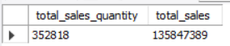

Q3 no of Restaurants per city
SELECT city,count(*) AS no_of_restaurants
FROM restaurants
GROUP BY city
ORDER BY no_of_restaurants DESC LIMIT 10;
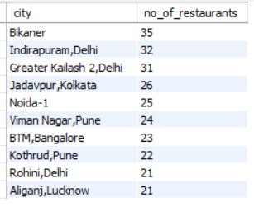

Q4 Veg vs Non-Veg food items
SELECT veg_or_non_veg,COUNT(*) as total_food_item
FROM food
GROUP BY veg_or_non_veg;
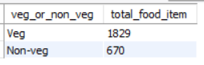

Q5 no of restaurants that have rating > 4.5
SELECT COUNT(*) as no_of_restaurants
FROM restaurants
WHERE rating >= 4.5;

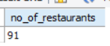

Q6 Display the user that have ordered 5 time or more than that
SELECT u.user_id,u.name,COUNT(o.order_id) as total_no_of_order
FROM users u
LEFT JOIN orders o ON u.user_id = o.user_id
GROUP BY u.user_id,u.name
HAVING total_no_of_order>= 5
ORDER BY total_no_of_order DESC;

Q7 Top 10 restaurant that have highest sales
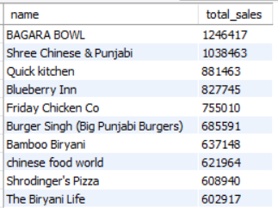
SELECT r.name,SUM(o.sales_amount) as total_sales
FROM restaurants r
JOIN orders o ON o.r_id = r.id
GROUP BY r.name
ORDER BY total_sales DESC LIMIT 10;

Q8 AVERAGE menu price per restaurant
SELECT r.name,AVG(m.price) as Average_price
FROM restaurants r
JOIN menu m ON m.r_id = r.id
GROUP BY r.name
ORDER BY Average_price DESC;

Q9 Top 10 city by Total no of Orders
SELECT r.city,COUNT(*) as no_of_order
FROM restaurants r
JOIN Orders o ON r.id = o.r_id
GROUP BY r.city
ORDER BY no_of_order DESC LIMIT 10;

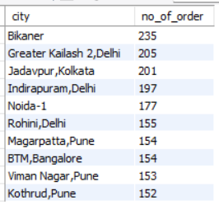

Q10 Total Order per city wise and name wise
SELECT r.name,r.city,COUNT(*) as no_of_order
FROM restaurants r
JOIN Orders o ON r.id = o.r_id
GROUP BY r.city,r.name
ORDER BY no_of_order DESC LIMIT 10;

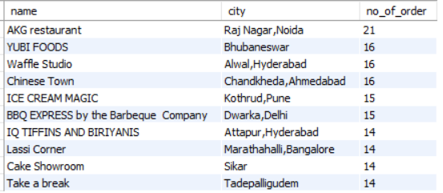

Q11 most popular cuisine based on number of menu items.
SELECT cuisine,COUNT(*) as no_of_item
FROM menu
GROUP BY cuisine
ORDER BY no_of_item DESC LIMIT 10;

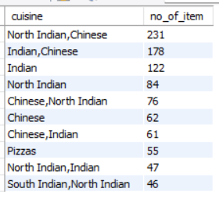

Q12 average rating of restaurants city-wise
SELECT city, ROUND(AVG(CAST(rating AS DECIMAL(2,1))),2) AS avg_rating
FROM restaurants
WHERE rating LIKE '%.%' OR rating LIKE '%[0-5]%'
GROUP BY city
ORDER BY avg_rating DESC;

Q13 Show restaurants that have never received any order.
SELECT r.name
FROM restaurants r
LEFT JOIN orders o ON o.r_id = r.id
WHERE o.order_id IS NULL;


Q14 Month wise total sales
SELECT DATE_FORMAT(order_date, '%Y-%m') AS month,
SUM(sales_amount) AS total_sales
FROM orders
GROUP BY month
ORDER BY month;

Q15 Identify the top 5 highest spending users
SELECT u.user_id,u.name,SUM(o.sales_amount) as total_spend
FROM users u
JOIN Orders o ON o.user_id = u.user_id
GROUP BY u.user_id,u.name
ORDER BY total_spend DESC LIMIT 5;
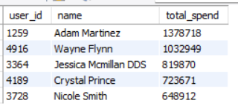

Q16 Average order per restaurant
SELECT r.name ,AVG(o.sales_amount) as Average_order_value
FROM restaurants r
JOIN Orders o ON o.r_id = r.id
GROUP BY r.name
ORDER BY Average_order_value DESC;

Q17 top 10 ordered food item
SELECT f.item ,COUNT(*) as Most_order_item
FROM food f
JOIN menu m ON m.f_id = f.f_id
JOIN orders o ON m.r_id = o.r_id
GROUP BY f.item
ORDER BY Most_order_item DESC LIMIT 10;
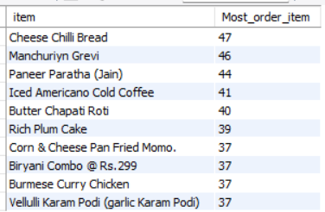

Q18 Top 10 cuisine by Revenue generated
SELECT r.cuisine,SUM(o.sales_amount) as total_sales
FROM restaurants r
JOIN orders o ON r.id = o.r_id
GROUP BY r.cuisine
ORDER BY total_sales DESC LIMIT 10;

Q19 users who ordered from more than one city
SELECT u.name
FROM users u
JOIN orders o ON u.user_id = o.user_id
JOIN restaurants r ON o.r_id = r.id
GROUP BY u.name
HAVING COUNT(DISTINCT(r.city)) > 1;

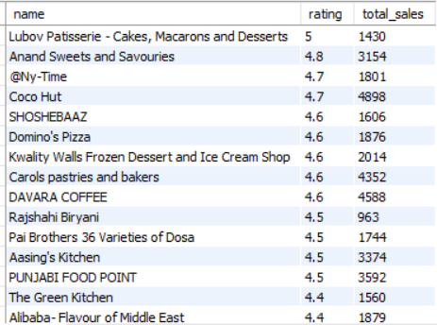

Q21 Peak ordering Year
SELECT EXTRACT(Year FROM order_date)AS Year,
SUM(sales_amount) AS Total_sales
FROM orders
GROUP BY Year
ORDER BY Total_sales DESC;

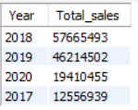

Q22 TOP 10 City witch highest Total sales
SELECT r.city,SUM(o.sales_amount) AS total_sales
FROM restaurants r
JOIN orders o ON r.id = o.r_id
GROUP BY r.city
ORDER BY total_sales DESC LIMIT 10;
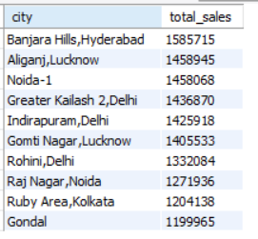

Q23 Rank restaurants city-wise by sales
SELECT r.name,r.city , SUM(o.sales_amount) as Total_sales,
RANK() OVER(PARTITION BY r.city ORDER BY SUM(o.sales_amount) DESC ) AS rank_in_city
FROM restaurants r
JOIN orders o ON r.id = o.r_id
GROUP BY r.city,r.name;

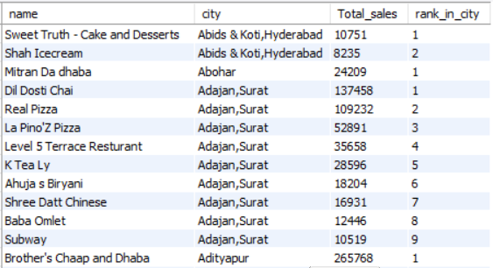

Q25 which cuisine performs best in each city
SELECT r.city,r.cuisine,SUM(o.sales_amount) as total_sales
FROM restaurants r
JOIN orders o ON r.id = o.r_id
GROUP BY r.cuisine,r.city
ORDER BY total_sales DESC;
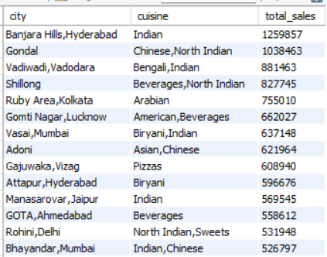

Q26 which user age group spends the most
SELECT
CASE
WHEN age BETWEEN 18 AND 25 THEN '18–25'
WHEN age BETWEEN 26 AND 35 THEN '26–35'
WHEN age BETWEEN 36 AND 45 THEN '36–45'
WHEN age BETWEEN 46 AND 60 THEN '46–60'
ELSE '60+'
END AS age_group,
SUM(o.sales_amount) AS total_sales
FROM users u
JOIN orders o ON u.user_id = o.user_id
GROUP BY age_group
ORDER BY total_sales DESC;

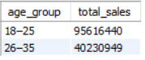

Q27 Veg vs Non-Veg food sales performance
SELECT f.veg_or_non_veg, SUM(o.sales_amount) AS total_sales
FROM food f
JOIN menu m ON f.f_id = m.f_id
JOIN orders o ON m.r_id = o.r_id
GROUP BY f.veg_or_non_veg;
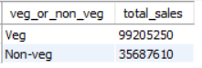

Q28 top restaurant per city by revenue
SELECT city, name, total_sales
FROM (
SELECT r.name,r.city , SUM(o.sales_amount) as Total_sales,
RANK() OVER(PARTITION BY r.city ORDER BY SUM(o.sales_amount) DESC ) AS rank_in_city
FROM restaurants r
JOIN orders o ON r.id = o.r_id
GROUP BY r.city,r.name
) AS t
WHERE rank_in_city = 1;

Q29 customer lifetime value (CLV)
SELECT u.name, SUM(o.sales_amount) AS CLV
FROM users u
JOIN orders o ON u.user_id = o.user_id
GROUP BY u.name
ORDER BY CLV DESC LIMIT 10;
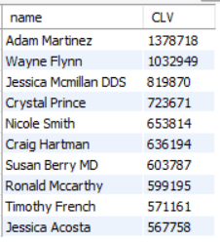

Q30 restaurants whose average order value is above city average
SELECT r.name
FROM restaurants r
JOIN orders o ON r.id = o.r_id
GROUP BY r.name, r.city
HAVING AVG(o.sales_amount) >
(SELECT AVG(o2.sales_amount)
FROM orders o2
JOIN restaurants r2 ON o2.r_id = r2.id
WHERE r2.city = r.city);

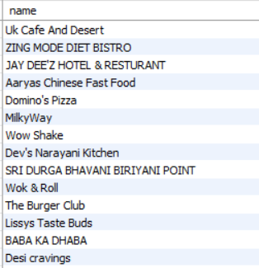

Q31 Inactive user
SELECT u.name
FROM users u
LEFT JOIN orders o ON u.user_id = o.user_id
WHERE o.order_id IS NULL;


Q32 Total order placed in each year
SELECT YEAR(order_date) AS year, COUNT(*) AS total_orders
FROM orders
GROUP BY year;
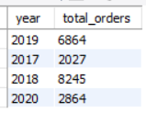

Q33 Restaurants with highest number of customers
SELECT r.name, COUNT(DISTINCT o.user_id) AS customers
FROM orders o
JOIN restaurants r ON o.r_id = r.id
GROUP BY r.name
ORDER BY customers DESC;

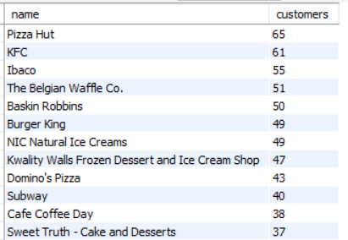
Q34 top 5 city who contribution to total revenue in Percentage
SELECT r.city,
SUM(o.sales_amount) AS city_sales,
ROUND(SUM(o.sales_amount) * 100 /
(SELECT SUM(sales_amount) FROM orders), 2) AS contribution_percent
FROM orders o
JOIN restaurants r ON o.r_id = r.id
GROUP BY r.city
ORDER BY contribution_percent DESC LIMIT 5;

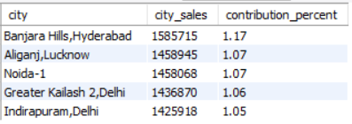

Q35 Find top 5 restaurants by total sales using CTE
WITH restaurant_sales AS (
SELECT r.id, r.name, SUM(o.sales_amount) AS total_sales
FROM restaurants r
JOIN orders o ON r.id = o.r_id
GROUP BY r.id, r.name
)
SELECT name, total_sales
FROM restaurant_sales
ORDER BY total_sales DESC
LIMIT 5;

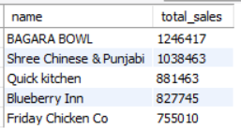

Q36 Restaurant Rating Category using CASE
SELECT name, rating,
CASE
WHEN rating >= 4.5 THEN 'Excellent'
WHEN rating >= 4.0 THEN 'Good'
WHEN rating REGEXP '^[0-3.9]' THEN 'Average'
ELSE 'New / Not Rated'
END AS rating_category
FROM restaurants;

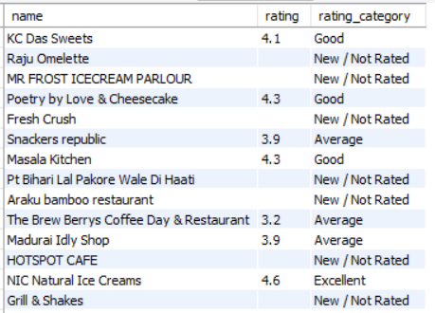

Q37 Sales by Occupation
SELECT u.occupation,
SUM(o.sales_amount) AS total_sales
FROM users u
JOIN orders o ON u.user_id = o.user_id
GROUP BY u.occupation
ORDER BY total_sales DESC;

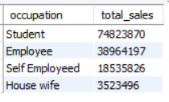

Q38 Sales by Marital Status
SELECT u.marital_status,
SUM(o.sales_amount) AS total_sales
FROM users u
JOIN orders o ON u.user_id = o.user_id
GROUP BY u.marital_status
ORDER BY total_sales DESC;
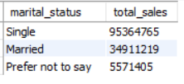

Q39 Year-wise + Month-wise Growth
SELECT year, month, total_sales,
total_sales - LAG(total_sales)
OVER (PARTITION BY year ORDER BY month) AS monthly_growth
FROM (
SELECT YEAR(order_date) AS year,
MONTH(order_date) AS month,
SUM(sales_amount) AS total_sales
FROM orders
GROUP BY year, month
) t;

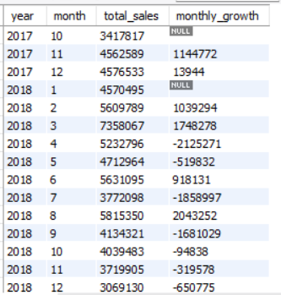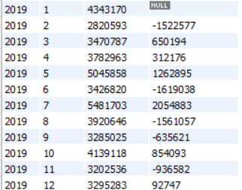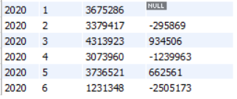

Q40 Customer repeat rate restaurant wise
SELECT
r.name AS restaurant_name,
ROUND(
(COUNT(CASE WHEN order_count >= 2 THEN 1 END) * 100.0)
/ COUNT(*),
2) AS repeat_customer_rate
FROM (
SELECT
r_id,
user_id,
COUNT(order_id) AS order_count
FROM orders
GROUP BY r_id, user_id
) t
JOIN restaurants r ON t.r_id = r.id
GROUP BY r.name
ORDER BY repeat_customer_rate DESC;

