E-COMMERCE PERFORMANCE REPORT
Report ID: FY23-25
Dashboard Analysis & Business Intelligence Report

Prepared by:
SUJAL BHAVSAR
DHRUV DESAI
NEHA MODI
RUDRA RAVAL

Course / Programme:
DATA ANALYTICS(BH-08)

Submission Date:
03 April 2026

Table of Contents

1. Introduction 3
1.1 Purpose of the Report 3
1.2 Why Data Analysis Matters 3
2. Dashboard Overview & Data Story 4
2.1 Dashboard at a Glance 4
2.2 Revenue by Category 4
2.3 Order Status Distribution 5
2.4 Top 10 Products by Revenue 5
2.5 Monthly Trends — 2025 6
2.6 Payment Method Analysis 6
3. Key Performance Indicators 7
4. Business Insights 8
4.1 Strengths 8
4.2 Weaknesses & Risk Areas 8
4.3 Opportunities 8
5. Recommendations 9
6. Conclusion 10
Appendix: Quick Reference Data Tables 11

1. Introduction

1.1 Purpose of the Report
This report — identified as FY23-25 — presents a structured analysis of an E-Commerce business dashboard built in Microsoft Excel. It consolidates transactional data spanning financial years 2023 through 2025, covering product categories, order statuses, and payment methods. The goal is to interpret the visuals, surface meaningful insights, and propose actionable recommendations.
The report is designed for both academic submission and professional review, walking through each dashboard component from headline KPIs to granular monthly patterns.

1.2 Why Data Analysis Matters in E-Commerce
Digital retail generates high-velocity transactional data that, left unanalysed, becomes noise. Effective analysis converts that noise into signal — revealing the most profitable categories, peak demand windows, fulfilment bottlenecks, and payment preferences that shape customer experience and margin.
Microsoft Excel dashboards serve as an accessible first layer of business intelligence, offering visual summaries that accelerate decision-making. This report harnesses that capability to move from what the data shows, to why it matters, to what the business should do next.

2. Dashboard Overview & Data Story

This section presents each panel of the dashboard alongside its narrative interpretation. Charts are reproduced directly below the analysis so the visual evidence sits next to the insight it supports.

2.1 Dashboard at a Glance
The full dashboard below provides a consolidated performance snapshot for FY23-25. Three horizontal zones organise the content: a KPI summary row at the top, category and product analytics in the middle, and time-trend charts at the bottom. An interactive slicer panel on the right enables filtering by Order Date, Category, Status, and Payment Method.
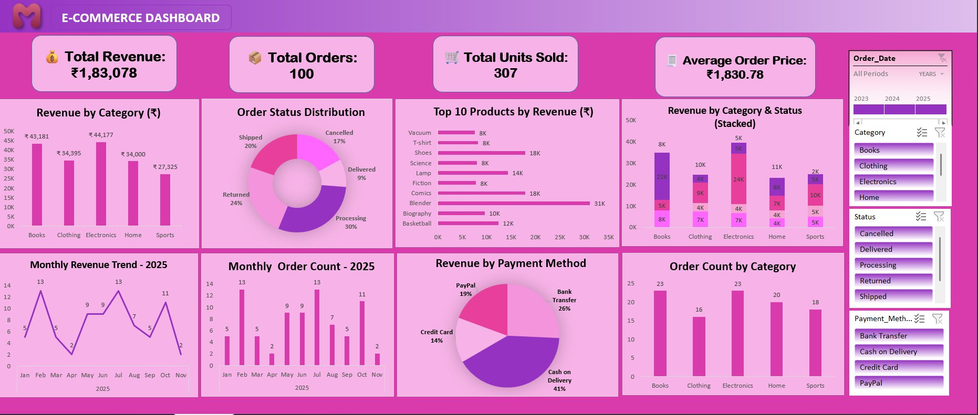
Figure 1 — E-Commerce Excel Dashboard, FY23-25 Full View

2.2 Revenue by Category
Electronics leads with ₹44,177, narrowly ahead of Clothing at ₹43,181. These two categories together contribute nearly half of total revenue, establishing them as the twin commercial pillars of the business. Home (₹34,395) and Books (₹34,000) are closely matched, collectively adding another 37%. Sports trails at ₹27,325 — the only category falling meaningfully below the others.
The story here is one of healthy diversification without a dominant flagship. No single category risks bringing down the whole business if it declines, but equally, none is accelerating fast enough to act as an obvious lever for step-change growth. Sports stands out as either a problem to fix or an opportunity to unlock.
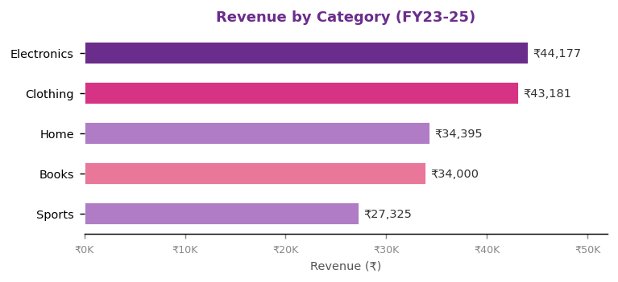
Figure 2 — Revenue by Category (₹) — FY23-25
Key Insight: Electronics + Clothing = ~47% of total revenue. Sports is the only category below ₹30K.

2.3 Order Status Distribution
The order status breakdown is the most operationally concerning section of the dashboard. Processing orders account for 30% — nearly one in three orders has not yet been fulfilled. Returns stand at 24% and cancellations at 17%, meaning over 40% of all initiated orders never reach a successful delivery. Delivered orders represent only 9% of the total.
This data tells a cautionary story: the business is generating orders but struggling to convert them into completed, retained transactions. High return rates typically signal product-description mismatches or quality issues. High cancellation rates point to checkout friction, payment trust gaps, or post-order regret. Combined, these figures erode the true revenue potential significantly.
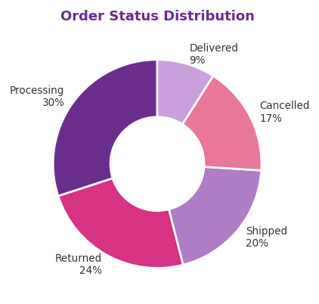
Figure 3 — Order Status Distribution (% of Total Orders)
Key Insight: 41% of orders are either returned or cancelled. Only 9% are confirmed delivered — a critical fulfilment gap.

2.4 Top 10 Products by Revenue
The Blender stands alone as the highest-revenue product at ₹31,000 — nearly double the next-best performers, Shoes and Comics, which each contribute ₹18,000. Lamp (₹14,000) and Basketball (₹12,000) form the mid-tier, while Biography, Vacuum, Fiction, Science, and T-shirt each generate approximately ₹8,000–₹10,000.
The Blender's outsized contribution reveals a customer segment willing to invest in premium home appliances. It also creates a single-product dependency risk — if Blender sales decline due to supply issues or competition, total revenue could drop sharply. The business would benefit from cultivating additional high-value products to spread this concentration risk.
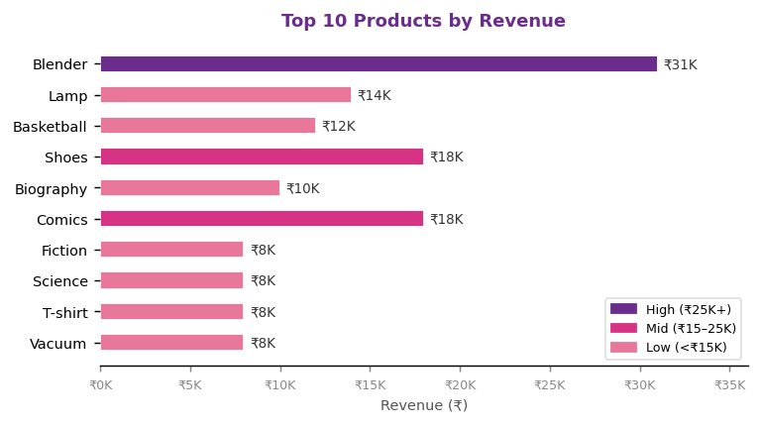
Figure 4 — Top 10 Products by Revenue (₹)
Key Insight: The Blender alone contributes ~17% of total revenue. The next 9 products combined contribute the remaining 83%.

2.5 Monthly Trends — 2025
The monthly trend data for 2025 reveals a highly irregular demand pattern. Order counts peak in February (13) and again in June (13), suggesting bi-annual promotional cycles or seasonal demand spikes. March sees a sharp drop to just 2 orders — the joint-lowest month alongside November. This February-to-March cliff is stark and warrants investigation.
October shows a partial recovery to 11 orders, but November — globally a peak retail month due to festive sales events — ends at just 2 orders. This missed November opportunity is a significant commercial gap. The absence of a November peak suggests the business has not yet built a seasonal marketing calendar aligned with consumer buying cycles.
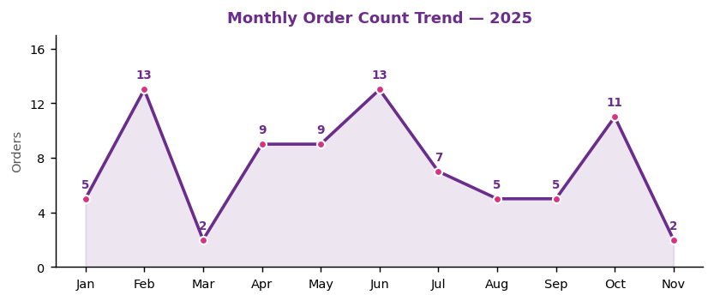
Figure 5 — Monthly Order Count Trend, 2025
Key Insight: February and June are natural peak windows. November is the largest missed opportunity in the calendar.

2.6 Payment Method Analysis
Cash on Delivery dominates at 41% of revenue, followed by Bank Transfer (26%), PayPal (19%), and Credit Card (14%). The COD majority reflects consumer behaviour typical of price-sensitive or trust-cautious markets, where buyers prefer not to commit funds before physically receiving the product.
While COD builds initial trust, it also increases return risk — customers face no financial consequence for returns, which may be contributing to the 24% return rate in the status distribution. Shifting the payment mix towards prepaid methods would simultaneously reduce returns and improve cash flow.
 |  | 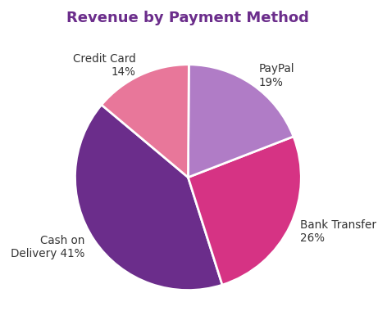
Fig 3 — Order Status |  | Fig 6 — Payment Method
 | Key Insight: COD (41%) and high return rate (24%) are likely correlated. Incentivising prepaid payments could reduce both.

3. Key Performance Indicators

The four KPI cards at the top of the dashboard provide an immediate financial and operational health check for FY23-25.

Metric | Value
Total Revenue | ₹1,83,078
Total Orders | 100
Total Units Sold | 307
Average Order Price | ₹1,830.78
Table 1 — Key Performance Indicators, FY23-25

3.1 Revenue and Order Value
Total revenue of ₹1,83,078 across 100 orders places the Average Order Price at ₹1,830.78. This elevated per-order value indicates a mid-to-premium product mix where individual transactions carry meaningful monetary weight. Losing even a single customer carries a disproportionate revenue impact, making retention strategy critical.

3.2 Units per Order
With 307 units sold across 100 orders, the average basket size is approximately 3.07 units per transaction. Customers are consistently purchasing multiple items per order — a positive indicator of effective cross-selling or product discovery on the platform.

4. Business Insights

4.1 Strengths
The business demonstrates a well-diversified revenue base with no single category representing an overwhelming dependency. Electronics and Clothing provide reliable revenue anchors, while the Blender demonstrates the platform's ability to convert high-value transactions. The AOP of ₹1,830.78 and a basket size above 3 units per order both indicate customers are engaged and willing to spend meaningfully.

4.2 Weaknesses and Risk Areas
The combined return and cancellation rate exceeding 40% is the most critical weakness. This represents direct revenue leakage, increased reverse-logistics costs, and a damaged post-purchase experience. The 30% processing backlog further indicates fulfilment timelines are not meeting customer expectations, likely feeding downstream cancellations and returns.
Sports as a category is consistently the weakest performer across both revenue and order count, suggesting insufficient inventory depth, pricing weakness, or poor discoverability.

4.3 Opportunities
The Blender's success points to a clear opportunity in the premium home appliance space. Expanding this sub-category with complementary products could leverage the same customer appetite already demonstrated. The strong November performance gap is a straightforward revenue opportunity — a structured festive-season campaign could realistically add 5–10 incremental orders in a month that currently contributes almost nothing.
Shifting the COD-heavy payment mix towards prepaid methods via targeted incentives would reduce return rates, improve cash flow, and lower reverse-logistics costs simultaneously.

5. Recommendations

Six targeted recommendations follow from the data insights above. Each is directly evidenced by the dashboard and designed to be measurable.

5.1 Launch a Return Reduction Programme
Conduct root-cause analysis on returns, segmenting by category, product, and month. For Clothing, improve size guides. For Home and Appliances, add video demonstrations. Introduce a post-return feedback form. Target: reduce return rate from 24% to below 15% within two quarters.

5.2 Enforce Fulfilment SLAs
Set formal Service-Level Agreements requiring same-day dispatch for in-stock orders. Automate order-status notifications at each fulfilment stage to reduce anxiety-driven cancellations. Review warehouse capacity to identify where the 30% processing backlog originates.

5.3 Build a Seasonal Marketing Calendar
Formalise February and June as flagship campaign windows with pre-planned stock positioning and targeted promotions. Develop a November festive campaign to capture a currently missed peak — target at least 8–10 orders in November, a fourfold improvement on the current 2.

5.4 Invest in the Sports Category
Commission a competitive audit. Introduce 3–5 trending sports or fitness products and run a dedicated category promotion for one month to test demand. If response is weak, consider rationalising the category in favour of higher-performing segments.

5.5 Incentivise Prepaid Payments
Introduce a 2–3% instant cashback for customers choosing Credit Card, PayPal, or Bank Transfer at checkout. Display this incentive prominently at the payment selection stage. 12-month target: reduce COD share from 41% to below 30%.

5.6 Expand the Premium Home Appliance Range
Build on the Blender's success by curating a Premium Home section with two price tiers: accessible (₹1,000–₹2,000) and aspirational (₹3,000+). Use existing Blender buyer data to drive personalised recommendations. Add buying guides and comparison tables to improve conversion.

6. Conclusion

This report (FY23-25) has examined the E-Commerce dashboard across seven analytical dimensions: headline KPIs, category revenue, order fulfilment health, top product performance, monthly demand trends, payment method distribution, and category-status cross-analysis.
The business enters its next phase with genuine strengths — a diversified category base, a healthy average order value, and the demonstrated ability to sell premium products. However, the 40%+ combined return and cancellation rate, the November revenue gap, and Sports category underperformance represent material drags on growth potential that are addressable with targeted action.
The six recommendations in this report are not aspirational — they are directly evidenced by the FY23-25 data. A structured return reduction programme, seasonal campaign calendar, fulfilment SLA enforcement, payment incentive scheme, Sports category review, and Home Appliance expansion collectively address the most significant value leaks and growth gaps identified.
A business that reads its data clearly and acts on it decisively compounds its advantages over time. The FY23-25 dashboard is not just a record of what happened — it is a roadmap for what comes next.

"Data is the new oil — but only when refined into insight and actioned into strategy."

Appendix: Quick Reference Data Tables

The tables below summarise key data points from the FY23-25 dashboard for quick cross-reference.

A. Revenue by Category
Category | Revenue (₹)
Electronics | ₹44,177
Clothing | ₹43,181
Home | ₹34,395
Books | ₹34,000
Sports | ₹27,325
Table A1 — Revenue by Product Category

B. Order Status Distribution
Order Status | Share (%)
Processing | 30%
Returned | 24%
Shipped | 20%
Cancelled | 17%
Delivered | 9%
Table A2 — Order Status Distribution

C. Top 5 Products by Revenue
Product | Revenue (₹)
Blender | ₹31,000
Shoes | ₹18,000
Comics | ₹18,000
Lamp | ₹14,000
Basketball | ₹12,000
Table A3 — Top 5 Products by Revenue

D. Revenue by Payment Method
Payment Method | Revenue Share (%)
Cash on Delivery | 41%
Bank Transfer | 26%
PayPal | 19%
Credit Card | 14%
Table A4 — Revenue by Payment Method

