Idea/Approach Details

**Ministry Category:** Government Polytechnic, Palanpur

**Problem Statement:** Digital platform for book sharing

**Problem Code:** (#SGH074)

**Team Leader Name:** Dhruv Gandhi

**College Code:** U-0873

**Problem: Digital platform for book sharing**

According to today’s scenario, it is required to develop a platform where allumanies and senior faculties can donate their unused books or stationary materials for newly entered students to the institutes. Also we can see problem like, newly entered student or junior can’t communicate with senior for study materials that creates a communication gap between senior and junior.

**Solution for the problem**

We can see all university and collages having online website for attendance and information about the institute, as a solution we will create a web protocol in html, css and JavaScript or else in angularjs or nodejs .in our system we have main 3 stack holder, 1st is admin, 2nd is faculty member and last one is student. All having a private profile so that other can’t see their profile due to privacy policy, all have to register once in system so that all get their own login and password. If anyone want to share or sell book with other, he have a post posting activity so that other can see what things or books are available at how much cost. A student or staff member who require book and that book is available on website so he or she can send request to owner of that book and after that owner accept or reject the request. If owner accept the request owner can chat or share contact details of him or her with requesting person and share the things and book. That thing reduce the communication gap between junior and student.

**Algorithm**

1. **Step must have to sign up once with institute provided email address.**
2. **Then User Get user name and password and sign to the system.**
3. **Profile create automatically on the base of given data**
4. **Most important part all user profile is private, no one can see the profile of anyone.**
5. **Now there have a multiple option like Timeline, donate book or things, sell the book and things, request accept or rejection, our request status, ask a query and get solution, searchbox.**
6. **If user want to donate book or things, he have to fill-up one from with proper details that create a post on Timeline box.**
7. **If someone want to donee or buy book he have to visit Timeline box and find book post and on that he or she can one option that request for book, fill one from and that send a request to owner of that book.**
8. **Owner of the book have to accept or reject option, if owner accept that will enable option like chat or share contact details.**
9. **Requester can see status of request that he or she had create.**
10. **This how whole system will work.**

**Key features**

* Time efficient.
* Privacy maintains.
* Easy to access and share.
* Reduce the communication gap between senior and junior.
* Reusability of unusing product and book.

**Technology stack**

**S/W : -** html, css, JavaScript, php, angularjs or nodejs or python.

**Database: -** Firebase (Real time database-authentication), MySQL (ZMapp server).

**System Flow Diagram**

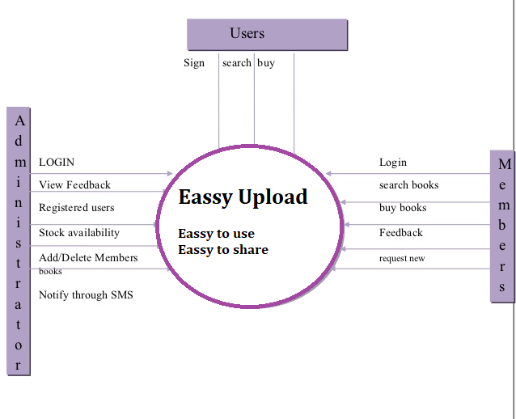

**Screenshot how system look like**

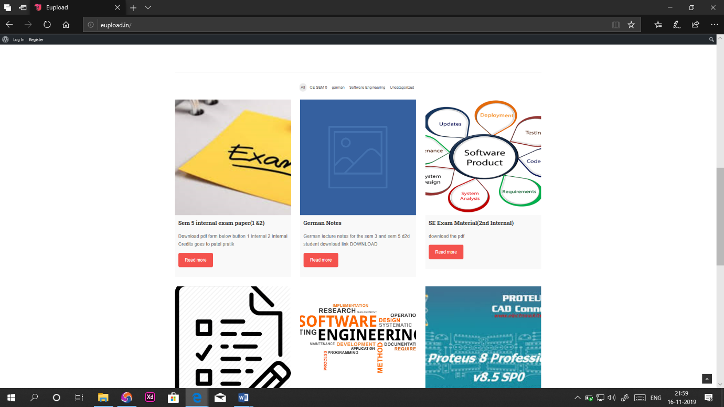

Database

