1

**Software Requirements**

**Specification**

**for**

**Campus Recruitment System**

**Prepared by:-**

**Yash Anghan**

**(17se02ce002)**

**Sumit Badreshiya**

**(17se02ce003)**

**Mohil Jariwala**

**(17se02ce021)**

**P.P SAVANI UNIVERSITY, SURAT**

**2nd February 2020**

# Table of Contents

## Table of Contents

**1. Introduction 4**

|  |  |  |
| --- | --- | --- |
| 1.1 Purpose |  | **4**  **4** |
| 1.2 Document Conventions |  |
| 1.3 Intended Audience and Reading Suggestions |  | **4** |
| 1.4 Product Scope |  | **4** |
| 1.5 References |  | **4** |
| **2. Overall Description** |  | **5** |
| 2.1 Product Perspective |  | **5** |
| 2.2 Product Functions |  | **6** |
| 2.3 User Classes and Characteristics | **7** |  |
| 2.4 Operating Environment | **10** |  |
| 2.5 Design and Implementation Constraints | **12** |  |
| 2.6 User Documentation |  | **13** |
| 2.7 Assumptions and Dependencies |  | **13** |
| **3. External Interface Requirements** |  | **14** |
| 3.1 User Interfaces |  | **14** |
| 3.2 Hardware Interfaces |  | **17** |
| 3.3 Software Interfaces |  | **17** |
| 3.4 Communications Interfaces |  | **18** |
| 1. **System Features**    1. System Feature |  | **18**  **18** |
| 4.2 System Feature 2 (and so on) |  | **18** |
| **5. Other Nonfunctional Requirements** |  | **19** |
| 5.1 Performance Requirements |  | **19** |
| 5.2 Safety Requirements |  | **19** |
| 5.3 Security Requirements |  | **20** |
| 5.4 Software Quality Attributes |  | **20** |
| 5.5 Business Rules |  | **20** |

1. **Introduction**
   1. **Purpose**

The primary purpose to develop this system is to optimize the recruitment process for college. Besides, the qualified applicants could be sort by this system based on their qualifications and company requirements. Based on the applicants skills and areas of interest , the company suitable or the company in which he/she is going to place can be predicted. Another purpose of the software is to facilitate the student (in the college) and the company to register and communicate with placement office.

* 1. **Document Conventions**

The font used in this document is Liberation Sans having size 12. The text is made bolt for the highlighting purpose so that it can be easily differentiated. In this document, Every functionality is equally important and every requirement has its own priority.

* 1. **Intended Audience and Reading Suggestions**

The document is meant for the student of the college, the company and the admin will operate the system. This document will server as a reference document for the Project management and Development team who will analyze, Design and Implement the system. They will coordinate every activity that take place in the software engineering process and will be guided by Ass Prof. Mitul patel and other staff of PPSU Computer science & Engineering Department under development.

* 1. **Product Scope**

Campus Recruitment System enables the user to have the typical recruitment facilities and features at their disposal. It resolves the typical issue of manual staffing processes and activities into a controlled and closely monitored work flow in the architecture of the Website. The objective of this application is to serve as a common meeting ground for jobseekers and company, locally. This kind of system is specifically designed for

organization to help in solving staffing problems and managing human resource department activities at higher degree of optimization.

* 1. **References**

1. **Overall Description**
   1. **Product Perspective**

In the “Campus Recruitment System ”, We will be having a user interface for the admin , student and company .The user can log In to their account. Depending on the the user , the utilities will be decided. The student can login to their respective account and can apply for the respective

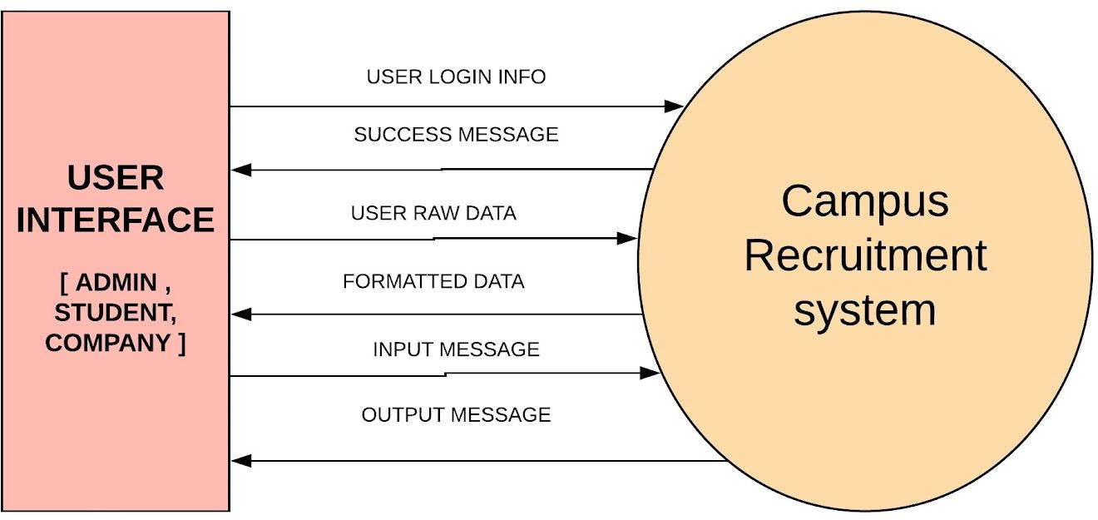

post available. If the user don’t have an account then he/she can create an account and can apply or the jobs. The company can login to their account and can update the details of the jobs available. If the company don’t have an account the they can create and account and can update the job details. Admin will already be having an ID and password. The admin will login and manage the student and companies activities. After the creation or the login of the user , a successful message will be displayed to the user.

* 1. **Product Functions**

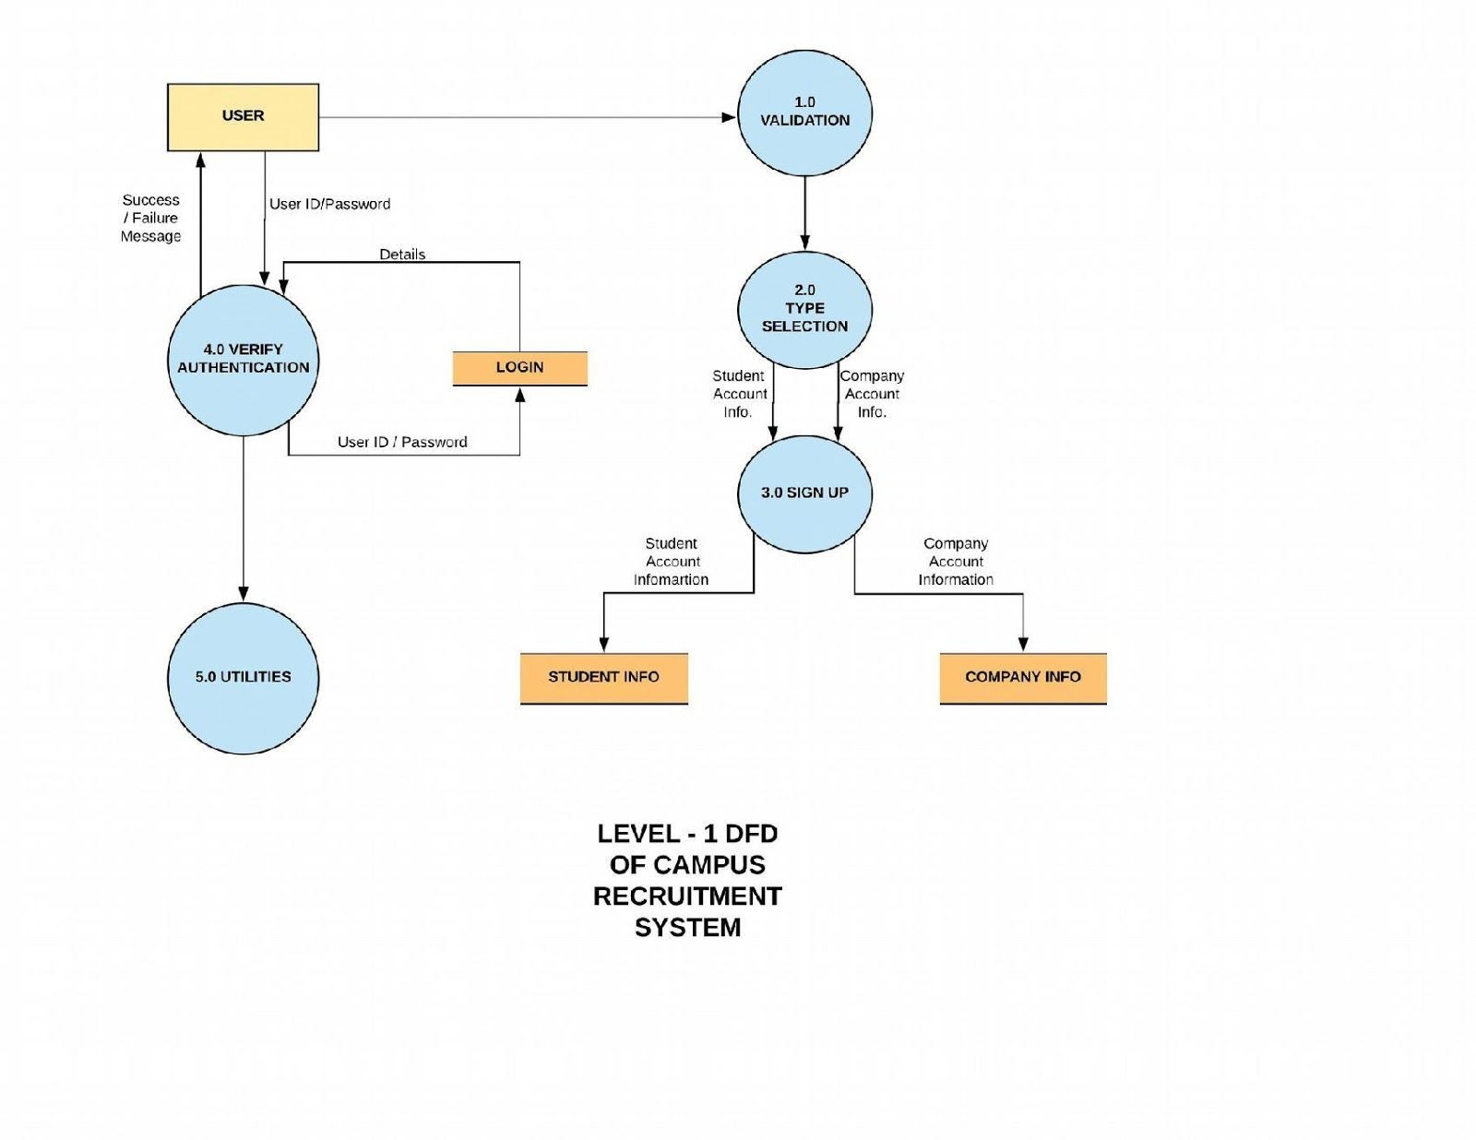

The above DFD clearly shows various various process associated with the project and how the data flows between the entities and database.

The student can create the account . If the account is already present then he/she can search for the available jobs, can view the jobs and also apply for the jobs. Further he/she can update the details, can change the password etc.

The company can create the account. If the company already have an account then the company can post the job and can also view how many candidates have applied for the jobs of that company.

The admin can manage the student and the company . Admin validates the account of the student

. Admin validates the account of the company. Admin can also remove company and the student if found any discrepancy. Admin manages all activities of company and student.

* 1. **User Classes and Characteristics**

The actors and use cases are clearly shown in below **use-case** diagram.

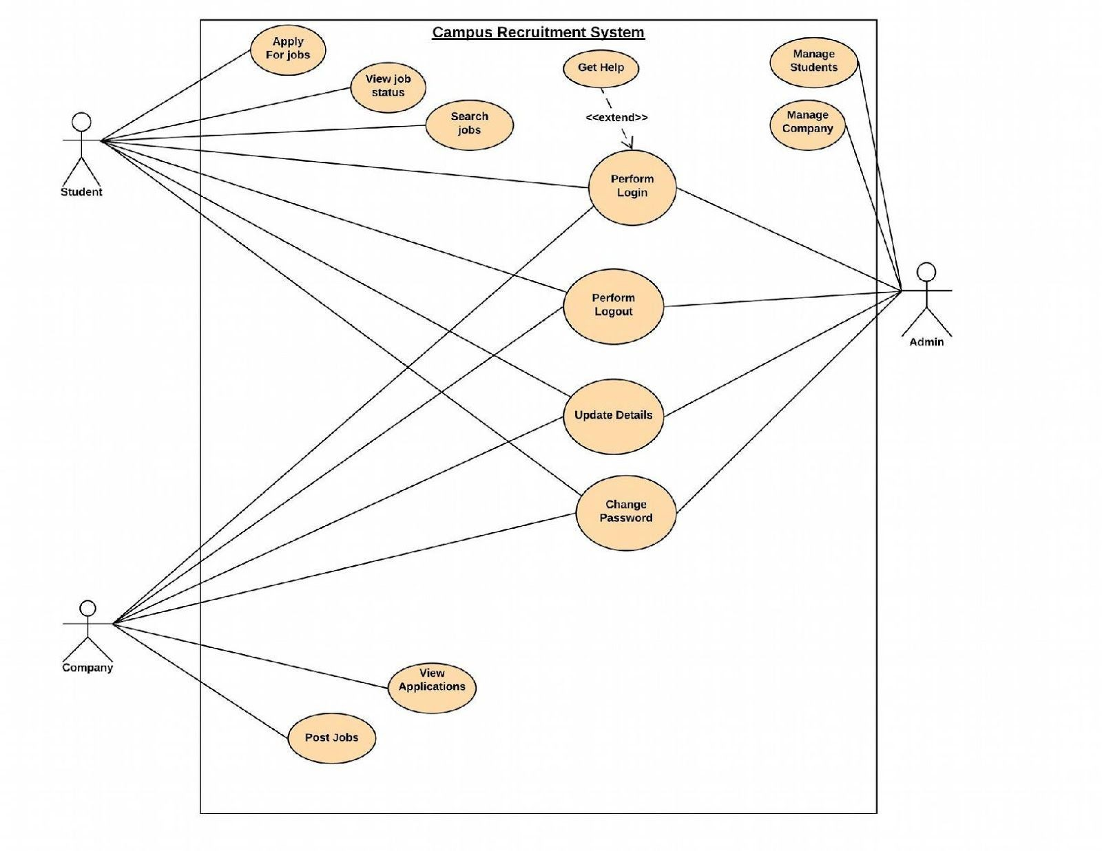

In software and systems engineering, a **use case** is a list of actions or event steps typically defining the interactions between a role (known in the Unified Modeling Language as an *actor*) and a system to achieve a goal. The actor can be a human or other external system. In systems engineering use cases are used at a higher level than within software engineering often representing missions or stakeholder goals.

The following are the actors who perform the use cases as stated above:

|  |  |  |
| --- | --- | --- |
| **S.No** | **Actor Name** | **Description / Actor’s Role** |
| 01 | ADMIN | Manage students & companies. |
| 02 | STUDENT | Apply for jobs, view job status & search jobs. |
| 03 | COMPANY | Post jobs & view applications of students. |