The following section describes the Use Cases with Pre and Post Conditions:

|  |  |  |  |  |
| --- | --- | --- | --- | --- |
| **S.No** | **Use case Name** | **Description** | **Pre-condition** | **Post condition** |
| 01 | Perform Login | User(admin,student or company) can perform  login. | User having account | Login successful |
| 02 | Perform Logout | User(admin, student or company) can perform  logout. | User logged in | Successfully logged out |
| 03 | Update Details | User(admin, student or company) can update  their details. | User logged in | View details |
| 04 | Change Password | User(admin, student or company) can change  passwords. | User having password. | Password is reset. |
| 05 | Manage Company | Admin can manage companies | Existing admin & atleast one company | Validated by admin & company can continue with it’s account |
| 06 | Manage Students | Admin can manage students | Existing admin & at least one student | Validated by admin & student can continue with it’s  account |
| 07 | Apply for jobs | Student can apply for job | Job should be there posted by company & student must be  eligible for job | Applied for job successfully & wait for response from  company |
| 08 | View Job Status | Student can view job status | Student must have successfully applied for job. | Viewed job status & can accept job if selected else can  apply for other job. |
| 09 | Search jobs | Student can search for  job | Student must have  account & logged in. | Can find a job or  not. |
| 10 | Post Jobs | Company can post jobs | Company must have  account & logged in. | Student can now  apply for jobs. |
| 11 | View  Applications | Company can view  applications of students. | Atleast one student  must have applied. | Company can react  to applications. |
| 12 | Get Help | User can get help for login | User should have tried for it or just get help if does not know  how to login | User will now login using this help. |

## Operating Environment

The campus recruitment system shall be deployed on a smartphone like oppo-f3, moto-G5-Plus and server running on android the Operating System Version abc.efg.

SQLite Database shall be used to maintain the databases. The system shall be accessed & downloaded from google play Store. It can run without wifi even.

The system will be built with the help of following softwares:

|  |  |  |  |
| --- | --- | --- | --- |
| Sr. No. | System | Development Environment | Description |
| 1. | Campus recruitment System | IDE (Android Studio) | * Android Studio is the official Integrated Development Environment (IDE) for Android   app development, based on |
|  |  |  | IntelliJ Idea. On top of IntelliJ's  powerful code editor and developer tools, Android Studio  offers even more features that  enhance your productivity when  building Android apps, such as:   * A flexible Gradle-based build system * A fast and feature-rich emulator * A unified environment where you can develop for all Android devices * Instant Run to push changes to your running app without building a new APK * Code templates and |

|  |  |  |  |
| --- | --- | --- | --- |
|  |  |  | GitHub integration to help you build common app features and import sample code   * Extensive testing tools and   frameworks   * Lint tools to catch performance, usability, version compatibility, and other problems * C++ and NDK support * Built-in support for Google Cloud Platform , making it easy to integrate Google Cloud Messaging and App Engine. * In Android Studio , Java Language would be used. |
| 2. | Campus Recruitment System | Database (SqLite) | SQLite in android will be used  for saving data to a database is  ideal for repeating or structured  data, such as contact Information.  We used SQLite in development & coding part for storing database.  We used SQLite in Integration  and testing part if during testing software fails or more  database to be added . |
| 3. | Campus Recruitment system | Java(Program ming Environment) | Java is a programming Language originally Developed by Sun Microsystems and released in 1995. |

|  |  |  |  |
| --- | --- | --- | --- |
|  |  |  | James Gosling, Patrick Naughton, Chris Warth, Ed Frank and Mike Sheridan developed Java at Sun Microsystems,Inc. in 1991. This Language was initially called “Oak” but was renamed  “Java” in 1995.  Platform Independent : The Write-Once-Run-Anywhere ideal has not been achieved (tuning for different platforms usually required), but closer than with other languages. |

## Design and Implementation Constraints

The following Design and Implementation Constraints are applicable for the Campus Recruitment System:

1. The system is designed to be the cross platform supportable. The system is supported on a wide range of hardware and any android platform which is

having any version of android built into the system. This application is being developed using android studio; hence it is extremely portable

1. To prevent multiple students of the same speciality to log-in onto same company portal.

Request, a workflow system needs to be designed which routes the company vacancy Requests to students.

1. System is expected to store maximum 64GB of data.
2. Initially system will be available on android system with versions greater than 5.1. Then the system will be available for even ios mobiles and even on PCs and Laptops.
3. In order to assist students for selecting a company and preparing for interview for that company , a machine learning algorithm will be designed and trained on a training

data-set to predict which skills will be required for students and also if student is eligible for company, this algorithm will continue to be trained on previous recorded data sets of students to improve the quality of predictions.

1. The database shall be maintained by admin and who have not logged in for last 1 year would get archived onto a parallel database. Restoring of students data is beyond the scope of the project and would need to be managed by admin.
2. As the system is supposed to be used by students and company as well, care needs to be taken from a usability perspective in terms of font sizes and ease of system usage.
3. Also UI is made with particular animations so that company can find it good for uploading jobs and interact with students. Even more and more companies and students use this app is the aim.

## User Documentation

The following documents shall be prepared:

1. Installation Guide
2. User Manual for end users
3. Even video tutorials of installation of campus recruitment will be provided as DVD.

## Assumptions and Dependencies

The Key Assumptions are:

1. The services is offered for only NITK students. So right now whole system is designed based on only one college.
2. There will be one authorised student for a particular id. So id will be unique.
3. There will be one authorised company for a particular id. So all ids will be unique.
4. Student can fill maximum 30 application form for jobs in a company.
5. A Machine Learning Algorithm to assist students for selecting a company and preparing for interview for that company will be implemented to predict which skills will be required for students and also if student is eligible for that company
6. The services can be qualified in terms of volumes of data, trends, frequency of updating in order to give an introduction to the technical system.

## External Interface Requirements

* 1. **User Interfaces**

The user interface section defines the way various stakeholders interact with the system. All the screens will be developed to work on android mobile. Error messages will appear as a popup on the screen. The maximum size of error message will be 40 characters.

Buttons will there to make the navigation simpler.

A first time user of the mobile should see the login screen when he/she will open the android application. If the user has not registered to the, then he/she should be able to redirect to the sign up page from login screen. Every user should have the profile where he/she can apply for the job. After the creation of account the user can login to the application and will be able to apply for the jobs.

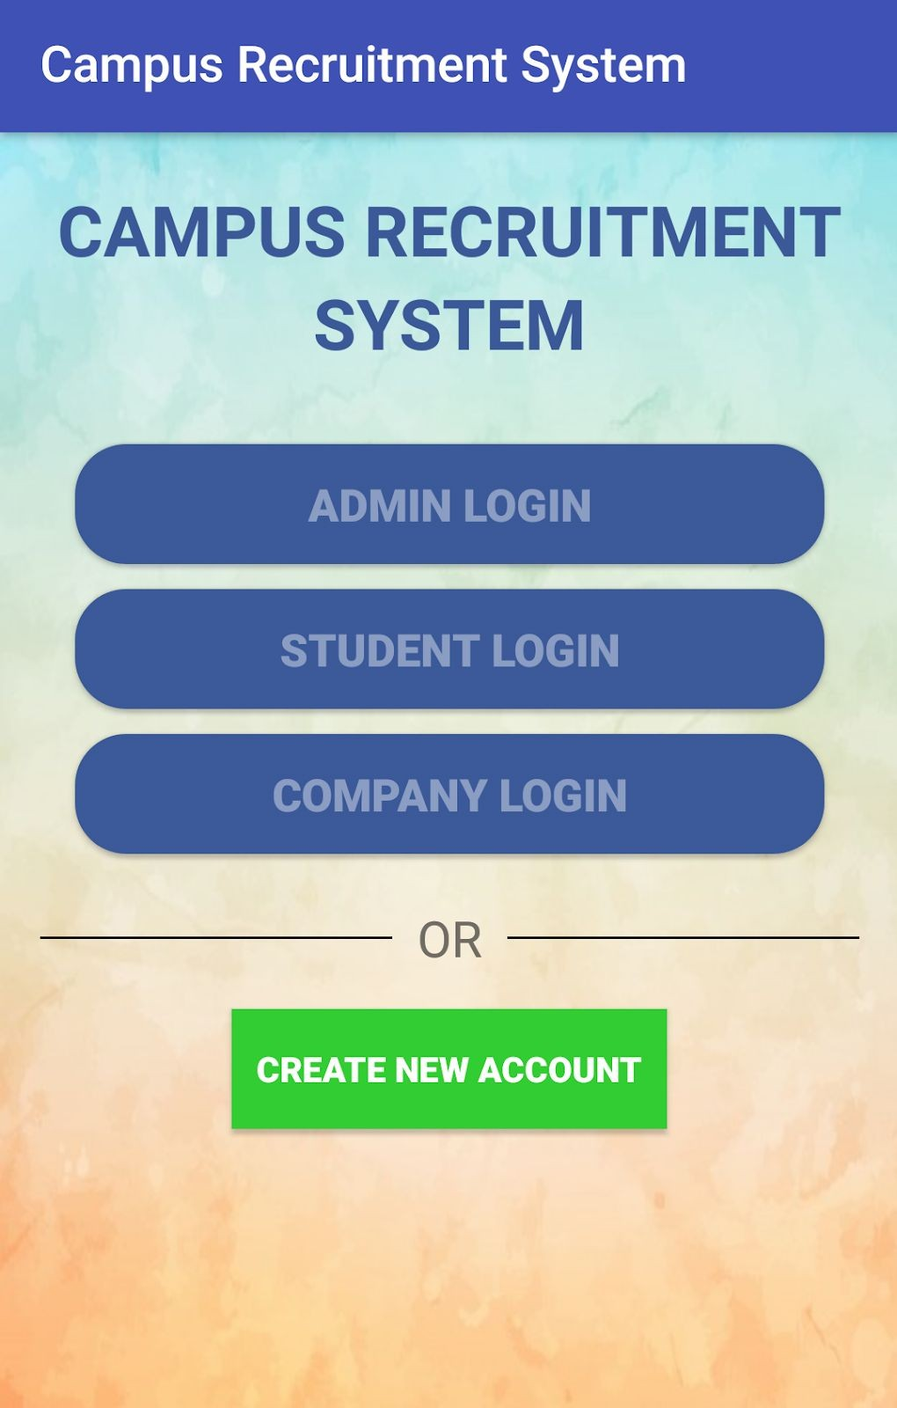 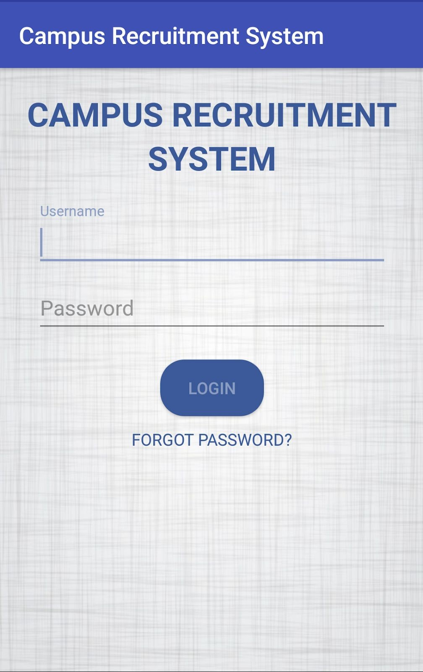

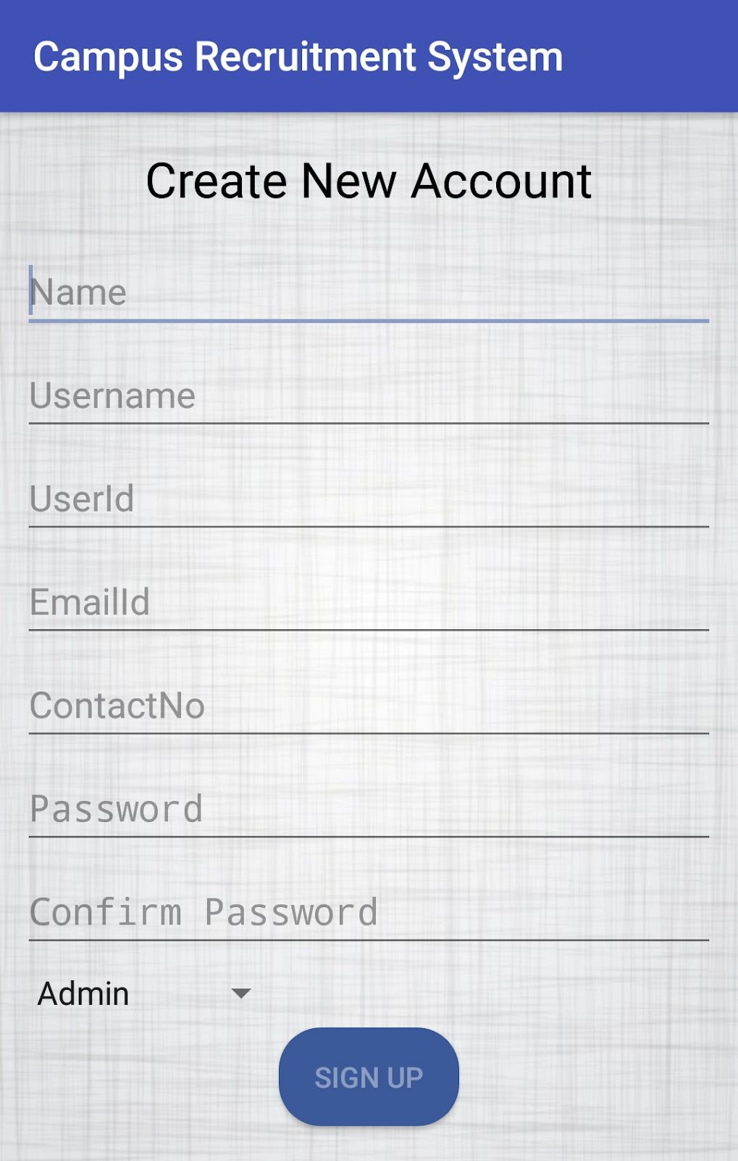

Similarly, here will be the same option for the login of the company where the company can signup and login. An Admin should also be log in to the web portal where he/she can administer the system by managing the student and company using the application.

After performing login the user will be able to see the side menu as shown in the figure below. After performing login by the company the company will be able to see side menu shown in the second figure below.

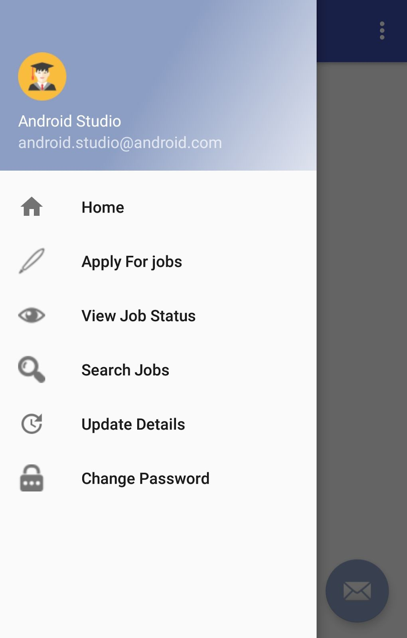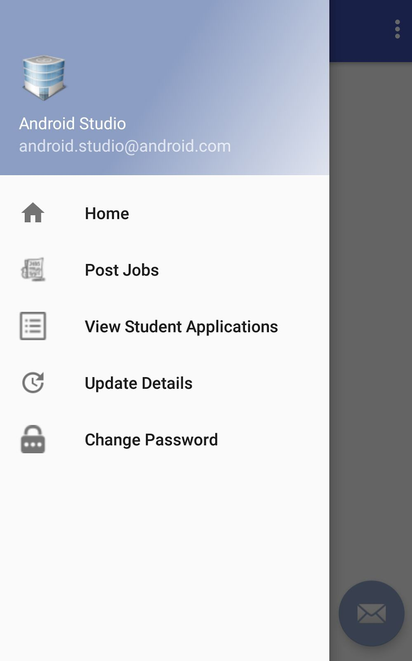

After performing login by the admin the admin will be able to see side menu shown in the figure below.

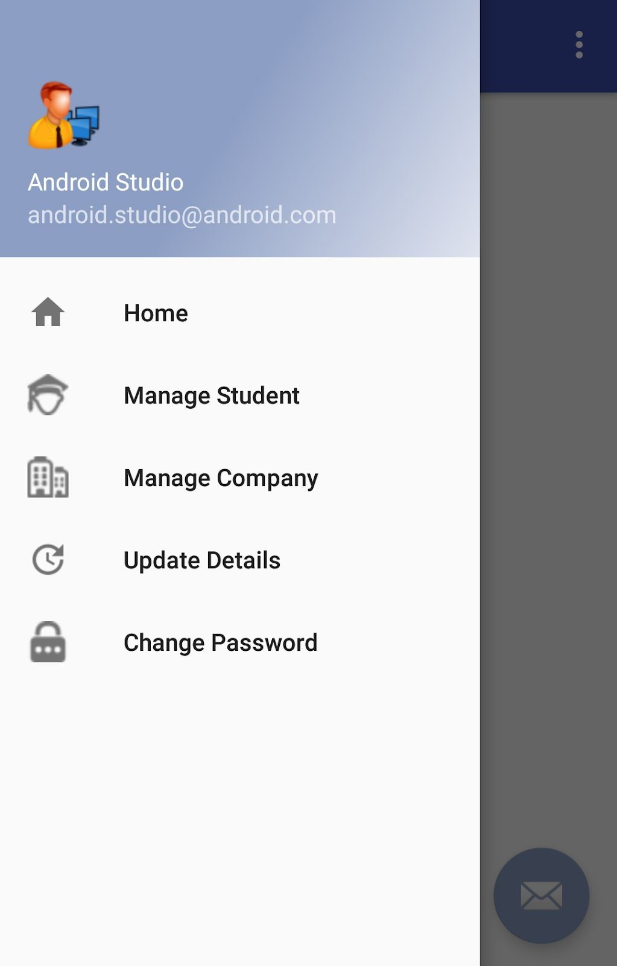

User can select the particular section and can perform the respective task. There is an option to add the jobs for the company where the companies can add the vacancies for their companies they have.

## Hardware Interfaces

Since the mobile application does not have designated hardware, it does not have any hardware interface. The hardware connection between the database server and application is managed by the underlying operating system on the mobile phone.

## Software Interfaces

The system is self-contained and no data is supposed to share with the third party. The communication of the mobile application between the database consist of both reading and modifying the data, while the communication between the database and the mobile application consists of only reading operation.

## Communications Interfaces

The communication between the different parts of the system is important since they depends on each other. However, in what way the communication is achieved is not important for the system and is therefore handled by the underlying operating system for the mobile application.

## System Features

* 1. **System Feature and Priority Matrix**

Following given is the system features and their priority matrix:

|  |  |  |
| --- | --- | --- |
| **Sr. No.** | **Feature** | **Priority** |
| 1. | Create an Account | High |
| 2. | Log in | High |
| 3. | Apply for Jobs | Medium |
| 4. | View job status | Low |
| 5. | Search jobs | Low |
| 6. | Change Password | Low |
| 7. | Manage student | High |
| 8. | Manage Company | High |
| 9. | Post jobs | High |
| 10. | View Application | Medium |
| 11. | Call for Interview | Medium |

## Functional Requirements

Following table describes the functional requirement:

|  |  |
| --- | --- |
| **Feature** | **Remark** |
| Update Information | This functionality will update the information of the  student. |
| Change Password | This functionality is used to change the password of  account. |
| Sign Up | This Functionality is used to sign up for student, admin  and company. |
| Log In | This functionality is used to Login for admin, student  and company. |

|  |  |
| --- | --- |
| Apply For Jobs | This functionality is used for students to apply for  jobs. |
| Post Jobs / Add Job Details | This functionality is used by the company to post  jobs. |
| View Job Status | This functionality is used to view job status by the  student. |
| Search Jobs | This is the functionality which is used to search for  jobs. |
| Manage Student | This functionality is used by the admin to manage  student. |
| Manage Company | This functionality is used by the admin to manage  company. |
| View Student Application | This functionality is used to view student student  application. |

## Other Nonfunctional Requirements

* 1. **Performance Requirements**

1. The completely separate business logic at admin side from the student interface ensures good performance.
2. The system exhibits high performance because it is well optimized. The business logic is clearly separate from the UI.
3. System should be able to scale to many users concurrently.
4. The response time of processes is as follows: Student Registration max 10 seconds Company Registration max 15 seconds Company Job posting max 15 seconds Student applying for job max 20 seconds
5. System is available 24 by 7.

## Safety Requirements

* + 1. Errors will be minimized and an appropriate error message that guides the user from an error will be provided.
    2. Validation of users input is highly essential.
    3. The time taken to recover from the error is less than 10 second.

## Security Requirements

* + 1. The system is provided a high level of security and integrity of the data held by the system.
    2. only authorized personnel such as admin can gain access to the to the

private data and only the user with valid username and password is allowed to view its user page.

## Software Quality Attributes

* + 1. The key software quality attributes are Availability, Reliability and usability.
    2. As the system is expected to be 24/7 working. High availability is important.
    3. A simple but quality user interface is developed to make it easy to understand and required less training.
    4. The error message displayed is more descriptive and can be easily understood.

## Business Rules

* + 1. System shall be available only for the particular college.
    2. All the users shall access the system using a login/user-id and password. The login-id/password will be managed in a secured manner.
    3. Each student can get recruitment only in one company.
    4. Once company selected the candidate, it cannot be rejected otherwise company will be blacklisted.
    5. Each student can have only one account.