LeadFlowML DSL
Executive Summary of Design and Implementation
Domain: Sales lead qualification with machine-learning case classification
Deliverable context: textX DSL + CWL workflow + notebook demo + presentation package
LeadFlowML is a lightweight domain-specific language built with textX for defining an end-to-end machine-learning workflow in a sales scenario. A short DSL specification describes the training dataset, new-case dataset, feature groups, classification model, threshold, metrics, and output artifacts. The processor parses this DSL into a Python object model and generates CWL CommandLineTools plus a CWL Workflow, allowing the same business specification to run locally or through a portable workflow engine.

1. Problem Framing
The assignment requires a DSL that is specialized for a single problem area and abstracts away general programming noise. To make the domain concrete, this project uses a sales lead qualification scenario where historical CRM cases act as training data and incoming leads are classified as qualified or not qualified. The target user is an ML expert or analyst who wants to express the workflow declaratively rather than wiring together scripts by hand.
The design also follows the workflow ideas emphasized in the CWL and workflow-engine literature: clear tool boundaries, explicit inputs/outputs, reuse of command-line components, and reproducibility through structured workflow files.

2. DSL Design Goals
- Readable by domain experts: the syntax resembles a compact project specification rather than general Python code.
- Traceable execution: every important business choice (algorithm, threshold, features, file paths, metrics) is visible in the DSL source.
- Portable orchestration: the DSL is converted into CWL artifacts so the workflow can be validated and executed in a standard way.
- Extensible structure: the current grammar can later be extended with hyperparameter sweeps, model selection, or deployment targets.

3. Syntax and Semantics
LeadFlowML uses a textual grammar with the following top-level sections. Each section maps directly to an execution concern in the generated workflow.
DSL section | Purpose | Generated effect
data | Identifies training and scoring CSV files plus id/target columns | Becomes workflow inputs and validation rules
features | Separates numeric and categorical variables | Used by preprocessing and model pipeline generation
model | Defines algorithm, test split, random state, threshold, CV folds | Controls training/evaluation behavior and output scoring logic
metrics | Lists evaluation measures expected by the analyst | Included in the generated evaluation report
outputs | Declares the desired artifact locations | Controls model, prediction, and report file names in the generated CWL tools

Example DSL snippet
project LeadQualification
description "Classify new sales leads from historical CRM cases using a reproducible workflow."

data
train "data/train_sales_cases.csv"
score "data/new_sales_cases.csv"
id lead_id
target qualified

features
numeric age, annual_income, website_visits, prior_purchases, support_tickets
categorical region, channel, loyalty_segment

model
algorithm logistic_regression
test_size 0.25
random_state 42
threshold 0.55
cv_folds 5

4. Implementation Architecture
- textX grammar: Defines the external DSL and builds the Python model.
- DSL processor: Parses the specification and emits CWL YAML files plus a JSON summary.
- ML runtime scripts: Validate data, train/evaluate the model, and classify new cases.
- CWL workflow: Connects validation, training, and scoring as reusable command-line tools.
- Notebook demo: Shows multiple usage scenarios and compares logistic regression vs random forest.
The implementation produced a working end-to-end prototype. The default scenario trains a logistic-regression classifier; an alternate scenario swaps in a random-forest model without changing any Python source code, demonstrating the value of declarative configuration.

5. Demonstrated Results
Metric | Logistic regression | Random forest
accuracy | 0.800 | 0.725
precision | 0.821 | 0.824
recall | 0.970 | 0.848
f1 | 0.889 | 0.836
roc_auc | 0.607 | 0.543
cv_f1_mean | 0.899 | 0.903

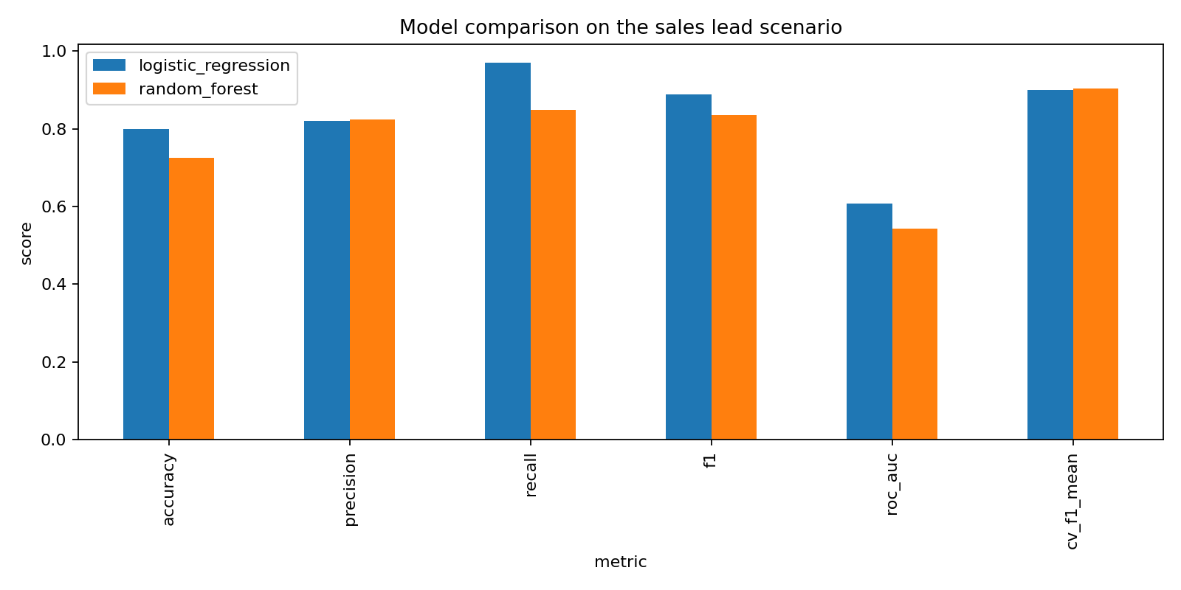
Figure: Metric comparison generated from the demo notebook.

6. Alignment with the Referenced Literature
The design reflects the textX approach of defining the grammar and resulting model structure from a common meta-language, which keeps the implementation compact and Python-native. It also follows the CWL model of separating reusable CommandLineTools from Workflow orchestration, making inputs, outputs, and step dependencies explicit. Finally, the workflow inspiration from the scientific-pipeline literature is visible in the reusable component boundaries, the focus on reproducibility, and the support for alternative ML scenarios without rewriting the orchestration logic.

7. Package Contents
- Executive summary in MS Word
- Executed Jupyter notebook with scenario demonstrations
- Full project package with source files, grammar, workflows, generated CWL, data, outputs, and README
- PowerPoint presentation for the group presentation

References
- Tomassetti, F. Quick Domain-Specific Languages in Python with textX. https://tomassetti.me/domain-specific-languages-in-python-with-textx/
- Karle, N. et al. Parsl+CWL: Towards Combining the Python and CWL Ecosystems. https://arxiv.org/html/2412.08062v1
- Lampa, S. et al. SciPipe: A workflow library for agile development of complex and dynamic bioinformatics pipelines. https://www.diva-portal.org/smash/get/diva2:1242254/FULLTEXT02.pdf

