Name : Dhruv Sharma Roll No: 16010421099 Batch: B1 Date: 22-08-23

**Get Request code:**

RequestForm.php:-

<html>

<body>

<form action="exp2.php" method="get">

Name: <input type="text" name="name">

Email: <input type="text" name="email">

<input type="submit" value="Submit">

</form>

</body>

</html>

exp2.php:-

Welcome   
<?php echo $_GET["name"]; ?> |

Your email address is <?php echo $_GET["email"]; ?> <br>

Your Data Is Here:

**OutPut:**

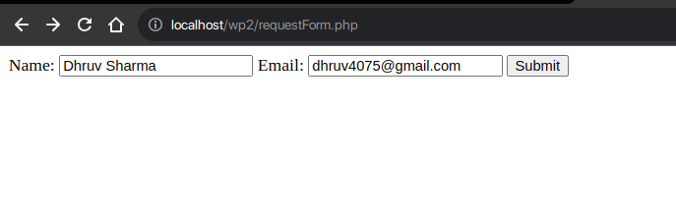

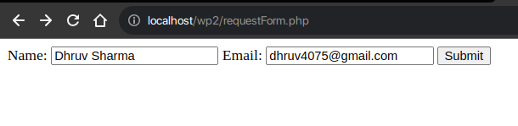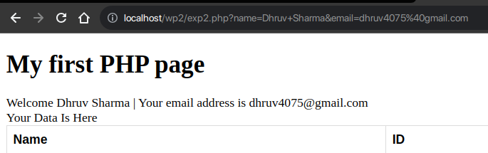

**Post Method:**

**Code:**

RequstForm.php:

<html>

<body>

<form action="exp2.php" method="post">

Name: <input type="text" name="name">

Email: <input type="text" name="email">

<input type="submit" value="Submit">

</form>

</body>

</html>

exp2.php:

Welcome <?php echo $_POST["name"]; ?> |

Your email address is <?php echo $_POST["email"]; ?> <br>

Your Data Is Here

**Out Put:**

Form:

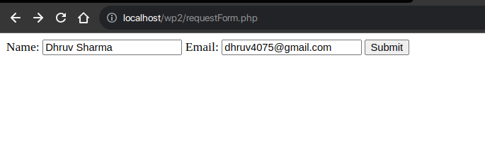

Second Page:

