End-to-End Marketing Data Pipeline for Packaged Drinking Water Business

Prepared for : Logicrest Technologies - Data Engineering & Analytics Team, industry professionals, Analysts and Decision makers
Prepared By: Dhruv Patil
Date: April 2026

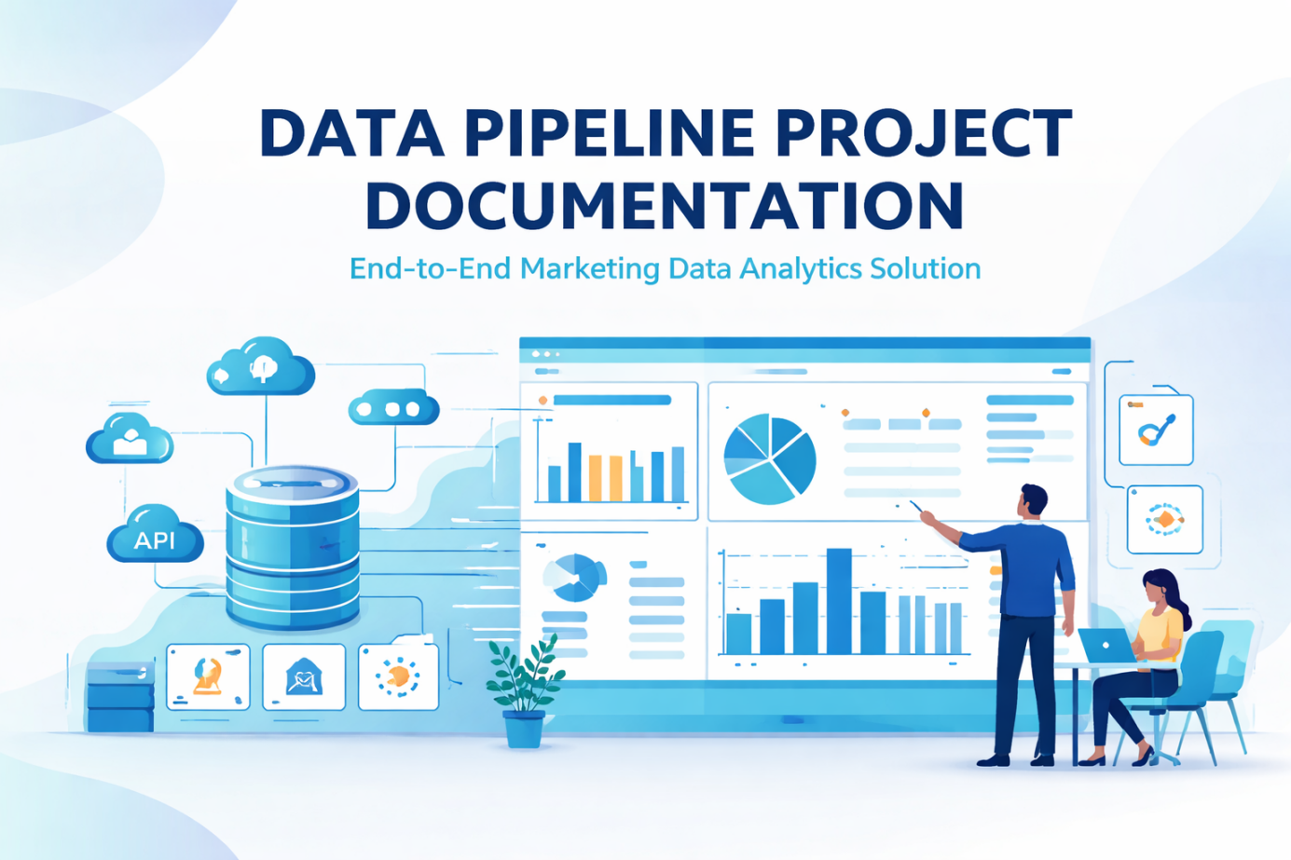

1.Executive Summary
The project successfully delivers a scalable and robust data pipeline that processes marketing data from ingestion to reporting. The system utilizes Databricks for data processing and transformation, and SQL Server Management Studio for data warehousing.
The pipeline supports incremental data loading through watermark-based logic, ensuring efficient processing of new records without duplication. Data quality is maintained through transformation rules and validation checks, and the final output is made available for visualization through dashboards built using Power BI and Tableau.
During implementation, several operational challenges were encountered. Queries involving large datasets and external systems often took longer than expected and sometimes appeared to be stuck. Terminating such queries resulted in rollback operations that blocked further execution. Additionally, incorrect watermark configurations caused certain runs to process zero rows without errors.
These issues were resolved through systematic debugging, reinforcing the importance of monitoring, logging, and understanding system behaviour in production environments.
In addition, careful attention was given to ensuring smooth data flow between Databricks and SQL Server, particularly during incremental loads where consistency across runs was critical. Adjustments were made to query logic and execution flow to improve stability and reduce processing failures during repeated pipeline runs.
The reporting layer was validated using both Power BI and Tableau to ensure consistency in business metrics across dashboards. This helped confirm that the transformed data in the warehouse accurately reflected the expected marketing KPIs.
Furthermore, the implementation of a structured data model in SQL Server improved query performance and simplified reporting logic, allowing dashboards to retrieve data efficiently without complex transformations at the visualization layer. This ensured that most of the heavy processing was handled within the pipeline itself rather than at the reporting stage.
The overall pipeline was designed with a focus on reliability and repeatability, ensuring that data processing could be executed consistently across multiple runs without data duplication or loss. The use of incremental loading and controlled transformations contributed to better performance and reduced execution time compared to full data reload approaches.
Overall, the project demonstrates the practical implementation of an end-to-end data engineering workflow, highlighting the importance of structured data processing, efficient data modeling, and reliable reporting. The final solution provides a stable and consistent foundation for generating marketing insights and supports decision-making through accurate and timely data.
2.Introduction
In today’s data-driven business environment, organizations rely heavily on structured data to monitor performance, optimize strategies, and drive growth. Marketing data, which includes campaign performance, revenue generation, customer engagement, and geographical insights, plays a critical role in understanding business outcomes. Accurate and timely analysis of this data allows businesses to evaluate the effectiveness of marketing campaigns, optimize budget allocation, and identify high-performing products and regions.
However, raw data obtained from external APIs is often unstructured, inconsistent, and contains missing or duplicate records. In addition to these issues, the data may also have inconsistent formats, varying levels of granularity, and incomplete relationships between different entities such as products, campaigns, and geographical regions. Without proper processing, such data cannot be directly used for analysis or reporting, as it can lead to inaccurate insights and unreliable business decisions.
This project addresses this challenge by building a complete data pipeline that systematically processes raw data into meaningful insights. The pipeline covers all stages of data engineering, including ingestion, transformation, modelling, validation, and visualization. Data is initially ingested into the system in its raw form, after which it undergoes structured transformation processes such as deduplication, null handling, and calculation of derived metrics like gross profit, marketing ROI, and campaign efficiency. The transformed data is then modeled into a structured format using a star schema, enabling efficient querying and analysis.
A key aspect of this pipeline is the implementation of incremental data processing using watermark logic. Instead of reprocessing the entire dataset during every execution, the pipeline identifies and processes only newly ingested records based on ingestion timestamps. This approach significantly improves performance and ensures scalability as data volume increases. The pipeline execution is managed through a centralized runbook in the form of a stored procedure, which coordinates all stages including staging load, dimension synchronization, fact loading, validation checks, and watermark updates.
Unlike purely theoretical implementations, this project involved real execution scenarios where multiple issues such as system delays, blocking queries, and incorrect incremental logic were encountered. For example, long-running queries during data transfer between systems appeared to be unresponsive, and terminating them led to rollback operations that blocked further execution. Similarly, incorrect watermark configurations resulted in pipeline runs where no data was processed despite the presence of new records. These practical challenges required detailed debugging using system monitoring tools and execution logs.
These real-world issues provided valuable insights into how data pipelines behave in production environments and highlighted the importance of proper logging, monitoring, and error handling mechanisms. The experience gained from resolving these challenges contributed significantly to building a more stable, efficient, and reliable data pipeline.

2.1 Project Background
The project was developed to simulate a real-world data engineering scenario where marketing data is continuously generated and requires structured processing for analysis. The dataset used in this project represents marketing and sales-related information, including revenue, campaign performance, and associated attributes.
Initially, the data existed in a raw format with inconsistencies and lacked a standardized structure for reporting. The need to transform this data into a usable format highlighted the importance of a well-defined data pipeline.
The project was designed to replicate industry practices by incorporating data ingestion, transformation, storage, and visualization stages. It also focused on handling real-world challenges such as data inconsistencies, performance issues, and incremental data updates.

2.2 Problem Statement
The business lacked a structured and reliable system to process and analyze marketing and sales data. The available data was raw, unstructured, and contained inconsistencies such as missing values, duplicate records, and incorrect formats. Due to the absence of a proper pipeline, the data could not be directly used for analysis, and reporting processes were manual and inconsistent. Incremental updates could not be tracked efficiently, and data quality issues often remained undetected.
In addition, there was no centralized and automated system to ensure consistent data transformation and storage for downstream reporting tools. As a result, generating insights required significant manual effort and was time-consuming, especially when working with large or frequently updated datasets. Existing ad-hoc processing methods were not scalable and led to redundant computations and inefficiencies during repeated data loads.
Another challenge was the lack of visibility into data processing stages, making it difficult to identify where errors or inconsistencies were occurring. Without proper monitoring or logging mechanisms, failures in data processing often went unnoticed until the reporting stage, leading to delays and rework. This further reduced confidence in the accuracy and reliability of business insights.
Moreover, the absence of a structured data model made it difficult to perform efficient analytical queries. Since the data was not organized in a reporting-friendly format, generating insights such as campaign performance, revenue trends, and marketing effectiveness required repeated manual effort and complex query logic.
Therefore, it became necessary to design and implement a robust data pipeline capable of cleaning, transforming, and structuring raw data into an analytics-ready format. The solution also needed to support incremental data processing and improve overall reliability, consistency, and efficiency of reporting and analysis, while ensuring that the processed data could be easily consumed by visualization tools for decision-making.

2.3 Project Scope
The scope of this project includes the design and implementation of a complete data pipeline for processing marketing data from ingestion to reporting. The pipeline covers data extraction from an API built using Supabase, data transformation using Databricks, and structured storage in SQL Server Management Studio. Supabase is used as the backend service to expose the dataset through API endpoints, enabling structured and consistent data retrieval for the pipeline.
The project includes implementing API-based data ingestion, where data is fetched from Supabase and loaded into the Databricks environment for further processing. The pipeline is designed to handle raw data in its initial form and progressively refine it through multiple transformation stages. This includes cleaning, validation, and structuring of the data to make it suitable for analytical use.
The scope also covers the development of a data model using a star schema approach in SQL Server, enabling efficient querying and reporting. Processed data is stored in structured tables, which are then connected to visualization tools such as Power BI and Tableau for dashboard creation and business insights.
A key focus of the project is implementing incremental data processing using watermark logic, ensuring that only new or updated records from the Supabase API are processed during each pipeline run. This reduces redundant computation and improves overall efficiency.
The project also includes data quality management, ensuring that inconsistencies such as missing values, duplicate records, and incorrect formats are handled during the transformation stage. Additionally, validation is performed by comparing outputs across Power BI and Tableau dashboards to ensure consistency in reporting.
However, the scope is limited to batch-based processing and does not include real-time data streaming or advanced orchestration tools. The project is implemented in a controlled development environment and does not include full-scale production deployment or cloud-native infrastructure.

2.4 Objectives
The primary objective of this project was to build a complete end-to-end data pipeline capable of transforming raw marketing data into structured insights. The key objectives included designing a Medallion Architecture consisting of Bronze, Silver, and Gold layers to ensure proper data segregation across different stages of processing. The project also focused on implementing API-based data ingestion to collect raw marketing data in a structured manner.
Further objectives included performing data cleaning and transformation to handle inconsistencies, missing values, and duplicates, as well as building a Star Schema model to support efficient analytical queries. The processed data was integrated into SQL Server Management Studio to serve as a centralized data warehouse layer. Incremental loading was implemented using watermark logic to ensure that only new or updated records were processed in each run, improving efficiency and reducing redundant computation.
In addition, data quality was ensured through validation checks at multiple stages of the pipeline to maintain accuracy and consistency. The final processed dataset was used to develop interactive dashboards for business insights using BI tools.
Beyond functional requirements, the project also aimed to simulate real-world data engineering challenges by handling execution issues, debugging errors, optimizing query performance, and ensuring stable pipeline execution across multiple runs.

3.Project Architecture
The final architecture follows a Medallion pattern with downstream warehouse and BI integration:
Supabase REST API → Bronze (Databricks Delta) → Silver (cleaned Delta) → EDA (Data visualization) → Gold (star schema) → SQL Server / SSMS (normalized warehouse) → Power BI / Tableau dashboards
This architecture was designed to ensure a clear separation of responsibilities across each layer of the pipeline, improving maintainability, scalability, and data quality control. Each stage plays a specific role in progressively refining raw data into business-ready insights.
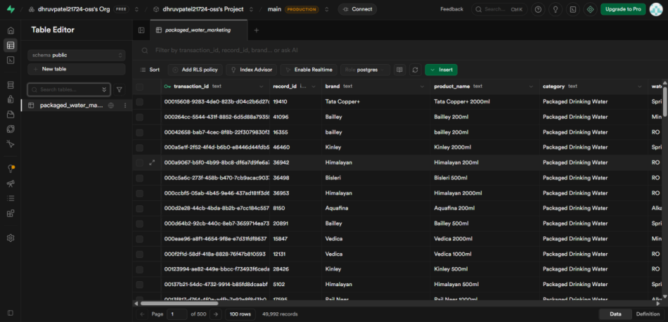

The Bronze layer is responsible for storing raw incremental data exactly as received from the API source. This layer acts as the landing zone and ensures that no data is lost during ingestion, while also supporting auditability and traceability of source records. It also helps in reprocessing scenarios where raw data needs to be replayed without re-calling the API, making the pipeline more reliable during debugging and failure recovery.
The Silver layer focuses on data cleansing and standardization. This includes handling missing values, removing duplicates, correcting inconsistent formats, and applying basic transformation rules. It also includes derivation of new fields required for analysis and ensures that only validated and structured data moves forward in the pipeline. During implementation, special attention was given to ensuring consistency in data types and timestamp handling, as these were critical for maintaining correct incremental loading using watermark logic.
The Gold layer is used to build analytics-ready structures using a star schema design. This layer organizes data into fact and dimension tables, enabling efficient querying for analytical and reporting purposes. It serves as the primary data model for business consumption. The fact table consolidates key marketing metrics such as revenue, spend, and performance indicators, while dimension tables provide contextual information such as product, campaign, and geographic attributes. This separation significantly improved query performance and simplified dashboard development.
The processed Gold data is then integrated into SQL Server Management Studio (SSMS), which acts as a controlled warehouse environment. This step provides an additional relational layer that supports enterprise-style storage, query optimization, and downstream access management. During this stage, careful mapping between star schema structures and relational tables was implemented to ensure consistency between Databricks outputs and SQL Server storage. This also helped in validating the correctness of transformations applied in earlier layers.
The integration process also reinforced the importance of incremental data handling, as repeated loads required strict control to prevent duplication and ensure consistency across runs. Watermark-based logic played a key role in maintaining this continuity across the entire pipeline.
Finally, the BI layer, consisting of Power BI and Tableau, is used to create interactive dashboards that deliver business insights. These dashboards enable users to analyze marketing performance, track KPIs, and explore trends through visual analytics. Key metrics such as revenue trends, marketing spend distribution, campaign effectiveness, and regional performance were visualized using multiple chart types for better interpretability.
Both tools were validated against the same underlying dataset to ensure consistency in reporting logic. This cross-validation helped confirm that the data model was stable and tool-independent, ensuring that insights remained consistent regardless of the visualization platform used.
Overall, this layered architecture not only ensured structured data flow from ingestion to reporting but also improved system reliability, reduced processing redundancy, and enabled scalable analytics across the entire marketing dataset.

3.1 High-Level Architecture Diagram
The high-level architecture represents the end-to-end flow of data from ingestion to reporting. The pipeline begins with an external API source, where raw marketing data is extracted and processed in Databricks using a Medallion Architecture (Bronze, Silver, and Gold layers).
The final processed dataset in the Gold layer is then transferred to SQL Server Management Studio (SSMS) using an ODBC driver connection. This connection acts as an integration layer between Databricks and SQL Server, enabling structured data movement from the processing environment to the data warehouse.
Once the data is loaded into SQL Server, it is used by Power BI and Tableau for dashboarding and reporting. This architecture ensures a smooth flow of data across processing, storage, and visualization layers while maintaining consistency and scalability.

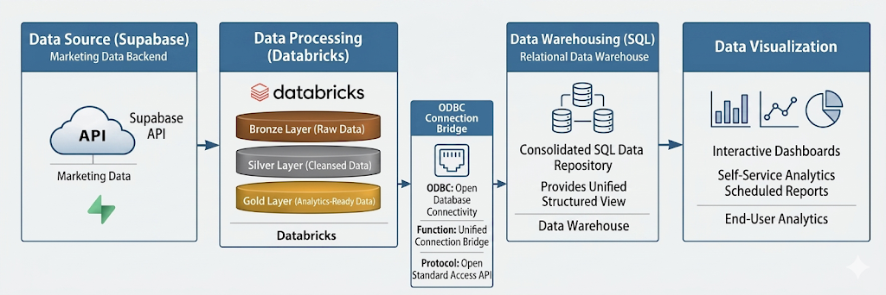

3.2 Data Flow Architecture
- Defines how data moves through different stages of the pipeline, from ingestion to visualization
- Ensures structured transformation, consistency, and reliable reporting across all layers
- Data extraction begins from an external API source
- Raw data is ingested into Databricks and stored in the Bronze layer
- Bronze layer acts as a landing zone and preserves original data structure without transformation
- Data is processed in the Silver layer
- Cleaning and transformation operations are performed, including:
  - Handling missing values
  - Removing duplicate records
  - Standardizing data formats
  - Applying basic validation rules
- Purpose of Silver layer is to ensure clean and consistent data
- Data is moved to the Gold layer after transformation
- Gold layer contains analytics-ready structured data
- Business logic is applied at this stage
- Data is organized to support reporting and analytical queries
- Databricks is connected to SQL Server Management Studio (SSMS)
- Integration is achieved using an ODBC connection
- Enables secure and structured communication between Databricks and SQL Server
- Processed data from Gold layer is loaded into SQL Server tables
- Data is stored in a relational format suitable for querying and reporting
- Supports fact and dimension tables based on star schema design
- ODBC connection ensures:
  - Efficient data transfer between Databricks and SSMS
  - Reliable and controlled data insertion
  - Structured loading into warehouse tables
- After loading into SQL Server, data becomes available for BI tools
- Power BI and Tableau connect directly to SQL Server database
- Tools use structured data to generate dashboards and reports
- This completes the full data flow cycle from ingestion to visualization
- Overall architecture ensures consistency, integrity, and efficiency across all stages

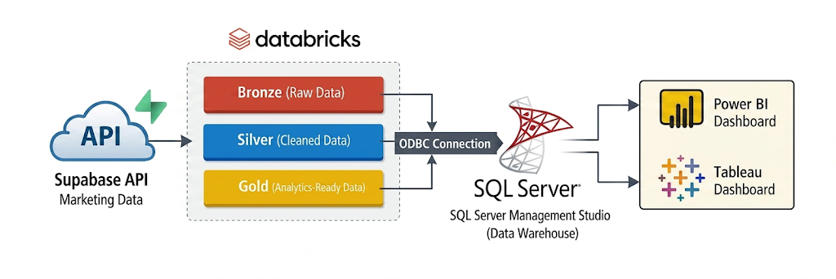

3.3 Component Overview
The system is composed of multiple interconnected components that together form the complete data pipeline from ingestion to reporting. Each component plays a specific role in ensuring smooth data flow and accurate transformation of raw marketing data into analytics-ready outputs.
Databricks serves as the core processing engine where data ingestion, cleaning, and transformation are performed using structured notebooks. It handles the movement of data through different layers of the Medallion Architecture, ensuring proper separation between raw, processed, and curated datasets.
SQL Server Management Studio acts as the centralized data storage layer, where the transformed and structured data is loaded into relational tables. This layer is optimized for querying and supports the creation of analytical models such as fact and dimension tables.
Power BI and Tableau function as the visualization layer, enabling the creation of interactive dashboards and reports for business insights. These tools connect directly to the structured data in SQL Server to generate real-time analytical views of marketing performance.
The external API acts as the data source, providing raw marketing and sales data that feeds into the pipeline. This data is continuously processed through the system to ensure updated and consistent reporting outputs.
Together, these components form a complete end-to-end pipeline that ensures reliable data processing, efficient storage, and accurate reporting for business decision-making.

4.Technology Stack
- The project utilizes a combination of data engineering, database management, and visualization tools to implement a complete end-to-end data pipeline. Each technology plays a specific role in ensuring efficient data processing, transformation, storage, and reporting.
- Databricks is used as the primary data processing platform, where data ingestion, cleaning, and transformation are performed using Python and SQL within notebooks. It supports distributed processing for large datasets and enables implementation of Medallion Architecture (Bronze, Silver, and Gold layers).
- SQL Server Management Studio (SSMS) is used as the data warehousing layer for storing structured and processed data. It supports relational data modeling and enables efficient execution of analytical queries required for reporting and dashboarding.
- Power BI is used for creating interactive dashboards that provide insights into key business metrics such as revenue, marketing spend, and campaign performance. It enables dynamic filtering, visualization, and exploration of processed data.
- Tableau is used as an additional visualization tool to validate dashboard consistency and ensure tool independence. The same dataset and business logic were replicated in Tableau to compare outputs and verify accuracy across platforms.
- Python is used within Databricks for data manipulation, transformation logic, and implementing incremental loading mechanisms such as watermark-based processing.
- SQL is used for querying, joining, and structuring data across different stages of the pipeline.
- Overall, the technology stack ensures smooth integration between data ingestion, processing, storage, and visualization layers, enabling a reliable and scalable data pipeline for marketing analytics.

5. Data Sources
The data sources for this project consist of structured marketing and sales-related data extracted from an external API. This data represents campaign-level performance information used for analytical processing and reporting. The dataset serves as the primary input for the entire data pipeline and is processed through multiple transformation layers before being used for visualization and insights generation.
The data includes key business attributes such as campaign details, revenue, marketing spend, product information, and geographic distribution. Since the data originates from an external system, it is initially in a raw format and requires significant preprocessing before it can be used for analytical purposes. The ingestion process ensures that this raw data is systematically captured and stored in the pipeline for further processing.

5.1 Source Systems
The primary source system for this project is an external API that provides marketing and sales performance data. This API acts as the entry point for all raw data used in the pipeline. It delivers structured records related to campaigns, revenue generation, and marketing activities.
The source system does not provide pre-processed or cleaned data, which makes it necessary to apply transformation logic after ingestion. The data retrieved from the API is considered the “Bronze layer input,” which preserves the original structure for traceability and debugging purposes.
This approach ensures that the pipeline maintains a clear separation between raw data and processed data, allowing better control over data quality and reproducibility of results.

5.2 Data Formats
The data received from the API is primarily in JSON format, which is a common format for web-based data exchange. This JSON structure contains nested and semi-structured fields representing different aspects of marketing performance.
Before processing, the JSON data is converted into a tabular format within Databricks to make it suitable for transformation and analysis. This conversion is essential because downstream systems such as SQL Server and BI tools require structured relational data.
The data includes both numerical and categorical fields, such as revenue values, marketing spend, campaign identifiers, product categories, and location-based attributes. Proper formatting and type conversion are performed during the transformation stage to ensure consistency across the pipeline.

5.3 Data Acquisition Methods
Data acquisition in this project is performed using API-based extraction. The pipeline makes scheduled or triggered API calls to retrieve the latest marketing data. This ensures that the dataset remains up to date and reflects recent business activity.
Once the data is retrieved, it is ingested directly into Databricks and stored in the Bronze layer without modification. This allows the pipeline to maintain an exact copy of the source data for auditing and reprocessing if required.
Incremental data acquisition is supported using watermark-based logic, which ensures that only new or updated records are fetched during each pipeline run. This improves efficiency by avoiding redundant data processing and reduces overall execution time.
The acquisition process is designed to be lightweight and scalable, allowing the pipeline to handle increasing data volume without impacting performance.

6.Data Ingestion Layer
The data ingestion layer forms the entry point of the data pipeline and is responsible for extracting raw marketing data from the source system and loading it into the processing environment. In this project, the ingestion layer was designed to handle API-based data extraction and ensure that the incoming data is reliably captured for further transformation in Databricks.
The primary objective of this layer is to ensure that raw data is collected in its original form without any modifications, preserving data integrity and traceability. This allows downstream layers to perform cleaning, transformation, and structuring based on a consistent raw dataset.
The ingestion process is designed to support incremental data loading using a watermark-based approach. This ensures that only new or updated records are fetched during each pipeline execution, reducing unnecessary data transfer and improving processing efficiency.
Once extracted from the API, the data is loaded into the Bronze layer in Databricks, which acts as the raw data storage zone. From here, it is further processed in subsequent layers of the pipeline.

Data Extraction Process
The data extraction process is performed using API calls that fetch marketing-related data such as campaign performance, revenue, and marketing spend. The API response is received in a structured format (JSON), which is then converted into tabular form for processing in Databricks.
The extraction logic ensures that data is pulled in batches, making the process efficient and scalable. Each execution retrieves only the required data based on the defined watermark condition.

Bronze Layer (Raw Data Storage)
After extraction, the data is stored in the Bronze layer within Databricks. This layer acts as a raw landing zone where data is stored without any transformations or cleaning.
The purpose of the Bronze layer is to:
Preserve original data as received from the source
Enable traceability and debugging
Allow reprocessing if required
Maintain historical raw data snapshots
This layer ensures that even if errors occur in later stages, the original data remains intact and can be reused.

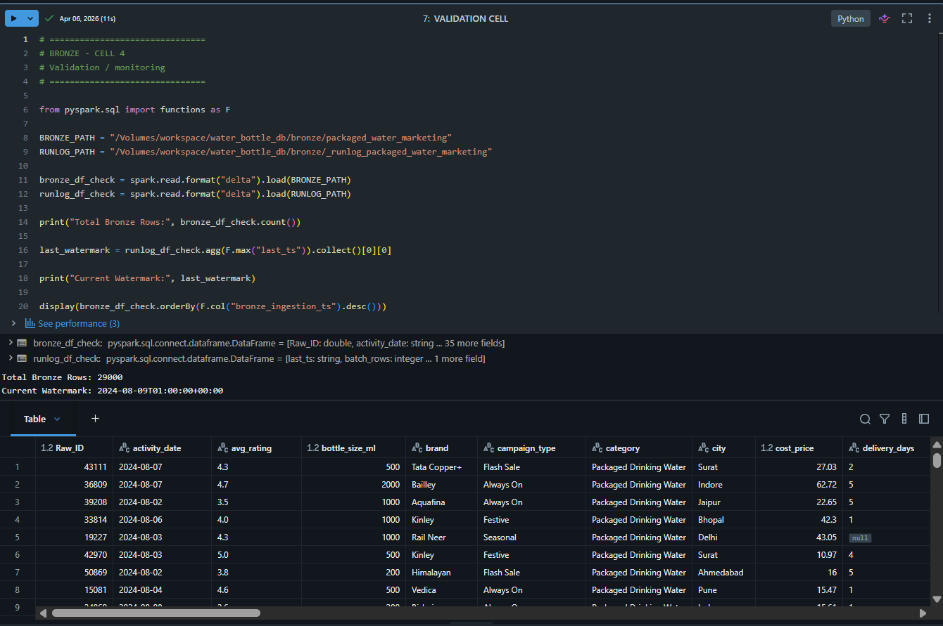

Incremental Loading Strategy (Watermark Logic)
Incremental data loading is implemented using a watermark-based mechanism. The watermark typically tracks the latest timestamp or unique identifier from the previously processed dataset.
During each pipeline run:
The system checks the last processed watermark value
Only new or updated records beyond that watermark are fetched from the API
This reduces redundant processing and improves performance
This approach ensures scalability as the dataset grows and avoids full data reloads, which would otherwise increase processing time and cost.

Key Responsibilities of Ingestion Layer
The ingestion layer is responsible for:
Extracting data from external API sources
Ensuring reliable and consistent data capture
Supporting incremental loading using watermark logic
Storing raw data in the Bronze layer
Acting as the foundation for all downstream transformations

Importance in the Pipeline
This layer plays a critical role in ensuring data reliability across the entire pipeline. Since all downstream processing depends on the accuracy of ingested data, any inconsistency at this stage can affect transformation logic, data modeling, and final reporting.
By implementing structured ingestion with incremental loading, the pipeline achieves better performance, scalability, and maintainability.

Data Processing and Transformation
The data processing and transformation stage is a core component of the pipeline where raw marketing data is converted into a structured and analytics-ready format. This stage is implemented in Databricks and follows a layered approach based on the Medallion Architecture (Bronze, Silver, and Gold layers). The main objective of this stage is to ensure that the data is clean, consistent, and suitable for analytical reporting in downstream systems such as SQL Server and BI tools.
The transformation process includes multiple steps such as cleaning, standardization, aggregation preparation, and applying business rules. These steps ensure that the final dataset accurately reflects business performance metrics and can be reliably used for reporting and decision-making.

Data Cleaning
Data cleaning is the first and most critical step in the transformation pipeline. The raw marketing data received from the API contained inconsistencies such as missing values, duplicate records,
and inconsistent formatting across different fields. These issues needed to be resolved before any meaningful analysis could be performed.
Missing values were handled based on the nature of the attribute. For important numerical fields such as revenue and marketing spend, records with null values were either corrected where possible or excluded from analysis to avoid distortion in KPIs. For non-critical fields, appropriate default values or placeholders were used to maintain dataset consistency.
Duplicate records were identified using key identifiers such as campaign ID and timestamp combinations. These duplicates were removed to ensure that metrics such as total revenue and campaign performance were not inflated due to repeated entries.
Data type inconsistencies were also corrected during this stage. For example, numerical fields stored as strings were converted into appropriate numeric formats, and date fields were standardized to ensure consistency across the dataset. This step was essential for enabling accurate aggregations and time-based analysis in later stages.
Overall, the data cleaning process ensured that only high-quality and consistent data was passed to the next stage of transformation.

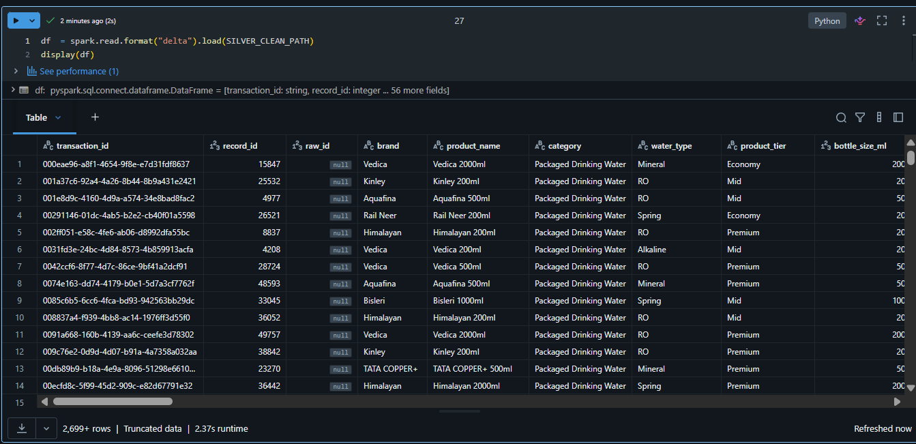
Data Transformation Logic
The data transformation logic focuses on converting cleaned data into a structured format suitable for analytical processing and reporting. This stage primarily takes place in the Silver layer of the pipeline and prepares the dataset for the Gold layer and data warehouse.
One of the key transformation steps involved structuring the data into meaningful analytical categories such as campaigns, products, and geographical segments. This helped in organizing the dataset in a way that supports efficient querying and dashboard development.
Additional derived fields were created to support analysis. For example, performance-related metrics were structured in a way that allows comparison across campaigns and time periods. Revenue and marketing spend fields were prepared for aggregation to enable KPI calculations in the reporting layer.
The transformation logic also ensured consistency in naming conventions, column structures, and data formats. This standardization was necessary to maintain uniformity across all downstream systems, including SQL Server and BI tools.
A key aspect of this stage was maintaining alignment between transformation logic and reporting requirements. This ensured that the same definitions of metrics such as revenue and spend were consistently reflected in both Power BI and Tableau dashboards.

Business Rules Implementation
Business rules were applied during the transformation stage to ensure that the processed data aligns with real-world marketing analysis requirements and provides accurate business insights.
One of the primary business rules involved handling revenue distribution behavior. Based on exploratory analysis, it was observed that a small number of high-performing campaigns contributed significantly to total revenue. Instead of treating these values as anomalies, the transformation logic was designed to retain them to ensure accurate representation of business performance.
Another important rule was related to incremental data processing using watermark logic. Only new or updated records based on the latest timestamp were processed during each pipeline run. This ensured that duplicate processing was avoided and system performance was optimized.
Validation rules were also applied to ensure data integrity. Records with invalid or incomplete critical fields were either corrected or excluded to maintain the reliability of downstream analytics.
Consistency rules were enforced across all transformation stages to ensure that metrics such as revenue, spend, and campaign performance remained uniform throughout the pipeline. This was essential for maintaining consistency between SQL Server outputs and BI dashboards.
Overall, the business rules implementation ensured that the transformed data was not only technically correct but also aligned with real-world analytical expectations, enabling accurate and reliable reporting.

EDA-Driven Transformation Adjustments
The EDA phase was conducted immediately after ingestion to evaluate the structure and quality of the raw marketing data. Analysis revealed a significant positive skew in revenue, with a small number of high-performing campaigns driving the majority of business value. While core attributes like marketing spend and campaign IDs were largely complete, outlier analysis was essential to distinguish between exceptional performance and potential data anomalies, ensuring that meaningful business signals remained intact for the modeling phase.
Beyond performance trends, the exploratory checks identified several data type mismatches and missing values in descriptive fields. These findings directly informed the transformation logic in the Silver layer, where specific rules for imputation, standardization, and numeric formatting were implemented. By addressing these inconsistencies early, the pipeline ensured that the final Gold layer and subsequent BI dashboards were built on a foundation of clean, reliable, and analytically sound data.

Revenue Distribution Histogram
The histogram analysis revealed a significant positive skew, confirming that a small fraction of high-performing campaigns generated the majority of the revenue. This finding was critical in determining that simple averages would lead to misleading insights, prompting the implementation of transformation logic in the Silver-to-Gold layer that preserved these high-value points rather than treating them as statistical outliers.
By identifying a large concentration of campaigns near the break-even range, the analysis highlighted the need for strategic segmentation rather than collective reporting. This directly influenced the final reporting strategy, ensuring that high-performing and low-performing campaigns were analyzed separately to provide a realistic and actionable view of overall marketing effectiveness.

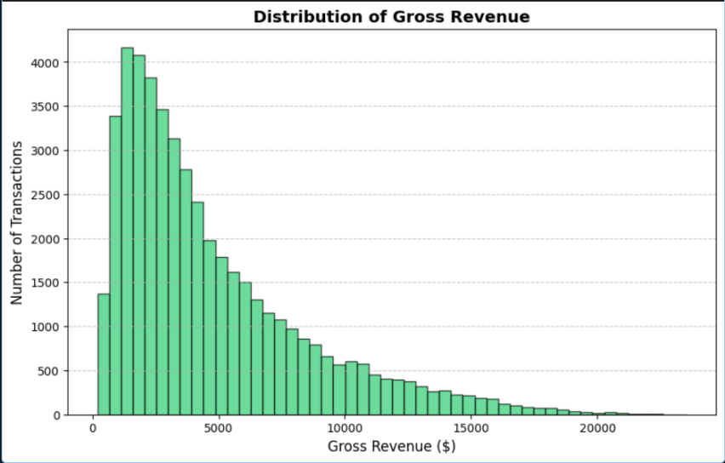

Revenue Distribution Histogram

Correlation Heatmap Analysis
The correlation heatmap provides a clear view of relationships between key numerical variables. A strong positive correlation is observed between marketing spend and revenue, confirming that increased investment is generally associated with higher returns. However, the correlation between other variables such as ROI and spend is not uniformly strong, indicating that efficiency varies across campaigns. This helped in understanding that higher spending does not always guarantee proportionally higher returns.
In addition to this, weaker and moderate correlations between certain variables highlighted the presence of external influencing factors that are not directly captured in the dataset, such as campaign targeting quality, timing, and audience segmentation. This reinforced the understanding that revenue performance is not solely dependent on budget allocation but also on how effectively the marketing strategy is executed.
The heatmap also played an important role in feature understanding before transformation, helping to identify which variables carried meaningful predictive strength and which had limited analytical contribution. This insight was useful while structuring the Gold layer, where only relevant aggregated metrics were retained for reporting purposes.
Furthermore, the correlation analysis helped validate the consistency of calculated KPIs such as revenue efficiency and return metrics, ensuring that derived measures aligned logically with underlying raw data patterns. This improved confidence in the overall data model used for reporting in Power BI and Tableau.
Overall, the heatmap served as a key step in understanding inter-variable relationships and guided better decision-making during both data modeling and dashboard design phases.

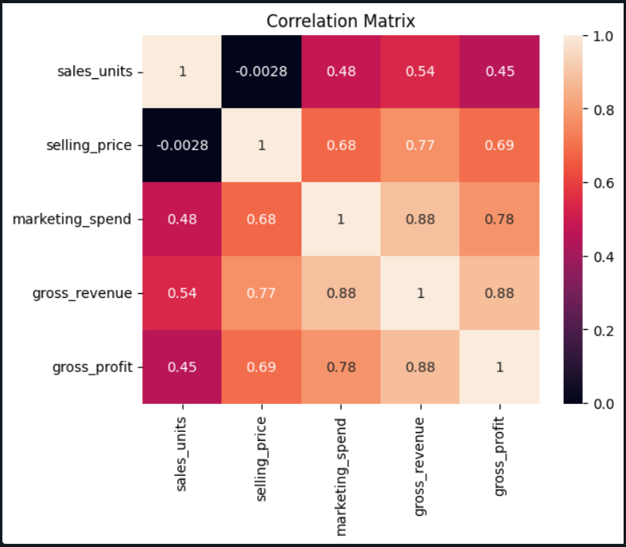

Correlation Heatmap

Gold Layer (Analytics-Ready Data)
The Gold layer represents the final stage of data transformation, where the processed data is structured into an analytics-ready format suitable for reporting and business intelligence tools. This layer contains refined and aggregated data derived from the Silver layer, ensuring that it is optimized for querying and visualization.
In this project, the Gold layer prepares data for loading into SQL Server Management Studio, where it is organized into a structured schema using a star schema design. The data at this stage includes key business metrics such as total revenue, marketing spend, and campaign performance indicators.
Unlike the Silver layer, which focuses on cleaning and structuring, the Gold layer emphasizes data organization for analytical consumption. This includes ensuring that all required fields are properly formatted, relationships between entities are maintained, and metrics are ready for aggregation.
The data in the Gold layer serves as the direct source for dashboards in Power BI and Tableau. By maintaining consistency in metric definitions and data structure, this layer ensures that reporting outputs are accurate and aligned with business expectations.
Overall, the Gold layer acts as the final bridge between data processing and visualization, enabling efficient and reliable business analysis.

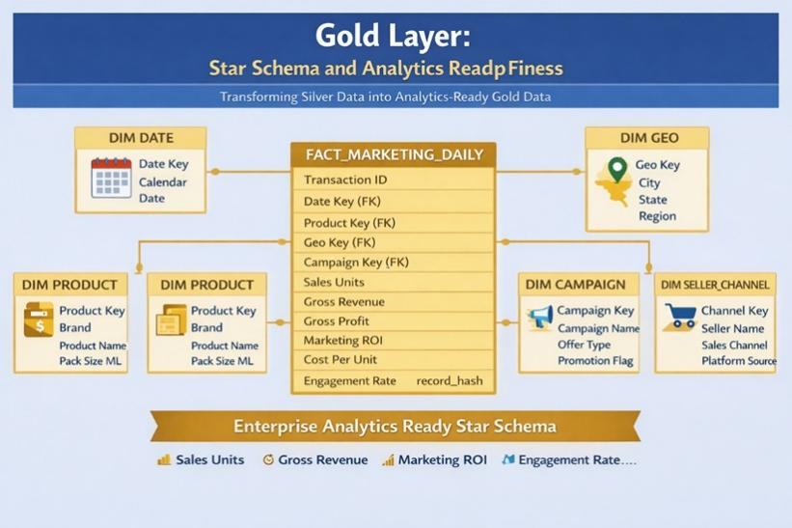

7.Data Storage Design
The data storage layer in this project is implemented using SQL Server Management Studio (SSMS), which acts as the central data warehouse for storing processed and structured marketing data. The primary objective of this layer is to organize transformed data into a relational format that supports efficient querying, reporting, and integration with visualization tools such as Power BI and Tableau.
The storage design follows a structured approach where data is moved from Databricks (Gold layer) into SQL Server after all cleaning, transformation, and validation steps are completed. This ensures that only high-quality, analytics-ready data is stored in the warehouse.
The design is optimized for analytical workloads rather than transactional operations, focusing on fast read performance and simplified query structures for reporting use cases

Schema Design
The schema design is based on a structured relational model that separates factual data from descriptive attributes. This ensures clarity, reduces redundancy, and improves query performance.
The database consists of two main types of tables:
Fact Table:
dw.fact_marketing_daily
- Campaign ID (Key)
- Date ID (Key)
- Geography ID (Key)
- Product ID (Key)
- Performance Metrics (Aggregated)
- Campaign Overview
- KPI Daily Summaries
- System Control Data
dw.dim_date_details
- Date ID (Key)
- Full Date
- Year
- Month
- Quarter
- Day of Week
- Week Number
dw.dim_geography_details
- Geography ID (Key)
- Geography City
- Geography State
- Geography Country
- Geography Region
- Geography Full
dw.dim_product_details
- Product ID (Key)
- Product Name
- Product Category
- Product Category 2
dw.dim_seller_channel_details
- Seller Channel ID (Key)
- Seller Channel Name
Relationships Overview
- Fact table is connected to all dimension tables using foreign keys
- Each record in the fact table links to:
- Date dimension via Date ID
- Geography dimension via Geography ID
- Product dimension via Product ID
- Seller Channel dimension via Seller Channel ID
- Star schema design is used for efficient querying and reporting

Data Modeling
The project uses a Star Schema Data Model, which is widely used in data warehousing for analytical processing.
In this model:
- The Fact Table sits at the center
- Multiple Dimension Tables surround it
- Each dimension connects directly to the fact table
This structure simplifies complex queries and improves performance for BI tools.
Why Star Schema was used:
- Reduces complexity of joins
- Improves query performance
- Easy for BI tools to consume
- Supports efficient aggregation of metrics
The model was specifically designed to support reporting requirements such as:
- Revenue analysis by campaign
- Marketing spend comparison
- Geographic performance tracking
- Product-level insights


Storage Architecture
The storage architecture of the project is designed to support efficient analytical processing by organizing data into a structured dimensional model within SQL Server Management Studio (SSMS). The architecture follows a star schema approach, where a central fact table is connected to multiple dimension tables, enabling simplified querying and improved performance for reporting tools.
At the core of the architecture is the fact table (dw.fact_marketing_daily), which stores the primary transactional and performance-related data. This table contains key metrics such as campaign performance indicators, aggregated KPIs, and system-level data required for analysis. It also includes foreign keys that link to various dimension tables, allowing data to be analyzed across different perspectives.
Surrounding the fact table are multiple dimension tables, each representing a specific aspect of the data. The date dimension (dw.dim_date) provides detailed time-based attributes such as year, month, quarter, day of the week, and week number, enabling time-series analysis and trend identification. The geography dimension (dw.dim_geo) contains location-based information including city, state, country, and region, which supports geographical performance analysis.
The product dimension (dw.dim_product) stores product-related attributes such as product name and category, allowing analysis of revenue and performance across different product segments. Similarly, the seller channel dimension (dw.dim_seller_channel) provides information about different sales channels, enabling comparison of performance across distribution platforms.
Each dimension table is linked to the fact table through a unique key, forming a clear and efficient relational structure. This design minimizes data redundancy and allows for fast query execution, as most analytical queries involve simple joins between the fact table and relevant dimensions.
The architecture is optimized for read-heavy operations, which is essential for dashboarding and reporting. By structuring the data in this way, BI tools such as Power BI and Tableau can easily query the data to generate insights without requiring complex transformations at the visualization layer.
Overall, this storage architecture ensures that the data warehouse is scalable, efficient, and well-suited for analytical workloads, while also maintaining consistency and integrity across all data elements.

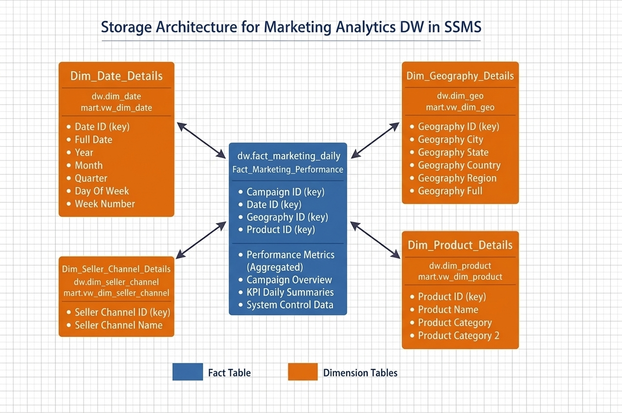
ETL Pipeline Design
The ETL (Extract, Transform, Load) pipeline is the core component of the project, responsible for moving marketing data from the source API to the SQL Server data warehouse in a structured and reliable manner. The pipeline is implemented using Databricks notebooks and follows a Medallion Architecture approach, consisting of Bronze, Silver, and Gold layers to ensure proper separation between raw, cleaned, and analytics-ready data. The process begins with data extraction from the API, where raw data is ingested into the Bronze layer without modification, preserving the original dataset for traceability. The data then moves to the Silver layer, where cleaning and transformation operations are applied, including handling missing values, removing duplicates, standardizing formats, and applying business rules. In the final Gold layer, the data is structured into an analytical format using fact and dimension tables, and then loaded into SQL Server Management Studio, where it is stored in a relational schema for reporting. This structured data is ultimately consumed by Power BI and Tableau dashboards for analysis and visualization.
The pipeline execution is managed through Databricks notebooks in a step-by-step sequence, ensuring that each stage completes before moving to the next. Although advanced orchestration tools were not used, the modular design allowed independent execution of each layer, making debugging and maintenance easier. A key feature of the pipeline is incremental data processing using watermark-based logic, where only new or updated records are processed in each run instead of reprocessing the entire dataset. This significantly improves performance and prevents data duplication. During implementation, issues such as long-running queries, rollback blocking, and incorrect watermark configurations (which caused zero rows to be processed) were encountered and resolved through validation and debugging. Overall, the pipeline design ensures reliability, efficiency, and repeatability, making it suitable for handling real-world data processing scenarios.

8.Data Quality Management
Data quality management was a critical component of the pipeline, as the raw marketing data obtained from the API contained inconsistencies that could impact analytical accuracy and reporting reliability. The objective was to ensure that the final dataset was clean, consistent, and aligned with business requirements.
The process began during the EDA phase, where issues such as missing values, duplicate records, inconsistent formats, and skewed distributions in key metrics like revenue and marketing spend were identified. These findings guided the design of transformation and validation logic in later stages.
Missing values in critical fields were carefully handled to prevent incorrect analysis, while non-critical fields were managed using appropriate strategies without affecting key calculations. Duplicate records were removed during transformation to avoid double counting, especially in revenue-related metrics. Data type consistency was also enforced to ensure accurate aggregation and time-based analysis.
Revenue distribution analysis revealed a strong positive skew, where a small number of campaigns contributed significantly to total revenue. These high-value records were preserved rather than treated as outliers to maintain realistic business insights.
Incremental processing using watermark logic introduced additional validation requirements. Issues such as incorrect watermark values leading to zero-record processing were identified and resolved by adding validation checks to ensure correct pipeline execution.
Data quality was further validated through cross-checking outputs in Power BI and Tableau. Any inconsistencies in metrics helped identify issues in transformation logic or aggregation behavior, improving overall reliability.
Overall, the data quality process ensured that the final dataset was accurate, consistent, and reliable, forming a strong foundation for reporting and decision-making.

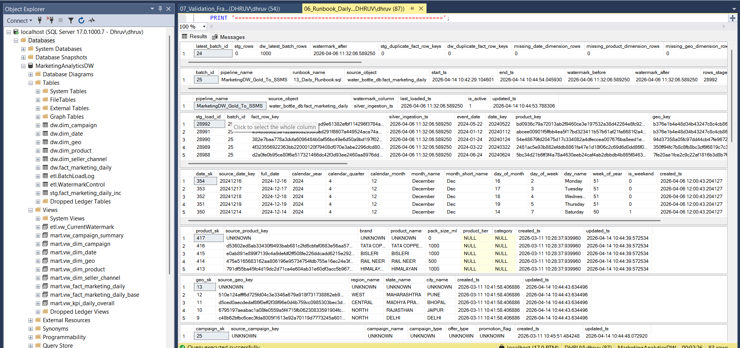

9.Power Bi Dashboard and Visualization
In this phase, a comprehensive marketing intelligence suite was developed using Power BI Desktop, transforming the curated data from the Gold layer into a high-impact visual interface. The dashboard was specifically engineered to provide both a "Pulse Check" on daily operations and a "Deep Dive" into campaign efficiency.

Strategic KPI Monitoring (Executive View)
At the top of the interface, a dedicated KPI ribbon provides immediate visibility into the health of the business.
- Revenue & Profitability: Real-time tracking of total revenue against net profit, allowing stakeholders to see the immediate bottom-line impact of marketing activities.
- Performance Ratios: Automated calculation of Marketing ROI and Conversion Rates, providing a standardized metric to compare the effectiveness of different budget allocations.
- Operational Volume: High-level counts of total records and active campaigns to ensure data pipeline completeness.

Geospatial & Temporal Analysis
- The dashboard leverages spatial and time-series visualizations to identify growth opportunities:
- Regional Market Penetration: A dynamic Map visualization that plots revenue by geographical region. This allows managers to identify "Hot Zones" where the packaged water brand has high market share versus regions that require increased marketing spend.
- Temporal Revenue Trends: Line and area charts that track revenue fluctuations over time. This is critical for identifying seasonal demand patterns in the drinking water industry and measuring the "ramp-up" period of new marketing campaigns.

Comparative Segment Analysis
To move beyond surface-level data, the dashboard utilizes grouped bar and column charts to compare segments:
- Campaign & Product Performance: A breakdown of revenue by specific product lines and campaign names, making it clear which "Hero" products are driving the most value.
- Category Benchmarking: Comparing different categories (e.g., promotional types or seller channels) to determine where the highest quality leads are originating.

Interactive Filtering & User Experience (UX)
The report is designed for self-service discovery through advanced interactivity:
- Dynamic Slicers: Strategic filters for Date Ranges, Geography, and Campaign Types allow users to "slice" the entire report. When a user selects a specific region on the map or a slicer, all related charts update instantly to show data for that specific segment.
- Data-to-Ink Ratio: The design prioritizes a clean, professional aesthetic with a consistent color palette, ensuring that the most critical data points—like the ROI and Revenue cards—remain the focal point for decision-makers.

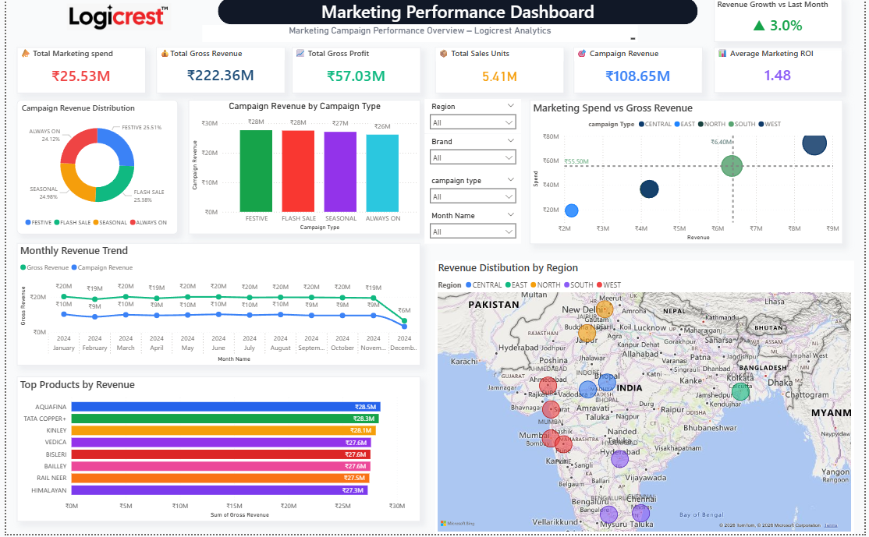
Power BI Dashboard Screenshot
9.1 Tableau Dashboard Design
Tableau Dashboard Implementation
- Dashboards were replicated in Tableau to ensure tool independence and consistency with Power BI outputs.
- The same underlying data model and visual structure were recreated using the processed data from SQL Server.
- Differences were observed in tool behavior, particularly in filter interactions, default aggregations, and chart rendering logic.

Handling Tool Differences
- Variations in context filters, aggregation levels, and visual-level calculations required careful handling.
- Minor adjustments were made in Tableau visual configurations to align results with Power BI.
- Core dataset and business logic were kept unchanged to maintain data integrity.

Dashboard Design and Structure
- The Tableau dashboard mirrored the analytical structure developed in Power BI.
- Key visuals included:
- Revenue trends
- Marketing spend distribution
- Campaign performance comparison
- Geographical analysis
- Multiple worksheets were created and combined into a unified dashboard layout.
- Focus was placed on clarity, usability, and logical arrangement of visuals.

Interactivity and Filters
- Interactive filters such as city, product, and campaign type were implemented.
- Dashboard actions were used to enable dynamic data exploration.
- An issue was encountered where filters (e.g., city filter) affected only specific charts.
- This was resolved by properly configuring filter actions across all worksheets.

Visualization Techniques
- Various chart types were used for different analytical purposes:
- Line charts for revenue trends
- Bar charts for comparisons
- Scatter plots for relationship analysis (e.g., spend vs revenue)
- Heatmaps for correlation analysis
- Issues with multiple lines in trend charts were resolved by adjusting the level of detail to avoid over-segmentation.

Aggregation and Data Consistency
- Measures such as total revenue, total spend, and KPIs were validated against Power BI outputs.
- Differences in default aggregation behavior were handled through explicit configuration in Tableau.
- Ensured consistency between Tableau visuals and the SQL Server data model.

Validation and Data Reliability
- Cross-validation between Tableau and Power BI helped identify inconsistencies.
- Differences highlighted areas requiring refinement in aggregation logic and filtering behavior.
- This process improved the reliability of the reporting layer.

Usability and Presentation
- Dashboard design focused on readability and user experience.
- Proper alignment, labeling, and formatting were applied.
- Titles, legends, and tooltips were configured to provide additional context.

Final Outcome
- Final dashboards in Tableau and Power BI were consistent in terms of key business insights.
- Confirmed that the pipeline outputs were stable and reliable.
- Ensured that the solution is tool-agnostic and reusable across different BI platforms.

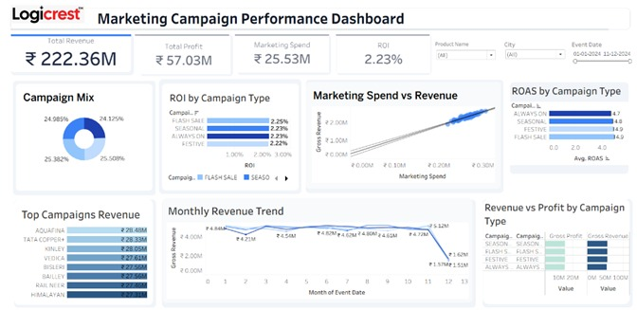
Tableau Dashboard Screenshot

KPI Definitions
The definition and calculation of Key Performance Indicators (KPIs) were carefully aligned with the transformation logic implemented in the data pipeline to ensure consistency and accuracy across all reporting layers. Instead of relying entirely on visualization-level calculations, most KPIs were derived from the structured data stored in SQL Server, where business logic had already been standardized during the Gold layer transformation.
Core KPIs such as Total Revenue and Total Marketing Spend were calculated as aggregated measures from the fact table, ensuring that values remained consistent regardless of the visualization tool being used. Derived metrics such as Return on Investment (ROI) were computed using the relationship between revenue and marketing spend, providing a clear measure of campaign efficiency.
Special attention was given to handling skewed data distributions identified during the EDA phase. Since a small number of campaigns contributed disproportionately to total revenue, KPI calculations were designed to preserve these high-value contributions rather than normalizing or excluding them. This ensured that business insights accurately reflected real performance.
In addition, consistency checks were performed across Power BI and Tableau dashboards to validate that KPI values matched across both tools. Any discrepancies observed were traced back to differences in aggregation logic or filter behavior and were resolved without altering the underlying dataset. This approach ensured that KPI definitions remained stable, reliable, and independent of the visualization platform.

Data Refresh Mechanism
The data refresh mechanism was designed to ensure that dashboards consistently reflected the most up-to-date information available from the pipeline. The refresh process was directly dependent on the successful execution of the data pipeline, where new data was ingested, processed, and loaded into SQL Server.
Since the pipeline utilized watermark-based incremental loading, only new or updated records were processed during each run. This approach significantly reduced processing time and ensured that dashboard updates were efficient without requiring full data reloads.
Once the updated data was available in SQL Server, both Power BI and Tableau dashboards were refreshed to reflect the latest values. This ensured synchronization between the data warehouse and visualization layer, allowing users to access current insights without delay.
During implementation, attention was given to ensuring that refresh cycles did not introduce inconsistencies in metrics. Validation was performed after each refresh to confirm that KPIs such as revenue and marketing spend remained consistent across different runs. This was particularly important in scenarios where incorrect watermark configurations could result in no data being processed, which required additional verification to ensure data continuity.
Overall, the refresh mechanism ensured a reliable flow of updated data from the pipeline to the dashboards, supporting accurate and timely reporting

- Pipeline Optimization
Pipeline optimization was an important part of the implementation, as several performance and execution issues were encountered during development. The goal of optimization was to improve execution efficiency, reduce processing time, and ensure consistent performance across multiple pipeline runs.
One of the key optimizations implemented was the use of incremental data processing through watermark-based logic. Instead of reprocessing the entire dataset in every run, the pipeline was designed to process only new or updated records based on a tracked timestamp or identifier. This significantly reduced computation time and improved overall efficiency, especially as the dataset size increased.
During development, long-running queries were frequently observed, particularly when working with larger datasets or when transformations involved multiple operations. In some cases, these queries appeared to be stuck, and terminating them led to rollback operations that blocked further execution. This highlighted inefficiencies in query execution and required careful analysis of the transformation logic.
To address these issues, the transformation steps were reviewed and optimized by reducing unnecessary computations and ensuring that operations were applied only where required. Query structure was improved to avoid redundant processing, and intermediate steps were streamlined to maintain a smoother data flow between pipeline stages.
Another important optimization involved ensuring efficient data movement between Databricks and SQL Server. Data loading operations were refined to avoid repeated inserts and ensure that only relevant records were transferred during each run. This helped in reducing load times and improving consistency in the data warehouse.
Incremental processing also required careful handling to avoid silent failures. Issues were encountered where incorrect watermark values resulted in pipeline runs processing zero records without any visible error. This was addressed by validating watermark logic and ensuring that input conditions were correctly defined before execution.
Overall, pipeline optimization improved execution reliability and reduced processing time, ensuring that the system could handle repeated runs efficiently without unnecessary overhead.

11. Security and Data Governance
Security and data governance in this project were maintained at a basic but structured level, focusing on ensuring data integrity, controlled access, and consistency across the pipeline.
The pipeline followed a layered architecture (Bronze, Silver, Gold), which inherently supported data governance by separating raw, processed, and analytical data. The Bronze layer preserved raw data in its original form, ensuring traceability and enabling reprocessing if required. The Silver layer applied cleaning and transformation logic, while the Gold layer contained finalized data used for reporting.
Data integrity was maintained by applying validation checks during the transformation stage. This included handling missing values, removing duplicates, and ensuring consistent data formats. These steps ensured that only clean and reliable data was passed to the data warehouse.
Access to data was controlled within the development environment, where only processed and validated datasets were used for reporting. The use of SQL Server as a centralized storage system ensured that structured data was consistently maintained and accessed in a controlled manner.
Consistency in business logic was also an important aspect of governance. All KPI calculations and transformation rules were implemented in the data processing layer rather than being duplicated across visualization tools. This ensured that both Power BI and Tableau dashboards relied on the same underlying logic, reducing the risk of inconsistencies.
Although advanced security mechanisms such as role-based access control or encryption were not implemented in this project, the design ensures that such features can be added in future enhancements without significant changes to the pipeline structure.

12. Deployment Architecture
The deployment architecture of the project was designed to simulate a real-world data pipeline environment while being implemented within a controlled development setup. The architecture integrates multiple components, including data ingestion, processing, storage, and visualization, ensuring a smooth flow of data from source to reporting layer.
The pipeline was not deployed in a full-scale production environment; however, the structure and workflow were designed in a way that reflects practical deployment practices. Each component was configured to interact seamlessly with others, enabling consistent execution and data availability across stages.
The deployment flow begins with data extraction from the API, followed by processing in Databricks, storage in SQL Server Management Studio, and finally consumption by visualization tools such as Power BI and Tableau. This layered approach ensures clear separation between processing and reporting, improving maintainability and reliability.

Development Environment
The entire pipeline was developed and tested within a development environment, where all components were configured and validated step by step.
Databricks served as the primary processing environment, where notebooks were used to implement ingestion, transformation, and incremental loading logic. Each stage of the pipeline (Bronze, Silver, Gold) was executed in a structured sequence, allowing validation of data at each stage.
To introduce automation, Databricks job scheduling was implemented to run the pipeline at regular intervals of every two hours. This ensured that data ingestion and processing occurred automatically without requiring manual intervention for each run. The scheduled jobs handled the execution of notebooks and maintained continuity in data updates, especially for incremental loading using watermark logic.
SQL Server Management Studio was used as the central storage layer. Processed data from the Gold layer was loaded into SQL Server tables designed using a star schema approach. This ensured that the data was structured and optimized for analytical queries.
Power BI and Tableau were connected to SQL Server to build dashboards. The connection to the database was established once and remained persistent, meaning there was no need to reconnect manually for each session. Dashboards accessed the latest available data directly from SQL Server whenever refreshed.
Although dashboard refresh itself was not fully automated, the availability of updated data in the warehouse ensured that reports reflected the latest processed data after each scheduled pipeline run.

Production Environment
Although a production environment was not fully implemented, the pipeline was partially automated through Databricks job scheduling, which reflects real-world deployment practices.
In a complete production setup, this scheduling mechanism would be extended with advanced orchestration tools to manage dependencies, retries, and failure handling. Monitoring and logging mechanisms would also be integrated to track pipeline performance and detect failures in real time.
The SQL Server database would continue to act as a centralized data warehouse, supporting multiple users and dashboards simultaneously. Visualization tools such as Power BI and Tableau would be configured with scheduled refresh mechanisms to automatically update dashboards based on the latest processed data.

Data Flow in Deployment
The deployed workflow follows a structured sequence:
- Data is extracted from the API and loaded into Databricks (Bronze layer)
- Data is cleaned and transformed in the Silver layer
- Processed data is structured in the Gold layer
- Final data is loaded into SQL Server tables
- Dashboards in Power BI and Tableau consume data from SQL Server
With the addition of Databricks scheduling, this entire flow is triggered automatically at regular intervals, ensuring continuous data updates without manual execution.

Execution and Dependency Handling
Pipeline execution follows a dependent sequence where each stage relies on the successful completion of the previous stage. For example, transformation cannot begin until data ingestion is completed, and data cannot be loaded into SQL Server until transformation is finalized.
The introduction of scheduled jobs in Databricks ensured that these dependencies were executed in a predefined sequence automatically. This reduced the need for manual intervention while still maintaining control over execution flow.
During development, issues such as long-running queries and rollback blocking highlighted the importance of controlled execution. These challenges reinforced the need for structured scheduling and dependency management in pipeline execution.

The current deployment setup has certain limitations due to its development-focused nature.
While Databricks scheduling automated the execution of the pipeline, other components such as dashboard refresh and monitoring were not fully automated. There was no centralized orchestration tool managing the entire workflow across all components.
Monitoring and logging were handled manually, making it difficult to track pipeline performance over time. Despite this, the scheduled execution significantly improved efficiency compared to a fully manual pipeline.

Summary of Deployment Architecture
The deployment architecture effectively integrates all components of the pipeline into a cohesive system. The use of Databricks job scheduling introduced partial automation, ensuring that data processing occurred at regular intervals without manual execution.
The persistent connection between SQL Server and visualization tools ensured seamless data access, allowing dashboards to reflect updated data without repeated configuration.
While implemented in a development environment, the architecture demonstrates key aspects of real-world deployment, including automation, structured data flow, and integration across multiple tools. With additional enhancements such as full orchestration and monitoring, the system can be extended into a production-ready pipeline.

13. Testing Strategy
The testing strategy for the project was designed to ensure accuracy, consistency, and reliability of data across all stages of the pipeline, from ingestion to visualization. Since the pipeline involved multiple transformation layers and incremental processing, testing was performed at each stage to validate data correctness and system behavior.
The testing process began at the ingestion level in Databricks, where raw data from the API was validated after loading into the Bronze layer. This step ensured that data was being correctly fetched and stored without structural issues or missing records. Basic schema validation was performed to confirm that all expected fields were present and correctly mapped.
At the transformation stage (Silver layer), testing focused on data cleaning and business logic validation. This included verifying that missing values were handled correctly, duplicate records were removed, and data types were properly standardized. Special attention was given to ensuring that transformation logic did not unintentionally modify or distort key business metrics such as revenue and marketing spend.
Incremental loading logic using watermark was also tested extensively. Multiple pipeline runs were executed to confirm that only new or updated records were being processed. In some cases, issues were observed where incorrect watermark values resulted in zero records being processed. These cases were identified during testing and corrected by validating watermark conditions before execution.
At the storage layer (SQL Server), testing was performed to ensure that data loaded into fact and dimension tables was consistent with the transformed output from Databricks. This included verifying row counts, checking key relationships, and ensuring that schema mapping between Gold layer output and SQL tables was correct.
Finally, testing was extended to the visualization layer using Power BI and Tableau. Both dashboards were compared to ensure that metrics such as total revenue, marketing spend, and campaign performance were consistent across tools. Any discrepancies observed were traced back to either aggregation logic differences or filter behavior, and were resolved to maintain consistency.
Overall, the testing strategy ensured that each layer of the pipeline was validated independently as well as end-to-end, confirming that the final output accurately represented the underlying data.

14. Monitoring and Logging
The monitoring and logging approach in this project was primarily implemented through manual tracking and observation of pipeline execution within Databricks. Since the project was built in a development environment, dedicated enterprise-grade monitoring tools were not used; however, structured observation of logs and execution outputs was maintained throughout the pipeline.
During execution of Databricks notebooks, logs were used to track the progress of each stage in the pipeline, including ingestion, transformation, and loading. These logs helped identify execution bottlenecks, failures, and unexpected behavior during processing. Each step in the pipeline was monitored to ensure that data was flowing correctly from one stage to another.
One of the key issues encountered during development was long-running queries, which sometimes appeared to be stuck during execution. In such cases, logs were reviewed to identify whether the issue was caused by data volume, query inefficiency, or system rollback behavior. Termination of such queries often triggered rollback operations, which temporarily blocked further execution. These incidents were carefully analyzed to understand execution behavior and improve stability.
Another critical observation came from watermark-based incremental processing. In some cases, incorrect watermark values resulted in pipeline runs processing zero records without throwing explicit errors. This highlighted the importance of adding validation checks before execution to ensure that watermark conditions were correctly defined and updated.
Although formal logging frameworks were not implemented, print statements and execution outputs within Databricks notebooks were used to track progress and validate intermediate results. This helped in debugging transformation logic and ensuring that data was being processed correctly at each stage.
Monitoring was also indirectly performed through the validation of outputs in SQL Server and dashboards. Any inconsistencies in Power BI or Tableau visuals were traced back to pipeline execution stages, which helped identify issues in transformation or data loading logic.
The absence of automated monitoring highlighted the importance of observability in data pipelines. It reinforced the need for structured logging, error tracking, and execution monitoring in production-grade systems to ensure reliability and faster issue resolution.
Overall, the monitoring and logging approach ensured that pipeline execution could be tracked, debugged, and validated effectively, even in a manually managed development environment.

15. Weekly Implementation Progress
The project was executed over a 12-week timeline, divided into structured phases covering end-to-end data pipeline development from requirement analysis to final reporting.

Week | Phase | Activities Performed | Short Summary
Week 1–2 | Project Foundation | Understanding business requirements, learning data pipeline concepts, MockAPI setup, initial data ingestion | Established project understanding and set up initial data source and ingestion flow
Week 3–4 | Data Processing Setup | Databricks environment setup, data cleaning and transformation, Apache Spark basics | Built processing environment and implemented initial data transformation logic
Week 5–6 | Data Modeling | Data modeling in SSMS, creation of Fact and Dimension tables | Designed structured data warehouse using star schema approach
Week 7–8 | Analytics Preparation | Gold layer creation, KPI identification and modeling | Prepared analytics-ready dataset and defined key business metrics
Week 9–10 | Dashboard Development | Power BI dashboard creation, executive reporting design | Developed interactive dashboards for business reporting and insights
Week 11–12 | Final Analytics & Reporting | Tableau dashboard development, final reporting and documentation | Validated insights across Tableau and completed final project documentation

16. Challenges and Resolutions
During the development and implementation of the data pipeline, several real-world challenges were encountered, primarily related to performance, data consistency, and pipeline reliability. These challenges helped in understanding practical issues that arise in end-to-end data engineering workflows.
One of the major challenges was related to query performance in Databricks when processing large datasets. Certain queries involving transformations and joins took significantly longer than expected and, in some cases, appeared to be stuck during execution. This impacted the overall pipeline runtime and made debugging difficult. In some instances, manually terminating such queries resulted in rollback operations, which further blocked subsequent executions until the session was reset. This highlighted the importance of efficient query design and proper resource handling in distributed processing environments.
Another critical issue was observed in the incremental loading mechanism using watermark logic. In certain pipeline runs, incorrect watermark configuration led to scenarios where no records were processed, even though new data was available. These failures did not always generate explicit errors, making them difficult to identify initially. This issue was resolved by carefully validating watermark conditions, ensuring correct timestamp tracking, and adding checks to confirm the availability of new data before execution of transformation logic.
Data consistency issues were also encountered during transformation and loading into SQL Server. Differences in aggregation behavior and data type handling between Databricks and SQL Server sometimes led to mismatched results in reporting outputs. These inconsistencies were resolved by standardizing transformation logic in Databricks and ensuring that calculated fields were finalized before loading data into the warehouse layer.
Another challenge was related to dashboard consistency between Power BI and Tableau. While both tools used the same underlying dataset, differences in default aggregation, filter behavior, and calculation logic occasionally led to variations in output values. These issues were resolved by explicitly defining measures, adjusting aggregation levels, and aligning filter configurations across both tools.
Additionally, during Tableau dashboard development, issues were faced with filter interactions where certain filters initially applied only to specific visualizations instead of the entire dashboard. This was corrected by properly configuring filter actions and ensuring consistent linkage between worksheets.
Overall, these challenges highlighted the importance of careful pipeline design, proper validation at each stage, and continuous debugging to ensure reliable data processing and reporting.

17. Results and Outcomes
The project successfully delivered a fully functional end-to-end data pipeline for processing marketing data from ingestion to visualization. The pipeline effectively handled data extraction from an API, transformation using Databricks, structured storage in SQL Server, and visualization through Power BI and Tableau dashboards.
One of the key outcomes of the project was the successful implementation of incremental data processing using watermark logic. This significantly improved pipeline efficiency by ensuring that only new or updated records were processed during each execution, reducing redundant computations and improving overall performance.
The transformation process ensured that raw and inconsistent marketing data was converted into a structured and analytics-ready format. Data quality improvements such as duplicate removal, handling missing values, and standardization of data types resulted in a more reliable dataset for reporting and analysis.
The dashboards developed in Power BI and Tableau provided clear visibility into marketing performance, including revenue trends, campaign effectiveness, marketing spend distribution, and regional performance analysis. The consistency between both tools confirmed that the underlying data model and transformation logic were correctly implemented.
Another important outcome was the validation of the star schema design in SQL Server, which improved query performance and simplified reporting logic. This ensured that BI tools could efficiently retrieve and visualize data without requiring complex transformations at the reporting layer.
The project also demonstrated the ability to identify and resolve real-world data engineering issues such as long-running queries, rollback blocking, and watermark misconfiguration. Resolving these issues improved the stability and reliability of the pipeline.
Overall, the project achieved its objective of building a scalable and reliable data pipeline that transforms raw marketing data into meaningful business insights. It also provided practical exposure to data engineering concepts such as ETL design, incremental processing, data modeling, and dashboard development.

18. Future Enhancements
The current implementation successfully delivers a complete end-to-end data pipeline for marketing data processing, covering ingestion, transformation, storage, and visualization. However, several enhancements can be introduced in the future to improve scalability, automation, performance, and enterprise-level readiness of the system.
One of the primary enhancements would be the introduction of full pipeline orchestration. Currently, the pipeline is executed manually through Databricks notebooks in a sequential manner. In a production-ready system, this can be improved by automating the workflow using scheduling mechanisms that ensure each stage (ingestion, transformation, and loading) runs in a controlled and time-bound manner without manual intervention. This would significantly improve reliability and reduce operational overhead.
Another important enhancement is the implementation of advanced monitoring and logging mechanisms. At present, pipeline execution is monitored manually by reviewing Databricks outputs and query results. Introducing structured logging would allow better tracking of data movement, execution time, and failure points. This would also help in quickly identifying issues such as failed watermark logic, incomplete loads, or transformation errors.
Performance optimization is another area for improvement. While incremental loading using watermark logic already reduces unnecessary processing, further optimization can be achieved by improving query efficiency, indexing strategies in SQL Server, and reducing unnecessary data scans in transformation logic. This would make the pipeline more efficient when handling larger datasets.
The system can also be enhanced by introducing real-time or near real-time data processing capabilities. Currently, the pipeline operates in batch mode, where data is processed at intervals. By extending the architecture to support streaming ingestion, the system could provide more timely insights for business decision-making, especially for time-sensitive marketing campaigns.
Data governance and security can also be improved in future iterations. Although the current system maintains structured data separation between raw and processed layers, advanced governance features such as role-based access control, data encryption, and audit tracking can be introduced. This would make the pipeline suitable for enterprise-level deployment where data security is critical.
Another potential enhancement is the integration of automated data quality frameworks. Currently, data quality checks are implemented manually within transformation logic. This can be extended by introducing standardized validation frameworks that automatically detect anomalies, missing values, and schema inconsistencies before data is processed further.
On the visualization side, dashboards can be further enhanced by introducing advanced analytics features such as predictive insights, trend forecasting, and anomaly detection visualizations. This would shift the dashboards from being purely descriptive to more predictive and diagnostic in nature.
The data model can also be further optimized by introducing slowly changing dimensions (SCD) to handle historical changes in attributes such as campaign details or product information. This would improve historical tracking and enable more accurate time-based analysis.
Finally, the pipeline can be extended to cloud-based deployment environments in the future. While the current system operates in a local or controlled environment, migrating to cloud platforms would improve scalability, availability, and integration with other enterprise systems.

- Conclusion
The project successfully demonstrates the implementation of a complete end-to-end data engineering pipeline for processing and analyzing marketing data. The system integrates multiple stages including data ingestion, transformation, storage, and visualization to convert raw and unstructured data into meaningful business insights.
The pipeline was built using Databricks for data processing and transformation, and SQL Server Management Studio for structured data storage. A layered approach using Bronze, Silver, and Gold stages was implemented to ensure proper data segregation and controlled data flow. This structure allowed raw data to be preserved initially, progressively cleaned and transformed, and finally optimized for analytical reporting.
One of the key achievements of the project was the implementation of incremental data loading using watermark-based logic. This ensured that only new or updated records were processed during each pipeline run, improving efficiency and reducing unnecessary computation. It also helped in managing large datasets effectively without requiring full data reloads.
Data quality played a major role throughout the project. Multiple validation checks were applied during the transformation stage to handle missing values, remove duplicates, and ensure consistency across datasets. Exploratory Data Analysis further helped in understanding data distributions, identifying skewed patterns in revenue, and detecting potential anomalies that influenced transformation logic.
The reporting layer was developed using Power BI and Tableau to ensure that processed data could be effectively visualized for business decision-making. Dashboards were designed to represent key metrics such as revenue, marketing spend, campaign performance, and regional analysis. Cross-validation between both tools ensured consistency in KPI calculations and confirmed that the underlying data model was reliable.
During implementation, several real-world challenges were encountered, including long-running queries, rollback issues during query termination, and incorrect watermark configurations leading to empty pipeline runs. These issues were resolved through systematic debugging and careful review of execution logic. This experience highlighted the importance of monitoring, logging, and understanding system behavior in data pipeline environments.
Additionally, differences observed between Power BI and Tableau in terms of aggregation behavior, filtering logic, and visual rendering helped in strengthening the accuracy of the data model. These validations ensured that the final outputs were consistent across different reporting tools and aligned with business expectations.
Overall, the project provided strong hands-on experience in building a realistic data engineering workflow. It reinforced key concepts such as ETL design, incremental processing, data modeling, and dashboard development. The final outcome is a stable and well-structured pipeline that successfully transforms raw marketing data into reliable, analytics-ready insights, supporting informed decision-making.

- References
- Databricks Documentation. Introduction to Databricks and Data Engineering Workflows. Available at: https://docs.databricks.com
- Microsoft. SQL Server Management Studio (SSMS) Documentation. Available at: https://learn.microsoft.com/sql/ssms
- Microsoft. Power BI Documentation. Available at: https://learn.microsoft.com/power-bi
- Tableau Software. Tableau Documentation and Learning Resources. Available at: https://help.tableau.com
- Databricks. Medallion Architecture (Bronze, Silver, Gold). Available at: https://docs.databricks.com/en/lakehouse/medallion.html
- Microsoft. Data Warehousing and Star Schema Concepts. Available at: https://learn.microsoft.com/sql/relational-databases/data-warehousing
- Kimball, R., & Ross, M. (2013). The Data Warehouse Toolkit: The Definitive Guide to Dimensional Modeling. Wiley.
- Python Software Foundation. Python Documentation. Available at: https://docs.python.org
- JSON. Introducing JSON Data Format. Available at: https://www.json.org
- Microsoft. Incremental Data Loading Concepts. Available at: https://learn.microsoft.com

